USAR MEDICAL GUIDANCE NOTE

3.4 DRAFT MEDICAL GUIDANCE NOTE ON THE IDENTIFICATION OF USAR MEDICAL PERSONNEL

It was noted that there were several issues pertaining to the obvious identification of medical personnel by the local population during the recent international disaster responses to Indonesia (2009) and Haiti (2010). In particular, medical personnel were placed under significant pressure to divert from their primary task (USAR medical operations) to render medical assistance to the wider affected community. While it is acknowledged that the identification of medical personnel both within the team and between teams is important, in some instances it is preferable that a USAR medic is not obviously recognisable by the wider community so that they can focus on their primary mission.

A perceived unwillingness to render medical assistance to the wider community in such circumstances may have adverse ethical, political, security and national (home country) implications.

The MWG recommends all medical personnel within a USAR team wear a green helmet when deployed away from their BoO. If this is not practicable, then they should adopt the use of a prominent green marking displayed on their helmet e.g., green reflective tape.

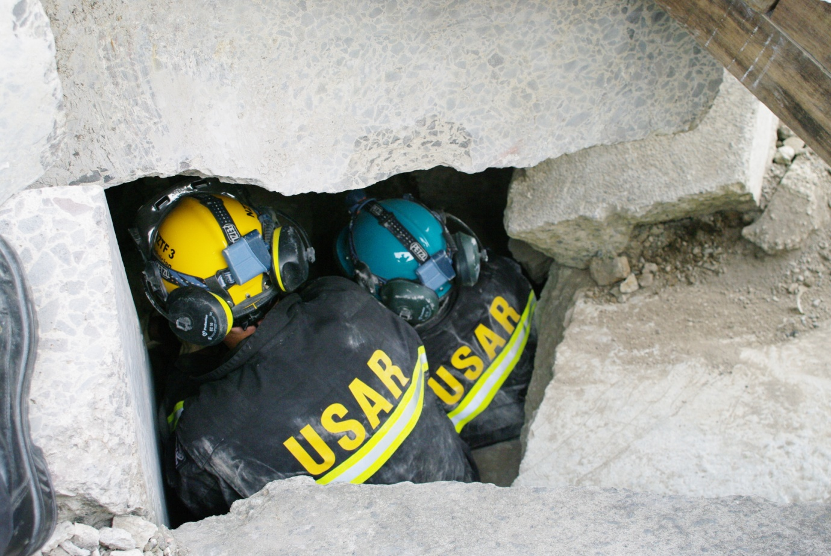

A similar identification issue may arise within a team’s BoO where the BoO Medical Station (BMS) is unintentionally prominently identified to the affected community. This may result in significant pressure on the BoO to address the healthcare needs of a very large group. Again, a perceived unwillingness to do so will have similar adverse ethical, political, security and national (home country) implications.

It is therefore recommended that the BMS is marked with prominent green marking e.g., green flag.

The above recommendations are indicated for those situations where medical identification to the wider community may result in adverse effects. However in other situations where this is not an issue, standard markings as are customary within the team can be utilised.

It is acknowledged that the adoption of these recommendations is entirely at the discretion of the USAR team management. However in situations where a team elects to remove or supplement formal medical markings for the reasons already identified, these recommendations should be adopted as they serve as a universal indicator of medical personnel.

