Title: | URBAN SEARCH AND RESCUE IN EXTREME ENVIRONMENTAL CONDITIONS
Last revised: | February 2014

1. Introduction

Collapsed structure incidents requiring Urban Search and Rescue (USAR) response occur in a variety of climates all over the world. It is important for response teams to consider the impact of these environments on the team, search dogs, and victims. These considerations become even more important when teams are responding from a home country with a significantly different environment than that of the impacted one.

This document is intended to give guidance to USAR teams responding into extreme environmental conditions. It is not intended to be a comprehensive medical, safety, or logistic text (references are made where appropriate).

Though there are multiple environmental considerations, the ones considered in this document are those related to extremes of altitude and temperature (heat and cold). Periods of acclimatization are helpful, however, USAR operations dictate a rapid response, which prevents delayed entry into a given environment. Appropriate preparation can mitigate the effects of sudden changes in climate for the USAR team.

Relevant environmental extremes are outlined below with important considerations related to prevention/preparation and treatment of individuals (both team members and victims). However, for any of the three environmental conditions discussed in this document the following should be considered:

- For any potential extreme environment the team could deploy to, they should be appropriately equipped. They may have to stock specific clothing, equipment (temperature can impede functionality of electronics, batteries, fuel, machinery), medicines, sunscreen, shelter, etc. that can facilitate team function.
- Pre-deployment preparations should include remote evaluation of the climate, last minute acquisitions, and briefings to the team on the effects of the climate.
- Certain medical conditions may be exacerbated during deployments into extreme environments. At risk individuals should be identified during the pre-deployment medical screening process to best advise appropriate action (e.g., prior history of frostbite, High Altitude Pulmonary Edema [HAPE]).
- The location and equipping of the Base of Operations (BoO) may require climate specific adaptations (e.g., heating; air conditioning; avalanche avoidance; drainage; sleeping at altitude lower than work area).
- Work rest periods may need to be adjusted.
- Adjustment to hydration and nutrition is essential. This may require additional quantities of food and water than normally carried.
- More vigilant monitoring of team member health (including canines) may be indicated (e.g. implement routine buddy checks).
- Environmental extremes may hinder emergency evacuation of the injured or ill team member. Appropriate planning should occur.

2. Altitude

Altitude is typically defined as an elevation above 1500m above sea level, with further classification as follows:

- Moderate Altitude: 1500m - 2500m
- High Altitude: 2500m – 4250m
- Very High Altitude: 4250m – 5500m
- Extreme Altitude: > 5500m

The medical problems associated with altitude include the hypoxic effects from the thinner atmosphere (resulting in Acute Mountain Sickness [AMS] and High Altitude Pulmonary Edema [HAPE]), freezing and non-freezing cold injury and hypothermia. There is also a risk from avalanche and rock-fall.

Acute Mountain Sickness (AMS) is rarely seen below 2000m. The features range from minor symptoms (e.g. mild headache) to High Altitude Cerebral Edema (HACE) and are thought to be largely due to varying degrees of brain edema. HAPE is an associated altitude condition, but one that is considered a distinct entity, affecting the lungs due to changes in pulmonary blood flow.

Successful deployment to altitude will depend on prior consideration and planning so that teams have strategies in place before hand (e.g. enhanced surveillance of team, treatment protocols, specialized equipment, ability to rapidly descend).

The diagnosis of AMS in the field is a clinical one and team members should be educated and encouraged to look for symptoms in themselves and their colleagues, using, for example, the Lake Louise Self-Assessment Score. (Annex A).

Normal preventive strategies for acclimatising to altitude may include the following:

- Total ascent of no more than 300m (sleeping altitude to sleeping attitude) per day.
- ‘Climb high – sleep low’: aim to sleep at a lower altitude than the one working if possible.
- Ascend slowly and steadily aiming to avoid excessive physical exertion.

It is acknowledge that there may only be rare circumstances in which this is an option for the USAR team.

2.1 Susceptibility

Factors predisposing one to AMS include a prior history of it and obesity. Of note, there is no difference in incidence between males and females and the older population tend to have a lower incidence of AMS.

Canines are also susceptible to the effects of altitude, which may present with subtle signs such as mild ataxia.

2.2 Signs and Symptoms

Signs and symptoms may be vague and can be incorrectly attributed to other factors such as hard physical work. The Lake Louise method provides one method of evaluation by scoring each of the following on a scale of 0-3:

- Headache of varying degrees
- Gastrointestinal symptoms
- Fatigue / weakness symptoms
- Dizziness / light-headedness symptoms
- Sleep difficulty

A score of 3 or more associated with a headache after recent gain in altitude is consistent with a diagnosis of AMS.

2.3 Management

Mild AMS symptoms can usually be managed by:

- Stopping ascent
- Simple oral analgesics
- Rest and hydration

It is important to observe the patient’s response to treatment. If symptoms are relieved, then the individual can continue working or ascending. If symptoms persist or become more severe, the management is:

- Descend
- Descend
- Descend

Once at an altitude where symptoms are relieved, the patient will usually make a recovery and, after a period of acclimatisation, may be considered for re-ascent.

2.4 Self-medicating

There are dangers in allowing team members to self-medicate as they may present late with features of AMS, which could lead to more severe cases and/or more difficult evacuation (e.g. ataxic patient).

2.5 Medication

Medication that may be considered in the management of these conditions (some for treatment, some also for prophylaxis) include:

- Acetazolamide – prophylaxis & treatment of AMS / HACE
- Dexamethasone – treatment of HACE
- Sildenafil citrate – treatment of HAPE
- Nifedipine – treatment of HAPE

Some of the medications listed above may not be routinely carried so teams should consider acquiring these prior to deployment to altitude.

Although prophylaxis is widely practiced, teams should be aware of the downside of potentially masking symptoms causing delayed recognition.

2.6 General Considerations

- Food preparation: the boiling point of water is lower and cooking may take longer. Lack of oxygen decreases efficiency of heating elements commonly found in Meals Ready to Eat (MRE).
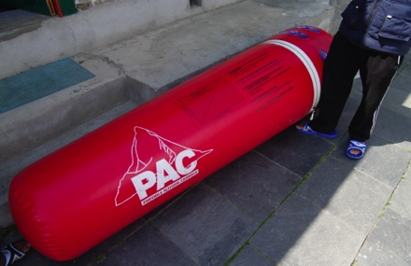
- Oxygen concentrators: Altitude decreases the efficiency of oxygen concentrators, the higher the altitude the lower the partial pressure or oxygen. Check the manufacturers specifications.
Figure 1 Portable Altitude Chamber. Courtesy Trevor Glass
- Portable altitude chambers: These have a role in providing temporary improvement only. This may have limited benefit in facilitating descent (e.g. briefly turning an ataxic or unconscious casualty into a walking casualty). The patient will often feel significantly better after treatment for a short period but must absolutely not be allowed to remain at altitude.

3. Cold

Extreme cold can have significant impact on a teams’ ability to function effectively and safely in the USAR environment. Beyond the impacts on equipment, vehicles and fuel, the impacts of extreme cold on personnel include the following:

A) Non-freezing cold injuries:
- Trench foot: Cold injury to an extremity exposed to non-freezing temperature involving prolonged exposure to moisture.
B) Freezing cold injuries:
- Frost nip: A reversible freezing cold injury which resolves completely within 30 minutes of rewarming.
- Frost bite: A localised cold injury resulting in tissue destruction due to freezing or sub-freezing temperature. Symptoms persist post 30 mins after rewarming.
- Contact injury: Touching very cold objects with tongue or fingers can cause the body part to stick to object formed by an ice bridge.
C) Hypothermia: A body core temperature of less than 35 Celsius (°C) or 95 Fahrenheit (°F).

The above conditions can be made worse by:

- Lack of acclimatisation
- Pre-existing conditions (e.g., poor circulation, history of frost bite)
- Wind
- Medications
- Alcohol
- Caffeine (contributes to dehydration)
- Moisture
- Immersion
- Dehydration

3.1 Prevention

Prevention is the primary objective. The most vulnerable body parts are:
- Face, particularly nose
- Hands, particularly fingers
- Feet, particularly toes

Prevention of cold injury/illness can be achieved by application of the following:

- Clothing

- Ensure access to a spare set of dry clothing.
- Dressing in layers is an efficient way of protecting the body from harmful exposure to the cold.
- The majority of body heat is lost through the head (up to 50-75%) therefore it is important that a thermal protection layer/s is worn. Also consider using thermal facial protection.
- Wear 3-4 layers of clothing as air trapped between layers increases the insulation effect i.e. base layer (e.g., thermal undergarments), intermediate layer for warmth and outer protection layer, this also applies to the hands i.e. layers of gloves. Layers can be added or removed as required.
- If you have to remove gloves to complete a task, make sure there is still a barrier between your hands and the cold surface to avoid a contact injury.
- Use a moisture wicking fabric (merino wool and/or purpose designed synthetics); sweating can cause rapid cooling during rest periods or when re-exposed to the cold.
- Boots for cold climates should be larger than those for warmer weather to accommodate for additional layers of socks.
- Don’t warm feet on an open heat source while wearing boots as this promotes sweating which can then cause freezing when re-exposed to the cold.
- Remind personal about mobility restrictions in the USAR environment (particularly confined space) when wearing additional layers.
- Trip hazards:
  - Surfaces covered in snow obscuring hazards;
  - Surfaces covered in ice making surfaces slippery.
- Clothing becoming wet drastically increases risk of hypothermia.
- Ensure Personal Protective Equipment (PPE) required for USAR operations still fits securely (e.g., helmet over thermal head protection).
- Eye protection: UV protection (snow blindness); eye protection must be separated from the nose and mouth to prevent exhaled moisture from fogging and frosting eye shields and glasses.

- Hydration & Nutrition

- Eat carbohydrate rich food frequently to meet increased daily caloric requirements.
- Cold weather increases risk of dehydration; therefore ensure adequate fluid intake is maintained.
- Warm fluids and meals aid in maintaining body temperature.

- Limit Exposure

- It may be necessary to reduce work periods.
- In addition to adjusting work-rest cycles, consideration should be given to placing a forward rehabilitation post near the worksite that offers protection from the elements (wind; snow), a warm environment, warm food and drinks and a place to change layers.
- Consider the implications of the Wind Chill factor (Annex B).

D) Early Awareness
- Implement buddy checks to monitor for early onset of signs and symptoms of cold injury/illness, including:
  - Cold Injury:
    - Non-freezing injury: Be aware that sometimes there is a lack of clinical signs so diagnosis is dependent on a high index of suspicion.
    - Freezing injury:
      - Pain at affected site
      - Extremity can become numb
      - Skin becomes blanched in appearance
  - Hypothermia (Mild):
    - Shivering
    - Inability to perform complex tasks
    - Complaining of ‘feeling cold’
    - Numbness in extremities

E) Special Victim Considerations

Even in generally mild environments, victims can become hypothermic. Light clothing worn at time of impact, entrapment on cold surfaces, and wet conditions can all contribute to victim hypothermia. The following can prevent or delay the ill effects of the cold:
- Cover the patient’s head
- Wrap the patient in an effort to insulate them
- Insert a barrier between the patient and the cold surface
- Attempt to warm the confined space/patient surrounds in a safe manner (e.g., warm air blower)
- If the patient is conscious and circumstances permit, provide warmed fluids/food orally

F) Canines

Canines are also susceptible to the ill effects of extreme cold. There is a variation in tolerance levels between breeds as well as individual animals.

3.2 Equipment

- Personal tents/sleeping bags should be rated for the temperature environment in which they will be used.
- Teams should have an ability to create a warm environment in the BoO Medical Station (e.g., heaters).
- The medical team should have access to specialised equipment for the cold. Consider:
  - Low-reading thermometers
  - IV Fluid warmers for treatment of hypothermia
- Specialized non-medical equipment can be useful in rewarming extremities

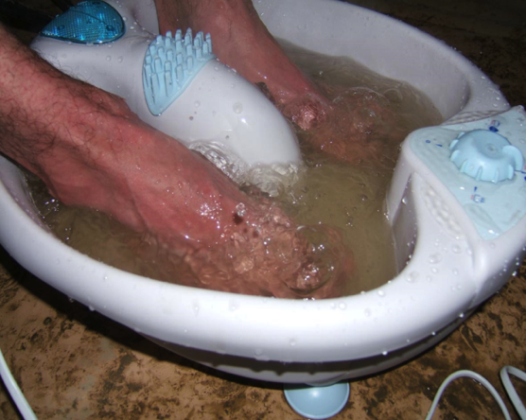
Figure 1 Foot spa rewarming feet. Courtesy Malcolm Russell

- Care should be taken with the placement of generators and other heating sources around living spaces, cooking in enclosed environments (e.g., personal tent), sitting/lying under or close to running vehicles due to the risk of carbon monoxide (CO) toxicity and burns.

3.3 Treatment Considerations

A) Non-freezing cold injury – Trench Foot

- Rewarm slowly
- Rest
- Elevation of extremities
- Allow affected extremity/s to air-dry
- Consider antibiotics if associated with signs of infection
- Analgesia as appropriate
- Recovery of severe cases may take months and the individual may not be able to return to active duty

B) Freezing cold injury: Frost-nip/Frost bite

Frostbite Rewarming Protocol
Pre-thaw | Thawing | Post-thaw
- Prevent pressure on the injured part as much as possible  - Do not rub or massage  - Stay off feet if possible (if patient cannot be carried, walking is better than hypothermia)  - Do not try to move joints in areas already frostbitten  - Remove victim from cold exposure ASAP  - Do NOT thaw or warm until there is NO chance of re-freezing  - Maintain adequate hydration | - Immerse in warm water (96.8° F [36°C] to 108° F [42.2°C])  - Tetanus booster if needed  - Ibuprofen 400 mg by mouth every 4 hours  - Establish IV access, and maintain adequate hydration (orally or IV)  - Parenteral analgesics as needed  - Heparin IV  - Encourage gentle motion of the affected part, but do not massage or force flexion or extension  - Consider: pentoxifylline, fibrinolysin, streptokinase, hyperbaric oxygen, dextran  - Smoking is prohibited | - Elevate injured part and keep dry  - Leave vesicles (blisters) intact unless signs of infection  - Debride broken vesicles and apply topical antibiotic  - Limited debridement without anaesthesia (and that does not cause victim pain!) as necessary to visualize tissue  - Surgery after 2 or 3 months if necessary  - Smoking is prohibited until no further recovery is expected, and then is strongly discouraged
Adapted from: Prevention and Treatment of Heat and Cold Stress Injuries. US Navy Environmental Health Center. Bureau of Medicine and Surgery. Technical Manual NEHC-TM-OEM-6260.6A. June 2007

Golden Rules for Frostbite
Do not: | Do:
Rub, beat or cover with snow | Rewarm rapidly in a safe environment (preferably hospital) and within 48 hours of injury
Warm with external heat source such as stove or fire | Give analgesia
Allow refreezing once thawed | Avoid infection
Rewarm a frostbitten part unless hypothermia is being treated | Delay surgery
Submit to early amputation
Adapted from: Imray C. Frostbite

Evaluate carefully with the view to evacuate to avoid the risk of refreezing.

C) Contact injuries

- Use warm water to melt the ice-bridge formed between the tissue and the object
- Treat symptomatically as required

D) Hypothermia

- Remove patient from environment
- Remove any wet clothing
- Insulate the patient to prevent further heat loss
- If fluids are administered ensure they are warm (this is to prevent further cooling rather than to try and rewarm)
- Active rewarming (e.g., administration of warm fluids via intercostal drains / peritoneal lavage) fall outside the scope of the typical USAR environment
- Medications may have less efficacy in severely hypothermic patients
- Avoid rough handling of patients due to myocardial irritability
- Evaluate carefully with the view to evacuate

4. Heat

Humidity, air temperature, and radiant heat have the synergistic effect of raising the body temperature beyond safe limits.

Those responding to equatorial earthquakes at any time and to countries with severe summer conditions can expect attrition rates from heat illness of over 10%. USAR teams may not have the opportunity to acclimatise to the hot environment. It is therefore essential that the Team Leader and medical team have an understanding of heat related issues. This will enable them to mitigate the risks by moderating activity, ensuring adequate rest periods and promoting regular hydration.

As well as operational prevention, pre-deployment screening and team member awareness is important.

4.1 Susceptibility

The following elements will increase the risk of heat injury/illness:

- Obesity
- Lack of physical conditioning/fitness
- Recent heat injury/illness
- Specific medications (e.g. medications with anticholinergic side effects like diphenhydramine)
- Heavy clothing/ PPE (as utilized in USAR)

Training in these environments will prepare the USAR Technicians in identifying issues themselves and with their peer group.

4.2 Environmental Monitoring

There are a variety of tools available to assist with gauging the heat threat allowing the USAR Team to modify their behaviour accordingly. The Canadian Centre for Occupational Health (CCOH) uses a system called Humidex. It provides a number that describes how hot people feel, much in the same way the equivalent chill temperature, or "wind chill factor," describes how cold people feel. Humidex is used as a measure of perceived heat that results from the combined effect of excessive humidity and high temperature (Annex C).

4.3 Prevention

Prevention of heat illness can be achieved by application of the following:

- Clothing

- PPE is often not light and loose fitting additional layers of PPE can exacerbate the effects of temperature, therefore it can promote hyperthermia. Make sure that it is removed when safe to do so
- Protect the head: wide brimmed hats, sun block
- Use light coloured clothing (if possible)

- Hydration & Nutrition

- Consume crushed ice if available
- Adequate access to drinking water. Remember to identify safe water sources as a priority (e.g., bottled water, filtered water)
- Avoid alcohol and excessive caffeine
- Hydration – water is the preferred rehydration solution in the presence of a normal diet
- Ensure appropriate nourishment as in hot climates the USAR team member may experience loss of appetite

- Limit Exposure

- Monitor heat stress indices (Annex C)
- Work / Rest periods – regulate activity in line with the demands of the task and the environment
- Shade: establish a shaded area for rest periods if possible
- Consider the use +/- pressure ventilation for cooling

- Early Awareness

- Medical team must have an increased vigilance with regard to health status monitoring
- Promote and encourage the early reporting of symptoms

4.4 Treatment Considerations

Heat becomes a problem when humidity, air temperature, and radiant heat combine with hard work to raise body temperature beyond safe limits. High heat stress can produce three forms of heat related illness:

- Heat Cramps
- Heat Exhaustion
- Heat Stroke
A) Heat Cramps: Involuntary muscle contractions, typically in the large muscle groups, caused by failure to replace fluids or electrolytes, such as sodium and potassium.

B) Heat Exhaustion: Heat exhaustion results when the body produces more heat that it can dissipate.

C) Heat Stroke: Caused by failure of the body’s heat control mechanisms.

Presentation

A) Heat Cramps:
- Painful contractions of larger muscle groups during or shortly after strenuous exercise in the heat
- Usually caused by replacement of water without adequate salt resulting in a low sodium state in the muscles
- No changes in mental status or fever

B) Heat Exhaustion:
- Salt or water depletion in the face of heat stress
- Mild hyperpyrexia, nausea, vomiting, lightheadedness, dehydration with only minimal altered mental status
- Leads to heatstroke if not rapidly reversed

C) Heat Stroke
- Heatstroke results when the body’s thermoregulatory mechanisms are overwhelmed by the heat stress. The body’s temperature rises markedly with eventual multisystem organ failure
- Cellular damage is directly proportional to the temperature and exposure time
- Compensatory mechanisms for heat dissipation fail
- Rhabdomyolysis can release myoglobin, potassium, creatinine, phosphokinase and purines (metabolised into uric acid) into the circulation

Heat Exhaustion | Heat Stroke
Syncope | Confusion and delirium, ataxia, fits and coma
Headache, dizziness and fatigue | Body temperature > 41ºC
Excessive sweating | Flushed
Pale and clammy skin | Sweating ceases
Body temperature could be normal, raised or lowered
Rapid pulse
Raised respiration

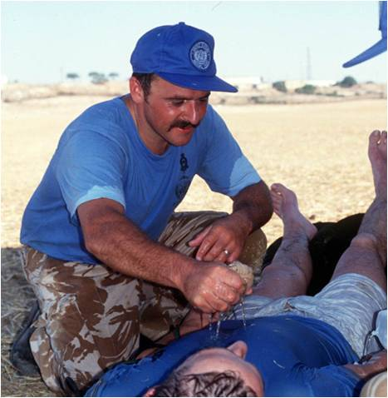
Management
Figure 3 Cooling using a base layer of clothing. Courtesy Malcolm Russell

- Stop activity
- Remove to shaded area
- Remove excess clothing – leaving a base layer to dampen down, assisting with core cooling (see adjacent picture)
- Misting with a spray bottle (can also be used in prevention)
- Fanning
- Monitoring Core temperature
- Fluid administration
  - Conscious - oral rehydration
  - Unconscious - IV Fluids
- Consider evacuation

Canine Considerations:

Currently, there is no published data regarding potential benefits of or contraindications to giving a working dog fluid subcutaneously (SC) in an effort to prevent or delay the onset of dehydration or other heat-related conditions. There are several pros and cons. In certain situations, as occurred in Haiti, when drinking water is not available, SC fluid administration may be a viable option.

Annex A: Lake Louise Score

Lake Louise Score
Symptom |  | Score
Headache | None at all | 0
 | Mild headache | 1
 | Moderate headache | 2
 | Severe incapacitating headache | 3
Gastrointestinal symptoms | Good appetite | 0
 | Poor appetite or nausea | 1
 | Moderate nausea or vomiting | 2
 | Severe nausea or vomiting | 3
Fatigue/weakness | Not tired or weak | 0
 | Mild fatigue/weakness | 1
 | Moderate fatigue/weakness | 2
 | Severe fatigue/weakness | 3
Dizziness / lightheadedness | None | 0
 | Mild | 1
 | Moderate | 2
 | Severe/incapacitating | 3
Difficulty sleeping | Slept as well as usual | 0
 | Did not sleep as well as usual | 1
 | Woke many times, poor nights sleep | 2
 | Could not sleep at all | 3
Overall, did these symptoms affect your activities? | Not at all | 0
 | Mild reduction | 1
 | Moderate reduction | 2
 | Severe reduction (bed rest) | 3
Ref: http://www.christopherimray.co.uk/highaltitudemedicine/acutemountainsickness.htm

Annex B - Wind Chill Chart

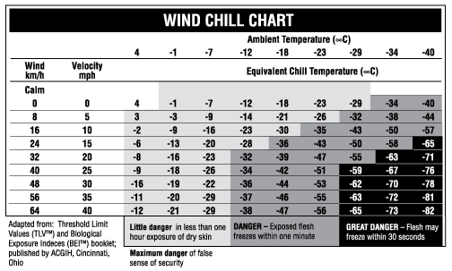

Adapted from: Canadian Centre for Occupational Health and Safety

Annex C: Humidex from Temperature and Relative Humidity Readings

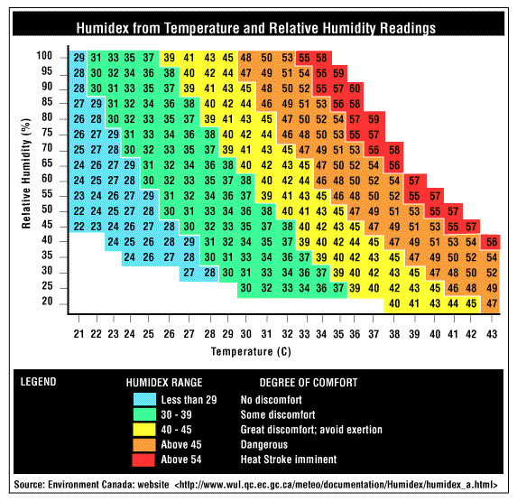

Suggested Reading List

- Responding to Emergencies: Manual for Cold Conditions. Crisis Management Centre (CMC) Finland.
- High Altitude Medicine Handbook (3rd Edition) Pollard & Murdock
- Heat Illness Prevention (HIP) Pocket Guide. The NWCG Risk Management Committee has created a new Heat Illness Prevention Pocket Guide, http://wildfirelessons.net/documents/HRI_HIP_pocket_guide.pdf. The HIP Pocket Guide is created to be used as a field document to be carried by fire fighters. This guide provides simple, concise guidelines to assist fire-fighters with prevention, recognition, and mitigation strategies to educate the fire-fighter on HRI http://wildfirelessons.net/documents/HRI_HIP_pocket_guide.pdf
- Prevention and Treatment of Heat and Cold Stress Injuries. US Navy Environmental Health Center. Bureau of Medicine and Surgery. Technical Manual NEHC-TM-OEM-6260.6A.

References

