

**Classified Light USAR Teams**

Position Paper - LTQAWG

**Introduction**

The INSARAG Steering Group (ISG) meeting took place in Geneva during February 2017. During that meeting a concept paper was provided from the Light Teams Working Group (LTWG) as a result of work completed throughout 2016. The ISG formalised the direction for the LTWG to progress the framework for the development of principles and quality assurance to support the deployment of Classified Light USAR teams in the international deployment environment. The LTWG was re-formed into the Light Team Quality Assurance Working Group (LTQAWG).

The endorsed recommendations from the ISG in February 2017 detailed:  
 - To endorse the definition, operations and tactical concept for “International Light Teams” and include the concept in the INSARAG Guidelines 2018/20 revision.

* To acknowledge the need for further discussions on the process of recognition (Quality Assurance by INSARAG) and possible linkages with National Accreditation.
* To establish that a working group is tasked to investigate and discuss the Quality Assurance concept at the Team Leader’s meeting in 2017.

The second LTWG meeting took place in Valabre, France during April 2017 with the Light Team concept developed further and recommendations for implementation into the INSARAG Guidelines. The development of the concept was socialised at Regional and Team Leader meetings throughout 2017.

The ISG meeting in February 2018 took place in Geneva and endorsed:  
 - Pilot an “International Light Teams IEC Classification in 2018 or 2019  
 - Request the LTWG to develop a Classification process and checklist in 2018  
 - Any team wishing to classify as an International Light USAR team must be supported …… ….by the INSARAG policy focal point.  
 - Existing Medium and Heavy teams can deploy as Light without further assessment  
 - Countries that do not wish to deploy Light teams are not required to  
 - Receiving countries can specify receival of Light, Medium, or Heavy teams as required

Further development of the concept was undertaken by the LTQAWG including an additional meeting in Filderstadt, Germany in April 2018. The outcomes of this meeting, combined with the approvals and decisions of the ISG in 2017 and 2018 have been developed into a format for implementation into the INSARAG Guidelines.

**ABSTRACT**The development of USAR capability throughout the world since the inception of INSARAG has been consistent and extremely productive with fifty-three teams currently *(January 2019)* holding INSARAG External Classifications (IEC). The development of global capability and capacity has brought with it the development and international deployment of smaller USAR and specialist rescue teams and groups, without the concurrent development of the INSARAG guidelines to support and coordinate this new capability. These smaller teams have notionally been referred to as “International Light USAR Teams”.

Recent global earthquake incidents have resulted in the coordinated response of INSARAG classified teams, along with the response of additional light teams who are not classified, resulting in a reduction in coordination of preparedness and response activities in the affected countries.

The INSARAG Guidelines provide an overview of the Light – Medium – Heavy USAR team concepts, with a detailed description of Medium and Heavy team capability and capacity. The Light USAR Team concept is a component of National capacity building, and is a stepping stone for teams developing the Medium or Heavy National (NAP Accredited) and international (IEC Classified) Capability.

It is evident that several unclassified USAR teams have developed the capability and capacity to deploy internationally in the ‘Light’ format, and have developed the technical skills and abilities to perform search and rescue operations at a level exceeding the existing Light USAR Team standards as listed in the INSARAG Guidelines. The resultant development of the concept for “Light USAR Teams” has identified that these teams can be developed to provide a level of capability above that of the first responder, and can provide a capability to rescue people from collapsed voids in a flexible and mobile response. The significant addition to the development of Light USAR teams for National response is the development opportunities for these teams to further develop into Medium or Heavy teams for National response, or Light, Medium or Heavy teams for International (IEC Classified) response to earthquakes and similar disasters. This provides a fully holistic approach to communities at risk and their need is met with the correct International response.

In response to the development of Classified Light USAR Teams, and the need to coordinate the response to earthquakes for the benefit of the receiving country, amendments to the INSARAG Guidelines have been drafted to better articulate the relationships between USAR teams of all sizes, and the relationships between National (NAP Accredited) and International (IEC Classified) capacity and capability. Light USAR Teams have previously been identified as a National capacity with surface search capability only, generally in the local and first responder model, with the IEC/R model used exclusively for Medium and Heavy USAR Teams. The revised guidelines align Accredited (NAP) and Classified (IEC) Light, Medium and Heavy team’s capabilities in technical aspects of USAR, with the additional requirement for Classified teams to meet the requirements of international deployment according to the INSARAG guidelines.

**The definition, operations and tactical concept for “Classified Light USAR Teams”**

The concept for recognition of Classified Light USAR teams has been developed to include the following overarching strategy.   
A Classified Light USAR Team would be:

* Able to deploy internationally in response to earthquakes and similar disasters, as a donor relief team.
* Able to provide a level of service above that of a National first responder capability, (and above the capability of a Light Team as described in the current INSARAG Guidelines). Specifically, the Classified Light team must be able to ‘value add’ to the response, not simply provide another surface rescue resource at the same level of capacity as the in-country first responder resources.
* Supported by the National Policy Focal Point as a deployable resource from the donor country.
* Supported by appropriate funding arrangements to support on-going operations in the International environment.
* Supported by INSARAG as a member and a productive member of the global USAR fraternity, providing a classifier to the global classifier team.
* Developed from the existing National capacity and capability base, where one exists.
* An extension of the National capacity, in preparation for future Medium or Heavy team classification if desired.
* Able to provide the five components of USAR within the team (Management, Search, Rescue, Logistics & Medical)
* Able to provide one team member to support either the RDC, SCC or UCC and still continue to function as an operational Light USAR Team for the entire period of the team deployment.
* Trained, equipped and required to have the capacity to work on a single worksite.
* Equipped to conduct search and rescue operations in collapsed structures of wood, masonry, and light reinforced concrete construction.
* Required to have the capability for search dogs and / or technical search.
* Must be adequately staffed and resourced to allow fully self-sustained 12 hour/day operations on one site (site may change) for up to 5 days, with capability for transport into and out of the country.
* Must be able to medically treat its own team members (including dogs if present) as well as victims encountered, if allowed to do so by the government of the affected country.
* Must be capable of conducting USAR operations to ASR3 level and integrating into the standard INSARAG reporting mechanisms.
* Recommended team size of between 17 and 20 personnel, with the ability to deploy one person to INSARAG support for the duration of the deployment.
* Undertake and complete a Classification process as determined by the revised INSARAG Guidelines and the approved Light USAR Team IEC Checklist.

**The Process of Recognition (Quality Assurance by INSARAG)**

The concept of ‘Light Teams – Light Classification’ was previously favoured by INSARAG, however the current full Classification process is presently endorsed. An opportunity exists for several (up to 4) Light teams to conduct a joint Classification exercise to reduce the burden on both the teams and the classifiers. An alternate option is for one Light USAR Team to work with a Medium or Heavy team to conduct a joint IEC/R exercise. This concept builds on the current examples of multiple teams conducting IEC/R exercises to optimise the financial implications of running a large exercise. The process of classifying more teams, including Light will provide more classifiers to the quality assurance system.

**Classified Light USAR Teams – Capability statement**

Light USAR Teams that wish to be considered for International Deployment are required to Classify. Specifically, there is a requirement for the team to be able to conduct the following technical capabilities.  
  
1. Conduct ASR3 search and rescue operations (one work period)  
2. Technical Search or Canine search (or both)  
3. HazMat detection - Radiation, Air Monitoring (Oxygen, CO, H2S, Flammability), Ph / Alkaline  
4. Structural assessment of damaged buildings prior to entry   
5. Breach non-structural mesh reinforced concrete up to 200mm thick  
6. Cut non-structural timber up to 200mm thick  
7. Cut light steel plate up to 3mm thick  
8. Shore a window or door  
9. Apply cribbing to stabilise a slab  
10. Lift 1 Tonne (levers etc)  
11. Lift 1 Tonne (Mechanical lifting capacity)  
12. Crane operations to 5 Tonne (Slings)  
13. Work safe at heights and rope rescue a patient from 10 metres above or below the work site  
14. Provide worksite lighting  
15. Two separate light teams could work on one work site in alternating shifts if needed.  
16. Muster at the departure point within 8 hours of activation.  
17. Light Teams should comprise between 17 and 20 persons only.

All tasks and capacity are designed to reflect those of existing Classified Medium and Heavy standards, to be performed with hand tools and small mechanical tools to the determined specifications.

**Tactical Deployment of teams**

The linkages between the development of Classified Light USAR teams, and the introduction of the National Accreditation Process (if there is such a process within host countries) cannot be understated. There is a clear benefit to INSARAG and also to countries, that those countries and NGO’s identify the level of capacity that is required in the USAR field. The development of the NAP provides a clear path for countries to develop their own National response capability for use within their sovereign borders. Those countries that wish to further develop their capacity to an International level can apply to be Classified, and as such will have the capability of deploying their resources to overseas locations at their expense.

A seven-level capacity system will commence at First Responder, and give options of NAP at Light / Medium / Heavy, and also Classification at Light / Medium / Heavy. These clear options will allow donor teams to choose their desired level of capability, and will also give receiving countries a broader menu of teams that they will accept into country in the event of an earthquake.

There is no intention that teams must progress through individual capabilities before moving to the next, with flexibility to work toward the desired level as they wish.

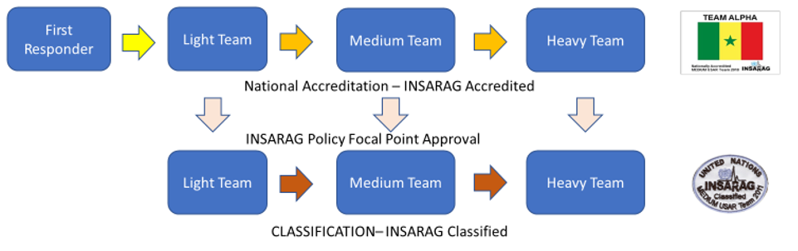

**Classification Process Light**

If a country or NGO wishes to develop their capacity internationally it is possible to classify a Light team. The process for this classification is similar for all levels (Light-Medium-Heavy). Teams are encouraged to follow the National Accreditation Process if available and preferably according to the INSARAG standard. Due to the ISG 2018 decision Light teams must have followed a NAP before applying an IEC process if this process is available.

In the following process the progressive steps are clarified;

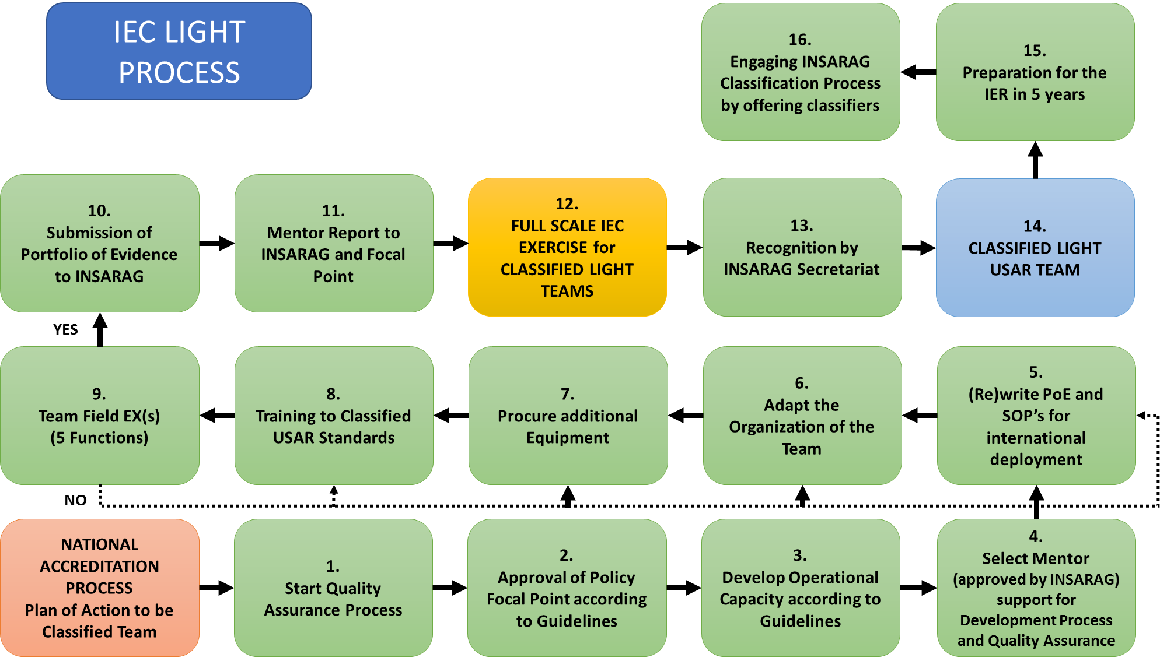

**Identification**

In consideration of the complexities introducing a badge for Classified Light USAR teams, along with the implementation of the NAP recognition process, the INSARAG Secretariat will determine the badge requirements for badging of NAP and Classified teams. The LTQAWG recommends the addition of “Light” according to the current Medium and Heavy badge application.