## Annex B19: Wide Area and Sector Assessment

**Sector Assessment**

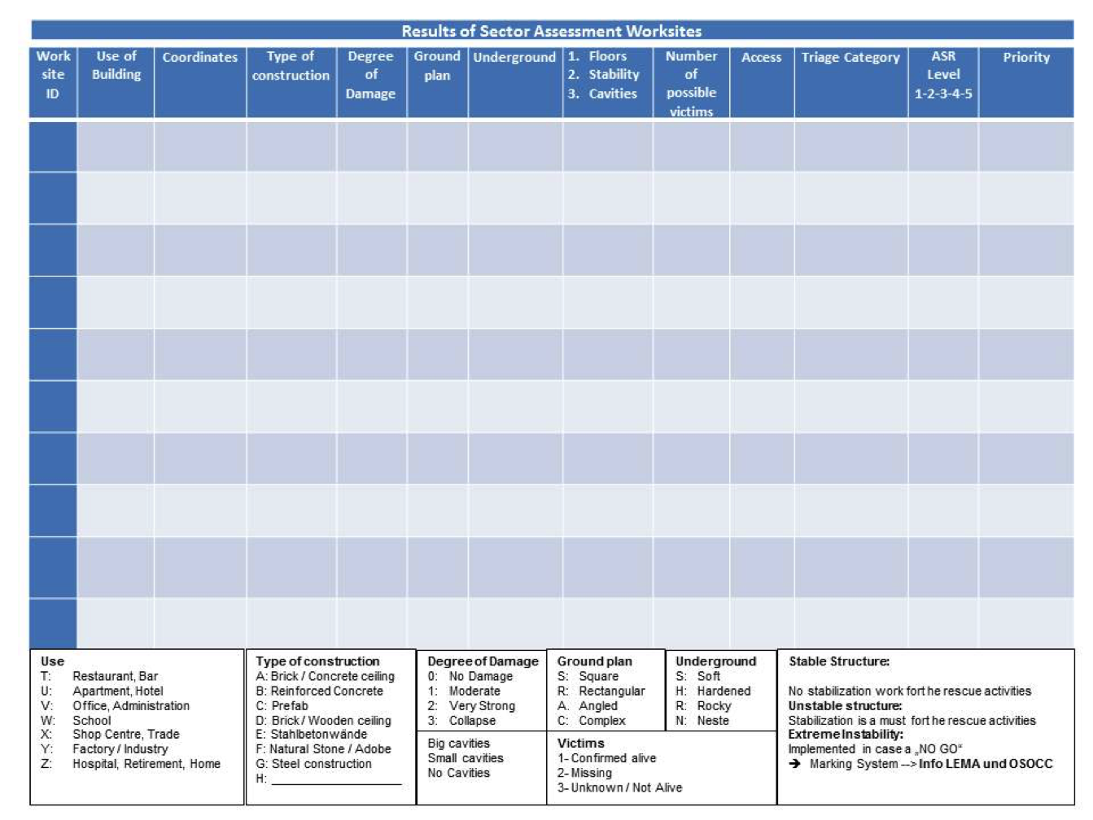

**Wide Area Assessment**



