**G ESTABLISHING A NATIONAL URBAN SEARCH AND RESCUE CAPACITY**

**G1 USAR Response Framework**

1. Urban Search and Rescue (USAR), as defined by the INSARAG Guidelines, refers to the “processes used to safely remove entrapped victims from collapsed structures”. Typically these steps are employed following the structural collapse incidents caused by earthquakes, cyclones or terrorist activity; incidents of this sort are described as being caused by a sudden onset event.

2. In order to understand the context in which this document has been developed, it is important that there is an understanding of the concept of continuous rescue at structural collapse incidents. This concept covers the chronological steps of rescue from passers-by rushing to assist in the immediate aftermath of a collapse and the response of the local emergency services in minutes. It continues with the arrival of regional or national rescue resources in hours through to the response of international rescue teams in the days after the event. The INSARAG Response Framework is shown in Figure 1.

Figure 1



3. The INSARAG Response Framework encompasses all levels of response, whether it is a spontaneous community response driven by necessity or a planned response of an international USAR team. It is important to note that rescue capacity within different countries varies. Whatever the capability of the rescue resource, in order for it to be effective, it should be in regular use within its locality (or region).

**G2 Capacity Building**

1. UN General Assembly Resolution 57/150 (16 December 2002) identifies that each country has the responsibility first and foremost to take care of the victims of natural disasters and other emergencies occurring on its territory. It has the primary role in the initiation, organisation, coordination and implementation of humanitarian assistance within its territory. Therefore, it is essential that countries develop a robust disaster management framework based on a national assessment of risk.

Insert diagram of typical national disaster management framework –

INSARAG Guidelines ‘Disaster Management response Framework’ Chapter G.2

2. The UNDAC ‘Disaster Preparedness Mission’ and INSARAG ‘USAR Capacity Mission’ are UN OCHA tools that are available to assist countries to strengthen and improve their disaster management frameworks.

3. Where deficiencies within a country’s national disaster management framework are identified, the need for capacity building to remedy such deficiencies will emerge. Capacity building is the process of identifying and supporting existing USAR resources or developing new capability through the creation of systems and processes, the procurement of equipment, training of personnel and its integration into the existing political and management infrastructure sufficient to support and sustain the capability.

4. The principles of USAR capacity building that support the objectives of the UN General Assembly Resolution 57/150 are as follows:

* Capacity building should be customised to meet the needs of the host community and the environment, which must be determined by a risk/vulnerability analysis.
* Capacity building should cover all five components of USAR capability (search, rescue, medical, management and logistics/support) and can range from community-based first responders to the development of a “Heavy” USAR resource.
* Countries should have the ability to effectively use their own capability and to integrate international assets into the national response.

5. In undertaking USAR capacity building, it is recommended that countries follow the principles found in the INSARAG Guidelines. The reasons for this are two-fold:

* Firstly the INSARAG Guidelines have a proven effectiveness regarding a coordinated approach to disaster response.
* Secondly the INSARAG Guidelines are endorsed by UN General Assembly Resolution 57/150 (16 December 2002) regarding, *Strengthening the Effectiveness and Coordination of International Urban Search and Rescue Assistance*.

Coupled together these documents provide a solid framework to ensure the developing resource is prepared to receive international assistance in an integrated, transparent and effective fashion.

6. INSARAG understands that in many instances, there may already be a developed USAR capacity in a disaster-prone country and that some of these resources may have been developed in compliance with the INSARAG Guidelines. Whilst INSARAG understands and accepts that these national resources may never be intended to be deployed abroad, the UN General Assembly Resolution 57/150 directs INSARAG to identify such national resources, include them in their Regional INSARAG activities and encourage them to continue to build capacity within their country.

7. An important tool to assist countries develop existing capacity is the National Classification System (NCS). NCS is a benchmarking system that measures progress and determine priorities. The methodology follows the INSARAG External Classification (IEC) System developed for international USAR Teams but does not contain requirements that refer to international deployment.

8. From a perspective of developing new USAR capability, an understanding of ‘continuous rescue’ provides a basis for the sequence of this development process. It is recommended that countries should undertake USAR capacity building using the following sequence:

1. Develop the management and administration infrastructure
2. Develop community-based first responder networks
3. Develop elements of these networks into USAR Teams at a ‘Light’ level
4. If necessary, develop Medium or Heavy USAR capability from the Light USAR Teams

**G3 Developing a National USAR Management & Administration Infrastructure**

1. The first step in USAR capacity building should be the creation of a document that provides policy and procedures regarding its management and administration. The document should also provide guidance that ensures the USAR capacity is maintained in a constant state of readiness.

2. The management and administration document will define the policy and procedures regarding administrative and financial management of the USAR capability. It should provide a mechanism for the application of funding for certain purposes in preparation for USAR disaster response. This funding will allow the USAR capability the opportunity to maintain a high standard and condition of operational readiness. It also:

* Describes the duties and responsibilities of management and administrative positions
* Delineates organisational responsibilities and roles
* Describes the process through which the USAR capability will administer annual funding
* Describes the record management processes
* Outlines how property is accounted for
* Outlines how new members are selected
* Outlines how members receive initial training as well as ongoing training to remain operational

3. Organisations seeking to develop a policy and procedures document can request support from the INSARAG Secretariat.

**G4 USAR First Responders Networks**

1. A key target for the INSARAG community within the objectives of UN GA Resolution 57/150 is the building of local rescue capacity for use in the immediate response that follows a sudden onset disaster. This is primarily based upon the recognition that rescue of up to 50% of all survivors following a disaster of this type is undertaken by local resources. Building the first tier of local capability involves the training and development of existing local emergency services and community responders to meet the needs of the affected population at the onset of the incident. Termed ‘USAR First Responders’, their role is that of:

* assessing the nature and scale of the incident
* rescue in the initial stages of a collapse incident
* providing information to domestic decision-makers about the event
* requesting the appropriate resources required to successfully complete the rescue phase

Insert a diagram depicting local structure (INSARAG TWG Notes)

2. First Responder Networks would be most effective in areas where no organised USAR structure exists, as well as areas where any USAR response may be delayed.

3. It is envisaged that USAR First Responders will typically be emergency personnel working in the local community or staff of local government organisations tasked with emergency management or response. For example, local police, medical staff or firefighters, local government workers or members of volunteer organisations.

**G4.1 USAR First Responder Training Programme**

1. To assist in the development of local community response, INSARAG has developed the USAR First Responder Training Programme. The programme is intended to be used as a foundation for first responder capacity building in disaster prone countries. The programme consists of:

* An inter-active CD-ROM
* A USAR First Responder Course – 40 hours
* A USAR First Responder Trainers Course – 48 hours
* Supporting material for the participants

2. The learning objectives of this course are as follows:-

* Create an awareness of the generic hazards and risks within a structural collapse environment
* Enable participants to conduct a survey of the impacted area
* Enable participants to perform simple search and rescue techniques and render basic life saving measures
* Develop local USAR capacity of the local emergency services
* Provide an understanding of regional, national and international USAR support systems
* Enable participants to organise volunteer rescuers on-site

3. **USAR First Responders Trainers Programme**

Participants on the Trainers Course will also learn how to deliver the modules of the USAR First Responder Course in their own country or region. At the conclusion of the Trainers Course, each participant will receive a complete package of training materials that can be used in his or her home country to further enhance local capacity building.

Participants should be instructors based in existing training centres in his or her country. This will facilitate the introduction of subsequent capacity building programme within each country.

4. **USAR First Responders Training Programme**

Participants of the First Responders Course get an overview of an organised approach to disaster response, with education provided primarily in the fields of rapid assessment, surface rescue, and initial medical care.

This course is targeted at the local responders from the emergency services and members of local community organisations that will become involved in the emergency management of sudden onset disasters.

|  |  |  |
| --- | --- | --- |
| **USAR First Responder**  Programme | |  |
| Course Programme | Content | |
|  | Course Administration   * Domestics – rules and regulations * Instructor/participant introductions * Safety rules | |
|  | Team Building Exercise   * Whole Class team building exercise * Split into three groups * Group dynamics exercise | |
| **MODULE 1**  **Introduction**  1.1 | Course Introduction   * Definition of urban search and rescue   + Why are we here     - A survivable event?     - Case study – China video     - The importance of first responders | |
|  | Break | |
| 1.2  1.3 | Group Discussion based on a scenario   * Question Paper - As trainers of first responders:   + What actions can be taken before assistance arrives?   + What resources are available?   + Equipment and training required?   Presentation of Group Findings  Introduction to the USAR Environment   * The urban environment   + Construction types   + Infrastructure * Disasters affecting the urban environment   + natural (earthquake, subsidence, floodwater),   + accidental (explosion, impact, fire)   + deliberate actions (terrorist attack, bomb) * Consequences of disasters   + Structural collapse   + Collapse patterns   + Hazards - dust, falling debris etc.   + Damaged utilities – gas, electricity etc. * Safety at work   + PPE   + Health and hygiene | |
|  | Lunch | |
| 1.4 | * R.E.P.E.A.T. – Overview of USAR Operations   + Stages of rescue operations   + Sequence of actions   + Principles underpinning the process   + Not just a sequential process | |
| **MODULE 2**  **Assessment**  2.1 | Reconnaissance and Survey   * Information collection   + Observation   + Interview   + Reports * Information requirements   + Where is it?   + What is involved? | |
|  | Break | |
|  | (Transport to exercise site) | |
| 2.2 | Exercise Brief | |
| 2.3 | Assessment Exercise   * Information collection through interaction with actors and observation of the scene * Completion of a report   *Includes a break* | |
| 2.4 | Assessment Exercise debrief | |
|  | (Transport from exercise site) | |

|  |  |
| --- | --- |
| Course Programme |  |
| **MODULE 3**  **Scene Management**  3.1 | Scene Management   * Refer back to Module 1.4 * Hazard Identification and Risk Management   + Secondary Collapse   + Special Risks   + Dust   + Utilities   + Etc. * Access Control and Site Management   + cordons and barriers   + evacuation   + site security |
| **MODULE 4**  **Search**  4.1 | Surface Search   * Hasty search * Primary search |
|  | Break |
| 4.2 | Search Exercise   * Split into three groups * Each group completes three searches |
| 4.3 | Search Exercise – Debrief |
|  | Lunch |
| **MODULE 5**  **Rescue**  5.1 | Rescue operations   * rescue equipment – outline list * rescue techniques   + lifting & moving   + cutting & breaking |
| 5.2 | Rescue Techniques – Practical 1   * Tool shop * Safe techniques |
|  | Break |
| 5.3 | Rescue Techniques – Practical 2   * Lifting and moving |
| 5.4 | Rescue Techniques – Practical 3   * Cutting and breaking |

|  |  |
| --- | --- |
| Course Programme |  |
| 5.5 | Casualty Management 1   * triage * casualty handling * evacuation techniques |
|  | Break |
| 5.6 | Casualty Management 2   * stretchers and improvised stretchers * dealing with the deceased * casualty holding point |
| 5.7 | Casualty Management Exercise |
|  | Lunch |
| 5.8 | Casualty Management Exercise –debrief |
| Exercise | Course Exercise Brief |
| Exercise | Course Exercise   * exercise to run 2 hours * course staff to direct operations * exercise simulates structural collapse (earthquake) |
|  | Break |
| Exercise | Course Exercise Debrief |
|  | Course Debrief   * Feedback to course staff * Participants depart |

**G4.2 USAR First Responders Equipment**

1. USAR First Responders do not require a dedicated cache of equipment as equipment requirements can be met by existing equipment available within the local community or operated by sponsoring organisations.

**G5 Urban Search and Rescue Teams**

1. Structured teams have the advantage over untrained spontaneous volunteers by reducing the risk of injury or death to themselves and the victims.

Structured USAR teams should comprise the following components:

* Management
* Logistics
* Search
* Rescue
* Medical

2. There are several tiers to the establishment of a structured USAR team. The progression through to each tier is based on both risk and the ability to staff and train the team. History has proven that the majority of people rescued after a disaster are by the first responders and light teams that are available and on scene quickly.

3. There is no requirement to progress to another tier if the risk and capability are not commensurate. It is far better to maintain at lower level with a very good capability than to progress higher and not be able to maintain the required skill and equipment levels.

**G5.1 Developing Light USAR Teams**

1. The second tier of local capacity building involves the training and development of structured rescue teams based within the local emergency services, civil protection or voluntary organisations. Termed ‘Light USAR Teams’, their role is that of:

* Reconnaissance and survey of the affected area
* Identify hazards and undertake actions to reduce the level of risk
* Surface search and rescue
* Initiating medical care and extrication of victims
* Assisting international teams to integrate into local emergency management arrangements

2. The “Light” Team structure is based around the concept of 18 personnel; this should be seen as a recommended structure and in no way represents as a definitive size.

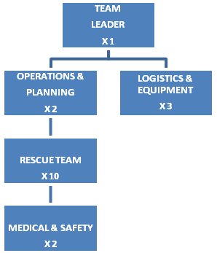

4. To assist in the development of structured teams capable of light rescue tasks, INSARAG has developed the Light USAR Training Programme…… Annex: B.

**G5.2 Developing Medium USAR Teams**

1. The third tier of local capacity building involves the training and development of structured rescue teams based within the local emergency services, civil protection or voluntary organisations. Termed ‘Medium USAR Teams’, they are considered to be a larger capability than the “Light” teams, their role is that of:

* Reconnaissance and survey of the affected area
* Identify hazards and undertake actions to reduce the level of risk
* Technical Search and rescue using sophisticated equipment or in some cases a Canine capability
* Cutting and breaching techniques in structural elements of collapsed buildings beyond that of the Light capability.
* Initiating medical care and extrication of victims that in some cases are deep entrapments
* Assisting international teams to integrate into local emergency management arrangements
* Medium teams that are classified under the INSARAG system must be able to initiate and staff an RDC or an OSOCC

2. The “Medium” Team structure is based around the concept of 36 personnel; this should be seen as a recommended structure and in no way represents as a definitive size.

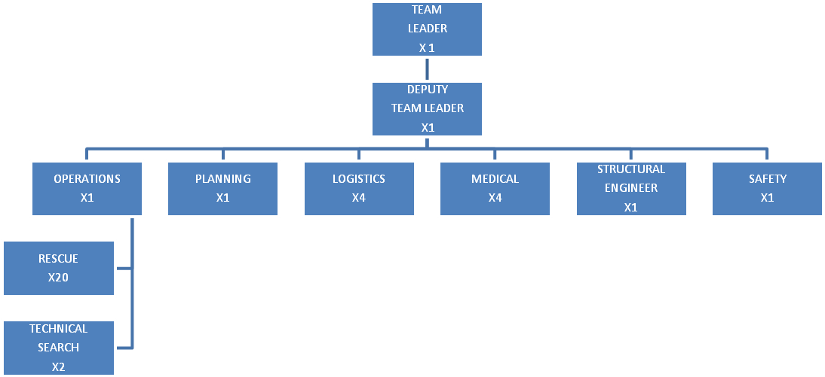

3. The INSARAG Secretariat suggests that those domestic resources interested in the development to the “Medium” Level refer to Section “G” of the INSARAG Guidelines.

4. The INSARAG Secretariat will offer assistance to those domestic USAR Teams that have received permission from their organisation to expand to the international levels of operations.

**G5.3 Developing Heavy USAR Teams**

1. The final tier of local capacity building involves the training and development of structured rescue teams based within the local emergency services, civil protection or voluntary organisations. Termed “Heavy” USAR Teams’, their role is that of:

* Reconnaissance and survey of the affected area
* Identify hazards and undertake actions to reduce the level of risk
* Technical Search and rescue using a combination of sophisticated detection equipment and a Canine capability
* Cutting and breaching techniques in structural elements of collapsed buildings beyond that of the Medium capability
* The Ability to operate at two remote location simultaneously
* Initiating medical care and extrication of victims that in some cases are deep entrapments
* Assisting international teams to integrate into local emergency management arrangements
* Heavy teams that are classified under the INSARAG system must be able to initiate and staff an RDC and an OSOCC

2. The Heavy Team structure is based around the concept of 72 personnel; this should be seen as a recommended structure and in no way represents as a definitive size.

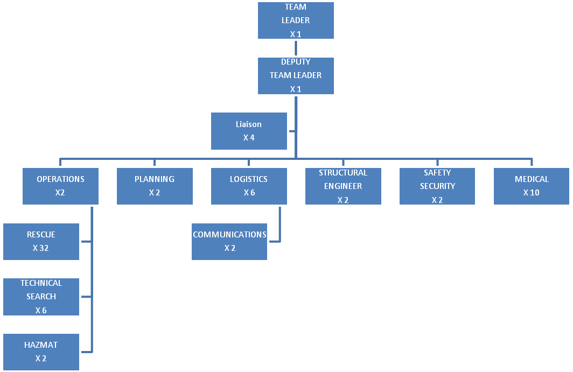

3. The INSARAG Secretariat will offer assistance to those domestic USAR Teams that have received permission from their organisation to expand to the international levels of operations.

**G6 USAR Equipment**

1. A USAR capability requires access to a dedicated cache of equipment which will cater for its needs during training and while on deployment. This cache must include equipment to establish and maintain a Base of Operations as well as all other equipment needed to safely operate at its operational level.

2. Annex M of the INSARAG Guidelines contains suggested equipment lists for all USAR team levels

**G7 USAR Training**

1. Training and development, both initial and ongoing, is critical to the successful implementation of any local USAR capability and must cater for all the components of the capability.

2. The USAR management and administration infrastructure is responsible for the development of a standardised process to identify training needs. This might include:

* Identification of existing resources, procedures and competences
* Self-evaluation to determine actual operational capability
* Gap analysis that will identify training requirements
* Identification of pre-conditions for training to be effective

3. Under UN General Assembly Resolution 57/150, national training resources involved in the capacity building of Domestic USAR Teams or the First Responders Training System will be supported by the INSARAG Secretariat with training material and general advice, when needed. The INSARAG Secretariat also understands the importance of identifying such training centres as “USAR Centres of Excellence” for the delivery of INSARAG training; these centres will receive appropriate identification markers that signify this.

**G7.1 Light USAR Training Programme**

1. The Light USAR Training programme is designed to meet the training and development needs of structured rescue teams based within the local emergency services, civil protection agencies or voluntary organisations. It is designed to be taught in disaster-prone countries. Any countries undertaking this course will need to have access to suitable training venues and facilities that simulate specific structural collapse scenarios, applicable to the course requirements.

2. The programme consists of:

* A Light USAR Course – 40 hours
* A Light USAR Trainers Course – 48 hours
* Supporting material for the participants

3. The learning objectives of this course are as follows:-

* Perform assessment of existing and potential conditions and identify the resources necessary to conduct safe and effective search and rescue operations.
* Understand the principles of Incident Management, including site control, scene management and integration of other assigned resources.
* Identify, utilise, and maintain all rescue equipment including personal protective equipment (PPE).
* Attain knowledge of construction types, building characteristics, and expected collapse patterns.
* Recognise all hazards associated with structural collapse, and the actions necessary for the safe mitigation of those hazards.
* Apply the INSARAG structural marking system.
* Safely conduct a surface search operation.
* Initiate procedures for the medical care and extrication of victims from structural collapse incidents.
* Undertake lifting and moving techniques to safely and efficiently lift structural components of buildings using levers, hydraulic jacks and other hand tools.
* Undertake shoring techniques to safely and effectively stabilise structural components of collapsed buildings.
* Undertake breaking and breaching techniques to safely and efficiently create openings in walls, floors, or roofs.
* Obtain a basic understanding of how international teams will integrate into local emergency management arrangement

|  |  |  |  |
| --- | --- | --- | --- |
| **Light USAR Programme** | |  | |
| Target Group | Structured rescue teams from the local emergency services | | |
| Pre-Entry Requirements | Participants on the programme must:   * Be an experienced practitioner from the local emergency services * Have a recognised First Aid Course Certificate that is provided within the participants home country (Equivalent to Red Cross or St Johns) * Have completed the basic USAR course CD rom | | |
| Description | The Light USAR programme contains eight individual modules that can be delivered within 40 hours or in a time frame suitable for the participants. | | |
| Aims and Objectives | The aim of the programme is to develop local life saving capacity by providing participants with a basic understanding of USAR concepts in order that they may operate effectively, safely and in a coordinated manner.  The course objectives are to allow participants to:   * Perform size-up of existing and potential conditions and identify the resources necessary to conduct safe and effective search and rescue operations. * Understand the principles of Incident Management, including site control, scene management and integration of other assigned resources. * Identify, utilise, and properly care for all rescue equipment including personal protective equipment (PPE). * Gain knowledge of construction types, building characteristics, and expected collapse patterns. * Recognise the general hazards associated with structural collapse including the potential for secondary collapse and the actions necessary for the safe mitigation of those hazards. * Understand the INSARAG structural marking system. * Safely conduct a surface search operation. * Initiate procedures for the medical care and extrication of victims from structural collapse incidents. * Undertake lifting and moving techniques to safely and efficiently lift structural components of walls, floors, or roofs using levers, hydraulic jacks and other hand tools. * Undertake shoring techniques to safely and effectively stabilise and support structural components to prevent movement of walls, floors, or roofs. * Undertake breaking and breaching techniques to safely and efficiently create openings in structural components of walls, floors, or roofs. * Obtain a basic understanding of how international teams will integrate into local emergency management arrangements. | | |
| Course Delivery | The course will be delivered by selected instructors from donor countries to rescue personnel from disaster prone countries or regions. | | |
| Certification | Participants will be issued a certificate of course completion by the INSARAG secretariat. | | |
| Content |  | | Time |
| **Module 1** | **Introduction to the USAR Environment:**  Overview of International response structures   * UNDAC * INSARAG * Virtual OSOCC   The urban environment:   * Construction types * Infrastructure * Disasters affecting the urban environment * natural (earthquake, subsidence, floodwater), * accidental (explosion, impact, fire) * deliberate actions (terrorist attack, bomb) * Consequences of disasters   The role of local emergency response teams  The role of International response teams. | | 1 hour  1 hour  1 hour |
| **Module 2**  **Change** | **Scene safety**  Structural collapse   * Hazards - dust, falling debris etc. * Damaged utilities; gas, electricity, Hazmat etc.   Risk Assessment   * PPE * Health and hygiene * Safety Officer * Safe systems of work | | 1 hour |
| **Module 3** | **Scene Management**  Command structures   * Operations * Logistics * Planning * Cordons * Sectorisation * Spans of control * Roles and responsibilities of other agencies * Communications * Base of Operations | | 1 1/2 hours |
| **Module 4** | **USAR Operations**  R.E.P.E.A.T. – Overview of USAR Operations  Reconnaissance & survey   * Collapse patterns * Structural triage * Assessment of the Impacted Area * Information collection * Observation * Interview * Reports * Information requirements   Elimination of utilities (covered in module 3)  Primary surface search   * Search techniques * Hasty search * Line & hail searches * International marking system   Exploration of voids  Access by selected debris removal  Termination of the incident  Assessment & Search Exercise | | 1 ½ hour  1 hour  30 mins  5 hours |
| **Module 5**  Practical | **Rescue Techniques**  Debris removal  Shoring   * Equipment * Basic shores * Cribbing   Lifting, stabilising and moving   * Equipment * Light rigging (vertical raising and lowering) * Working at Height   Breaking and breaching   * Equipment * Timber * Steel * Concrete * (refer to list of equipment)   * All to include practical exercise component | | 4 hours  4 hours  4 hours |
| **Module 6** | **Casualty Management**   * Casualty triage * Patient packaging * Clearing surface casualties * Extrication of patients * Lowering & raising systems * Scenario Exercise | | 4 hours |
| **Module 7** | **Final exercise**  Post exercise summary and debrief | | 1 day |
| **Module 8** | Domestic classification system  Documentation  End of course debrief & feedback | | 4 hours |

**G7.2 Light USAR Trainers Programme**

1. Participants on the Trainers Programme will also learn how to deliver the modules of the Light USAR Course in their own country or region. At the conclusion of the Trainers Programme, each participant will receive a complete package of training materials that can be used in his or her home country to further enhance local capacity building.

2. Participants should be instructors based in existing training centres in his or her country. This will facilitate the introduction of subsequent capacity building programme within each country.

**G7.3 Medium USAR Training Programme**

1. Personnel wishing to participate in this programme must first complete the “Light USAR Training Programme. Upon completion they will then be eligible to attend the Medium USAR course, which consists of XXX training modules equating to XX hours of instruction. This may be delivered in one complete course or staggered to the needs of the individual or organisation. This flexible approach allows control to be maintained over the overall training programme.

2. On successful completion, participants will be deemed competent in rescue techniques commensurate with a Medium USAR capability

3. Medium USAR Programme trainers will come from within the jurisdiction developing the programme and will have sufficient skills and training techniques to deliver the required capability.

**G7.4 Heavy USAR Training Programme**

1. Personnel wishing to participate in this programme must first complete the “Light USAR Training Programme. Upon completion they will then be eligible to attend the Heavy USAR course, which consists of XXX training modules equating to XX hours of instruction. This may be delivered in one complete course or staggered to the needs of the individual or organisation. This flexible approach allows control to be maintained over the overall training programme.

2. On successful completion, participants will be deemed competent in rescue techniques commensurate with a Heavy USAR capability.

3. Heavy USAR Programme trainers will come from within the jurisdiction developing the programme and will have sufficient skills and training techniques to deliver the required capability.