

“NO EXCUSES”
VIDEO SERIES
Prevention of Sexual Exploitation and Abuse
FACILITATION GUIDE

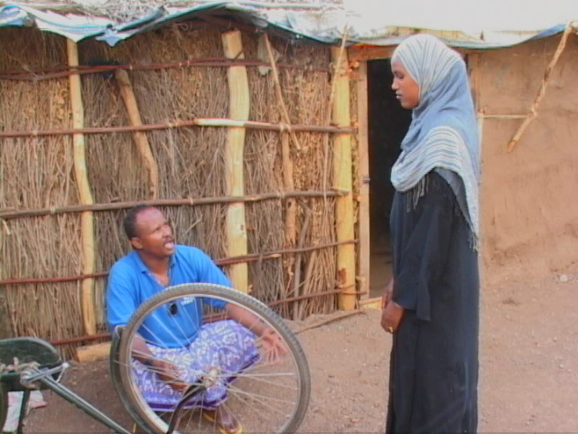

About the Prevention of Sexual Exploitation and Abuse (PSEA) Project
The Prevention of Sexual Exploitation and Abuse Project (PSEA) is aimed at eliminating sexual exploitation and abuse in the Kenya refugee program. The project is being implemented at various levels by different organization working with refugees in Kenya. Raising awareness among the target communities is critical if the project is to succeed. Film Aid has developed four videos (under the series title: No Excuses) to be used in discussions and general awareness campaigns.
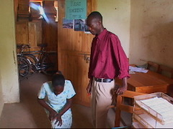

What is this facilitation guide about?
This Facilitation Guide is designed to be used together with the No Excuses Video Series on Prevention of Sexual Exploitation and Abuse, to manage discussions during any screening of the PSEA Awareness videos
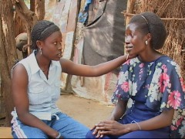
This guide is not cast in stone. It offers a general direction on how to manage discussions and users are encouraged to use their own innovations. We encourage you to contact FilmAid with any feedback on how to improve this guide.

This guide is divided into the following sections.
- Some Key Concepts: A brief overview of some of the terms, definitions and concepts used in the project.

- Reporting Procedures: A brief outline with procedures on how to report sexual exploitation and abuse cases in all the three project locations in the Kenya Refugee Program. Facilitators are expected to be familiar with these.

- Code of Conduct Summary: A quick checklist of the Kenya Code of Conduct Undertakings. This can be a quick reference during discussions. It is however useful for the facilitators to be thoroughly familiar with the Code of Conduct and to always carry one when going to facilitate a discussion.
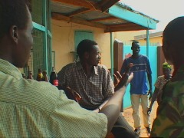
- About the Videos: This section gives a brief summary of the No Excuses videos and the content covered in them. The issues contained in the videos are highlighted. This should offer the discussion facilitators with a quick reminder of the video contents and help in selecting particular areas of discussion.

- How to use the video resources in discussions: Points out some of the ways in which you can use the videos for targeted discussion forums. Also offers a brief reminder of how you can best organize your audience for discussions.

- Discussion Notes: This is the actual discussion guide. It helps you set your objectives for a particular discussion session, have an overview of the issues to be covered and the type of questions to stimulate a discussion. Remember, these are not cast in stone and the facilitator has to adjust depending on type of audience, time limit, issue considered critical by that particular audience, etc.
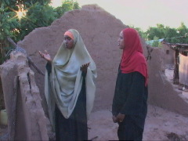

- Feedback Form: It is essential to collect feedback from the participants in every awareness session. We recommend that one person takes notes as another leads the discussion, and then they fill the form together. However, if this is not possible, one can fill the form after the session.

1. Some Key concepts:

The following are some of the key concepts / issues that you should be familiar with as you engage in discussion on sexual exploitation and abuse.

Exploitation: Taking advantage of someone’s vulnerability for personal gain

Sexual Exploitation: When someone gives money or shelter, food, resettlement, employment marks in school, scholarships and other goods in exchange for sex.

Abuse: Use of force, threats or position of power to make intrusions on another person.

Sexual Abuse: Actual or threatened physical intrusion of a sexual nature, by force or under unequal or coercive conditions.

Reporting Procedures: This refers to the channel through which sexual exploitation and abuse complaints can be received from the community to the agencies. Complaints can be made to PSEA Focal Points from any agency (examples) UNHCR Protection and Community Services, LWF and CARE Gender departments, NCCK, GTZ and JRS.

Entitlements: Essential services such as shelter, health care, food, water, sanitation, education, firewood (in some camps) and resettlement are offered to refugees for free. Money and/or sex should not be requested in exchange for these services.

Exploitation by Community Leaders: Exploitation by community leaders should also be reported through normal channels (see section on reporting procedures).

Code of Conduct (CoC): All humanitarian workers have signed the Code of Conduct that discourages sexual relationships between humanitarian workers and beneficiaries of their project (see Code of Conduct summary).

Incentive Workers: The Code of Conduct applies to incentive workers as well as all international and national staff.

Reporting: All staff are under obligation to timely report breaches of the CoC. Failure to do will result in disciplinary actions.

Investigations Reports are treated as allegations and will be investigated. Confidentiality is stressed and any party breaching confidentiality may have disciplinary action taken against them.

The Police: The police have their own Code of Conduct. Cases of exploitation by the police can be reported to senior police or to UNHCR who will follow up on the case.

Interagency protocols: These are 7 procedures agreed on by agencies party to the protocols elaborating on handling complaints and investigation, providing support to survivors, referral of legal cases, handling cases touching more than one agency, guidance on what should be done when an alleged perpetrators agency is not confirmed, staff making complaints against managers and situations where an agency may receive a complaint against another.
2. Reporting Procedures

Kakuma Camp

Cases in Kakuma can be reported through any of the following channels:
- Any PSEA Focal Point of the Agency employing alleged perpetrator.
- The PSEA Focal Point from another Agency
- A staff member from UNHCR’s Protection or Community Services
- The LWF gender program staff
- Men/women support group or community leaders/chairpersons/sultans
- Medical personnel and school teachers
- The Kenya police – for criminal cases (e.g. rape)

In addition to the above-mentioned channels, the host community can report SEA cases to their village elders.

Dadaab Camps

Cases in Dadaab can be reported through any of the following channels:
- A designated PSEA or GBV focal point staff member of the Agency employing the alleged perpetrator
- Any PSEA focal point staff member of another Agency
- Directly to Gender Based Violence (GBV) staff, women and children officers based at Camp level (Ifo, Dagahaley and Hagadera).
- A staff member from UNHCR’s Protection or Community Services

Nairobi

Cases in Nairobi can be reported through any of the following channels:
- A designated PSEA focal point staff members of the Agency employing the alleged perpetrator
- Any PSEA focal point staff members of another Agency
- Counselors in Agencies providing psychosocial support to urban refugees.
- A staff member from UNHCR’s Protection or Community Services
3. Kenya Code Of Conduct Summary

- Respect and promote fundamental human rights for all without discrimination

- Never commit any act or form of harassment that could result in physical, sexual or psychological harm or suffering to individuals, especially women and children

- Never engage in any sexual activity with children (persons under the age of 18)

- Never engage in sexual exploitation or abuse of beneficiaries under any circumstances

- Never condone or participate in any corrupt or illegal activities

- Never accept or exchange money, employment, goods, or any other services for sex, including sexual favors for services which must otherwise be provided to the beneficiaries by duty or free of charge

- Never engage in any other forms of humiliating, degrading or exploitative behavior under any circumstances whatsoever

- Never abuse your authority, position or influence by withholding protection, humanitarian assistance and services, nor give preferential treatment in order to solicit sexual favors, gifts, and payments of any kind or any other advantage

- Ensure that all confidential information, including reports of breaches of these standards by other workers or obtained from beneficiaries, is channeled correctly and handled with utmost confidentiality

- Ensure that any breaches of the standards set out in this Code are immediately reported

- Create and maintain an environment that prevents sexual exploitation and abuse, corruption or abuse of power

- Those who purposely make false accusations against another worker of breaching the provisions of the Code of Conduct will face disciplinary action.

4. About the Videos

The videos in this series were made with the participation of the refugee community, the host community and humanitarian workers. The videos are adapted from stories submitted by the refugee and host communities in Kakuma and Dadaab refugee camps and refugees living in Nairobi.

The four videos mainly cover the following areas: definition of sexual exploitation and sexual abuse, exploitation, corruption and abuse by humanitarian workers and community leaders, entitlements and rights, reporting procedures, and the Code of Conduct.

Wounded Butterfly: 25 minutes

Languages available: English, Swahili, Somali, Dinka & Arabic

A schoolteacher (aid worker) threatens his student (Maria, refugee) with failing her examinations if she does not introduce her elder sister to him for a romantic relationship. If she cooperates, she is rewarded with increased marks in Science subjects. Her sister (Sarah) is sexually abused by the teacher when she does not give in to his demands. The sisters suffer in silence due to intimidation by the teacher before they breakdown and confess to their mother. The mother reluctantly seeks help from her informed sister and her fears regarding reporting such cases is put to rest.
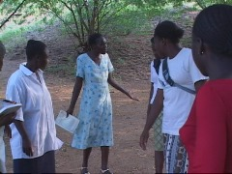
Issues covered: Sexual Exploitation and Sexual Abuse, Reporting Procedures

Walking on Wind: 13 mins

Languages available: English, Swahili, Somali & Dinka

A refugee woman (young widow) is desperate for resettlement because she is pregnant yet not remarried. A driver working for the UN has promised to help her, for a fee. She is too poor to raise the money and she eventually agrees to offer herself for sex as payment. Few weeks later, no action has been taken on her file and the said driver has been transferred to another station.
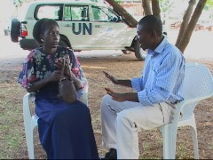

Issues covered: Sexual Exploitation by Humanitarian Workers, Entitlements, Corruption, and Reporting Procedures

Jamilla: 8 mins

Languages available: English, Swahili & Somali

Jamilla’s (Somali single woman, refugee) house has been destroyed by recent flooding. Desperate, she goes to the community leader for help. The community leader is willing to help her only if she will help him in return, by offering her body to him. Jamilla is not ready to accept his advances and is determined to personally see the officer in charge of distributing building materials. Eventually she manages to get access to the NGO’s office.
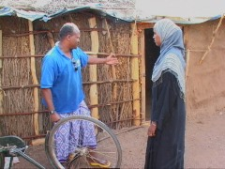
Issues covered: Sexual Exploitation by Community Leaders, Entitlements, and Reporting Procedures

No Excuses: 25 mins

Languages available: English, Swahili & Somali

Peter, the Drug Distribution Manager of an NGO, is interested in Alek (a young Dinka girl, with an ailing mother) and requests the help of John, (an incentive refugee employee working at the hospital and neighbour to Alek). As a reward for the relationship, Alek’s mother gets preferential treatment at the hospital while Alek receives some much-needed money. One of Peter’s friends sees nothing wrong with the arrangement while the other tries to point out their responsibilities as outlined in the Code of Conduct. Peter dismisses this, with serious consequences.
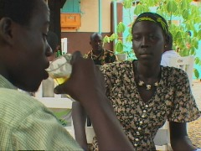
Issues covered: Sexual Exploitation by humanitarian workers (national and refugee) and the police, the Code of Conduct, reporting procedures, and investigations

5. How to Use the Videos in Discussions

There are four (4) videos in this series, 2 long videos (Wounded Butterfly and No Excuses) and 2 short videos (Walking on Wind and Jamila). In an ideal situation, all the four videos can be shown separately. However, in some situations, various constraints may deter one from having four separate sessions with the same group.

In such a case, we recommend that two videos can be shown at the same seating. In such cases, we recommend that Wounded Butterfly be screened together with Walking on Wind. This gives the participants an opportunity to define sexual exploitation and abuse and discuss corruption, reporting procedures and entitlements. The second screening can combine No Excuses and Jamilla. It is recommended that the longer pieces be screened first.

REMEMBER….

- Make sure everybody is comfortable and has a clear view of the screen

- Before you begin screening, introduce yourself and your team (Using your individual names). If the participants are not many, ask them to introduce themselves.

- Give a brief introduction on the purpose of the session, and the background of the project in general (if appropriate for the audience, and especially if you are meeting with the participants for the first time)

- Briefly introduce the videos (you can use the summary of the stories in the discussion notes session). Briefly tell them what you want them to notice (i.e. “I want you to observe how many wrongs the teacher will have committed by the end of the film because we shall discuss it at the end”). This helps in making them an active audience. Remember if you are going to show two videos, tell them this beforehand so that others don’t walk away assuming the session is over

- Start the film and then move to the back of the audience.

- At the end of the film, stop it and start by getting first reactions about the film. This is a smooth way of getting into discussion. If done well, you will find that you are already discussing the serious issues without anybody noticing! Avoid reading questions from the guide during discussions.

- If the group is not very conversant with the language of the video, you can stop the video at key points, and ask that someone in the audience explains what has happened to that point. Avoid entering into a discussion on the topic, but allow the group to ask questions if they have them so that they can understand what is happening in the story.

- If the participants in the screening session are part of an organized group, e.g. a women organization or a youth a group, it adds a lot of value to have them participate in some activities. In the discussion notes, there is space for suggested activities.

- Fill in the Feedback form after the discussions are over. One form should be filled for each film shown. Fill in the form immediately after discussion session is over when the issues are still fresh in your mind. Some of the questions in the form can be asked to the participants immediately after the main discussions e.g. “What did you like most about the videos? What did you not like about the videos?” Use the back of the form and additional stationery if necessary.
6. Discussion Notes

Video 1: Wounded Butterfly
Synopsis:
A schoolteacher (Mr. Shinza, National staff) exploits and abuses one his students (Maria, refugee) and her out of school sister (Sarah). He makes several promises to Maria if she can facilitate a meeting between him and her sister. He directly or indirectly promises her better marks in her science class, and suggests that he can find a place in college for her sister, employment opportunity for her mother and even organizing an increase in food ration for the family. Maria gives in to his demands. He repeats similar promises to Sarah and when she rejects his advances, he resorts to sexually abusing her. The sisters suffer in silence due to intimidation by the teacher before they break down and confess to their mother. Mother and daughters are not sure on what to do. They are afraid of a backlash from the teacher and what the community will say when they hear about this case. The mother reluctantly seeks help from her informed sister and her fears regarding reporting such cases is put to rest.

Aim: to know what sexual exploitation and abuse is and how to respond to it.

Objective: By the end of the session, the participants should be able to:
- State what sexual exploitation is
- State what sexual abuse is
- State how they can report a case of sexual exploitation and abuse
- Know what will happen after they have reported a case

Discussion:
Q1. Did Mr. Shinza sexually exploit and abuse the two sisters?
Definition of sexual exploitation:
- Discuss how Mr. Shinza takes advantage of Maria (promises of good marks, rewards for family)
- Discuss Mr. Shinza’s scene with Sarah (promises of college education)
- Discuss and point out Mr. Shinza’s status against that of the girls (national versus refugee, employed versus poor, etc)
- Discuss Mr. Shinza’s use of money to buy the girl’s silence
Definition of sexual abuse:
- Discuss Mr. Shinza’s sexual assault on Sarah
- Discuss Mr. Shinza’s use of threats to get his way with Sarah

Q2. How should the two girls have responded to Mr. Shinza’s advances?
- Discuss response before the rape and after the rape
- Discuss the advice given by Maria’s school mates

Q3. What could the girls’ mother have done after receiving the report about Mr. Shinza from her daughters?
- Discuss reporting channels highlighted by the aunt and Focal Point
- Discuss specific reporting channels in your location (e.g. Kakuma, Nairobi, Dadaab)

Q4. What happens after you have reported a case of sexual exploitation and abuse?
- Discuss explanation given by Focal Point and aunt
- Checklist: confidentiality, protection, investigation, interviews, tell the truth, suspension of alleged perpetrator from work

Activities
Q5. What can I do as an individual to fight against sexual exploitation and abuse?
- Discuss this with my family
- Visit the women’s resource center or talk with an NGO PSEA focal point to find out more information about sexual exploitation and abuse and how to report it
- Encourage victims we know to report cases
- _________________________________________________________
- _________________________________________________________

Q6. What can we do as a community to fight against sexual exploitation and abuse in our community?
- Hold discussions about sexual exploitation and abuse in our community
- Encourage victims (survivors) who we know to report cases
- _____________________________________________________
- _____________________________________________________

Video 2: Walking on Wind
Synopsis:
A young refugee widow (Juliet Alek) is desperate for resettlement because she is pregnant yet not remarried. In her community, this would put her in danger. A driver (Maxwell) working for the UN has promised to help her. He wants 500,000 shillings to facilitate the process but she is too poor to raise the money. He suggests another way in which she can repay him; having a sexual relationship. Being desperate, she has no option but to agree. Two weeks later and no action have been taken on her file and Maxwell has been transferred to another workstation. A focal point in the organization explains to her that what Maxwell did could be a case of Sexual Exploitation and that investigations will have to be carried out.

Aim: To reinforce awareness among the community on entitlements that are free and that should not be exchanged for money or sex

Objective: By the end of the session, the participants should be able to:
- Clearly understand that essential services offered by NGOs are free of charge and should not be exchanged for sex or money
- State how they can report a case of sexual exploitation and abuse
- Know what will happen after they have reported a case

Discussion:
Q1. Do you think that Maxwell (the driver) was in a position to help Juliet get resettlement?
- Discuss how one should beware of NGOs workers purporting to be able to help them / speed up applications for cash or sexual relationship in return

Q2. Should one, just like Juliet in the film, be asked to pay for services offered by NGOs in the refugee camps? (Or in Nairobi?)
- Name and discuss the range of services offered free of charge by different NGOs. (Start with essential relief services e.g. food distribution, protection and security, health etc). If possible have a list of these services.
Q3. How can you report a case of sexual exploitation and abuse?
- Discuss specific reporting channels in your region (e.g. Kakuma, Nairobi, Dadaab)
- If possible, name Focal Points / Areas / Offices where allegations can be reported

Video 3: Jamilla
Synopsis:
Jamilla is a single Somali refugee woman whose house has been destroyed by recent flooding. Desperate, she goes to the Community Leader for help. The Community Leader is unwilling to help unless she offers her body to him. Jamilla will have none of that and is determined to personally see the officer in charge of distributing building materials. Her efforts to seek help from the Community Development Worker have been in vain. She eventually sees the Focal Point who advises her how to report such cases.

Aim: To reinforce awareness among the community on entitlements that are free and that should not be exchanged for money or sex

Objective: By the end of the session, the participants should be able to:
- Clearly understand that essential services offered by NGOs are free of charge and should not be exchanged for sex or money
- State how they can report a case of sexual exploitation and abuse
- Know what will happen after they have reported a case

Discussion:
Q1. Do you think it is wrong for the Community Leader to demand to sleep with Jamilla before he can help her? Why do you think so?
- Discuss the responsibility of community leaders and other humanitarian workers in serving refugees.

Q2. What should Jamilla have done instead of camping at the compound gate for a whole week?
- Discuss specific reporting channels in your region (e.g. Kakuma, Nairobi, Dadaab)
- If possible, name Focal Points / Areas / Offices where allegations can be reported

Video 4: No Excuses
Synopsis:
Peter, the Drug Distribution Manager, is interested in having an affair with a young Dinka girl named Alek. He approaches John, incentive worker working at the hospital and neighbour to Alek, to facilitate a meeting between him and Alek. As a reward for the relationship, Alek’s ailing mother gets preferential treatment at the hospital while Alek gets some much needed money. One of Peter’s friend (Moses the policeman) sees nothing wrong while another (Dan) tries to point out their responsibilities as outlined in the Code of Conduct. Dan feels that he has an obligation to report Peter’s actions to the Manager.

Aim: To understand the responsibilities and obligations of humanitarian workers and other service providers in their relationship with refugees and the host communities

Objective: By the end of the session, the participants should be able to:
- Understand the responsibilities of Humanitarian workers in their relationship with refugees and host communities
- Clearly understand the Code of Conduct and its undertaking
- Know what constitutes a breach of the Code of Conduct
- Know how to report any breach of the Code of Conduct

Discussion:
Q1. Is Peter engaged in any act of sexual exploitation?
Definition of sexual exploitation:
- Discuss how Peter exploits Alek’s situation to have a relationship with her
- Discuss the power dynamics between Peter and Alek in regards to their positions in this environment

Q2. Why is the relationship between Moses the policeman and his new girlfriend illegal? Are the police and other government workers serving refugees also ‘humanitarian workers’?
- Discuss relationship with under-age girls. Emphasize local culture notwithstanding
- Discuss whether the police and other government workers serving refugees should abide by the same principles as other humanitarian workers.
Q3. What are some of the undertakings of the Code of Conduct that Peter and John breached?
- Discuss the undertakings in the code of conduct
- List down instances where the code of conduct has been breached in the film

Q4. Was Dan right in reporting Peter to the senior manager? What should one do and not do when one is aware of a breach of the code of conduct?
- Discuss the importance of timely reporting of breaches
- Discuss the dos and donts of reporting a work colleague suspected of breaching the Code of Conduct

Q5. What steps should managers receiving reports of allegations take?
- Highlight steps that are taken when receiving reports of allegations

Activities
Q6. Where can we/ I get a copy of the Code of Conduct
- ______________________________________________________
- ______________________________________________________
- ______________________________________________________

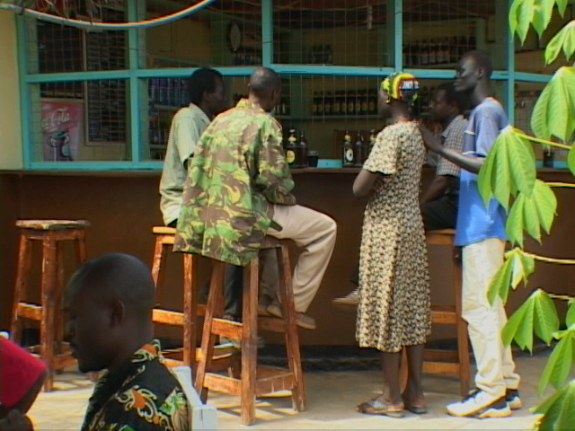

- Feedback Form (Sample)

Film Aid PSEA Feedback Form: To be filled by the facilitator during and after discussions

Date: Location

Name of Film: ______________________ Language used: _______________________

Participants (Describe the type of participants): ______________________________
___________________________________________________________________________

No: of participants: Women: Men: Total:

How many were youth (age 13-25)?

  - What main issues were raised in the discussion? …………………………………….……………………………………………….……………………

  - What were the main questions asked? ………………………………………………………………………………………………

  - List any controversial issues that emerged from the discussions
………………………………………………………………………………………………………………

  - What other issues would they like to see being addressed by the PSEA Videos?
.…….……………………………………………………………………………………………….

  - What PSEA related activities, if any, did the participants undertake or agree to undertake as a result of this session? ………………………………………………….………………………………...…………………

  - What did the participants like most about the videos? ……………………………………………………………………………………………………….

  - What did the participants not like about the videos? ……………………………………………………………………………………………………….

Name of facilitator: _______________________________________________________
Use the back of this form for any additional information.

A project funded by the Bureau of Refugees, Population and Migration

© FilmAid International, 2006

Manual developed by: FilmAid International
P.O. Box 21751-00505 - Nairobi – Kenya
Tel: +254-(0) 20- 3877800

TO REQUEST MORE COPIES, PLEASE CONTACT:
nairobi@filmaidinternational.org – info@filmaidinternational.org




PSEA Kenya project - a joint collaboration by:

