No | LOCATION | MEDICAL RESPONSE | LEGAL | PSYCHOSOCIAL | SECURITY  /  PROTECTION | OTHERS
1 | BOMI | CCC | CCC | CCC | CCF | ANPPCAN: Awareness, Education and Training
1 | BOMI | CCF | CCF | CCF | SC-UK | CCF: Livelihood
1 | BOMI | NATPHA | UNHCR | IRC | WFP | NACROG: Monitor, Document and Report
1 | BOMI | UNHCR |  | NACROG | UNHCR | NATPHA: Income Generation
1 | BOMI |  |  | SC-UK |  | SC-UK: Economic Reintegration (Livelihood generating opportunities skills)
 |  |  |  | World Vision |  | UNICEF: Awareness
 |  |  |  | UNHCR |  | World Vision: Agriculture, Child Protection and Health issues
2 | BONG | AIDSCORPS | ARC | AIDSCORPS | ARC | CCF: Livelihood
2 | BONG | ARC | CCF | ARC | CCF | MPCHS (WHDP): Awareness
2 | BONG | CCF | AFELL | CCF | SC-UK | NATPHA: Income Generation
2 | BONG | NATPHA | UNHCR | MCRS | WFP | OXFAM: Advocacy, Awareness and Empowerment
2 | BONG | UNFPA |  | SC-UK | WOLPNET | SC-UK: Economic Reintegration (Livelihood generating opportunities skills)
2 | BONG | UNHCR |  | AFELL | UNHCR | UNFPA: 1. To create proactive awareness on all types of violence against women and adolescent girls. 2. Male-gender violence sensitization for promotion RH and rights of women and girls 3. Development IEC/advocacy material 4. Sensitization on reporting GBV
 |  |  |  | UNHCR | WOCDAL | UNICEF: Develop IEC material for prevention
 |  |  |  | WOCDAL |  | WOLPNET: Advocacy and Awareness
 |  |  |  |  |  | Women Health and Development Program of Mother Pattern: Empowerment
 |  |  |  |  |  | UNHCR: Training activities
No | LOCATION | MEDICAL RESPONSE | LEGAL | PSYCHOSOCIAL | SECURITY  /  PROTECTION | OTHERS
3 | CAPE MOUNT | AIDSCORPS | CCC | AIDSCORPS | CCF | CCF: Livelihood
3 | CAPE MOUNT | CCC | CCF | CCC | WFP | UNICEF: Develop IEC material for prevention
3 | CAPE MOUNT | CCF | UNHCR | CCF | UNHCR | World Vision: Agriculture, Child Protection and Health issues
3 | CAPE MOUNT | UNHCR | UNHCR | World Vision | CEP
3 | CAPE MOUNT |  |  | UNHCR
 |  |  |  | CEP
4 | GBOPOLU | CCF | CCF | CCF | SC-UK | CCF: Livelihood
4 | GBOPOLU | UNHCR | UNHCR | SC-UK | WFP | SC-UK: Economic Reintegration (Livelihood generating opportunities skills)
4 | GBOPOLU |  |  | UNHCR | CCF
 |  |  |  |  | UNHCR
5 | GRAND BASSA | CCC | CCC | CCC | WFP | NACROG: Monitor, Document and Report
5 | GRAND BASSA | UNHCR | UNHCR | NACROG | UNHCR | NACROG: Monitor, Document and Report
 |  |  |  | UNHCR | UNHCR | NACROG: Monitor, Document and Report
6 | GRAND GEDEH | UNFPA | AFELL | NAWOCOL | WFP | UNICEF: Develop IEC material for prevention
6 | GRAND GEDEH | UNHCR | UNHCR | Medica Mondiale | NAWOCOL | UNFPA: 1. To create proactive awareness on all types of violence against women and adolescent girls. 2. Male-gender violence sensitization for promotion RH and rights of women and girls 3. Development IEC/advocacy material 4. Sensitization on reporting GBV
 |  |  |  | AFELL | UNHCR | UNHCR: Training activities
 |  |  |  | UNHCR | UNHCR | UNHCR: Training activities
7 | GRAND KRU | CHS | UNHCR | CHS | CHS
7 | GRAND KRU | UNHCR | UNHCR | UNHCR | WFP
 |  |  |  |  | UNHCR
No | LOCATION | MEDICAL RESPONSE | LEGAL | PSYCHOSOCIAL | SECURITY  /  PROTECTION | OTHERS
8 | LOFA | CCF | CCF | CCF | CCF | CCF: Livelihood
8 | LOFA | IMC | AFELL | IRC | UNDP | UNDP: Awareness
8 | LOFA | UNFPA | UNHCR | AFELL | WFP | UNFPA: 1. To create proactive awareness on all types of violence against women and adolescent girls. 2. Male-gender violence sensitization for promotion RH and rights of women and girls 3. Development IEC/advocacy material 4. Sensitization on reporting GBV
8 | LOFA | UNHCR | UNHCR | UNHCR | UNHCR | UNICEF: Develop IEC material for prevention
 |  |  |  | WOCDAL | WOCDAL | Women Health and Development Program of Mother Pattern: Training Centre for Women
 |  |  |  |  |  | UNHCR: Training activities
9 | MARGIBI | AIDSCORPS | ARC | AIDSCORPS | ARC | ANPPCAN: Awareness, Education and Training
9 | MARGIBI | ARC | UNICEF | ARC | SC-UK | MPCHS (WHDP): Awareness
9 | MARGIBI | LIB SWAA | UNHCR | LIB SWAA | UNICEF | NACROG: Monitor, Document and Report
9 | MARGIBI | UNFPA |  | NACROG | WFP | SC-UK: Economic Reintegration (Livelihood generating opportunities skills)
9 | MARGIBI | UNICEF |  | SC-UK | UNHCR | UNFPA: 1. To create proactive awareness on all types of violence against women and adolescent girls. 2. Male-gender violence sensitization for promotion RH and rights of women and girls 3. Development IEC/advocacy material  4. Sensitization on reporting GBV
9 | MARGIBI | UNHCR |  | UNICEF | WOCDAL | UNICEF: Awareness
 |  |  |  | UNHCR |  | Women Health and Development Program of Mother Pattern: Advocacy
 |  |  |  | WOCDAL |  | UNHCR: Training activities
No | LOCATION | MEDICAL RESPONSE | LEGAL | PSYCHOSOCIAL | SECURITY  /  PROTECTION | OTHERS
10 | MARYLAND | MERCI | UNHCR | World Vision | WFP | UNICEF: Develop IEC material for prevention
10 | MARYLAND | UNHCR | UNHCR | UNHCR | UNHCR | World Vision: Agriculture, Child Protection and Health issues
11 | MONTSERRADO | UNICEF | ARC | AIDSCORPS | ARC | ANPPCAN: Awareness, Education and Training
11 | MONTSERRADO | AIDSCORPS | CCC | ARC | Childrensmile | Childrensmile: Advocacy and Training
11 | MONTSERRADO | ARC | CCF | CCC | IRC | HELP MY PEOPLE Inc: Training and Grade School
11 | MONTSERRADO | CCC | LSAWC | CCF | Liberian Red Cross | LSAWC: Shelter Protection
11 | MONTSERRADO | ELWA Hospital | UNICEF | Childrensmile | LSAWC | MARIANNE: Training/capacity Building
11 | MONTSERRADO | HELP MY PEOPLE inc | UNHCR | CVT | OXFAM - GB | MERLIN: Information, Education and Communication
11 | MONTSERRADO | Liberian Red Cross |  | ELWA Hospital | SC-UK | NACROG: Monitor, Document and Report
11 | MONTSERRADO | LSAWC |  | HELP MY PEOPLE Inc | THINK Inc. | NATPHA: Income Generation
11 | MONTSERRADO | MERCI |  | IRC | TWIN | OXFAM: Advocacy, Awareness and Empowerment
11 | MONTSERRADO | MERLIN |  | Liberian Red Cross | UN Police | SC-UK: Economic Reintegration (Livelihood generating opportunities skills)
11 | MONTSERRADO | MFS Belgium |  | LSAWC | UNDP | THINK Inc: Prevention, awareness and skill training
11 | MONTSERRADO | MSF Spain |  | MARYANNE | UNICEF | TWIN: Skill training and business entrepreneurship for self sustainability
11 | MONTSERRADO | NATPHA |  | MCRS | WFP | UNDP: Awareness
11 | MONTSERRADO | THINK Inc. |  | MSF Belgium | WOCDAL | UNICEF: Mobilization communities and creation of awareness
11 | MONTSERRADO | UNHCR |  | MSF Spain | WOLPNET | WOCDAL: Micro Credit
11 | MONTSERRADO |  |  | NACROG | W.C.P / Liberia National Police | WOLPNET: Advocacy and Awareness
 |  |  |  | OXFAM - GB | UNHCR | Women Health and Development Program of Mother Pattern: Supporting Groups
 |  |  |  | SC-UK | WOCDAL | World Vision: Agriculture, Child Protection and Health issues
 |  |  |  | THINK Inc. |  | UNHCR: Training activities
 |  |  |  | TWIN
 |  |  |  | UNICEF
 |  |  |  | World Vision
 |  |  |  | UNHCR
 |  |  |  | WOCDAL
 |  |  |  | CEP
No | LOCATION | MEDICAL RESPONSE | LEGAL | PSYCHOSOCIAL | SECURITY  /  PROTECTION | OTHERS
12 | NIMBA | IRC | IRC | AFELL | WFP | MPCHS (WHDP): Awareness
12 | NIMBA | MERCI | AFELL | UNHCR | UNHCR | NATPHA: Income Generation
12 | NIMBA | NATPHA | UNHCR |  |  | UNFPA: 1. To create proactive awareness on all types of violence against women and adolescent girls. 2. Male-gender violence sensitization for promotion RH and rights of women and girls 3. Development IEC/advocacy material 4. Sensitization on reporting GBV
12 | NIMBA | UNFPA |  |  |  | Women Health and Development Program of Mother Pattern: Awareness
12 | NIMBA | UNHCR |  |  |  | UNHCR: Training activities
13 | RIVER GEE | MERCI | CHS | CHS | WFP | UNHCR: Training activities
13 | RIVER GEE | UNHCR | UNHCR | Medica Mondiale | CHS | UNHCR: Training activities
 |  |  |  | UNHCR | UNHCR | UNHCR: Training activities
14 | RIVERCESS | UNHCR | UNHCR | UNHCR | WFP | UNHCR: Training activities
 |  |  |  |  | UNHCR | UNHCR: Training activities
15 | SINOE | UNHCR | UNHCR | Medica Mondiale | WFP | UNHCR: Training activities
 |  |  |  | UNHCR | UNHCR | UNHCR: Training activities

MEDICAL RESPONSE
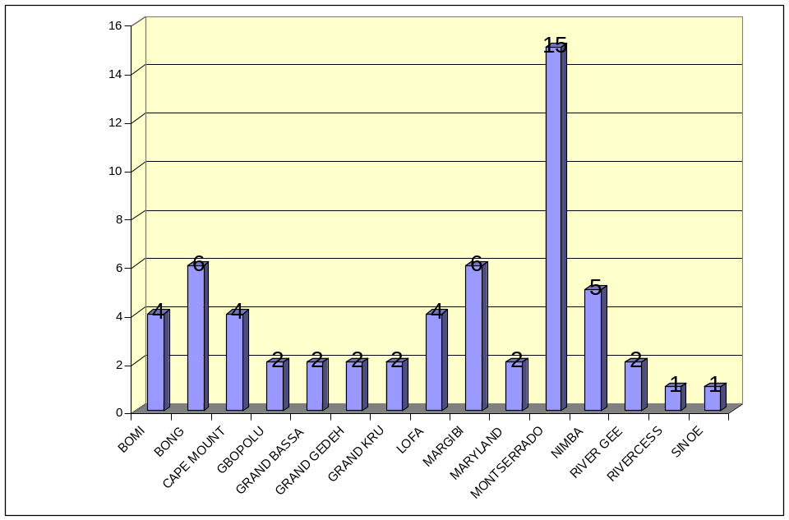

LEGAL
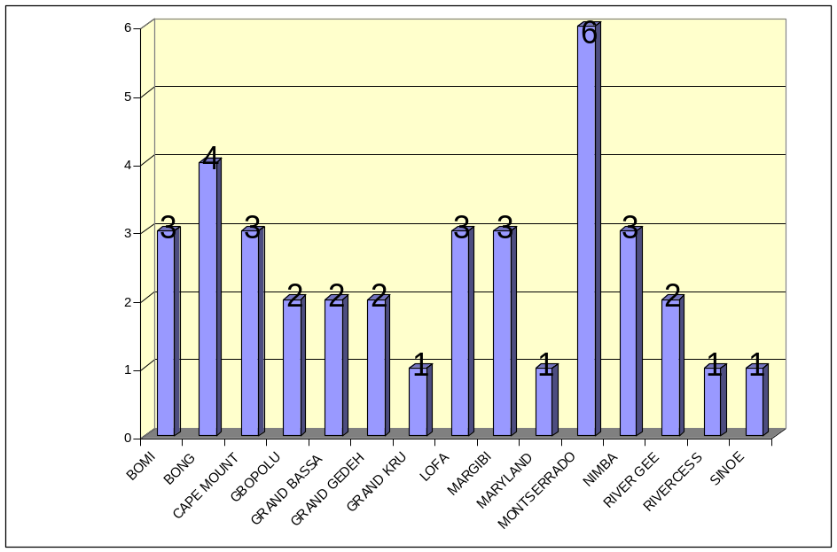

PSYCHOSOCIAL

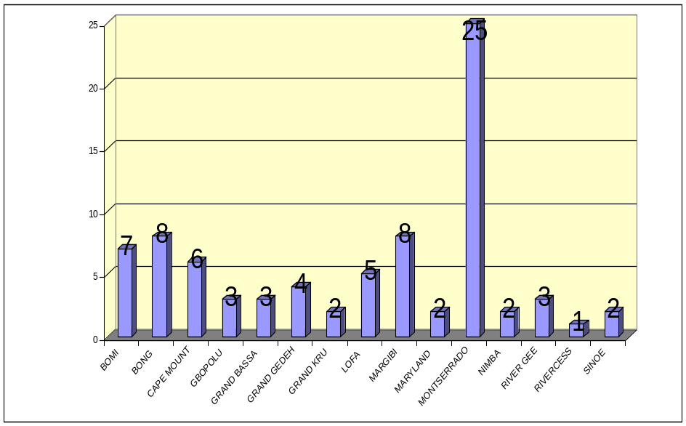

SECURITY / PROTECTION

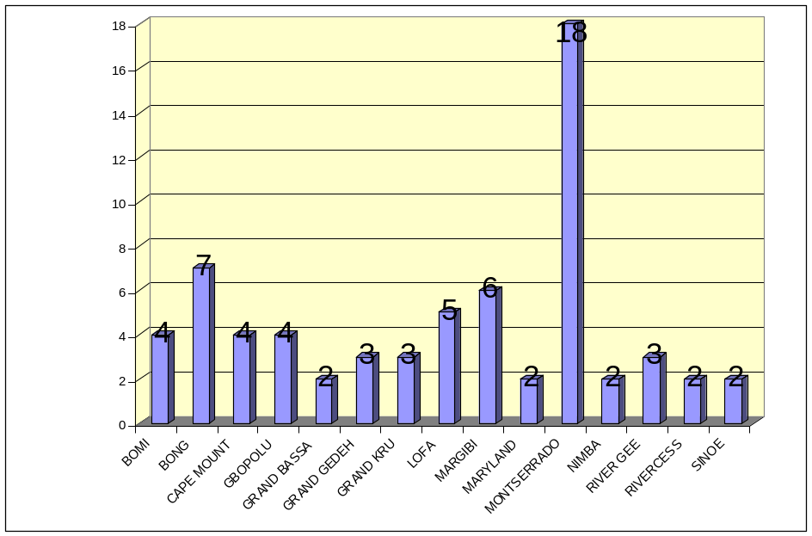

MINISTRY OF GENDER AND DEVELOPMENT
110 UN Drive & Gurley Street
P.O. Box 10-1375
1000 Monrovia 10, Liberia, West Africa

MINISTRY OF GENDER AND DEVELOPMENT
110 UN Drive & Gurley Street
P.O. Box 10-1375
1000 Monrovia 10, Liberia, West Africa

