From: | John Holmes/OCHA/NY
Date: | 27/04/2009 02:18 PM
Subject: | Letter to HCs: Request to implement UN Victim Assistance Strategy

Dear Colleagues,
Further to my message to you of 22 December 2008 on implementation of the UN's victim assistance strategy, please find herein a letter to a number of RC/HCs from myself, UNDG and DFS. Kindly assist the HC in your country to take the requested action, in consultation with him/her:
-forwarding the letter to all humanitarian country team members (both UN and NGO),
-working toward implementation of the victim assistance strategy, and
-helping to submit by 15 May information on progress made for inclusion in the SG's report to the GA.
Should you have questions or need assistance, please contact our headquarter focal point on this matter, Ariana Pearlroth (pearlroth@un.org or seatf@un.org).
Best regards,
John Holmes
----- Forwarded -----
From: | SEATF/United Nations@UNHQ-DPKO
Date: | 22/04/2009 01:48 PM
Subject: | Sent on behalf of Ad Melkert, Acting Chair UNDG; John Holmes, USG, OCHA; Susana Malcorra, USG, DFS: Request to implement UN Victim Assistance Strategy
Dear Colleagues,
We are forwarding the letter below (and also attached) which has been signed by Mr. John Holmes, Emergency Coordinator and Under-Secretary-General, Office for the Coordination of Humanitarian Affairs, Mr. Ad Melkert, Acting Chair, United Nations Development Group and Ms. Susana Malcorra, Under-Secretary-General, Department of Field Support.
The letter requests your cooperation and that of all members of the United Nations Country Team to implement the United Nations Comprehensive Strategy on Assistance and Support to Victims of Sexual Exploitation and Abuse by United Nations Staff and Related Personnel (A/RES/62/214), adopted by the General Assembly in December 2007. The resolution requests a report from the Secretary-General on its implementation, including lessons learned, best practices and recommendations for the 64th session of the General Assembly.
While we appreciate it will be early days, your feedback by 15 May 2009 on initial progress and/or action taken on assistance to victims is critical for drafting the Secretary-General's report, which is due on 27 July 2009. With our thanks in anticipation and looking forward to your response.
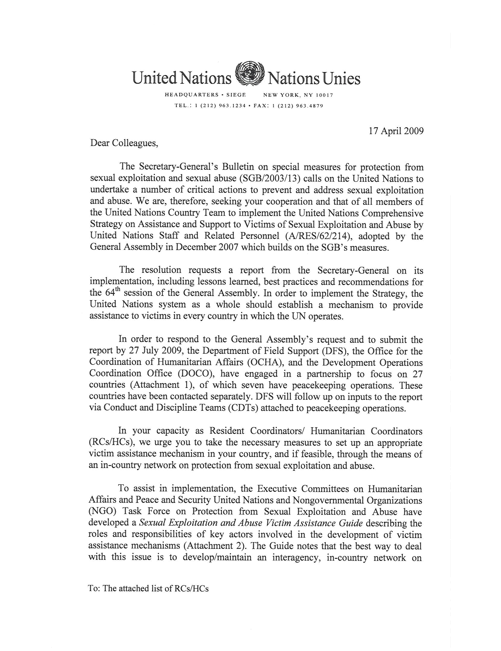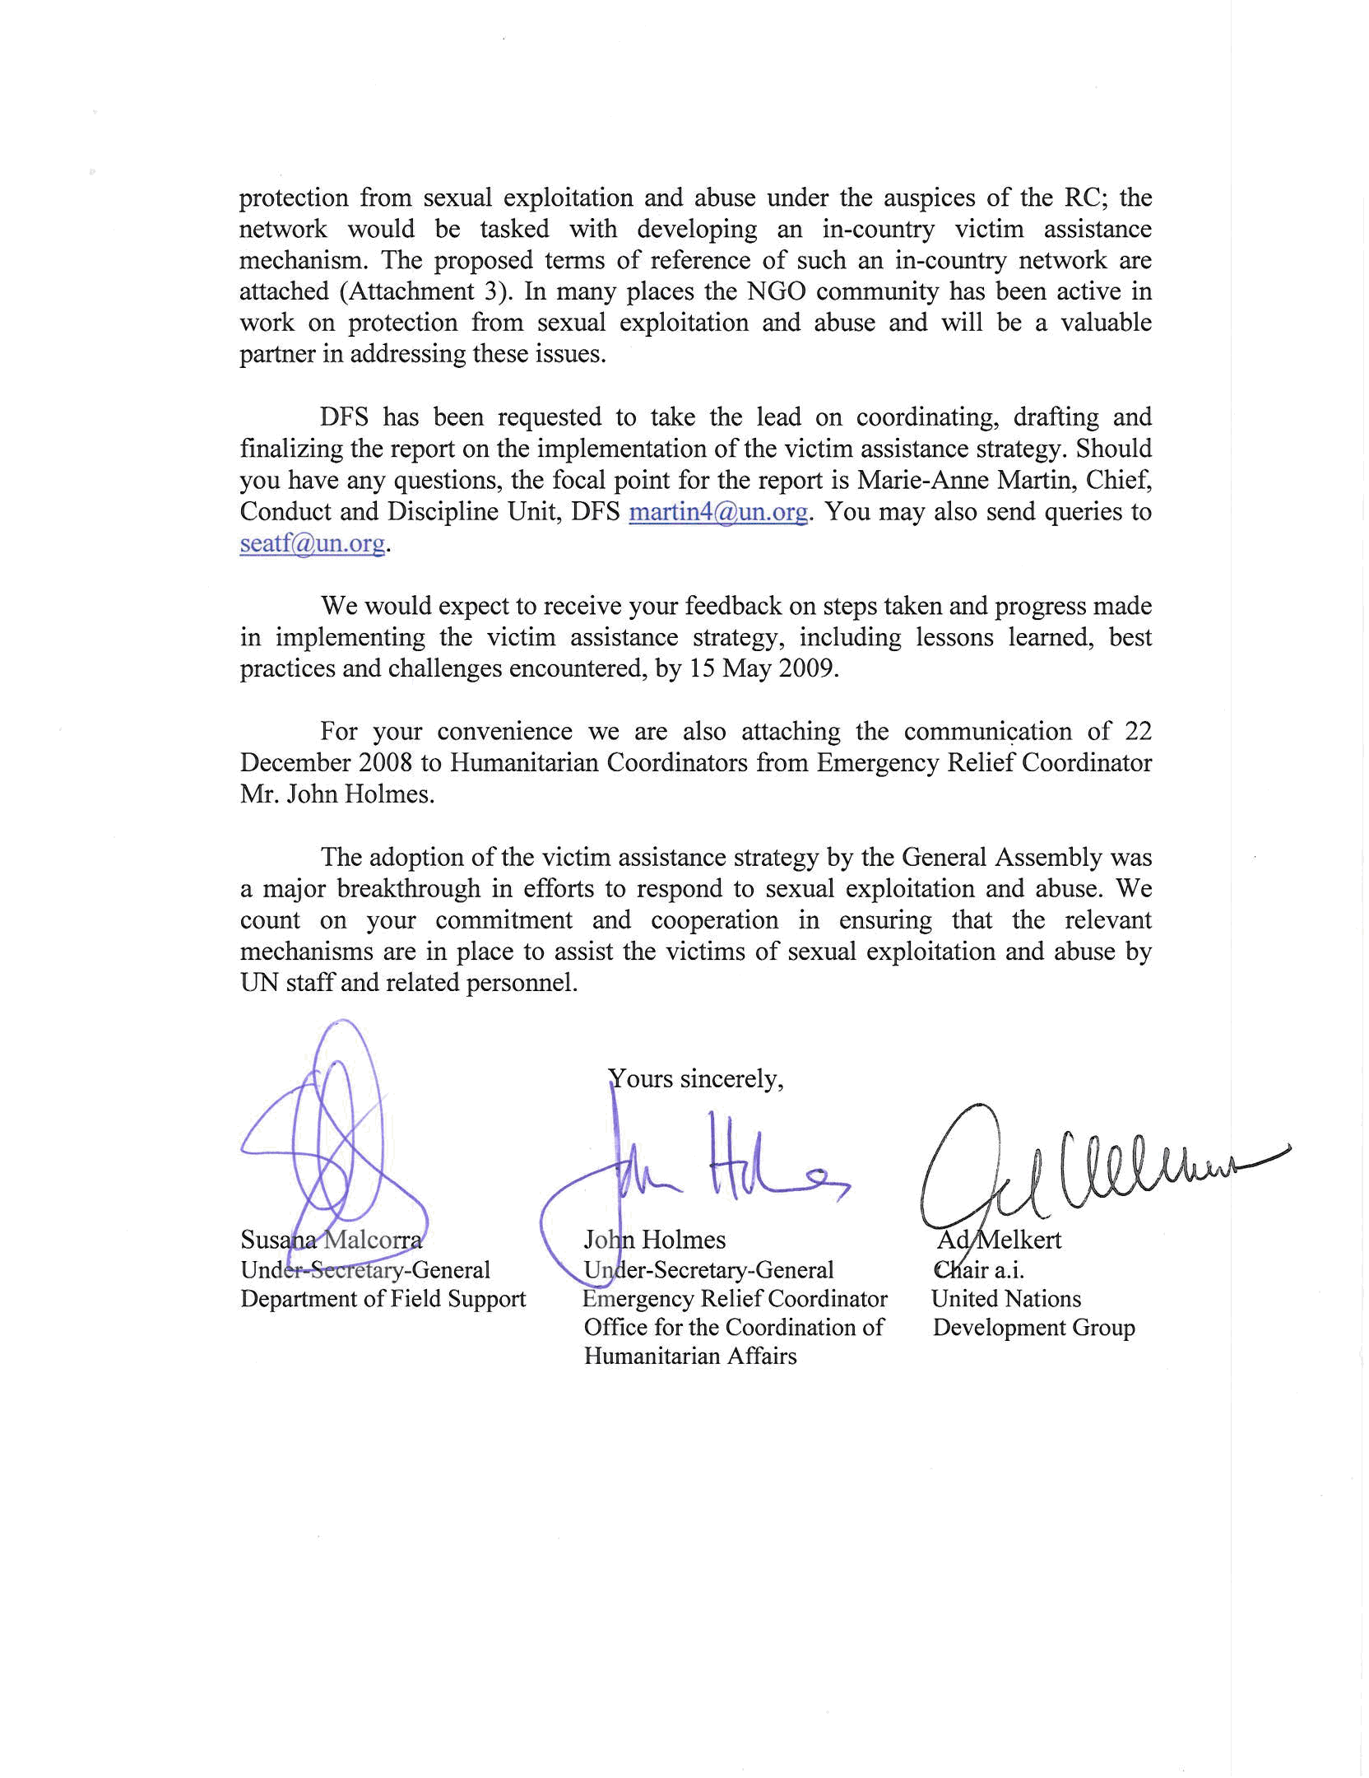
John Holmes/OCHA/NY@OCHA  22/12/2008 11:11 AM
  To
  cc
  Subject | new TORs and Guide to help your PSEA efforts
Dear Humanitarian Coordinators and OCHA Heads of Office,
Three new documents are available to support your efforts on protection from sexual exploitation and abuse by UN, NGO and IGO personnel (PSEA):
-SEA Victim Assistance Guide
-ToR for in-country Focal Points on PSEA
-ToR for in-country Network on PSEA
Concerning the SEA Victim Assistance Guide, please note that the General Assembly requires that the UN in every country establish a mechanism to provide assistance to victims of SEA (GA Res 62/214). The Secretary-General is to report to the GA in 2009 on progress made thus far. As such, I urge you to help ensure that these mechanisms are developed in your respective country. As noted in the Guide, the in-country PSEA Network, under the auspices of the RC/HC, is responsible for the development of the mechanism. It is the RC/HC’s responsibility to ensure that such a Network is in place and the Head of Office’s responsibility to ensure that his/her office has a PSEA Focal Point who is actively participating in the Network. This participation should include active involvement in the development and operation of an SEA victim assistance mechanism as part of the overall PSEA programme in each country. Other guidance notes, such as on the implementation of the SGB on PSEA, setting up community-based complaints mechanisms and various training packages for PSEA Focal Points and senior managers, are under development and will be shared with you in 2009.
If you have any questions, please contact the ECHA/ECPS UN and NGO Task Force on PSEA at seatf@un.org.
Kind regards,
John Holmes
Under Secretary-General and Emergency Relief Coordinator
Officer for the Coordination of Humanitarian Affairs
