Summary Report

Pilot Discussion Event for Senior Mangers on Prevention from Sexual Exploitation and Abuse: Somalia

Nairobi, Kenya
November 20, 2008

Conducted under the auspices of the ECHA/ECPS UN and NGO Taskforce on Protection from Sexual Exploitation and Abuse by
UN and NGO Staff and Related Personnel

Organised by

the Somalia Resident /Humanitarian Coordinator’s Office

Background: Assisting Senior Managers to Address SEA

At a high-level conference on eliminating sexual exploitation and abuse (SEA) held in December 2006, numerous UN agencies and INGOs endorsed a “statement of commitment” to eliminate SEA and protect those that the UN, INGOs, and their partners are mandated to serve. The Executive Committees on Humanitarian Affairs and on Peace and Security (ECHA/ECPS) UN and NGO Task Force on Protection from Sexual Exploitation and Abuse is currently the main UN body working on this issue. The Task Force has in the last year intensified its efforts to develop tools and guidelines to facilitate field-based action on SEA.

As a member of the Task Force, UNDP is chairing a working group on ‘Strengthening the Field-Based Networks’. In this context UNDP is leading efforts to (further) develop learning tools for managers on SEA. In September 2008, UNDP initiated a project to develop a learning package for Senior Managers and pilot several “discussion events” for this audience. This project aims to strengthen the shared commitment toward protection from sexual exploitation and abuse by assisting managers to understand and meet their responsibilities in creating safe organizations free from SEA.

This summary report describes the assessment process that informed the development of the tools, as well as the outcome of the first pilot of the senior manager’s discussion event that was conducted in November 2008 for the Somalia UN and NGO Country Team.

Phase 1: Assessment of Senior Manager’s Learning Needs
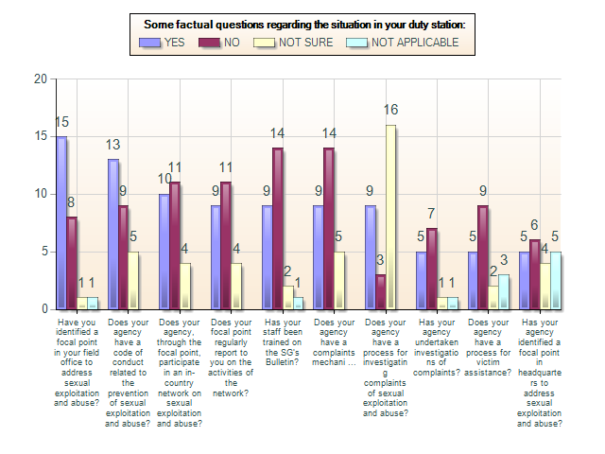
In preparation for developing tools to assist senior managers to address SEA in their field offices, a questionnaire relating to the learning needs of senior managers was developed by the UNDP-chaired ECHA/ECPS UN and NGO Task Force’s working group on “Strengthening Field-based Networks”, and distributed via e-mail in October 2008 to select senior managers working in humanitarian and development settings around the globe. The questionnaire was also used as the basis of face-to-face interviews conducted with senior managers of the Kenya and Somalia UNCTs. (Site/country selection for the face-to-face interviews was due to the fact that the consultant responsible for conducting the interviews is based in Kenya.)

The general results of the assessment indicated that most senior managers were familiar with the Secretary General’s Bulletin, and two-thirds had focal points in their field offices. The majority of respondents felt that their most important SEA-related responsibilities as senior managers were informing staff about codes of conduct, ensuring staff would feel free to come forward to make reports, and having adequate systems for addressing complaints. However, few organizations had developed formal reporting mechanisms at the field level, and while some organizations indicated that they had investigation methods at the headquarters level, few had standardized investigation procedures at the country level, and few organizations had implemented victim assistance procedures. Interestingly, several respondents were unsure whether their organization had an SEA focal point at headquarters level. Several managers participating in the face-to-face interviews also indicated that they considered the issue of sexual harassment as synonymous with SEA.
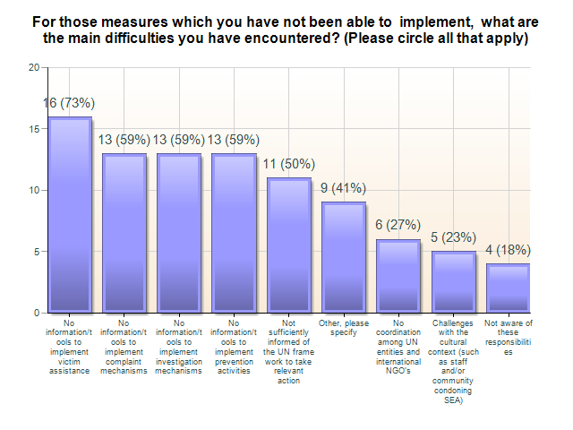
For those measures that had not yet been implemented at the field level, a majority of senior managers indicated that this was due to a lack of guidelines and tools, particularly highlighting lack of information about victim assistance, complaints mechanisms, investigation mechanisms, and prevention. Half of all senior managers completing the survey indicated that they were not familiar with the UN framework for addressing SEA. However, most felt that they were aware of their basic responsibilities regarding SEA.

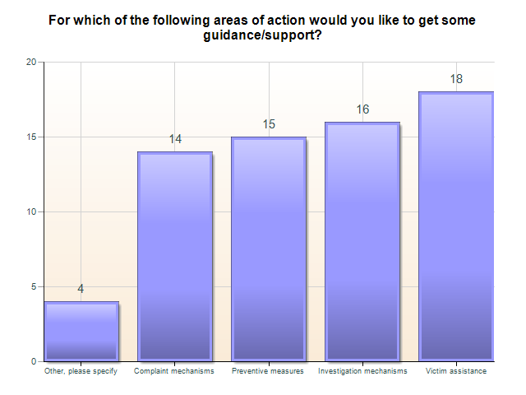
When asked about the areas in which senior managers would like guidance and support, the majority of respondents indicated all key areas related to addressing SEA, prioritizing them in the following order: victim assistance, investigation mechanisms, prevention, and complaints. Several respondents further mentioned being able to differentiate the actions to be taken within these key areas when working internally (with staff) and externally (with communities).

In addition to these key areas, several senior managers indicated that they would like additional information about how to quantify the problem of SEA at the country level, in order to rationalize the expenditure of resources to put programs in place. Respondents also indicated that they would like information about how to mainstream SEA activities into broader UN systems, so as not to create parallel programs (i.e. using staff associations to receive complaints; facilitating focal points’ access to ombudsmen at the international level; integrating SEA into the Consolidated Appeals Process (CAP), making SEA a standing agenda item for the UNCTs, etc.)

When asked what might be most useful to senior managers in terms of learning tools and discussion activities, the majority indicated sharing good practices. A large percentage of respondents also requested basic information on the UN framework for addressing SEA. Additional requests included training of focal points and support in coordination.
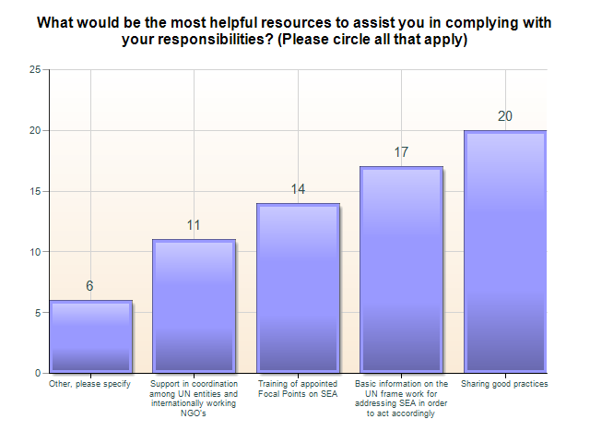
Supplementary recommendations included helping senior managers to understand how to integrate their SEA responsibilities within their other management responsibilities. Several participants also requested more support from headquarters in order to develop adequate mechanisms to address SEA at the field level. Still others expressed concerns about the legalities of responding to complaints, and requested information about minimum standards of evidence and how to address the legal dimensions of a complaints process. One respondent requested information about how to work more effectively with implementing partners, and also indicated a need to understand the respective roles of focal points and senior managers with regard to SEA, so as to ensure that focal points would not be overburdened.

Phase 2: Development of a Learning Tool for Senior Managers
The purpose of the brief assessment was to solicit recommendations from senior managers about their learning needs related to SEA. Overwhelmingly respondents requested concrete guidance and tools to meet their responsibilities within the key areas of victim assistance, complaints, investigations and prevention. The assessment informed the development of a learning tool for senior managers in which these areas are addressed in a half-day “discussion event.”

The discussion event includes a viewing of the training film “To Serve with Pride”, followed by a review of the key principles contained within the Secretary General’s Bulletin. Senior Managers are then asked to consider what some of the risk factors are for SEA in their areas of operation, in order to “localize” the issue to the contexts in which the senior managers and their organizations are working. Managers are also provided resources and guidelines related to their responsibilities and the responsibilities of focal points, and are introduced to a comprehensive “four pillars” approach to addressing SEA through 1) engagement and support of local populations; 2) prevention; 3) response; and 4) management and coordination. Using case studies relevant to their field operations, managers are asked to apply their learning to considering how to address SEA in terms of the four pillars. The event closes with a brief discussion about how senior managers can move forward collectively to improve efforts to address SEA in their organizations at their duty station and with the beneficiary population. (See Annex 1 for the agenda of the discussion event.)

Phase 3: Preparation for and Participation in the Pilot Workshop for the Somalia UN and NGO Country Team
The first pilot of the learning tools described above was held for the Somalia UN and NGO Country Team in November 2008. The Resident/Humanitarian Coordinator’s Office led the effort to organize the discussion event, sending out invitations to members of the UN and NGO community that emphasized the importance of senior management attendance. In order to ensure intimacy and encourage participation, the discussion event was held at the RC/HC’s home. UNDP assumed costs associated with providing participants lunch prior to the discussion event and tea during the event. Photocopying and preparation of participant binders was also completed by UNDP. Representatives from OCHA Somalia and UNDP reviewed the training material, provided feedback, assisted in developing relevant case studies, and encouraged participation by contacting members of the Somalia FP network.

Twenty-one senior managers (with 18 representing UN agencies and three representing INGOs) participated in the discussion event. Attendees represented a range of PSEA knowledge and expertise. For many, much of the information presented in the workshop was new, while others already had significant experience in implementing PSEA codes of conduct and in responding to complaints. Representatives of the INGO community provided particular insights into some of the problems encountered by field-level actors, and therefore added an important dimension to the discussions.

Two members of the Somalia FP Network (both from OCHA and in leadership positions with regard to the FP Network) attended the discussion event to provide commentary during the discussions. The entire FP Network was not invited so as to provide senior managers an opportunity to focus on their own responsibilities. However, one member of the FP Network was specifically identified to present the activities of the Network to the senior managers at the end of the discussion event and to solicit senior managers’ support for the FP Network Action Plan.

Phase 4: Outcomes of the Pilot Discussion Event
The discussion event not only provided senior managers an opportunity to receive new tools and guidelines, it also offered the opportunity for participants to share some of the particular challenges of addressing SEA in Somalia. These included:

- General complacency regarding the issue (related to the assumption that SEA is not a problem because few reports come forward)
- Security issues in Somalia that require remote monitoring of field staff
- High level of organizational dependency on national staff
- Proximity of national staff to the communities for which they work
- Cultural attitudes that support practices that are forbidden by the SG’s Bulletin (i.e. early/child marriage)
- Resistance by some government and other community leaders to undertake SEA prevention and response
- Cultural practices that blame the victim as well as the perpetrator (sometimes leading to vigilante justice that includes physical retaliation) and therefore create safety concerns for complainants, alleged victims, and alleged perpetrators
- Lack of infrastructure to develop comprehensive victim assistance mechanisms
- Lack of strategies that incorporate SEA into broad-based program design
- Lack of financial resources to meet SEA responsibilities at the Country-team level (i.e. through the assignation of a fixed SEA position in the HC’s office)

There was a common feeling amongst the senior managers that strategies to address SEA must be developed very carefully based on the concerns presented above; some even felt that it would be nearly “impossible” to institute effective PSEA mechanisms in Somalia. During discussion, the two FP Network representatives who were present in the room provided a useful update about on-going activities to train and work with in-country FPs to develop methods to combat SEA in the context of Somalia. Thus the presence of these FPs at the discussion event offered value in terms of assisting senior managers to understand some of the activities already underway in Somalia to combat the challenges raised by senior managers.

Several attendees had dealt with allegations of SEA; in once example, the alleged perpetrator was investigated, found guilty, and fired. In another example, the alleged perpetrator was also found guilty, but the Somalia government blocked his dismissal. In exchanging brief anecdotes of organizational challenges, participants concluded that they might work more effectively if they coordinated around SEA response.

At the end of the discussion event, senior managers agreed that they would continue their dialogue about how best to address SEA in the weekly UNCT meetings. It was further decided that the basic reference tool for future discussion would be the FP Network Action Plan, to be presented at the UNCT for endorsement and support two weeks after the senior manager’s event.

Phase 5: The Way Forward: Revising the Training Tools and Conducting Additional Discussion Events
Participants were asked at the end of the discussion event to complete a brief evaluation in order to guide the process for revising the pilot materials. All the participants evaluated the discussion event as either “good” or “excellent” (4s and 5s on a 5-point scale). Participants felt that the group work delineating responsibilities of managers and FPs was especially helpful; several specifically mentioned the training film as a useful tool, and several others commented on the value of applying the “four pillars” framework to the case study. Many also expressed appreciation for the way in which issues and resources were presented.

Nevertheless, several recommendations were made for refining the training materials and process. These included:

- Extending the amount of time for the discussion event to allow for more in-depth exchange of challenges and best practices, as well as more in-depth review of resource materials
- Allowing for more time to develop an action plan/next steps
- Improving the presentation of the materials in the binder so that they are more easily accessible according to topic area
- Offering some materials for review in advance of the discussion event
- Repeating the exercise in six months in order to address follow-up issues
- Extending the training to the managers at the field level

These recommendations will be incorporated to every extent possible in subsequent piloting of the learning tools. UNDP anticipates a second pilot in Libya in January/February 2009, after which a final draft of the training tools will be produced and distributed for review. Once the materials have been vetted and accepted, they will be organized for wide distribution according to a strategy developed by UNDP and ECHA/ECPS UN and NGO Task Force colleagues.

Annex 1 –Workshop Agenda
Senior Manger’s Learning Event on Protection from Sexual Exploitation and Abuse
1pm-5pm, 2008
November 20, 2008

Agenda

Time | Topic | Activities | Resource Documents
1.00- 1.15 | Opening Remarks
1.15-1.45 | Introductions | Agree/Disagree Activity | ECHA/ECPS Overview  Agenda  Agree/Disagree Statements
1.45-2.30 | The Secretary General’s Bulletin: Definitions and Standards of Conduct | Film: “To Serve with Pride”  PowerPoint Presentation  Case Scenarios  Q&A | The SGB  FAQs on SEA  IASC Six Core Principles  IASC Scenarios  Statement of Commitment
2.30-2.45 | Analysis of SEA Risks/Consequences in the Somalia Context | Pair Exercise  Plenary Discussion
2.45-3.30 | Responsibilities of the Senior Mangers and Focal Points within the Four Pillars of Community Engagement, Prevention, Response, and Management and Coordination | PowerPoint Presentation  Speed Game: Focal Points vs. Senior Managers  Organizational Assessment  Q&A | Head of Office Responsibilities  RC/HC Responsibilities  MOS-PSEA  IASC TOR for Focal Points  IASC TOR for ICN  Liberia Case Study  Kenya Checklist
3.30-3.45 | TEA BREAK
3.45-4.45 | Focus on Response: Overview of Reporting Systems, Investigations, Disciplinary Procedures, and Victim Assistance | PowerPoint Presentation  Small Group Work: Applying the Four Pillars to Practice: Complaints Mechanisms, Conducting Investigations, and  Providing Victim Assistance  Q&A | Case Scenarios  IASC Draft Model Complaints and Investigations Procedures  Victim Assistance Policy  Service Provision Matrix
4.45-5.00 | Closing: The Way Forward | Plenary Discussion | Action Plan Format  Evaluation

It is highly recommended, for future learning events, to ensure inclusion of senior managers from the INGO community.

