**FILM DISCUSSION GUIDE**

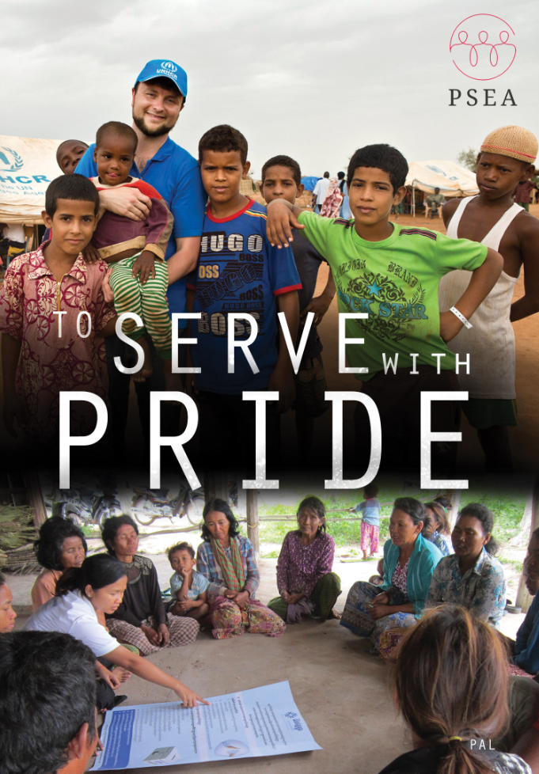

**For facilitated presentation of the film ―To Serve with Pride**

**On prevention of sexual exploitation and abuse by UN, NGO and IOM staff and related personnel**

Contents

1. Introduction 4

1.1 Film Discussion Objectives: 4

2. Notes for the facilitator 5

2.1 Preparation and Key Considerations 5

2.2 Tools and Resources 5

2.3 Handouts for Participants 6

2.4 Session Structure 6

2.5 Timing 6

2.6 Session Plan 6

3. Training Session on Sexual Exploitation and Abuse 7

3.1 Introduction 7

3.2 Initial Discussion 7

3.3 Introduction to the SGB 8

3.4 To Whom the SGB Applies 8

3.5 Review of Definitions 9

3.6 Consequences of SEA 11

3.7 Six Core Principles of the SGB 12

3.8 Marriage 15

3.9 Reporting Procedures 16

3.10 Follow-up to Reports 16

Annex 1: Secretary-Generals Bulletin (ST/SGB/2003/13) 18

Annex 2: Frequently Asked Questions 18

Annex 3: PSEA Information Sheet 19

Annex 4: Power Point Presentation 19

**ANNEXES**

Handout: Secretary-Generals Bulletin (ST/SGB/2003/13)

Handout: Frequently Asked Questions

Handout: PSEA Information Sheet

Power Point Presentation

**ACRONYMS**

CDT Conduct and Discipline Team

CDU Conduct and Discipline Unit

CoC Code of Conduct

DPKO Department of Peacekeeping Operations

FAQ Frequently Asked Questions

IASC Inter-Agency Standing Committee

IGO Inter-governmental Organisation

IOM International Organisation for Migration

NGO Non Governmental Organisation

OHRM Office of Human Resources Management

OIOS Office of Internal Oversight Services

PPT Power Point

PSEA Protection from Sexual Exploitation and Abuse

SEA Sexual Exploitation and Abuse

SGB Secretary-General‘s Bulletin (on special measures for protection from sexual exploitation and sexual abuse)

This guide was originally created by the Executive Committees on Humanitarian Affairs and Peace and Security (ECHA/ECPS) UN and NGO Task Force on PSEA in 2008 and updated in 2013 by the IASC Task Force on PSEA to accommodate for the updated version of the film “To Serve with Pride”.

# 1. Introduction

This is a guide for facilitating a presentation and discussion of the training film ―To Serve with Pride: Zero Tolerance for Sexual Exploitation and Abuse (SEA) by our own staff.‖ The film addresses the problem of sexual exploitation and abuse by UN staff and related personnel[1] as well as IOM and NGO personnel[2] (hereon collectively referred to as “staff”). It is a useful tool to better understand SEA as one form of misconduct which brings harm to those that international aid organizations are mandated to serve, and also jeopardizes the reputation of these organizations.

The film was originally developed in 2006 with the idea that it should be viewed by staff of international aid organizations. Updated in 2013, the film has strengthened the NGO and development perspective, while including new SEA survivor stories from different parts of the world. It is recommended that the screening and discussion be facilitated by senior management, training specialists, or PSEA Focal Points. Combating SEA is a leadership issue and it is crucial that senior management participate in the session. Please note that the film and the facilitation guide can be downloaded online at [www.pseataskforce.org](http://www.pseataskforce.org).

## 1.1 Film Discussion Objectives:

1. Raise awareness among staff of the occurrence of sexual exploitation and abuse, the seriousness of the problem and what should be done to prevent and respond to it;
2. Explain the main principles of the Secretary-General‘s Bulletin on Special measures for protection from sexual exploitation and sexual abuse (ST/SGB/2003/13) (the SGB) with focus on the prohibition of exchanging money, employment, goods or services for sexual favors or other forms of humiliating, degrading or exploitative behavior; and
3. Highlight the impact of sexual exploitation and abuse (for survivors as well as perpetrators) and the importance of staff complying with the SGB‘s provisions or organizational specific code of conduct.

The facilitator‘s task is to get their audience‘s attention, raise awareness, initiate discussions and highlight key aspects of the SGB[3].

# 2. Notes for the facilitator

## 2.1 Preparation and Key Considerations

* Facilitators should prepare for the awareness session by **watching the film in advance**. Doing so with a colleague or friend can provide an opportunity to discuss any issues or questions that arise and help you clarify your thoughts before presenting the material to others.
* Discussions about sexual exploitation and abuse by our own staff can be difficult for some people for a variety of reasons. There are cultural issues and sensitivities born out of individuals’ own experiences which must be addressed carefully and with respect. People will have their own personal views with which others might agree or disagree. It is important to respect other’s views, to be sensitive and not to harshly judge or criticize. The role of the facilitator is to **encourage participants to explore their own attitudes and perceptions about PSEA** as well as the principles outlined in the film and in the SGB.
* You should **educate yourself about the cultural issues and sensitivities that might inhibit discussion of PSEA** in the context in which the session is being conducted. In some settings, for example, it might be difficult to have a mixed-gender audience discussing issues of sexual exploitation and abuse. You should seek advice from those who have experience working on these issues in the context in which the session is being conducted in order to maximize the benefits of the session.
* It may be helpful for you to work with a co-facilitator. This second facilitator might be a gender advisor, an expert trainer or perhaps someone who complements your skills in a manner that fits the backgrounds of the participants.
* In section 3 “Training Session on Sexual Exploitation and Abuse” you will see a mixture of red and black text. The red text is directed to you as a Facilitator (containing instructions and useful facilitation tips), while the black text is information that should be communicated to participants.

## 2.2 Tools and Resources

* A power point presentation (PPT) has been developed based on this guide to further assists you in carrying out the session. An electronic version of the PPT together with the Facilitation guide and handouts are available at [www.pseataskforce.org](http://www.pseataskforce.org).
* To conduct the discussion after showing the film, it is critical that you have a strong understanding of the Secretary-General’s Bulletin on Special measures for protection from sexual exploitation and sexual abuse (ST/SGB/2003/13) (SGB) that falls part of this guide package.
* Sometimes, complicated questions arise during question and answer sessions (Q&A) on the issue of PSEA. The set of FAQs accompanying this guide should be read by facilitators in advance of the session and should also be referred to during the session to assist you in answering such questions. In fact, the FAQs provide significant additional information and may form the basis for substantive conversation about difficult issues. If in any doubt as to how to answer a question that is not covered in the facilitation guide and/or FAQs, it is better to admit to not knowing the answer to a question and offering to get back to the questioner with the relevant information at a later date. Further support can be obtained by contacting the IASC Task Force on PSEA at [www.pseataskforce.org/en/contact](http://www.pseataskforce.org/en/contact)
* Supplemental information to help you prepare for the session and address challenging issues can also be sought from [www.peataskforce.org](http://www.peataskforce.org)

## 2.3 Handouts for Participants

* The facilitation guide includes FAQs and a copy of the SGB which should be distributed to participants during the session (see below). The SGB can be replaced by organizational specific codes of conduct.

## 2.4 Session Structure

* It is recommended that the session start with a short introduction (preferably by Senior Management) explaining the objectives of the session. It is then useful to show the film, and follow the viewing with a facilitated discussion. You may want to conclude the session by re-emphasizing the main messages of the SGB. A proposed session structure is provided below.

## 2.5 Timing

* A maximum of one hour should be devoted to the session, including time for watching the film and discussion.

## 2.6 Session Plan

This is a model session plan for the facilitated presentation of the film.

|  |  |  |  |
| --- | --- | --- | --- |
| TIMESLOT | CONTENT | WHO | MATERIAL |
| 09:00 | Welcome and Introductions | Senior Management |  |
| 09:05 | Overview of the session (objectives) | Facilitator | Agenda of the Training |
| 09:10 | DVD “To Serve with Pride” | Facilitator | DVD, Computer/TV with DVD player, Projector, Speakers |
| 09:30 | Discussion of the DVD – first impressions | Facilitator |  |
| 09:45 | Discussion on the SGB/CoC | Facilitator | SGB/CoC, FAQs |
| 09:55 | Summary of the Discussions/ Re-emphasizing the key messages of the SGB/CoC | Facilitator | Summary of Key Points |
| 10:00 | Conclusion | Senior Management/Facilitator |  |

# 3. Training Session on Sexual Exploitation and Abuse

## 3.1 Introduction

Welcome participants; remind people to turn off their mobile phones.

If possible, have a Senior Management Representative open the session to highlight the importance of the issue. (PPT Page 1)

Review the objectives of the session (PPT Page 2):

* Raise awareness of the occurrence of sexual exploitation and abuse, the seriousness of the problem and what should be done to prevent and respond to it.
* Explain the principles of the Secretary-General‘s Bulletin on Special measures for protection from sexual exploitation and sexual abuse (ST/SGB/2003/13) (the SGB); and
* Highlight the consequences of sexual exploitation and abuse (for survivors and perpetrators) and the importance of complying with the SGB‘s provisions.

Now watch the 20-minute training film ―To Serve with Pride: Zero tolerance for Sexual Exploitation and Abuse. Inform participants that the film, which was developed by the IASC Task Force on PSEA, is intended for the UN, NGOs and IOM and will be followed by a discussion and some explanations to expand on the topic and cover any concerns or questions raised by the film. It may be useful to also inform participants that the updated film includes some UN and NGO representatives that were featured in the original film (produced in 2006) who might no longer be in the same position.

## 3.2 Initial Discussion

In case people are hesitant to start a dialogue on the film you might want to choose one or two of the questions below to initiate a discussion among the participants. It may be useful to stimulate participation by sharing your own impressions, e.g. ―when I saw the film for the first time, what struck me the most was…and then ask what others think.

* What do you think about the film? Is anything surprising? Confusing? Unclear? What images struck you the most? What did you get out of it? Did you learn anything new?
* Does the film raise any questions, concerns, doubts?
* What do you think is the impact of sexual exploitation and abuse? On victims? On communities? On our work? On our relationship with government?
* As people working with us, we all have an obligation to create and maintain an environment that prevents sexual exploitation and abuse. How do you think you could personally contribute to such an environment?
* In your entire working career (not just this job), how many of you have had a feeling that someone you work with might be sexually exploiting or abusing someone? [Using show of hands] Have you ever experienced that someone reported this impression/observation to management?

## 3.3 Introduction to the SGB

Distribute copies of the SGB to all participants.

You may want to use the text below as an introduction to the SGB.

* It is important that we understand the rules of the SGB and that we are able to make the link between the standards in this Bulletin and our working environment.
* The fundamental purpose of the SGB is not to place restrictions on our lives or prevent sexual relationships, but to prevent exploitive or abusive sexual relationships. It is our mandate to protect and assist the most vulnerable and respect human dignity. The SGB sets out some specific standards on how to avoid harming those whom we have committed to protecting.
* Often we use the term ―beneficiary of assistance when discussing those whom the SGB tries to protect. It is important for us to understand that beneficiaries are not just passive recipients of aid; they are our partners and should be treated with dignity and respect at all times.

## 3.4 To Whom the SGB Applies

Now ask participants to whom the SGB applies.

Use the text below to clarify; being sure to emphasize that PSEA is an issue among all international aid workers in humanitarian, development and peacekeeping settings.

As noted in the film, the SGB applies to:

* All UN Staff and Non-Staff members (this includes all internationally-recruited and locally-recruited UN staff, including staff of separately administered organs, funds and programmes of the United Nations; United Nations personnel, including volunteers, interns, JPOs, international and local consultants, and corporate and individual contractors, including day labourers)
* All Categories of Peacekeeping Personnel (this includes military members of national contingents, experts on mission, including police officers, corrections officers and military observers; and members of national formed police units)
* All Staff and Non-Staff members of Non-UN entities, such as IOM and NGOs, in co-operative arrangements with the UN.

Note that the SGB applies to staff and related personnel at all times. It is a condition of employment and applies throughout the entire period that someone is under contract with the UN or partner organisation. This means the standards apply during and outside ―office hours‖ and during leave or mission breaks. They apply globally and not just at a particular duty station.

## 3.5 Review of Definitions

* For UN audience: Note that the SGB points out that sexual exploitation and abuse have always been unacceptable behavior and prohibited conduct under the Staff Regulations and Rules (s3.1).
* The SGB gives definitions of ―sexual exploitation‖ and ―sexual abuse and prohibits all such acts.
* Refer participants to page 1 of the SGB and ask them to find the definitions of sexual exploitation and sexual abuse.

**Sexual exploitation (PPT Page 3):**

*“Any actual or attempted abuse of a position of vulnerability, differential power, or trust, for sexual purposes, including, but not limited to profiting monetarily socially, or politically from the sexual exploitation of another.”*

Possible question for participants:

* What kind of relationships between our staff and beneficiaries might be exploitative according to this definition?

Elicit a couple of examples, e.g. relationships with potential contractors, beneficiaries living in refugee/IDP camps, victims of humanitarian crises, sex workers.

* Note that as personnel working amongst vulnerable populations, we are almost always in positions of power or trust compared to those we are there to assist. It is this position that creates the potential for abuse and requires our judgment and vigilance. Also note that even if someone is not directly involved in the sexual act (or the attempted sexual act) but profits from it in one of the 3 ways identified above, then his/her conduct also constitutes sexual exploitation.
* For UN participants: It may also be useful to note that the UN differentiates between sexual harassment and SEA. While some acts that constitute sexual exploitation and abuse might also constitute sexual harassment, within the UN context, the term ―harassment‖ is used when the alleged incident occurs between UN personnel. In the UN Secretariat, ST/SGB/2008/5 (Prohibition of discrimination, harassment, including sexual harassment, and abuse of authority) defines ―sexual harassment‖ as any unwelcome sexual advance, request for sexual favor, verbal or physical conduct or gesture of a sexual nature, or any other behavior of a sexual nature that might reasonably be expected or be perceived to cause offence or humiliation to another, when such conduct interferes with work, is made a condition of employment or creates an intimidating, hostile or offensive work environment. Unlike sexual harassment‘s connection to the workplace, sexual exploitation and abuse are not by definition linked to any particular context. Most often, SEA will occur between a member of UN/NGO personnel and an outsider (i.e. someone not working for the UN or within an NGO). To determine whether something constitutes sexual exploitation or sexual abuse, one must explore whether it fits the definition, regardless of whether it takes place between colleagues or between personnel and local community members. Complaints and reports of sexual harassment have to follow the organizations‘ own policies (e.g. for the UN Secretariat according to ST/SGB/2008/5, which allows the alleged victim of sexual harassment the option to choose between formal and informal procedures to deal with the matter). Notably, the SGB on PSEA does not allow UN staff and related personnel to opt whether or not to report an incident of sexual exploitation and abuse.

**Sexual Abuse**

Possible question for participants (before showing PPT Page 4):

* Is it necessary to apply force for sexual abuse to occur?

According to the SGB (PPT Page 4) sexual abuse occurs when there is:

*“The actual or threatened physical intrusion of a sexual nature, which can occur by force, under unequal conditions, or under coercive conditions.”*

* This means that actual force isn‘t necessary for sexual abuse to occur. It can also occur where there are unequal conditions or coercive conditions.

Possible questions for participants:

* Can you provide examples of unequal conditions?

Elicit a couple of examples, e.g. adult-to-child.

* Examples of coercive conditions?

Elicit a couple of examples, e.g. an aid worker refusing rations unless a beneficiary agrees to sex, an aid worker giving extra rations if a beneficiary agrees to sex.

* What if the person consents? Even if it is a vulnerable woman, if she is an adult and agrees to have sex with someone from the UN/NGO/IGO community is this okay?

Elicit: persons who are vulnerable or have less power may not know or feel that they can refuse to have sex; the vulnerable may see sex as a commodity to obtain survival items, such as food or security (referred to as ―survival sex‖), but it is not for UN/NGO/IOM personnel to take advantage of their desperation.

Even those who ―voluntarily‖ engage in sex work are often doing so because of limited opportunities to support themselves and/or their families in other ways. Again, it is not for UN/NGO/IOM personnel to take advantage of this.

* Note that under both definitions, sexual exploitation and sexual abuse can occur even if only an attempt is made or threatened but is not successful. For example, simply asking for sex with a child is a prohibited act.
* Note that under both definitions, sexual exploitation can occur between males and females, and also amongst those of the same sex. The SGB includes homosexual sexual exploitation and abuse.

1. Note that ―consent‖, or what is often referred to as ―informed consent‖ is not mentioned in the definitions and is irrelevant. (Facilitator(s) may wish to clarify here informed consent entails 1) the person giving consent understands the implications of that to which he/she is agreeing; and 2) the person giving consent understands and is able to exercise his/her right to say ―no.) Children (persons under the age of 18 according to the standards set forth in the Convention on the Rights of the Child) are unable to give consent because they do not have the maturity to understand the implications of that to which they are agreeing. In the case of adults, even if an adult gives informed consent for sex, it can still constitute sexual exploitation or sexual abuse if the other conditions—such as unequal and/or coercisve conditions--exist.

Possible question for participants:

* Do you have any questions about the types of relationships that are exploitative or abusive?

The facilitator may wish to note as participants are reviewing the definitions that some language in the definitions, such as ―position of vulnerability‖ and ―differential power‖ have been criticized as being somewhat vague and therefore difficult to apply and/or enforce. Facilitators may wish to spend some extra time in discussing how these aspects of the definitions might be interpreted.

## 3.6 Consequences of SEA

Sexual exploitation and abuse have real and serious physical, mental, and emotional consequences. As the film demonstrates, these can sometimes be quite traumatic and long lasting. Whilst our primary concern rests with the direct victim, negative consequences of sexual exploitation and abuse can extend much further than the victim.

Possible questions for participants:

* What are some of the consequences for (a) the victim? (b) The community? (c) The perpetrator? (d) The organisation?

Elicit only a couple for each, such as (a) sexually transmitted infections, stigmatisation, pregnancy, (b) breakdown of family structures, drain on resources, (c) loss of employment/income, loss of reputation, prison (d) loss of trust by the community in the UN and its partners, security risks and other problems.

Note that the UN has established a victim assistance strategy to address the needs of certain categories of victims of SEA that will be reviewed briefly before the session closing.

## 3.7 Six Core Principles of the SGB

Note that the SGB can be organized in terms of six core principles, Go through each of them using (PPT Pages 5-9) and elaborating with the points below.

1. Sexual exploitation and sexual abuse constitute acts of serious misconduct and are therefore grounds for disciplinary measures, including summary dismissal;
2. Sexual activity with children (persons under the age of 18) is prohibited regardless of the age of majority or age of consent locally. Mistaken belief in the age of a child is not a defense;
3. Exchange of money, employment, goods or services for sex, including sexual favors or other forms of humiliating, degrading or exploitative behavior, is prohibited. This includes any exchange of assistance that is due to beneficiaries;

* The lack of economic options for women in vulnerable circumstances may result in sex work and/or survival sex being one of the few avenues they have for obtaining money to meet basic needs. It is not for UN personnel to take advantage of women‘s vulnerability. Nonetheless, it is well documented that in many countries, where the UN is present, the level of sex work and/or survival sex increases dramatically, often in turn generating and maintaining a demand for trafficked persons. We create the demand and become part of the problem.
* Note that under the SGB, engaging the services of a prostitute is prohibited. It doesn‘t matter if prostitution is legal in the country where the sex takes place or is legal in the staff member‘s own country, it is absolutely prohibited for UN staff, related personnel and partners to use the services of prostitutes. It is also prohibited to offer someone a job in exchange for sex, to offer someone additional assistance for sex, or to exchange any kind of money, goods or services for sex, including sexual favors or other forms of sexually humiliating, degrading or exploitative behavior. Asking beneficiaries for sex in exchange for the assistance that is due to them is a clear breach of this provision.
* It is important that UN, NGO and IOM staff, related personnel and partners remain vigilant about the risks of SEA in communities where sex work/survival sex is apparent/increasing.

Facilitators may wish to refer to the FAQs‘ section on prostitution to address any additional issues with regard to this subject.

(d) Sexual relationships between staff and beneficiaries of assistance, since they are based on inherently unequal power dynamics, undermine the credibility and integrity of the work of the United Nations and are strongly discouraged;

* The purpose of this provision is to highlight that sexual relationships between personnel and beneficiaries of assistance (however small or large the group) are generally based on inherently unequal power dynamics. Where there is an unequal power dynamic, there is a strong potential for abuse. The SGB is requiring UN, NGO and IGO personnel—whether they are internationals or from the local population--to show good judgment, and to think about their actions and the consequences of their actions. Because of the unequal power dynamic in sexual relationships between UN/NGO/IGO personnel and beneficiaries of assistance, these relationships are strongly discouraged.
* Who is a beneficiary of assistance means different things to different agencies and departments. For peacekeeping missions, which are mandated to provide peace and security, the entire population in a given country constitutes ―beneficiaries of assistance‖. For other agencies and organizations, it is defined more narrowly and may only include the persons in a particular refugee or IDP camp, or the people on a certain distribution list. Regardless, it is important to remember that the purpose of the SGB is to protect people from sexual exploitation and abuse, and that key components of sexual exploitation and abuse concern the abuse of vulnerability, trust and/or differential power, whether through force, unequal conditions, or coercion. All acts that meet these conditions are prohibited, whether they are committed against a direct beneficiary of assistance or someone else living in the setting in which UN/NGO/IGO personnel are working.
* Note that SEA can be committed by local staff—who may also technically fit under the category of ―beneficiaries of assistance.‖ What is important to remember is that once a person living in the beneficiary community becomes an employee or even a volunteer within a UN agency or in an NGO or IGO, they are held to the standards that apply to all employees, regardless of their former or current ―beneficiary‖ status.

(d) Sexual relationships between staff and beneficiaries of assistance, since they are based on inherently unequal power dynamics, undermine the credibility and integrity of the work of the United Nations and are strongly discouraged;

* The purpose of this provision is to highlight that sexual relationships between personnel and beneficiaries of assistance (however small or large the group) are generally based on inherently unequal power dynamics. Where there is an unequal power dynamic, there is a strong potential for abuse. The SGB is requiring UN, NGO and IOM personnel—whether they are internationals or from the local population--to show good judgment, and to think about their actions and the consequences of their actions. Because of the unequal power dynamic in sexual relationships between UN/NGO/IOM personnel and beneficiaries of assistance, these relationships are strongly discouraged.
* Who is a beneficiary of assistance means different things to different agencies and departments. For peacekeeping missions, which are mandated to provide peace and security, the entire population in a given country constitutes ―beneficiaries of assistance‖. For other agencies and organizations, it is defined more narrowly and may only include the persons in a particular refugee or IDP camp, or the people on a certain distribution list. Regardless, it is important to remember that the purpose of the SGB is to protect people from sexual exploitation and abuse, and that key components of sexual exploitation and abuse concern the abuse of vulnerability, trust and/or differential power, whether through force, unequal conditions, or coercion. All acts that meet these conditions are prohibited, whether they are committed against a direct beneficiary of assistance or someone else living in the setting in which UN/NGO/IOM personnel are working.
* Note that SEA can be committed by local staff—who may also technically fit under the category of ―beneficiaries of assistance.‖ What is important to remember is that once a person living in the beneficiary community becomes an employee or even a volunteer within a UN agency or in an NGO or IGO, they are held to the standards that apply to all employees, regardless of their former or current ―beneficiary‖ status.

(e) Where a United Nations staff member develops concerns or suspicions regarding sexual exploitation or sexual abuse by a fellow worker, whether in the same agency or not and whether or not within the United Nations system, he or she must report such concerns via established reporting mechanisms;

* Note that this is an obligation on all UN, NGO and IOM personnel and partners. A personnel member with knowledge of misconduct by another personnel member should report the matter. This means the reporting obligation applies even if the alleged perpetrator is from another agency, or from one of the UN or NGO partner organizations, or is a member of uniformed personnel.
* Note that the obligation is to report ―concerns or suspicions. It is not necessary to be sure or to have proof before reporting a concern. Managers and/or personnel members should not take it upon themselves to investigate allegations in order to obtain ―proof‖ before reporting. However, all concerns or suspicions must be reported in good faith. Making a complaint that one knows to be false is itself subject to disciplinary procedures. There are some measures in place to protect those who report allegations of misconduct (in good faith):
  + Various UN Organisations provide protection for the individual who makes an allegation in good faith. The ST/SGB/2005/21 is known as the whistleblower‘s SGB and outlines the UN Secretariat‘s policy of protection for whistleblowers.
  + The SGB states that any individual who cooperates in good faith with an audit or investigation has the right to protection from retaliation. This applies to all personnel members. Retaliation is in itself seen as misconduct.
* Note that it is not necessary for managers and/or personnel members to distinguish whether a particular act constitutes sexual exploitation or sexual abuse before reporting. Many acts may constitute both. Similarly, some acts may breach more than one of the standards set forth in the SGB, such as a sexually exploitative relationship in exchange for money with someone under the age of 18.

Possible question for participants:

* Can you think of an example of suspicious behaviour that should be reported?

Note that information about reporting procedures will be discussed further in a few minutes.

(f) United Nations staff are obliged to create and maintain an environment that prevents sexual exploitation and sexual abuse. Managers at all levels have a particular responsibility to support and develop systems that maintain this environment.

* This creates an obligation on all UN, NGO and IOM personnel and partners to be proactive. Other sections in the SGB detail some of the ways in which managers must fulfill this obligation, including providing staff with copies of the SGB and informing them of its contents (s4.1), taking appropriate action when there is reason to believe that sexual exploitation and abuse has occurred (s4.2), appointing focal points and advising the local population how to contact them (s.4.3), handling reports of sexual exploitation and abuse confidentially (s4.3), and keeping the Department of Management (or responsible body within the organization) informed on actions that have been taken (s4.6). Again, this list is not exhaustive. The efforts required will depend on circumstances and on the development of further policy and practice for combating sexual exploitation and abuse.
* The involvement of managers is extremely important to the success of addressing the problem and more work is being done on how to hold managers specifically accountable for implementing the SGB. There are already examples in peacekeeping contexts of commanders being sent home for having failed to prevent their troops from engaging in sexual exploitation and abuse when they could have taken steps to address the problem. The publicly accessible OIOS website www.un.org/depts/oios/pages/annual_reports.html can be a useful source of information about investigations into SEA allegations. The OIOS Investigations Division brochure (www.un.org/depts/oios/pages/id_brochure.pdf, also contains information about OIOS hotlines and may be a useful resource for those with additional questions.

## 3.8 Marriage

Turn to (PPT Page 10):

* Section 4.4 of the SGB creates an extremely limited exception to the prohibition on sex with children and applies when a staff member is legally married to someone under the age of 18 but over the age of consent in their country of citizenship: If a member of UN staff or related personnel is married to a person under the age of 18 their relationship is not an issue in terms of provisions of the SGB. It does not allow sexual relationships with persons under the age of 18 with a view to marriage or when a marriage has been promised and cannot be used as an excuse in this way.

Distribute the handout on the Frequently Asked Questions (FAQs). Ask if there are any additional questions about what constitutes sexual exploitation and abuse and the principles of the SGB.

## 3.9 Reporting Procedures

Possible questions for participants:

* Do you know where to report SEA?
* Do you know what a Focal Point on sexual exploitation and abuse is?
* Do you know who your Focal Points are, in-country and at Headquarters?

If participants do not know, explain as follows (PPT Page 11):

* If you have any concerns or suspicions report these according to your organisation's internal reporting procedures. These include your: Human Resource Office, Investigation Unit, Compliance Officer, or Senior Manager.
* Ideally, persons reporting should provide all supporting information that is available to them, such as incident date, location, name of witnesses, etc. The less information available about the incident, the more difficult it will be to prove the alleged incident at the investigation stage. However, it is essential that reports are made based only on the information/evidence that is already available to the person reporting. One should not seek further information before reporting, as this could tip off the perpetrator and, in so doing, potentially leave evidence and witnesses vulnerable to manipulation and intimidation. ONLY EXPERIENCED PROFESSIONAL INVESTIGATORS HAVE THE SKILLS NECESSARY TO INVESTIGATE.
* Confidentiality is one of the key aspects to making and receiving a complaint/report about sexual exploitation and abuse, both to protect the alleged victim and the alleged perpetrator, who also has a right to due process. You do not have to follow the normal chain of command or go through your supervisor. Confidentiality is more easily preserved the fewer the number of people who deal with the report.
* You do not have to make the report locally. You can report to another organization‘s Focal Point or another Conduct and Discipline Team if you are not comfortable speaking to your own. Several missions have established mechanisms to facilitate reporting of complaints, including locked drop-boxes, private meeting rooms, telephone hotlines, secure email addresses, outreach to civil society including local women‘s organizations and use of the local UN-NGO network of focal points on sexual exploitation and abuse to refer complaints received by other agencies.

## 3.10 Follow-up to Reports

There are established systems for confidentially recording and channeling information on a ―need to know‖ basis, conducting investigations, and implementing disciplinary measures. More information on this can be obtained from your Focal Point or from the Office responsible for investigations.

**Wrap-up Questions**

Ask if there are any questions about the film, the presentation or about sexual exploitation and abuse in general.

**Final Summary**

Distribute copies of the PSEA Information Sheet handout (which should be adapted to your organization’s specific needs).

You may wish to state briefly that this handout summarizes the key points of the Secretary-General‘s Bulletin and organizational specific reporting procedures.

Summaries the session with the following (PP Page 12):

In summary, the key messages are that:

* Sexual exploitation and abuse are unacceptable and cause serious harm;
* The purpose of the SGB is to protect the vulnerable, and
* We each, individually, can play a role in addressing the problem, principally by taking the issue seriously and reporting suspicions and concerns.

Draw attention to the website (www.pseataskforce.org) for those seeking more information (PP Page 13):

**Suggested Conclusion**

If possible, it is recommended that the Senior Manager who opened the session also concludes it. The facilitator may add several points as per below:

* This is a difficult topic. We also need to remember that all around the world our staff and related personnel are dedicated to assisting and serving the most vulnerable and transforming their lives for the better. In the most difficult of circumstances, we have managed to achieve great things and we can all be proud of this. But while acts of sexual exploitation and abuse continue, the role and purpose of our organization is gravely undermined and we harm those we are there to help.
* Sexual exploitation and abuse are not inevitable. With compassion, discipline and bravery, we can work to eliminate sexual exploitation and abuse and restore the world‘s pride, hope and faith in us.

Thank participants for attending.

ANNEXES

## Annex 1: Secretary-Generals Bulletin (ST/SGB/2003/13)

http://daccess-dds-ny.un.org/doc/UNDOC/GEN/N03/550/40/PDF/N0355040.pdf?OpenElement

## Annex 2: Frequently Asked Questions

<http://www.pseataskforce.org/uploads/tools/faqsseabyunpersonnelandpartners_echaecpsunandngotaskforceonpsea_english.pdf>

## Annex 3: PSEA Information Sheet

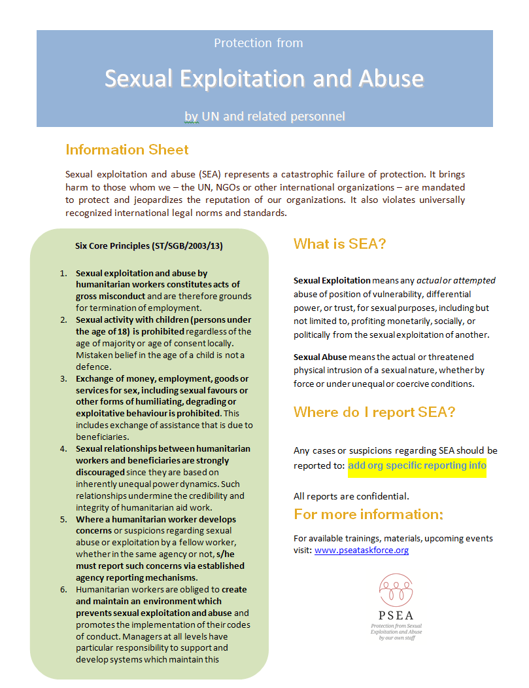

## Annex 4: Power Point Presentation

<http://www.pseataskforce.org/uploads/tools/1384523712.pptx>

1. This includes: United Nations staff and related personnel such as United Nations Volunteers, personnel or employees of non-United Nations entities or individuals who have entered into a cooperative arrangement with the United Nations (including interns, international and local consultants as well as individual and corporate contractors), experts on mission including United Nations police officers, members of national formed police units, corrections officers and military observers, as well as military members of national contingents serving in United Nations peacekeeping missions).
2. This includes: personnel as defined by international organizations and their membership bodies; and personnel of non-governmental organizations.
3. For ease of reference this guide will refer to the rules set out in the ST/SGB/2003/13. However, depending on your organization’s preference, you may want to refer to your Code of Conduct instead.