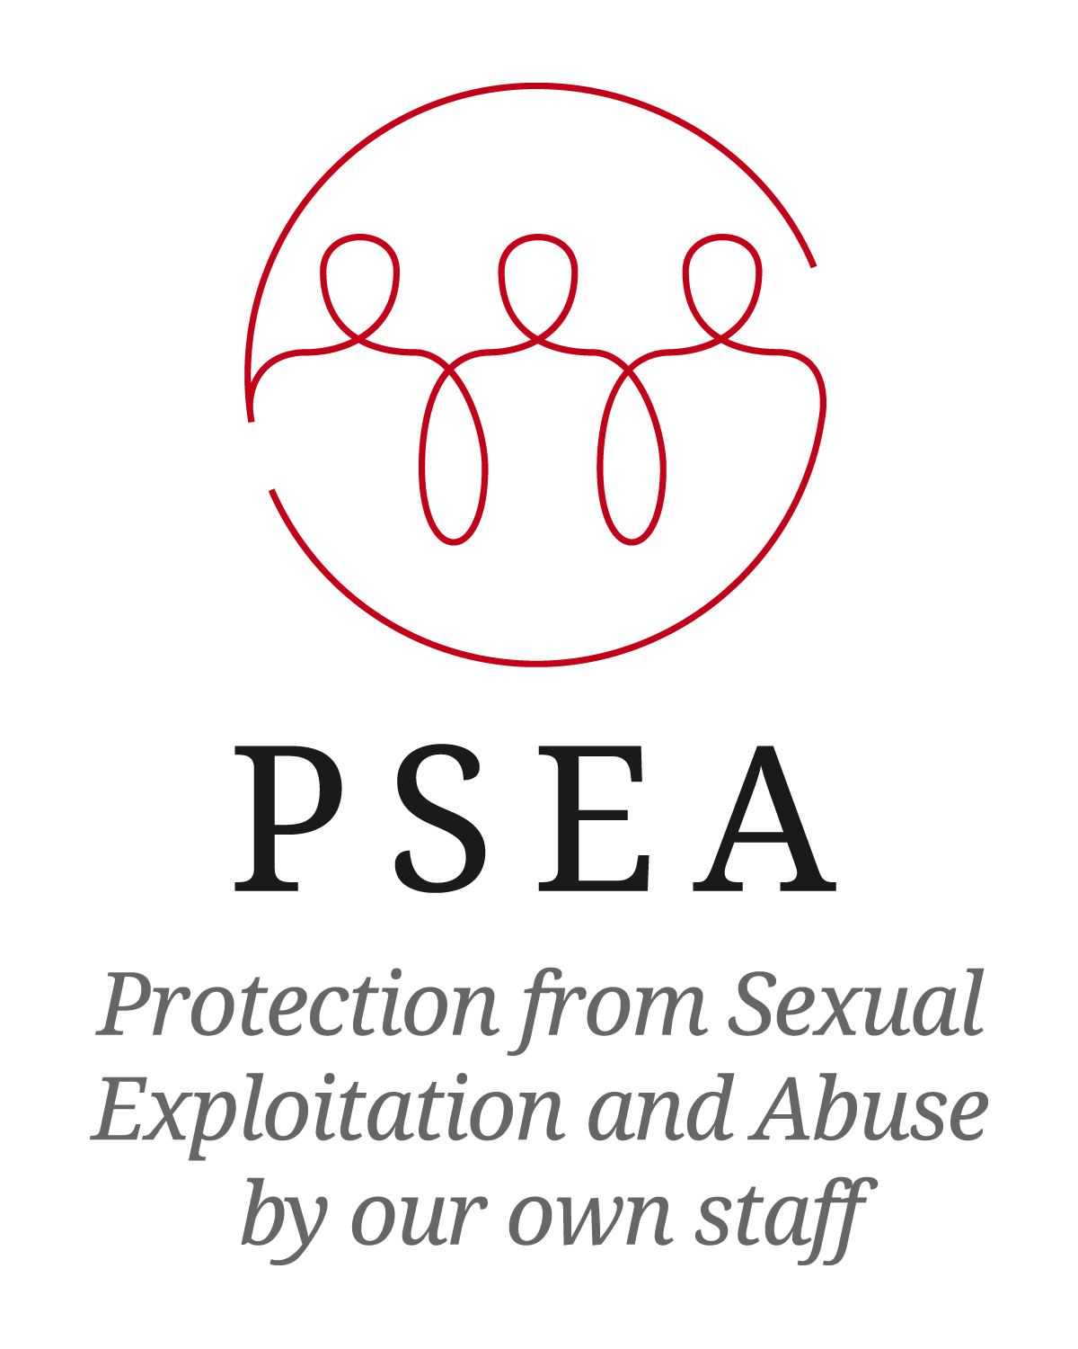

Terms of Reference – Taking forward the work of the NGO Recruitment Task Team

**Background**

The IASC (Inter-Agency Standing Committee) Task Force on PSEA (Protection from Sexual Exploitation and Abuse) has developed a workplan for 2013. One of the objectives for the workplan is to ‘Identify challenges and options in improving recruitment processes in the context of PSEA with the goal of providing a report on good practices and recommendations’. The Task Force appointed two Task Teams – one to examine the issue from a UN perspective, and one from an NGO perspective (for more details of its ToR see Annexe 1). The NGO Recruitment Task force has developed a specific Terms of Reference to unpack key issues within the NGO sector and propose how to take them forward.

**Problem Statement**

The failure of the international humanitarian community to protect affected populations from its own staff has been well documented.

‘Our own fieldwork suggests that the scale of abuse is significant. We asked participants to state the number of incidents of different kinds of abuse involving peacekeepers and aid workers that they could recall having occurred in their community. … More than half of the research participants identified incidents of sexual touching and coerced sex.’ - ‘*No-One to Turn To’, Save the Children 2008*

The international community is making serious efforts to identify and follow up on incidents of sexual exploitation and abuse (SEA) by its own staff. However, even if misconduct is proven, perpetrators are often either ‘recycled’ to other agencies, or re-employed by the same agency. This can occur either because the perpetrator’s past activities are simply not known, or because agencies are unable to access this information from previous employers, due to labour legislation or data protection laws. Another concern is that often, due process is simply not followed, and there are no records of misconduct to share even if this were possible. Staff are moved sideways, their contracts not renewed, or they leave the organisation before an investigation is complete, leaving no grounds for an employer to reject them.

**Objective**

As per the initial Terms of Reference (see Annexe 1), the purpose of the Recruitment Task Teams is to ‘review legal issues surrounding the problem of hiring and rehiring persons who have committed misconduct or are alleged to have committed misconduct’, in order to better safeguard the people whom the humanitarian community seeks to assist. A final report is due for submission to the IASC Principals by the end of November 2013.

**Outputs**

1. Publicity materials on ‘exploding the myth’ – demonstrating that these issues are possible to address, using examples of impact from member agencies. (These would be brief initial messages to raise awareness).
2. Clear guidelines on the legal parameters of addressing this issue, for the main countries where NGOs are headquartered.[1]
3. Tools and resources to guide NGOs through implementing preventative measures, including good practice examples.
4. A summary report of above mentioned outputs

**Activities**

The first meeting of the Task Team identified the below key recruitment and misconduct areas to take forward. This will be expanded on through a consultation with a wider audience.

* Reference checks
* Sharing information with other employers
* Interview questions
* Criminal reference checks
* Administrative investigation procedures

The following research will be undertaken for each of the key areas:

|  |  |
| --- | --- |
| **What** | **Who** |
| What are the legal constraints in this area per headquarters country? What is the *most* we can do/ask? | Research with help from International Advocates for Development |
| What are the tools and best practice in this area that other NGOs can share? | Task Team members to collect this information from contacts |

The research above will then be developed into a series of products as outlined in the Outputs section.

Annex 1

**Term of Reference for a Task Team**

**to identify challenges and options in improving recruitment processes in the context of PSEA**

**Background**

In December 2012, the Inter-Agency Standing Committee (IASC) Principals agreed to identify challenges and options in improving recruitment processes in the context of Protection from Sexual Exploitation and Abuse (PSEA) with the goal of providing a report on good practices and recommendations at the next Principals meeting in December 2013.

UNDP volunteered to compose and lead a Task Team to undertake the above mentioned research.

**Purpose of Task Team**

The Task Team will review legal issues surrounding the problem of hiring and rehiring persons who have committed misconduct or are alleged to have committed misconduct.

Initial consultations have shown that it should be legally feasible to put in place measures to prevent the hiring of persons sanctioned for SEA related misconduct.   
The Secretary-General will work with the United Nations Agencies, Funds and Programmes to ensure that proposals are developed to exchange general information both on reported allegations of sexual exploitation and abuse and on sharing the names of all civilian personnel who have been terminated or otherwise separated from service in substantiated cases of sexual exploitation and abuse as a prevention measure against possible future reemployment in the United Nations.

However, it will be a challenge to develop a good practice, respecting due process for staff and non-staff members when dealing with alleged perpetrators who leave the organisation before an investigation is finalized and disciplinary charges have been made.

Another challenge will be the difference in the legal systems of UN and non-UN organisations. Therefore it is suggested that as a start the Task Team will work in two subgroups: The first subgroup will address issues within NGO’s, the second subgroup the issues of UN System organisations. Depending on the outcomes of the two groups’ work it might be recommended integrating the work and develop joint recommendations to the IASC Principals.

Specific activities include:

* Identify good practices among UN agencies and the NGO community by undertaking consultations among human resource and legal specialists;
* Develop concrete measures that follow the identified good practices;
* List the issues that have not been addressed so far;
* Clarify if there are solutions to respond to any of the issues still complying with the standards of due process;
* List the issues that the subgroup cannot find any solution to;
* Integrate the work of the two subgroups; and
* Develop recommendations for the final report for submission to the IASC Principals by end of November 2013.

**Composition**

As mentioned above, it is suggested that the Task Team builds two subgroups in order to facilitate the finding of solutions, as the legal framework of UN System Organisations strongly differs from the legal framework of internationally working NGOs.

Each subgroup of the Task Team should ideally be composed of specialists from the following areas of work: PSEA in international field; international administrative labor law, Human Resources, Audit, Investigation, Accountability, Compliance etc., representing either the international NGO community, or UN System organisations, including peacekeeping, as they face another challenge due to the different kind of personnel.

Feb 2013, UNDP/BoM/OHR/SWB/JC/CB

1. Countries to research to be determined– likely to include US, Canada, UK, Ireland, Switzerland, Italy, France etc.