Trainers Guide: Standard Reports

Quick Reports for data out of DHIS2

# Introduction to this guide

This guide is part of a support package for trainers who are teaching participants to use the Sudan FMOH DHIS2 platform. The main objective of this session is to familiarise all participants with *some* of the Standard Reports in DHIS2.

This guide will help the trainer prepare and deliver a demonstration of two Standard Reports (Reporting Rates and Dataset Aggregates). The purpose of this session is to outline these reports, and provide an opportunity for participants to become comfortable with accessing and running them.

The ‘demonstration’ is outlined as a Quick Guide (a list of steps or ‘cheat sheet’) while the exercises are also briefly described. The participants can either download the exercises from DHIS2 once they have logged in or the trainer can hand them out separately.

Trainers can use the Quick Guide to help them plan the session.

# Learning objectives for this session

1. Learn how to access two standard reports
2. Understand the purpose of and be able to run
   1. Reporting Rates report
   2. Dataset report

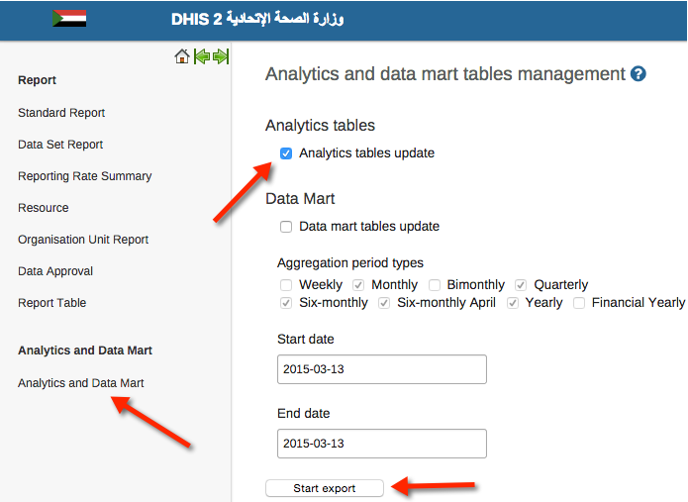Time needed

Introductory demonstration: 20 minutes

Hands-on exercises: 10 to 20 minutes

**NOTE: BEFORE RUNNING THIS SESSION, ONE OF THE FACILITATORS SHOULD RUN THE ANALYTICS TABLE UPDATE**

# Quick Guide - overview of steps for the demonstration

|  |  |
| --- | --- |
| 1. Briefly highlight that a number of common M&E and Management type questions of the data have been set up as Standard Reports in DHIS2. |  |
| 1. Reporting Rates Summary: The first common questions that you’ll show participants how to answer are:    1. ‘How many facilities have reported (for a given form/dataset)?    2. How many facilities have reported on time (for a give form/dataset)? |  |
| 1. Reporting Rates Summary: Go to the Reporting Area | Navigate to the  menu item and select the  icon. |
| 1. Reporting Rates Summary: Select the Reporting Rates Summary option. |  |
| 1. Reporting Rates Summary: Remind Users of the common DHIS2 requirement of entering 3 types of info.    1. Organizational Level    2. Dataset (Form)    3. Period |  |
| 1. Reporting Rates Summary: Demonstrate generation of a report by selecting:    1. The State of the Participants    2. A dataset they practiced on in data-entry exercises    3. Period they were using (e.g. 2015) |  |
| 1. Reporting Rates Summary: Go through the resulting report highlighting the columns and their meaning:    1. Expected Reports - the system knows that for each facility how many reports it should receive for a given period/dataset combination.    2. Actual Reports - will depend on whether the participant pressed the Form Completion button.    3. Reports on Time - if the ‘Completion’ occurred before the mandatory reporting period (e.g. 15 days after end of month), then this column will be show a value.    4. Percent – Actual Reports / Expected Reports X 100    5. Percent on Time – Reports on Time / Expected Reports X 100 2. Dataset Report: Explain that the dataset report allows you to ‘see on a form’ the ‘values’ (or counts) for any given facility or combination of facilities selectable from the facility tree. It is not necessary to manually ‘tally’ the child facilities, and allows you to quickly view the ‘tally’ for a give dataset/period. |  |
| 1. Dataset Report: Go to the Reporting Area. | Navigate to the  menu item and select the  icon. |
| 1. Dataset Report: Select the Dataset Report |  |
| 1. Dataset Report: Remind Users of the common DHIS2 requirement of entering 3 types of info.    1. Organizational Level    2. Dataset (Form)    3. Period |  |
| 1. Dataset Report: Demonstrate using the following for best results (remember that immunisation data was loaded at the level of Locality … not at facility level). 2. Immunisation 3. 2013 4. Locality Level (and then State Level to show difference). |  |
| 1. Dataset Reports: Explain results   As an option, add a comment and click the Share button … (the exercise asks participants to do this). |  |

# Exercises

## Exercise 4.1 – Reporting Rates

**The goal of this exercise is for each participant to become familiar with running a Reporting Rates report.**

*Note: three items are necessary to be known before data can be retrieved; the Organisation Unit, the Form, and the Period.*

## Exercise 4.2 – Dataset Report

**The goal of this exercise is for participants to quickly generate a tally sheet for a combination of organisations, form and period.**