GOOGLE EARTH ENGINE : ENTORNO Y FUNDAMENTOS - PARTE I

## Warning in knitr::include_graphics("C:/R/assets.jpg", error = FALSE): It is highly  
## recommended to use relative paths for images. You had absolute paths: "C:/R/assets.jpg"

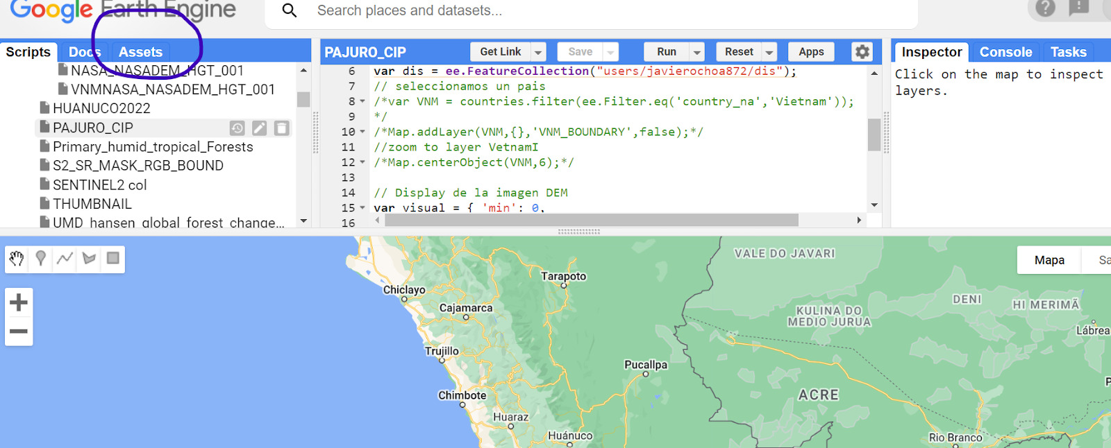

## Warning in knitr::include_graphics("C:/R/inspector.jpg", error = FALSE): It is highly  
## recommended to use relative paths for images. You had absolute paths:  
## "C:/R/inspector.jpg"

