**Working with Data in Excel**[**Download Companion Excel Sheet**](https://github.com/UNC-Libraries-data/Excel/raw/master/Excel_Workshop.xlsx)

[] indicate sheet names in the companion Excel workbook

**[Getting Started]**

|  |  |  |
| --- | --- | --- |
| **To…** | **Windows** | **Mac** |
| Find and replace | CTRL + F | +F |
| Move to the edge of the data region | CTRL+ Arrow key | +Arrow key |
| Select to the edge of the data region | CTRL+SHIFT+Arrow key | +SHIFT+Arrow key |
| Select entire column | CTRL+SPACEBAR | CTRL+SPACEBAR |
| Select entire row | SHIFT+SPACEBAR | SHIFT+SPACEBAR |
| Enter value into all selected cells | CTRL+ENTER | ^+RETURN |

**Shortcuts**

**Best Practices and** [**Tidy Data**](http://vita.had.co.nz/papers/tidy-data.pdf)

* Think of each row as an “observation” and each column as a “variable” or “field”.
* Avoid color or other formatting alone to encode data.
* Only one table per sheet.
* Each observation should be of the same type (e.g. a student, or a NC county in a given year).
* Try saving your data as a .csv (comma separated values) file. This saves one sheet without formatting.

**[Functions]**

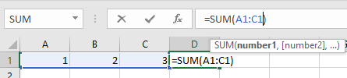**Using Functions in Excel**

* =SUM()
* =AVERAGE()
* Etc.

**Working with Text**

* **LEFT()** Extracts a specified number of characters from a variable, counting from the left
  + **RIGHT()** same as above, but counting from the right
* **TRIM()** Removes all whitespace aside from single spaces between words
* **CONCATENATE()** combines multiple strings into a single string

**Paste Special:** Making Functions Permanent

* Right-click: Copy
* Right-click: Paste Special>Values

**Paste [Transpose]**

* Right-click: Copy
* Right-click: Paste Special>Transpose

**Common Problems: [Splitting] on Delimiters**

The Text to Columns tool (Data Tab>) lets you split a cell into multiple cells based on width or a special character (delimiter).

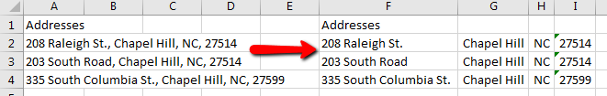

**Common Problems: Filling [Blanks]**

When dealing with human-readable text, we often have categories listed once with the implication that all lines before the next category fall into this group. For example, Bertie Rudolph is a Freshman.

* (PC) Home Tab, Editing > Find & Select> Go to Special> Blanks> OK
* (Mac) Edit Menu>Find>Go To…>Special…>Blanks>OK
* Type =, then hit the up directional arrow. Hit CTRL+Enter (PC) or CMD+Enter (Mac)

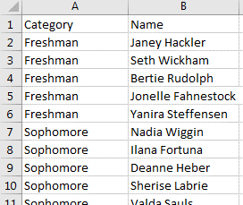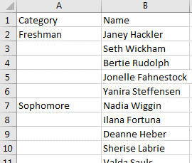

**[VLOOKUP]**

The VLOOKUP function provides a way to merge or join additional data into a dataset, using a common code or value.

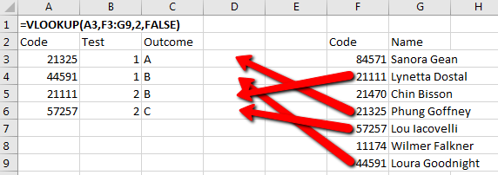

|  |  |  |  |
| --- | --- | --- | --- |
| **=VLOOKUP(A3,$F$3:$G$9,2,FALSE)** | | |  |
| Parameter |  | Value | Description |
| lookup_value | | **A3** | ***value in our main table*** that we’re looking to match in the other table |
| table_array | | **$F$3:$G$9** | the ***other table*** we need information from **(lock references with $: $F$3:$G$9)** |
| col_index_num | | **2** | the ***column from the other table*** we’re looking for |
| [range_lookup] | | **FALSE** | whether you want approximate matches (TRUE) or exact matches (FALSE) |

**Exercise:** [Ex_Main], [Ex_Lookup]

**Introduction to PivotTables**

[**Pivot_Tables_IPEDS.xlsx**](https://github.com/UNC-Libraries-data/Excel/raw/master/Pivot_Tables_IPEDS.xlsx)

**Windows**: Insert Tab>PivotTable

**Mac**: Go to Data Tab>PivotTable>Create Manual PivotTable…

PivotTables create cross-tabulations displaying values split out across categories displayed as row and/or column headings.

**Adding data:** Click and drag to areas at the bottom of “PivotTable Fields”. Remove by dragging back to list.

**Columns and Rows:** The *categories* on the edges of the table

* Multiple categories on a single axis will be nested

**Values:** The *numbers* shown in the cells of the table (each cell represents the combination of its column and row categories.)

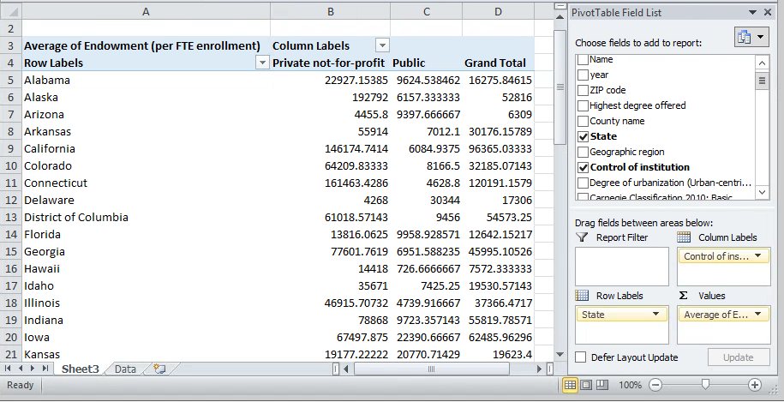

**I**n most cases, there will be **many** rows in your dataset represented by one cell in your PivotTable, so we need to summarize or aggregate the data. In the example above, there are many public or private universities in each state.

**Aggregation of Values**

* Click on a field in the Values area and choose “Value Field Settings” to change the default aggregation



* “Summarize Values By” determines the mathematical function used to summarize the cells
  + Frequencies are available via the Count function. Note: this **will not count missing values**.  
    **Exercise:** Compare Frequency of Control of Institution using Count on Control of Institution and a Count on Applicants Total.  
     1. Drag Control of Institution to Rows.

2. Drag Control of Institution to Values, and make sure it is summarized by “Count of”

3. Drag Applicants Total to Values, and make sure it is summarized by “Count of”

* “Show Values As” allows more complex calculations based on other cells (e.g. percent of total)
* **Mac:** Click the “i” icon on the Value. “Show Values As” is located under the “Options>>” tab.

**Sorting and Filtering Columns and Rows**

* Use the arrows at the right of “Row Labels” and “Column Labels”



* “More Sort Options” provides advanced sorting by Values (***Mac****: Not Available)*
* Filter with the check boxes next to unique values (***Mac****: Not Available)*
  + Advanced filtering available in “Label Filters” and “Value Filters”

**Filters**

* **Filters:** Dragging a field to the Filters area will create a drop-down filter at the top of the sheet.

**PivotTable Exercises**

1. What are the Enrolled Totals in public and private schools (see Control of institution)?
2. Which Geographic Region has the highest average ACT Composite 75th percentile score? How many regions have average scores below the national (Grand Total) average?
3. Which category of Degree of Urbanization contains the most public (Control of Institution) universities?
   1. What percent of the Applications total go to each of the top two Degrees of Urbanization? (Hint: Use the Show Values As tab in Value Field Settings)

**Next Steps:**

**Other Useful Tools:**

* Power Query (Windows-only): Loading and filtering large datasets
  + Data Tab> Get & Transform
* Data Validation: Control data entry to prevent errors
  + Data Tab> Data Validation
* Macros: Record and re-use processes, or write your own code

**Getting Help:**

* [Lynda.com](http://software.sites.unc.edu/lynda/) provides training videos (free to UNC affiliates) on a wide variety of Excel functions
* [Matt Jansen](http://guides.lib.unc.edu/mattjansen) ([guides.unc.edu/mattjansen](http://guides.lib.unc.edu/mattjansen)) of the Davis Library Research Hub is available for one-on-one consultations.

**Data Sources:**

* [World Development Indicators](https://data.worldbank.org/products/wdi) (Excel_Workshop.xlsx)
* [IPEDS](https://nces.ed.gov/ipeds/use-the-data) (Pivot_Tables_IPEDS.xlsx), accessed [here](https://public.tableau.com/en-us/s/resources).

PivotTable Exercise  
SOLUTIONS BELOW

**SOLUTIONS**

*DISCLAIMER: For many of these questions, there are multiple ways to get to the correct values. These are merely one way you could get the desired results*.

1. What are the Enrolled Totals in public and private schools (see Control of institution)?

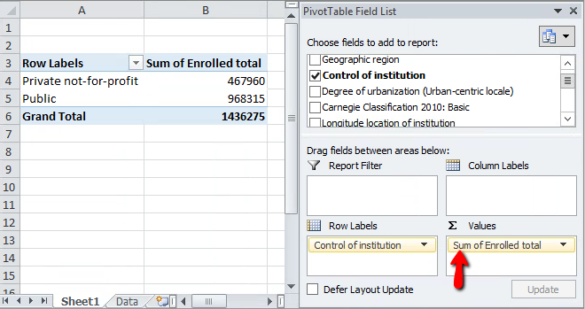

**Instructions:**

* Drag Control of institution to Row Labels to layout the table.
* Drag Enrolled total to Values.
* Click Enrolled total in Values and select Value Field Settings…
  + Change Summarize Values by to **Sum** instead of the default Count.

1. Which Geographic Region has the highest average ACT Composite 75th percentile score? How many regions have average scores below the national (Grand Total) average?

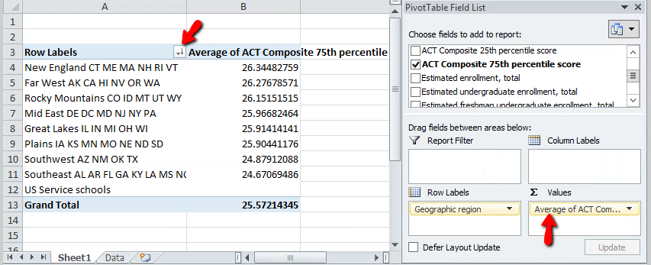

**Instructions:**

* Drag Geographic region to Row Labels.
* Drag ACT Composite 75th percentile score to Values.
* Click ACT Composite 75th percentile score in Values and select Value Field Settings…
  + Change Summarize Values by to **Average**.
* Sort the table by clicking the arrow icon in the corner of **Row Labels** on the table itself (see arrow)
  + Click More Sort Options, then select Descending (Z to A) and set to Average of ACT Composite 75th percentile score

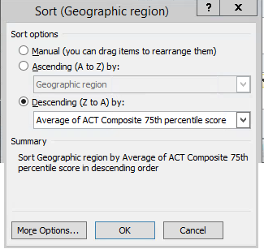

1. Which category of Degree of Urbanization contains the most public (Control of Institution) universities?

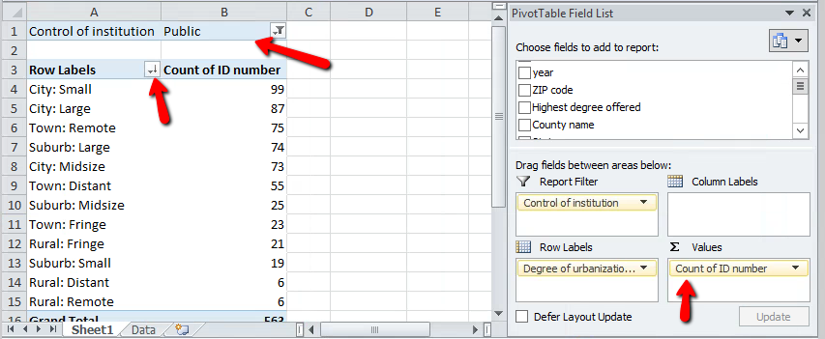

**Instructions:**

* Drag Degree of Urbanization to Row Labels. Drag ID number to Values.
* Click ID number in Values, then Value Field Settings>Summarize Values by to set aggregation to **Count.**
  + **Note:** ANY variable that doesn’t have missing values will work here. The **Count** aggregation is essentially counting the number of filled cells in the given categories. So some values will have slightly different counts due to empty cells.
* Drag Control of Institution to Report Filter. Use the Filter appearing at the top of the screen to select **Public**.
* Use the Row Labels arrow, then More Sort Options to sort by Count of ID number.
  1. What percent of the Applications total go to each of the top two Degrees of Urbanization? (Hint: Use the Show Values As tab in Value Field Settings)

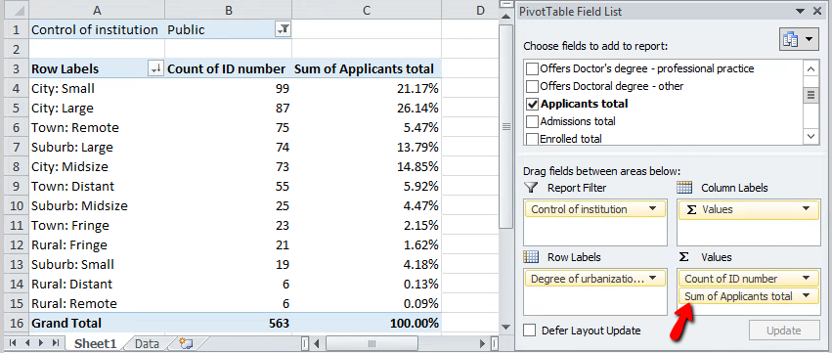

**Instructions**

* Assume that we keep the Public filter active. Leave the earlier work in place.
* Drag Applicants total to Values and place it under Count of ID number.
* Click Applicants total and select Value Field Settings.
  + Under Summarize Values by, choose **Sum**
  + Under Show Values As, choose **% of Column Total**