Lab 3

Part 1: Authenticated Encryption Analysis (45 Points)
Q1. Practical Evaluation of Confidentiality and Integrity
Alice wants to send a message to Bob in a way that provides both confidentiality and integrity. There are a few schemes she can use.
Your Task:
For this question, you must use the parameters corresponding to yourself shown in the “Parameters” section below as inputs to evaluate each scheme.
Using the CyberChef, generate the values for the following schemes.
The Schemes:
(5 Points each, 3 points for screen shots and 1 point each for analysis of integrity and confidentiality)
- Scheme 1:
Alice sends (C, H) where:


- Scheme 2:
Alice sends (C, H) where:


- Scheme 3:
Alice sends (C) where:
- Scheme 4:
Alice sends (C, H) where:

- Scheme 5:
Alice sends (C) where:
- Scheme 6:
Alice sends (C, H) where:


- Scheme 7:
Alice sends (C, H) where:


- Scheme 8:
Alice sends (C) where:
- Scheme 9:
Alice sends (C) where:
Parameters:
- M = “[Your Name] does not know which one is Diffie and which is Hellman”
- K1 = [StudentID] * 7
  - For an example ID 801234567
- K2 = [StudentID]
  - For an example ID 801234567
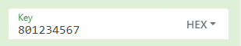
- IV = Firstname+Lastname+Padded with repeated StudentID to achieve 16 bytes
  - For an example ID 801234567 belonging to Firstname Lastname
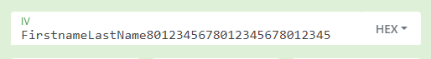
To keep track of length you can repeatedly keep on entering Student ID until this (or a similar error) vanishes from the output console on the bottom right
- Encryption Mode = CBC
  - An example block using K1 should look like this
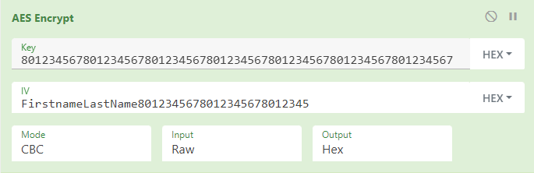
- HMAC = Using the hashing function SHA256
  - An example block using K2 should look like this
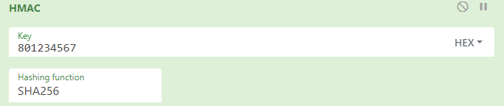
- Hash = Wherever you are expected to use a hash block, use the following recipe
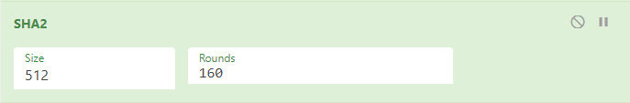
- Search the operations tab for X if you want to use Y
  - “AES Encrypt” to use encryption blocks
  - “HMAC” for HMACs
  - “SHA2” for Hashes
  - “AES Decrypt” for decryption block
Deliverables:
It’s fine to use separate windows to simultaneously show several parameters, for example one window can be used to show the ciphertext, and this entire recipe copied and chained with a hash block can show the hash of this ciphertext. So if Alice were to send (C, H) where C is the AES encryption of the message M, and H is the HMAC of this ciphertext, you can use a screenshot like this:
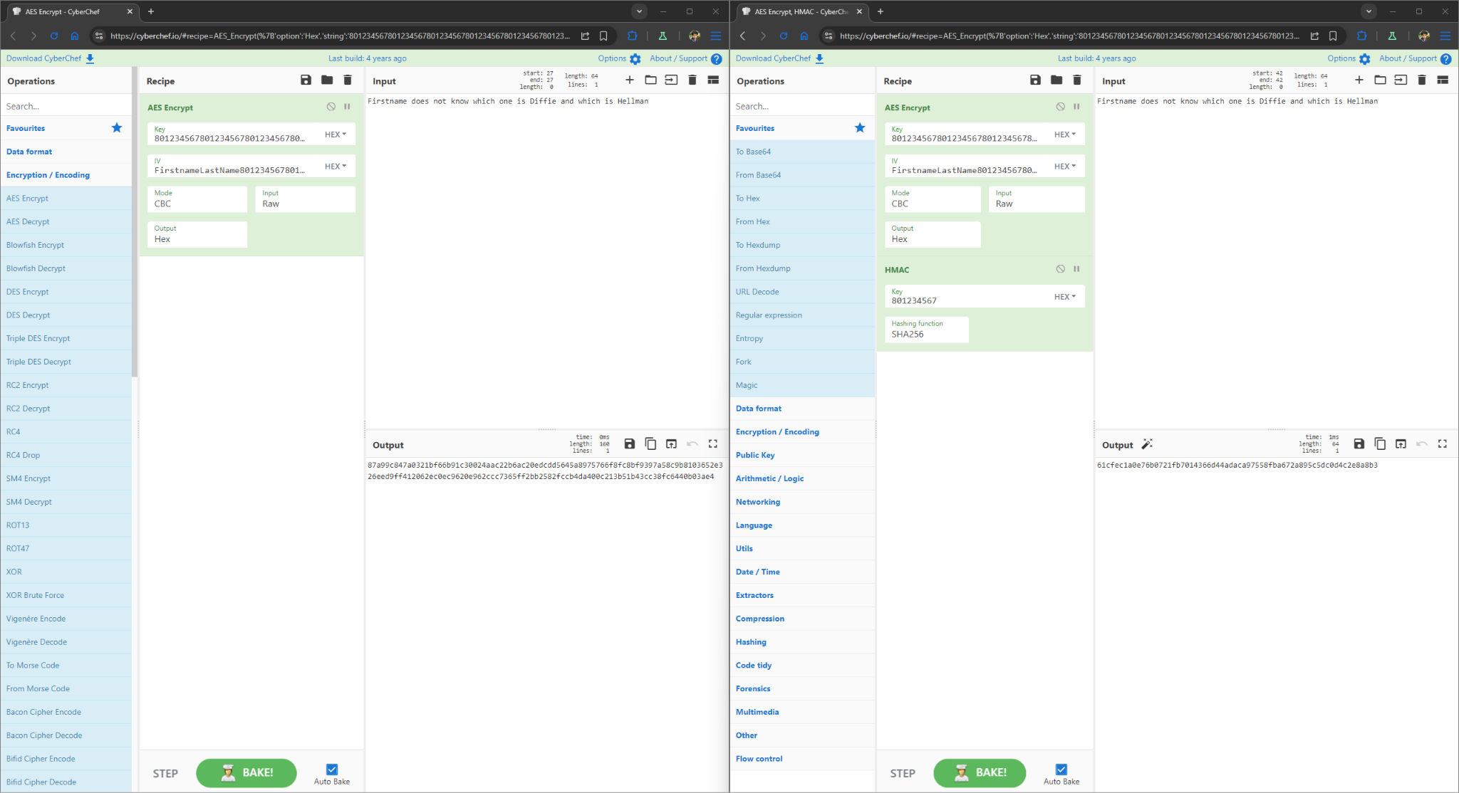
Additionally to show both Alice and Bob’s side of the communication, you can use a screenshot like this:
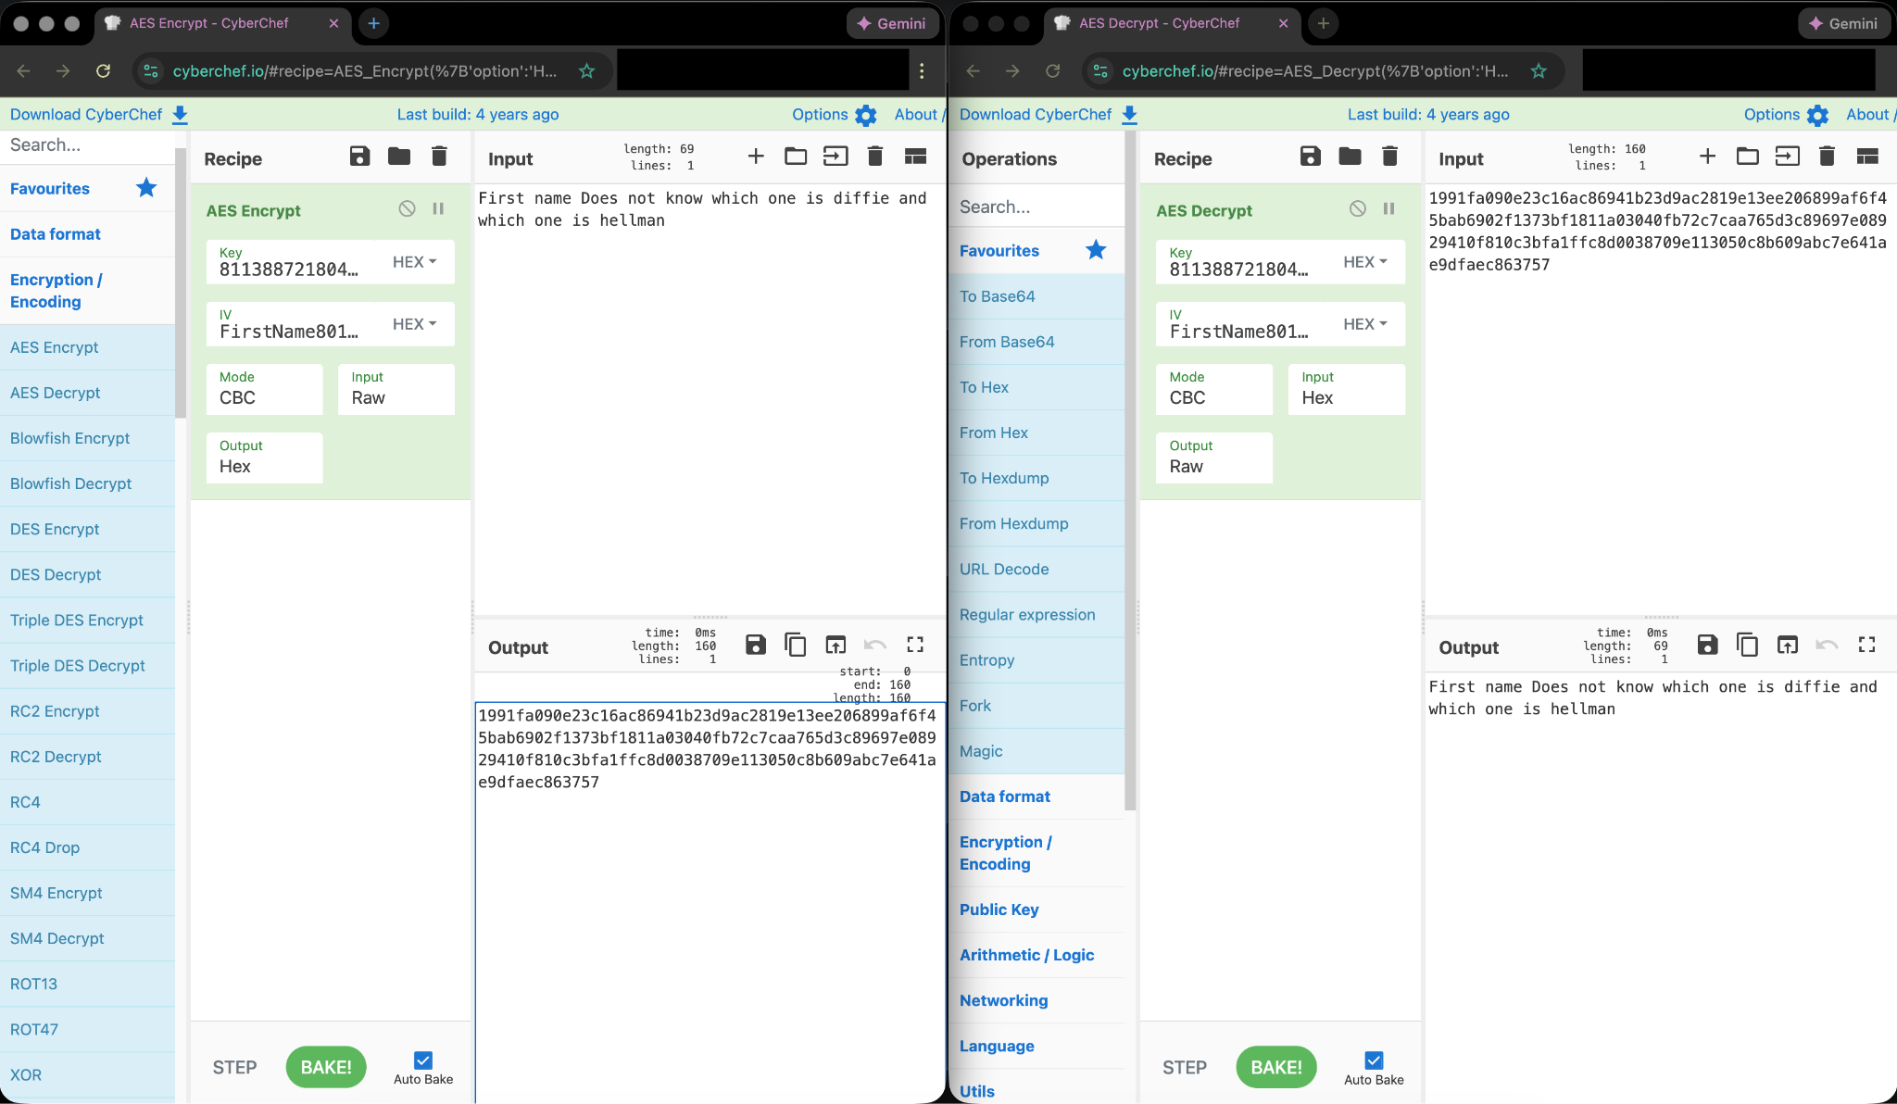
Make sure to caption each image like: Ciphertext of M using K1 calculated and sent by Alice (C) on the left; The HMAC of this ciphertext using K2 calculated and sent by Alice (H) on the right.

For each of the given schemes, show:
- Full screen shot: Alice’s side of the communication with the inputted message highlighted in yellow and the output ciphertext boxed in red.
- Full screen shot: Bob’s side of the communication with the inputted ciphertext highlighted in yellow and the output plaintext boxed in red.
- Analysis: Explain if the scheme provides confidentiality, if yes, explain why, if not, explain how a passive observer Eve can compromise the original message M.
- Analysis: Explain if the scheme provides integrity, if yes, explain why, if not, then how can a malicious threat actor Mallory make undetected modifications to the intercepted values?
- Conclusion: Highlight the scheme that provides both confidentiality and integrity in yellow.

Part 2: Diffie-Hellman & PRNG Analysis (40 Points)
Personalized Diffie-Hellman Exchange
Alice and Bob are performing a Diffie-Hellman key exchange. To ensure your analysis is unique, you will use values derived from your own Student ID.
Parameters:
- Prime 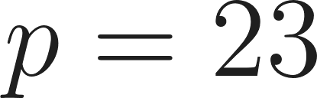
- Generator 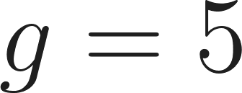
- Alice's Secret (): Use the last digit of your Student ID (if 0 or 1, use 3).
- Bob's Secret (): Use the second to last digit of your Student ID (if 0 or 1, use 4).
Tasks:
Q2. (3 Points) Calculate Alice's Public Key () and Bob's Public Key (). Show your calculation.
Q3. (3 Points) Calculate the Shared Secret () that Alice computes.
Q4. (3 Points) Calculate the Shared Secret () that Bob computes.
PRNG Rollback Analysis
Eve is eavesdropping on the communication established above.
Q5. (9 Points) If Alice and Bob use PRNGs that are not rollback-resistant to generate their secrets, and Eve learns their internal state after the exchange, can Eve retroactively discover your calculated Shared Secret S? Explain why or why not.
Q6. (10 Points)If Alice switches to a rollback-resistant PRNG but Bob does not, is the Shared Secret S secure? Explain why or why not.
Q7. (12 Points) Mallory intercepts the exchange. She wants Alice and Bob to agree on the same shared secret so they don't suspect a mismatch, but she wants to know what it is. Using your specific values for , , , and : find a value  that Mallory can send to both Alice and Bob to force them to agree on the key S = 1. Prove that this value works mathematically.

Part 3: Programming Assignment - The Stateful Interceptor (15 Points)

1. Objective
Build a system that simulates a secure communication session using Diffie-Hellman (DH) and a Stateful PRNG Stream Cipher. You will then implement an "Active Adversary" (Mallory) who intercepts the communication, decrypts the traffic, modifies it, and re-encrypts it for the recipient.
We have provided a Python template in the Canvas page for this assignment. We encourage you to use this as it is a great starting point, however, you are still allowed to use any language of your choice and any libraries of your choice. The template provided has comments to describe the requirements and functionalities of each part. Do not remove or modify any existing code, simply add the logic for each section. Additionally, we have provided several links to documentation for Python functions and libraries in the Canvas page for this assignment. These are great resources to complete this program, so we encourage you to take some time reading them if you are having trouble.
Note: On line 173 in the Main function (this will change as you add code, so input your message first), there is a variable for message. You will modify this line to input a message of your choice for the lab. This is the ONLY line that you should change in Main. This is the message that Alice is sending to Bob, and Mallory will modify this message when she intercepts it.

2. Implementation Flow (The Simulation)
To receive full credit, your script must demonstrate two distinct execution flows.
Scenario A: Secure Communication
- Step 1: Alice and Bob generate their DH private/public keys.
- Step 2: They exchange public keys as Hex Strings via the Network.
- Step 3: Both calculate the shared secret and use it to seed their SecurePRNG.
- Step 4: Alice encrypts a message using a Stream Cipher (XOR).
  - Constraint: The message M must be a string. Ex: "We are meeting at 10am tomorrow."
- Step 5: Bob decrypts the message. The secrets should match, and the message should be intact.
Scenario B: The MITM Attack
- Step 1: You "plug" Mallory into the Network.
- Step 2: When Alice and Bob try to exchange keys, Mallory intercepts them and provides her own key instead.
- Step 3: Alice and Bob now have different shared secrets (both are shared with Mallory).
- Step 4: Alice encrypts a message. Mallory intercepts it, decrypts it, modifies a word, and re-encrypts it for Bob.
- Step 5: Bob decrypts the message. He receives the modified version without any errors.

3. Classes and functions to implement:
The PRNG: SecurePRNG
- init(): Uses the DH shared secret to set the initial 32-byte state.
- generate(): Produces n pseudorandom bytes.
- Crucial: To ensure Rollback Resistance, you must update the internal state using a hash function after every generation block so that the process cannot be reversed.
The Cipher: stream_cipher()
- Logic: This function should call prng.generate() to get a keystream.
- Operation: Return Plaintext XOR Keystream.
The Entities: Entity
- init(): Initializes Alice/Bob with private/public keys.
- get_public_hex(): Returns public key as hex. This function is already implemented and should not be changed.
- establish_session(): Calculates secret and initializes SecurePRNG.
The Interceptor: Mallory
- init(): Initializes Mallory with private/public keys.
- intercept():
  - If Key Exchange: Store sender's key, generate fake secret, return Mallory's public key.
  - If Encrypted Message: Decrypt using "Sender-side" PRNG, modify string, Re-encrypt using "Recipient-side" PRNG.
We have provided a main function to help you test the functionality of your program. The output of the main function is what is required for screen shots in the Deliverables section below.

4. Deliverables (15 Points for public GitHub link and both screen shots, 0 if any of the 3 are missing)
- Source Code: GitHub link to your repo titled "Lab03DHProgram".
- Screenshots:
  - Programming: Full-screen screenshots of the console output for Scenario A and Scenario B, clearly showing your unique message being transmitted and modified.
Example output for Main:
