Lab 4

Step 1: RSA Key Pairs and Encryption 24 Points
Context: Unlike AES, which uses a single shared key, RSA is an asymmetric algorithm. It uses a Public Key (which can be shared with anyone) for encryption and a Private Key (which must be kept secret) for decryption. In this scenario, Alice will generate her keys so that Bob can send her a secure message.
Tools Required: CyberChef

1.1 The Experiment
- Generate Alice's Keys:
  - Open CyberChef and search for the "Generate RSA Key Pair" operation. Drag it into the Recipe area.
  - Set the key size to 1024-bit and the format to PEM.
  - Click Bake. The "Output" window will now contain two blocks of text: the Public Key and the Private Key.
  - Alice now posts her public key to an online forum so people can send her messages.
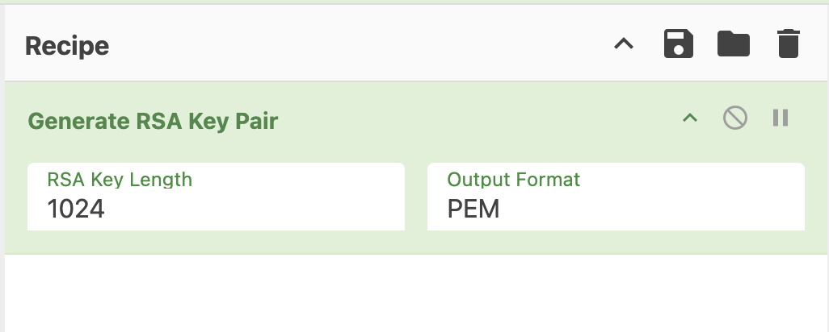
- Bob Encrypts a Message:
  - Open a new tab of CyberChef. Search for the “RSA Encrypt” operation, drag it into the Recipe area.
  - Copy Alice’s Public Key from the previous step and paste it into the Key box in the RSA Encrypt operation.
  - Ensure the Encryption Mode is set to RSA-OAEP and SHA-1 for message digest.
  - Search for the “To binary” operation, drag it into the Recipe area under the RSA encrypt operation.
  - In Bob’s input window, type the following message “Can you send me <Your student id> dollars for V-Bucks".
  - The resulting Output is the Ciphertext that will be sent over the internet to Alice.
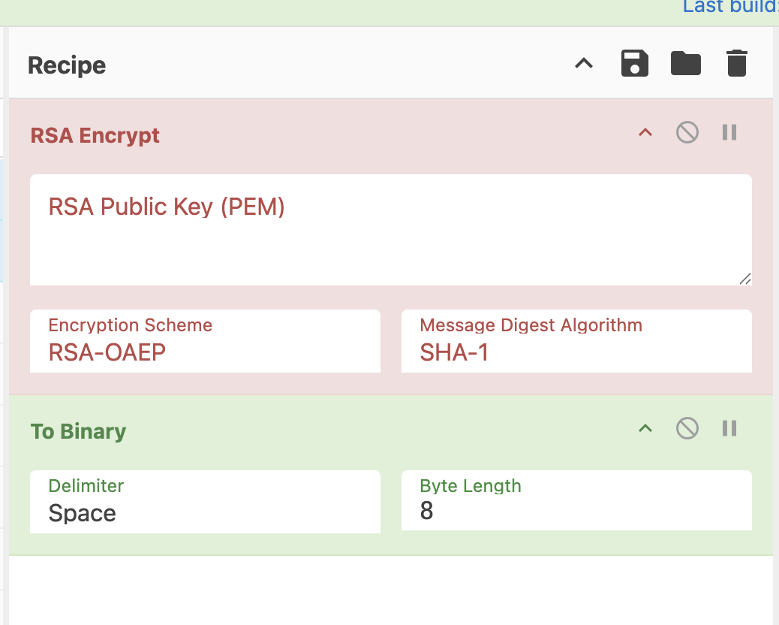
- Alice Decrypts the Message:
  - In another new window of CyberChef, search for the “From binary” operation and drag it into the Recipe area. Additionally, search for the “RSA Decrypt” operation and place it below the binary operation.
  - Next, copy the Ciphertext from Bob’s Output and paste it into Alice’s Input window.
  - Copy Alice’s Private Key and paste it into the Key box.
  - Observe the Output to see the original secret message restored.
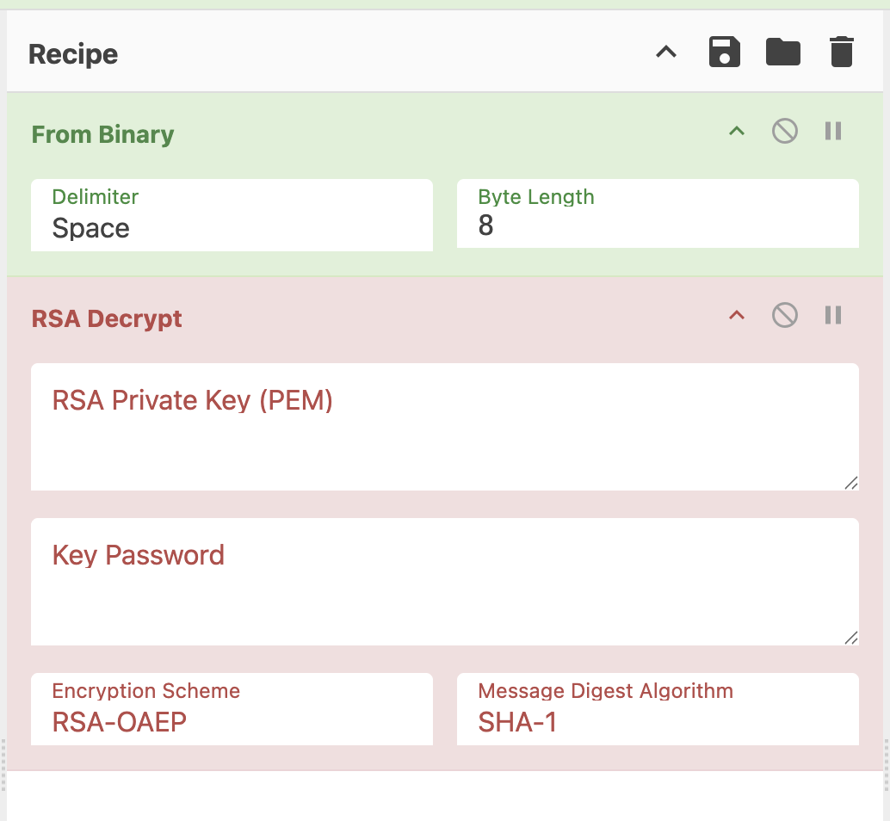

1.2 Deliverables
- (2 Points) Full screenshot showing Alice's generated Public and Private key pair in CyberChef.
- (2 Points) Full screenshot Showing Bob’s window to send Alice a message where the inputted message is highlighted in yellow and the outputted ciphertext is boxed in red.
- (2 Points) Full screenshot Showing Alice’s window receives a message where the inputted ciphertext from Bob is highlighted in yellow and the output plaintext is boxed in red.

1.3 Analysis
- Q1 (6 Points): Why is it safe for Alice to post her Public Key on a public website, but catastrophic if she loses her Private Key? What is the mathematical relationship between the two keys in RSA?
- Q2 (6 Points): In the current experiment, Bob uses Alice's Public Key to encrypt a message. This ensures Confidentiality (only Alice can read it). However, can Alice know if the message actually came from Bob and not from an imposter? Why or why not?
- Q3 (6 Points): Referring to the RSA Encrypt and RSA Sign operations, you are required to select a message digest algorithm (Hash algorithm). Why do we need to include a hash when doing RSA encryption and signing instead of performing the operations on the message directly?

Step 2: RSA Digital Signatures & Hybrid Encryption (30 Points)
Context: In Step 1, we ensured confidentiality (only Alice can read the message). In Step 2, we ensure Authenticity. Alice needs to be certain that the message actually came from Bob. To do this, Bob will encrypt the message with AES and then "sign" it using his own Private Key.
Tools Required: CyberChef

2.1 The Experiment
- Generate Bob's Keys:
  - In a new tab of CyberChef, do the following:
  - Use the "Generate RSA Key Pair" operation so Bob can generate his private and public RSA signing keys.
  - Set to 1024-bit and PEM format. Click Bake.
  - Bob now posts his RSA public key to an online forum so users can verify messages are coming from him.
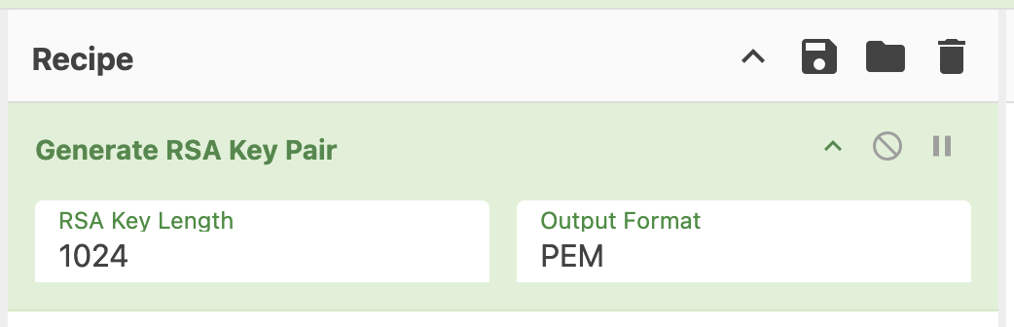
- Bob Encrypts the Message (AES):
  - Clear your Recipe. Search for the “AES Encrypt” operation and drag to the Recipe area. Use CBC Mode, Input Raw, and Output Hex, and your student ID as the key and IV. You will need to repeat (CTRL-V) your student ID until the length requirements are met.
  - Enter the message “Thank you for sending me <Your student id> dollars, I have a lot of Fortnite skins now!>” and click bake. The output is the ciphertext of your message.
  - ** Copy or write down the ciphertext as it will be needed later **
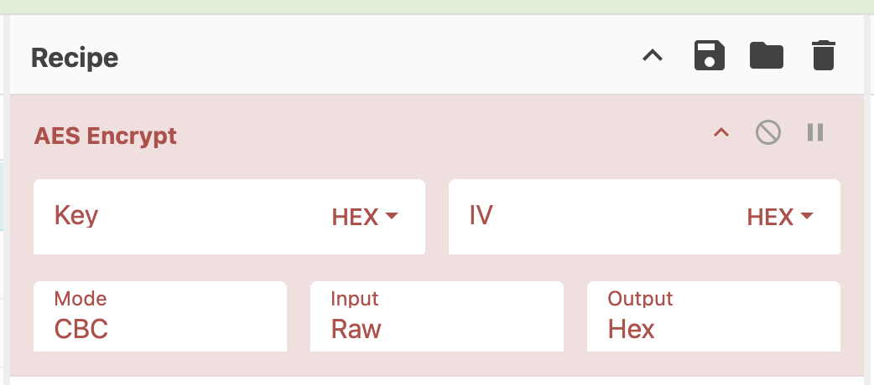
- Bob Signs the Ciphertext (RSA Sign):
  - Add the "RSA Sign" operation to your recipe (after the AES Encrypt).
  - Add the “To binary” operation to your recipe (after the RSA Sign).
  - Paste Bob's Private Key into the Key box.
  - Set the Message Digest to SHA-256 and click bake.
  - The Output now shows the Signature of the encrypted message.
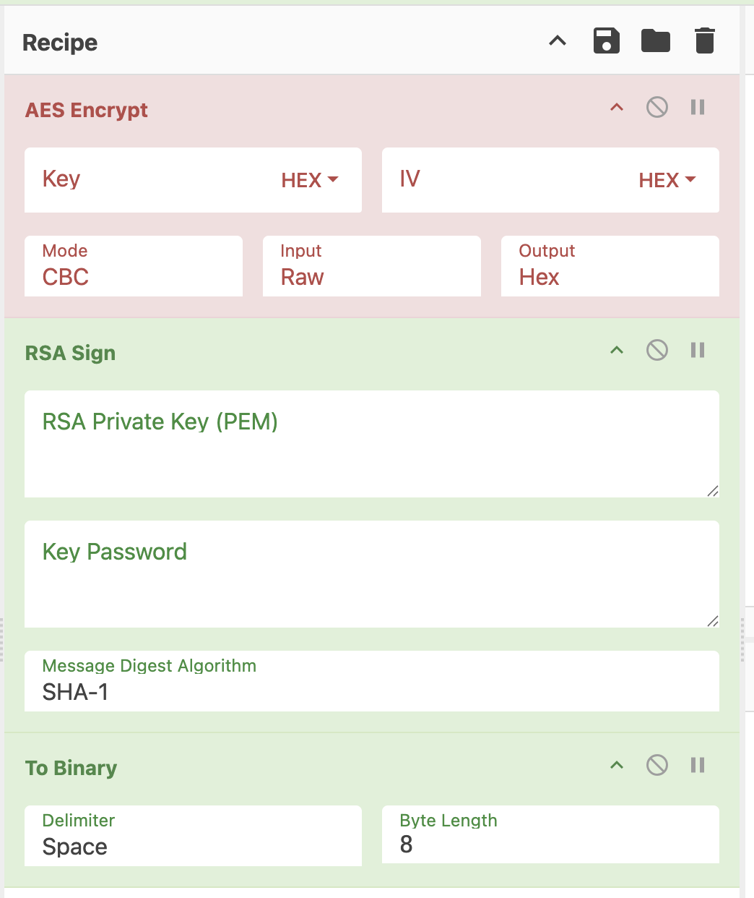
- Alice Verifies the Message (RSA Verify):
  - Now, in a new tab of CyberChef, Alice will verify the message.
  - Search for the “From binary” operation and drag it to the Recipe area.
  - Search for the “RSA Verify” operation and drag it to the Recipe area.
  - Paste Bob’s Public Key into the Key box.
  - Paste the RSA signature generated in step three in the input box for RSA Verify.
  - Paste the ciphertext generated in step 2 in the message box for RSA verify.
  - If the signature is valid, CyberChef will display "Verified: true".
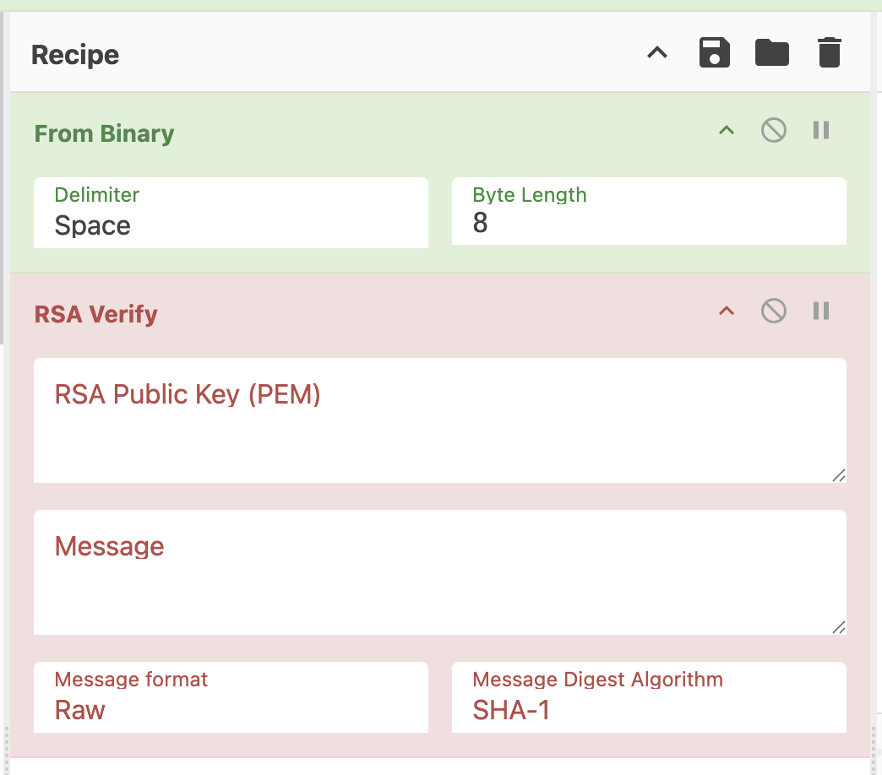

2.2 Deliverables
- (2 Points) Full screenshot Showing Bob’s generated RSA key pair.
- (2 Points) Full screenshot Showing Bob’s inputted message highlighted in yellow and the generated RSA digital signature boxed in red.
- (2 Points) Full screenshot Showing Alice’s inputted RSA digital signature highlighted in yellow, the inputted message (ciphertext) highlighted in yellow, and the result of the verification boxed in red.

2.3 Analysis
- Q4 (8 Points): Why does Bob use his Private Key to sign the message instead of his Public Key? If Bob used his Public Key to sign, would it still prove the message came from him?
- Q5 (8 Points): In this experiment, Alice used Bob’s RSA public key to verify that the message was sent from Bob. Alice got Bob’s public key from the online forum, but can she prove that this is actually Bob’s public key and not Mallory pretending to be Bob? Why or why not?
- Q6 (8 Points): This lab uses Hybrid Encryption. We used AES to encrypt the message and RSA to sign it. Why don't we just use RSA to encrypt the entire message and the signature? (Hint, think computational efficiency)

Step 3: Certificates (20 Points)
Refer to the "Certificate Authorities" in lecture 7. Suppose Alice receives a certificate for Mallory that is signed by Bob. To verify this certificate is legitimate, Alice must follow a "Chain of Trust" back to BC.
- Q7 (7 Points): List the specific steps (the sequence of certificates) Alice must verify to trust Mallory's key.
- Q8 (7 Points): If Bob’s intermediate certificate was signed using an algorithm that is now considered "broken," does Alice still trust Mallory? Why or why not?

Q9 (6 Points): The slides state, "You cannot gain trust if you trust nothing. You need a root of trust." In a modern web browser, who are the "trust anchors," and how do they actually get onto your computer? If you were to manually delete all "Root CA" certificates from your browser's settings, what would happen when you tried to visit a secure site like Google or Canvas?

Step 4: The Exponential Wall (26 Points)

4.1 The Experiment: High-Complexity Simulation
- Open up the python notebook here
- If prompted, select “open in Colab” on the top right
- Go through the code, try to understand what is happening, once you’re ready to see it in action, press the run (play) button on the top left of the code cell.
- 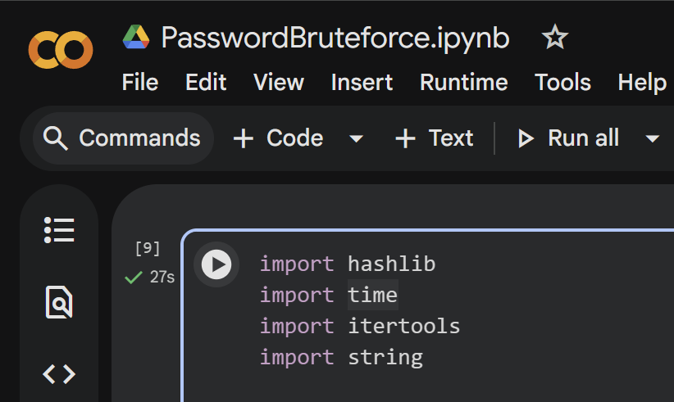
- At the very bottom, look at the output and see how much time it takes to bruteforce the passwords in the unsalted database, and how much for the salted databases.

4.2 Deliverables
Deliverable (2 Points): A full screenshot of the browser window with the output console, red box around the time and the number of extra hashes calculated for the salted database.
- Note: The Salted attack may take between 1 and 3 minutes. This delay is the "Security" in action.

4.3 Analysis
- Q10 (8 Points): A developer argues that since salts are stored in plaintext next to the username, they don't actually provide security because an attacker who steals the database can see them. If the salts are public/visible, how do they still successfully prevent an attacker from using a pre-computed Rainbow Table to crack the entire database?
- Q11 (8 Points): While a slow hash protects against Offline Attacks, explain how it creates a new vulnerability for Online Attacks. If it takes a server 0.5 seconds of CPU time to verify one password, how could an attacker use this "feature" to crash the login portal?
- Q12 (8 Points): Hardware vs. Hashing. Why do hackers use GPUs (Graphics Cards) instead of CPUs for this specific type of work? How does salting reduce the efficiency of a high-speed GPU "cracking rig"?

