**Library-Computer-Usage-Analysis: Presentation**

**Brown Biggers**

**Michael Ellis**

**Nick Lloyd**

**Patricia Tanzer**

*NOTE: Each section should include a brief description of what data was used and how it was manipulated. A more detailed summary will come at the end. I’ve filled in one graph as an idea of what I’m intending as documentation – if you have any concerns let’s bring that up ASAP so we can all come to an agreement on what we should have documented.*

**Library Gate Counts vs. Semester schedule pg. 2**

**Next Item (example) pg. 4**

**Library Gate Counts vs Semester Schedule**

One early theory our group supposed was that the library as a whole would be more busy around exam times, and less so between breaks. Additionally, we though the library would have more traffic on weekdays than weekends. This hopefully would also correlate to the number of computers in use, as well as the time they were used. To get an idea if this would be the case, we examined the gate counts of Jackson Library for the first six months of 2017.

There are two gates in Jackson library, and passing through either one increments a counter which is manually checked twice a day. By taking the difference of the evening count and the morning count, we can find the total gate passages per day. Dividing that in two gives us the total gate entrances per day (we assume that the same number of people exited as entered.) We then plotted the Sunday entrances, the Monday entrances, and so on, through the first half of the year, as seen below:

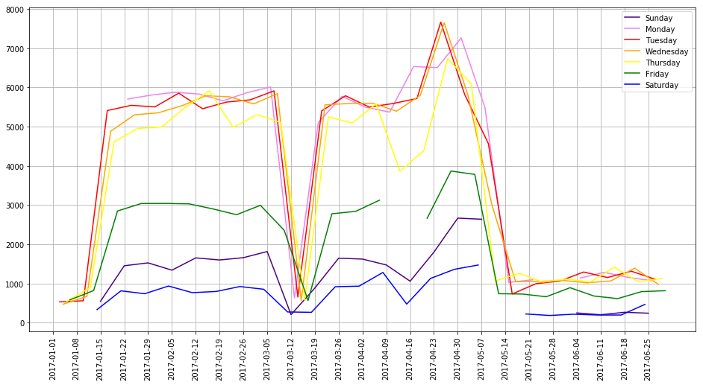

It is clear from a glance that our assumption that the library receives more traffic on weekdays was quite correct, except for Fridays, which were nearly as low as the weekend values. Perhaps surprisingly, Sundays are also apparently busier than Saturdays. The peaks and valleys also correlate to the scheduled semester events, summarized below (<https://reg.uncg.edu/calendars/spring-2017-academic-calendar/> )

01/17/17, Tuesday: Classes begin

03/11/17, Saturday: Spring Break begins

03/20/17, Monday: Spring Break ends

04/14/2017, Friday: Holiday

05/03/17, Wednesday: Reading Day

05/04/17, Thursday: Finals start

05/12/17, Friday: Commencement

From looking at the graph, we see the first rise is in the week just preceding the start of term, as students are moving in and new freshmen touring campus. The gate counts stay about the same until a few days before Spring Break, where there is a steep drop, and pick up again to the same point as Spring Break ends. There is a gap in the Friday data the corresponds to the Friday holiday in April, as well as a dip in counts for the Thursday just before. Then the counts rise dramatically about a week before the start of exams, peaking a few days before exams start, and then drop steadily to the ‘Break’ levels by the day of commencement, which remain low through the end of June.