Revised Project Proposal
CISC7204 Data Science and Data Visualization · Assignment 02 (Pair Work)
UN CHI KIT (mc65308) · Kelden Jamtsho (mc66418)
Due 25 October 2026, 11:00 pm

1. Project Topic Name
Marriage and Happiness in America: Does Marriage Buy Happiness? (1972-2024)

Precisely written research question
In the United States of America, are married adults happier than adults who are widowed, divorced, separated or never married, and has that relationship — and the level of reported happiness itself — changed between 1972 and 2024, even as the share of adults who were married fell from 72.0% to 41.8%?

2. Region and Domain Category
- Region: United States (GSS national sample, 1972-2024)
- Domain category: Sociology of the family and subjective well-being — marital status and happiness

3. Available Datasets
1. General Social Survey (GSS), NORC, 1972-2024 — self-reported happiness (HAPPY), marital status (MARITAL) and the control variables age, sex and family income (REALINC). The project uses all 35 published waves that carry these variables, retaining 72,087 usable respondents after validity filtering.
- GSS data download page — https://gss.norc.org/Get-The-Data
- GSS cumulative Stata file — https://gss.norc.org/content/dam/gss/get-the-data/documents/stata/GSS_stata.zip
2. World Bank GDP per capita, United States — indicator NY.GDP.PCAP.KD, GDP per capita in constant 2015 US dollars, carried alongside the happiness series as national economic context.
- World Bank indicator page — https://data.worldbank.org/indicator/NY.GDP.PCAP.KD?locations=US
- World Bank API — https://api.worldbank.org/v2/country/USA/indicator/NY.GDP.PCAP.KD?format=json&per_page=1000&date=1972:2024
Both levels of the analysis are computed from the GSS, so that "married" means the same thing twice: a national marriage rate taken from NCHS vital statistics counts marriages per 1,000 population rather than the share of adults who are married, and the two series would not be comparable. NCHS is cited in the References as corroboration only.

4. Justification: how the visualization addresses the research question
At the individual level the visualisation answers the first half of the question. Across 72,087 respondents in 35 waves, the share who describe themselves as "very happy" is 38.8% among married adults, against 22.7% among the widowed, 18.6% among the divorced, 19.6% among the never married and 15.5% among the separated. The gradient is statistically significant (χ²(8) = 4514, p < 1e-300) and not trivial in size: Cramér's V = 0.177, Cohen's d = 0.49 between married and never-married respondents, and an odds ratio of 2.60 (95% CI 2.49–2.72) on reporting "very happy". The 19.2-percentage-point gap between those two groups carries a bootstrap 95% CI of 18.5 to 20.0 points, so it is not an artefact of sampling noise.
Adding age, sex and family income as controls leaves the pattern intact: all four non-married statuses keep a negative and significant coefficient — -0.25 points for the never married (p = 8.4e-305) and -0.40 for the separated — so marital status is not standing in for age or income. The second half of the question is national, and the paired time series is what carries it: the share of respondents who were married fell from 72.0% in 1972 to 41.8% in 2024, while the share reporting "very happy" fell from 30.3% to 20.2% even though real GDP per capita rose 2.49 times. Across the 35 waves the two national series correlate at Spearman ρ = +0.689 (p = 4.7e-06). The document states the limit of that reading explicitly: people who are already happier may be more likely to marry and to stay married, so the evidence is an association between marital status and happiness, not proof that marrying makes anyone happier.

5. Figures Produced by the Notebook
F1 — Share reporting "very happy" by marital status, pooled 1972-2024, with 95% confidence intervals.
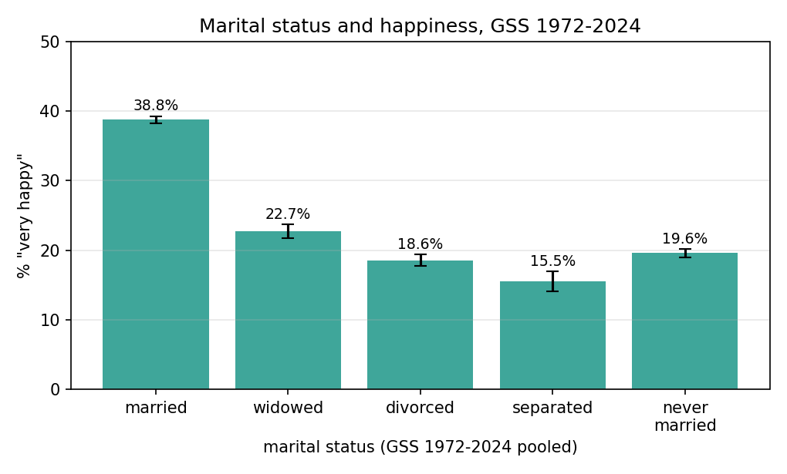
F2 — Dual-axis national trend: share "very happy" (left) and share married (right), 1972-2024.
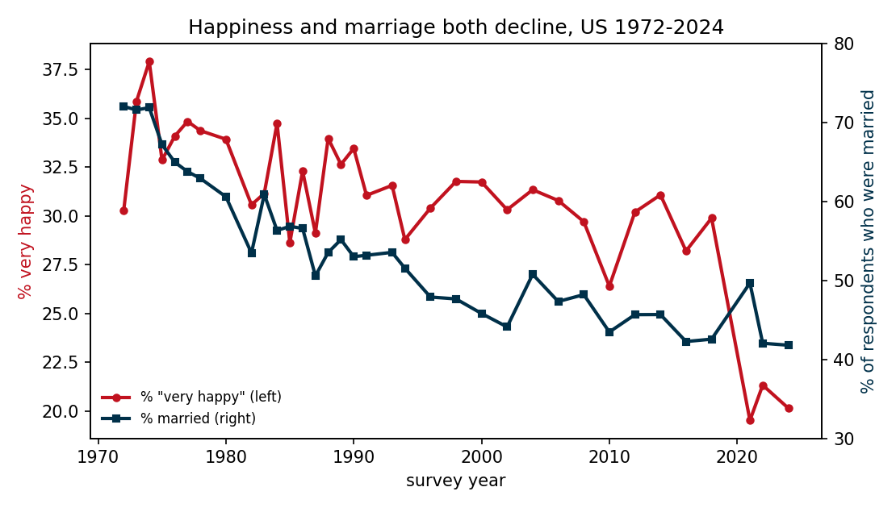
F3 — Married versus separated "very happy" share by decade; the gap holds in all six decades.
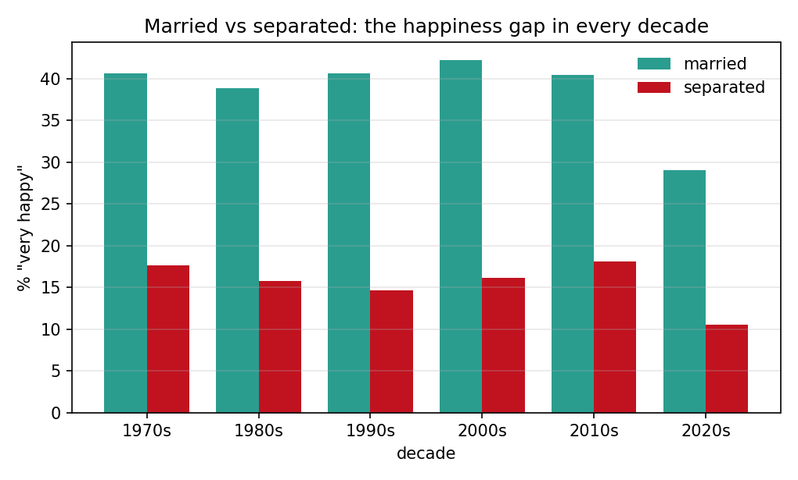
F4 — 2024 wave only: happiness composition within each marital status, as 100% stacked bars.
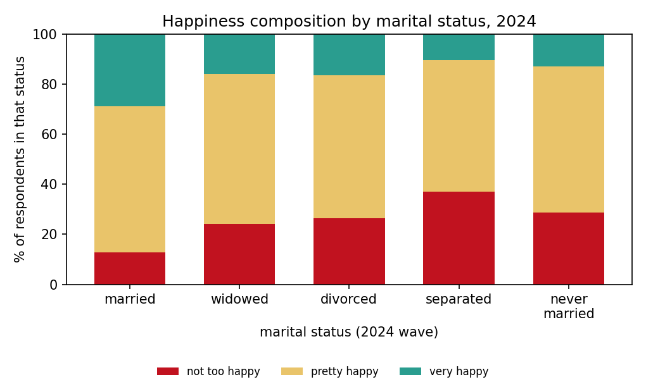

6. Project Purpose

Outcomes
- Apply a complete data-science workflow to public real-world data: acquisition, cleaning, exploratory analysis, statistical testing, visualisation and interpretation.
- Demonstrate the course learning outcomes on importing and wrangling real survey data and on producing visualisations that are statistically defensible rather than merely decorative.
- Build experience relevant to future study or career work in social-science research, data analysis and data-driven storytelling.

Skills
- Python 3 data wrangling with pandas: pooling 35 survey files, recoding categorical variables, and keeping a nominal predictor nominal.
- Statistical analysis: chi-square tests, Cramér's V, ordinary least squares with dummy coding, odds ratios with Woolf intervals, Cohen's d and bootstrap confidence intervals.
- Multi-panel matplotlib work: error bars, twin axes, grouped bars and 100% stacked bars, each with labelled units and a stated n.

Knowledge
- The marital-status and well-being literature, and what a stable cross-sectional gradient does and does not imply once the population's marital composition changes underneath it.
- How survey measures are coded: ordinal happiness categories, nominal marital status, and the consequences of treating a nominal variable as if it were a scale.
- The distinction between association and selection, which no amount of statistical significance can settle on its own.

7. Project Tasks
- Acquire and clean the 35 GSS waves: keep valid happiness answers and the five marital codes, and document every filter.
- Tabulate marital status against happiness, then test the association and report its effect size rather than its p-value alone.
- Fit the unadjusted model and the model adjusted for age, sex and family income, and check that the direction survives the controls and an 80/20 hold-out.
- Analyse the national series — share married and share "very happy" per wave — and its correlation with reported happiness and with GDP per capita.
- Deliver four static figures, the executed notebook that reproduces every number, and the written justification of how the figures answer the question.

8. Project Criteria for Success
- Every statistic in this document can be reproduced by running the submitted notebook on the stated public sources: 72,087 respondents, 35 waves.
- Each figure is readable without the code — title, axis units, legend and sample size all present.
- The document states the associational caveat and the selection concern in its own words, in the justification rather than in a footnote.
- The proposal stays within the required 2-5 A4 pages, with both student IDs on the front page.

9. Project Collaboration

Division of work
- UN CHI KIT (mc65308) — data acquisition and cleaning, statistical testing, notebook
- Kelden Jamtsho (mc66418) — visualisation design, figure captions, written justification
- The Assignment 02 lab split is recorded in scope.txt of the shared repository.

Ground rules
- Weekly progress check, and the shared repository is synchronised from the first day.
- Agree the analysis definitions — which respondents count, how missing answers are treated — before interpreting any result.
- Each member reviews the other's code, figures and written sections before submission.
- Document every change to code, filters or visual design, so that a rerun reproduces the same numbers.
- No causal wording: the analysis establishes association only.

Group structure
- Project coordinator — UN CHI KIT
- Project scribe — Kelden Jamtsho
- Project progress tracker — UN CHI KIT
- Project liaison — Kelden Jamtsho

10. References
NORC at the University of Chicago. General Social Survey (GSS), 1972-2024. https://gss.norc.org/Get-The-Data
Easterlin, R. A. (1974). Does economic growth improve the human lot? Some empirical evidence. In P. A. David & M. W. Reder (Eds.), Nations and households in economic growth: Essays in honor of Moses Abramovitz (pp. 89-125). Academic Press.
World Bank. (n.d.). GDP per capita (constant 2015 US$) - United States. World Development Indicators. https://data.worldbank.org/indicator/NY.GDP.PCAP.KD?locations=US
National Center for Health Statistics. Marriage and Divorce. https://www.cdc.gov/nchs/nvss/marriage-divorce.htm
Oreopoulos, P., & Salvanes, K. G. (2011). Priceless: The nonpecuniary benefits of schooling. Journal of Economic Perspectives, 25(1), 159-184.

11. Declaration of AI Usage
Did I use an AI LLM? Yes
Exact LLM used: ChatGPT – 5.6 Luna, DeepSeek – V4 Flash
Web Browser used: Google Chrome at chatgpt.com

