CISC7204
Data Science & Data Visualization
ASSIGNMENT 02 - PROJECT PROPOSAL
(Proposal Ideation and Proposal)
UN CHI KIT (Student ID mc653081)
Kelden Jamtsho (Student ID mc664183)
Pair Work

Submission deadline: 25 October 2026, 11:00 pm

Marriage and Happiness in America: Marital Status, Subjective Well-Being, and National Change (1972-2024)

1. Project Topic Name
Marriage and Happiness in America: Does Marriage Correlate with Happiness? (1972-2024)

Precisely written research question
This project continues our Assignment 01 study of what shapes happiness in the United States. The study found that richer Americans report greater happiness in any given year, yet national happiness fell between 1972 and 2024 even though GDP per capita rose 2.49 times. Income alone, then, cannot explain the trend. In this project, we turn to a second possible source, marital status, and ask: are married adults in the United States happier than adults who are widowed, divorced, separated or never married, and has this gap changed between 1972 and 2024?

2. Region and Domain Category
- Region: United States - National sample of General Social Survey (GSS) respondents, 1972-2024.
- Domain category: Subjective well-being (happiness) and family sociology, focusing on marital status. This extends the Assignment 01 domain of happiness, family income and national economic growth.

3. Available Datasets
- General Social Survey (GSS), NORC, 1972-2024 - self-reported happiness (HAPPY), marital status (MARITAL) and the control variables age, sex and family income (REALINC). The project uses all 35 published waves that carry these variables, retaining 72,087 usable respondents after validity filtering.
  - GSS data download page - https://gss.norc.org/Get-The-Data
  - GSS cumulative Stata file - https://gss.norc.org/content/dam/gss/get-the-data/documents/stata/GSS_stata.zip

- World Bank GDP per capita, United States - indicator NY.GDP.PCAP.KD, GDP per capita in constant 2015 US dollars, carried alongside the happiness series as national economic context.
  - World Bank indicator page - https://data.worldbank.org/indicator/NY.GDP.PCAP.KD?locations=US
  - World Bank API - https://api.worldbank.org/v2/country/USA/indicator/NY.GDP.PCAP.KD?format=json&per_page=1000&date=1972:2024
Both levels of analysis are computed from the GSS, so “married” means the same thing in the individual and national analyses. A national marriage rate from NCHS vital statistics counts marriages per 1,000 population, not the share of adults who are married, so the two series would not be comparable. NCHS is cited in the References as corroboration only.

4. Justification: how the visualization addresses the research question
The visualization is built around two analyses that answer the two halves of the research question. The first is individual level. Across 72,087 respondents in 35 GSS waves, the share describing themselves as “very happy” is 38.8% among married adults, compared with 22.7% among the widowed, 18.6% among the divorced, 19.6% among the never married and 15.5% among the separated. The association is statistically significant (χ²(8) = 4514, p < 1×10⁻³⁰⁰) and not trivial in size: Cramér’s V = 0.177, Cohen’s d = 0.49 between married and never-married respondents, and an odds ratio of 2.60 (95% CI 2.49-2.72) for reporting “very happy”. The 19.2-percentage-point gap between those two groups has a bootstrap 95% CI of 18.5 to 20.0 points. After controlling for age, sex and family income, all four non-married statuses keep a negative and significant coefficient (for example, -0.25 points for the never married, p = 8.4×10⁻³⁰⁵), so marital status is not simply standing in for age or income.
The second analysis is national and answers the question of change over time. The share of respondents who were married fell from 72.0% in 1972 to 41.8% in 2024, while the share reporting “very happy” fell from 30.3% to 20.2%, even though real GDP per capita rose 2.49 times. Across the 35 waves, the two national series are positively correlated (Spearman ρ = +0.689, p = 4.7×10⁻⁶). This adds a different angle to Assignment 01, where GDP per capita was negatively associated with happiness. The interpretation remains associational. Happier people may be more likely to marry and stay married, so the evidence shows that marital status and happiness go together, not that marrying makes anyone happier. A correlation between two national series also cannot show that the same individuals are driving both trends.

5. Figures Produced by the Notebook
Figure 1 (F1): Happiness by marital status. Share reporting “very happy” for married, widowed, divorced, separated and never-married adults, pooled over 1972-2024, with 95% confidence intervals.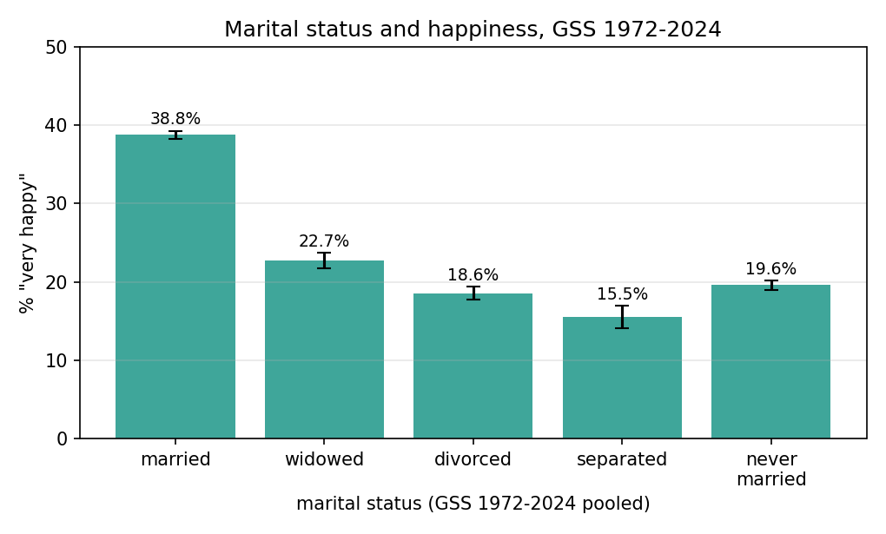
Figure 2 (F2): Marriage and happiness over time. Dual-axis national time series, 1972-2024, with the share reporting “very happy” on the left axis and the share of adults who are married on the right axis.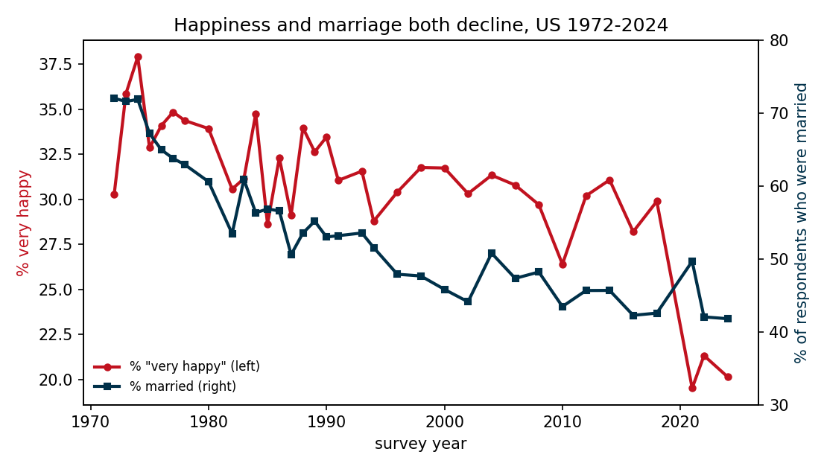
Figure 3 (F3): Married versus separated adults by decade. Share reporting “very happy” among married and separated adults in each decade, showing whether the gap persists across the study period.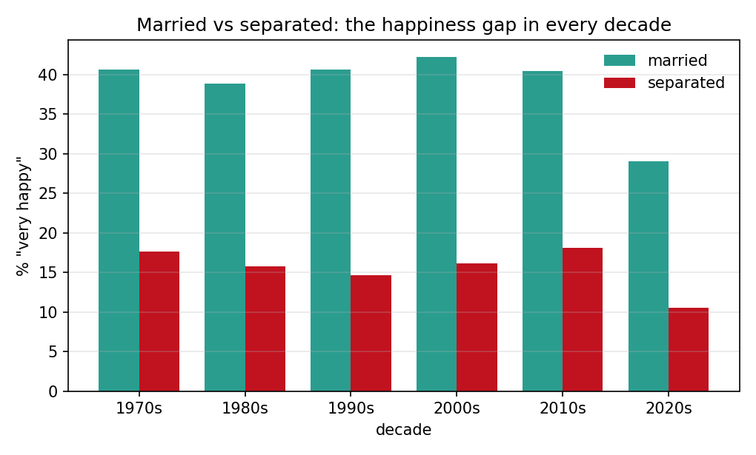
Figure 4 (F4): 2024 happiness composition. Proportions reporting “very happy”, “pretty happy” and “not too happy” within each marital status, shown as 100% stacked bars.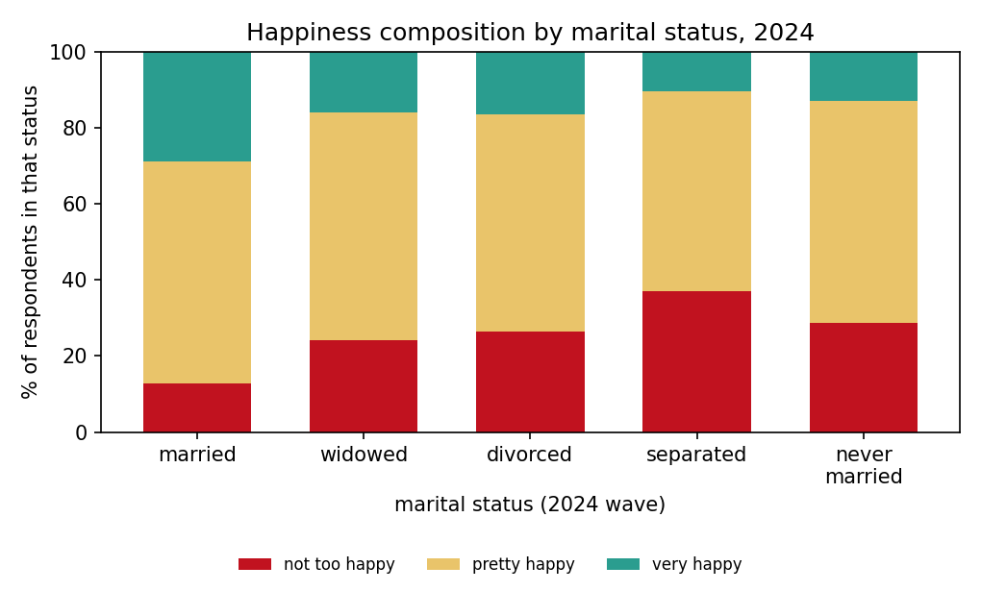

6. Project Purpose
Outcomes
- Apply a complete data-science workflow to public real-world data: acquisition, cleaning, exploratory analysis, statistical testing, visualization and interpretation.
- Demonstrate the course learning outcomes on importing and wrangling real survey data and on producing visualizations that are statistically defensible, not merely decorative.
- Extend our Assignment 01 work on income and happiness to a second possible source of happiness and gain experience relevant to future study or careers in social-science research, data analysis and data-driven storytelling.
Skills
- Python 3 data wrangling with pandas: pooling 35 survey files, recoding categorical variables and keeping a nominal predictor nominal.
- Statistical analysis: chi-square tests, Cramér’s V, ordinary least squares with dummy coding, odds ratios with confidence intervals, Cohen’s d and bootstrap confidence intervals.
- Multi-panel Matplotlib work: error bars, twin axes, grouped bars and 100% stacked bars, each with labelled units and a stated sample size.
Knowledge
- The literature on marital status and well-being, and what a cross-sectional gradient does and does not imply when the marital composition of the population changes over time.
- How survey measures are coded: ordinal happiness categories, nominal marital status, and the consequences of treating a nominal variable as a scale.
- The distinction between association and selection, which statistical significance alone cannot settle.

7. Project Tasks
  - Data acquisition: Obtain the GSS yearly Stata files and the World Bank GDP-per-capita data used by the notebook.
  - Data cleaning: Keep valid happy answers and the five marital codes (married, widowed, divorced, separated, never married).
  - Exploratory analysis and statistical testing: a) Cross-tabulate marital status against happiness, test the association, and report effect sizes (Cramér’s V, Cohen’s d, odds ratio) along with p-values. b) Fit an unadjusted model and a model adjusted for age, sex and family income, and check whether the direction of the association holds under the controls and in an 80/20 hold-out.
  - Time analysis: a) Calculate the share married and the share “very happy” for each survey wave. b) Examine how the two series relate to each other and to World Bank GDP per capita.
  - Visualization and reproducibility: a) Produce four static figures with titles, axis units, legends and sample sizes. b) Ensure every reported value can be reproduced from the Python 3 notebook, and review the code, figures, wording and caveats before submission.
  - Deliverables: Four static figures, the executed Jupyter Notebook, and the written justification.

8. Project Criteria for Success
- Data completeness: The analysis uses all 35 GSS waves that contain the required variables, with 72,087 usable respondents after filtering
- Reproducibility: Every statistic in this document can be reproduced by running the submitted notebook on the stated public sources.
- Visual Clarity: Each figure is readable without the code, with a title, axis units, a legend and the sample size.
- Interpretive accuracy: The document states the associational caveat and the selection concern in its own words, in the justification and not in a footnote.

9. Project Collaboration

Division of work
- UN CHI KIT (mc65308) - data acquisition and cleaning, statistical testing, notebook
- KELDEN JAMTSHO (mc66418) - visualization design, figure captions, written justification

Ground rules
- Conduct a weekly progress check and keep the shared code/data repository synchronized from the first day.
- Agree on the analysis definitions before interpreting any result, including which respondents count and how missing answers are treated.
- Each member reviews the other member’s code, figures and written sections before submission.
- Document every change to code, filters or visual design, so that a rerun reproduces the same numbers.
- Do not use causal wording: the analysis establishes association only.

Group structure
- Project coordinator - UN CHI KIT
- Project scribe - Kelden Jamtsho
- Project progress tracker - UN CHI KIT
- Project liaison - Kelden Jamtsho

10. Declaration of AI Usage

- Did I use an AI LLM? Yes
- Exact LLM used: ChatGPT – 5.6 Luna, DeepSeek – V4 Flash
- Web Browser used: Google Chrome at chatgpt.com

11. GitHub link for the Project Ideation and Project Proposal

https://github.com/UNCHIKIT/CISC7204-Assgn-02.git

References
Easterlin, R. A. (1974). Does economic growth improve the human lot? Some empirical evidence. In P. A. David & M. W. Reder (Eds.), Nations and households in economic growth: Essays in honor of Moses Abramovitz (pp. 89–125). Academic Press. https://doi.org/10.1016/B978-0-12-205050-3.50008-7
National Center for Health Statistics. (n.d.). Marriage and divorce. Centers for Disease Control and Prevention. https://www.cdc.gov/nchs/nvss/marriage-divorce.htm
NORC at the University of Chicago. (n.d.). General Social Survey (GSS), 1972–2024 [Data set]. https://gss.norc.org/Get-The-Data
Oreopoulos, P., & Salvanes, K. G. (2011). Priceless: The nonpecuniary benefits of schooling. Journal of Economic Perspectives, 25(1), 159–184.
World Bank. (n.d.). GDP per capita (constant 2015 US$) – United States [Data set]. World Development Indicators. Retrieved October 22, 2026, from https://data.worldbank.org/indicator/NY.GDP.PCAP.KD?locations=US

