CISC7204
DATA SCIENCE AND DATA VISUALIZATION
THE POWER-HUNGRY
WORLD
Comparing Global Electricity Consumption Across Sectors
SEMESTER PROJECT • TEAM PROJECT PROPOSAL
2026/2027 • Semester 1 • Class G – Team 03

FULL NAME | STUDENT ID | ROLE
UN CHI KIT | mc653081 | Team coordinator and project tracker
KELDEN JAMTSHO | mc664183 | Project analyst and quality reviewer
GAN RUIYAN | mc664801 | Lead project developer
HE YIFEI | mc664916 | Team reporter and team liaison
SHENG TIAN | mc664961 | Second project developer
TANG JING | mc666256 | Second project analyst and team scribe

Revised 10 November 2026
University of Macau

1. Project Overview and Research Question
Revision note (10 November 2026). The IEA World Energy Balances dataset has been dropped because of its known licence issues: the IEA confirmed that its licence does not permit the project’s planned public tables, charts, maps and dashboard. The UNdata Energy Balance is therefore now the primary dataset. The research question, scope and analysis period are unchanged; only the data sources and related preparation steps have been revised.
Project title:
The Power-Hungry World: Comparing Global Electricity Consumption Across Sectors

Main research question:
How has final electricity consumption changed across countries and regions between 1990 and 2022, and which countries and end-use sectors account for the largest shares of that consumption?

The project will use descriptive statistics, exploratory data analysis (EDA), comparative visualisation and geospatial analysis to examine the scale, distribution and composition of electricity consumption over three decades. The analysis is organised around four connected sub-questions:
- Change over time. How did electricity consumption evolve globally, regionally and in selected high-consuming countries? Which regions and countries experienced the largest absolute and percentage growth?
- Country contributions. Which countries accounted for the largest amounts and shares of global consumption, and how did their rankings and shares change between 1990 and 2022?
- Sector composition. How was final consumption divided among industry, transport, residential and services/other uses, and how did these proportions differ across regions and over time?
- Geographical distribution. How was electricity consumption distributed across countries in 1990 and 2022, and which geographical patterns or changes can be identified from the two world choropleth maps?
The study is suitable for a data-science project because it requires the acquisition, cleaning, harmonisation, exploration and comparison of multi-source time-series and geospatial data. The data are observational; the project will describe patterns and associations rather than claim that particular factors caused changes in consumption.

Scope and definitions
The geographic scope is global, subject to the coverage of the selected datasets. The analysis period is 1990–2022. The principal measure is final electricity consumption—electricity consumed by end users—rather than electricity generation or total energy supply. Results will be expressed in terawatt-hours (TWh), using 1 TWh = 3.6 PJ = 3,600 TJ. The project will group sector data into industry, transport, residential and services/other. Generation mix will be presented separately because generation and final consumption are different measures.
The geospatial component will use country-level observations and compatible country boundary data to create two world choropleth maps: one for 1990 and one for 2022. The maps will communicate the geographical distribution of final electricity consumption and will be interpreted with due attention to missing data, country coverage and boundary or country-code matching limitations.

2. Project Purpose and Expected Learning Outcomes
The project aims to move beyond a single global electricity-consumption total and examine how consumption is distributed across countries, regions and end-use sectors. It will provide a clear, evidence-based account of long-term changes from 1990 to 2022 while making data coverage, estimation and comparability limitations visible. EDA will be used as a formal analytical stage to understand the structure, quality, distribution and relationships in the data before drawing comparisons or building visual outputs.

Expected learning outcomes
By completing the project, the team expects to:
- apply a reproducible data-science workflow to multiple public energy datasets;
- evaluate differences in coverage, definitions, units and reporting practices across sources;
- conduct EDA using summary statistics, distributions, missing-value checks and exploratory visualisations;
- calculate and interpret absolute change, compound annual growth rates, indexed trends and percentage shares;
- use appropriate static and interactive visual encodings to communicate time trends, rankings and sector composition;
- perform basic geospatial data preparation and analysis, including country-code matching and choropleth mapping;
- develop an interactive dashboard that combines charts and maps;
- assess uncertainty arising from estimated values, missing observations and cross-source disagreement; and
- communicate findings accurately without making unsupported causal claims.

Skills and software to develop
The team will develop practical skills in Python, pandas, NumPy, GeoPlotLib, Folium, Plotly and Dash. Jupyter Notebook will be used to document the workflow and make calculations traceable. Pandas and NumPy will support data cleaning, harmonisation and numerical analysis. GeoPlotLib will be evaluated and used for geographical visualisation, including rendering country boundary shapefiles and developing the two world maps; a custom layer may be needed to shade country polygons according to consumption values. Folium will read the same country boundaries as GeoJSON and render the two world choropleths as an interactive web map with OpenStreetMap tiles and a time slider for year-by-year exploration. Plotly will be used to create interactive analytical charts and, where appropriate, interactive choropleth maps. Dash will be used to build the web-based dashboard and connect Plotly figures with interactive controls. Matplotlib and seaborn may also be used for exploratory and static visualisations.

Disciplinary knowledge to apply
The analysis will draw on energy economics and the study of structural change. It will distinguish final electricity consumption from electricity generation, imports, exports, power-plant own use and network losses. It will also consider how differences in national statistical systems and estimation practices affect international comparisons. Population and GDP-per-person indicators may be used as contextual comparisons, but not as evidence of causation.

3. Data Context and Sources
The project focuses on electricity use within the global energy system. The UN Statistics Division Energy Balance dataflow (UNdata) is the primary source for final consumption, country coverage, rankings and sector analysis. Official national statistics are used only to fill documented sector gaps, and Our World in Data (OWID) provides contextual information on electricity demand and generation mix. The IEA World Energy Balances dataset named in the original proposal is no longer used because its licence does not permit the project’s public outputs.
DATA SOURCE | COVERAGE AND PERIOD | MEASURES AND ROLE | ACCESS
UN Statistics Division – Energy Balance dataflow | 218 countries and territories; 1990–2023; TJ. | Country-level energy balances and sector transactions. Primary source for final consumption, country coverage, rankings, regional totals and sector analysis. | Public SDMX/API and CSV access; cite the UNSD source and follow its terms.
Official national statistics (supplementary) | Selected countries and years where UNdata lacks sector rows (e.g., Germany 1990, Indonesia transport, Pakistan industry 1990–1992); converted to TWh. | Fill documented UNdata sector gaps after checking that definitions match; France and Saudi Arabia series are kept as cross-checks (AG Energiebilanzen e.V., 2026; General Authority for Statistics, n.d.-a, n.d.-b; Ministry of Energy and Mineral Resources of the Republic of Indonesia, 2012, 2018; Service des données et études statistiques, 2026; State Bank of Pakistan, n.d.). | Official publications; each source’s terms are recorded. Raw files without an open licence are not redistributed; values are cited.
Our World in Data – Energy | Country-level demand data for approximately 213 countries; relevant demand series cover 2000–2022. | Total demand, per-person indicators and electricity generation by source. Used as contextual evidence, not as a substitute for final consumption. | Downloadable CSV, XLSX and JSON; source and dataset credits will be retained.

Dataset links

- UN Statistics Division Energy Statistics:
https://unstats.un.org/unsd/energystats/data

- OWID Energy:
https://ourworldindata.org/energy
- Germany – AG Energiebilanzen, Evaluation Tables 1990–2024:
https://ag-energiebilanzen.de/wp-content/uploads/EBD24e_Auswertungstabellen_english.pdf
- Indonesia – Ministry of Energy and Mineral Resources, HEESI:
https://www.esdm.go.id/en/publikasi/handbook-of-energy-economic-statistics-of-indonesia-heesi
- Pakistan – State Bank of Pakistan, Handbook of Statistics, Table 2.3:
https://archive.sbp.org.pk/departments/stats/pakEconomy_HandBook/Chap-2.3.pdf
- Saudi Arabia – General Authority for Statistics, Electric Energy Statistics 2021 and 2023:
https://www.stats.gov.sa/documents/20117/2435259/Electric_Energy_Statistics_2021_En.xlsx_fixed_2485653/4514645a-3dec-cff4-c109-43b1849aa506?t=1734812777295
https://www.stats.gov.sa/documents/20117/2435281/Electricity_Energy_Statistics_2023_-_EN.xlsx_fixed_2519805/24fd6097-d5da-482-09fd-0c84f3055ec2?t=1739973787411
- France – SDES, Chiffres clés de l’énergie 2026 (cross-check):
https://www.statistiques.developpement-durable.gouv.fr/media/9748/download?inline

Geospatial data
Country-level boundary geometries will be obtained from a documented public geospatial source suitable for global country mapping, in GeoJSON for Folium and in shapefile format for GeoPlotLib. The selected boundary source, version, licence and date of access will be recorded in the source manifest. Country identifiers in the boundary file will be matched to the harmonised country identifiers in the electricity dataset. The team will document any unmatched, disputed or differently defined territories and will not infer zero consumption for countries with missing observations. GeoPlotLib supports shapefile rendering and custom visualisation layers; the team will test whether a custom layer is required to shade country polygons by electricity-consumption values. Folium reads the GeoJSON boundaries directly, so one boundary file serves both libraries.

Data comparability and limitations
The sources differ in geographic coverage, sector classifications, reporting periods and measurement boundaries. The team will document these differences before combining or comparing observations. Country-level comparisons will use clearly identified common coverage where appropriate. Missing sector observations will not automatically be treated as zero, and parent categories will not be added to their own subcategories. Differences between sources will be reported rather than silently averaged or merged. The team will also retain available estimate flags and examine their influence on key findings.
The IEA World Energy Balances dataset was dropped after the IEA confirmed (5–9 November 2026) that the planned public tables, charts, maps and dashboard were not permitted because underlying values could be inferred. UNdata permits copying and redistribution with citation, so the shared repository holds UNdata-derived tables, code and figures. Supplementary national publications are cited; raw files without an open licence are not redistributed, and each source’s terms are recorded in the source register.

4. Project Tasks, Methods and Deliverables
The work will proceed through seven stages. The detailed implementation and data-cleaning record will be maintained in the project notebook and repository; this proposal summarises the planned approach.
STAGE | PLANNED WORK | METHODS / TOOLS | OUTPUT
1. Data acquisition | Obtain the UNdata Energy Balance and OWID datasets, supplementary national statistics for documented gaps and suitable country boundary data; record source versions, dates, access conditions and licences. | Excel/CSV/API; source manifest; data documentation; geospatial boundary file. | Documented source inventory and untouched raw files or authorised access instructions.
2. Data preparation | Harmonise country identifiers, years, units and sector groupings; assess coverage and missingness; prepare country boundary data for joining. | Python, pandas and NumPy for harmonisation; shapefile support for checking country boundary attributes; GeoPlotLib for loading and rendering geographical layers; documented identifier mapping and conversion rules. Folium for GeoJSON country layers and the interactive world maps. | Comparable analysis tables and a checked country-boundary dataset ready for geographical visualisation.
3. Exploratory data analysis (EDA) | Explore dataset structure, variable types, descriptive statistics, distributions, outliers, missing observations, time coverage and relationships between key variables. | Pandas profiling and summary statistics; exploratory tables and charts; Matplotlib/seaborn and Plotly where useful. | EDA findings, data-quality observations and documented decisions that inform subsequent analysis.
4. Time trends and regional analysis | Describe global and regional changes and trends in selected large-consuming countries from 1990–2022. | Annual totals, absolute change, CAGR and indexed series; line charts and regional comparisons. | Trend summaries and time-series visualisations.
5. Country and geospatial analysis | Identify the largest consuming countries; compare country shares and rank changes; examine geographical patterns for 1990 and 2022. | Rankings, percentage shares and concentration measures; GeoPlotLib for country-boundary visualisation and the two world maps, with a custom layer if required; Plotly for interactive choropleths in the dashboard where appropriate. Folium for the time-slider version of the two world maps. | Country ranking and share comparisons, plus two world choropleth maps for 1990 and 2022.
6. Sector analysis | Compare industry, transport, residential and services/other consumption across years and regions. | Sector shares, percentage-point changes and contribution to growth; stacked bars and other appropriate charts. | Sector composition tables and visualisations.
7. Validation, dashboard and communication | Check calculations, coverage, source differences and estimate sensitivity; integrate interactive charts and maps into a dashboard; prepare final outputs. | Reconciliation checks, balanced-panel sensitivity analysis, Plotly, Dash, Jupyter Notebook and version control. Dash will host interactive Plotly figures and controls. | Final report, executed notebook, figures, interactive dashboard and presentation/video.

Planned visualisations and interactive outputs
The following are planned analytical outputs. They are design plans, not completed findings; values and rankings will be calculated from the validated datasets during the project. The actual maps and charts will be inserted into the final report or dashboard after the analysis is completed.
OUTPUT | PLANNED DESIGN | QUESTION IT ANSWERS
1. Global electricity consumption, 1990–2022 | Line chart of annual world final electricity consumption (TWh), with clearly labelled years and source. | How did total global consumption change over the 32-year period?
2. Largest electricity-consuming countries | Horizontal bar chart ranking the ten largest countries in 2022; values in TWh. A consistent scale makes country differences easy to compare. | Which countries consumed the most electricity in the final comparison year?
3. Regional consumption trends | Small-multiple line charts or a multi-line chart showing annual TWh by region, 1990–2022. | Which regions account for the largest totals, and where was growth strongest?
4. Sector composition: 1990 vs 2022 | Two 100% stacked bars for global sector shares, with a companion regional comparison if coverage allows. | How did the relative importance of industry, households, transport and services/other change?
5. Country share shift | Slope chart or paired bars for the leading countries’ shares of world consumption in 1990 and 2022. | Did the leading countries gain or lose share over time?
6. World choropleth map – 1990 | World map shading countries according to final electricity consumption in 1990, using GeoPlotLib with country-boundary shapefiles and a custom value-shading layer if required. If that implementation is not practical, Plotly will be used for the choropleth. Include a clearly labelled scale, units and source. Folium will provide an interactive version of the same map with OpenStreetMap tiles. | How was final electricity consumption geographically distributed across countries in 1990?
7. World choropleth map – 2022 | World map shading countries according to final electricity consumption in 2022, using the same mapping approach and a consistent scale and presentation approach where appropriate. The Plotly version may be embedded in the Dash dashboard for interactive exploration. Folium will provide the equivalent time-slider map covering 1990 to 2022. | How did the geographical distribution of final electricity consumption look in 2022, and how does it compare with 1990?
8. Generation mix (contextual) | 100% stacked bars comparing electricity generation by source in 2000 and 2022, using OWID. | How did the generation fuel mix change? This will be clearly separated from consumption analysis.

The core proposal will prioritize Outputs 1 - 7. GeoPlotLib will be evaluated for rendering the two country-level world maps, using shapefile layers and a custom layer if necessary to represent consumption values. Folium will present the same two maps as an interactive web map with OpenStreetMap tiles and a year slider built on its TimeSliderChoropleth plugin. Plotly will be used for interactive charts and can also provide interactive choropleth maps for the dashboard where appropriate. Dash will bring the selected Plotly figures together in a web-based dashboard, with controls for exploring years, countries and sector groups. The dashboard will complement, rather than replace, the static figures used to communicate the main findings.

Preliminary Visualisations
To demonstrate the proposed analytical approach, two preliminary visualisations have been developed using the UNdata Energy Balance dataset. The first visualisation examines the trend in global final electricity consumption between 1990 and 2022, for all reporting countries and for a fixed sample of 179 countries present in 1990 (15 former Soviet countries report only from 1992), while the second compares the ten countries with the highest final electricity consumption in 2022. These figures illustrate the project's planned use of time-series analysis and country-level comparisons. Further visualisations, including sector comparisons and geospatial maps, will be developed during the subsequent analysis stage.

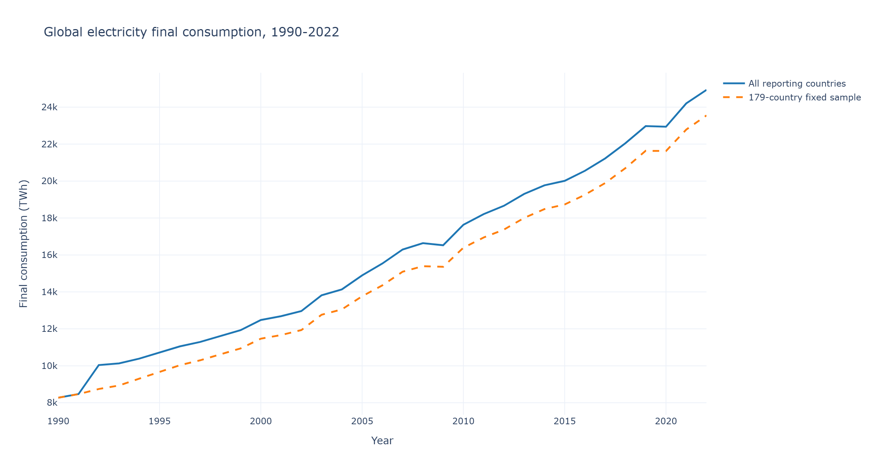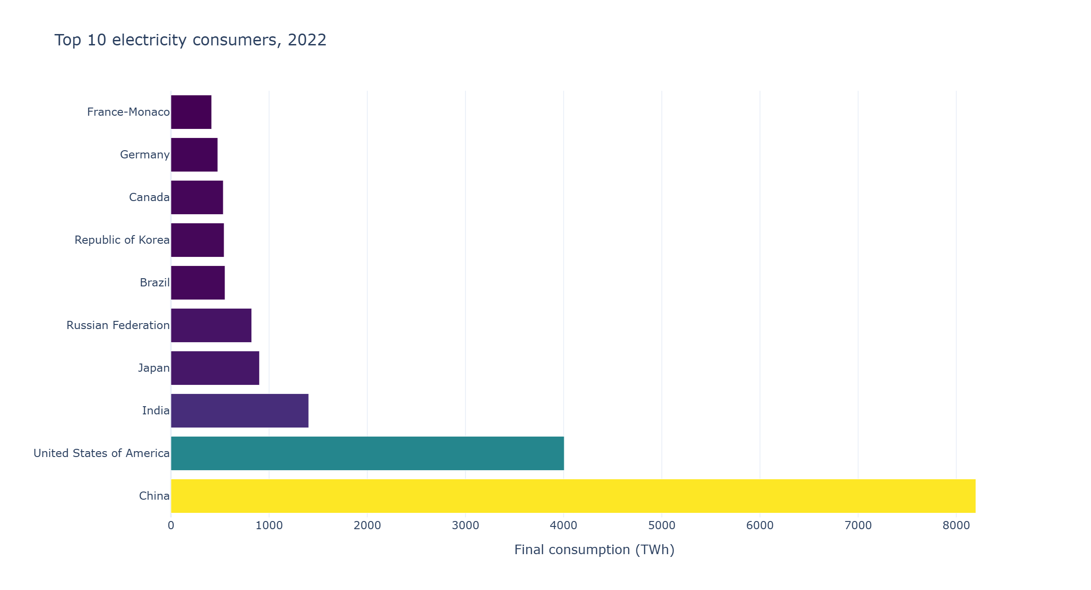

5. Success Criteria and Quality Assurance
The project will be judged by whether the analysis is accurate, reproducible, transparent and understandable to its intended audience. The team will use the following checklist before submission:
CRITERION | EVIDENCE OF SUCCESS
Data quality and coverage | Missing observations, estimates, reporting coverage and source definitions are disclosed for relevant analyses.
EDA completeness | The EDA stage documents dataset structure, descriptive statistics, distributions, missing values, outliers and relevant exploratory patterns; decisions arising from EDA are recorded.
Reproducibility | The Jupyter Notebook runs from a clean restart using the documented Python environment and data-access instructions.
Calculation correctness | Unit conversions are consistent; totals and sector shares are checked; percentages use clearly stated denominators.
Comparability | Source differences, combined territories and sector classification decisions are documented; incompatible measures are not presented as equivalent.
Geospatial accuracy | The two country-level maps render the correct country boundaries and matched consumption values; unmatched or missing countries are disclosed; the 1990 and 2022 maps use clear legends, units, years and sources. Any GeoPlotLib custom-layer implementation is tested and documented, with Plotly available as the choropleth implementation if needed.
Interactive visualisation and dashboard | Plotly charts and maps have clear titles, labels, hover information and usable scales; the Dash dashboard allows users to explore the selected data through interactive controls without obscuring missing values or source limitations.
Visual communication | Every figure has a descriptive title, readable labels, units, year range and source. Scales and colours are consistent and avoid misleading comparisons.
Robustness | Key sector trends are checked on a balanced set of reporting countries where feasible, and selected results are re-examined with estimated observations excluded.
Citations and licences | Datasets, geospatial boundary data and software documentation are cited; source-specific access and redistribution requirements are respected.
Traceability | Reported numbers can be traced to notebook outputs and the corresponding source data and transformations.

Visualisation standards
The team will favour chart types suited to the question: line charts for change over time, horizontal bars for country rankings, 100% stacked bars for composition, slope charts for changes in country shares, and choropleth maps for country-level geographical comparisons. GeoPlotLib will be tested for rendering the country boundary layers and the two consumption maps; if value-based polygon shading requires a custom layer that proves impractical, Plotly will be used to produce the choropleth maps. Folium will provide an alternative rendering of the same country boundaries for web display. Axes will begin at zero where appropriate for magnitude comparisons; percentage charts will clearly state their denominator. Choropleth maps will include a clear legend, units, year and data source, and missing observations will be visually distinguishable from zero values. Where maps for 1990 and 2022 are compared, the colour scale and classification approach will be kept consistent where this supports a fair comparison. Figures will avoid unnecessary decoration and will use accessible, distinguishable colours. These principles are informed by research on graphical perception and effective statistical graphics (Cleveland & McGill, 1984).

6. Team Collaboration and Responsibilities
Each member has a defined role, while major analytical and scope decisions will be discussed collectively and recorded. The designated roles required by the assignment are assigned as follows:
MEMBER | RESPONSIBILITY
UN CHI KIT (mc653081) | Team coordinator and progress tracker: coordinate meetings, maintain the task tracker, monitor deadlines and oversee proposal/project submission.
KELDEN JAMTSHO (mc664183) | Project analyst and quality reviewer: lead analytical planning, review data interpretation and check calculations and outputs before submission.
GAN RUIYAN (mc664801) | Lead project developer: lead data acquisition and preparation workflow, notebook structure and repository organisation.
HE YIFEI (mc664916) | Team reporter and liaison: coordinate communication with the instructor, prepare the written report and support the presentation/video.
SHENG TIAN (mc664961) | Second project developer: develop visualisations and dashboard components and support implementation and testing.
TANG JING (mc666256) | Second project analyst and team scribe: maintain meeting minutes, support the analysis and conduct a second review of figures and results.

Communication and working rules
- The team will hold one scheduled online meeting each week and arrange additional meetings when a milestone requires joint review.
- A shared repository will hold notebooks, documentation, meeting records and permitted derived outputs. Files will follow an agreed naming convention.
- Tasks will be assigned an owner and deadline in the shared progress tracker; members will update task status before weekly meetings.
- Code, data filters, mapping decisions and figure revisions will be documented through version control and concise commit messages.
- The team scribe will record decisions, actions and responsible members. The liaison will communicate instructor questions and feedback to the group.
- Every reported number must be traceable to the analysis notebook. The quality reviewer will check each major deliverable, and the coordinator will confirm completion before submission.

7. Project Timeline
The schedule begins on the proposal submission date, 5 November 2026, and completes the main project activities by 3 December 2026, within the four-week limit. The collaboration record is scheduled for 5 December as a post-project administrative item.
PERIOD | ACTIVITIES AND MILESTONES | LEAD RESPONSIBILITY
Week 1  5–11 Nov | Acquire and document the UNdata, OWID and supplementary national datasets and country boundary data; confirm definitions, licences and coverage; establish the shared repository and Python environment, including pandas, NumPy, GeoPlotLib, Folium, Plotly and Dash; test GeoPlotLib installation and shapefile rendering; complete initial harmonisation and begin EDA. | Analysts and developers; coordinator tracks progress.
Week 2  12–18 Nov | Complete EDA and record data-quality findings; analyse global and regional time trends; calculate growth measures; identify leading consuming countries and compare country shares; begin country-code matching and test the GeoPlotLib approach for country-level map rendering. | Analysts lead; developers support data preparation and figure development.
Week 3  19–25 Nov | Complete sector composition analysis and geospatial analysis; prepare the two world choropleth maps for 1990 and 2022, implementing a GeoPlotLib custom layer if required or using Plotly for polygon shading if necessary; prepare draft figures; develop the contextual generation-mix comparison and initial Plotly/Dash dashboard. Folium maps accompany the static figures. | Analysts and developers; quality reviewer checks results.
Week 4  26 Nov–3 Dec | Complete validation and sensitivity checks; test interactive charts, maps and dashboard; finalise figures, dashboard, report and presentation/video; rehearse and submit the project by 3 December. | Reporter and coordinator coordinate final outputs; all members review.

Weekly coordination: one online team meeting per week, with minutes and action items recorded by the scribe. The coordinator will review the tracker and escalate schedule risks early.
Software implementation note. The tools have distinct roles: GeoPlotLib is the intended Python library for geographical visualisation and shapefile rendering; Plotly is the interactive charting library and can create choropleth maps; Folium is the web-mapping library that renders GeoJSON country layers over OpenStreetMap tiles and provides the year slider for the two world maps; and Dash is the web application framework that brings Plotly figures and interactive controls together in the dashboard. GeoPlotLib documentation describes shapefile rendering and custom layers rather than a dedicated built-in country choropleth function. The team will therefore test the required polygon shading early and use a custom GeoPlotLib layer if feasible; otherwise, Plotly will produce the choropleth maps. The GeoPlotLib package has an older published release, so installation and compatibility will be tested in the project Python environment during Week 1.

8. References
AG Energiebilanzen e.V. (2026). Evaluation tables of the energy balance for Germany: Energy data for the years 1990 to 2024 [Data set]. https://ag-energiebilanzen.de/wp-content/uploads/EBD24e_Auswertungstabellen_english.pdf
Cleveland, W. S., & McGill, R. (1984). Graphical perception: Theory, experimentation, and application to the development of graphical methods. Journal of the American Statistical Association, 79(387), 531–554. https://doi.org/10.1080/01621459.1984.10478080
Csereklyei, Z., Rubio, M. d. M., & Stern, D. I. (2016). Energy and economic growth: The stylized facts. The Energy Journal, 37(2), 223–255. https://doi.org/10.5547/01956574.37.2.zcse
Cuttone, A., Lehmann, S., & Larsen, J. E. (2016). geoplotlib: A Python toolbox for visualizing geographical data [Preprint]. arXiv. https://arxiv.org/abs/1608.01933
Folium Developers. (n.d.). Folium documentation. https://python-visualization.github.io/folium/
General Authority for Statistics. (n.d.-a). Electric energy statistics 2021 [Data set]. https://www.stats.gov.sa/documents/20117/2435259/Electric_Energy_Statistics_2021_En.xlsx_fixed_2485653/4514645a-3dec-cff4-c109-43b1849aa506?t=1734812777295
General Authority for Statistics. (n.d.-b). Electricity energy statistics 2023 [Data set]. https://www.stats.gov.sa/documents/20117/2435281/Electricity_Energy_Statistics_2023_-_EN.xlsx_fixed_2519805/24fd6097-d5da-482-09fd-0c84f3055ec2?t=1739973787411
GeoPlotLib Developers. (n.d.). geoplotlib: Python toolbox for visualizing geographical data [Computer software]. GitHub. https://github.com/andrea-cuttone/geoplotlib
Hunter, J. D. (2007). Matplotlib: A 2D graphics environment. Computing in Science & Engineering, 9(3), 90–95. https://doi.org/10.1109/MCSE.2007.55
McKinney, W. (2010). Data structures for statistical computing in Python. In S. van der Walt & J. Millman (Eds.), Proceedings of the 9th Python in Science Conference (pp. 56–61). https://doi.org/10.25080/Majora-92bf1922-00a
Ministry of Energy and Mineral Resources of the Republic of Indonesia. (2012). Handbook of energy & economic statistics of Indonesia 2012. https://www.esdm.go.id/assets/media/content/content-handbook-of-energy-economic-statistics-of-indonesia-2012-dcexnjb.pdf
Ministry of Energy and Mineral Resources of the Republic of Indonesia. (2018). Handbook of energy & economic statistics of Indonesia 2018 (Final ed.). https://www.esdm.go.id/assets/media/content/content-handbook-of-energy-and-economic-statistics-of-indonesia-2018-final-edition.pdf
NumPy Developers. (n.d.). NumPy documentation. https://numpy.org/doc/
pandas Development Team. (n.d.). pandas documentation. https://pandas.pydata.org/docs/
Plotly Technologies Inc. (n.d.-a). Dash documentation. https://dash.plotly.com/
Plotly Technologies Inc. (n.d.-b). Plotly Python graphing library documentation. https://plotly.com/python/
Python Software Foundation. (n.d.). Python 3 documentation. https://docs.python.org/3/
Ritchie, H., Roser, M., & Rosado, P. (2024). Energy. Our World in Data. https://ourworldindata.org/energy
Service des données et études statistiques. (2026). Chiffres clés de l’énergie: Édition 2026 [Data set]. Ministère de la Transition écologique. https://www.statistiques.developpement-durable.gouv.fr/media/9748/download?inline
State Bank of Pakistan. (n.d.). Energy consumption (Chapter 2.3). In Handbook of statistics on Pakistan economy. https://archive.sbp.org.pk/departments/stats/pakEconomy_HandBook/Chap-2.3.pdf
Stern, D. I. (2011). The role of energy in economic growth. Annals of the New York Academy of Sciences, 1219(1), 26–51. https://doi.org/10.1111/j.1749-6632.2010.05921.x
United Nations Statistics Division. (2025). Energy statistics: Energy balance dataflow (DF_UNData_EnergyBalance) [Data set]. https://unstats.un.org/unsd/energystats/data
Wickham, H. (2014). Tidy data. Journal of Statistical Software, 59(10), 1–23. https://doi.org/10.18637/jss.v059.i10

