Initial exploratory data analysis of ACLED-UCDP conflict trends

Sean Ng

13 June 2024

Table of Contents

# Comparison

### Fatalities

Both ACLED and UCDP data on fatalities are quite highly correlated – in the cases in which there is overlap in reporting.

Of the 10 countries in the Asia-Pacific between 2014 and 2023 for which the data was comparable, 8 had a statistically significant relationship between the number of fatalities reported in the ACLED and UCDP datasets:

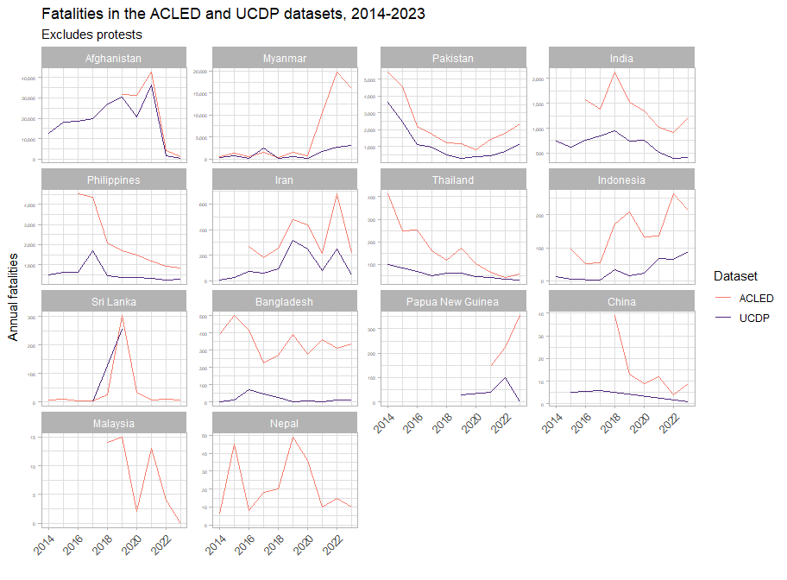

However, we note that the number of conflict fatalities reported by UCDP are consistently lower, due to a number of factors, which we will discuss later.

However, this finding illustrates our hypothesis that even when accounting for ACLED’s broader coverage of event types (protests), UCDP’s coverage of conflicts in the Asia-Pacific is not as comprehensive as that of ACLED.

We don’t really have enough for trends yet, but we can note prominent spikes in fatalities. For instance, Afghanistan had a fairly long lead up to the peak of violence in 2021, the US withdrawal and the subsequent lessening of tensions. Iran saw a spike of violence coinciding with the 2021-2022 Iranian protests. In Thailand, we see a lessening of tensions from the 2014 coup and its fallout, and the state reasserting itself. And the spike in Sri Lanka in 2019 was related to the 2019 Easter Sunday bombings.

### Sources

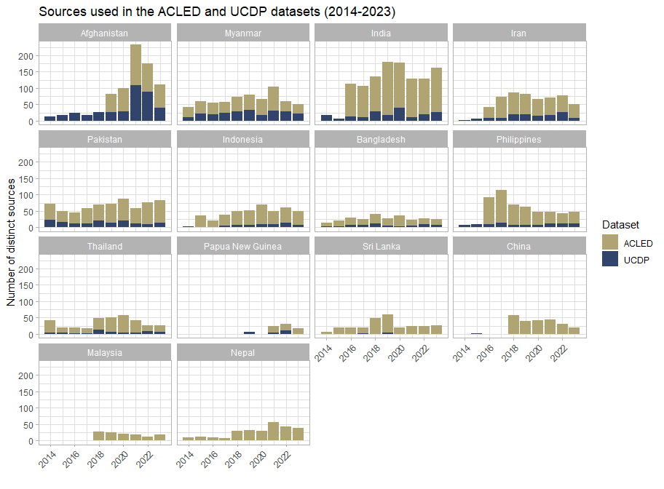

We note that ACLED, in general, draws from a much wider range of sources than UCDP. Additionally, from the treemaps below, we see that not only does ACLED use more sources than UCDP, UCDP is also highly reliant on a relatively small number of sources: the top 10 sources in the UCDP dataset are responsible for 70.68% of all source articles.

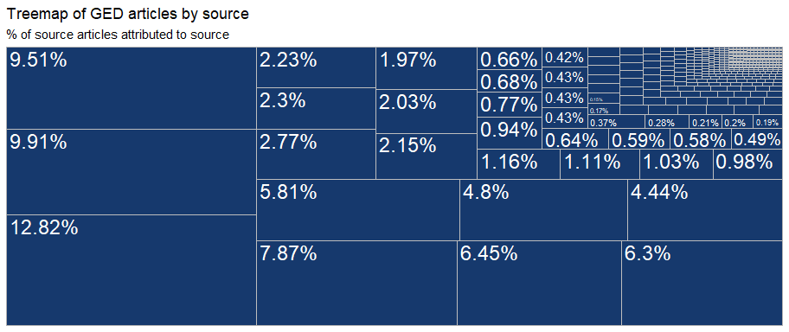

Comparatively, the ACLED dataset is much more diverse. The top 10 sources in ACLED issued 26.26% of all source articles.

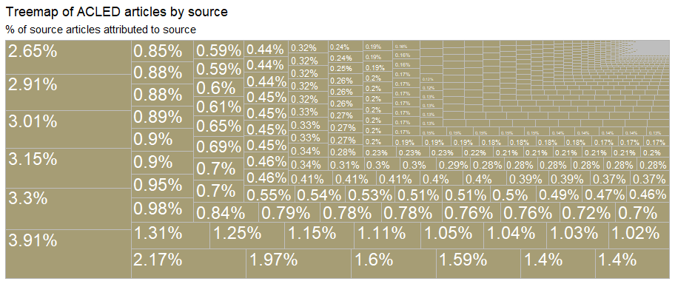

### Types of violence

ACLED is an event-based dataset, as such, comparing event types does not really work out. Instead, we will undertake the comparison using interaction type, which are analogous to UCDP’s type of violence. variable.

| GED_type | ACLED_type | ACLED_fatalities |
| --- | --- | --- |
| State-Based | State Forces Versus Rebels | 129,076 |
| State-Based | State Forces Versus Political Militia | 36,043 |
| State-Based | Other | 2,397 |
| State-Based | State Forces Versus Rioters | 2,269 |
| One-Sided | Political Militia Versus Civilians | 16,408 |
| One-Sided | State Forces Versus Civilians | 15,446 |
| One-Sided | Rebels Versus Civilians | 7,952 |
| One-Sided | Other | 2,990 |
| One-Sided | Rioters Versus Civilians | 1,878 |
| One-Sided | State Forces Versus Protesters | 609 |
| Non-State | Other | 9,106 |
| Non-State | Rioters Versus Rioters | 1,813 |

Overall, there is just much less detail in the UCDP dataset. The map below mirrors another done by [Raleigh, Kishi and Linke](https://www.nature.com/articles/s41599-023-01559-4/figures/1) where they noted that UCDP did not collect data on incidents related to the Philippine drug war.

The plot below already excludes protest events.



### Actors

Perhaps one of the most easily identifiable differences is that conflict actors within the ACLED dataset are classified into broader groups, whereas UCDP data is not, preventing plots like these:

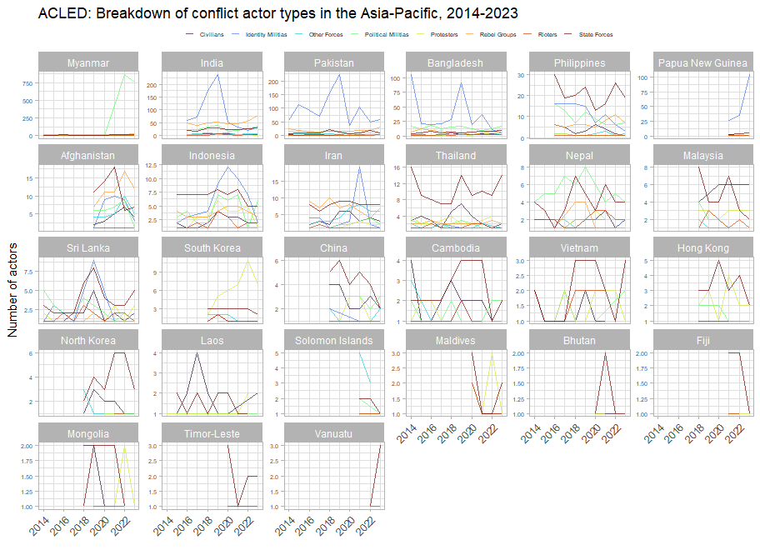

From the plot above, we observe that India, Pakistan, Indonesia, Bangladesh and Papua New Guinea all experience spikes in the activity of identity militias – this group includes a large number of tribal and communal militias.

Myanmar is in open civil war and has seen a massive proliferation of political militias, who, in many cases have broader aims compared to identity militias.

Elsewhere, in Thailand, China and Cambodia, the breakdown of actors shows these countries’ tendencies towards state control.