SDMX-DDI Mapping: FAIR Dissemination Use Case
Arofan Gregory, 7 February 2025

Overview
This document describes the functional requirements for a use case to be addressed by the UN/ECE SDMX-DDI Mapping being undertaken by the Supporting Standards group. It is based on work which has been started in the development of the Cross-Domain Interoperability Framework development, part of the WorldFAIR Project lead by CODATA. In this work, the UN Statistical Division prototyped a service which queried an SDMX web service and transformed the output into CDIF-compliant DDI-CDI form.
This use case is based on the desire for non-statistical agency users to integrate or otherwise use data coming from official statistical sources. This is common in cases where aggregate data are used to contextualize microdata coming from other sources. A typical example can be seen in the European Social Survey: as researchers work with data about social behaviors and attitudes across Europe, it is useful for them to understand the general trends in economics, employment, education, and other factors which are made available by various official statistical sources at a national level.
The needed mappings between SDMX and DDI are driven by the eventual goal of integration, but this use case focuses on the first step of that process: getting the needed aggregate data into a standard form which can then be further processed. This means the translation of structural and conceptual metadata into DDI-CDI, and rendering the data itself into a form which can be usefully described using the DDI-CDI metadata model. This touches on the need to describe data structures based on variables – something which does not natively exist in SDMX aggregate data descriptions, and on the rendering of SDMX data into a text-based form such as CSV, which is already present in the SDMX standard.
Note that there is no requirement here for “round-tripability”: the researcher is satisfied once they have the SDMX aggregates in a form which they can use. They will not be taking their final outputs (e.g., the integrated data set) and describing them in SDMX. While this might be possible, it is beyond the limits of the use case being considered here.
Further, this use case looks at how possible differences in technology platforms can be addressed. While most SDMX web services provide SDMX-ML (an XML expression), most researchers are more comfortable working with an RDF-based syntax expression such as JSON-LD. This use case assumes that these are the technologies involved.

Use Case Workflow Description
The diagram below shows the set of interactions between the counterparties.
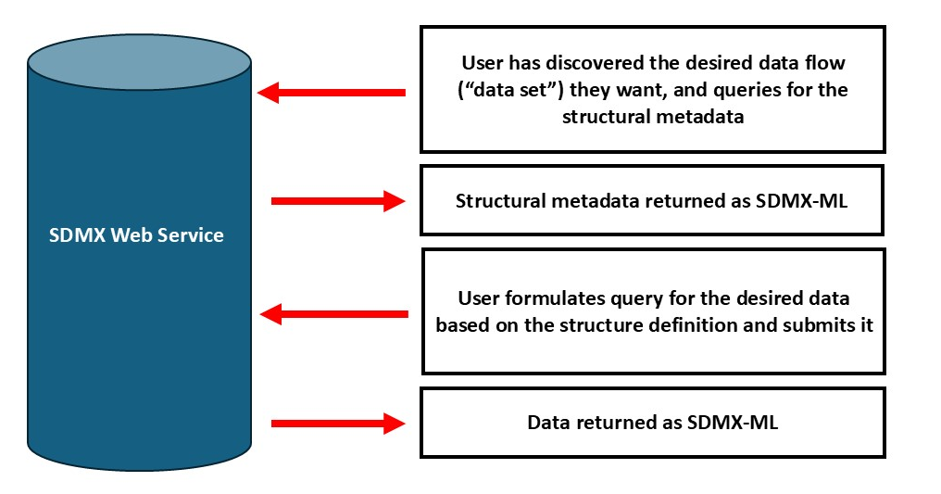
Up to this point, all communications are made using the SDMX standard queries and formats for data and metadata, etc. The user, however, is performing transformations in order to support this exchange, because their systems do not use SDMX natively, but are built on the DDI-CDI model.
The work flow below shows what the user’s system is doing to facilitate the exchanges with the SDMX web service and to produce the outputs they want.
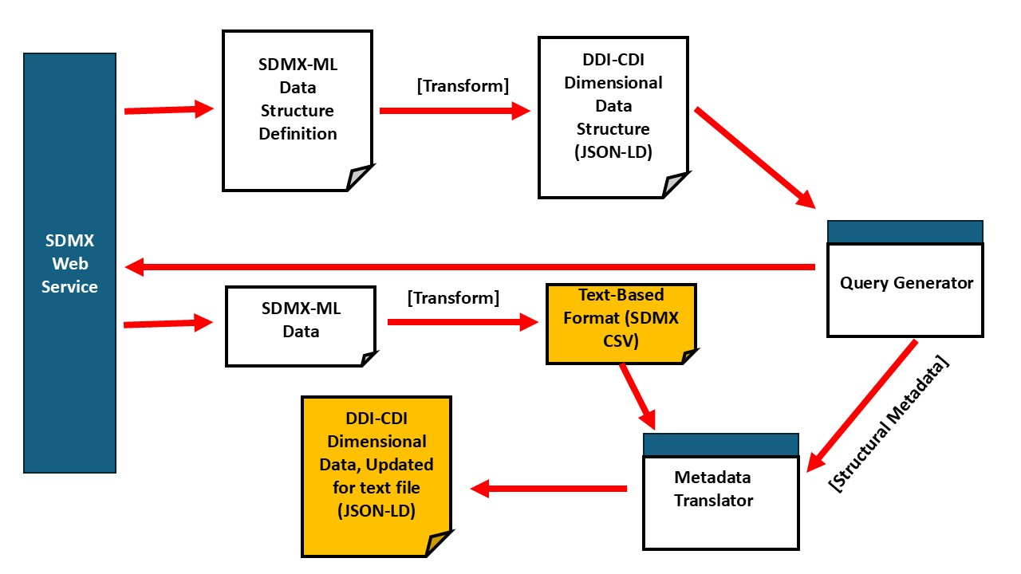
The boxes in yellow are the outputs the user needs to perform their further work (typically integration with other data, also described in DDI-CDI).
The first transformation – going from an SDMX-ML Data Structure Definition to its corresponding DDI-CDI description is at the logical level: it does not provide the location of datums within a data set, since there is at this point no data set to describe. The dimensions, attributes, and measures provided by SDMX are used, as well as the concepts which define them. These all have corresponding classes in DDI-CDI. What is missing, however, are the variables which are required in DDI-CDI. It would be possible to generate these in a minimal form based on what SDMX provides, or – if they already exist, and have standard URIs which can be mapped from or are contained in the SDMX – they could be referenced.
The codelists used by the SDMX data structure definition will also be wanted. In CDIF, these are described using SKOS/XKOS, and might already exist in that form, if the URIs cam be determined. For “pure” DDI-CDI users, these would also need to be transformed, which would require the generation of the concept defining each code (in DDI-CDI, these are termed “categories”). (In DDI-CDI, codelists provide the literal codes, and the categories provide the definitions of the codes – in SDMX these are combined into a single codelist.)
The second transform in the workflow – from SDMX-ML data to a text-based format which can be described using DDI-CDI – is a simpler one. Because DDI-CDI does not have any pre-conception of how such a text file is structured, it would be possible to use existing tools to generate SDMX CSV, which would be an acceptable format. Indeed, this transformation may not even be necessary if the SDMX Web Service is capable of providing the data in the SDMX CSV form.
What is necessary here is the work performed by the “Metadata Translator”, which takes the logical DDI-CDI structural description of the data set, and generates all of the needed additional metadata to show where in the CSV file each variable can be found (that is, which column holds the values for each variable). The data-set-level metadata would also need to be generated, which might require access to the SDMX-ML information contained in the data set (e.g., the data set identifier, date created, etc.)

Considerations
The idea here is that this entire process could be automated, with the human user only needing to indicate what data they desire, once the structural metadata has been obtained and transformed.
It is important to note that – because there is no requirement for round-trippability – the automated generation of minimal variables and categories (if needed) is acceptable. While existing standard ones should be used if possible, the generated ones are “throw-aways” because there will never be a requirement for them to be transformed back into the corresponding SDMX expression. (They will be persisted for provenance reasons, perhaps, by the user, but that is beyond the scope of this use case: the requirement is that the incoming metadata and data can be processed and used in the wanted DDI-CDI JSON-LD/CSV form.) For the purposes of improved data comparability, however it is very desirable to have standard expressions of codelists, concepts, and variables in a native RDF form (that is, with known URIs). This is something already being undertaken by SDMX< so the requirements here should be explored.
Note that this process assumes that the user wants a multi-dimensional data set. While SDMX now supports microdata, that is not what is required for this use case. For this use case, the need is for aggregates.
Real-world examples of this can be seen in the prototype web service developed as part of the UNSD work in WorldFAIR (Gregory, A., Bell, D., Brickley, D., Buttigieg, P. L., Cox, S., Edwards, M., Doug, F., Gonzalez Morales, L. G., Heus, P., Hodson, S., Kanjala, C., Le Franc, Y., Maxwell, L., Molloy, L., Richard, S., Rizzolo, F., Winstanley, P., Wyborn, L., & Burton, A. (2024). WorldFAIR (D2.3) Cross-Domain Interoperability Framework (CDIF) (Report Synthesising Recommendations for Disciplines and Cross-Disciplinary Research Areas) (Version 1). Zenodo. https://doi.org/10.5281/zenodo.11236871, page 80 – ILOStat example) and in the European Social Survey, where many different aggregates from ifficial statistical agencies are used to contextualise the harmonized European microdata (Gregory, A., Hodson, S., & Wackerow, J. (2021). The Role of DDI-CDI in EOSC: Possible Uses and Applications. Zenodo. https://doi.org/10.5281/zenodo.4707263 p. 33)

