 | Views
 | Capability Map Viewpoint - Level 1,2
 | 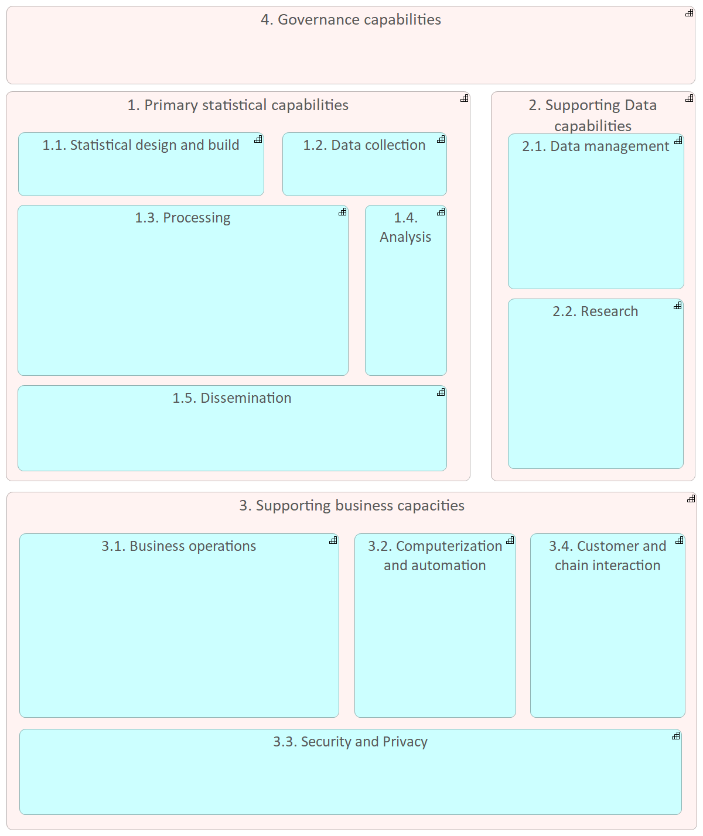
 | Statistical Architecture Framework | 1 | / 24
 | Documentation
A capability map provides a structured, visual overview of the organization’s core abilities required to achieve its mission of producing and disseminating official statistics. This map displays capabilities as stable, business-centric building blocks, grouped to align with strategic goals and is useful to highlight areas for development and investment.
A capability map helps a statistical bureau assess and communicate its strengths, gaps, and areas needing improvement to support organizational objectives such as delivering high-quality, timely statistics, maintaining the trust of data providers, and promoting innovation in data processing.
 | Statistical Architecture Framework | 2 | / 24
 | Capability Map Viewpoint - Level 1,2,3
 | 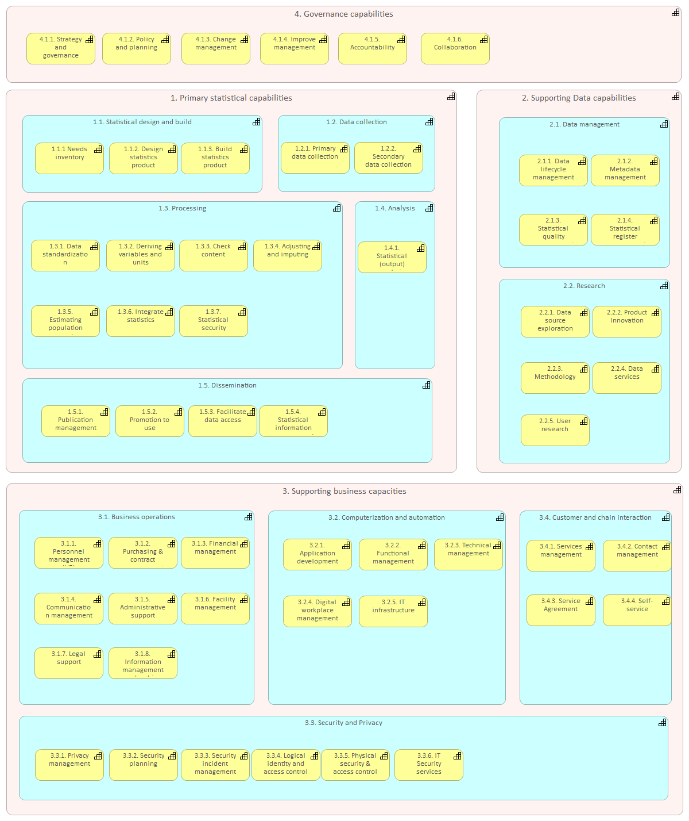
 | Statistical Architecture Framework | 3 | / 24
 | Documentation
A capability map provides a structured, visual overview of the organization’s core abilities required to achieve its mission of producing and disseminating official statistics. This map displays capabilities as stable, business-centric building blocks, grouped to align with strategic goals and is useful to highlight areas for development and investment.
A capability map helps a statistical bureau assess and communicate its strengths, gaps, and areas needing improvement to support organizational objectives such as delivering high-quality, timely statistics, maintaining the trust of data providers, and promoting innovation in data processing.
 | Statistical Architecture Framework | 4 | / 24
 | SAF Drivers
 | 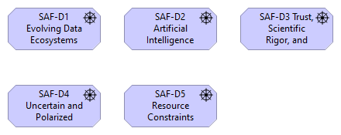
 | Documentation
Architecture drivers are the forces that make change necessary. They capture the pressures, trends, and constraints that statistical offices face and which the SAF is designed to address. Drivers can be external, such as technological advancements or new regulations, or internal, such as the need to replace legacy systems or respond to stakeholder demands. By documenting these drivers, SAF ensures that its architecture is not an abstract ideal but a practical response to real-world challenges.
For statistical organizations, these drivers are particularly intense. Rapid technological change requires continuous adaptation, while political and societal pressures demand timely, relevant, and transparent data. At the same time, many organizations face limited budgets and must balance modernization with cost control. Recognizing these drivers helps statistical offices prioritize investments and avoid the pitfalls of reactive decision-making, where short-term fixes can lead to long-term inefficiencies.
Including architecture drivers in the framework also strengthens communication with stakeholders. By clearly articulating the external and internal factors shaping architecture, CIOs, CTOs, and enterprise architects can build a stronger case for change, justify strategic initiatives, and ensure that all parties understand the urgency of modernization. In this way, SAF creates a shared understanding of why action is necessary and what risks are avoided by adopting a structured framework.
 | Statistical Architecture Framework | 5 |  | / 24
 | SAF Goals
 | 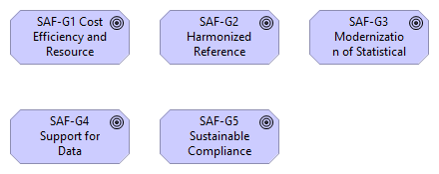
 | Documentation
Architecture goals represent the outcomes an organization aims to achieve by adopting and implementing the framework. They define what success looks like and serve as the link between strategy and action. In the case of the SAF, these goals are not just about modernizing IT systems, but about ensuring that national statistical institutes can continue to provide trustworthy, relevant, and high-quality statistics in a rapidly changing environment.
The goals of SAF address both operational and strategic needs. On one hand, they focus on efficiency, modernization, and compliance, which are essential for ensuring sustainability. On the other hand, they support innovation, adaptability, and collaboration, enabling statistical offices to embrace new opportunities such as integrating alternative data sources or experimenting with advanced analytics. Together, these goals ensure that modernization efforts do not compromise the fundamental values of official statistics — neutrality, accuracy, and reliability.
By defining goals explicitly, SAF provides a roadmap that can be adapted by each statistical organization according to its maturity and local context. This ensures that while each office may have unique challenges and resources, they are all working toward a shared vision that promotes harmonization, comparability, and global collaboration in official statistics.
 | Statistical Architecture Framework | 6 |  | / 24
 | SAF Meaning
 | 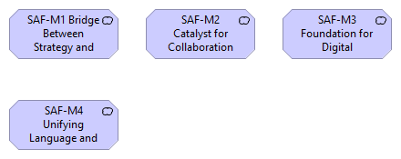
 | Documentation
Architecture meaning provides the “why” behind the framework. While goals and outcomes describe what SAF achieves, meaning explains why it matters. For statistical organizations, architecture is not just a technical exercise but a way of ensuring their continued relevance in a digital society. SAF’s meaning lies in its role as the foundation for modernization, trust, and international collaboration.
One dimension of this meaning is its role as a bridge between strategy and technology. Without such a framework, investments in IT risk being disconnected from the mission of providing high-quality statistics. SAF ensures that every technological decision — from adopting a new platform to restructuring business processes — can be traced back to strategic objectives, creating a coherent organizational narrative.
Another dimension is collaboration. The meaning of SAF extends beyond individual organizations: it is a unifying language for the UNECE statistical community. By providing shared models, practices, and principles, SAF fosters international collaboration, reduces duplication, and amplifies collective impact. In this sense, SAF is not just meaningful to IT professionals but to the broader community of statisticians, policymakers, and citizens who depend on trustworthy statistics.
 | Statistical Architecture Framework | 7 |  | / 24
 | SAF Outcomes
 | 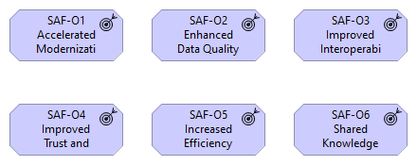
 | Documentation
Architecture outcomes describe the tangible benefits that organizations can expect when adopting SAF. They translate principles, goals, and drivers into measurable impacts such as improved interoperability, reduced costs, and enhanced data quality. Outcomes are critical for demonstrating the value of architecture to stakeholders, as they provide a clear “return on investment” for adopting the framework.
In the SAF, outcomes are both technical and societal. On the technical side, NSIs benefit from streamlined processes, better metadata management, and more efficient system development. On the societal side, SAF supports trust, transparency, and comparability of statistics, which are essential for informed policy-making and democratic accountability. This dual perspective ensures that SAF delivers benefits beyond IT, directly supporting the mission of statistical organizations.
By emphasizing outcomes, SAF also reinforces a culture of continuous improvement. Outcomes are not static — they evolve as organizations mature and as new challenges emerge. Making outcomes explicit allows NSIs to assess progress, measure success, and adjust their modernization strategies in line with both internal priorities and external demands.
 | Statistical Architecture Framework | 8 |  | / 24
 | SAF Principles
 | 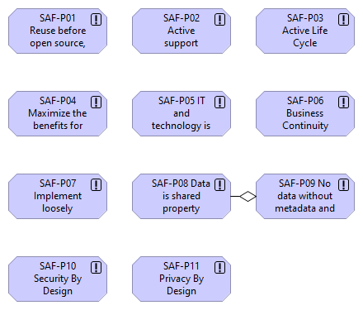
 | Documentation
Architecture principles are the basis for any enterprise architecture framework. They provide the guiding rules and fundamental truths that define the way organizations design, implement, and manage their IT landscapes. In the context of official statistics, principles are particularly important because they ensure consistency across an interconnected environment.
For the SAF, architecture principles act as a compass for decision-making. They ensure that whenever there is a choice to be made between technologies, processes, or solutions, decisions are not taken in isolation but in accordance with the overarching vision of the statistical community. They also prevent short-term convenience from undermining long-term sustainability, a challenge that statistical offices often face given their reliance on legacy systems and resource constraints.
These principles also provide an element of accountability. When stakeholders understand the principles behind architectural decisions, it becomes easier to justify investments, explain trade-offs, and demonstrate that architecture is not a purely technical exercise but a strategic enabler of the organization’s mission. In this way, principles make architecture transparent, predictable, and anchored in trust.
 | Statistical Architecture Framework | 9 |  | / 24
 | Statistical Architecture Framework | 10 | / 24
 | SAF Stakeholders
 | 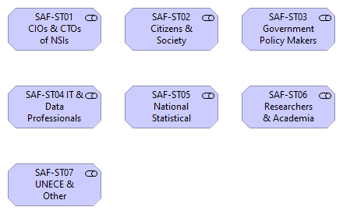
 | Documentation
Architecture is never developed in isolation. Stakeholders — the individuals, groups, or organizations that influence or are influenced by architecture — are central to its success. In the SAF, stakeholders range from technical experts and CIOs within NSIs to international organizations, policymakers, researchers, and ultimately, society at large. Each of these stakeholders has unique interests, expectations, and contributions, and the framework must balance these to be effective.
Identifying stakeholders clarifies who should be involved in governance, decision-making, and implementation. For example, IT professionals are responsible for translating SAF principles into concrete systems, while policymakers are concerned with the outcomes those systems enable. International organizations such as UNECE play a custodial role, ensuring that SAF remains harmonized and relevant across countries. By mapping these roles, SAF ensures that no perspective is overlooked and that architecture decisions are inclusive and robust.
Engaging stakeholders also strengthens legitimacy. When those affected by architecture decisions are part of the conversation, they are more likely to support the outcomes. For statistical organizations, where public trust is essential, engaging stakeholders such as researchers, academia, and citizens indirectly ensures that the architecture remains aligned with societal expectations of transparency, security, and fairness.
 | Statistical Architecture Framework | 11 |  | / 24
 | Statistical Architecture Framework | 12 | / 24
 | SAF Value
 | 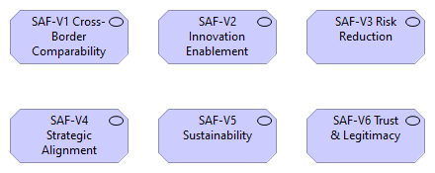
 | Documentation
The value of architecture lies in the benefits it creates for stakeholders. While outcomes describe specific impacts, value captures the broader, long-term importance of SAF to statistical organizations and society. It is about demonstrating that investing in architecture is not merely a technical necessity but a strategic decision that creates trust, efficiency, and sustainability.
For NSIs, the value of SAF includes reduced risks, greater agility, and improved alignment between IT and business objectives. For international organizations, it provides harmonization and comparability, enabling more effective collaboration across borders. For citizens and policymakers, the value lies in the trustworthiness of the statistics produced, ensuring that public policy and democratic processes are grounded in reliable data.
Value is also about sustainability. Without a framework, modernization efforts can be fragmented, costly, and short-lived. SAF provides a stable foundation that reduces technical debt, improves governance, and ensures that investments yield long-term benefits. In doing so, it secures the role of statistical organizations as trusted institutions in the digital age.
 | Statistical Architecture Framework | 13 |  | / 24
 | Value Stream to Process Realization View
 | Statistical Architecture Framework | 14 | / 24
 | VS-01.0 Data Acquisition and Ingestion Value Stream
 | 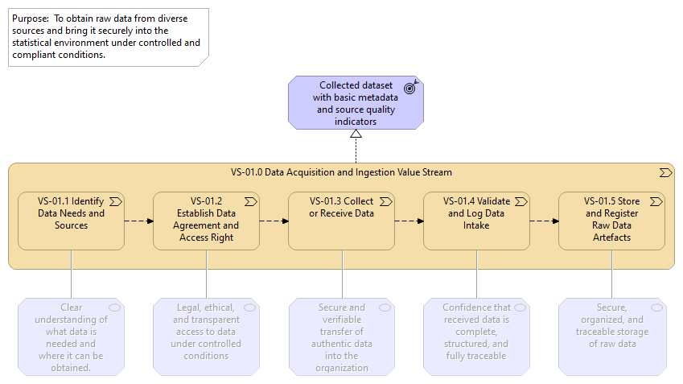
 | Statistical Architecture Framework | 15 | / 24
 | VS-02.0 Data Standardization and Integration Value Stream
 | 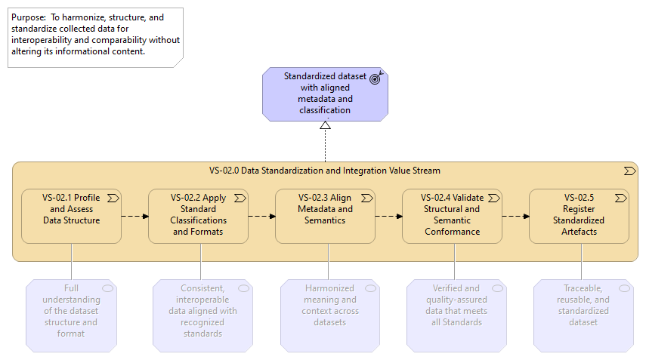
 | Statistical Architecture Framework | 16 | / 24
 | VS-03.0 Data Editing and Enrichment Value Stream
 | 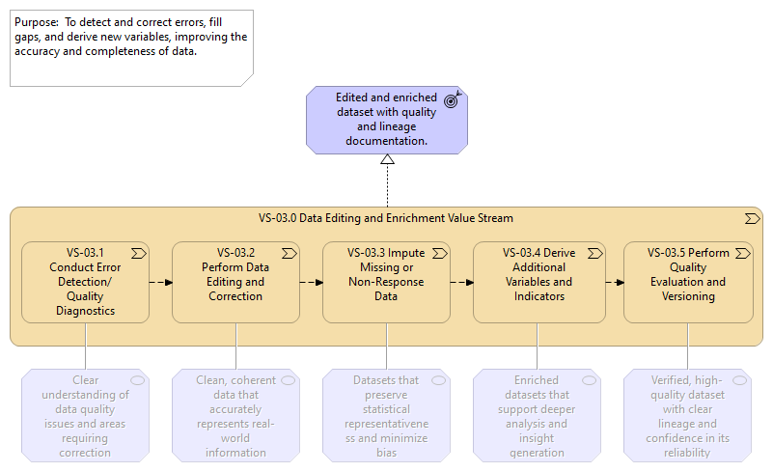
 | Statistical Architecture Framework | 17 | / 24
 | VS-04.0 Estimation, Analysis, and Statistical Modeling Value Stream
 | 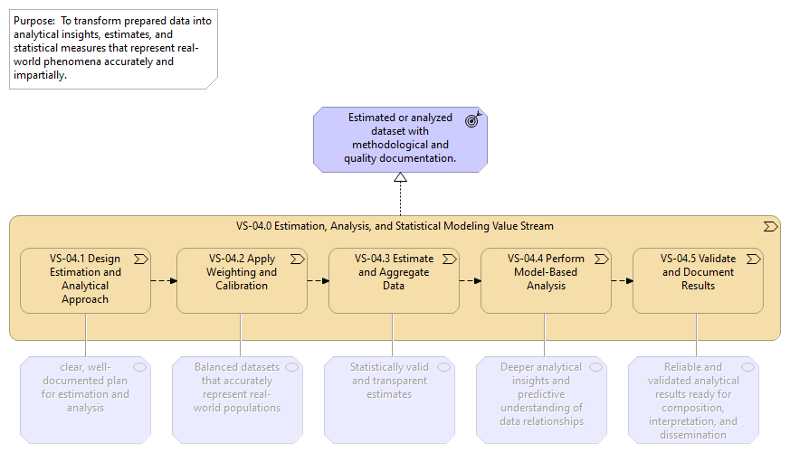
 | Statistical Architecture Framework | 18 | / 24
 | VS-05.0 Statistical Product Composition Value Stream
 | 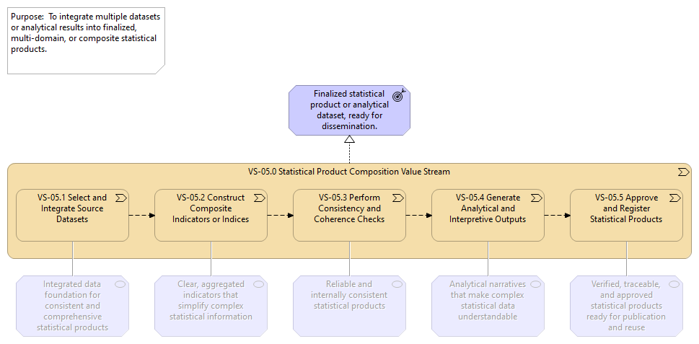
 | Statistical Architecture Framework | 19 | / 24
 | VS-06.0 Dissemination and Service Delivery Value Stream
 | 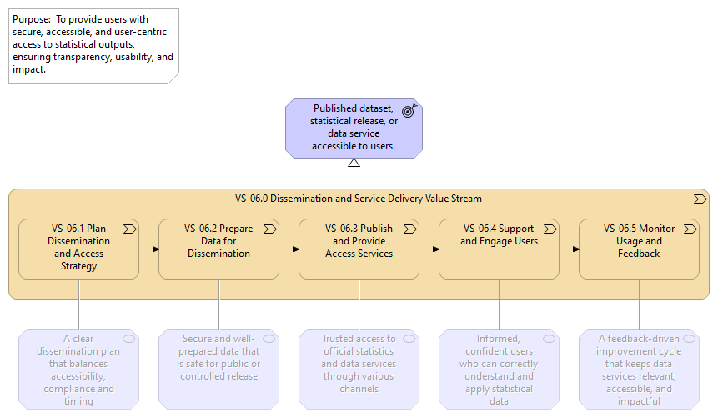
 | Statistical Architecture Framework | 20 | / 24
 | VS-07.0 Supporting Value Stream: Governance and Compliance
 | 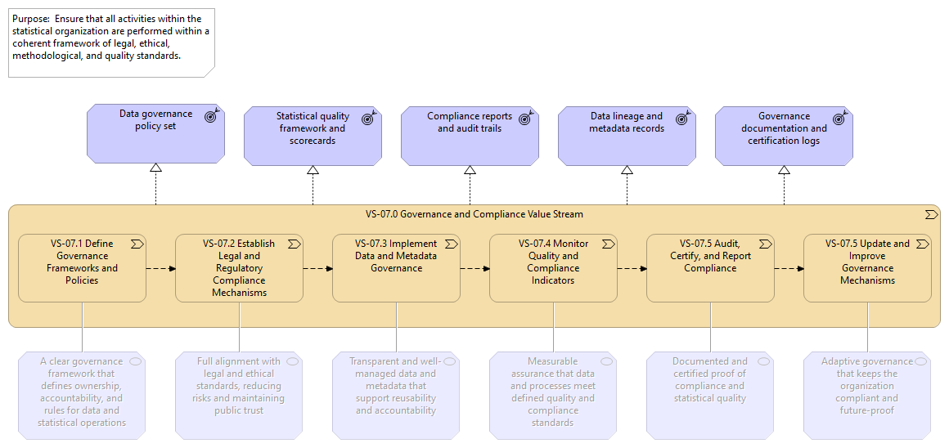
 | Statistical Architecture Framework | 21 | / 24
 | VS-08.0 Supporting Value Stream: Innovation and Methodological Development
 | 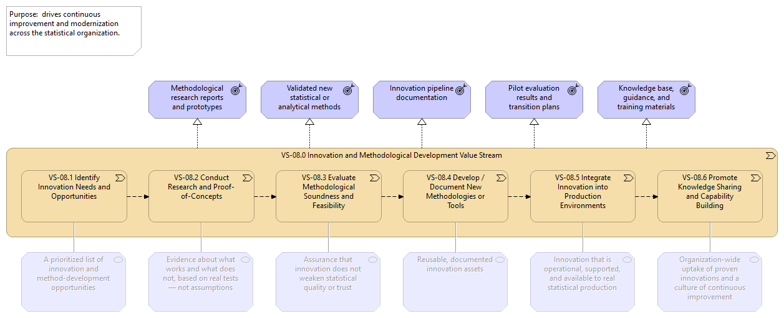
 | Documentation
 | Statistical Architecture Framework | 22 | / 24
 | VS-09.0 Supporting Value Stream: Infrastructure and Platform Enablement
 | 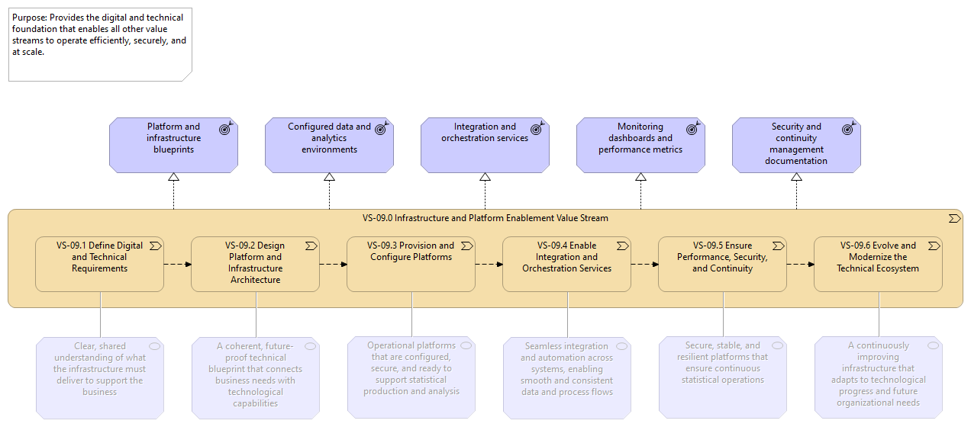
 | Statistical Architecture Framework | 23 | / 24
 | VS-10-0 Supporting Value Stream: Customer and Stakeholder Engagement
 | 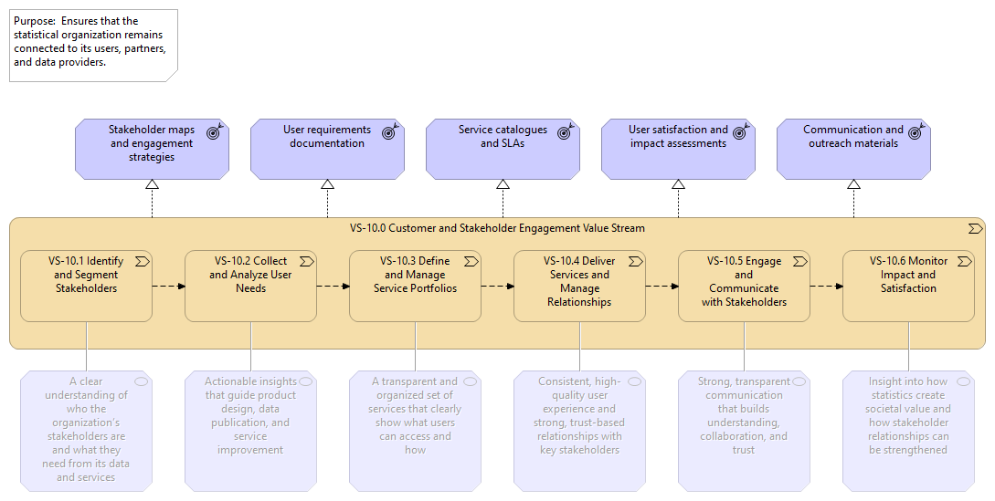
 | Documentation
 | Statistical Architecture Framework | 24 | / 24

