**Hydroinformatics**

**Exercise**

**Modelling Systems Development**

Development of a simple hydrological modelling system

# Introduction

In this exercise you will be using the Python code implementing the *lumped conceptual model HBV*, and updating it to be able to analyse the water balance, groundwater contribution as well as to evaluate the model performance. The result will be a simple *hydrological* *modelling system*.

**After this workshop, you are able to**

* Build graphical user interface for the hydrological model (HBV)
* Develop visualization and data analysis tools
* Perform analysis of water balance in a hydrological model

**HBV Model**

Lumped conceptual rainfall-runoff model, commonly used for forecasting in Europe. There is also a version implementing a semi-distributed conceptual model (not used in this exercise). The main equation used follows:



P = Precipitation

E = Evapotranspiration

Q = Discharge

SP = Snow Pack

SM = Soil Moisture

UZ = Upper zone

LZ = Lower zone

Required data inputs (hourly or daily) include:

* Precipitation (maximum end-of-winter SWE and summer precipitation)
* Air temperature
* Evapotranspiration (pan evaporation or estimated) daily or monthly

Routines include:

* Snow
* Soil Moisture Accounting
* Response
* Transformation

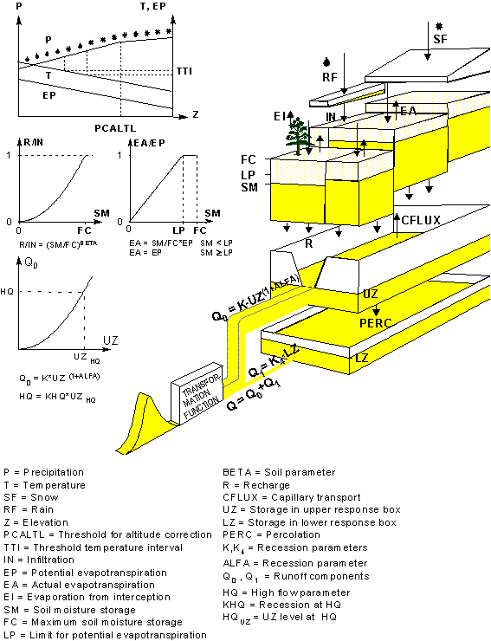

Figure 1 HBV model

**Tasks in this exercise:**

You are given the whole code of the HBV model. You will be adding components to this code, including the GUI, aiming at building a *modelling system*. This system will allow you to analyse the model results and the state variables (Q, UZ, LZ, Ea). The main goal is to interpret, modify the code and include it in your GUI so it can be run as many times as needed.

Data for calibrating your model is given as well.

**Description of the activities**

* Main functions to be implemented in the modelling system:
  + Reading the data from a file
  + Plotting the data and to visualize boxes with parameters of the mode
  + To deal with the ranges of the model parameters
  + Interface options to run the model, to calibrate the model
  + Visualizing the model results and model states (Q, Ground water, UZ and LZ)
* Open the HBV96.py file and make an overview of which functions can be interpreted from the theoretical concepts given in the class.
  + Identify
    - Parameters of the mode
    - Ground water system levels

**Some steps to follow after the design of your system is ready**

Create a folder where your GUI will be.

Place in that folder the sample data

Type guide and add components from the designed made in the previous instructions

Copy the model function

Create a script to run the HBV code

* 1. In this script make the changes from Python to update parameters
  2. Make sure the inputs and output results are working fine with the data
  3. Create a structure that contains all the parameters of the model and its time series.
  4. Look at your GUI design and look for the events object needed to read, write, run and then to plot
  5. Add a visualization plot into the axes created in the GUI (Q, UZ, LZ, Ea). Make it interactive.
  6. Go through the options and improve the functionality of the code (slide bar)
  7. Explore what does the user need to calibrate the model with this interface.
  8. Optional (Add an uncertainty module, and animations if possible).

**Submission**

This exercise will be integrated into the report for Friday 10 of February.