GitHub Flow Strategy

(https://guides.github.com/introduction/flow/)

GitHub.com

Master

Branch: dev

Origin

Clone a repository:

* On the command Git Bash prompt:
  + git clone [https://<GITUSERID>@github.com/UNH-COMP830/Core.git](https://%3cGITUSERID%3e@github.com/UNH-COMP830/Core.git)

Steps:

1. view branches:
   1. git branch -a
2. change branch
   1. git checkout development

Master

Branch: dev

Origin

1. make changes locally then add then commit them to the local branch
   1. git add <source file>
   2. git commit -m “Story#”

Master

Add and commit

Origin

1. push your changes to github
   1. git push

Master

Branch: Dev

Github.com/Origin

Master

Branch: Dev

Local

1. View changes and pull request change to GitHub “development” branch
   1. Click the compare & pull request

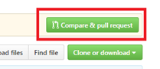

Master

Branch: Dev

Github.com/Origin

1. Create a pull request change to GitHub “development” Initialization branch
   1. Click Assign reviewers for request
   2. Create Pull request

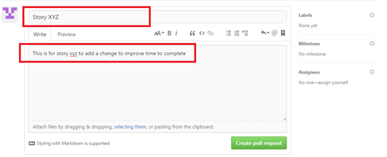

Create Pull Request

Assign reviewers for Pull Request

1. Merge a pull request change to GitHub “Development” branch
   1. Click the compare & pull request

Master

Branch: Dev

Github.com/Origin

Other useful Commands

How to create a new branch:

1. First, you create your branch locally:
   1. git checkout -b <branch-name>
2. The remote branch is automatically created when you push it to the remote server. So when you feel ready for it, you can just do:
   1. git push <remote-name> <branch-name>
      1. <remote-name> is typically origin

View changes:

# show differences between index and working tree

# that is, changes you haven't staged to commit

git diff [filename]

# show differences between current commit and index

# that is, what you're about to commit

git diff --cached [filename]

# show differences between current commit and working tree

git diff HEAD [filename]

git status

undo an add:

|  |
| --- |
| git reset filename.txt  Will remove a file named filename.txt from the current index, the "about to be committed" area, without changing anything else.  To undo git add . use git reset (no dot). |