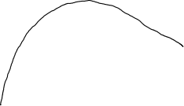

Moving obstacles

Robot

Static obstacles

Goal

Start