ALP Module – User Manual
BMA Platform – Accelerated Learning Programme
For school focal points running the Accelerated Learning Programme
Last updated: 26 October 2026
Version 1.0

Contents
1. Getting Started – Login and Navigation
2. The Student List
3. Registering a Student
4. The Student Profile
5. Student Attendance
6. Teacher Attendance
7. Teachers
8. Grading
9. School Profile
10. Dashboards
11. Your Account
12. Frequently Asked Questions

This manual explains, step by step, how to use the ALP (Accelerated Learning Programme) module of the BMA platform. It is written for the school focal points who register ALP students, record daily student and teacher attendance, enter grades, maintain the school profile and consult the dashboards.
ALP records belong to a school. Your account is linked to one school and you only see and edit the data of that school. If the lists stay empty and a warning is shown, your account is not yet linked to a school: ask your administrator.
Each step is illustrated with a screenshot taken from the system. The data shown is demonstration data only.

1. Getting Started – Login and Navigation
Open Google Chrome or Mozilla Firefox and go to the platform address given to you by your coordinator. Accounts are created by the system administrator; there is no self-registration.
1. Open the login page and enter your username and password.
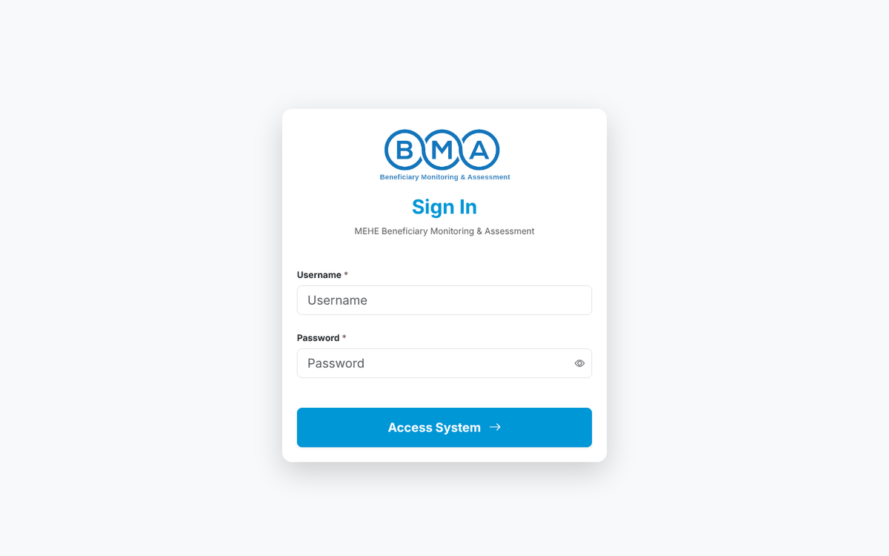
Figure 1 – The login page
2. Click Sign in. ALP users are taken straight to the ALP home page.
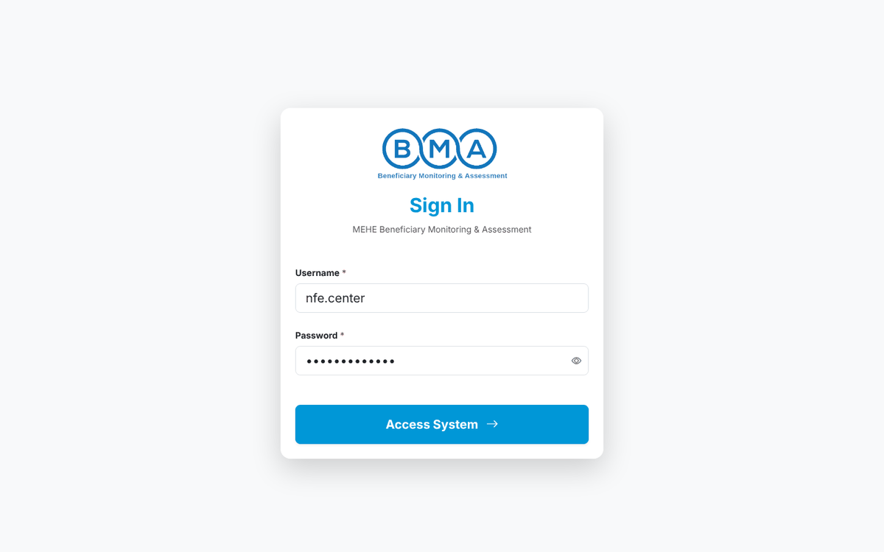
Figure 2 – Login form with the credentials filled in
3. The home page shows today's and this week's registrations, the schools reporting, the average attendance of the month, a 14-day registration trend and the recent exports. The quick action cards open New Registration, Beneficiary List and Track Attendance.
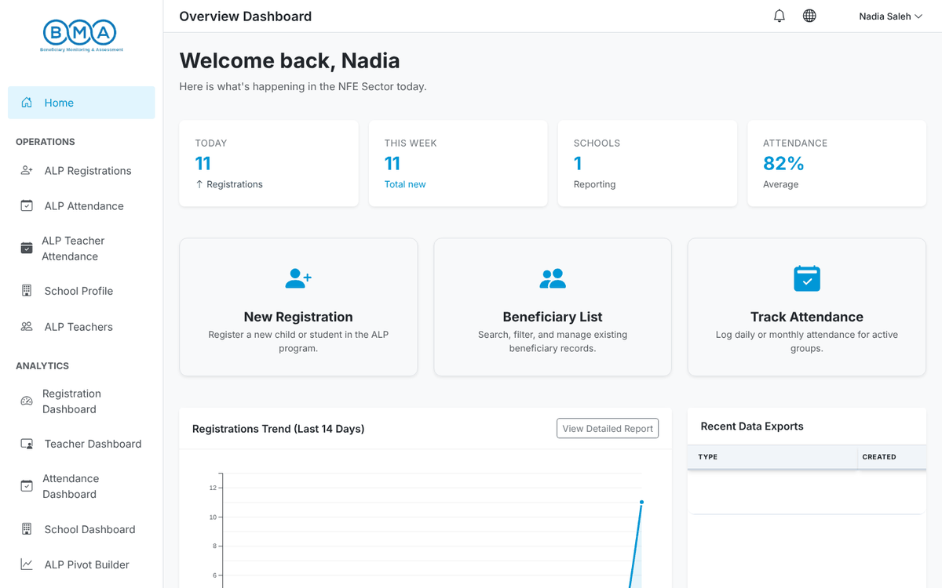
Figure 3 – The ALP home page
4. To change the language click the globe icon in the top bar and choose English or العربية.
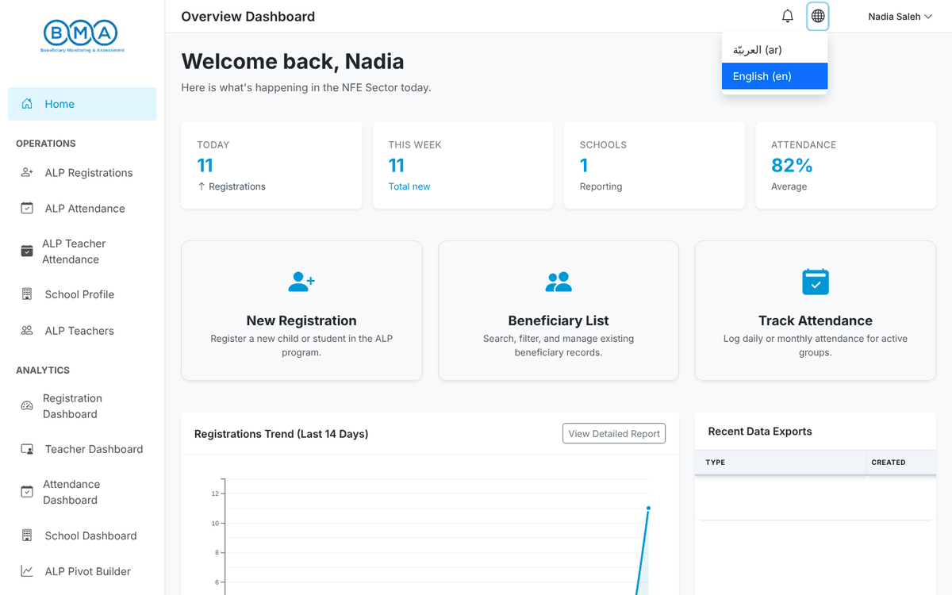
Figure 4 – Language menu
5. Click your name in the top-right corner for Profile, Change Password and Logout.
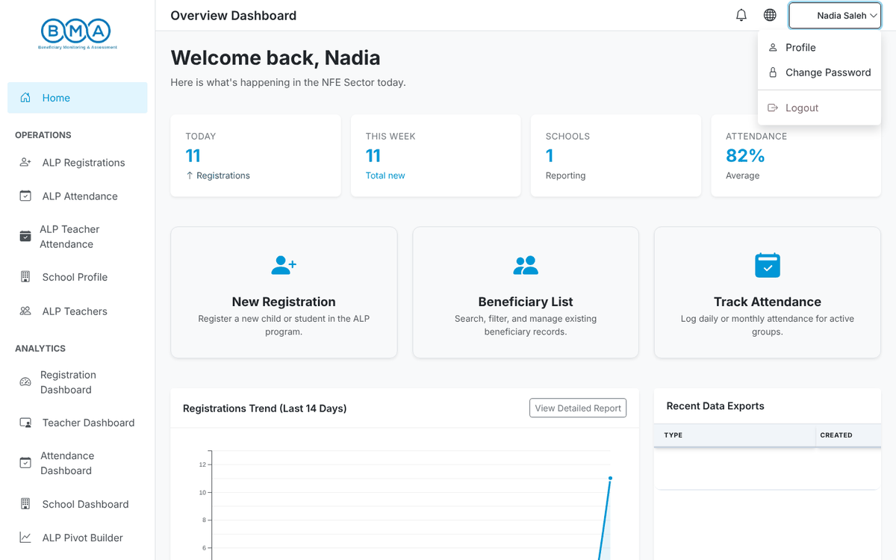
Figure 5 – User menu

The side menu
Menu entry | What it opens
Home | The ALP home page
ALP Registrations | The student list, the registration form and the student profiles
ALP Attendance | Daily student attendance
ALP Teacher Attendance | Daily teacher attendance
School Profile | Your school record
ALP Teachers | The teacher list and the teacher form
Registration Dashboard | Registration counts and learning outcomes
Teacher Dashboard | Teacher demographics, assignments and training
Attendance Dashboard | Attendance heatmap over the year
School Dashboard | Map of the ALP schools
ALP Pivot Builder | Build your own cross-tabulations
User Guide | The documentation inside the system

Note: The system logs you out automatically after a period of inactivity. Save your work regularly.

2. The Student List
Open ALP Registrations in the side menu. The list shows every student registered in your school.
1. Each row shows the registration ID, names, school, academic year (round), programme and section. Click a column header to sort. The three icons in the Actions column open the profile, edit the registration or delete it.
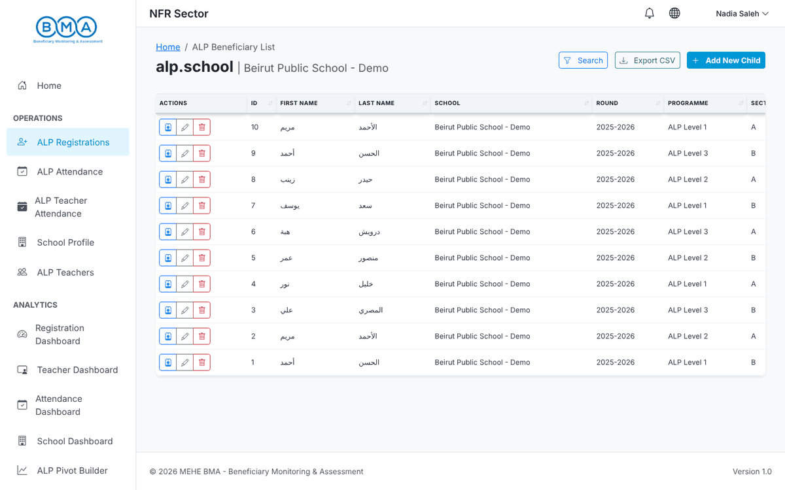
Figure 6 – The ALP student list
2. Click Search to filter by name, academic year, programme, section or date, then Apply Filters.
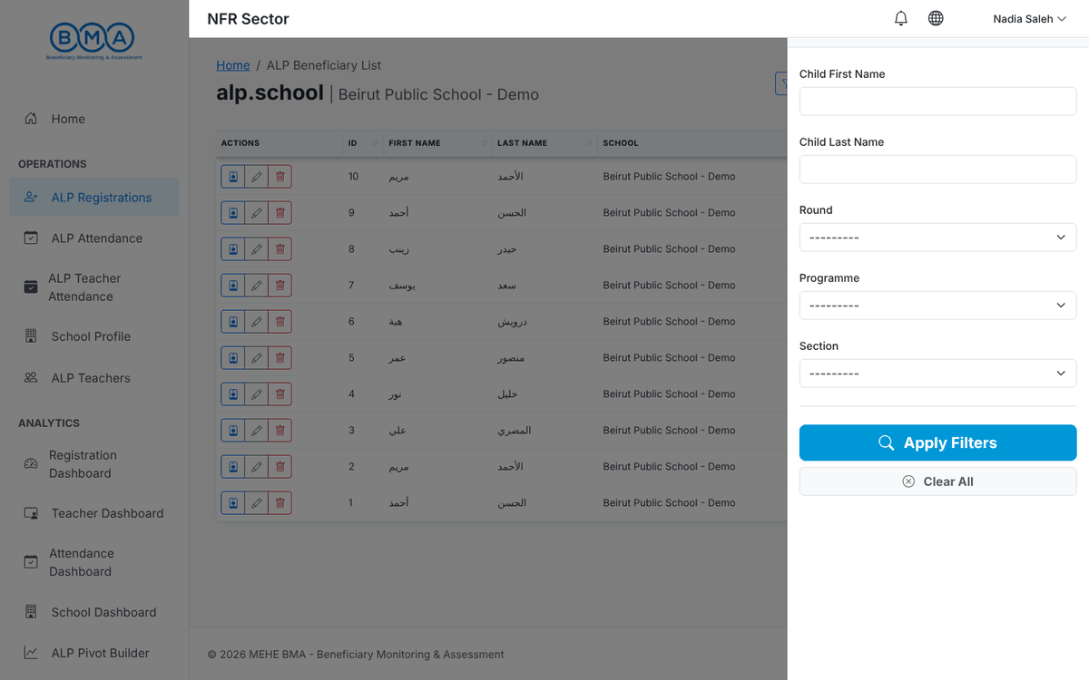
Figure 7 – The search panel
3. Export CSV downloads the current list as a CSV file (UTF-8, Arabic names open correctly in Excel). Add New Child opens the registration form.

3. Registering a Student
Registration uses a 3-step wizard: Identity, Caregivers and ALP Enrolment. The student is saved only when you click Complete Registration on the last step. Fields marked with a red asterisk (*) are mandatory. Names must be written in Arabic letters.
While you type the name and date of birth, the Potential Matches panel checks for an existing child. If a match is shown, review it before continuing instead of creating a duplicate.

Step 1 – Identity, status and background
1. Fill in the Basic Identity Information: photo (optional), first, father and family name, date of birth, gender, mother's full name and nationality.
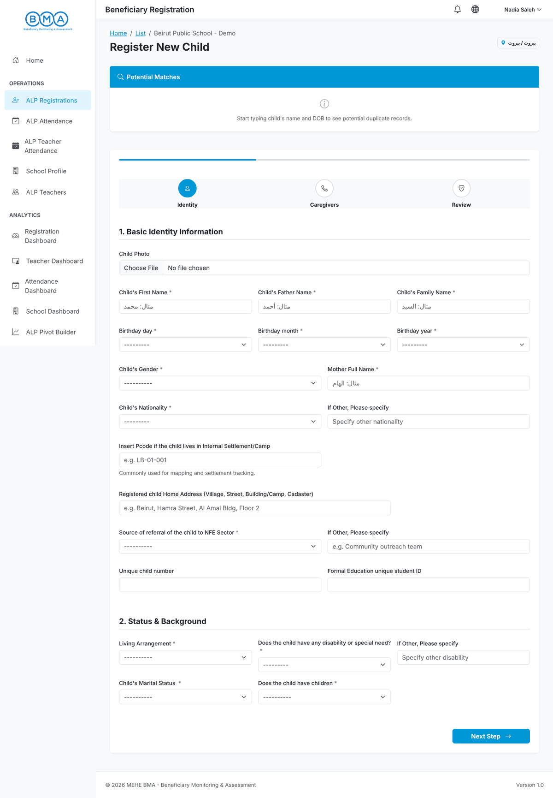
Figure 8 – Step 1 – identity
2. Fill in Status & Background: P-code and home address (optional), source of referral to the NFE sector, unique child number, formal education unique ID, living arrangement, disability, marital status and whether the child has children. Then click Next Step.
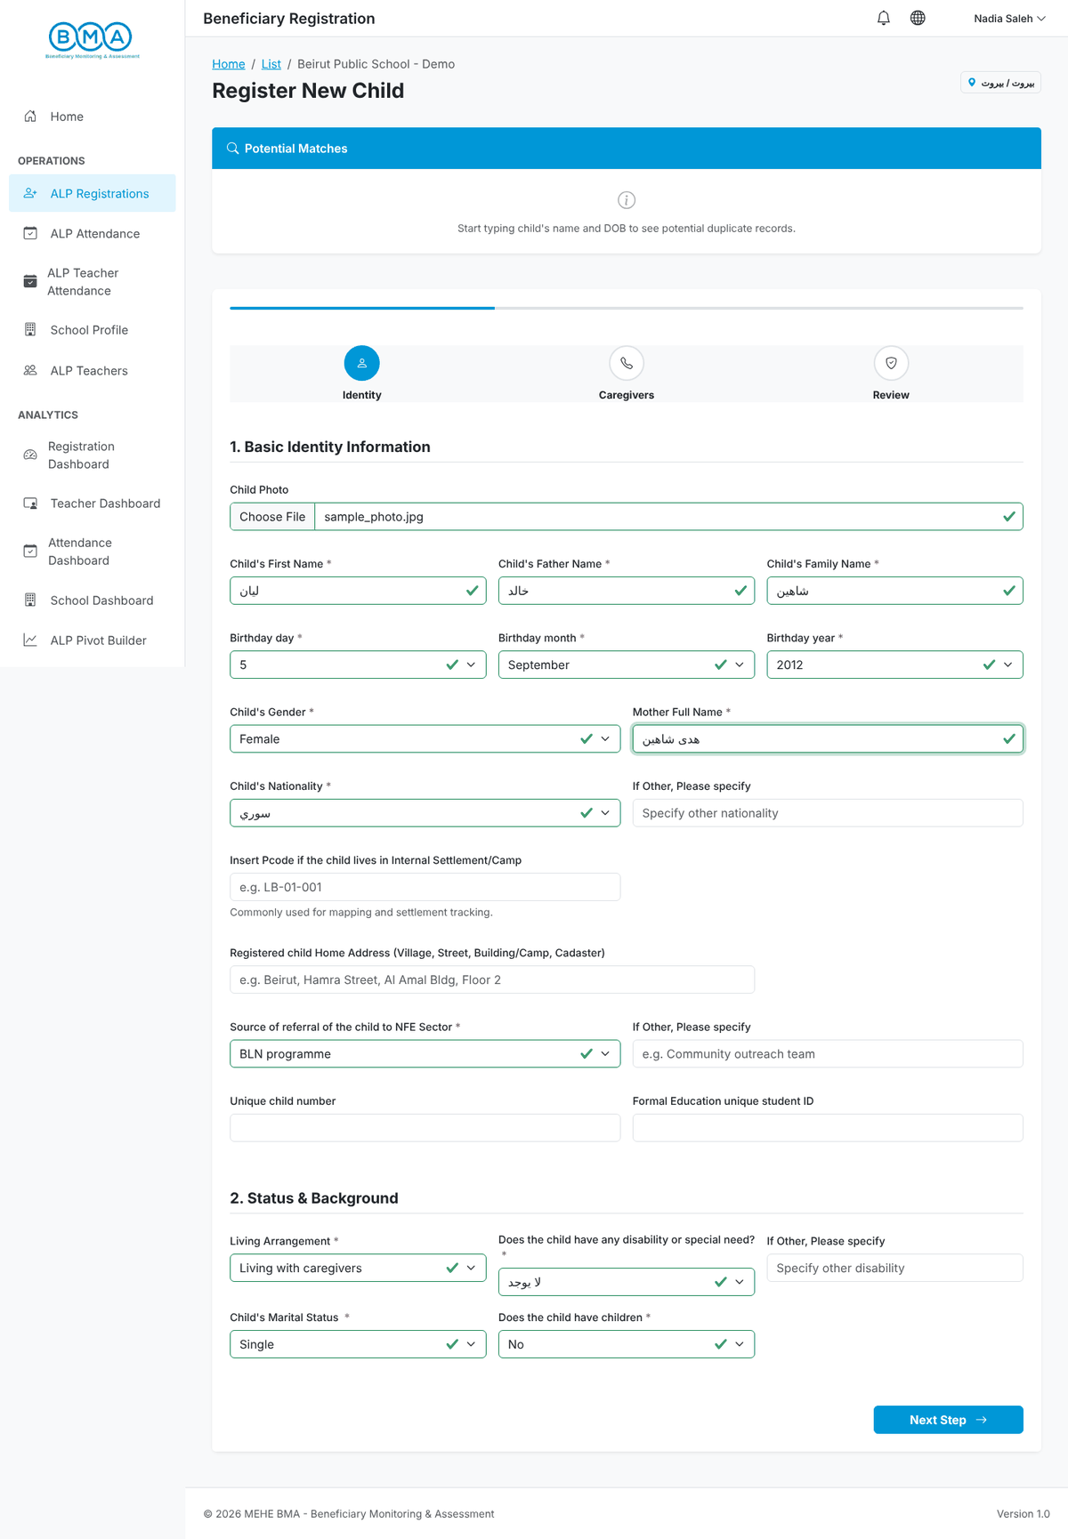
Figure 9 – Step 1 completed

Step 2 – Caregiver details and identification documents
1. Answer the household questions (siblings, siblings with disability, mother pregnant), the parents' educational level, the primary phone number (format XX-XXXXXX) with its confirmation and the person who answers it, the number of children under 18, the primary caregiver and the caregiver's names and nationality.
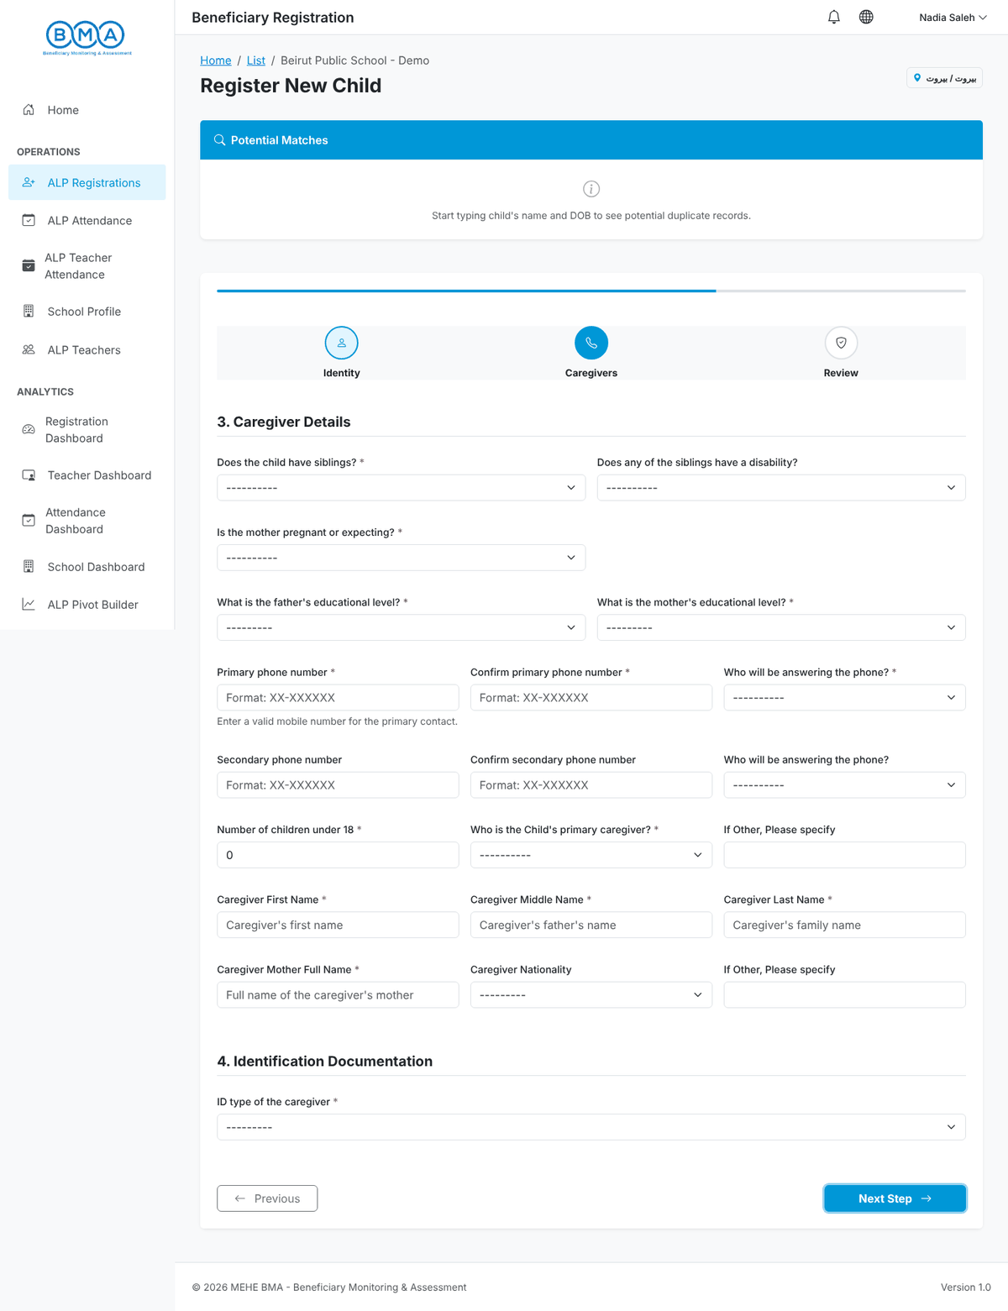
Figure 10 – Step 2 – caregiver details
2. Choose the ID type of the caregiver. The document fields that apply to that ID type appear: type each number and confirm it (for example the UNHCR case number, the individual IDs and the barcode number). Follow the format shown under each field, then click Next Step.
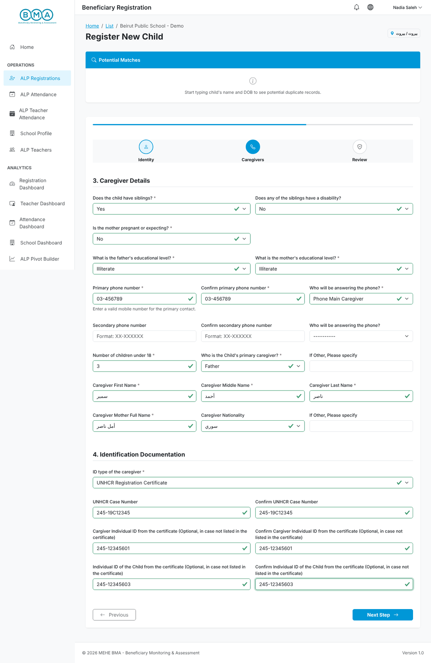
Figure 11 – Step 2 completed

Step 3 – ALP enrolment, labour and vulnerability
1. Enter the registration date, the academic year (round), the programme (ALP level) and the section. Upload a scanned copy or clear photo of the signed consent form (PDF or image).
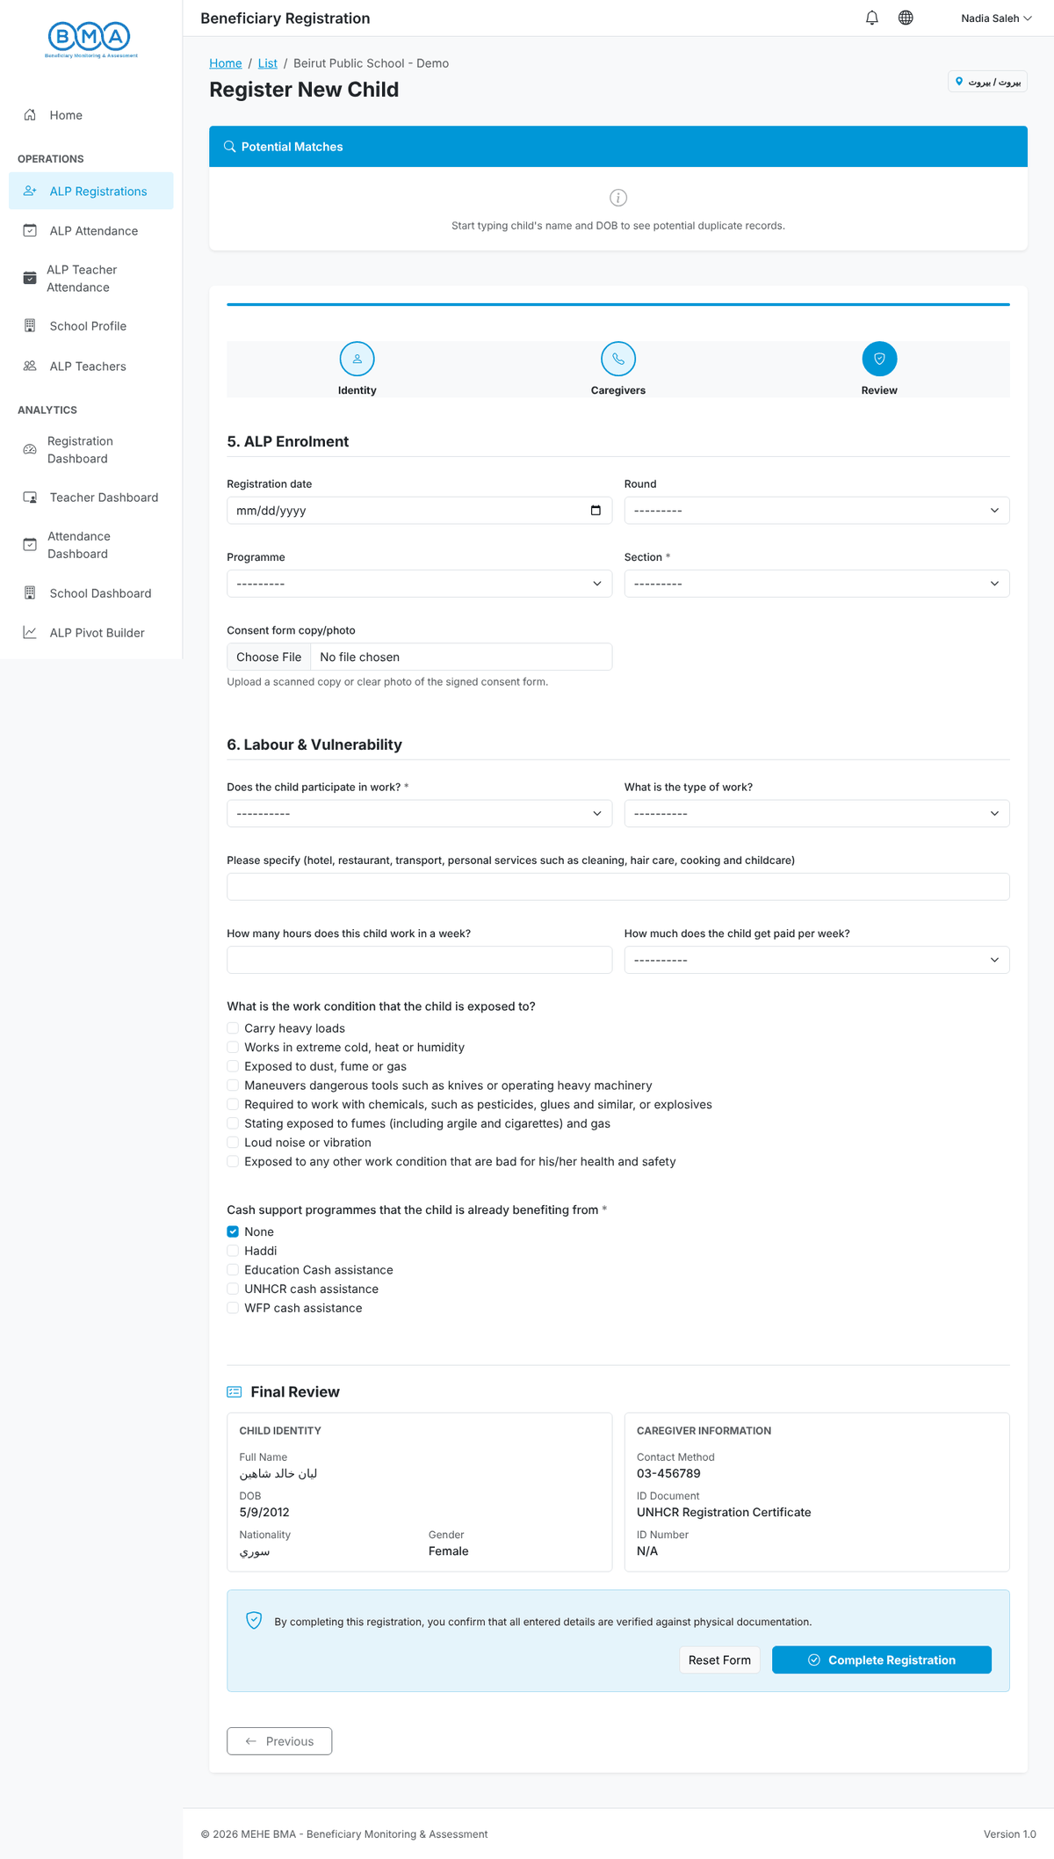
Figure 12 – Step 3 – ALP enrolment
2. Answer Does the child participate in work? (mandatory). If the answer is Yes, the type of work, hours per week, weekly income and working conditions appear. Tick the cash support programmes the household receives, then click Complete Registration.
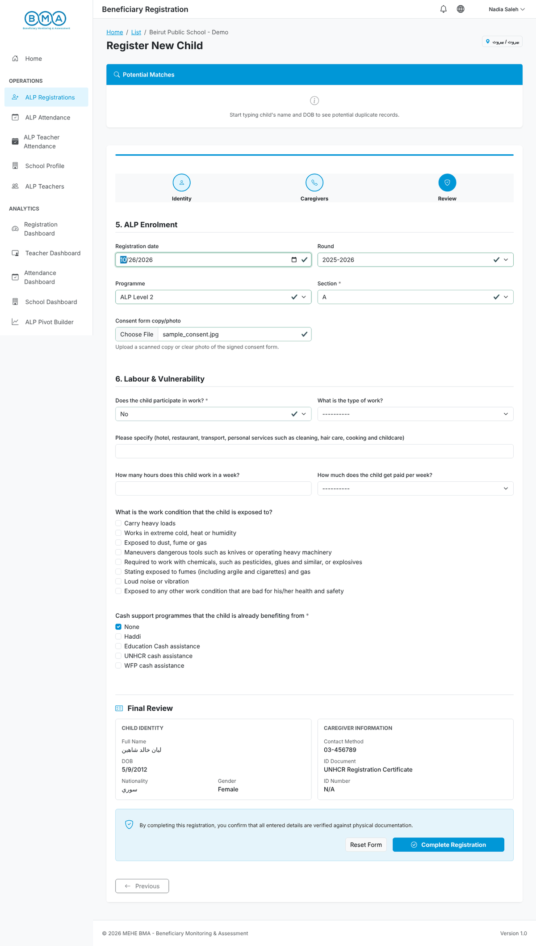
Figure 13 – Step 3 completed
3. The message "Your data has been sent successfully" confirms the registration and the student profile opens.
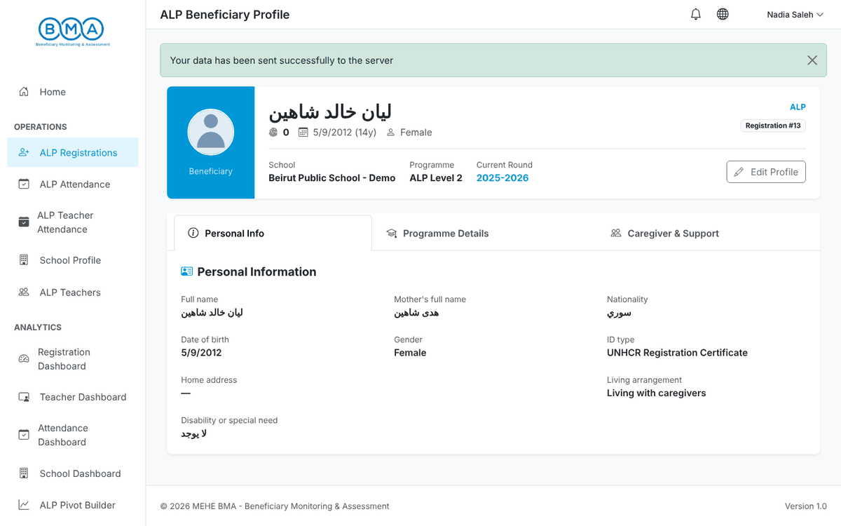
Figure 14 – The profile right after registration
Note: The school is not shown on the form: it is set automatically from the school linked to your account.

4. The Student Profile
1. The header shows the photo, the full name, the unique ID, the date of birth and age, the school, the programme, the current round and the registration number. Edit Profile reopens the registration form.
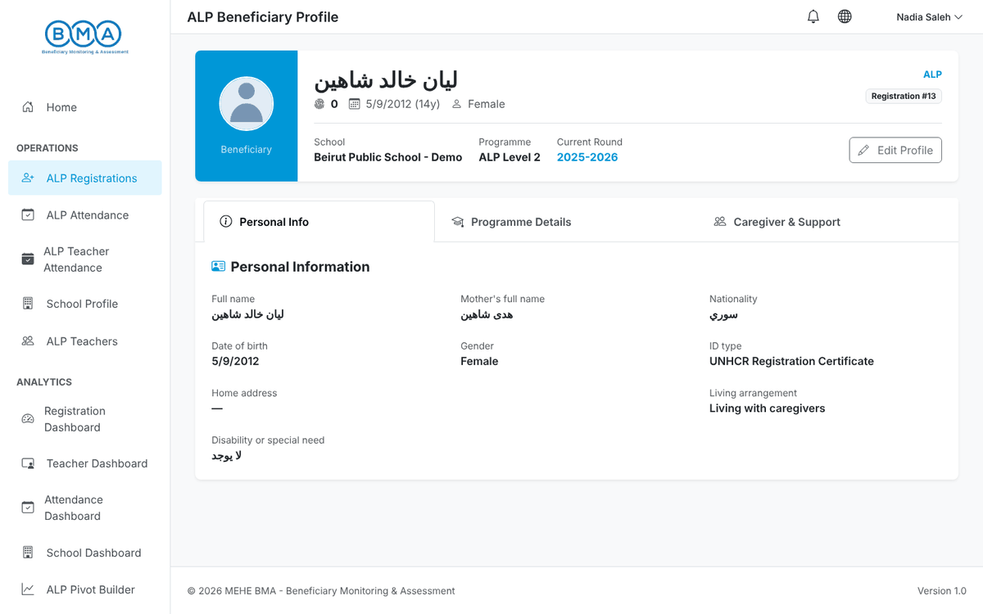
Figure 15 – Profile header and Personal Information tab
2. The Programme Details tab shows the ALP registration: school, programme, round, registration date, unique child number, source of referral and the child labour answers.
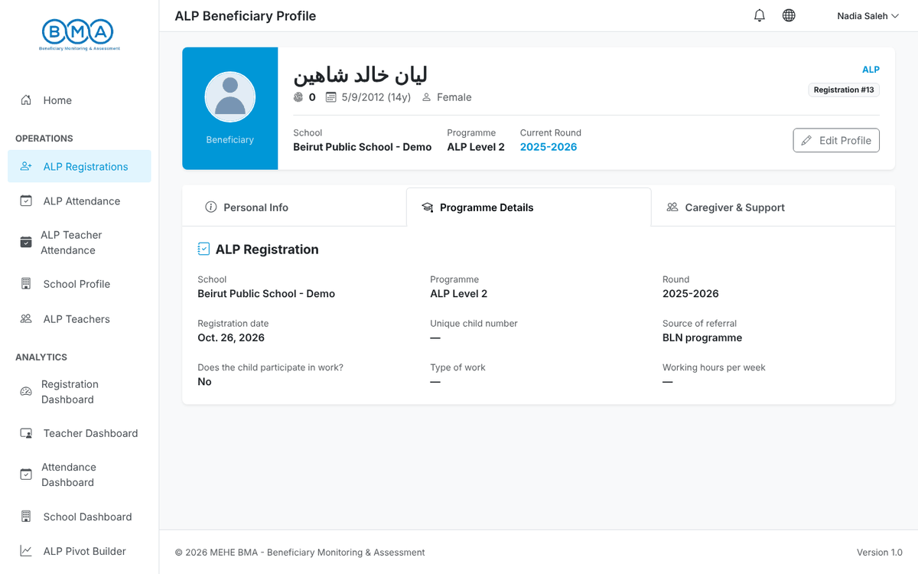
Figure 16 – Programme Details tab
3. The Caregiver & Support tab shows the caregiver, the phone numbers, the identification documents and the cash support programmes.
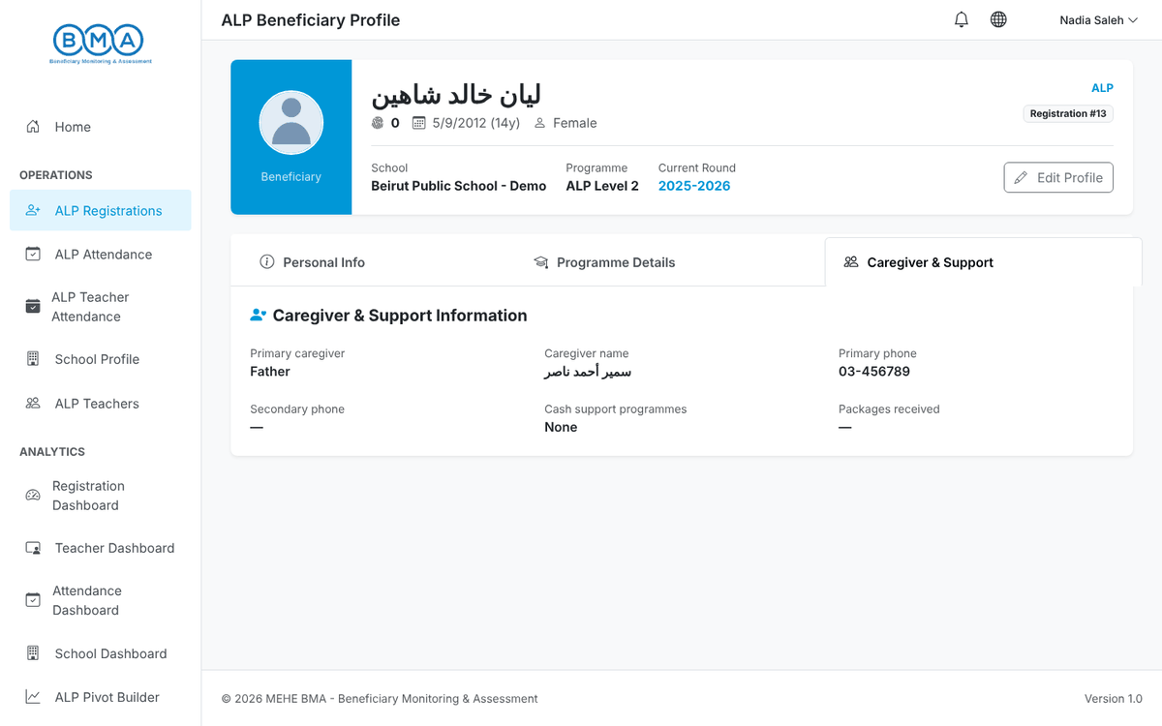
Figure 17 – Caregiver & Support tab
4. To correct a registration click Edit Profile (or the pencil icon in the list), update the values through the three steps and click Complete Registration.
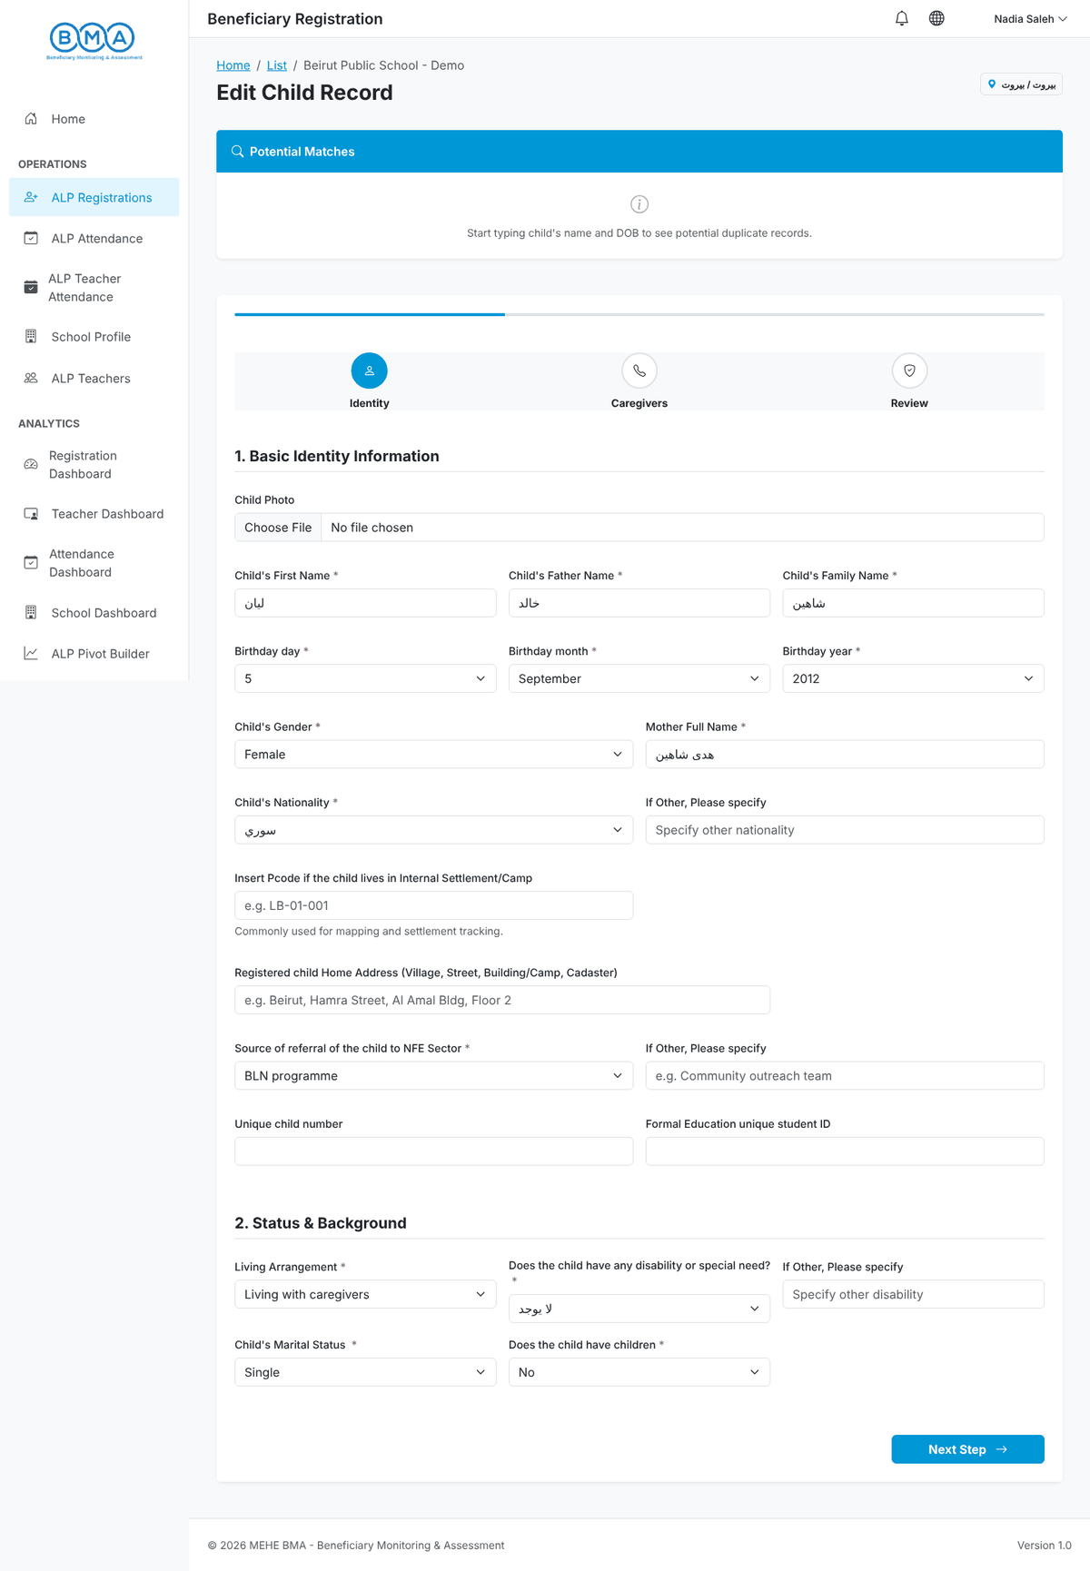
Figure 18 – Editing a registration
5. To delete a registration click the red bin icon in the list and confirm with Delete. This cannot be undone.
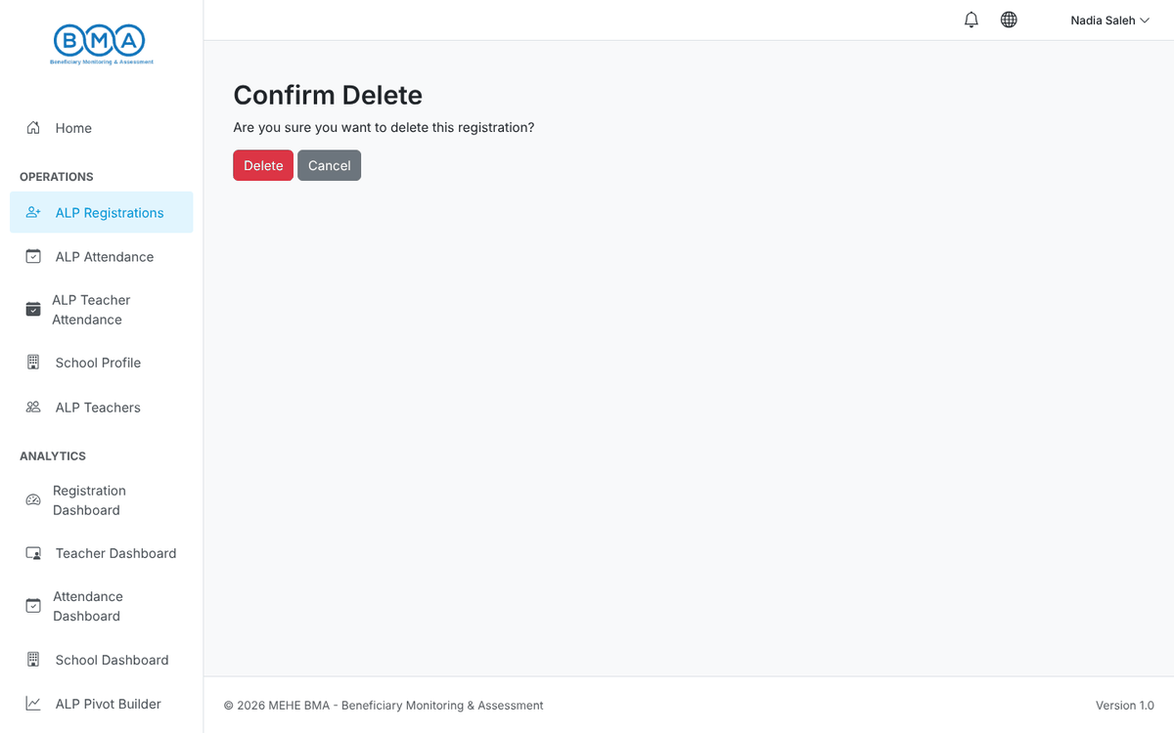
Figure 19 – Delete confirmation

5. Student Attendance
Attendance is recorded per day, programme, round and section. Open ALP Attendance in the side menu.
1. The date defaults to today. Choose the Programme, the Round and the Section.
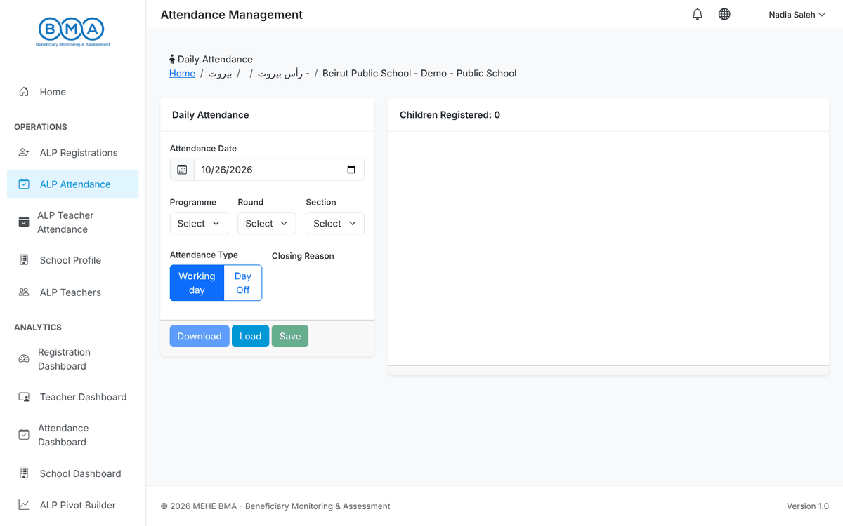
Figure 20 – The attendance page
2. Click Load. The students of that class appear with Attended and Absent buttons.
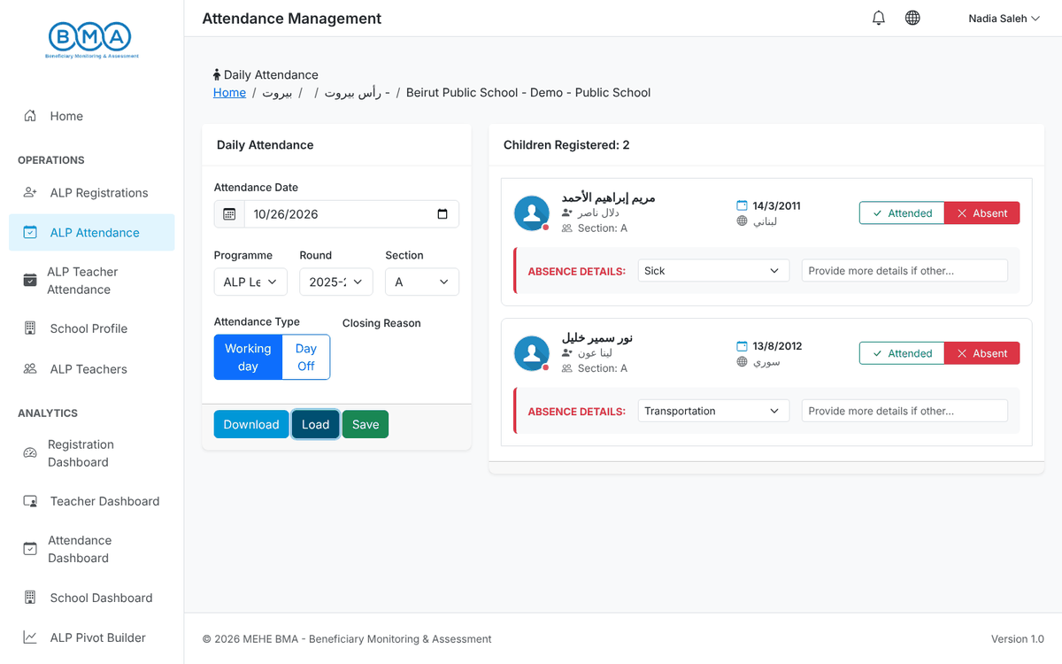
Figure 21 – Students loaded
3. For each absent student click Absent and choose the absence reason (Sick, Transportation or Other with a description).
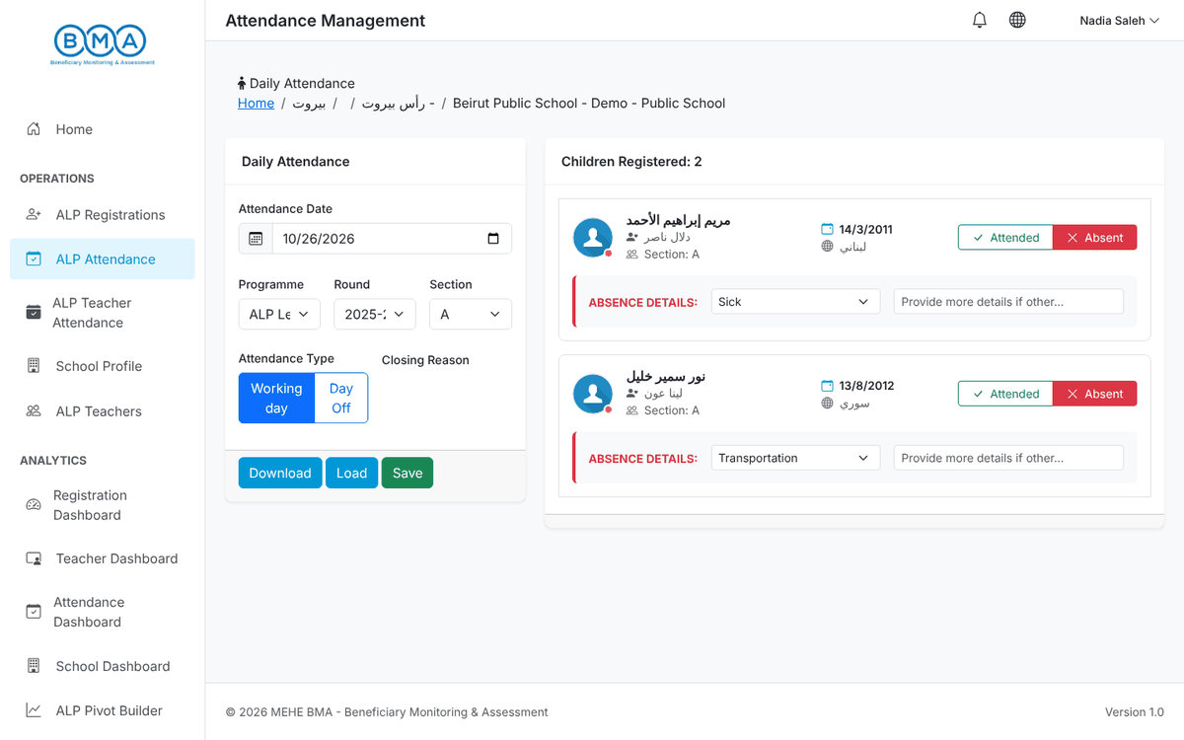
Figure 22 – Absences marked
4. Click Save. A Success message confirms the save.
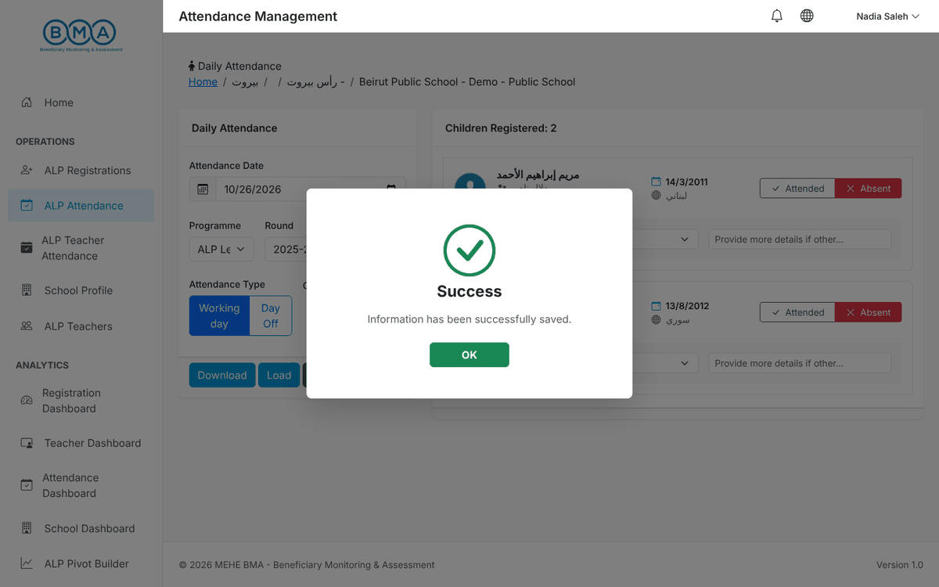
Figure 23 – Attendance saved
5. If the school was closed, select Day Off, choose the closing reason and save instead of marking students.
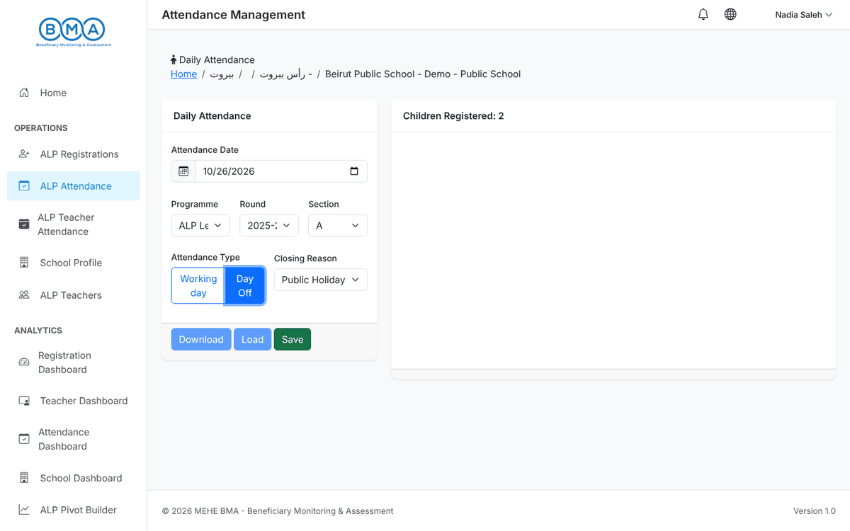
Figure 24 – Recording a day off
- Future dates are refused; past dates can be corrected by loading them again.
- Download gives a CSV of exactly what is loaded on screen. The date, round and programme must be selected first.

6. Teacher Attendance
1. Open ALP Teacher Attendance, pick the date and click Load.
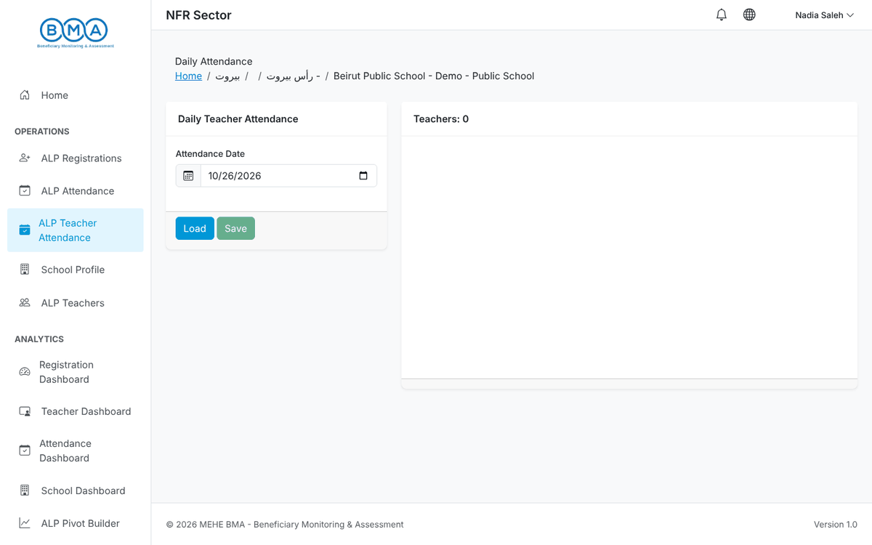
Figure 25 – Teacher attendance page
2. The teachers of your school appear with Present and Absent buttons.
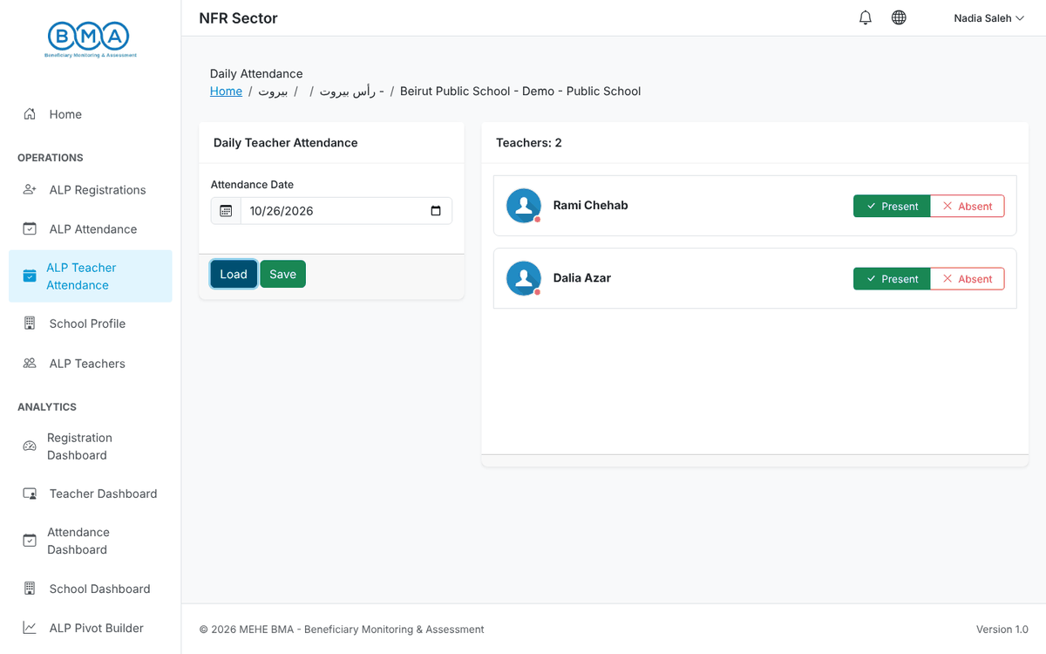
Figure 26 – Teachers loaded
3. Mark each teacher, then click Save.
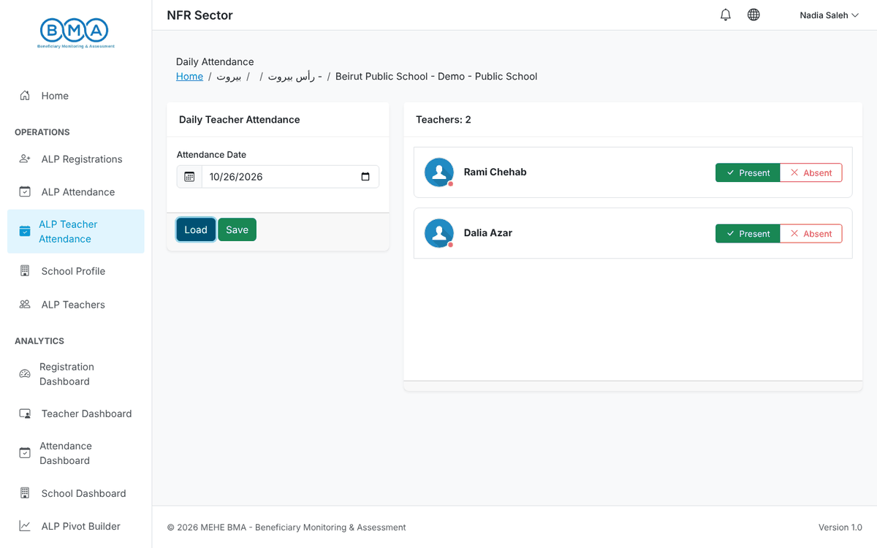
Figure 27 – Teacher status marked
4. The confirmation message appears; the whole list is saved in one action.
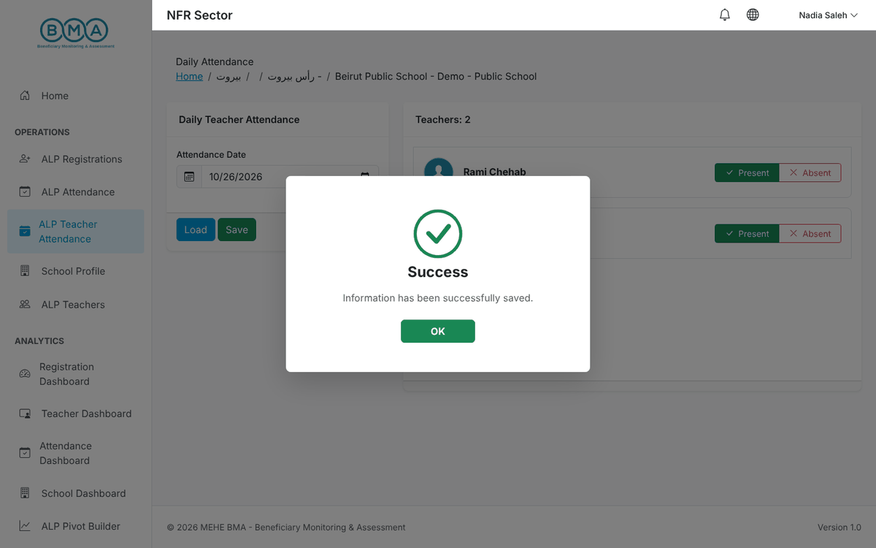
Figure 28 – Teacher attendance saved

7. Teachers
Open ALP Teachers in the side menu to manage the teachers of your school.
1. The list shows the teachers of your school with their contact details and round. Click Add Teacher.
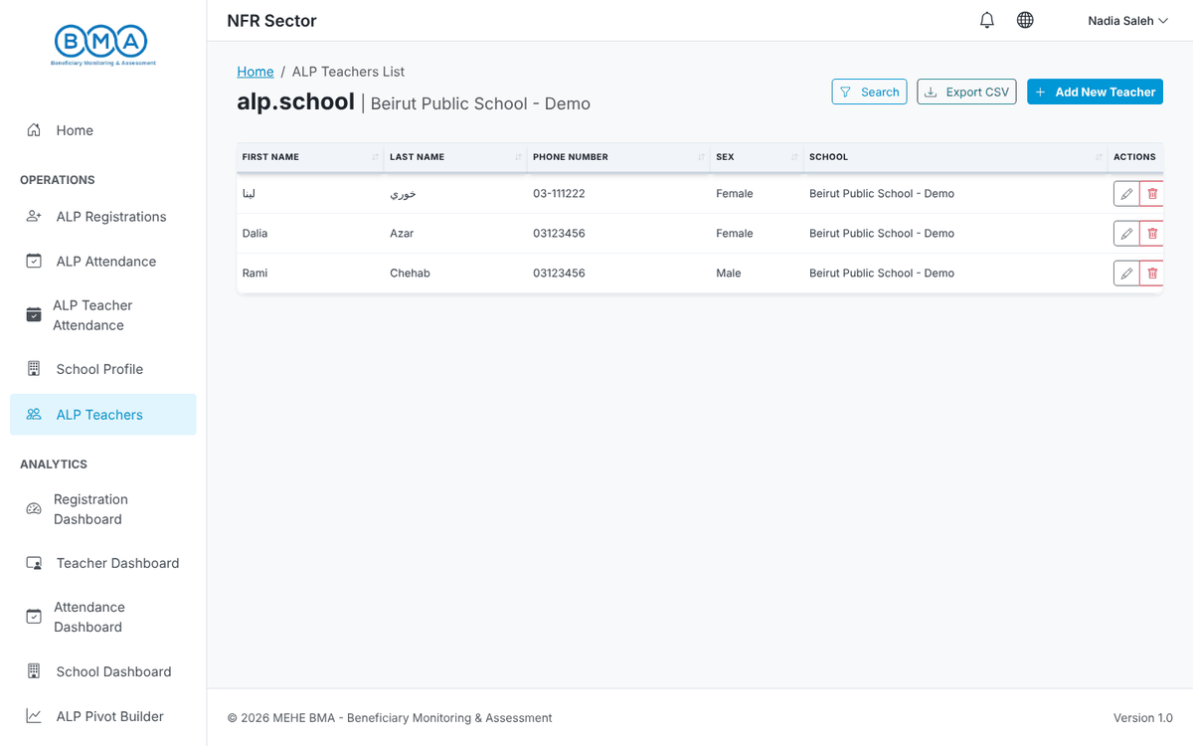
Figure 29 – The ALP teacher list
2. Fill in Identity & Contact (names in Arabic letters, gender, birth date, nationality, phone in the format XX-XXXXXX, email).
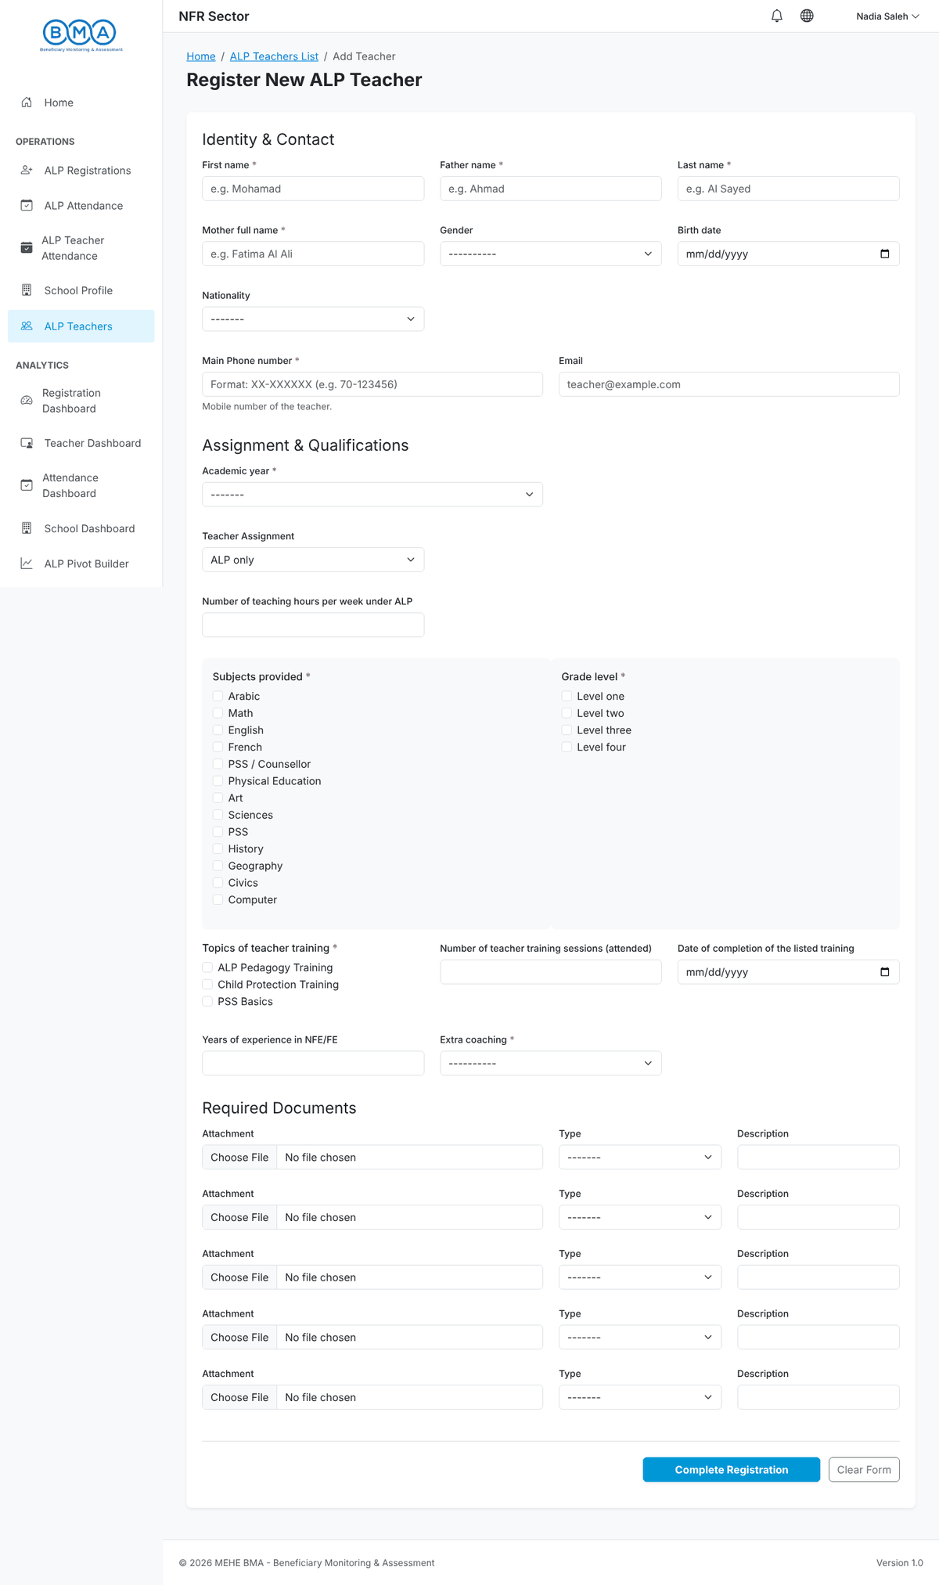
Figure 30 – The teacher form
3. Fill in Assignment & Qualifications: academic year, assignment, teaching hours per week under ALP, subjects provided, levels taught, training topics, years of experience and extra coaching. Attach up to five supporting documents with their type and description.
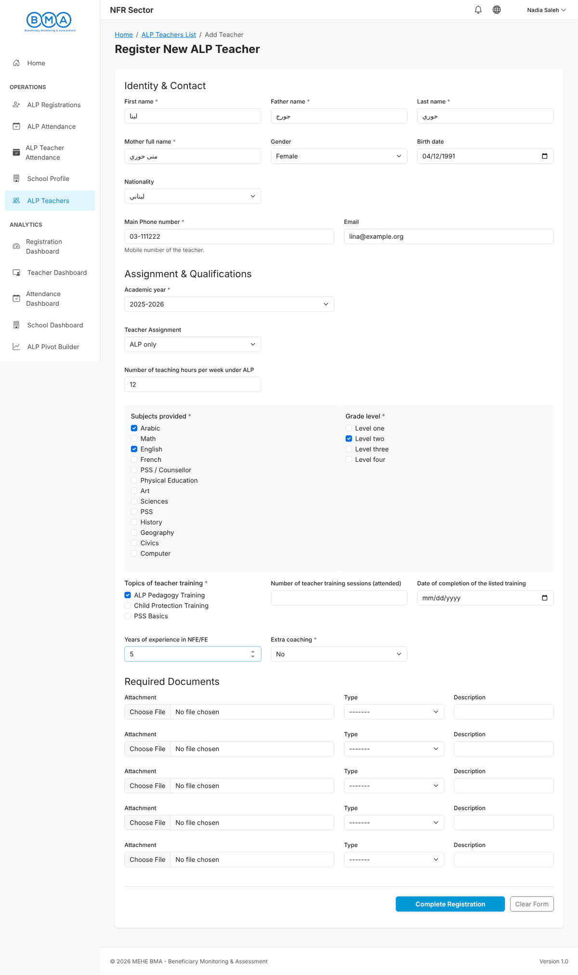
Figure 31 – Teacher form completed
4. Click Complete Registration. The teacher appears in the list.
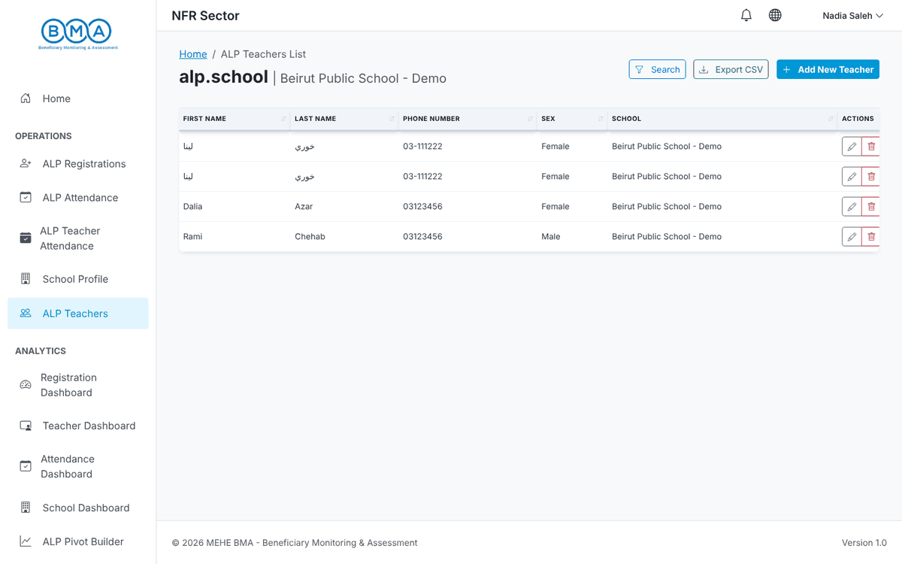
Figure 32 – Teacher saved
5. Use the row actions to Edit or Delete a teacher.
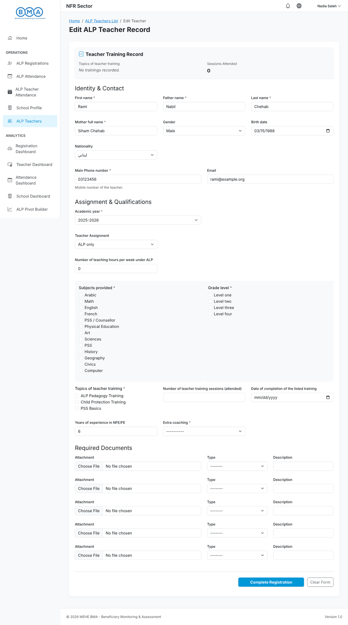
Figure 33 – Editing a teacher

8. Grading
Grades are entered per student registration. The subjects and the allowed ranges are configured by the administrator.
1. Open the grading form from the student list (Actions) or the address ALP → Grading → Add. Select the registration of the student.
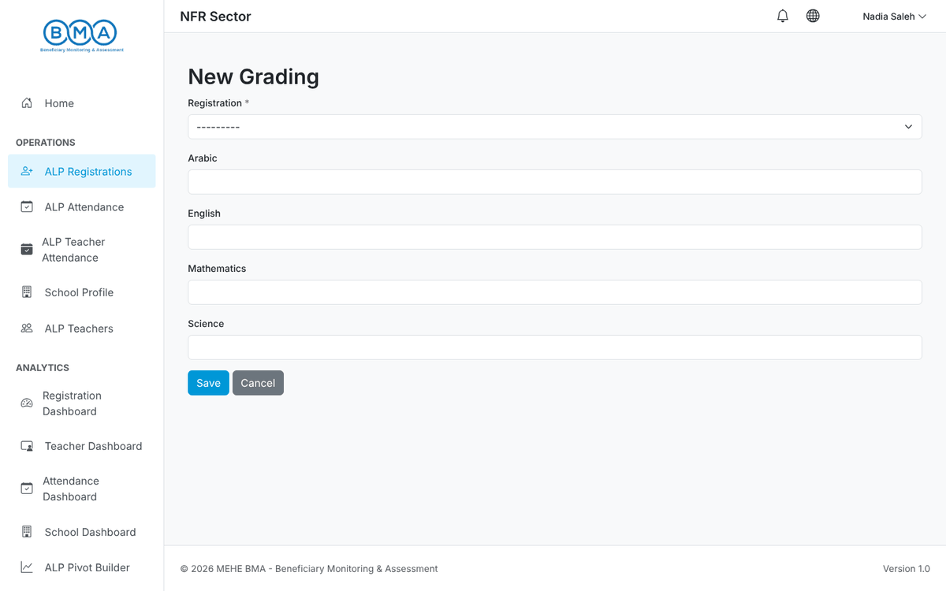
Figure 34 – The grading form
2. Enter a value for each subject. A value outside the allowed range is rejected.
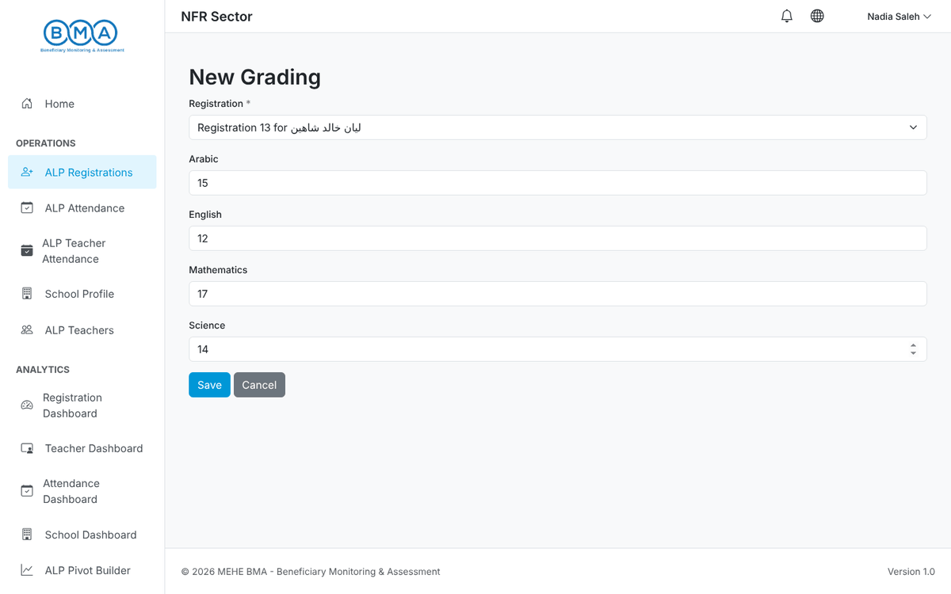
Figure 35 – Grades entered
3. Click Save. The grades are stored with the registration and feed the Learning Outcomes section of the Registration Dashboard. They can be edited later.
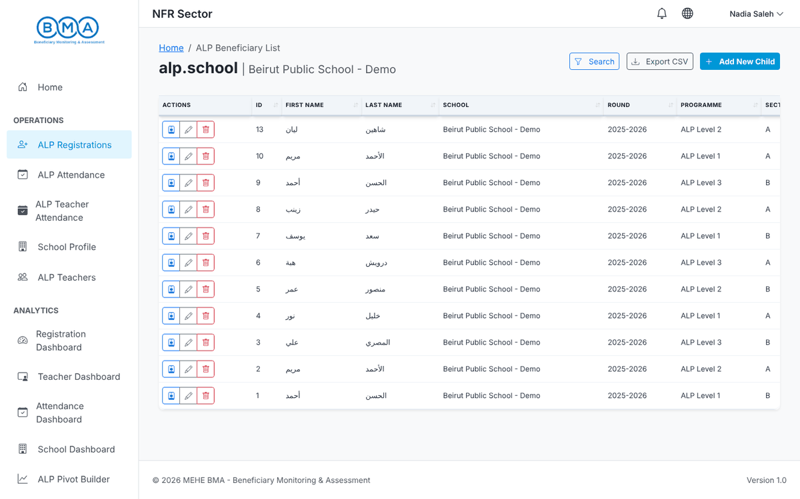
Figure 36 – Back to the student list after saving

9. School Profile
1. Open School Profile. Update the school information (type, operating shift, programme manager, phone, email), the location (governorate, district, cadaster and GPS coordinates) and the provided services (packages, digital learning, digital hub, number of ALP staff, nearby PHCC).
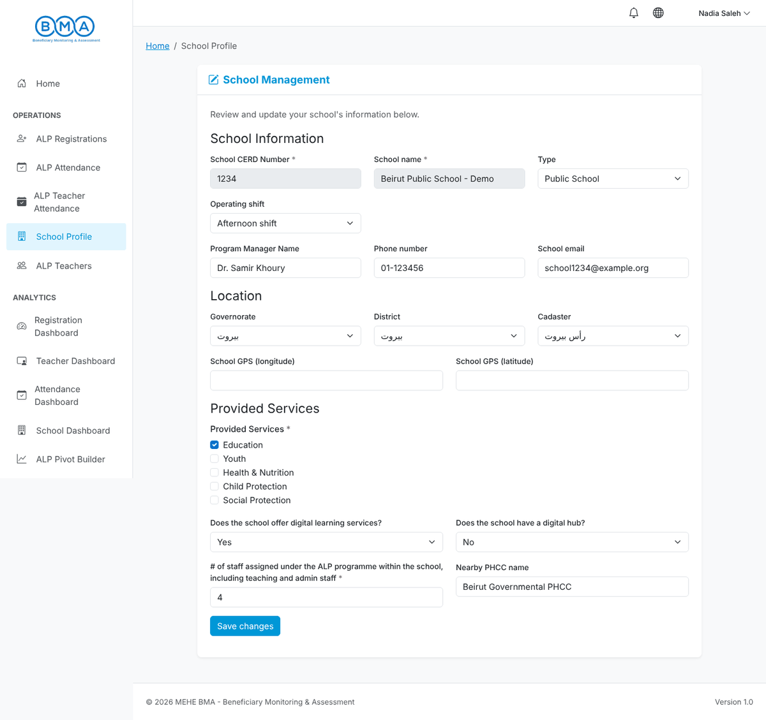
Figure 37 – The school profile form
2. Click Save changes. The confirmation appears at the top of the page.
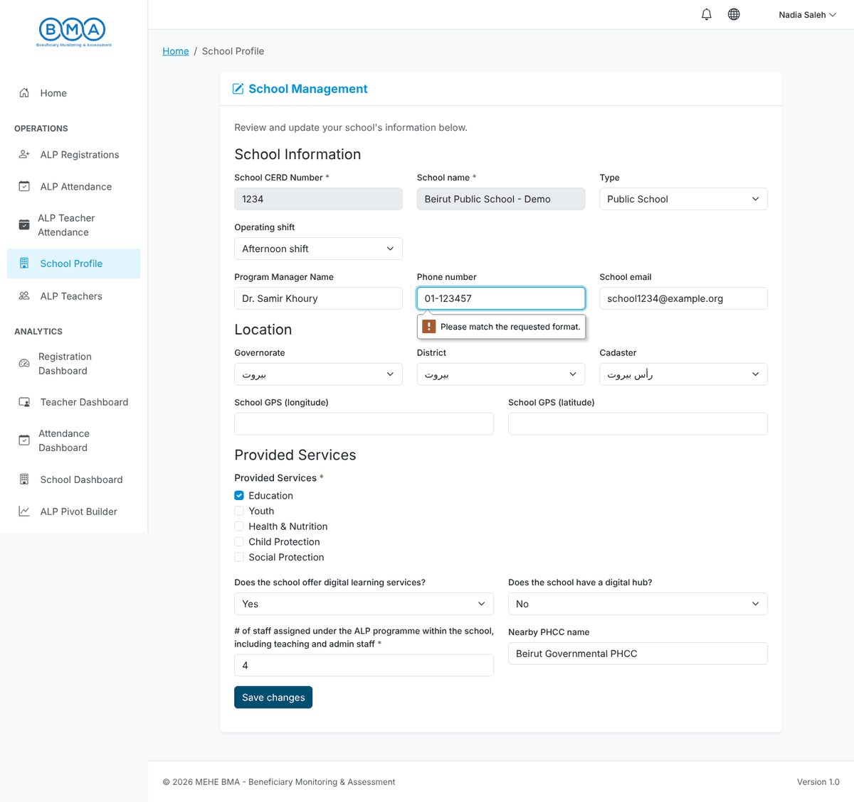
Figure 38 – School profile saved
Note: Keep the GPS coordinates accurate: they place your school on the School Dashboard map.

10. Dashboards
All dashboards are limited to your school.
1. Registration Dashboard – total registrations, rounds and the Learning Outcomes block (children assessed, average achievement, progress, achievement by subject), followed by charts on gender, nationality, source of identification and vulnerability.
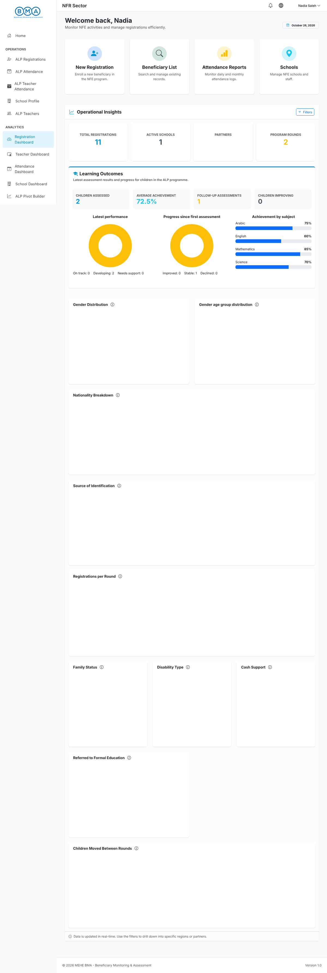
Figure 39 – Registration dashboard
2. Teacher Dashboard – number of teachers, gender, nationality, assignments, subjects and training.
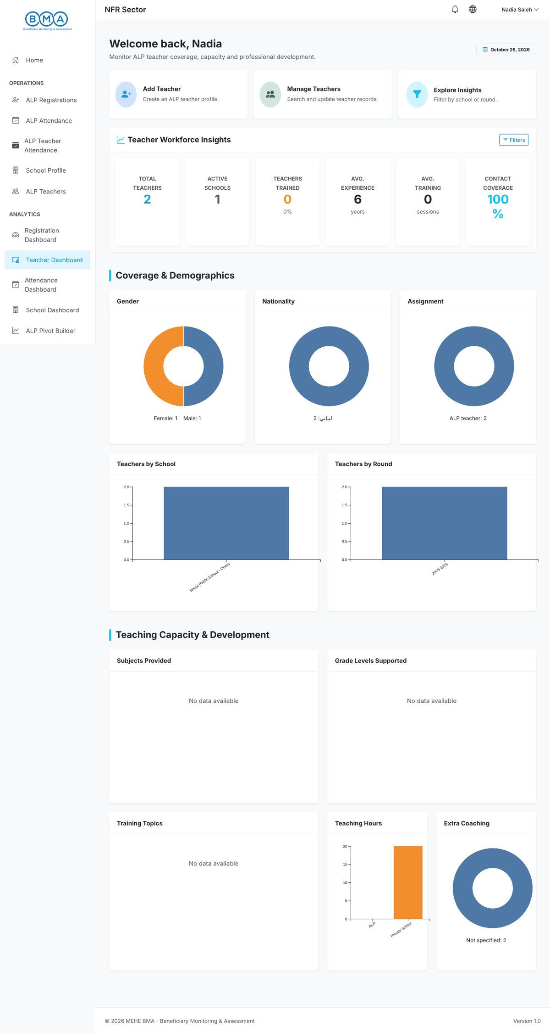
Figure 40 – Teacher dashboard
3. Attendance Dashboard – a heatmap with one square per day, overall and per ALP level. Dark green means high attendance.
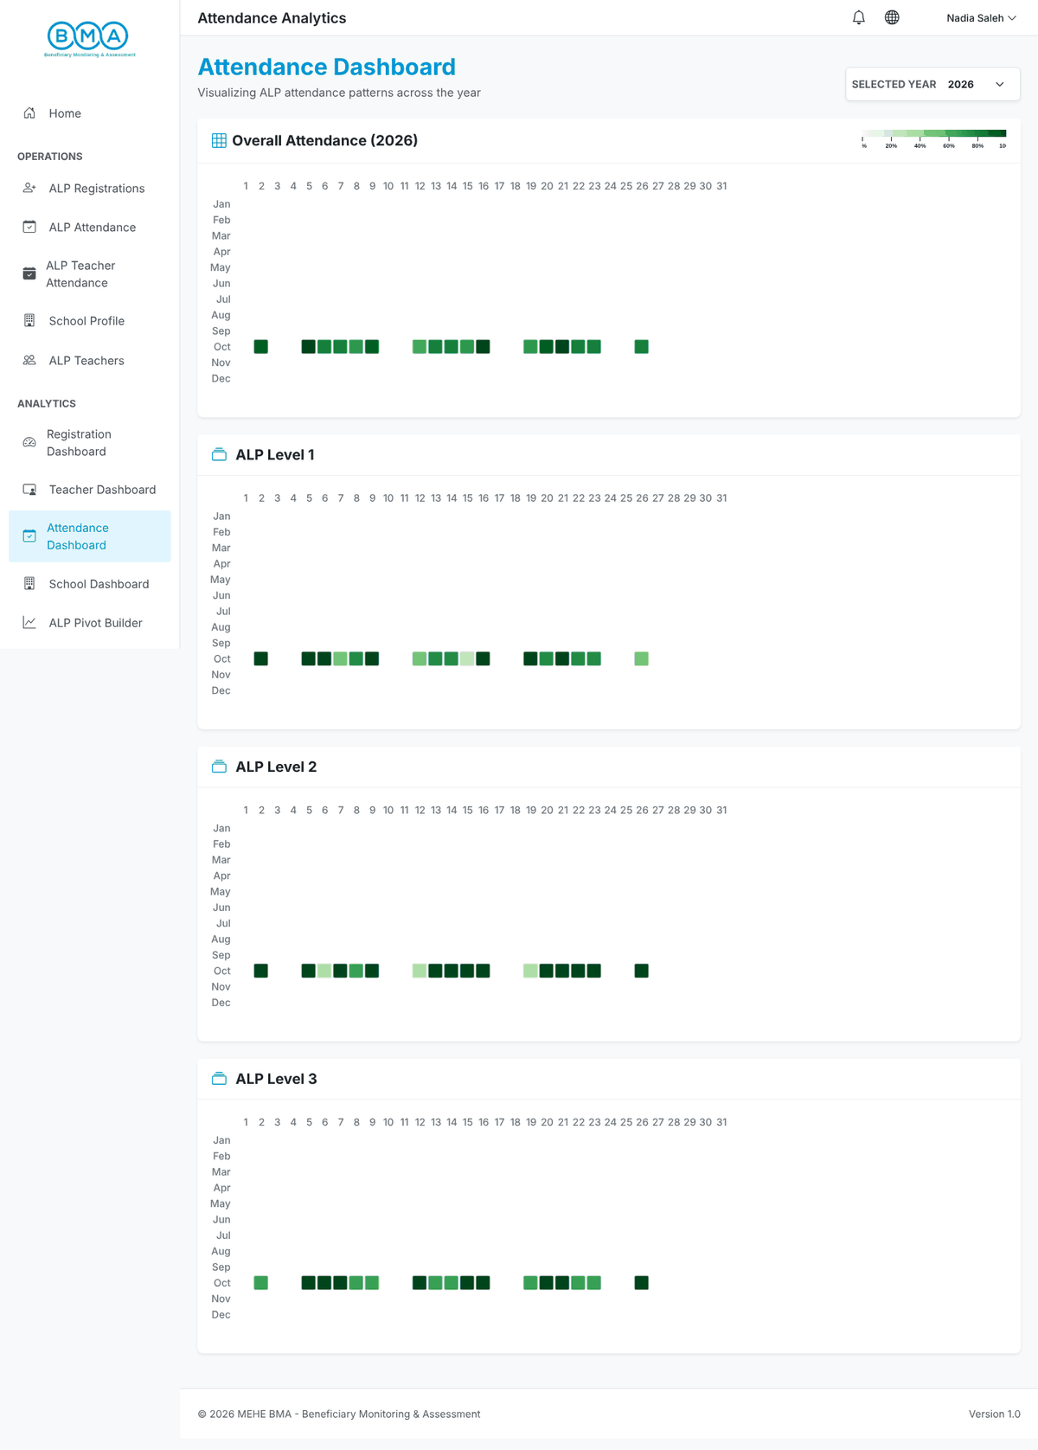
Figure 41 – Attendance dashboard
4. School Dashboard – the ALP schools on a map with their students and teachers. Schools without GPS coordinates are not mapped.
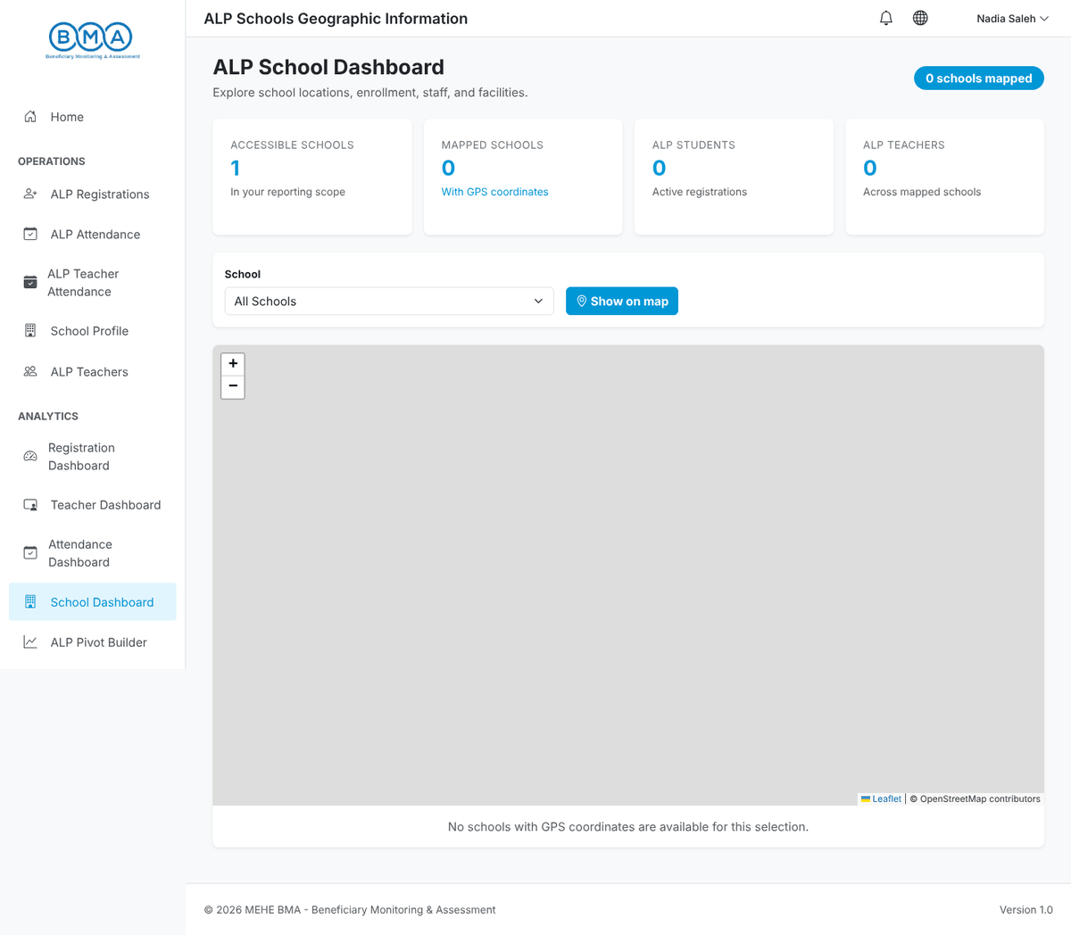
Figure 42 – School dashboard
5. ALP Pivot Builder – drag fields into rows and columns to build your own tables and charts.
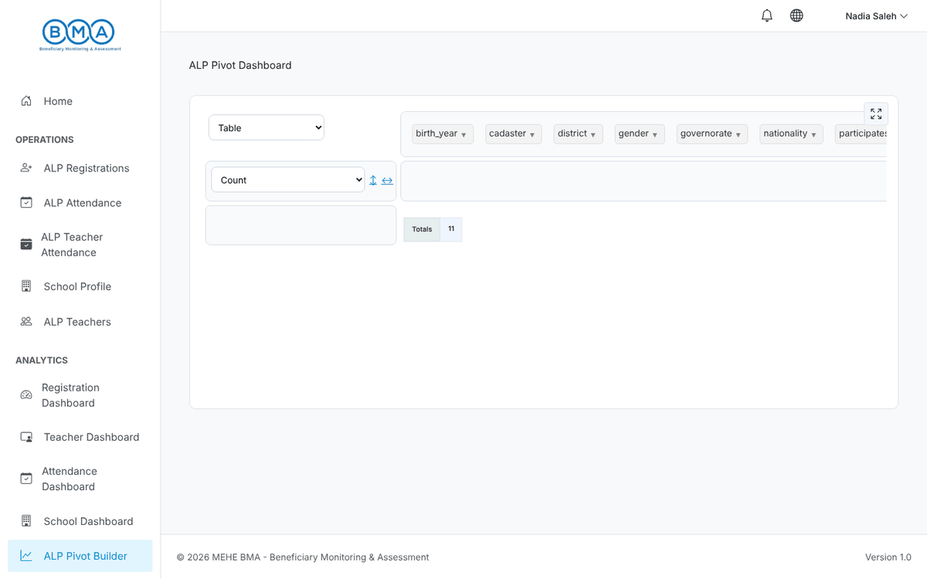
Figure 43 – Pivot builder

11. Your Account
1. Change Password (user menu): enter the current password and the new password twice, then click Change Password.
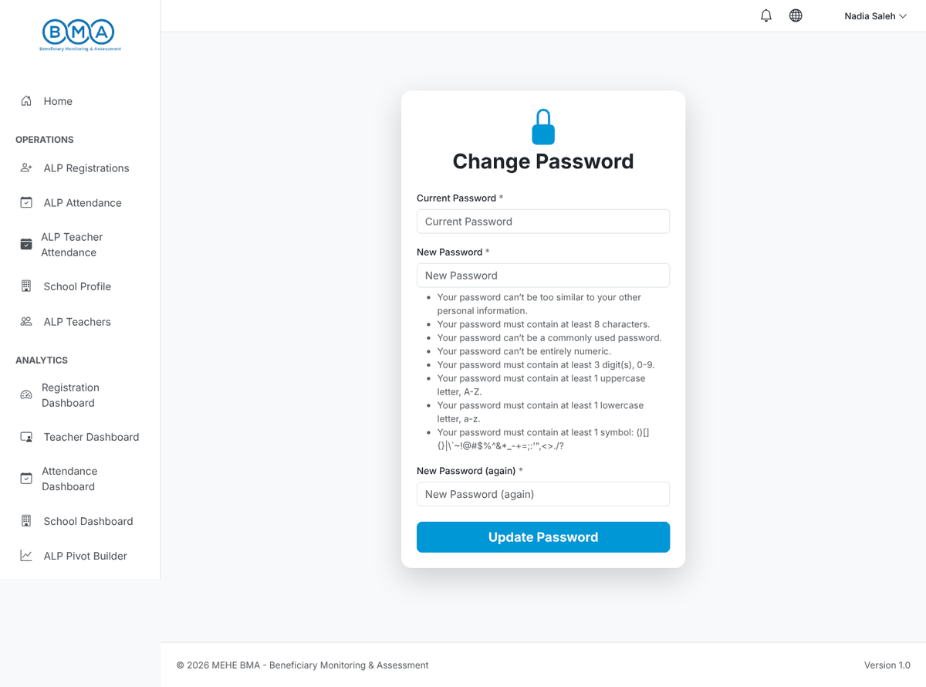
Figure 44 – Change password form
2. Logout (user menu) ends the session. Always log out on a shared computer.
Password rule | Requirement
Length | At least 8 characters
Digits | At least 3 digits
Letters | At least one upper-case and one lower-case letter
Symbol | At least one symbol such as ! @ # $ % & *
Not common | Not a common word and not similar to your username

12. Frequently Asked Questions
Question | Answer
The lists are empty and a warning is shown. | Your account is not linked to a school. Ask your administrator.
The Next Step button is disabled. | A potential duplicate was found; check the Potential Matches panel before continuing.
My names are erased when I leave the field. | Names must be written in Arabic letters only.
The phone number or an ID number is refused. | Follow the format shown under the field (phone: XX-XXXXXX).
A student is missing from the attendance list. | Check the programme, round and section of the registration (Programme Details tab).
The grading form has no subjects. | The grading definitions are configured by the administrator; ask for the missing subject to be added.
Can the administrator enter data for me? | No. Site administrators can view ALP data but cannot add or edit it; data entry is the school's responsibility.
I forgot my password. | There is no self-service reset. Contact your system administrator.

