NFE Module – User Manual
BMA Platform – Non-Formal Education Sector
For center staff, partner organisation staff and coordinators
Last updated: 26 October 2026
Version 1.0

Contents
1. Getting Started – Login and Navigation
2. The Beneficiary List
3. Registering a New Child
4. The Child Profile
5. Education Situation and Round Enrolment
6. Exceptional Exam
7. Daily Attendance
8. Teachers
9. Centers
10. Exporting Data
11. Dashboards and Analytics
12. Your Account
13. Frequently Asked Questions

This manual explains, step by step, how to use the NFE (Non-Formal Education) module of the BMA platform. It is written for center staff who register children, record the services they receive, track daily attendance, manage teachers and consult the dashboards. No technical knowledge is required.
Each step is illustrated with a screenshot taken from the system. Screens may differ slightly depending on your role: a center user sees only the children of their own center, a partner user sees all the centers of their organisation, and UNICEF users have a read-only view across all partners.
The data shown in the screenshots is demonstration data only.

1. Getting Started – Login and Navigation
Open Google Chrome or Mozilla Firefox and go to the platform address given to you by your coordinator. Accounts are created by the system administrator; there is no self-registration.
1. Open the login page. Enter your username and password.
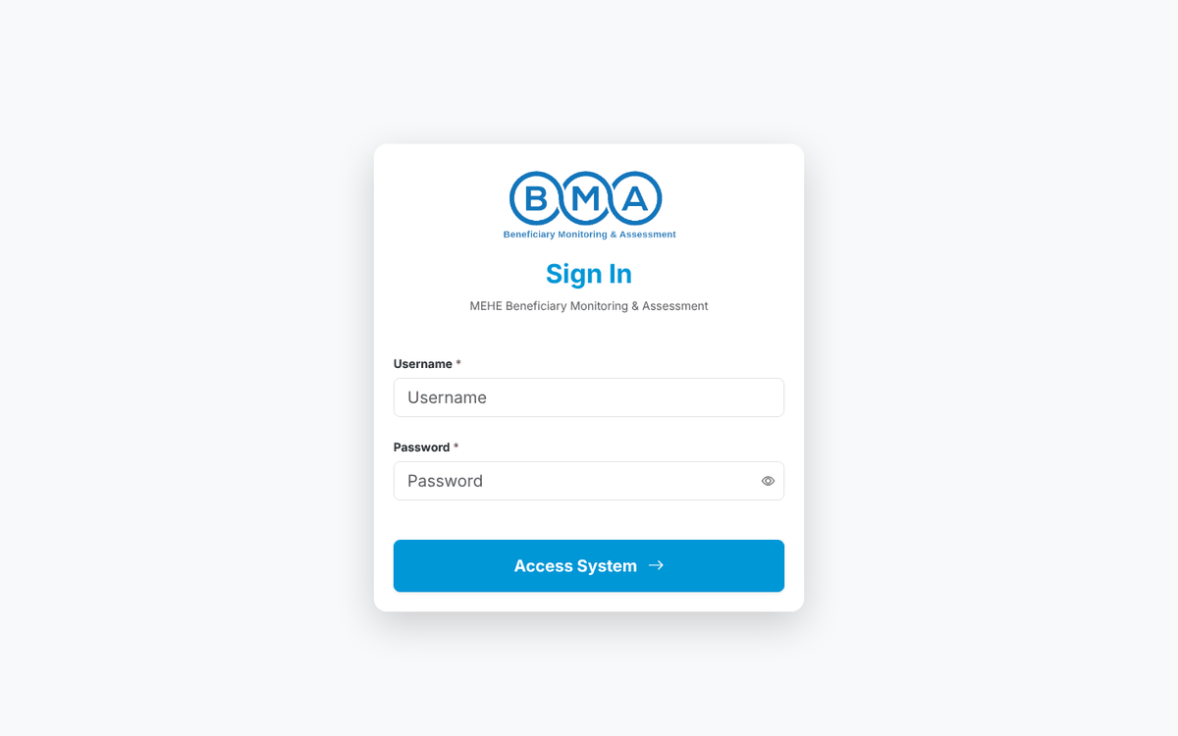
Figure 1 – The login page
2. Click Sign in. If the details are correct you are taken to your home page.
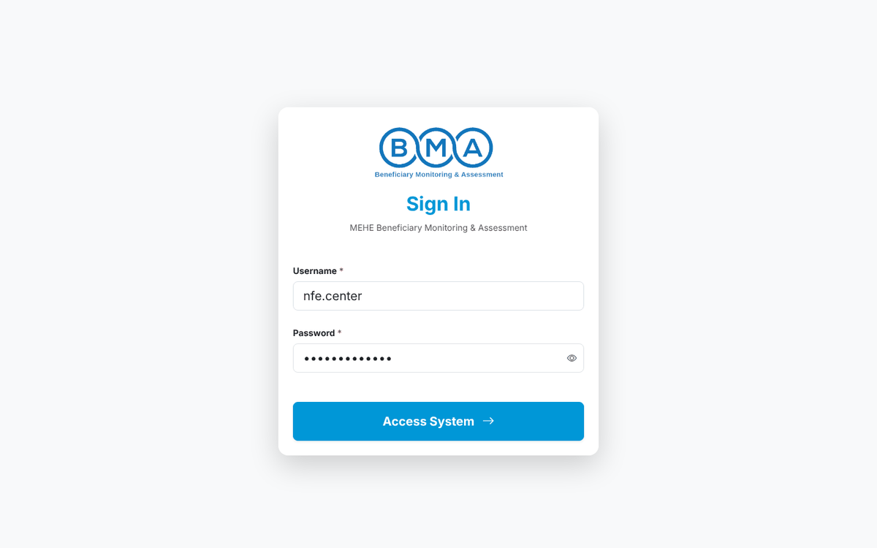
Figure 2 – Login form with the credentials filled in
3. The home page shows today's registrations, this week's registrations, the centers reporting, the average attendance, a 14-day registration trend and your recent data exports. The New Registration card opens the registration form directly.
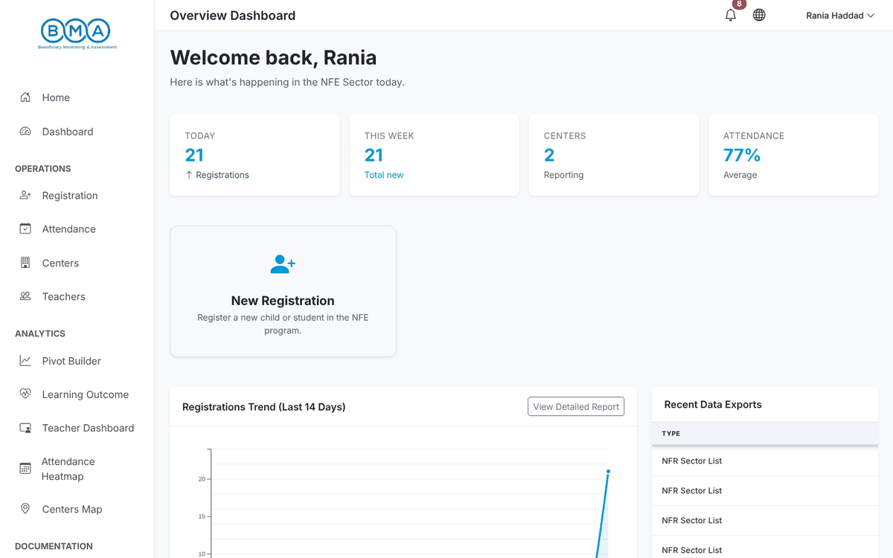
Figure 3 – The home page after login
4. To change the interface language, click the globe icon in the top bar and choose English or العربية. The page reloads in the chosen language with a right-to-left layout for Arabic.
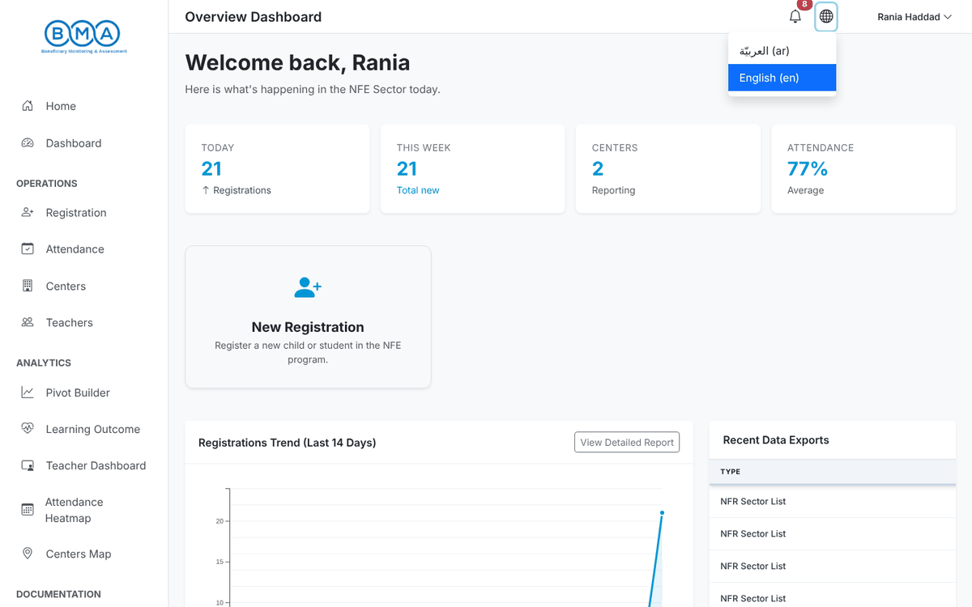
Figure 4 – Language menu
5. Click your name in the top-right corner to open the user menu: Profile, Change Password and Logout.
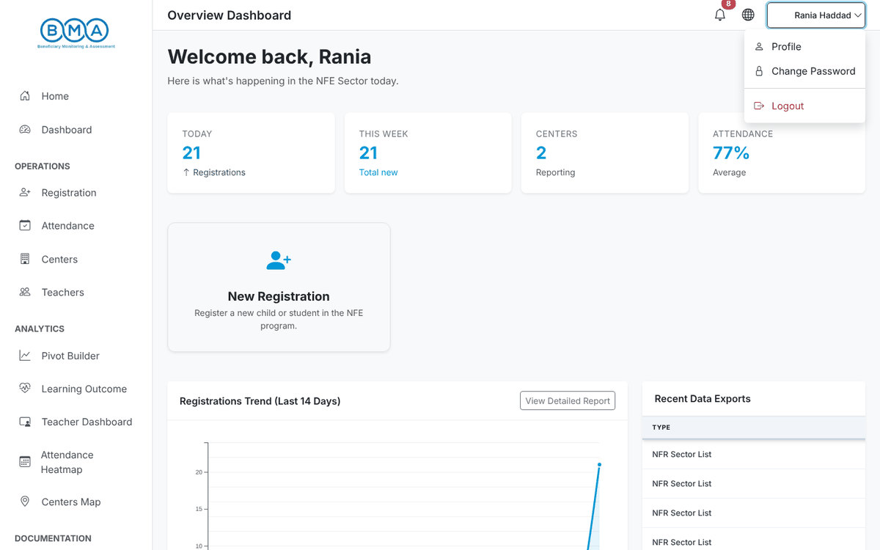
Figure 5 – User menu

The side menu
Menu entry | What it opens
Home | The home page with the daily summary cards
Dashboard | The NFE operational dashboard (registrations, gender, nationality, age groups…)
Registration | The beneficiary list, the registration form and the child profiles
Attendance | Daily attendance entry for your center
Centers | The list of centers you can access
Teachers | The teacher list and the teacher form
Pivot Builder | Build your own cross-tabulations of the registration data
Learning Outcome | Learning outcome and socio-economic analysis
Teacher Dashboard | Teacher demographics, assignments and training
Attendance Heatmap | Attendance patterns across the year
Centers Map | Map and profile of the centers
User Guide | The documentation inside the system

Note: For security, the system logs you out automatically after a period of inactivity. Save your work regularly. After five failed login attempts in five minutes the account is temporarily blocked: wait a few minutes and try again.

2. The Beneficiary List
The beneficiary list shows every child registered in your center (or in all the centers of your partner organisation). Open it with Registration in the side menu.
1. The list shows one row per registration: round, unique ID, names, gender, age, birthday, nationality and programme. Click a column header to sort by that column. Scroll horizontally to see all the columns.
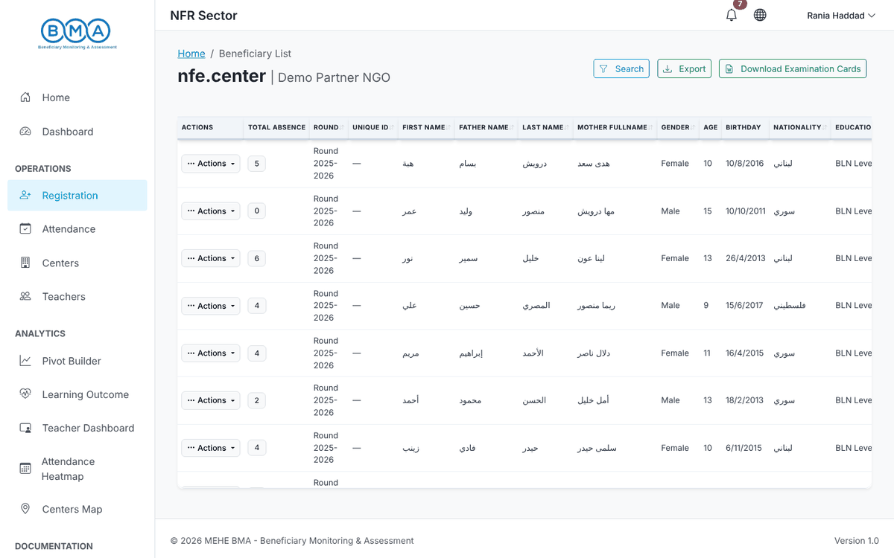
Figure 6 – The beneficiary list
2. Click Search to open the filter panel. Filter by first, father, last or mother name, unique ID, gender, nationality, round or programme, then click Apply Filters. Clear All removes the filters.
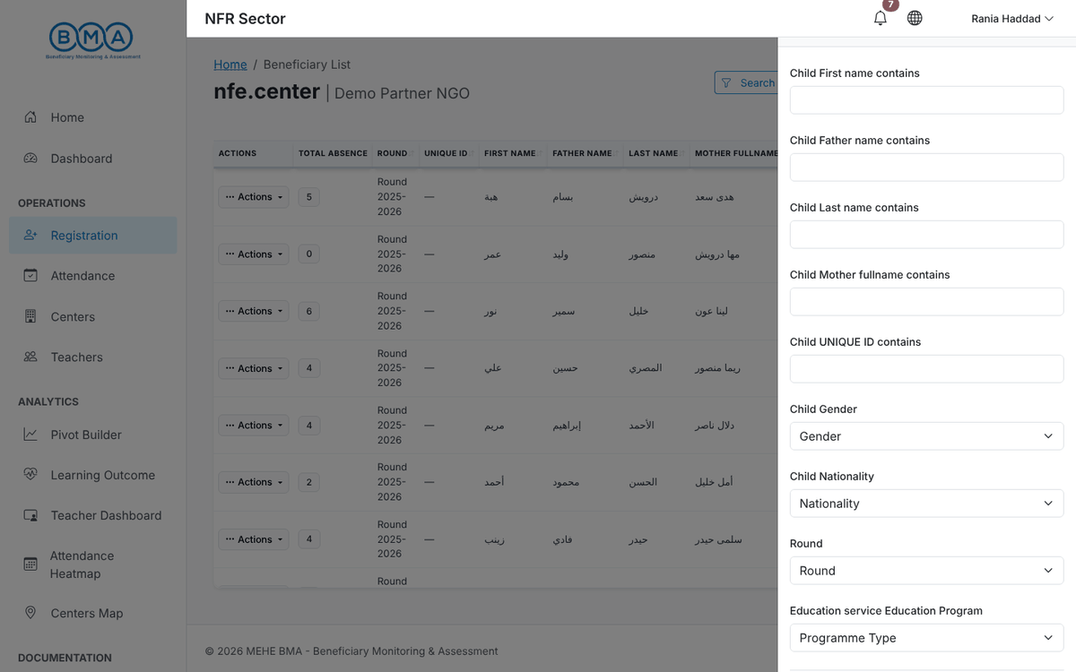
Figure 7 – The search and filter panel
3. Click Actions on a row to open the row menu: View Profile, Upload Photo, Edit Information and Delete Record. Deleting asks for a confirmation and cannot be undone.
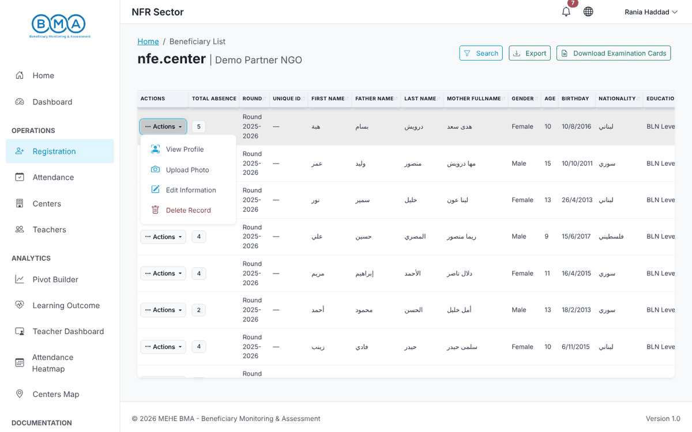
Figure 8 – The Actions menu of a registration
Note: The Total absence column counts the days the child was marked absent in the current round. It is a quick way to spot children at risk of dropping out.

3. Registering a New Child
Registration is done through a 3-step wizard: Identity, Caregivers and Review. The child is only saved when you click Complete Registration on the last step. Fields marked with a red asterisk (*) are mandatory.
Open the form with New Registration on the home page, or from the beneficiary list.

Before you start: avoid duplicates
As soon as you type the child's name and date of birth, the Potential Matches panel at the top of the form searches the existing records. If the same child is already registered, the panel turns red, shows the existing record and blocks the Next Step button. In that case do not create a new record: open the existing profile, or use Select & Re-register to add the child to a new round.
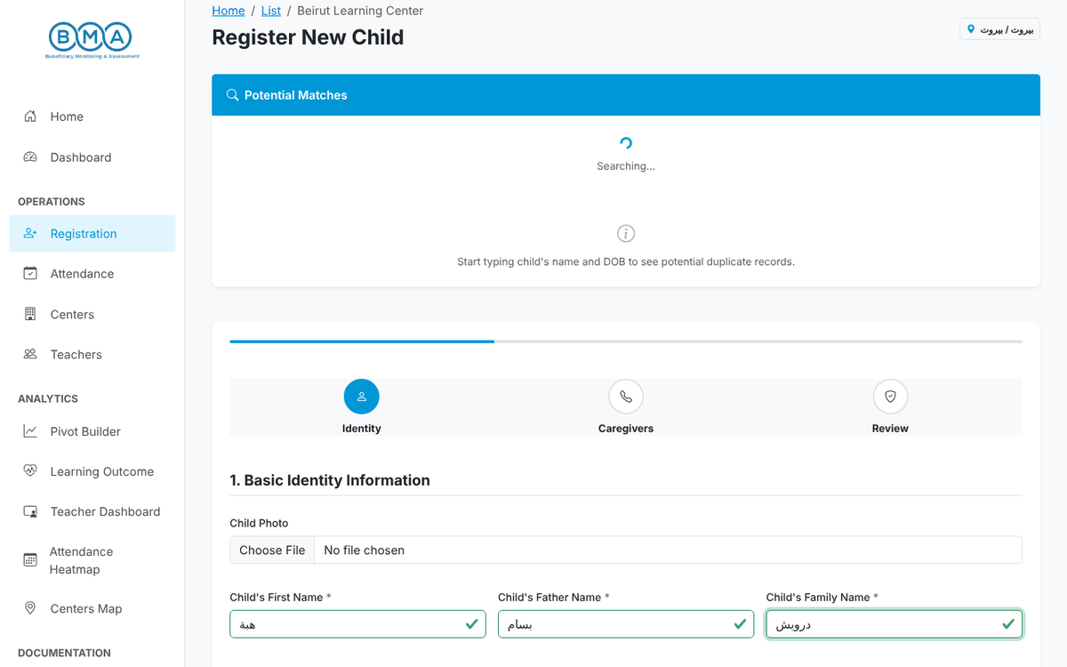
Figure 9 – The duplicate check runs while you type the identity

Step 1 – Identity
1. Fill in the Basic Identity Information: child photo (optional), first name, father's name, family name, date of birth (day, month, year), country and place of birth, gender, mother's full name, nationality and the non-formal education programme (BLN Level 1, 2 or 3). Names must be written in Arabic letters exactly as on the official document.
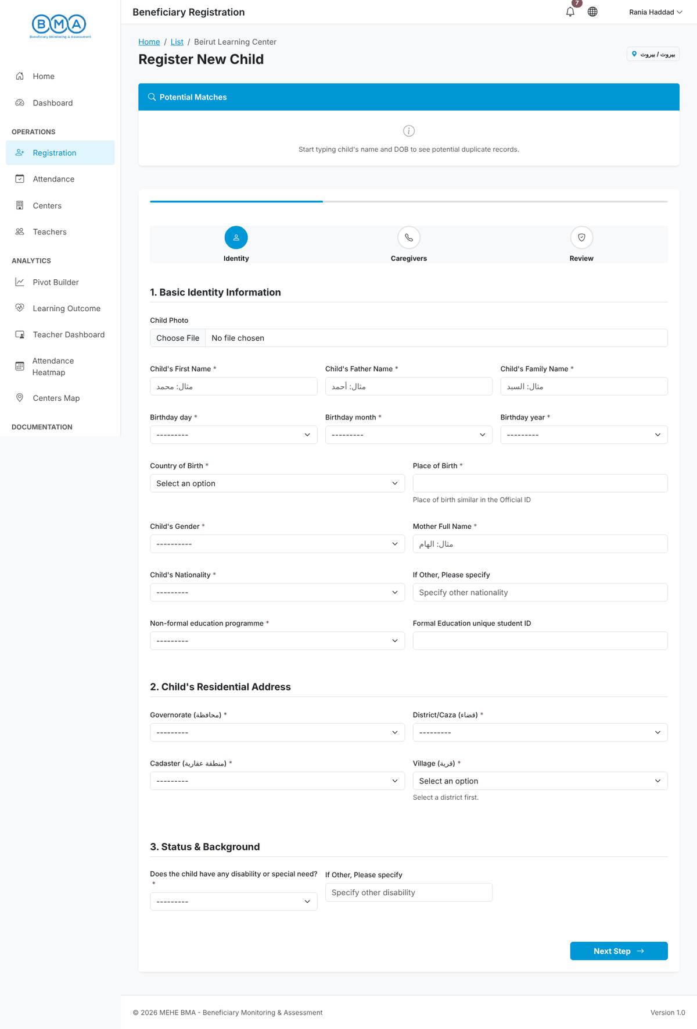
Figure 10 – Step 1 – the empty identity form
2. Fill in the Residential Address: governorate, district, cadaster and village. Each list is loaded after you choose the previous level. Then answer the disability question in Status & Background.
3. Check the data and click Next Step. If a mandatory field is missing, the field is highlighted in red and a Verification Required message lists what must be corrected.
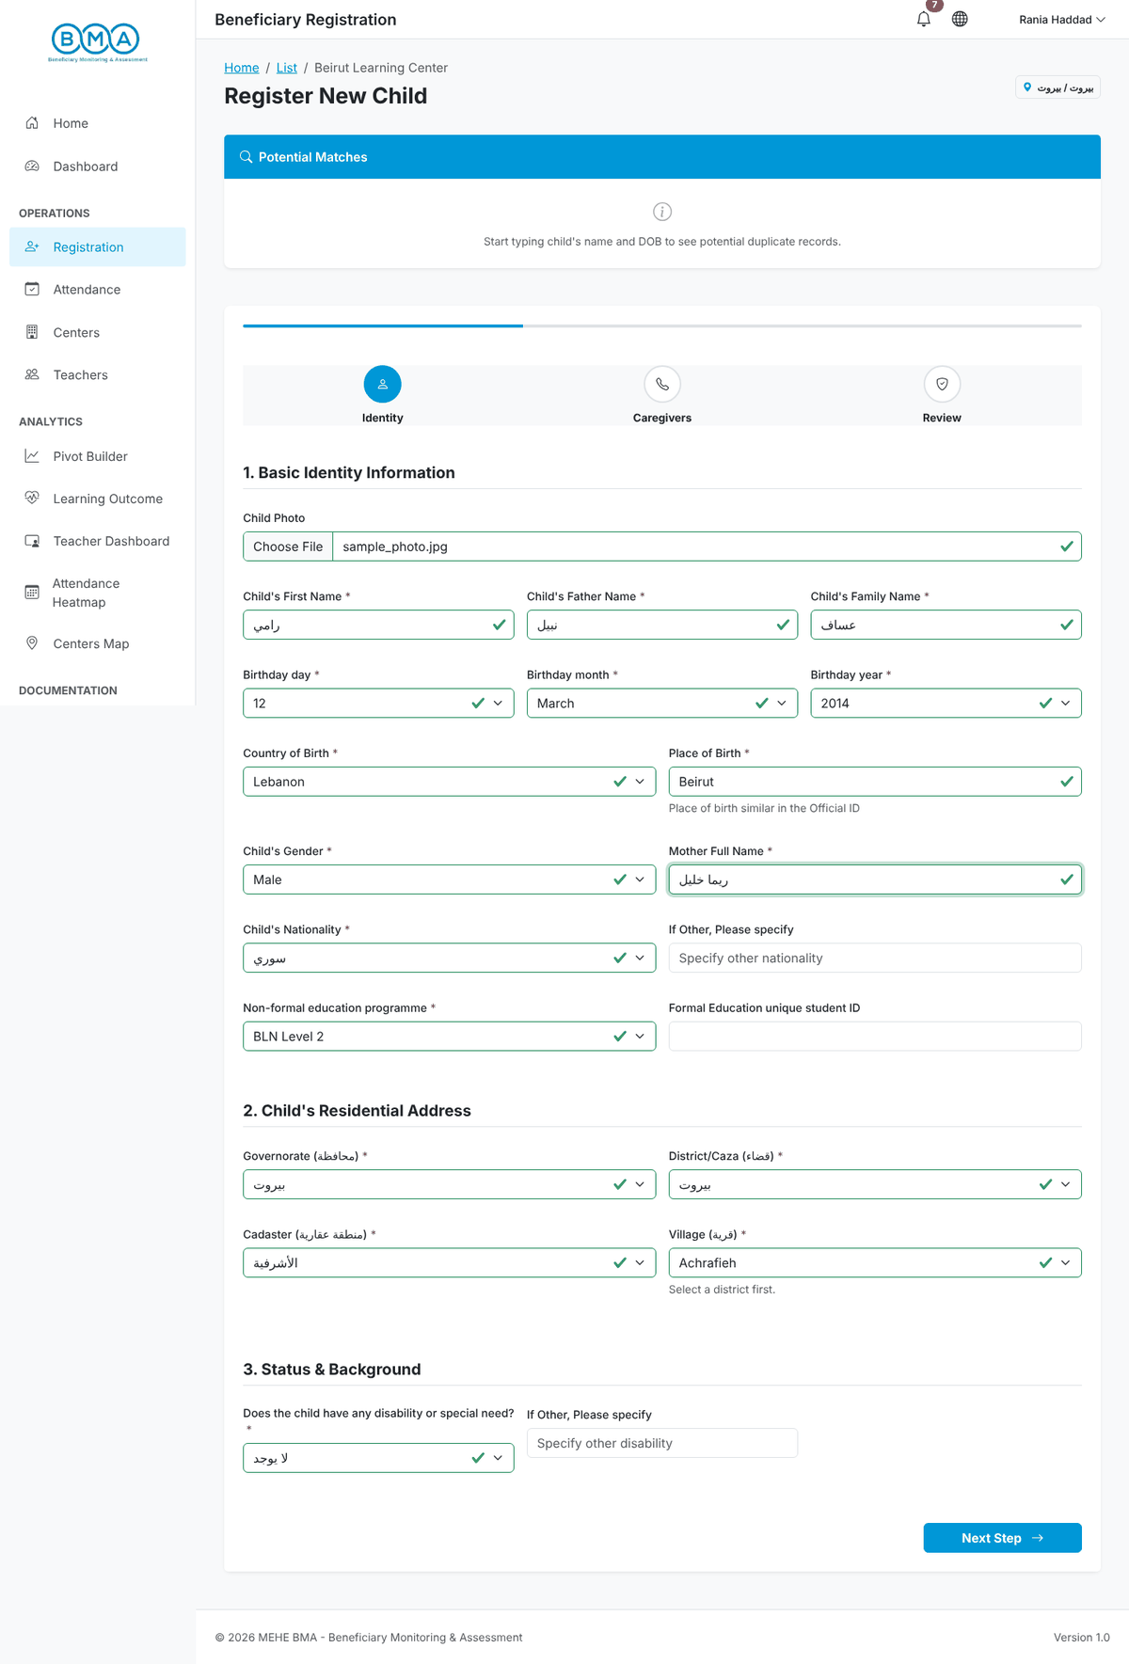
Figure 11 – Step 1 completed
Field | Guidance
First / Father / Family name | In Arabic letters, as written on the ID document
Date of birth | Select day, month and year from the lists
Country and place of birth | As written on the official document
Mother full name | Required, in Arabic letters
Nationality | Choose from the list; if "Other" specify it in the next field
Non-formal education programme | BLN Level 1, BLN Level 2 or BLN Level 3
Formal education unique student ID | Optional – the ID used in the formal school, if any
Governorate / District / Cadaster / Village | Where the child currently lives
Disability or special need | Required; if "Other" describe it

Step 2 – Caregivers
1. Enter the primary phone number of the caregiver in the format XX-XXXXXX (for example 03-123456). This is the number the center uses to contact the family.
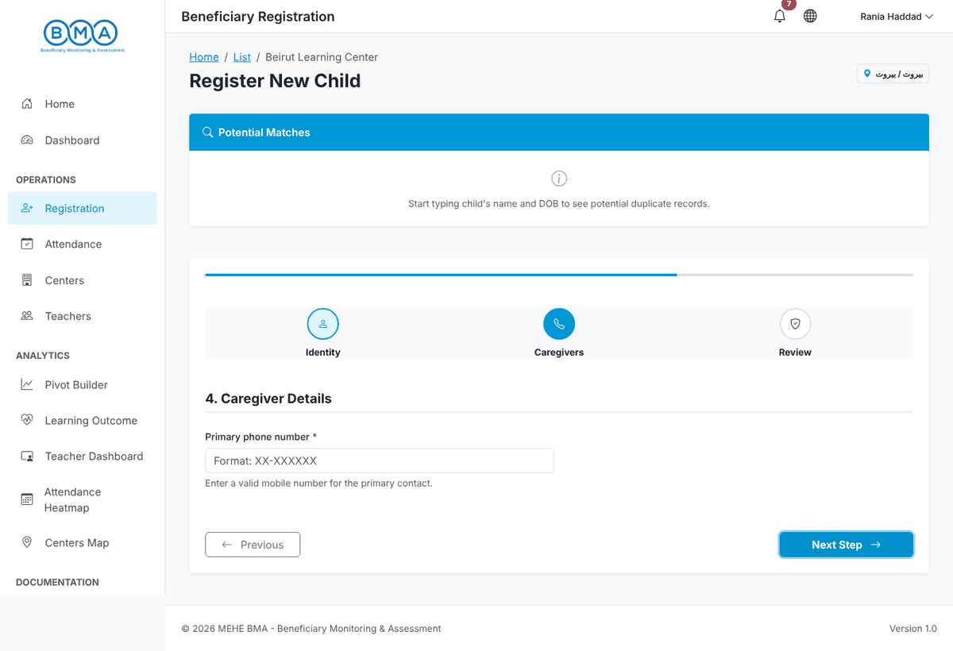
Figure 12 – Step 2 – caregiver contact
2. Click Next Step. Use Previous at any time to go back and correct a value.
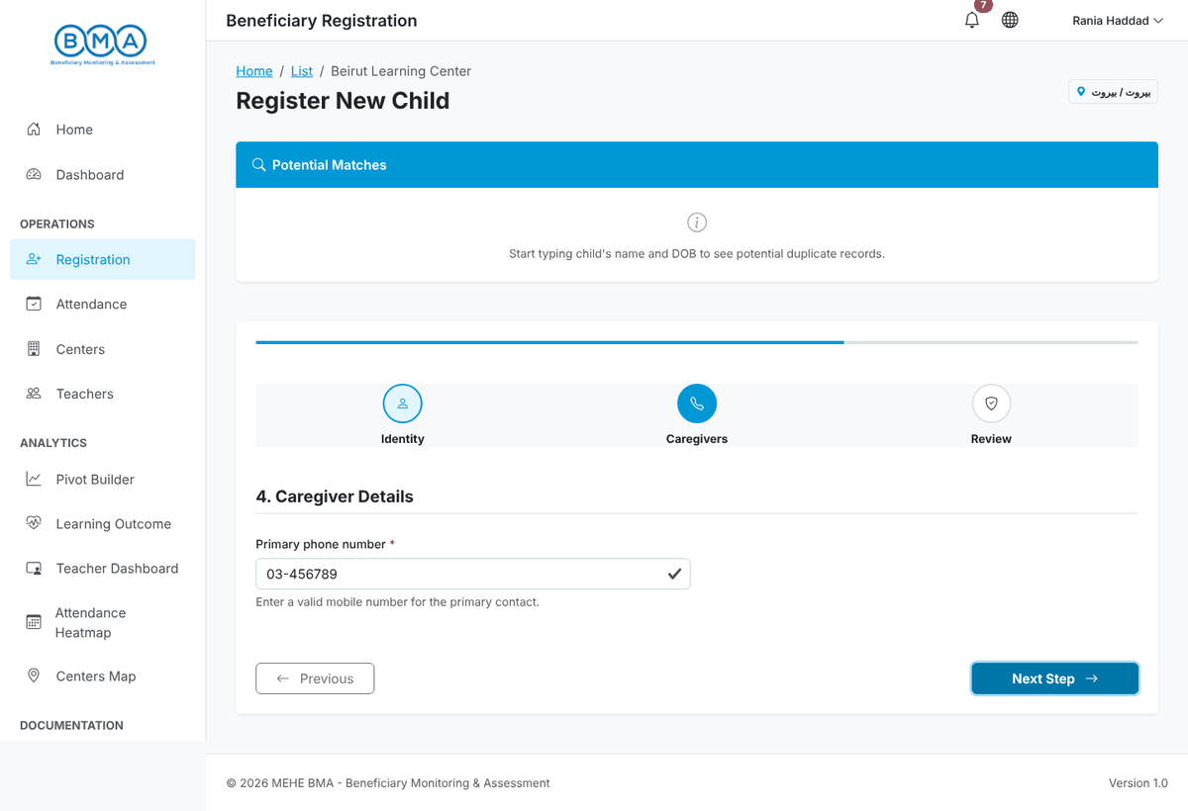
Figure 13 – Step 2 completed

Step 3 – Review and submit
1. Review the summary: full name, date of birth, country and place of birth, nationality, gender, phone number, programme and address. If anything is wrong click Previous and correct it. Reset Form clears everything.
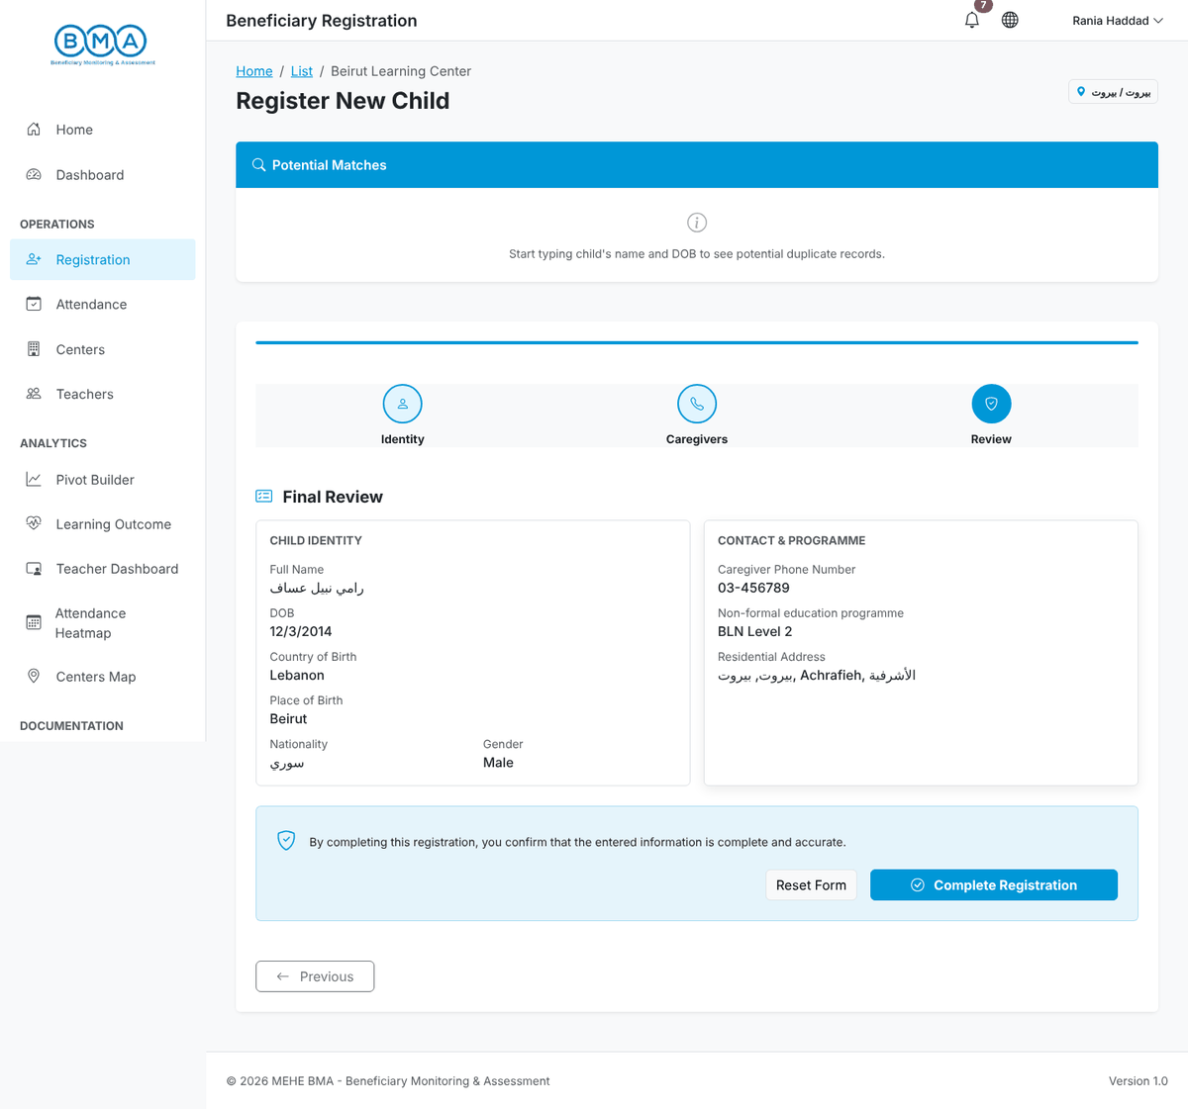
Figure 14 – Step 3 – final review
2. Click Complete Registration. The message "Your data has been sent successfully to the server" confirms the registration and the child's profile page opens.
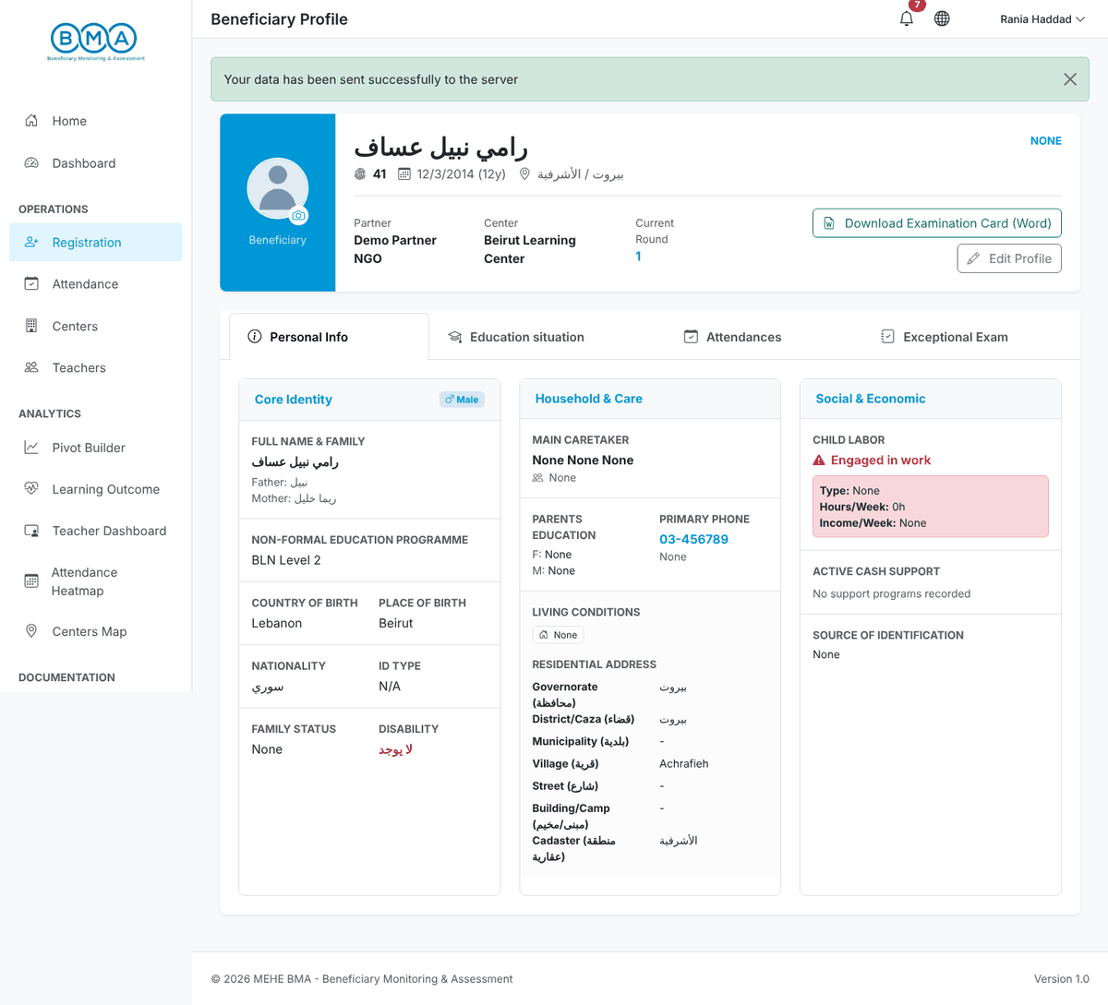
Figure 15 – The profile page right after registration
Note: The center, partner and round are filled in automatically from your account. If your account has no center assigned, a warning is displayed on the list: ask your administrator to link your account to a center.

4. The Child Profile
The profile is the central record of a child. Open it from the beneficiary list with Actions → View Profile.
1. The header shows the photo, the full name, the unique ID, the date of birth with the age, the address, the partner, the center and the current round. The buttons on the right open Download Examination Card (Word) and Edit Profile.
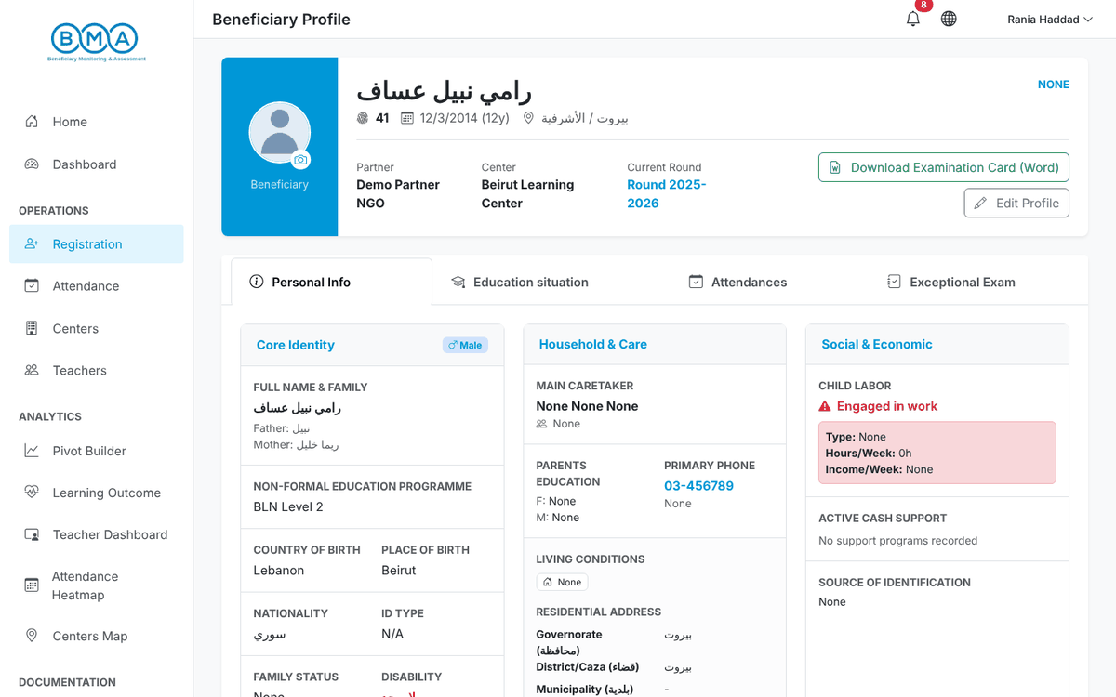
Figure 16 – Profile header
2. The Personal Info tab groups the core identity, the household and care information and the social and economic situation.
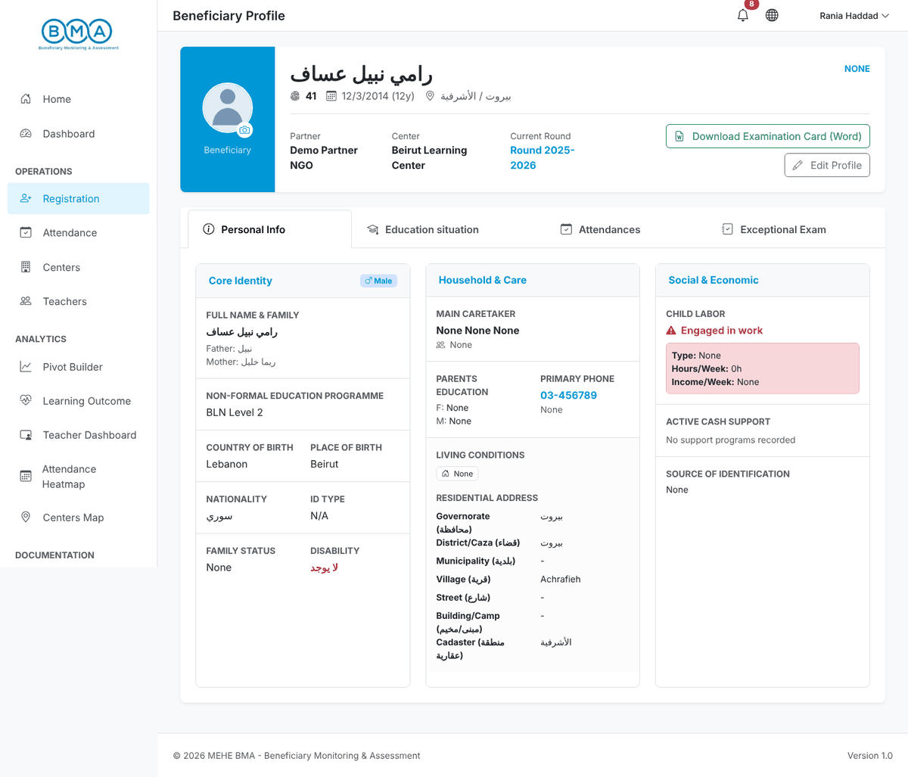
Figure 17 – Personal Info tab
3. The Education situation tab shows the current enrolment (educational level, programme, round, section, registration date), the education history, the pre/post grading of the programme and the referral card.
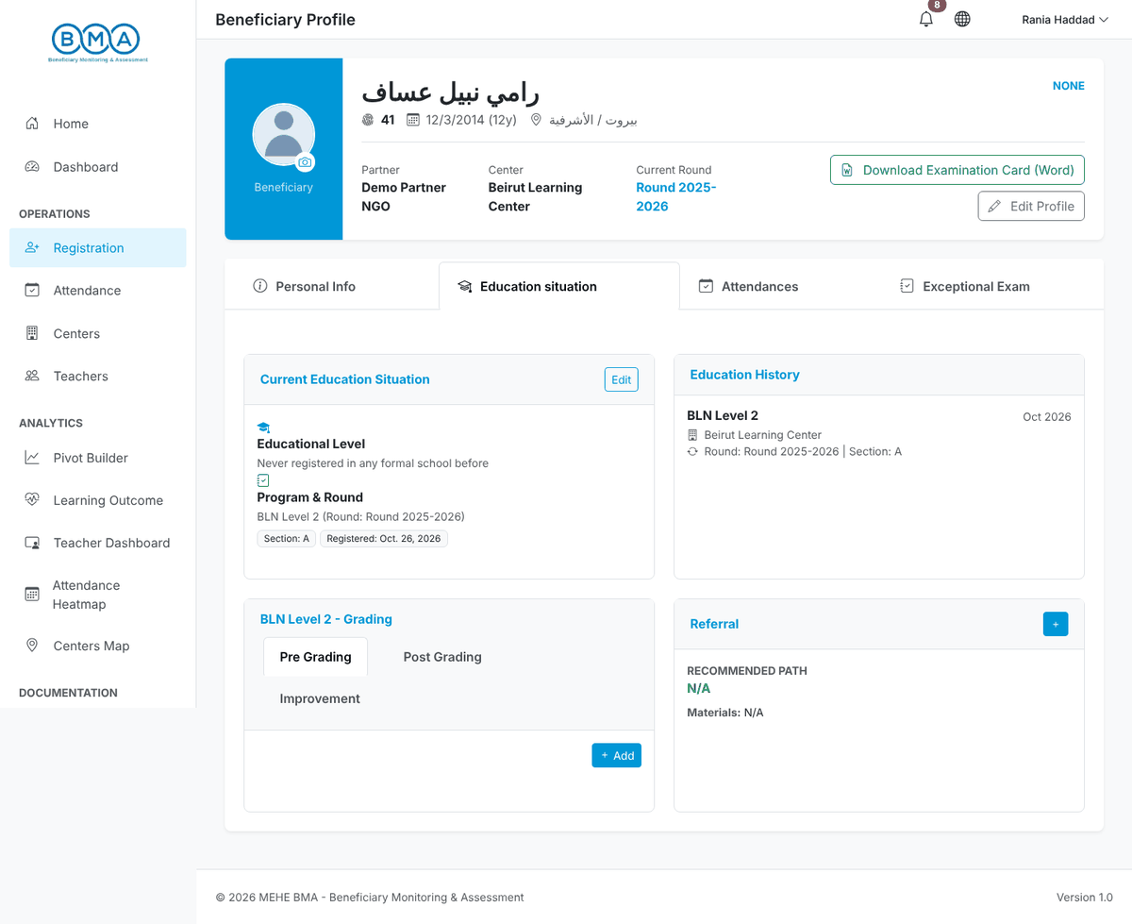
Figure 18 – Education situation tab
4. The Attendances tab shows the total teaching days, the days attended, the absences and the absences of the current month. Click a month in Monthly History to see the detailed daily records.
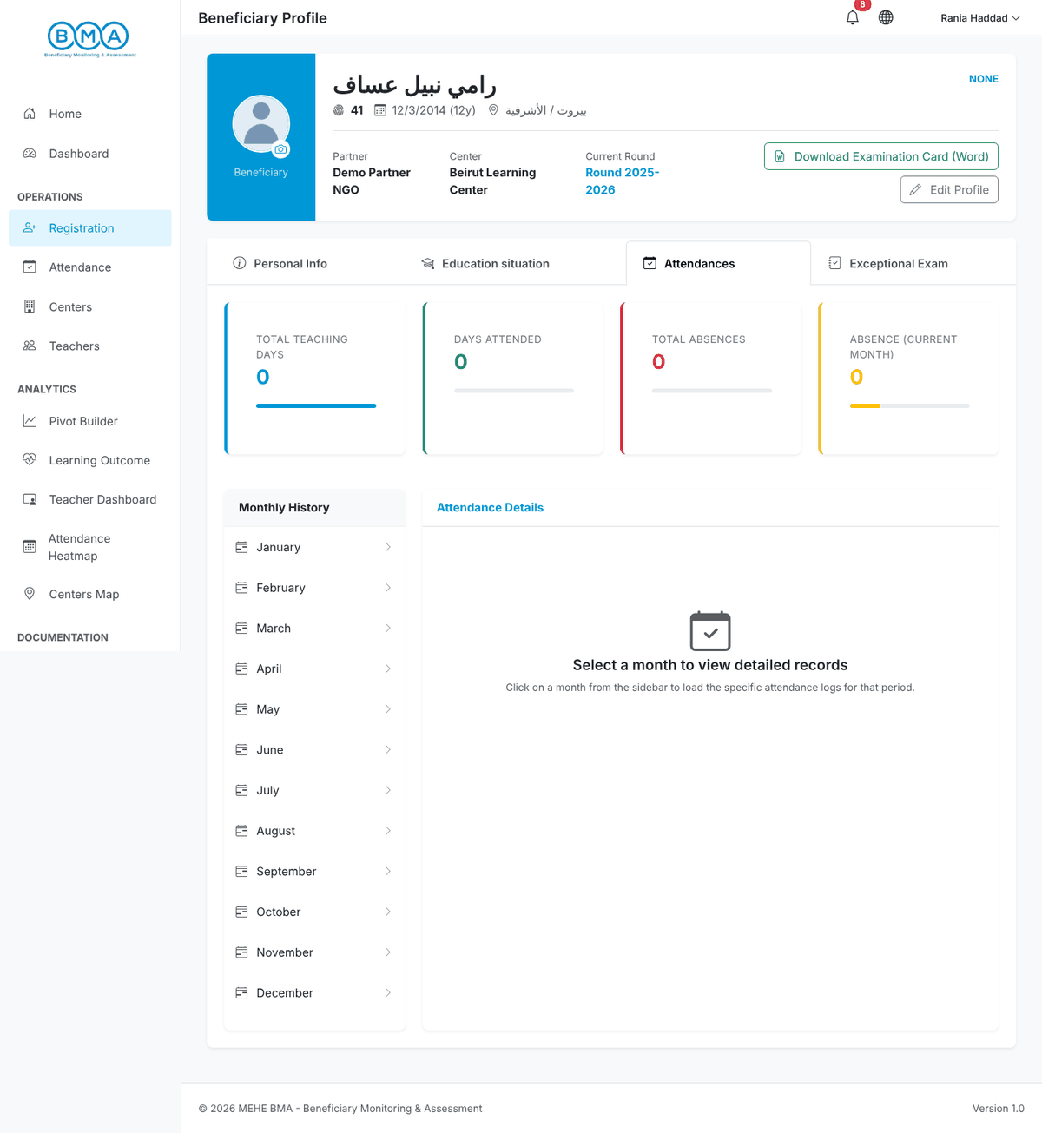
Figure 19 – Attendances tab
5. The Exceptional Exam tab shows the exam details recorded for the registration, or a button to add them (see section 6).
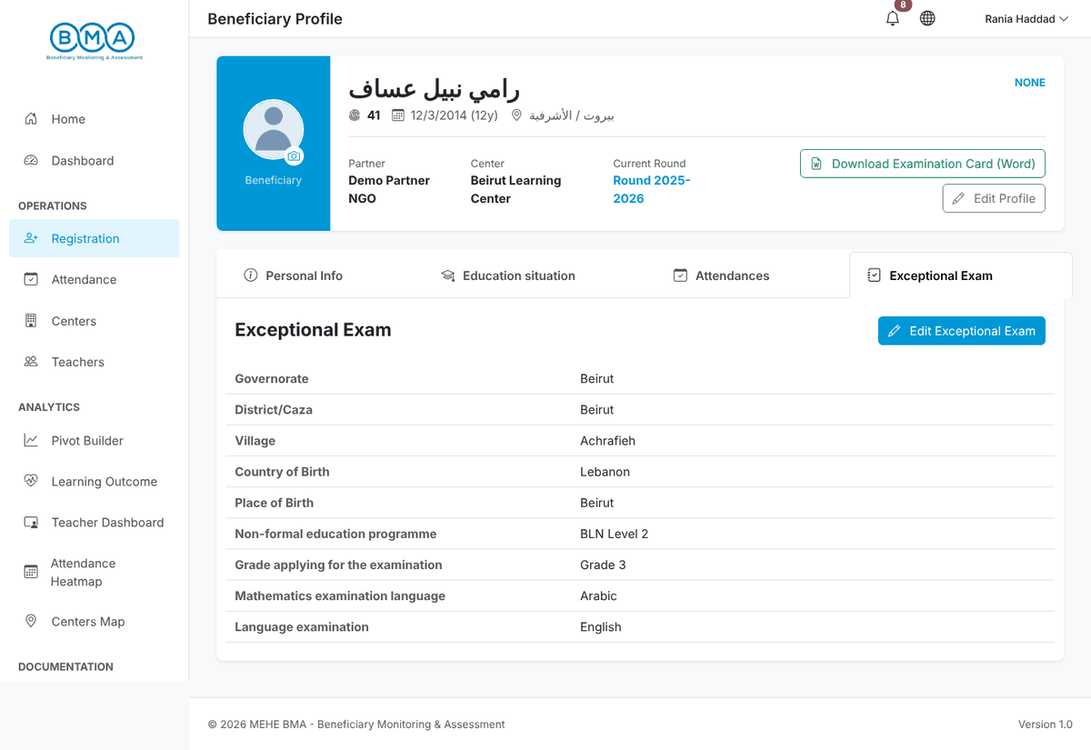
Figure 20 – Exceptional Exam tab

Editing the profile
1. Click Edit Profile (or Actions → Edit Information in the list). The same 3-step form opens with the saved values. Change what is needed, go through the steps and click Complete Registration to save.
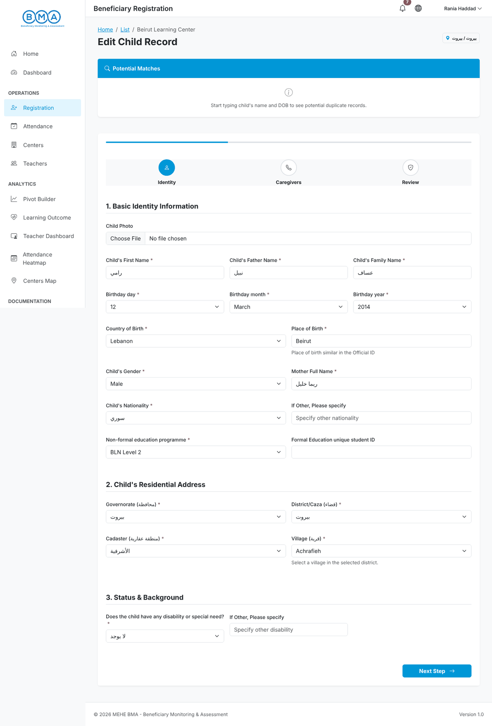
Figure 21 – Editing a registration

Uploading the child photo
1. Click the camera icon on the profile photo, or Actions → Upload Photo in the list. Choose a clear, recent photo of the child (JPG or PNG) and click Save.
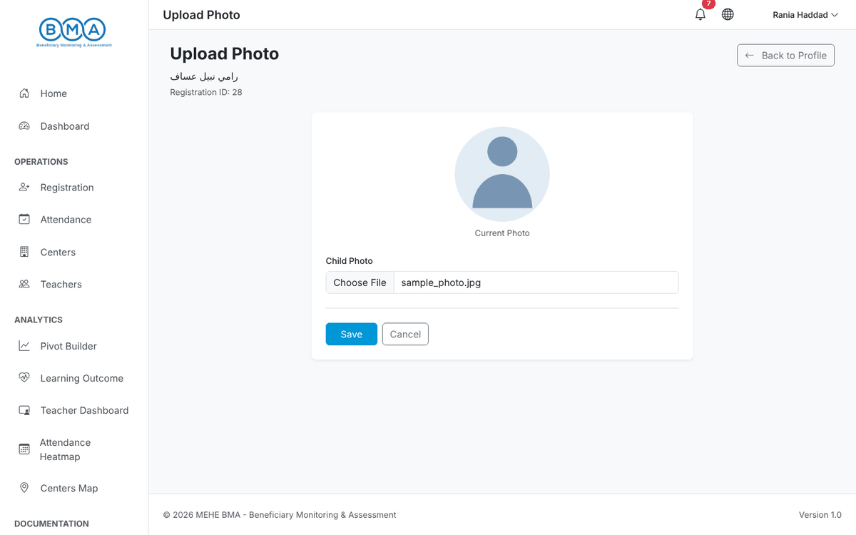
Figure 22 – Photo upload form
2. The profile reopens with the new photo. The photo is also embedded in the Excel export and printed on the examination card.
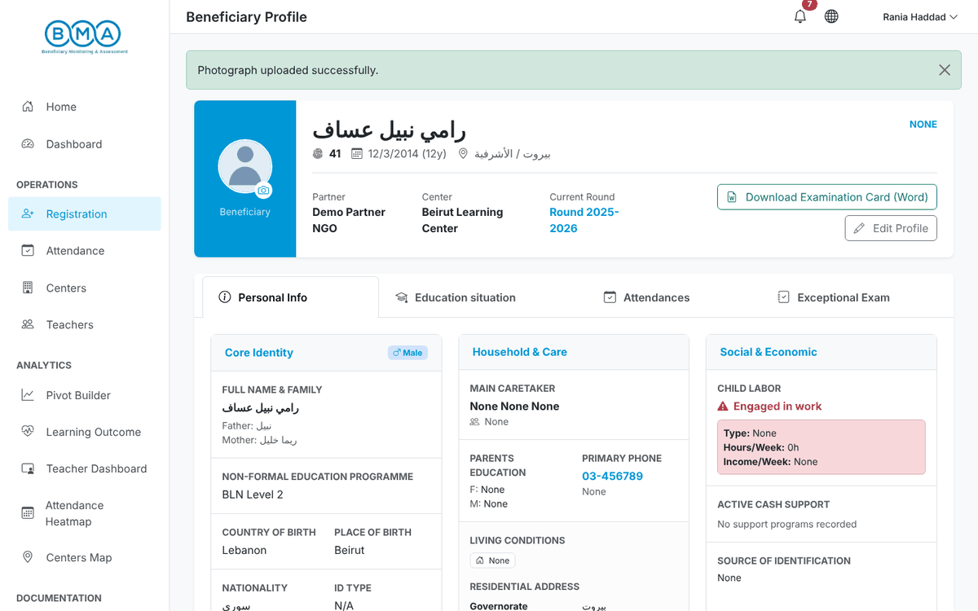
Figure 23 – Photo saved

Examination card
Click Download Examination Card (Word) in the profile header to download an editable Word card with the child's photo, round, registration ID, partner, full name, date of birth, nationality and governorate. Correct the profile first if anything is wrong: each download reads the saved record again.

5. Education Situation and Round Enrolment
The education situation records the child's educational level at registration and the programme, round and class section the child attends. It is required before the child appears in the attendance sheets.
1. Open the profile, go to the Education situation tab and click Add (or Edit if a situation already exists).
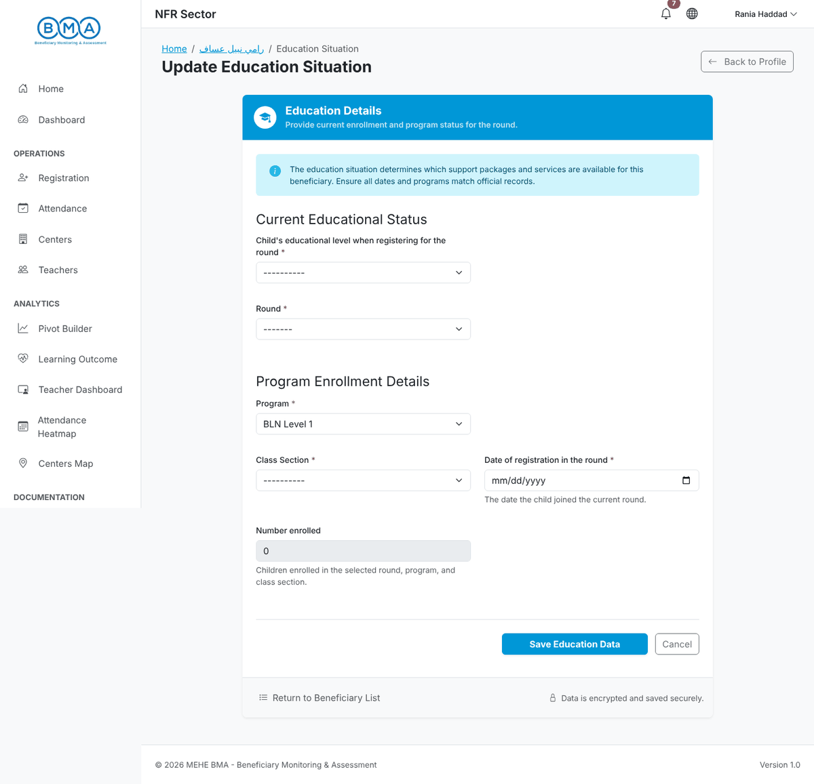
Figure 24 – The education situation form
2. Choose the educational level when registering, the round, the programme, the class section and the date of registration in the round. If the child dropped out of a school, give the dropout date.
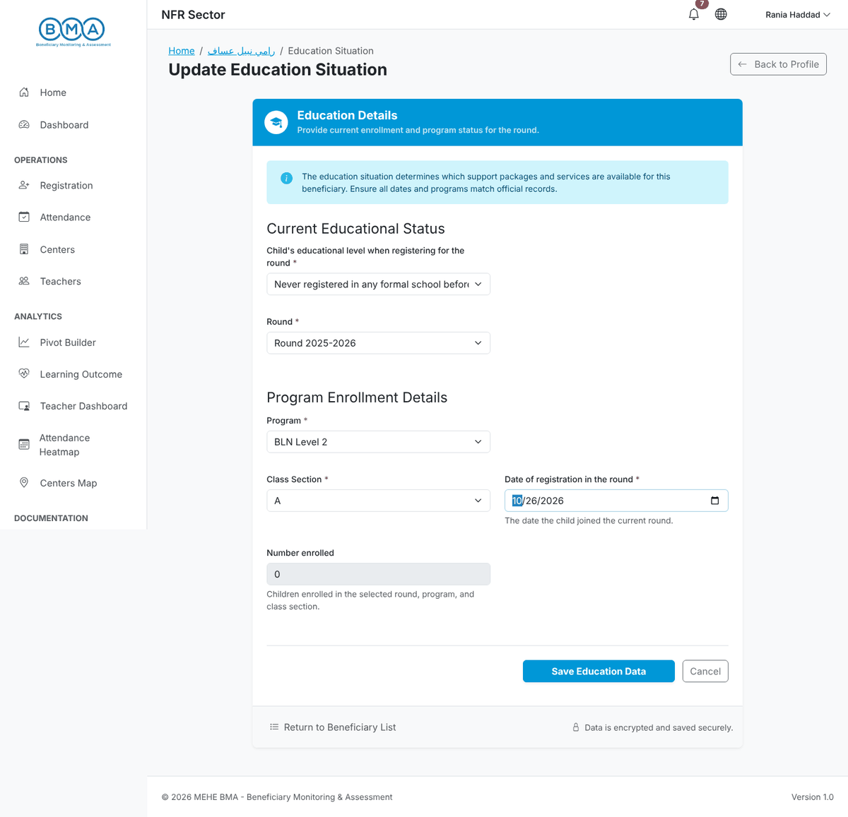
Figure 25 – Education situation completed
3. Click Save Education Data. The profile reopens on the Education situation tab with the new enrolment and a new line in the Education History.
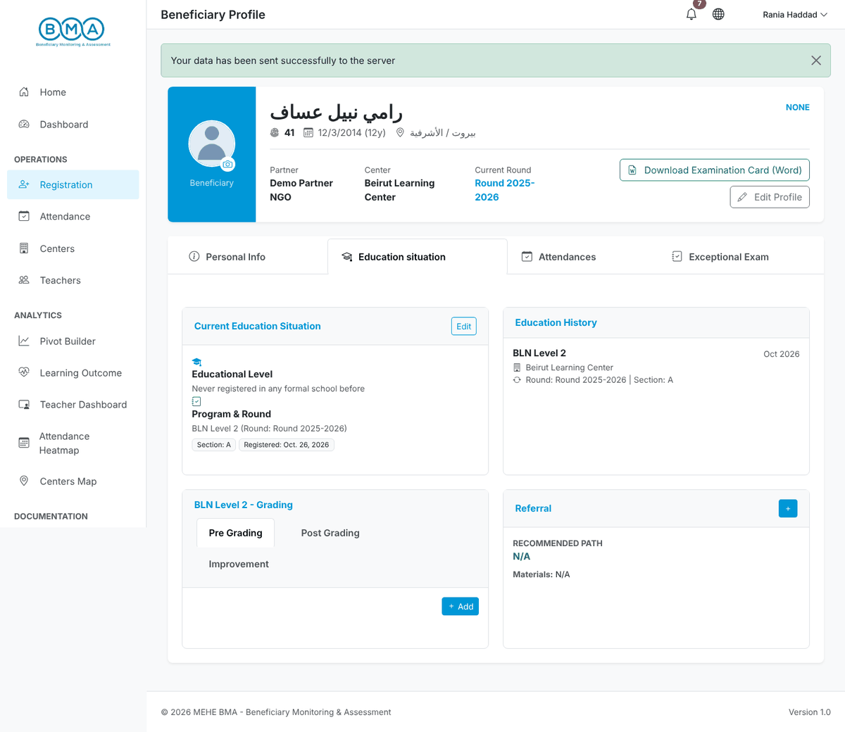
Figure 26 – The saved education situation

Registering the child in a new round
1. When a new round starts, open the Register in a New Round page for the child (from the duplicate warning's Select & Re-register button, or from the New Round button in the profile header when your role has it). The Registration History lists the rounds the child already attended.
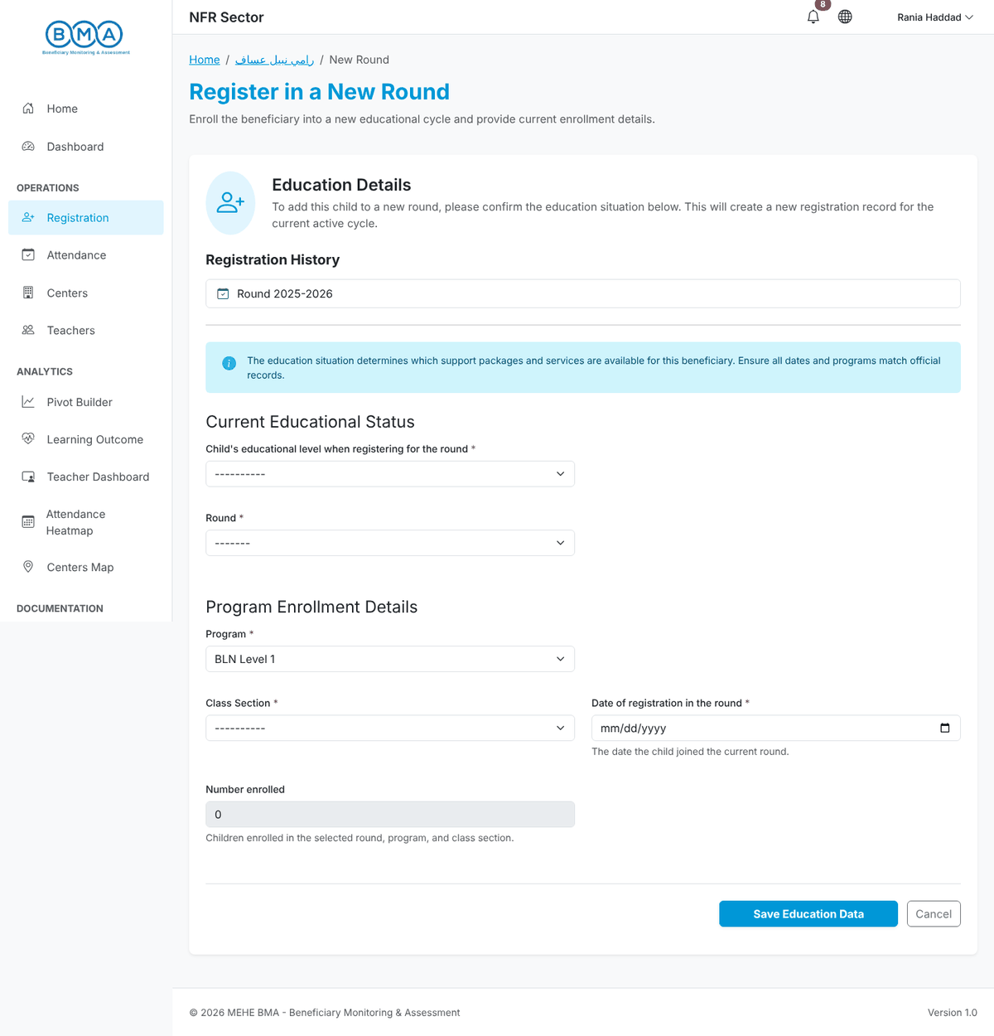
Figure 27 – Register in a new round
2. Fill in the education situation for the new round and click Save Education Data. A new registration record is created for the current round; the previous rounds stay in the history.
Note: The programmes offered depend on the child's age. If the programme you need is not listed, check the date of birth.

6. Exceptional Exam
Children who sit the exceptional examination need an exam record on their registration. Each registration has one exam record.
1. Open the profile, go to the Exceptional Exam tab and click Add Exceptional Exam. The residence, country and place of birth and the programme are taken from the registration and displayed in grey.
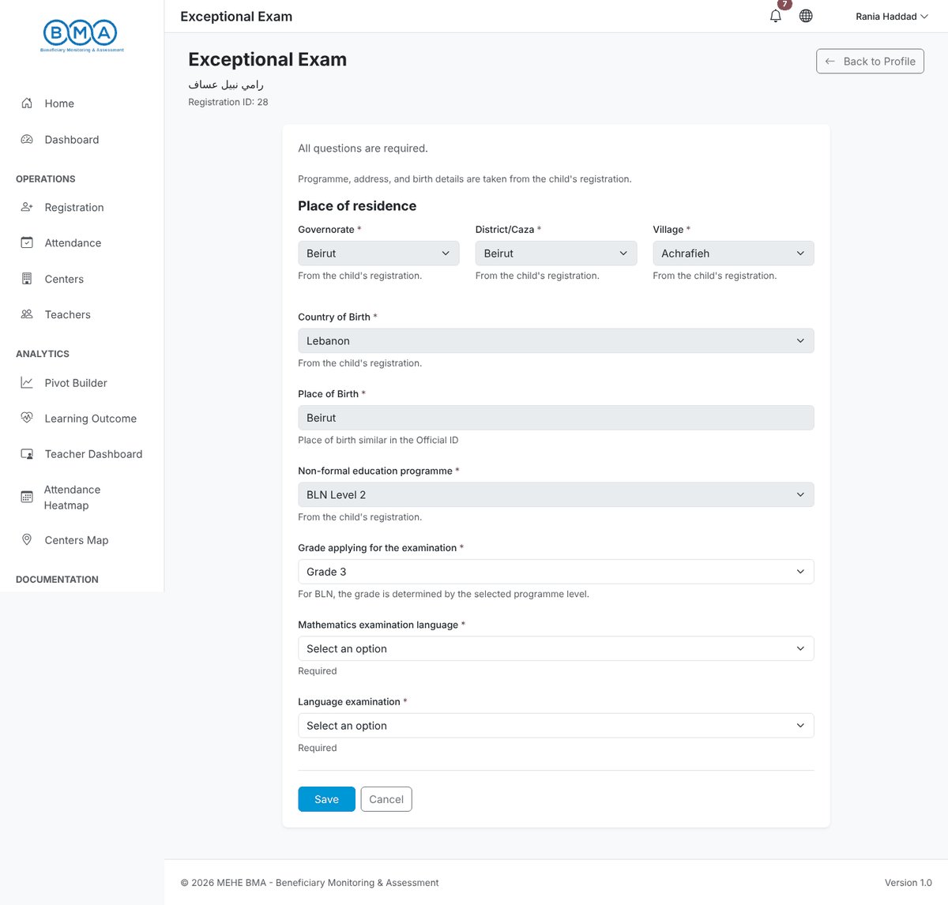
Figure 28 – The exceptional exam form
2. Check the grade applying for the examination (derived from the programme level), choose the mathematics examination language (Arabic, English or French) and the language examination (English or French).
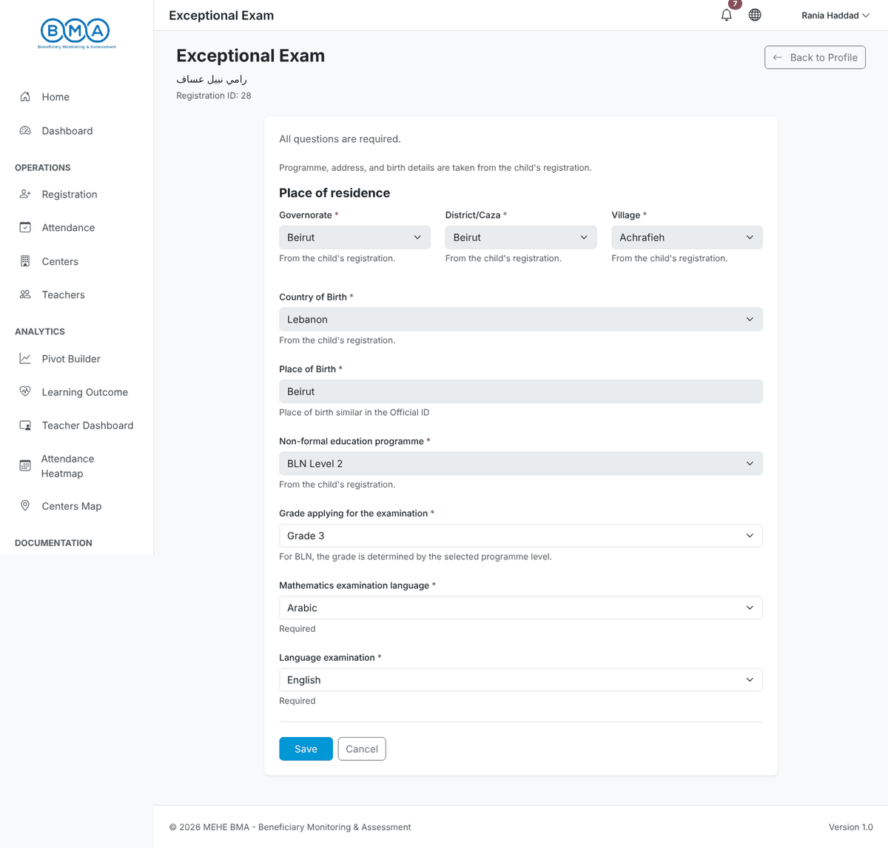
Figure 29 – Exam form completed
3. Click Save. The message "Exceptional exam saved" appears and the tab shows the recorded answers. Use Edit Exceptional Exam to correct them later.
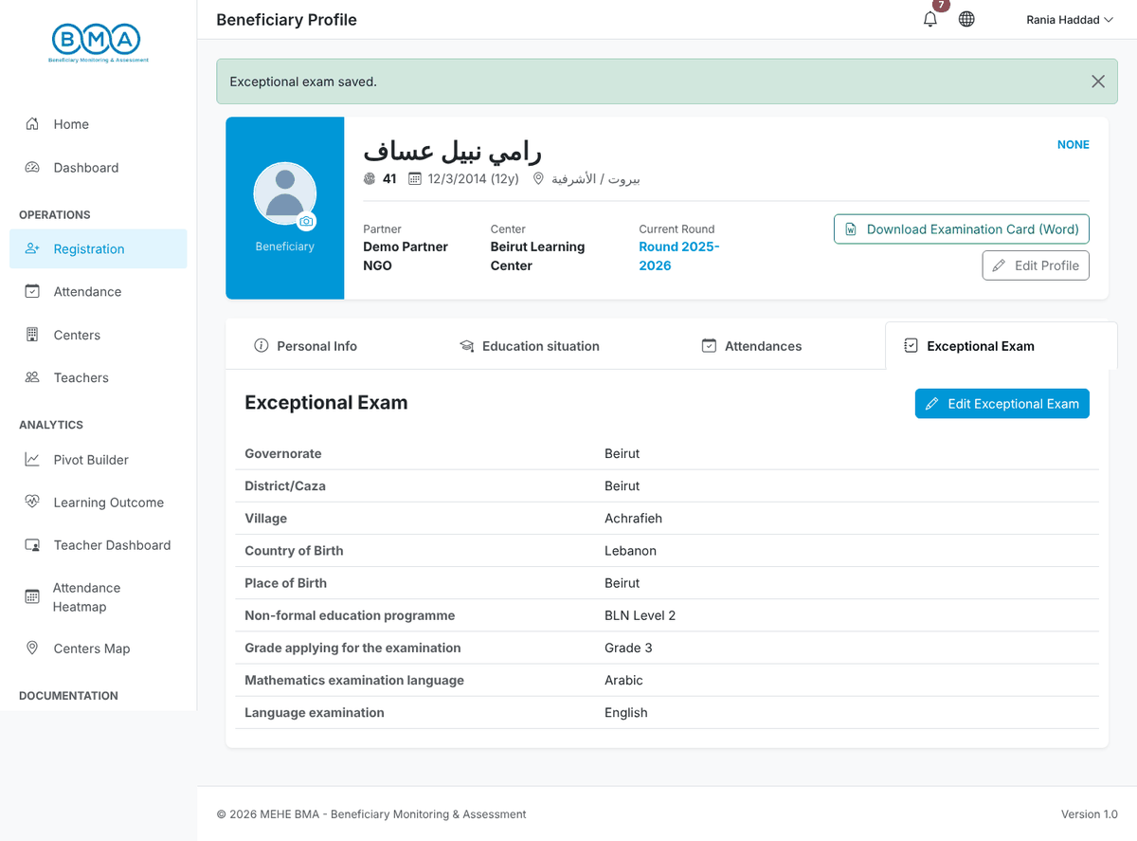
Figure 30 – The saved exam details
Note: If the residence or programme shown is wrong, correct the child's registration first (Edit Profile) and then come back to the exam form.

7. Daily Attendance
Attendance is recorded per day, per programme and per class section. Open it with Attendance in the side menu.
1. The date defaults to today. Choose the Education Program, the Round and the Section.
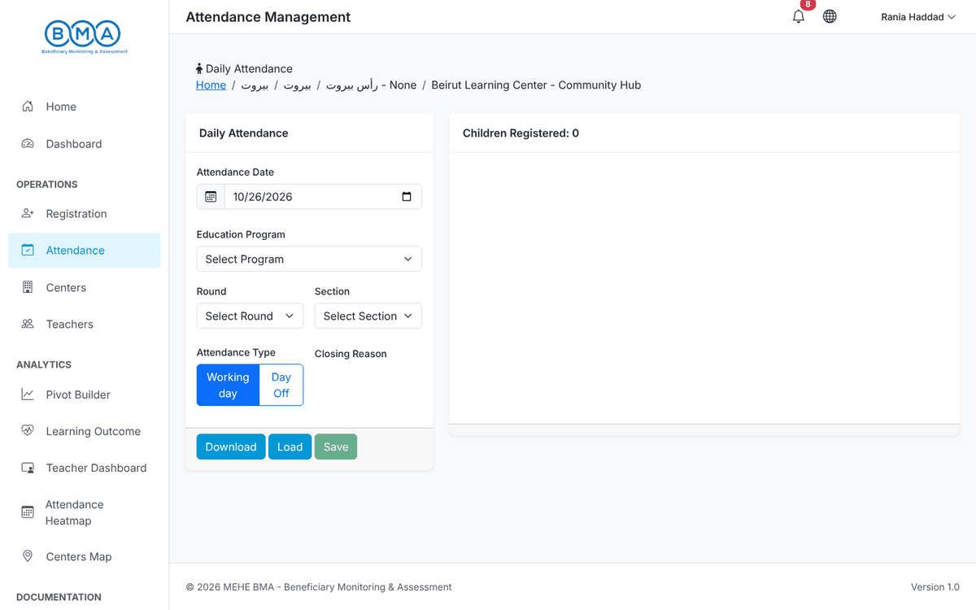
Figure 31 – The attendance page
2. Click Load. The children enrolled in that programme and section appear on the right, each with Attended and Absent buttons.
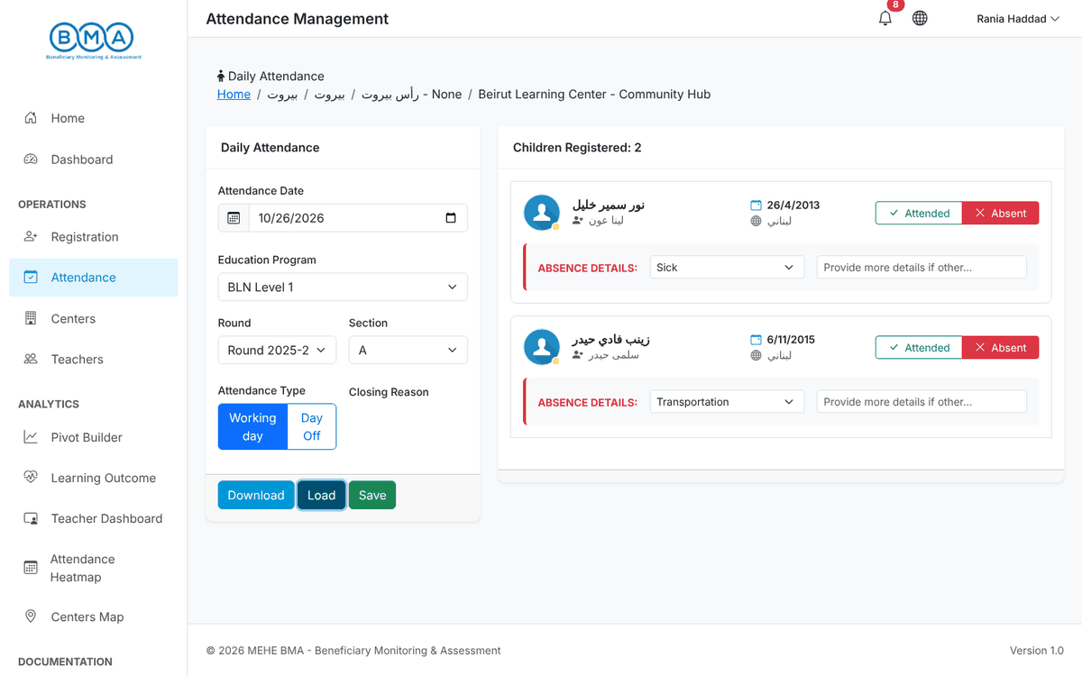
Figure 32 – Children loaded for the selected class
3. Children are marked Attended by default. For each absent child click Absent and choose the absence reason (Sick, Transportation or Other – describe it in the text box).
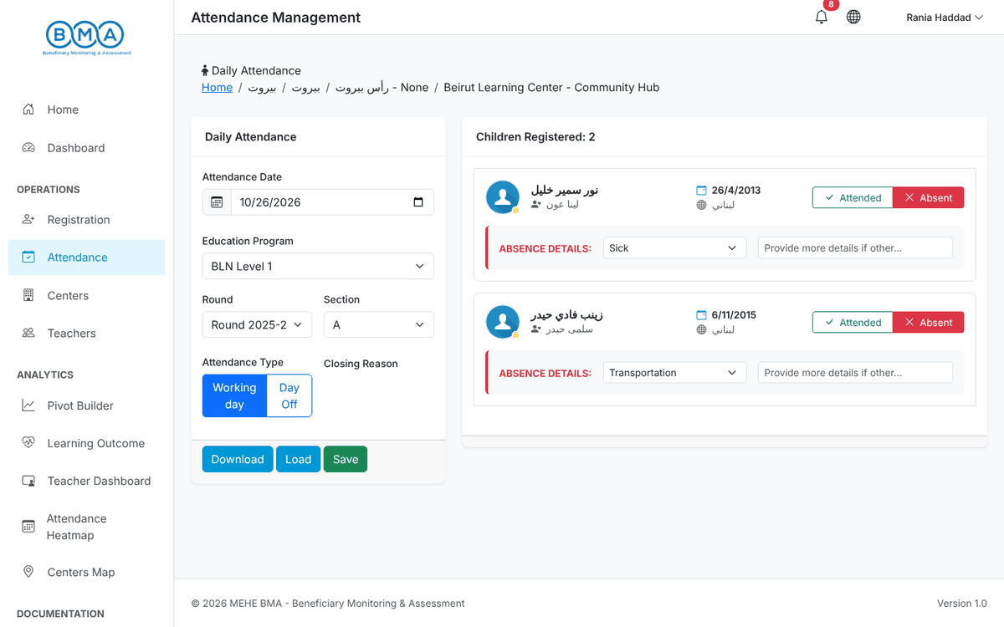
Figure 33 – Absences marked with their reason
4. Click Save. A Success message confirms the attendance was saved. You can reload the same day later to correct it.
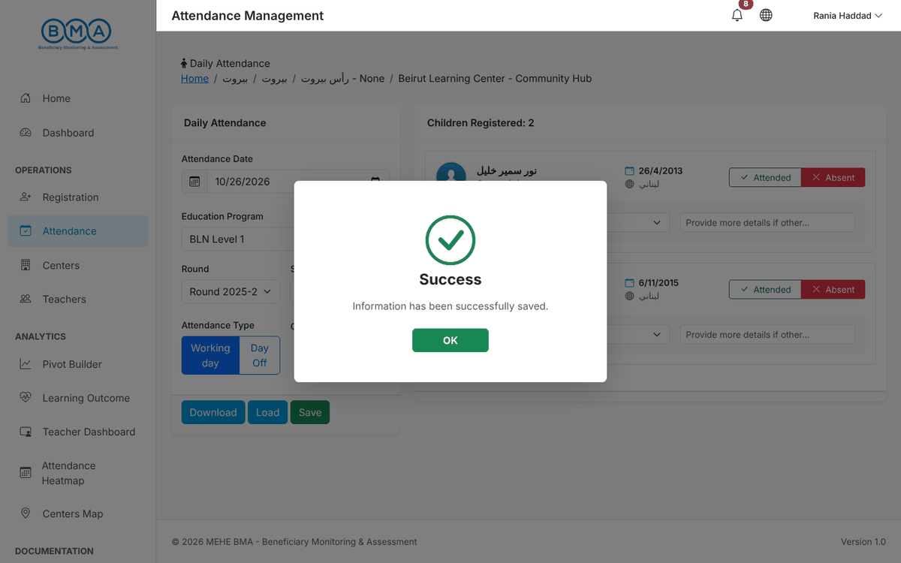
Figure 34 – Attendance saved
5. If the center was closed, select Day Off instead of marking children, choose the closing reason and save.
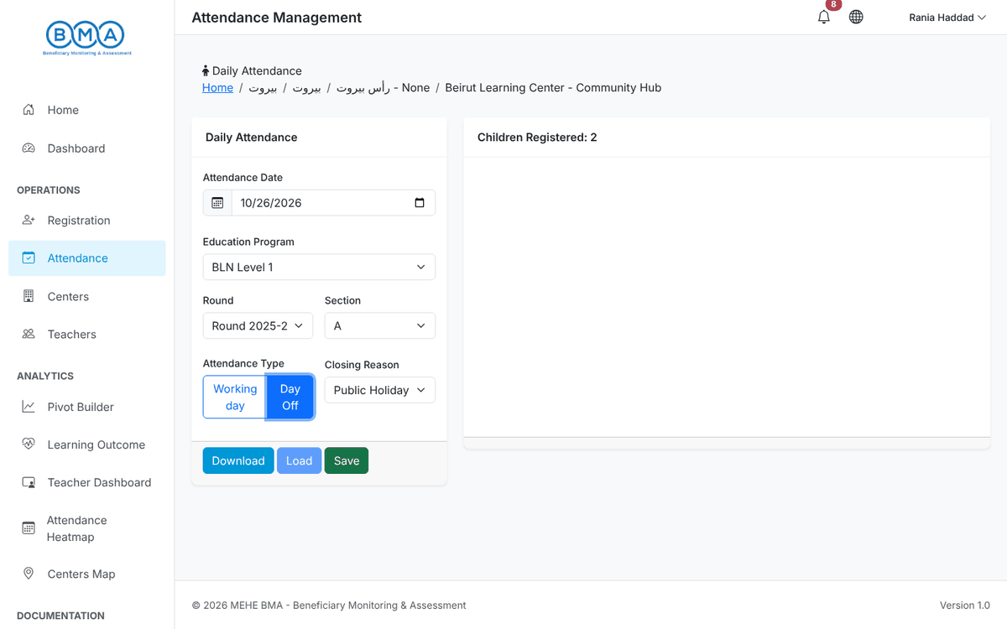
Figure 35 – Recording a day off
- Attendance can be recorded for today or for a past date; future dates are refused.
- A child who does not appear in the list has no education situation for that programme and section (see section 5), or the registration is not active.
- Download gives a CSV file of the list currently loaded on screen.

8. Teachers
Every teacher or facilitator of the center must be recorded. Open Teachers in the side menu.
1. The teacher list shows the names, gender, phone number, center, round and who created the record. Use Search to filter and Export to download the list. Click Add Teacher to create a record.
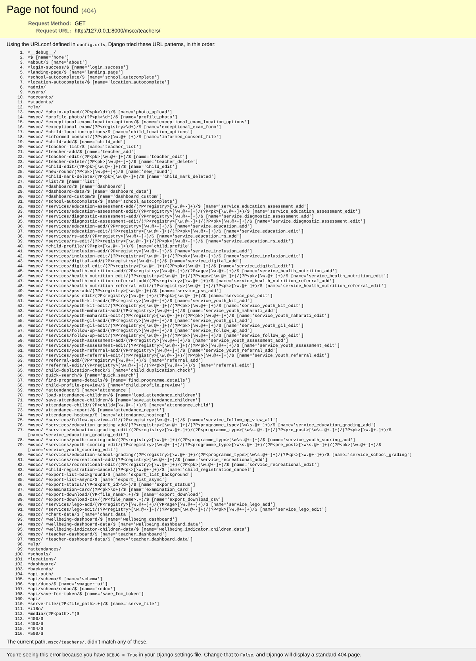
Figure 36 – The teacher list
2. Fill in Identity & Contact: names in Arabic letters, gender, birth date, nationality, ID type and number, phone (format XX-XXXXXX) and email.
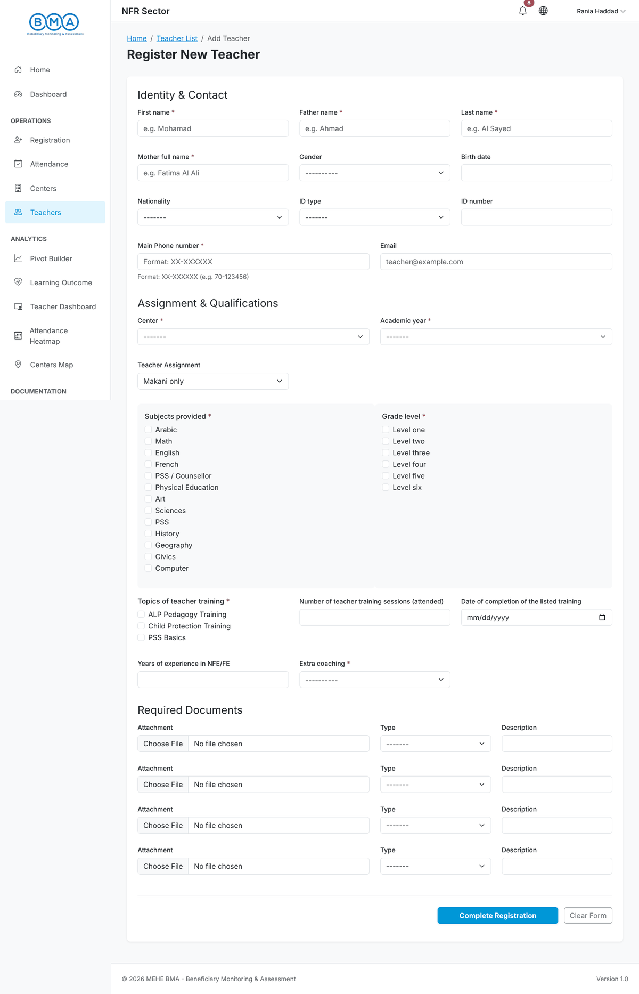
Figure 37 – The teacher form
3. Fill in Assignment & Qualifications: center, academic year, assignment, teaching hours, subjects provided, grade levels, training topics attended, years of experience and extra coaching. Add up to four supporting documents under Required Documents.
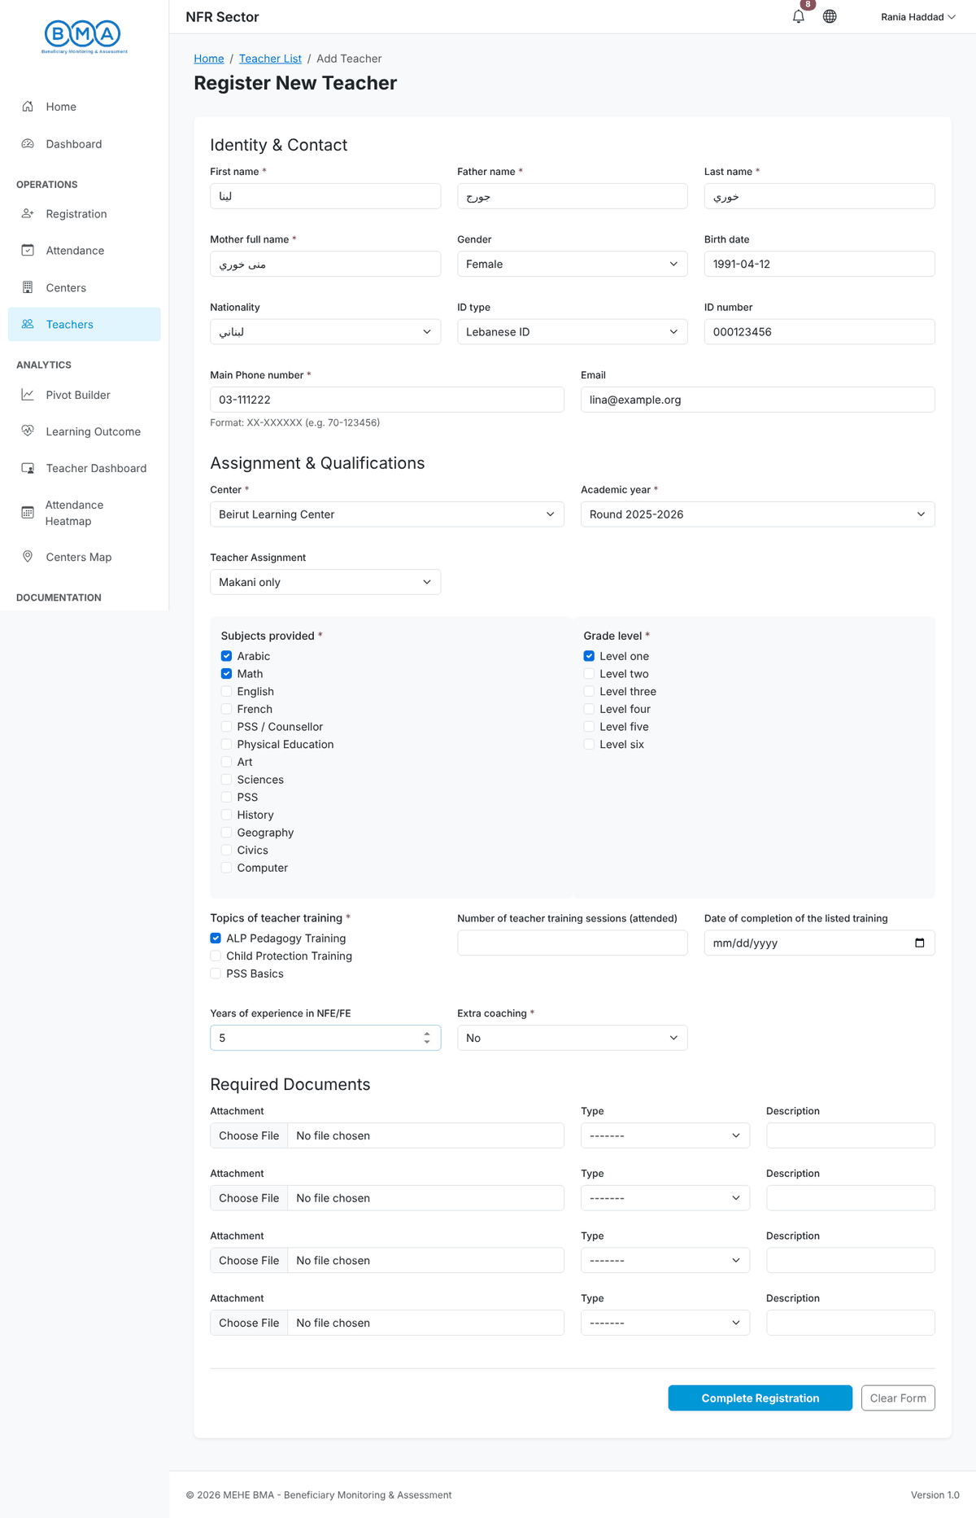
Figure 38 – Teacher form completed
4. Click Complete Registration. The teacher appears in the list.
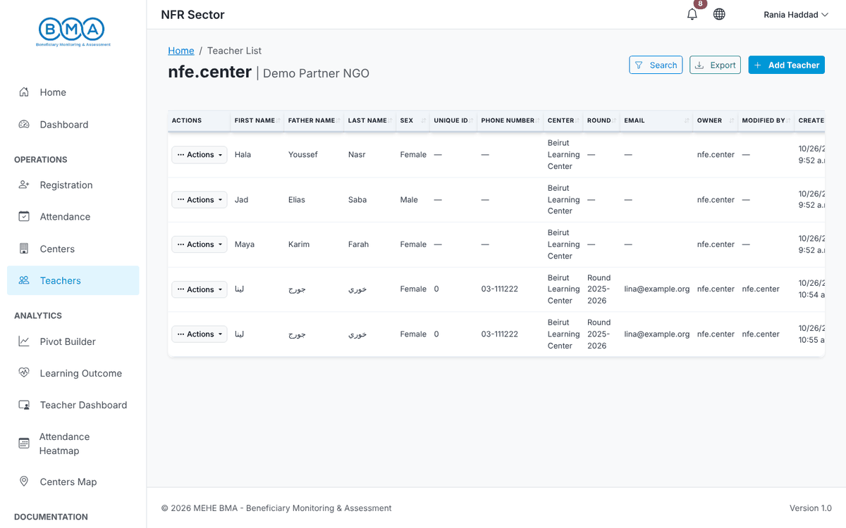
Figure 39 – Teacher saved
5. To update a teacher use Actions → Edit in the list, change the values and save. Delete removes the teacher after confirmation.
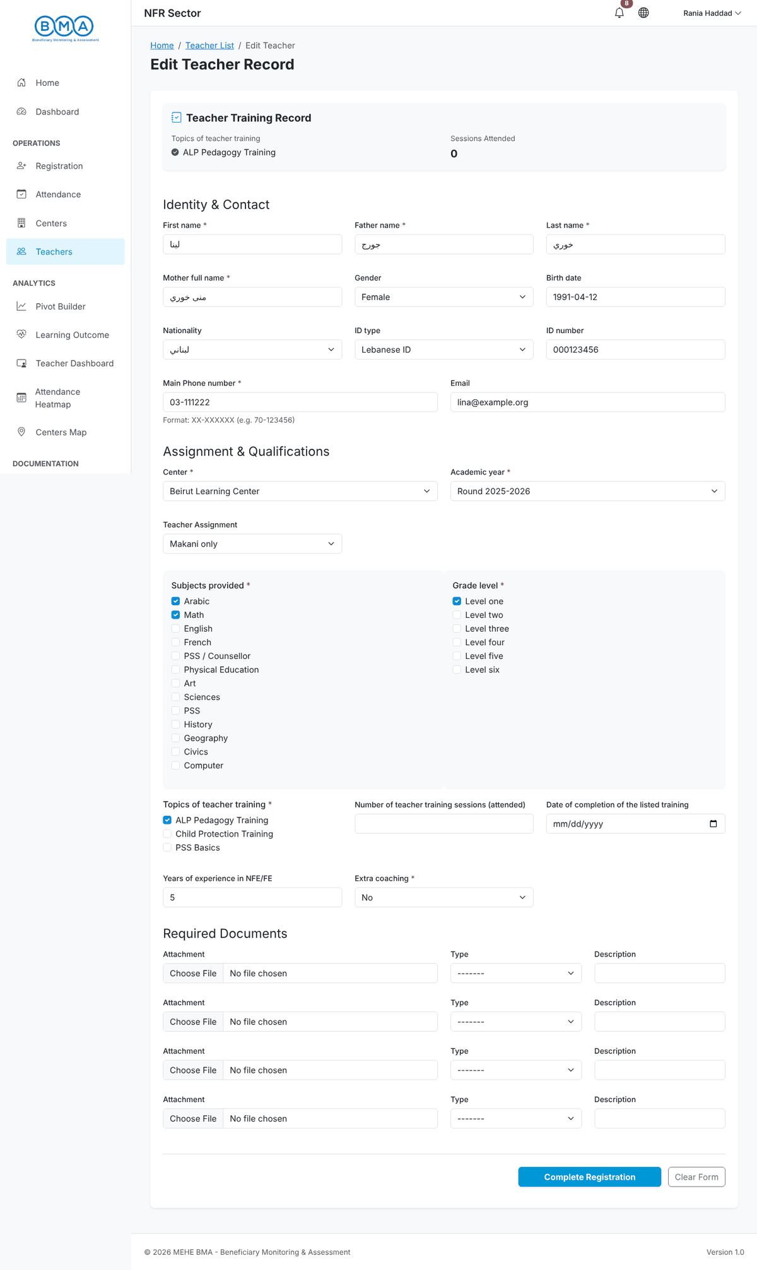
Figure 40 – Editing a teacher

9. Centers
1. Centers in the side menu lists the centers you can access with their partner, type and location. Center users see their own center; partner users see all the centers of their organisation. Use the row actions to open or update a center profile (name, type, address, GPS coordinates, services provided).
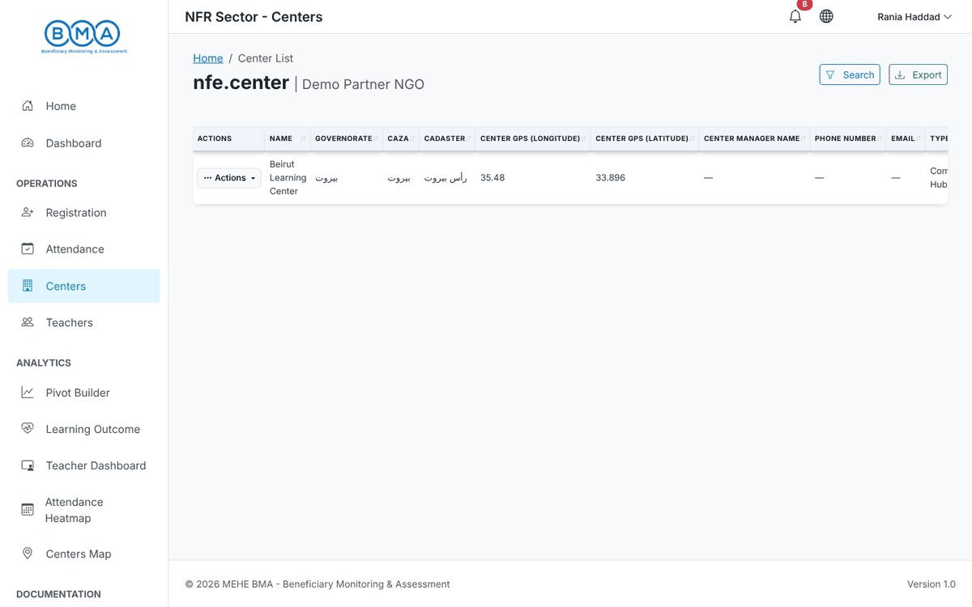
Figure 41 – The center list

10. Exporting Data
Exports are started from the beneficiary list and prepared in the background, so you can keep working.
1. In the beneficiary list click Export. Choose the children to export (all the children you can access, or only the current filter results) and the format: CSV (text only), Excel with photographs, or Word examination cards (ZIP).
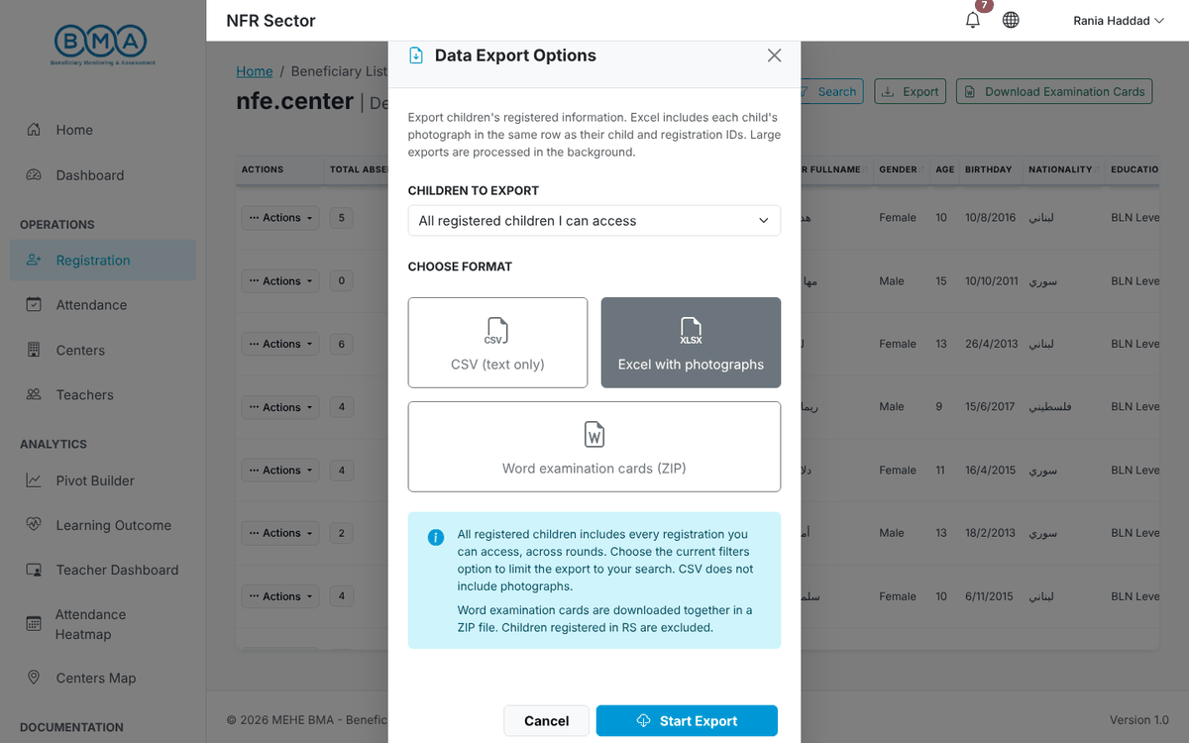
Figure 42 – Export options
2. Click Start Export. When the file is ready a message tells you the download starts automatically.
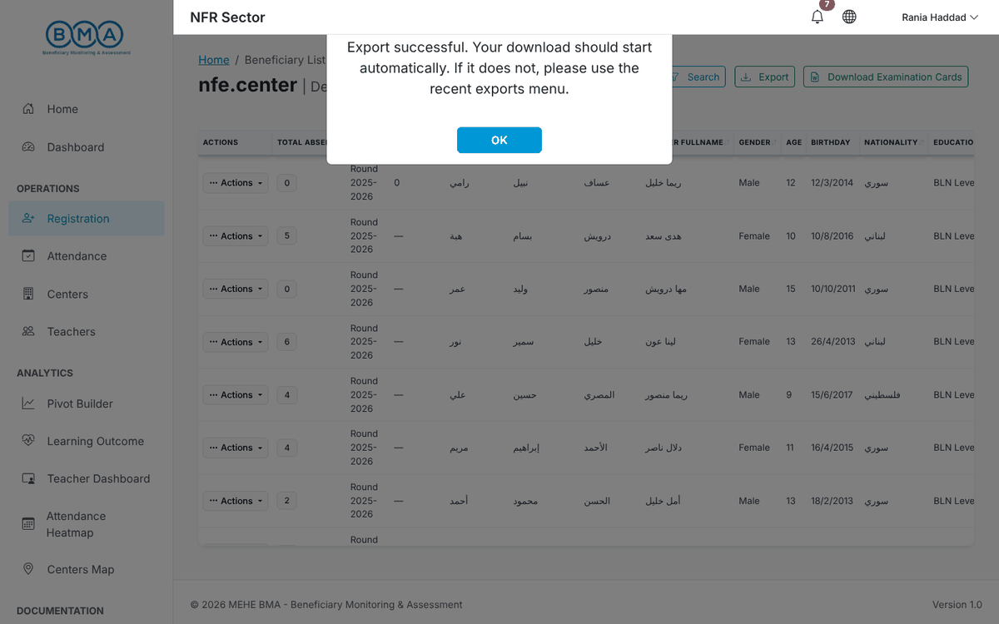
Figure 43 – Export completed
3. Click the bell icon in the top bar to open Recent Exports. Each entry shows its status and lets you download the file again. View All History opens the full export history.
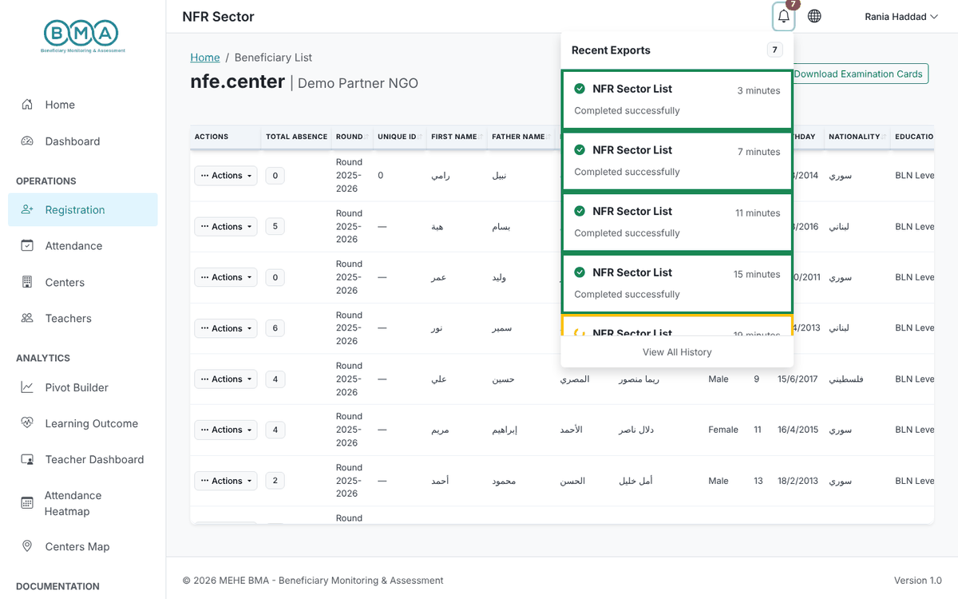
Figure 44 – Recent exports menu
- Excel exports embed each child photo in the same row as the child and registration IDs.
- CSV files are UTF-8 with a byte-order mark, so Arabic names open correctly in Excel.
- Only the user who requested an export can download it.
- Download Examination Cards on the list prepares the Word cards of the selected children as one ZIP file.

11. Dashboards and Analytics
The Analytics entries of the side menu give an overview of your data. All dashboards are limited to the centers you can access.
1. Dashboard – total registrations, active centers, partners and rounds, followed by charts on gender, age groups, nationality, source of identification, registrations per round, family status, disability, cash support and children moved between rounds. Use Filters to narrow the data.
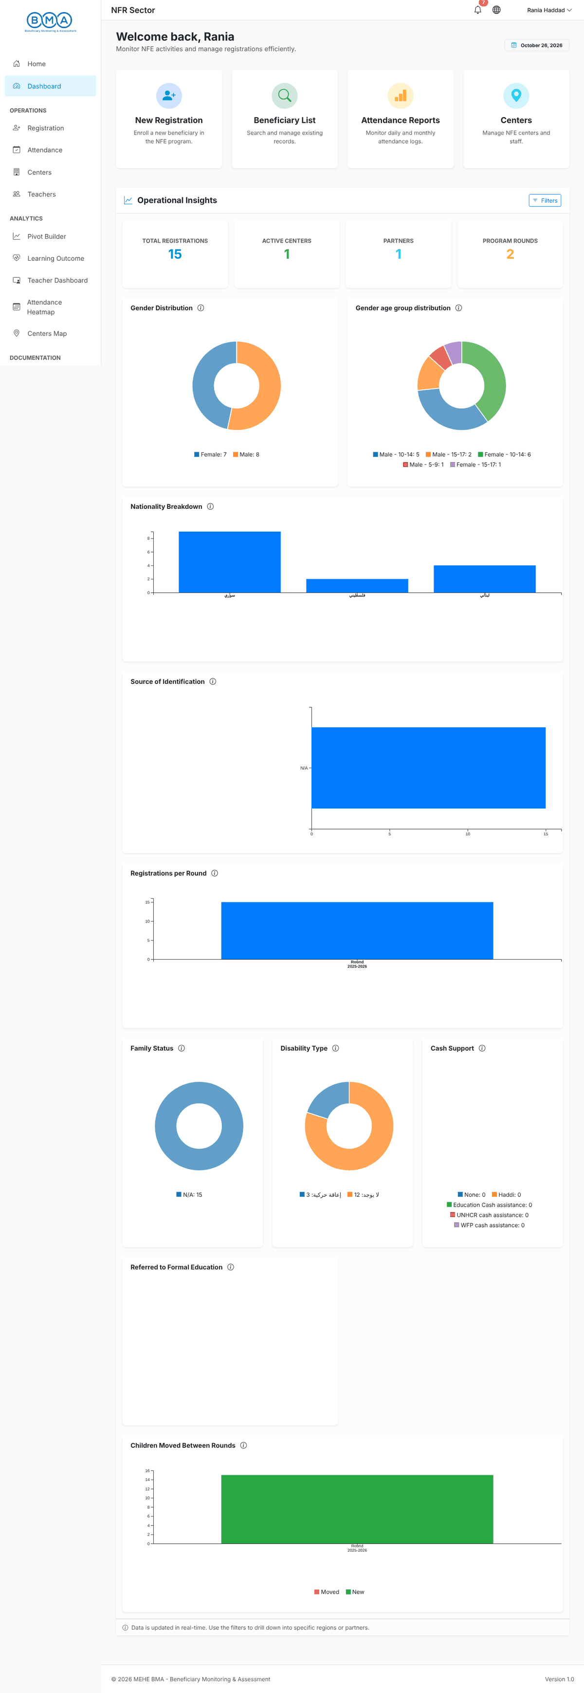
Figure 45 – The operational dashboard
2. Learning Outcome – attendance rate, child labour rate, transition to formal education, grade improvement and dropout, with socio-economic and impact charts.
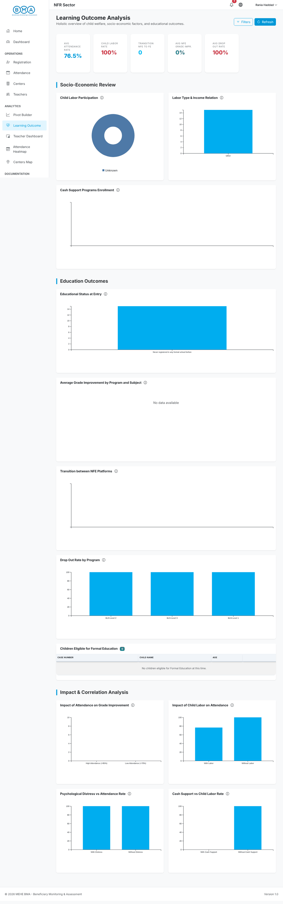
Figure 46 – Learning outcome analysis
3. Teacher Dashboard – number of teachers, gender, nationality, assignments, subjects and training.
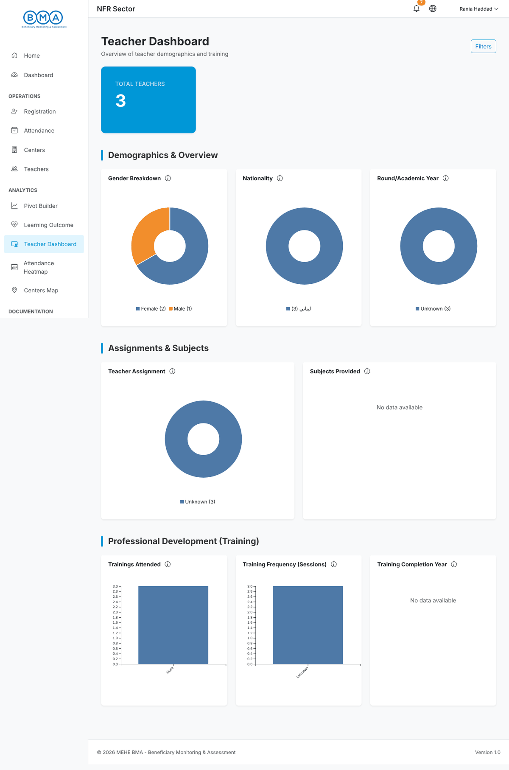
Figure 47 – Teacher dashboard
4. Attendance Heatmap – one square per day coloured by the attendance rate, overall and per programme. Dark green is high attendance; light squares show days to check.
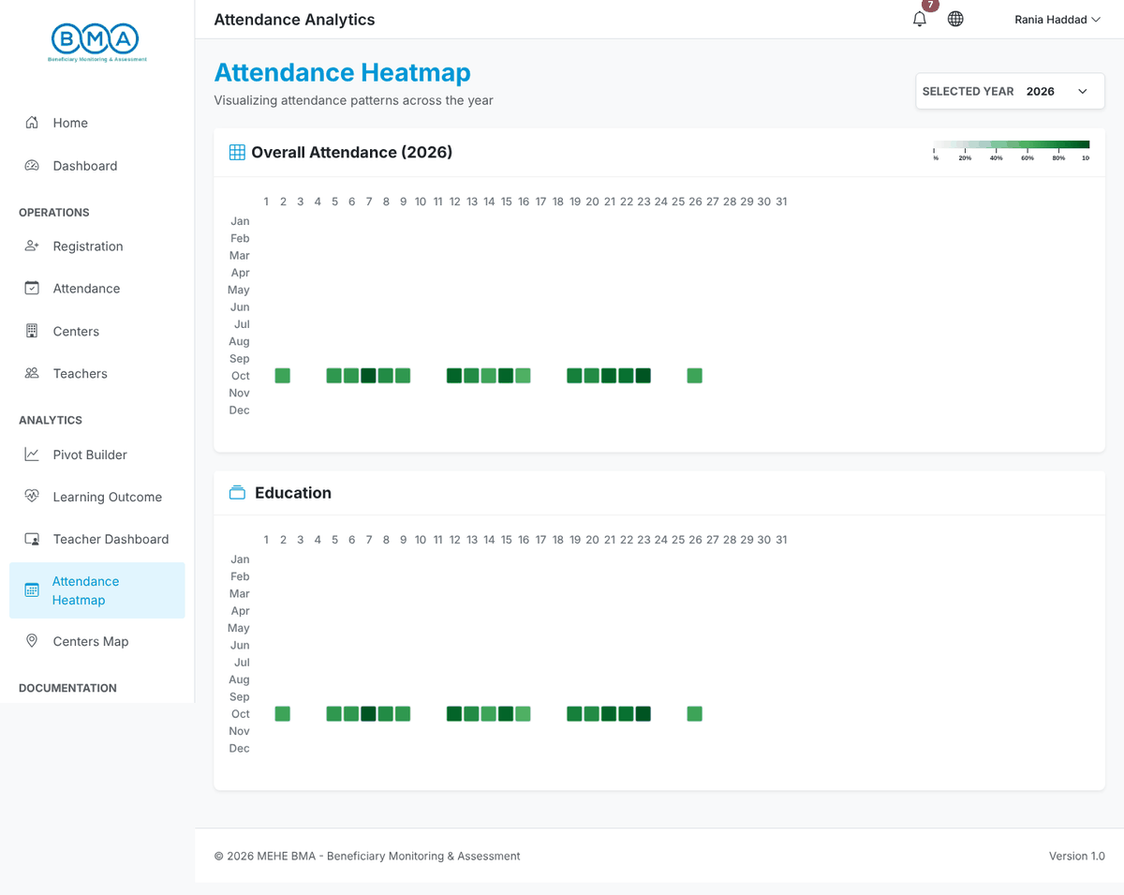
Figure 48 – Attendance heatmap
5. Centers Map – the centers on a map with their characteristics and the list of registered children. Filter by partner and center.
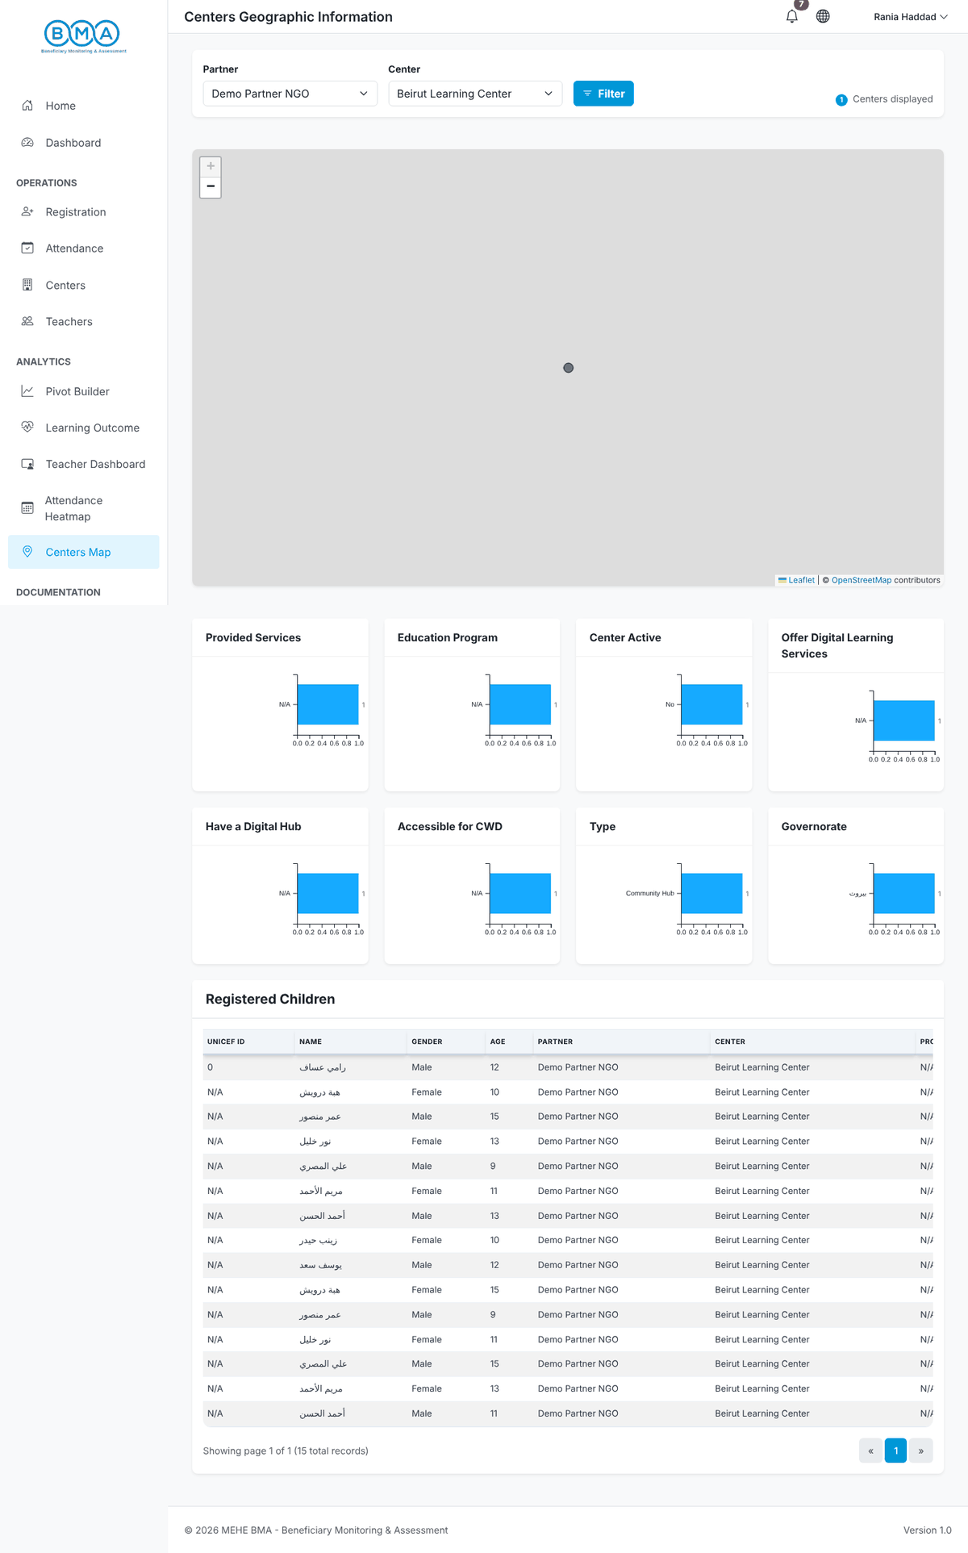
Figure 49 – Centers map
6. Pivot Builder – drag the fields (center, district, gender, governorate, nationality, partner, programme…) into rows and columns to build your own table or chart; choose the aggregation (count, sum…) in the list on the left.
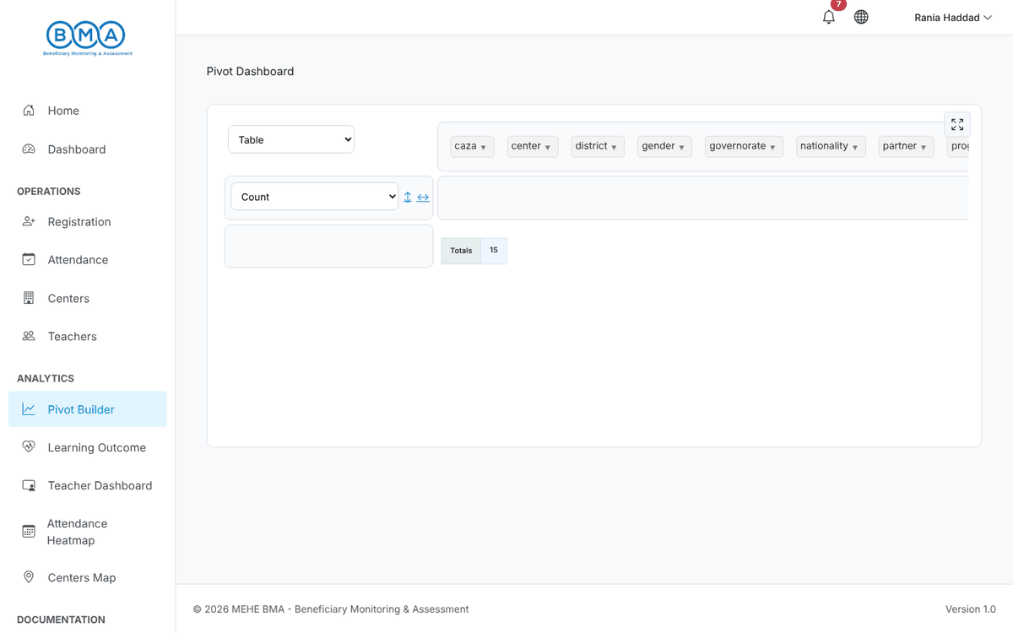
Figure 50 – Pivot builder

12. Your Account
1. Profile (user menu) shows your partner organisation, center and the information linked to your account. Contact the administrator to change these assignments.
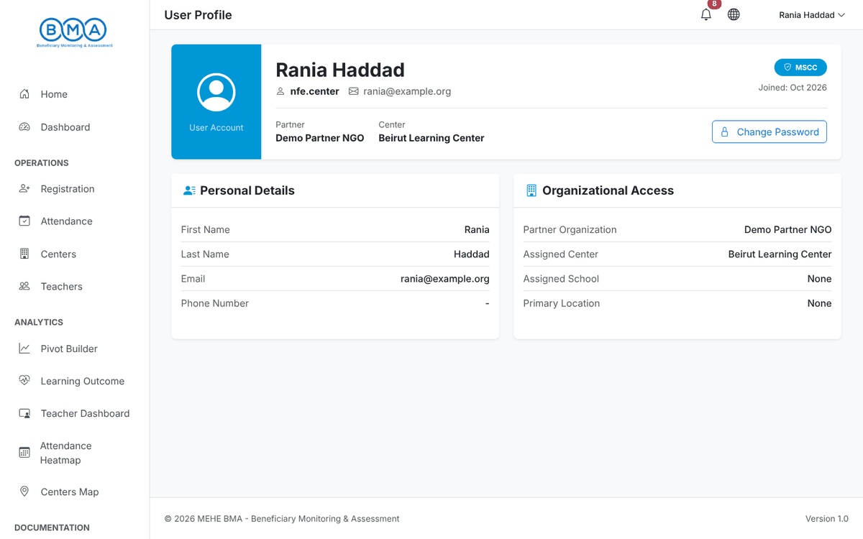
Figure 51 – Profile page
2. Change Password (user menu): enter the current password and the new password twice, then click Change Password.
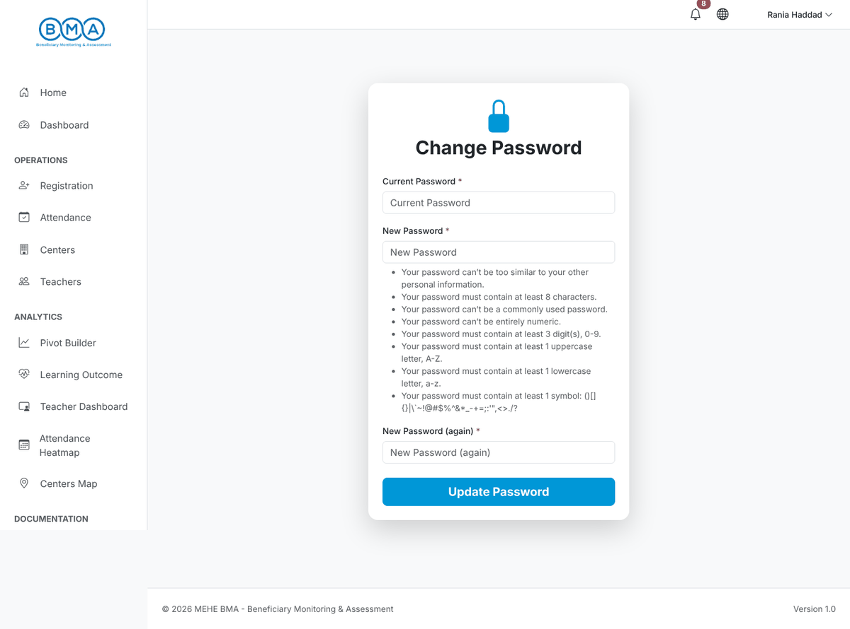
Figure 52 – Change password form
3. Logout (user menu) ends your session. Always log out when you leave a shared computer.
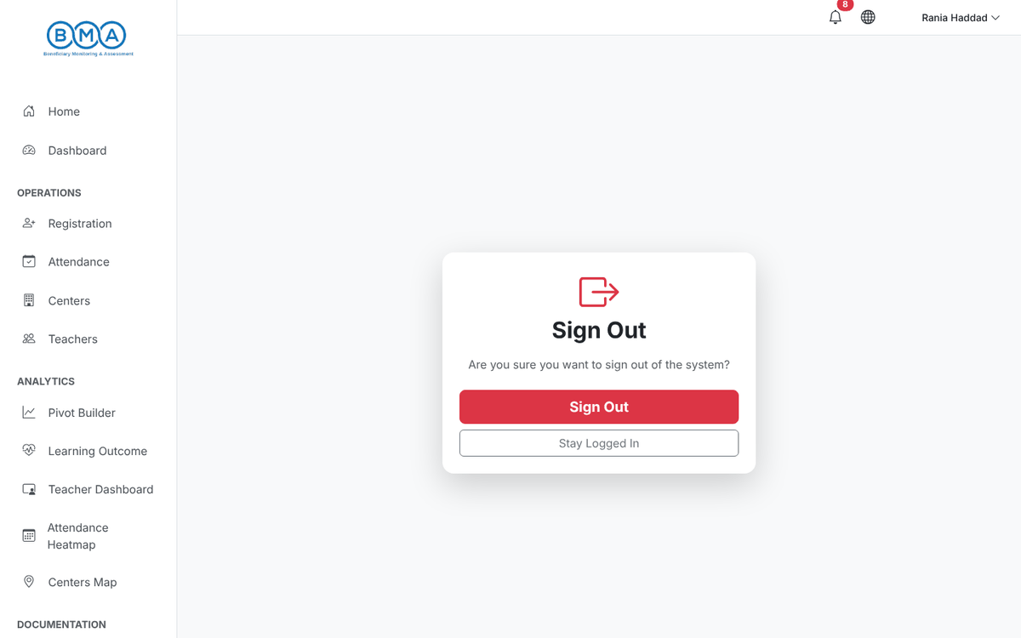
Figure 53 – Logout
Password rule | Requirement
Length | At least 8 characters
Digits | At least 3 digits
Letters | At least one upper-case and one lower-case letter
Symbol | At least one symbol such as ! @ # $ % & *
Not common | Not a common word and not similar to your username

13. Frequently Asked Questions
Question | Answer
The Next Step button is disabled on the registration form. | A potential duplicate was found. Check the Potential Matches panel: open the existing profile or re-register the child in a new round instead of creating a new record.
My names are erased when I leave the field. | Names must be written in Arabic letters only. Latin letters and digits are removed automatically.
The phone number is refused. | Use the format XX-XXXXXX, for example 03-123456.
A child does not appear in the attendance list. | Add the education situation (programme, round and section) on the child profile, then reload the attendance sheet.
The district or village list is empty. | Select the governorate first, then the district. If the lists still do not load, click Try again or refresh the page.
I cannot see children from another center. | Center users only see their own center. Ask your coordinator if you need a wider scope.
I forgot my password. | There is no self-service reset. Contact your system administrator.
Who do I contact for support? | Your partner focal point first, then the BMA support team through your coordinator.

