Guidance Note for use of Strengths and Difficulties Questionnaire (SDQ) in pre-and post-assessment of focus PSS support programmes for children 2020 -2021
Prepared by
Roula Abi saad – Sahar al amine – Ali chamseddine
2021
Table of Contents
Background 3
Which activities in the 2020 LCRP require use of the SDQ 4
How to administer the SDQ 4
Ages 6-11 4
Ages 12-17 4
Who should administer the SDQ 5
When to administer the SDQ 5
Sampling 5
Coding 6
Code structure 6
Data collection, storage and reporting 8
Use of Measuring Well Being Dashboard 8
Dashboard users 9
UNICEF Admin Staff 9
Partners 9
Collectors 9
The Dashboard 10
Admin dashboard 10
List all Partners 11
View Partner 12
Add a New Partner 13
Edit existing Partner 14
List collectors 15
Application List 16
Change decrease 17
Analytics page (Graphs) 18
The Partner Dashboard 21
List partners’ collectors 21
Add Collector 22
Applications 23
View application 24
Transfer application collector 24
Partner Add Change decrease reason 25
A partner can choose up to two reasons from the list, and write the reason in the box. Then click on submit to send the message. As shown in the popup message below. 26
Analytics 26
The Collector dashboard 27
Create Post-test 31
The Android app 33
How to Create an application as a Collector step by step 33
The collector dashboard explained 34
The Add application feature 35
Create a Post test application from a Submitted pretest application 38
Additional notes: 40

Background

The CPiEWG needs a standard way of reporting to the Outcome 4, indicator C: % of children (boys and girls) who reported an improvement in their psychosocial wellbeing as measured through the SDQ”. The Strengths and Difficulties Questionnaire (SDQ) is a brief behavioral screening questionnaire relevant for 6-17-year-old. It exists in several versions to meet the needs of researchers, clinicians and educationalists. It includes 25 items on psychological attributes divided into 5 scales:
1) emotional symptoms (5 items),
2) conduct problems (5 items),
3) hyperactivity/inattention (5 items),
4) peer relationship problems (5 items),
5) prosocial behavior (5 items).
While the SDQ is often used as a diagnostic tool, for the CPiEWG purpose, it will be used to evaluate outcome. “Before” and “After” SDQs can be used to evaluate specific interventions, such as psychosocial support activities and life skills programming.
There are two validated versions of the SDQ in Arabic language:
- The first for age group 6-11 should be administered by facilitators with caregivers (caregivers will answer the questions for the child of age 6-11).
- The second version, which is for age group 12-17, can be self-administered given the child ability to read and write. It is highly recommended that even when adolescents are self-administering the questionnaire, verbal guidance should be provided by the facilitators.
All organizations will need to use the same tool; however they can choose to use their own supplemental tools in addition to the SDQ.
It is important to note that the SDQ (as all tools do) has limitations. Other tools should be used in order to adequately understand improvements in children’s wellbeing, including those tools that have been developed and are recommended by the PSS Committee, such as the CFS checklist and the Focus Group Discussion Guide for evaluating PSS activities with children. These tools as well as the SDQ forms and guidance note are available on the PSS Committee Dropbox and can be found here:
https://www.dropbox.com/sh/zpfu5umh03j8m0m/AAAwt3FqOZOr7lEmI_Wk1uxEa?dl=0

Which activities in the 2021 LCRP require use of the SDQ
SDQ will be required for any actor conducting Focused PSS programmes for children and/or adolescents ages 6 to 17 years old which falls under the child protection LCRP Outcome 4 “Provide boys and girls at risk and survivors of violence, exploitation and abuse with access to an improved and equitable prevention and response”; Indicator 4 “% of children (boys and girls) who reported an improvement in their psychosocial wellbeing as measured through the SDQ”

How to administer the SDQ
For the purposes of the CPiEWG, in order to compare results, it is important to administer the questionnaire in the same way to each age group. It is important to take consent from the caregivers and the adolescents who will participate in the questionnaire. A script is provided in the questionnaire. When you take consent from the adolescent participants for the self-administered questionnaire, ensure that you inform them that their answers are confidential, and you will not share any information with their parents/caregivers.

Ages 6-11
The PSS Committee in Lebanon recommends that the SDQ not be administered for children under age 6, based on experience implementing the questionnaire in the Lebanese context. The preferred way to administer for age group 6-11 is to caregivers through one-on-one discussion meetings. These meetings should occur in a private space in order to preserve the confidentiality of the answers. When administering the SDQ to caregivers, it is important to “translate” the language from standard Arabic to dialect that is accessible.
Tip: When caregivers register their children for the focused PSS activities, this is the ideal time to administer the pre-questionnaire.

Ages 12-17
For age group 12-17, the PSS Committee recommends administering the SDQ through self-administration. However, it should not be given to adolescents to fill out on their own especially if adolescents are illiterate. Instead, facilitators should read and translate the questions from Standard Arabic into dialect in order to ensure understanding of the questions. This should be done, however, in a standard way according to the terminology listed below for both age groups in a private setting.

Who should administer the SDQ
Persons supporting the administration of the SDQ should be trained on child protection, communication with children and safe identification and referral. If organizations choose to use M&E staff to administer the SDQ, they need to be trained on the above-mentioned topics. Only one person should administer the SDQ; However, facilitator shall never be alone with the child as set per the Child Protection Minimum Standards. It is highly recommended that the same person who administered the pre-assessment should administer the post-assessment.
If possible, it is recommended that the person who would administer the SDQ is not the same person who is running the sessions with the children to avoid biasing the answers.

When to administer the SDQ
The pre-assessment should be administered with the caregivers or children/adolescents upon registration or maximum before the child/adolescent participates in the third session of the cycle. The post-assessment should be done with the caregivers or children/ adolescents after the end of the cycle, and not before, in the same manner that the pre-assessment was administered according to each organization’s system of cycles.
If the child doesn’t answer more than two questions, the questionnaire is considered invalid.

Sampling
Sampling should be done randomly, according to a sample size required which is 200 children per organization in one specific governorate participating in Focused PSS. The recommended sample size does not account for attrition (drop outs, not being able to find children, etc.). Therefore, the pre-assessment should be given ideally to 20% more children than the recommended sample size, meaning 240 children. You can request as many codes as you want, and cover multiple governorates however you need to assess at least 240 children per governorate.
Codes for UNICEF partners will be allocated after discussion with UNICEF team who will ensure equal governorate representation. Therefore, and for this purpose, UNICEF will reserve the right to decide whether the additional requested data per governorate will be included in the analysis or not.
The sampling should ideally be done randomly, with a minimum of 25 sampler per location accounting for sex and age group. For example, the list of children participating in the cycle of PSS activities could first be divided by age group (6-11, 12-17) and then within the age groups by male, female. If you have 2 cycles in your calendar year from which to assess children, then you would sample 120 children per cycle. 30 males from 6-11, 30 females 6-11, 30 males 12-17, 30 females 12-17, according to your target age groups, etc.
If your organization cannot reach the recommended sample size, please contact the PSS Committee to discuss possible options as soon as possible.

Coding
The system will be auto generating codes for each application that is included in the sample population.
The application code is autogenerated automatically by the SDQ app, no more manual creation, each partner will have a specific set of applications per year.

Code structure
Each Partner will have a Prefix during the addition to the system, same for the collector. Example for Partner “Robert” the prefix could be ROB and collector “Michel” who is a team member within Partner “Robert”, will be MICH. The current year of the application is “2021”
So the application auto generated code will be Year + Partner Prefix + Collector Prefix + application ID in this case for example It will be 2021 - ROB-MICH-1.
In Online and offline mode, the application id is auto increment by 1, so the next saved or submitted application will be 2021-ROB-MICH-2, 2021-ROB-MICH-3 …..
The code will be shown in the app while filling the pre-test or post test application inside the Child’s code field and after the collector submits the application in the post-pending page, the last item (U can use the date of the application as an indicator).
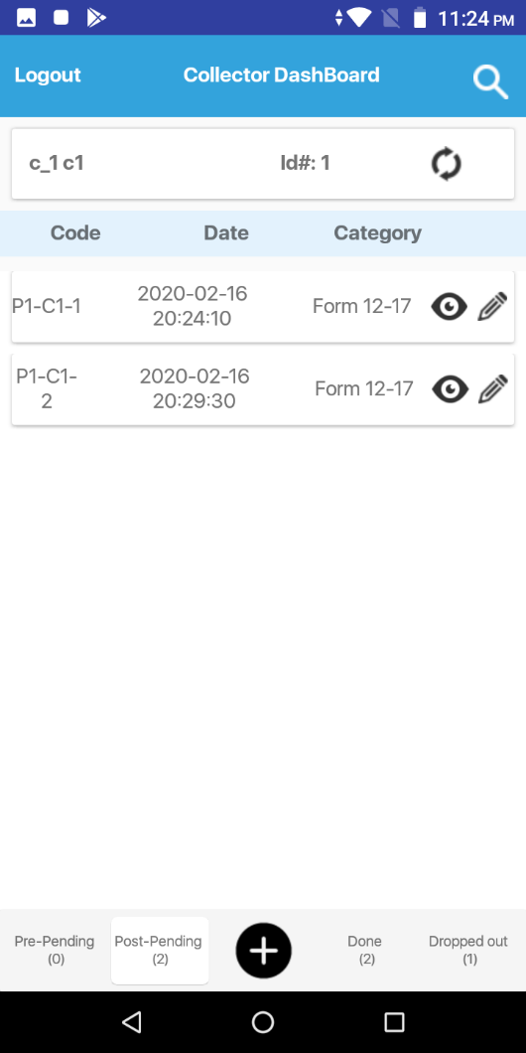
However, each organization will need to develop a key to match each child to his/her code in order to be able to include the same code number in the pre-assessment as the post-assessment. Please refer to UNICEF guidance within the excel spreadsheet, where you would need to register the auto-generated code with child’s name, location, age,…

For any technical support or information needed on the SDQ platform, please contact sector and UNICEF IM focal point:
Vicken Ashkarian vashkarian@unicef.org and Yosr Beydoun ybeydoun@unicef.org
Please ensure that you mention where you will be sampling. UNICEF would reserve the right to guide you to prioritise the sampling in the governorates as needed to ensure proper distribution and representation in all governorates..

Data collection, storage and reporting
Data should be collected through Android tablets by downloading the measuring wellbeing app (https://measuringwellbeing.org/apk/sdq-10.apk ) provided by UNICEF. Data collection takes approximately 15-20 minutes.
Data can be collected by one person only, in a face-to-face interview, in a confidential space. However, and as mentioned above a facilitator should never remain alone in a closed space with a child. Facilitators should have an extra paper form with them if they are using a tablet, in case of technical problems.
Use of Measuring Well Being Dashboard

The solution consists of two components:
1-The Dashboard | 2-The Android Mobile Native APP
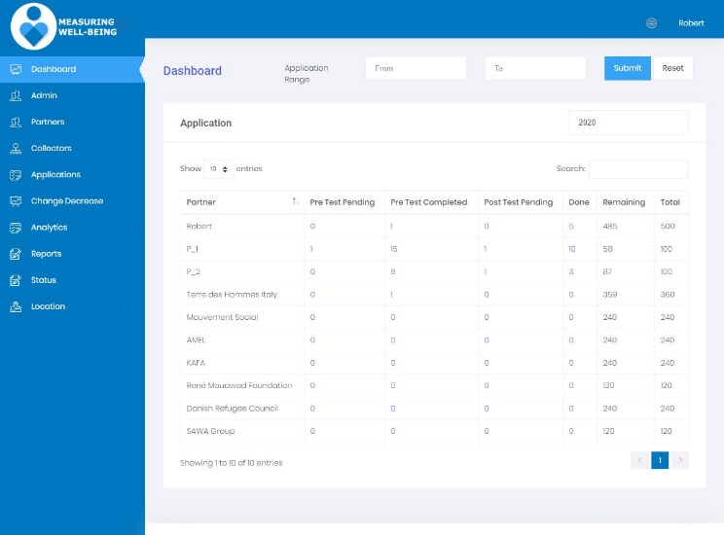 | 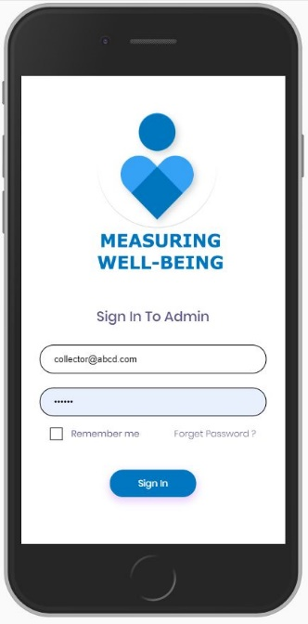
- Located at https://measuringwellbeing.org/ | Can be downloaded and installed on Android phones from this link  https://measuringwellbeing.org/apk/sdq-10.apk
Using Desktop/Laptops only running modern desktop browsers | Using only on Android App  Supports Android 5+  Preferable Android 8+
Can be accessed by  Admin (UNICEF Staff & Robert)  Partners  Collectors | Accessed by the collectors only using a collector account created by the Partner they are working for.

Dashboard users
UNICEF Admin staff, using the web version on laptops.
The Partners, using the web version on laptops.
The Collectors working for the Partners, using the web version on laptops, tables and phones running Android Operation system version 5+.

UNICEF Admin Staff
- The Admin should be able to login to the solution dashboard with Full access to the solution.
- View all partner details and collectors’ details
- View all applications for all partners and their collectors.
- Should be able to List, Edit, Add, Activate and Deactivate a Partner.
- Should define the number of applications per partner per year while creating the partner.
- Should be able to list all applications Realtime and view each one of them.
- View applications list
- Export applications of all collectors in the system in excel form
- View application detail
- View solution logs
- Set solution settings
- Can view graphs
- Can download and extract data and graphs

Partners
- Can login to the dashboard and
- Can only Add, View, Delete, Activate/Disactivate his Collectors.
- View Applications
- Change application ownership
- View Statistics
- Can download and extract data and graphs of his own organisation.

Collectors
- Login to the app using phone or tablet
- View Edit Applications
- Filter application by Pre-pending, Post-Pending, Done and Dropped
- Create application
- Save application to be completed for another time.
- Submit application

The Dashboard

Admin dashboard
- Go to https://measuringwellbeing.org/
- Use your admin username and password
- You should be redirected to the landing page
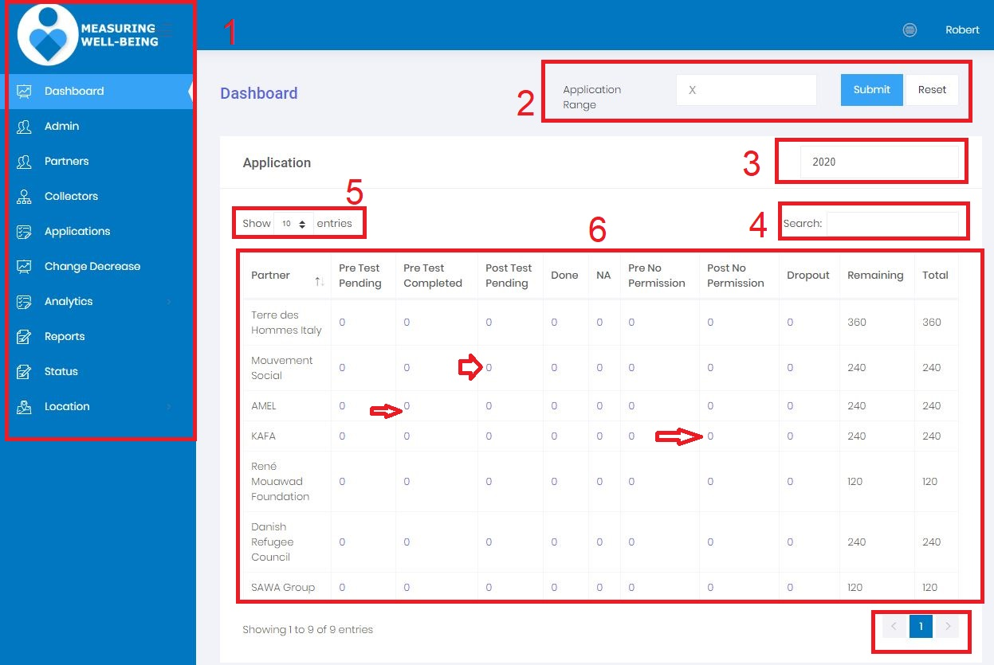
Legends:
1-The left menu where you can navigate through the whole application module
2-Application Range where you can select the number of applications for all governates the system will change the data based on the number you enter in the field instead of X, then you click submit to apply that value. Reset button will reset the website to read all values from all the applications.
3- The year calendar will show the values per year for the whole website.
4-Search by collector name
5- Show number of Partners per page
6-The dashboard body shows all the applications count per state per Partner. These numbers (next to the red arrows) can be clicked and it will take you the applications page.

List all Partners
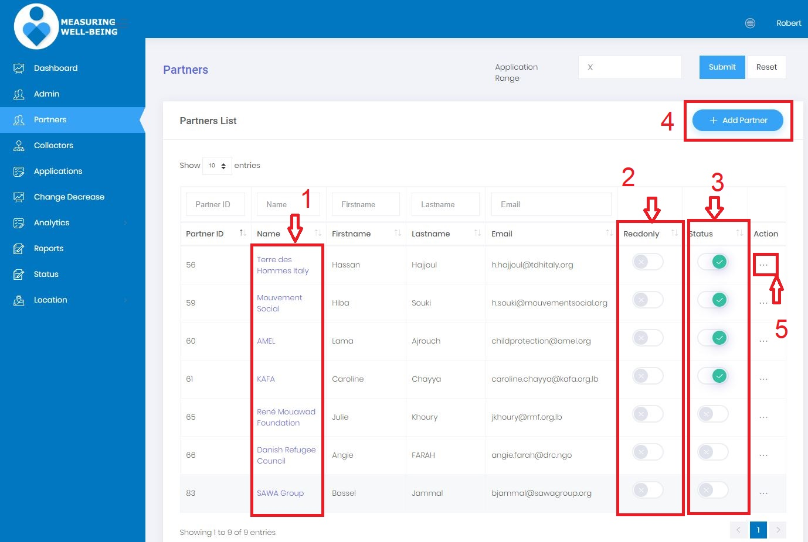
- Clicking on the partner name will take you to the View partner section with the partner detail screen (View partner section, Page 10 of this document, next page)
- Read only will allow the Partner to access the system but can’t add data like create new collector.
- Status Active and Inactive will prevent the Partner to login to the system
- Add Partner will take you to the create a new partner (Will be covered in next page)
- Actions: will open a small window to edit a Partner like change information.

View Partner
In this page an Admin can see details about the Partner, like name, phone number, number of collectors …. And list of applications
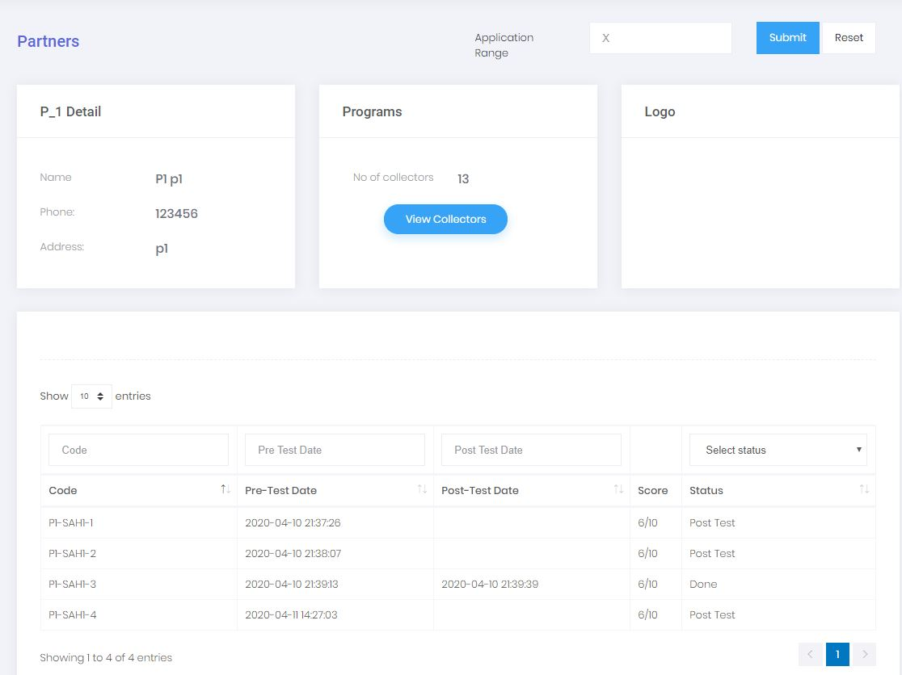

Add a New Partner
If you click on the +Add Partner button from the dashboard screen it will take you to this page where you can add a new partner. The form below allows you to fill Partner details
- Partner name (Agency name usually)
- Partner Prefix, very Important for the application Code generation, 3 letters recommended
- First and last name
- Email, to be used for login, a separate email will be sent to the Partner to set his password

- Phone
- Logo
- Max Number of codes will be selected per year per governorate, an email will be sent to the partner when he passes that limit. Additionally, the gov dropdown will only enable to select the active ones on the web interface
- Save to create the application.
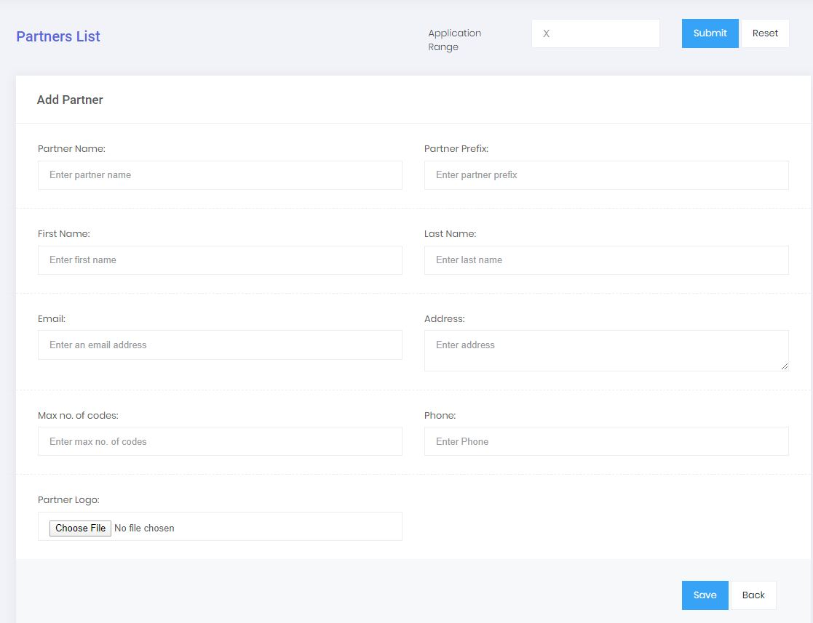

Edit existing Partner
In this page an Admin can edit Partner details and click Save button when done. 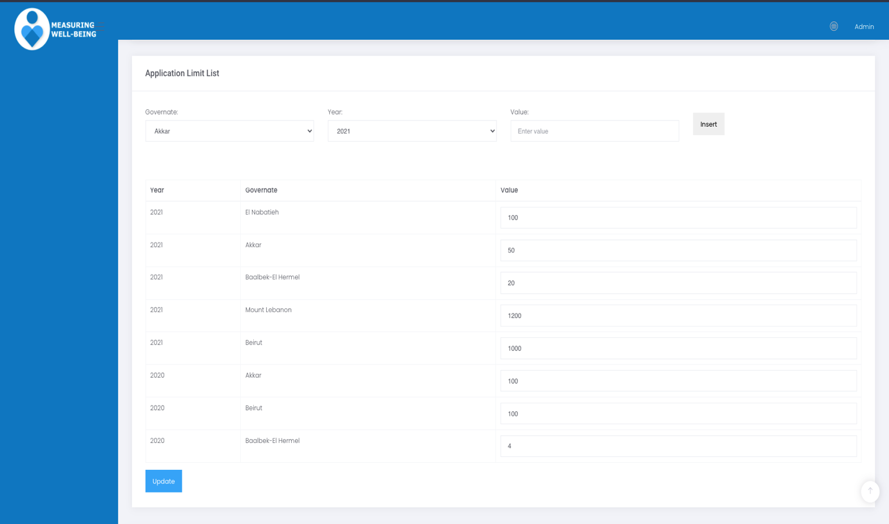
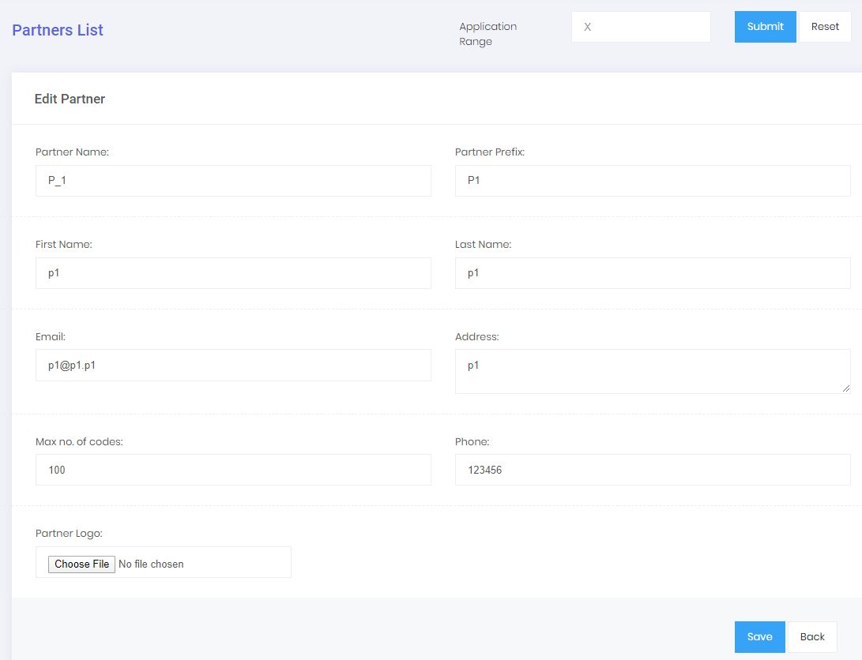

List collectors
The admin can only see a collector and cannot add one. Only Partners can add collectors using the collector dashboard.
Admin can switch a collector from read only that mean the collector can only login to the system but can’t add applications.
Status field on/off mean the Collector can’t login to the application if off.
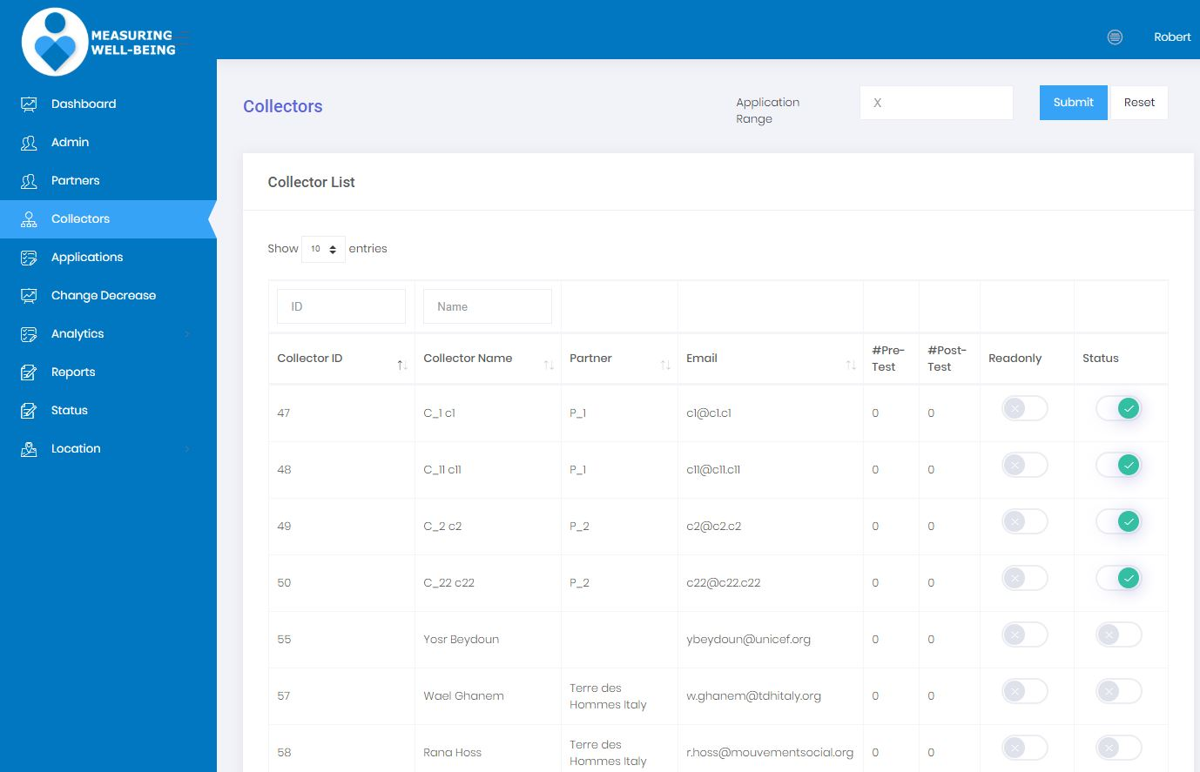

Application List
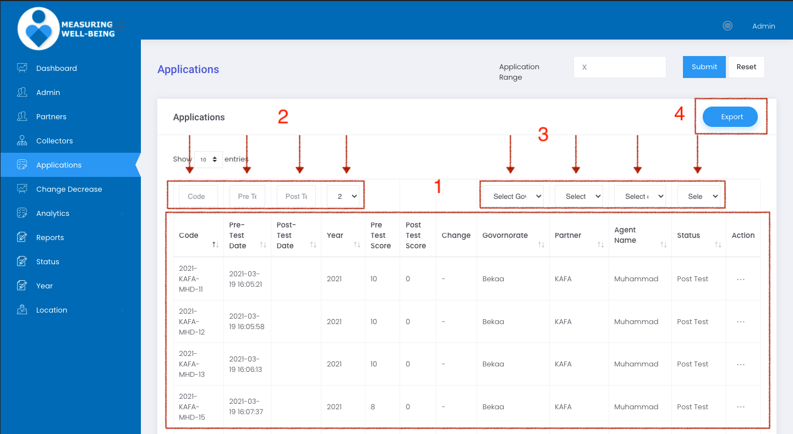

In this page an admin can see all the applications submitted by all Partner collectors in Realtime.
We can see, by columns, the
1- Application code
- Pre-test date
- Post-test date
- Year
- Pre-test score
- Post-test score
- Change
- Governate
- Partner name
- Collector/Agent name
- Application status
- Action: View application

2-Filter application: You can always filter the application by code, pre-test/post-tests date
3-Dropdown Filter application by Governate, Partner name, Agent/collector name and status

4-Export application to excel sheet.

Change decrease
List page
In this page UNICEF will be communicating with the partner to add more details for the change decrease. Here the system will show all the applications for all partners with Change field is decrease.
1- Admin can filter the application by code category….
- If an application has a reason filled the view button will show
Clicking on the View button it opens the popup in the next screen
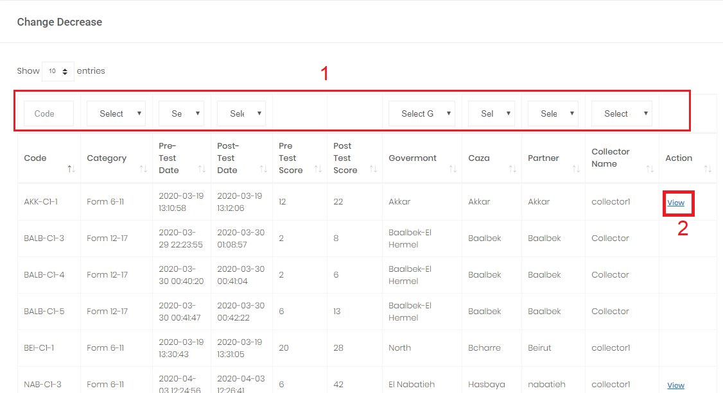

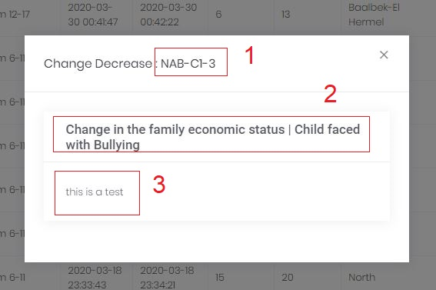
If I click on View the popup will open with the application details
1-Application id
2-Application reason
3-Reason details

Analytics page (Graphs)
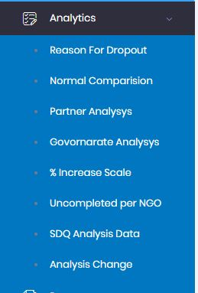

Reason for Dropout per partner
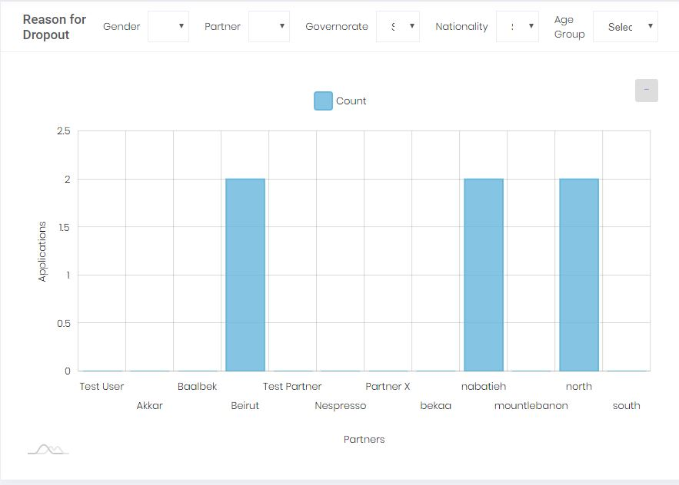

Reason for Dropout percentage

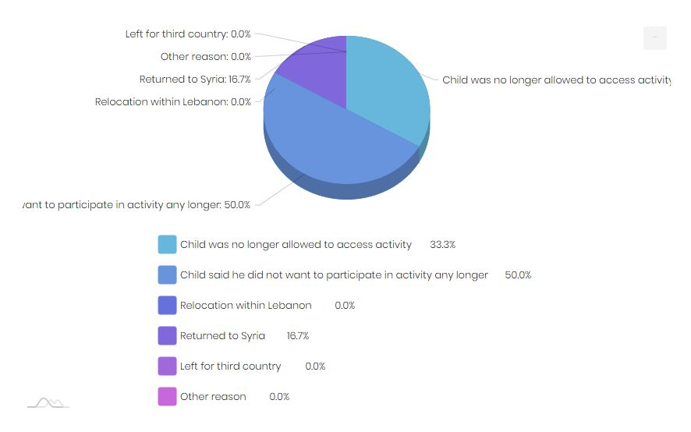

How to download a graph or data
Mouse hover the … button on the top right of the chart like in the picture below and choose image and the extension you want, like JPEG and the graph will be downloaded to your machine.
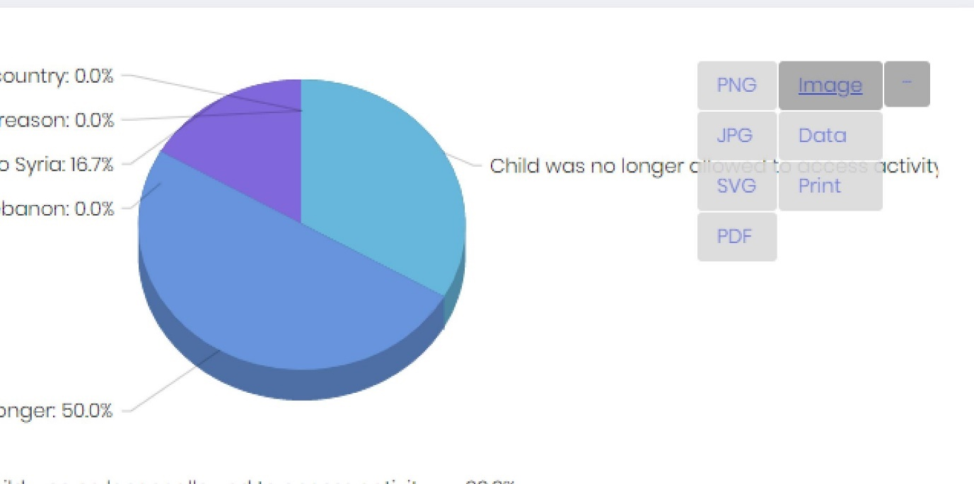

The Partner Dashboard
As you can see in the screenshot below, partner can see his applications dashboard, the list collectors working for him, and his own graphs and data.
From the dashboard he can click on the number to filter an application by its status.
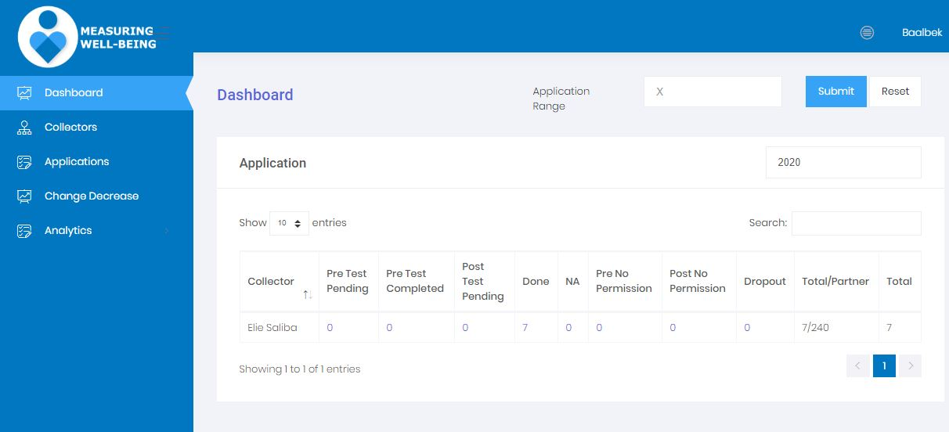

List partners’ collectors
A partner can see details about his collectors only, can activate (so he can login to the solution) or make him read only(Access but can’t submit new applications).
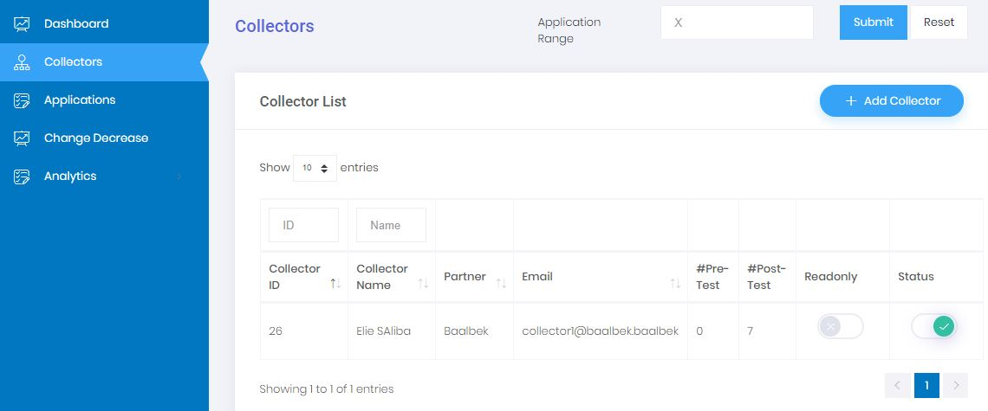

Add Collector
A partner can only add a collector by clicking on Add Collector button
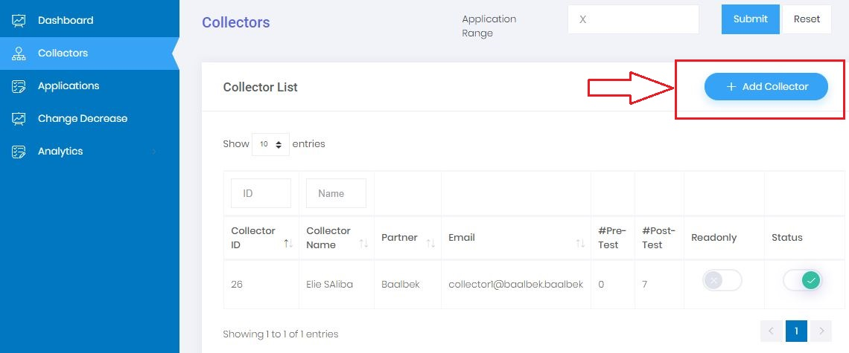
It will take you to the screen below where a partner can add the collector details.
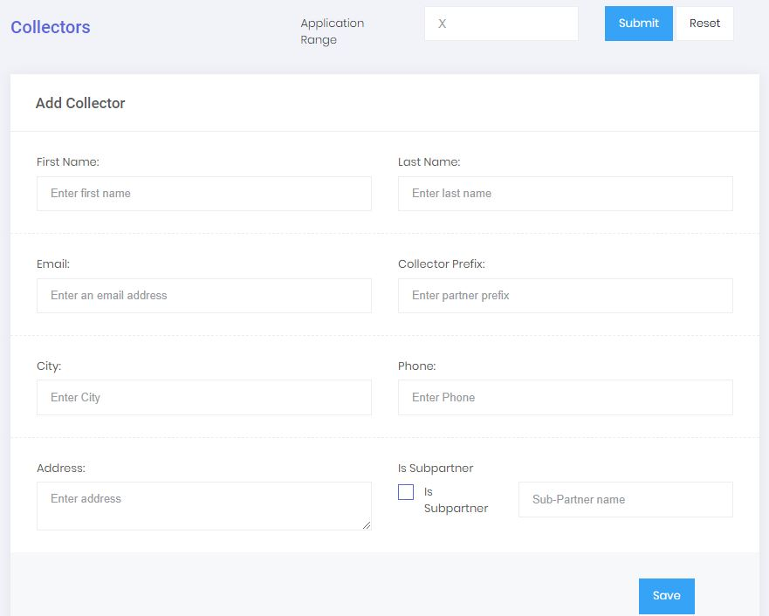
The partner can add the collector information, first name last name, email prefix…
The Prefix is very important and it will be used for the application code auto generation.
The email address will be used as username for the collector to connect using the Android application and the collector web version.
An email will be sent to the collector asking him to set a strong password.
Click save to create the collector

Applications
A partner can see and filter the applications submitted by his collectors only.
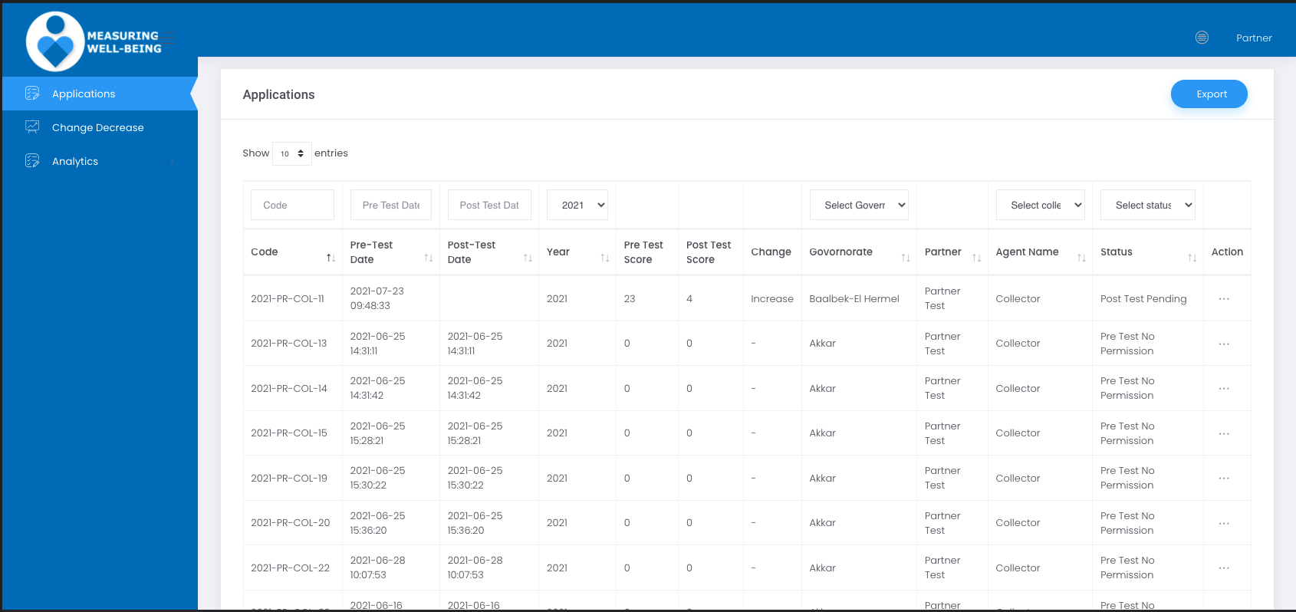

View application
A partner can perform couple of actions on the applications. He/She can view an application in read-only mode by clicking on the … button at the end of the application.

Transfer application collector
A partner can transfer an application ownership from a collector to another only if the application is not “Done”.
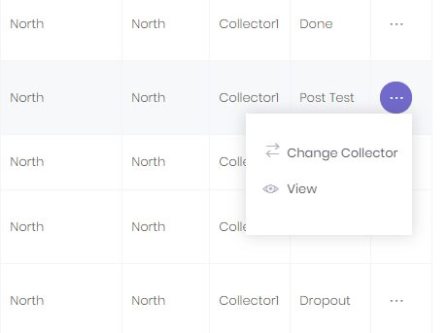
And select collector name, then click save
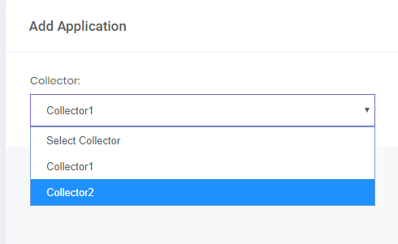

Partner Add Change decrease reason
This page will filter all applications from Change = Decrease
A partner can add explanation and the reason by clicking on Edit
Can click on Reset to clear the messages
Can click on View to view the message in read only mode. A checkbox of correct sign to indicate that the comment has been added.
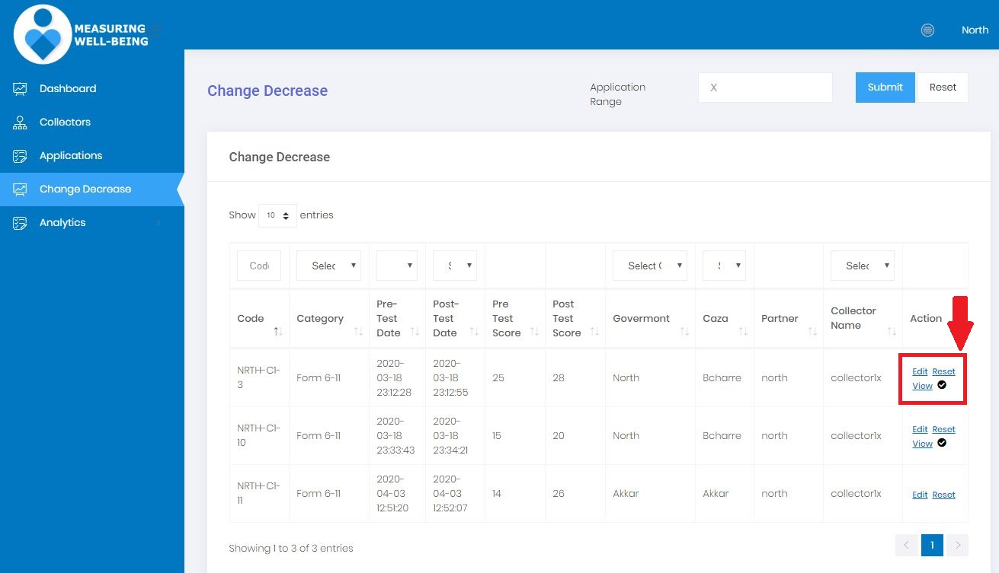

A partner can choose up to two reasons from the list, and write the reason in the box. Then click on submit to send the message. As shown in the popup message below.

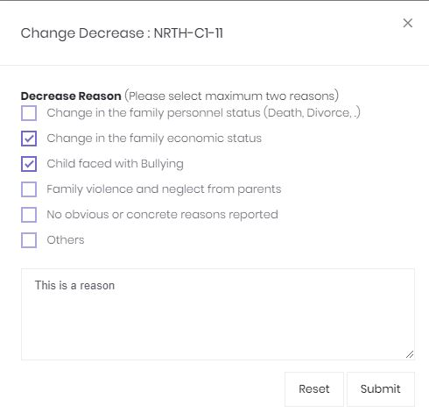

Analytics
Same as the Admin part but the partner can see only his data.

The Collector dashboard
Collector who don’t have Android devices can submit applications using the web version, login using the same credentials on https://prod.measuringwellbeing.org and will be redirected to the collector dashboard where he can see all the applications he submitted.
Create Pre-test
To Add a new application (Pre-test), click on + Add Application button
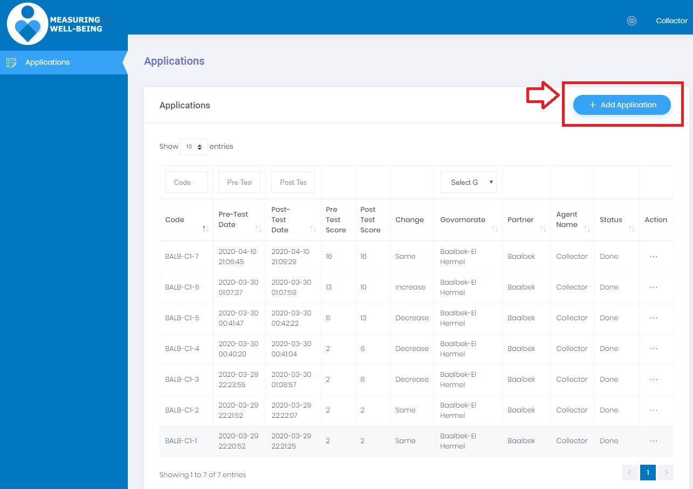
The application section will open with all the questions needed to be filled in English by default but the collector can switch to Arabic at the top of the page.
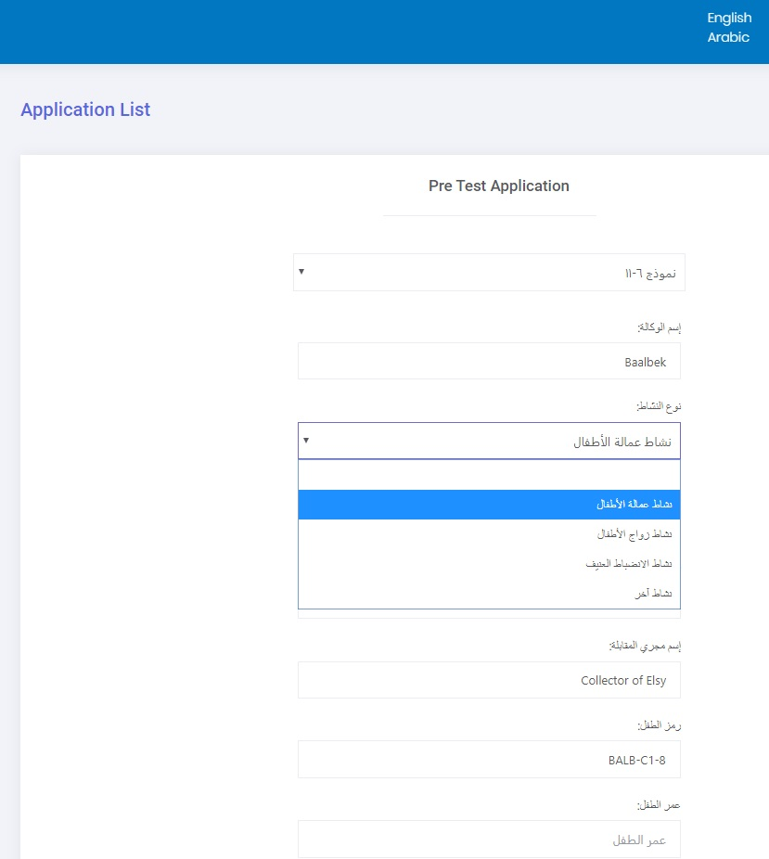

The Collector has the consent to move forward with the application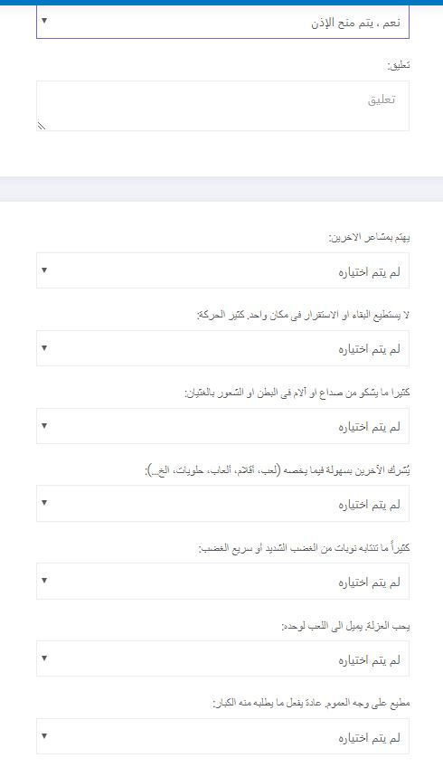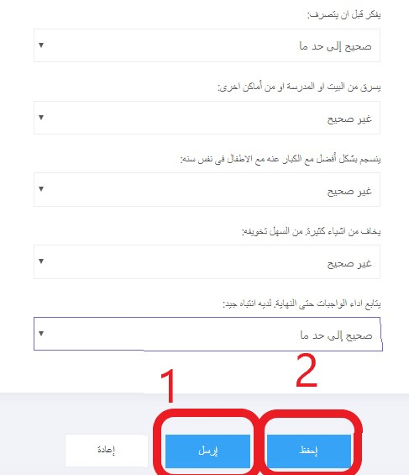
When all the information is filled and valid he can
1-Submit the application
or
2-Save the application to submit it later.

Create Post-test
After the successful submission of the application you will be redirected to the Collector dashboard, the newly created application will be at the top. The Status will be Post test. To create a post test, click on the “…” button as per the screenshot below and click on the “Post Test” link. You can also see the application Pre-test values by clicking on View.
Repeat the same scenario as the previous pre-test
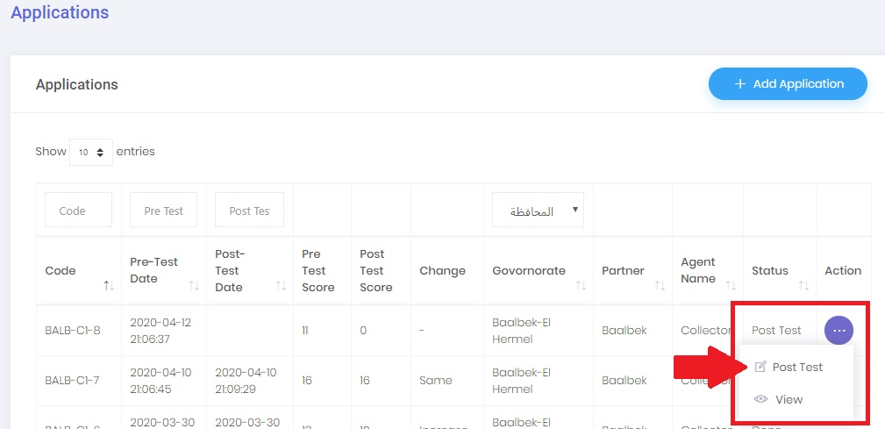

In post test we have extra steps and to process we need to make sure to put a value to Dropout reason and values to the number of total and attended hours.

For a normal flow you should select “Did not dropout”
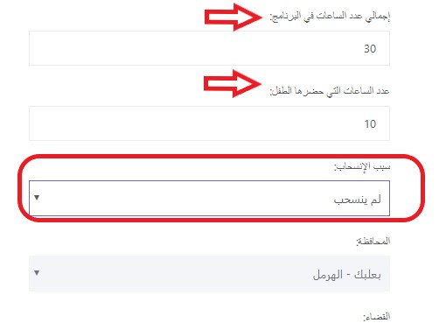
After the submit the application status will become Done with a date and score

The Android app

How to Create an application as a Collector step by step
Steps | Screen | Description
1-The login screen | 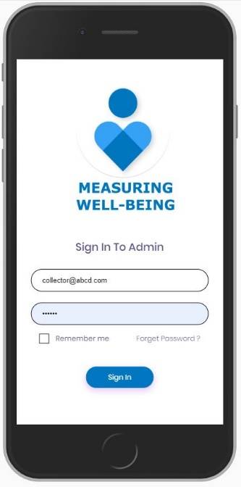 | Download and install on Android phones from this link  https://measuringwellbeing.org/apk/sdq-10.apk  Click on the application icon  Use the Collector credentials (username and password) to login  On success you will be redirected to the collector dashboard where you can see all the application submitted.
2-The Collector dashboard | 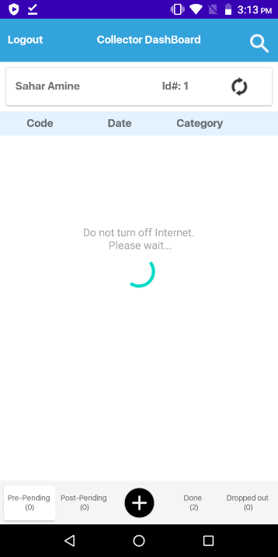 | You might also see a Spinner asking you  “Do not turn off internet, Please wait” wait for couple of minutes while the app is initiating and fetching all the latest data from the server as well as synching all the saved data on the phone.

The collector dashboard explained
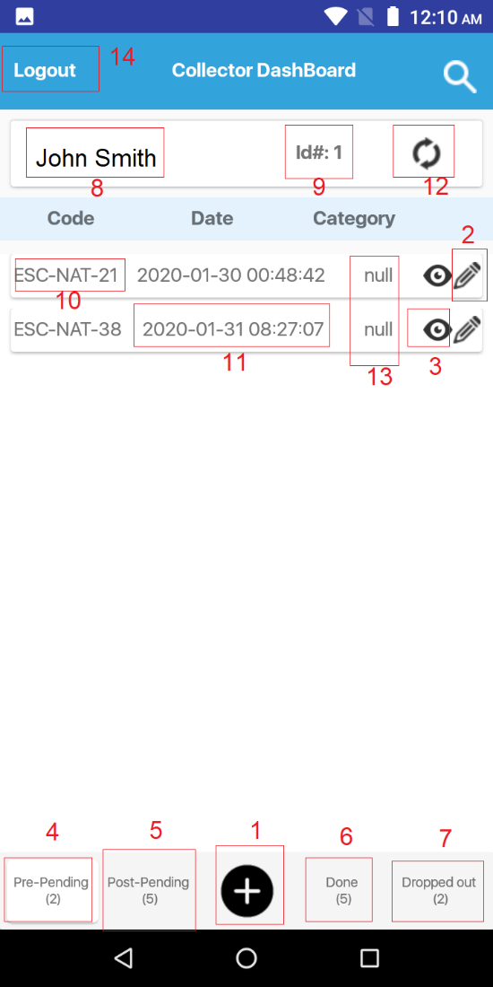 | 1-Add new application (Pre-test): To add a new application click on the + button.  2-Resume button: This button will resume adding values a saved application is we are in Pre-pending tab (Button number 4). It will also create a post test application if we are in a Post-pending tab (Button number 5). Doesn’t show in the Done or Dropped out tabs since these applications cannot be edited.  3-View Application: To open an application in a view mode and read the values.  4-Pre-Pending: This tab if clicked will show the Pre-test applications that are saved and not submitted.  The number in parenthesis indicates how many application we have in that tab. In this example (2) means that we have 2 saved pre-test applications that are not submitted.  5-Post-Pending: This tab if clicked will show the Pre-test application that are done or Post-test applications that are saved and not submitted.  6-Done: This tab if clicked will show Done applications (Pre-test and Post test submitted).  7-Dropped out: This tab if clicked will show Dropped out applications  8-Collector name  9-Collector ID  10-Application code  11-Application Date  12-Sync/Refresh: Will allow us to sync offline data from our phone to the server when the internet is back to keep the info up to date.  13-Application Status (Pre-test or Post-test)  14-Logout button: To logout from the application

The Add application feature
When I click on the application add button ( + ) at the footer of the application
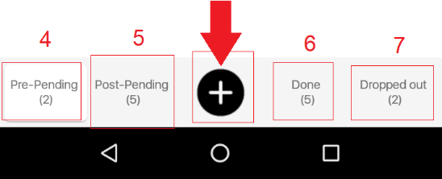 | Click on the add icon will create a new Pre-test application and it will open in the screen below.
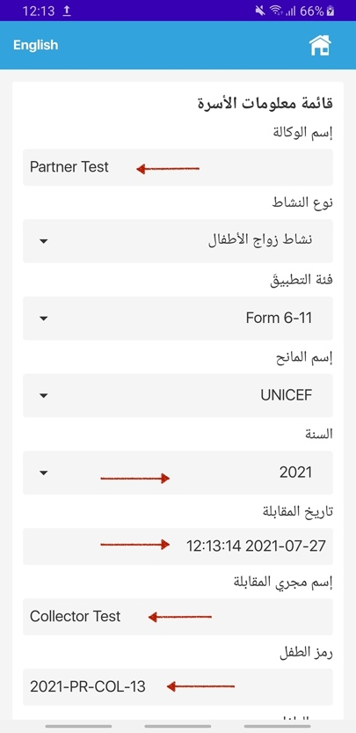 | User will select the correspondent data.  By default, the Agent name will be autogenerated as well as the collector name and application code/id as seen in the screenshot next to the red arrows.  The default year will be the one activated in the year table.  The year can be changed if there is more than one year activated
 | If we scroll down
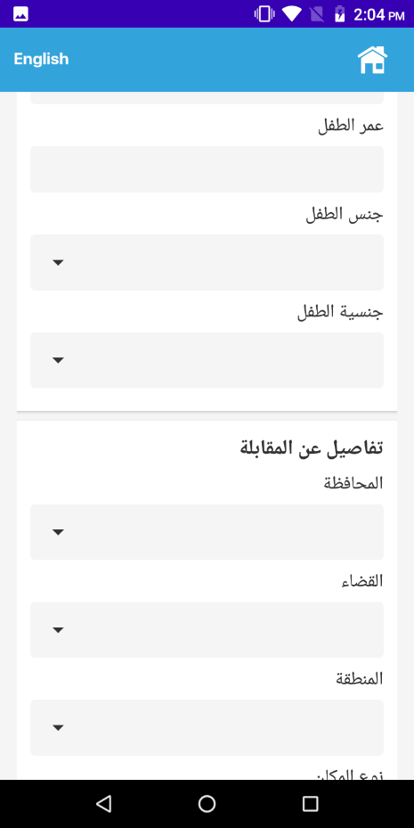 | Age  Gender  Nationality  Governate  Caza  Area  Gateway type
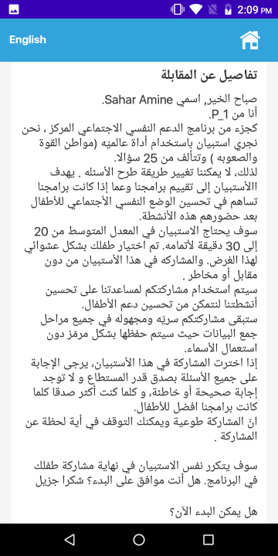 | Consent page asking the user for permission
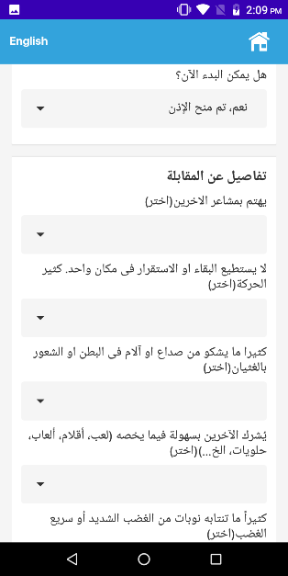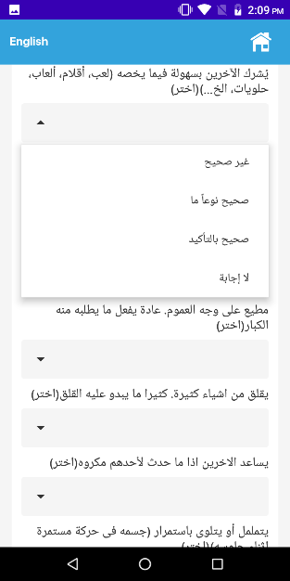 | If yes is selected the Collector will start adding the answers in the selected dropdowns.  All answers are mandatory
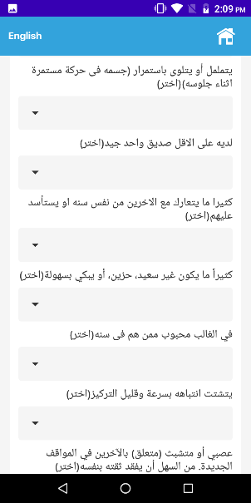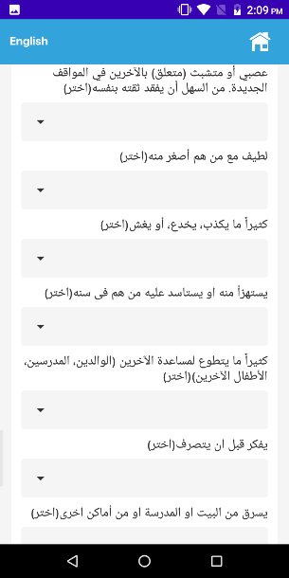 | 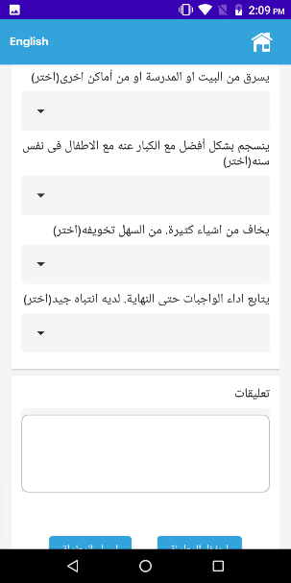
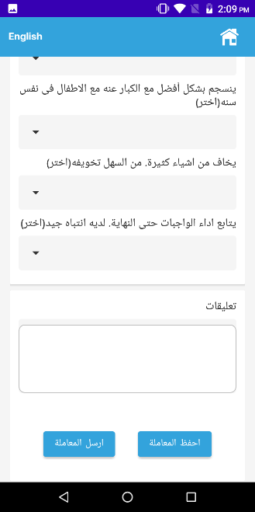 | At the end of the application, a collector can Save and application to continue later or he can Submit the application and he’ll be redirected to the Post pending application with the newly created application.  If Saved the application will show in the Pre-pending tab  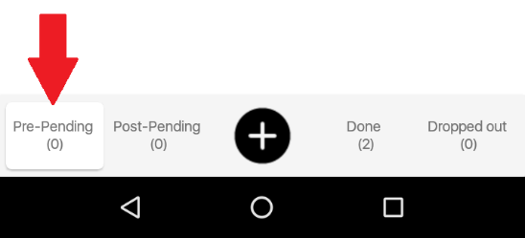  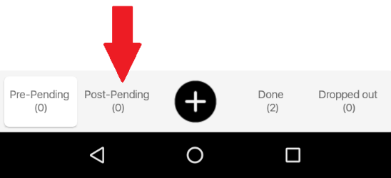

Create a Post test application from a Submitted pretest application

 | Click on the Post-pending tab in the footer and you will see the application that are Pre-test done
 | Click on the Pen icon next to the application
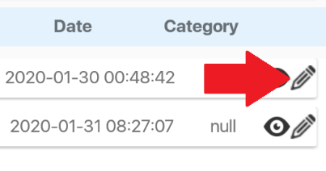 | Start filling the application
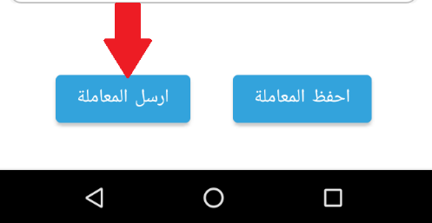 | Submit the application when done and you should see it in the Done tab at the footer part.

At the beginning of the form, you will fill out the following fields:
- Agency name and interviewer name will come automatically generated from the Collector login
- Date of the interview will be by default the current phone date, it can be changed.
- Geographic location (all to be selected from a dropdown list):
  - Governorate
  - Caza
  - Cadastral
  - Site type (e.g. village, informal settlement, school, community centers, SDC, municipalities, etc.…)
  - P-code (the format of the P-code should be adhered to)
  - If P-code not found, report on location level
  - Record GPS coordinates when possible but not required.
- Donor to be selected from a dropdown list
- Information about the child:
  - Child code to be autogenerated.
  - Age (restricted according to each form: between 6-11 or 12-17),
  - Gender to be selected from a dropdown list
  - Nationality to be selected from a dropdown list
- Type of vulnerability that the programme is addressing:
  - Child labour
  - Child Marriage
  - Violent discipline
  - Other
- The same page includes the 25 SDQ questions. Each question has a dropdown list of the possible ratings (not true, somewhat true, and certainly true). Tap on the appropriate response for each question.
- In the post-assessment form there is a box in which you should fill out the number of program hours total that the child was enrolled in. There will be a box for the total number of hours in the program and a separate box for the total number of hours that specific child attended. Each organization should be able to obtain this information through the attendance sheets. For example, if there are 20 sessions in the total program and each session is 2 hours, the total number of hours will be 40. Then, from the attendance sheet you will know that child attended 15 sessions, so you will enter 30 hours into the second box.
- The scoring will be calculated in the background by the SDQ platform.
- The final page marks the end of the interview. It is important to make sure that the form is marked as finalized prior to submitting it.
If you cannot complete the post-assessment
- Go to the correct post-assessment SDQ form in Kobo.
- Enter the unique 6-digit code of the child
- Enter ‘No’ when prompted to answer if you could find the child for the post-assessment
- Enter from the dropdown list the reason why you could not complete the post-assessment
  - Child was no longer allowed to access activity
  - Child said he did not want to participate in activity any longer
  - Relocation within Lebanon
  - Returned to Syria
  - Left for third country
  - Other ___________________________

Additional notes:
- If you select an incorrect form, or you don’t want to continue with the form (because the child doesn’t wish to continue with the interview), you can click on the “Home” button on the SDQ app, and select “ignore changes” to exit the questionnaire without saving any information.
- At any point during the interview, you can switch the questionnaire from English to Arabic and vice versa by clicking on En or Ar at the top left of the screen. Note that this only means you can read the questionnaire in Arabic and English.
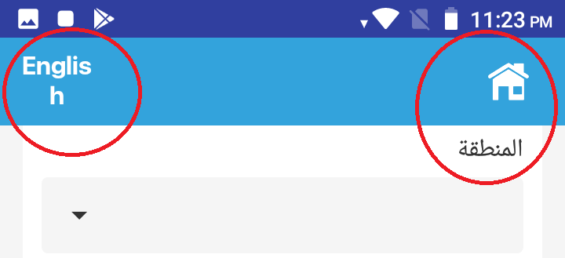

Scoring and analysis
For the purposes of the LCRP Outcome 4 indicator C, the definition for “increase in psychosocial wellbeing” will be the equivalent of the number of children whose overall stress score decreased, even by one point. Further analysis will be done based on the mean total stress score in the pre- and post-assessment, in order to understand if the change was significant or not. Furthermore, each of the 5 sub-scales will be analysed according to the internationally recognized categories of “normal”, “borderline” and “abnormal”. While it is a limitation as the categories have not been contextualized for Lebanon, the intent is not to make a diagnosis but to provide different ways to analyse the data. The number of contact hours will also be considered.
Identification and referral
For serious concerns regarding the mental health of any child participating in PSS activities that arise during activities or through the administration of the SDQ, please contact your supervisor or follow the relevant referral pathway in your location.

Annex 1: Guidance on translation of questions
Question 5:
English: Often loses temper
Arabic: كثيرا ما تنتابة نوبات من الغضب الشديد أ و سريع الغضب
Suggested Colloquial Arabic Translation: يفقد أعصابه كثيرا ويغضب بسرعة
English Translation of Colloquial Arabic: loses his temper often/gets angry quickly

Question 10:
English: Constantly fidgeting or squirming
Arabic: يتململ او يتلوى باستمرار {جسمه فى حركه مستمره اثناء جلوسه}
Suggested Colloquial Arabic Translation: يتحرك باستمرار
English Translation of Colloquial Arabic: moves constantly/agitated

Question 12/19:
English: often fights with other children or bullies them/ picked on or bullied by other children
Arabic: كثيرا ما يتعارك مع الاخرين من نفس سنه او يستأسد عليهم/ يستهزا منه او يستاسد عليه من هم فى سنه
Suggested Colloquial Arabic Translation: كثيرا ما يتعارك مع الاخرين من نفس سنه او يتسلط عليهم/ يستهزا منه او يتسلط عليه من هم فى سنه
English Translation of Colloquial Arabic: same as original text

Question 16:
English: Nervous or clingy in new situations, easily loses confidence
Arabic: عصبى او متشبث {متعلق} بالاخرين فى المواقف الجديدة. من السهل ان يفقد ثقته بنفسه
Suggested Colloquial Arabic Translation: يتوتر او متعلق بالاخرين فى المواقف الجديدة. من السهل ان يفقد ثقته بنفسه
English Translation of Colloquial Arabic: same as original text

Questions:
 |  | 6-11 Pre and Post test questions labels [English] |  |  | 6-11 Pre and Post test questions labels [Arabic]
 |  | Considerate of other people's feelings |  |  | يهتم بمشاعر الاخرين
 |  | Restless, overactive, cannot stay still for long |  |  | لا يستطيع البقاء او الاستقرار فى مكان واحد. كثير الحركة
 |  | Often complains of headaches, stomach-aches or sickness |  |  | كثيرا ما يشكو من صداع او آلام فى البطن او الشعور بالغثيان
 |  | Shares readily with other children, for example toys, treats, pencils |  |  | يُشرك الآخرين بسهولة فيما يخصه (لعب، أقلام، ألعاب، حلويات، الخ…)
 |  | Often loses temper |  |  | كثيراً ما تنتابه نوبات من الغضب الشديد أو سريع الغضب
 |  | Rather solitary, prefers to play alone |  |  | يحب العزلة. يميل الى اللعب لوحده
 |  | Generally well behaved, usually does what adults request |  |  | مطيع على وجه العموم. عادة يفعل ما يطلبه منه الكبار
 |  | Many worries or often seems worried |  |  | يقلق من اشياء كثيرة. كثيرا ما يبدو عليه القلق
 |  | Helpful if someone is hurt, upset or feeling ill |  |  | يساعد الاخرين اذا ما حدث لأحدهم مكروه
 |  | Constantly fidgeting or squirming |  |  | يتململ أو يتلوى باستمرار (جسمه فى حركة مستمرة اثناء جلوسه)
 |  | Has at least one good friend |  |  | لديه على الاقل صديق واحد جيد
 |  | Often fights with other children or bullies them |  |  | كثيرا ما يتعارك مع الاخرين من نفس سنه او يستأسد عليهم
 |  | Often unhappy, depressed or tearful |  |  | كثيراً ما يكون غير سعيد، حزين، أو يبكي بسهولة
 |  | Generally liked by other children |  |  | في الغالب محبوب ممن هم فى سنه
 |  | Easily distracted, concentration wanders |  |  | يتشتت انتباهه بسرعة وقليل التركيز
 |  | Nervous or clingy in new situations, easily loses confidence |  |  | عصبي أو متشبث (متعلق) بالآخرين في المواقف الجديدة. من السهل أن يفقد ثقته بنفسه
 |  | Kind to younger children |  |  | لطيف مع من هم أصغر منه
 |  | Often lies or cheats |  |  | كثيراً ما يكذب، يخدع، أو يغش
 |  | Picked on or bullied by other children |  |  | يستهزاْ منه او يستاسد عليه من هم فى سنه
 |  | Often offers to help others (parents, teachers, other children) |  |  | كثيراً ما يتطوع لمساعدة الآخرين (الوالدين، المدرسين، الأطفال الآخرين)
 |  | Thinks things out before acting |  |  | يفكر قبل ان يتصرف
 |  | Steals from home, school or elsewhere |  |  | يسرق من البيت او المدرسة او من اْماكن اخرى
 |  | Gets along better with adults than with other children |  |  | ينسجم بشكل اْفضل مع الكبار عنه مع الاطفال فى نفس سنه
 |  | Many fears, easily scared |  |  | يخاف من اشياء كثيرة. من السهل تخويفه
 |  | Good attention span, sees chores or homework through to the end |  |  | يتابع اداء الواجبات حتى النهاية. لديه انتباه جيد

12-17 Pre and Post test questions labels [English] | 12-17 Pre and Post test questions labels [Arabic]
I try to be nice to other people. I care about their feelings | أحاول أن أكون لطيفا مع الآخرين. أهتم بمشاعرهم
I am restless, I cannot stay still for long | لا أستطيع أن أبقى ساكنا لفترة طويلة في مكان واحد. غير مستقر. كثير الحركة
I get a lot of headaches, stomach-aches or sickness | كثيرا ما تصيبني آلام في الرأس أو آلام في البطن أو الشعور بالغثيان
I usually share with others, for example CD's, games, food | أُشرك الآخرين فيما يخصني من أشياء (أكل، أقلام، ألعاب، إلخ…)
I get very angry and often lose my temper | ينتابني غضب شديد. وكثيرا ما أفقد أعصابي
I would rather be alone than with people of my age | في العادة أحب العزلة. ألعب لوحدي. أبقى مع نفسي معظم الوقت
I usually do as I am told | أنا عادة أفعل ما يطلبه مني الكبار
I worry a lot | أقلق كثير
I am helpful if someone is hurt, upset or feeling ill | أساعد الآخرين إذا ما حدث لأحدهم مكروه
I am constantly fidgeting or squirming | أتململ وأتلوى (أتقلقل وجسدي يتحرك) باستمرار أثناء جلوسي
I have one good friend or more | لدي صديق عزيز واحد أو أكثر
I fight a lot. I can make other people do what I want | تعارك كثيرا. أتسلط على الآخرين وأجعلهم ينفذون ما أريد
I am often unhappy, depressed or tearful | كثيرا ما أكون غير سعيد، حزين، أو سريع البكاء
Other people my age generally like me | بشكل عام من هم في سني يحبونني
I am easily distracted, I find it difficult to concentrate | يتشتت انتباهي بسرعة. أجد صعوبة في التركيز
I am nervous in new situations. I easily lose confidence | أنا عصبي في المواقف الجديدة (غير المعتادة). بسهولة أفقد ثقتي بنفسي
I am kind to younger children | أنا لطيف مع من هم أصغر مني سنا
I am often accused of lying or cheating | كثيرا ما يتهمني الآخرون بالكذب أو الخداع
Other children or young people pick on me or bully me | الأطفال الآخرون يسخرون مني أو يتنمرون علي
I often offer to help others (parents, teachers, children) | كثيرا ما أتطوع لمساعدة الآخرين (الوالدين، المدرسين، الأطفال الآخرين)
I think before I do things | أفكر قبل أن أتصرف
I take things that are not mine from home, school or elsewhere | آخذ أشياء ليست ملكي من البيت أو المدرسة أو من أماكن أخرى
I get along better with adults than with people my own age | أنسجم بشكل أفضل مع الكبار عنه مع من هم في نفس سني
I have many fears, I am easily scared | لدي مخاوف كثيرة . من السهل تخويفي
I finish the work I'm doing. My attention is good | أكمل العمل الذي أقوم به حتى النهاية . انتباهي جيد

For the profiles of the facilitators, please refer to Guidance Notes - PSS Intervention in Lebanon – Final version 2018; Annex II - TOR for Focused Non-Specialized PSS Facilitator
For definition and further understanding of the focused PSS support programmes, please refer to the Guidance Notes - PSS Intervention in Lebanon – Final version 2018
See glossary annexed below.

