Measuring Wellbeing through Strength and Difficulties Questionnaire (SDQ)

Measuring Wellbeing is a web based solution and an online/offline mobile application for the “Strength and Difficulties Questionnaire” (SDQ). This platform will be used by the Child Protection Partners and sector’s actor who provide Focused Psychosocial Support activities.

The Child Protection section in UNICEF Lebanon Country Office implement a range of activities to the vulnerable children across all the country. Part of these activities, is the Focused Psychosocial Support activities that targets medium to high risk children. The CPiEWG needs a standard way of reporting to the Outcome 4, indicator 4: “% of children (boys and girls) who reported an improvement in their psychosocial wellbeing as measured through the SDQ”. The Strengths and Difficulties Questionnaire (SDQ) is a brief behavioral screening questionnaire relevant for 4-17-year-old. It exists in several versions to meet the needs of researchers, clinicians and educationalists. It includes 25 items on psychological attributes divided into 5 scales: 1) emotional symptoms (5 items), 2) conduct problems (5 items), 3) hyperactivity/inattention (5 items), 4) peer relationship problems (5 items), 5) prosocial behavior (5 items).

During 2018, UNICEF Lebanon continued working in close cooperation with key Lebanese ministries, especially the Ministry of Social Affairs (MoSA), Ministry of Justice (MoJ) and Ministry of Education and Higher Education (MEHE) in preventing and responding to child protection violations and gender-based violence. UNICEF Lebanon works with partners to ensure good laws and policies are in place, protection services are available for those in need and positive social and behavioral change is promoted to build a society that keeps children safe.
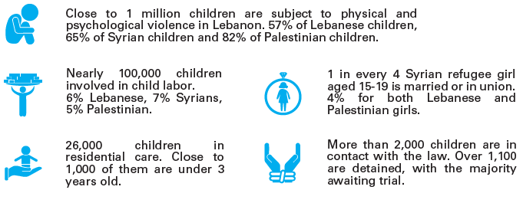

To ensure these efforts are reaching the most affected, the Lebanon Child Protection team continuously measures its results at different levels including measuring change in the emotional wellbeing of individuals accessing protection services including psychosocial support activities and more specifically the focused non-specialized psychosocial support. UNICEF in Lebanon all along with Child Protection in Emergency working group (CPiEWG) agreed as a sector to use the “Strength and Difficulties Questionnaire” (SDQ), a Kobo based form to measure the increase of the wellbeing both boys and girls as a result of them benefiting from the focused non-specialized psychosocial support programme. The data analysis was conducted manually in an excel sheet, which limited child protection partners access to their data. To address this UNICEF developed the SDQ platform a web-based solution and a mobile application that allowed the partners to submit entries through their mobile phones and analyze the data through the web platform, the platform also enabled UNICEF to have an overview of all entries made by the partners for extraction and further analysis to inform programme performance. The mobile application supports offline data collection allowing data collection in communities that lack connectivity. To date twelve (12) organizations are using the platform with more than 3350 entries.

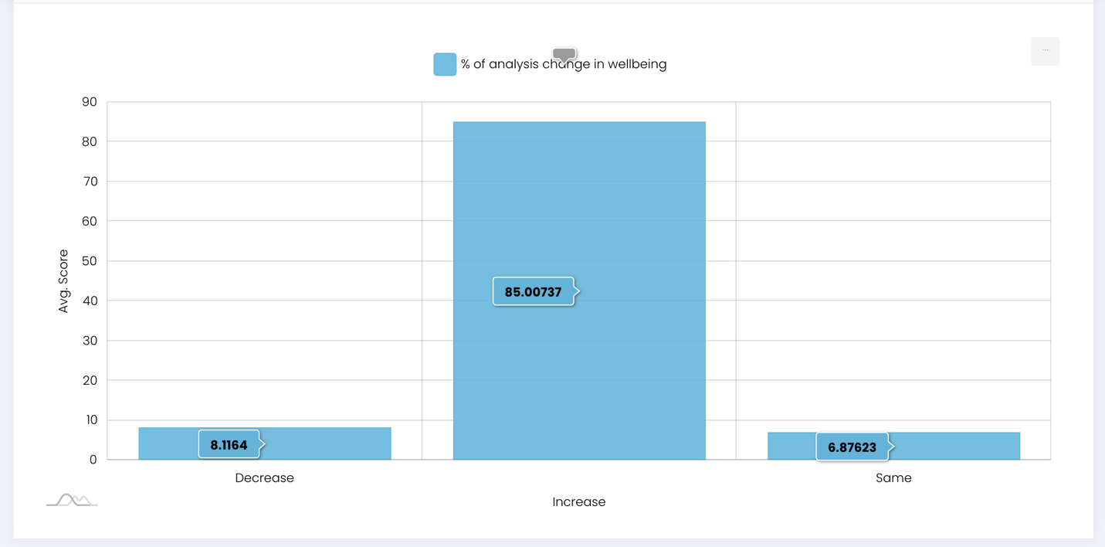

“% of children (boys and girls) who reported an improvement(increase) in their psychosocial wellbeing as measured through the SDQ.”. This indicator is measured at the child-level which means that it records changes in individual children. It is important to note that the SDQ is not used as a diagnostic tool in this case, but instead it is used to evaluate the outcome of activities through use of “before” and “after” questionnaires.”

Technologies used:
The existing platform is built using Laravel 5 and database MySQL. This platform the currently is hosted on Godaddy. The tablet applicationis developed for Android devices and is supported by version 5+.

