**SPATIAL ANALYSIS FOR GWLA**

**What’s needed:**

* **Polygon of the aquifer to be studied**
* **Output from Step 2 in Jupiter Notebook**
* **.xlsx file of all borehole coordinates in the area**

1. Match all boreholes in the study area and their coordinates with the output from the Jupiter notebook Step 2 True or False values. They indicate whether they are selected further for the analysis or not:

1. Import .csv data points into QGIS and export to .shp file “all_coordinates_demo”

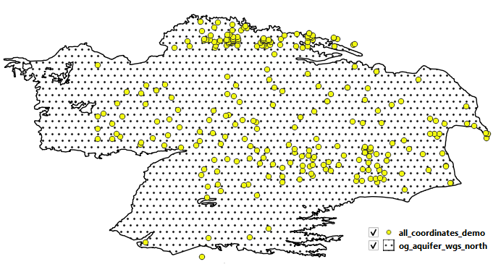

1. Open “all_coordinates_demo” and on the “t/f” column erase all boreholes that have FALSE values:

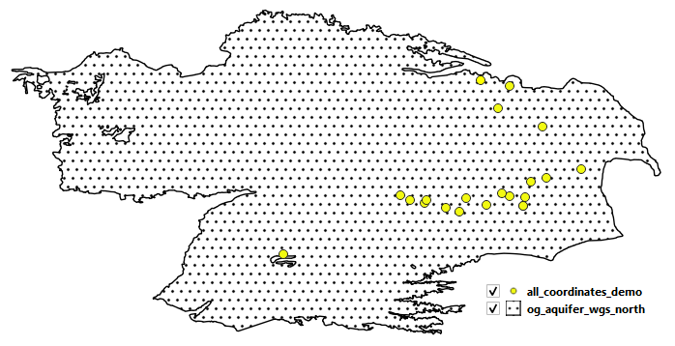

1. If the selected boreholes do not cover the entire study area (as it is in this example), a polygon is drawn around the available boreholes. Make sure that the boreholes fall within the aquifer area. This polygon is used for the G3P GWSA selection.

1. Go back to jupyter notebook