**SPATIAL ANALYSIS:**

**What’s needed:**

* **Polygon of the aquifer to be studied**
* **Raster file of specific yield in the area**
* **Output from Step 2 in Jupiter Notebook**
* **.xlsx file of all borehole coordinates in the area**

1. Match all boreholes in the study area and their coordinates with the output from the Jupiter notebook Step 2 True or False values. They indicate whether they are selected further for the analysis or not:

1. Import .csv data points into QGIS and export to .shp file “all_coordinates_demo”

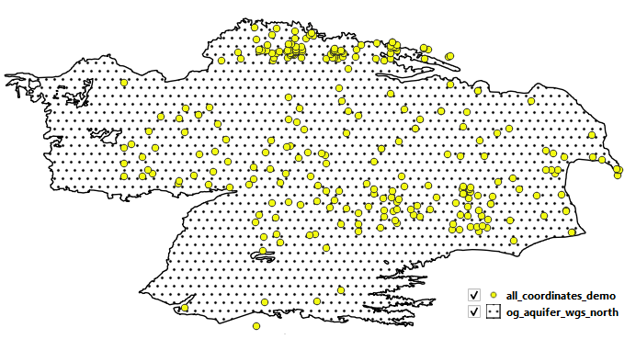

1. Open “all_coordinates_demo” and on the “t/f” column erase all boreholes that have FALSE values:

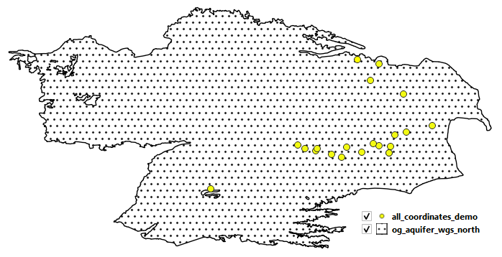

1. If the selected boreholes do not cover the entire study area (as it is in this example), a polygon is drawn around the available boreholes. This polygon is used for the Thiessen polygon analysis.

1. Generate Thiessen polygons (Voronoi polygons in QGIS) around this area:

1. Upload the specific yield raster available in this case (.tiff file) and use the “zonal statistics” option in QGIS to obtain the average specific yield per Thiessen polygon that belongs to each borehole.

In the attribute table:

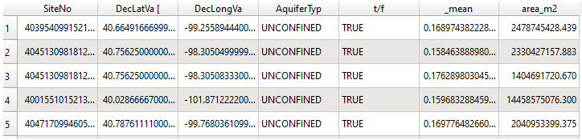

Where: _mean = average specific yield within each polygon

Additionally, calculate the area in m2 per each polygon.

1. Export this table to excel:

1. Save file as “boreholes_sy_area_demo”
2. Go back to jupyter notebook