Groundwater Trends Dashboard — User Guide

How to run the application:
- Download and extract: Download the application as a ZIP file and extract it to a local folder (e.g. Desktop). Do not run the application from inside the ZIP file.
- Prepare the input files
Place the following files in the input folder:
- Monitoring_data.csv
- Sites_coordinates.csv
- metadata.csv
- IGRAC_logo_FC.png
File names must match exactly. See below paragraph “Input Files Guide” to prepare the input files.
Note: The files in input are examples.
To use your own data, replace the three files in input with your own files (same names), then run the .exe.
- Run the application
Double-click GwDashboard.exe
Now wait for 2-3 minutes for the simulation to run

- View the results
Outputs are saved in the output folder
Open the dashboard (html) by double-clicking it

Input files guide
This section explains how to prepare the four input files required to run the Groundwater Trends Dashboard script:
- Monitoring_data.csv
- Sites_coordinates.csv
- metadata.csv
- IGRAC_logo_FC.png
Note: These files must be placed in the folder named input (see Figure 1). which is in the same directory as the GwDashboard.exe file (see Figure 2).
If the file names or file locations differ, the application will not run.
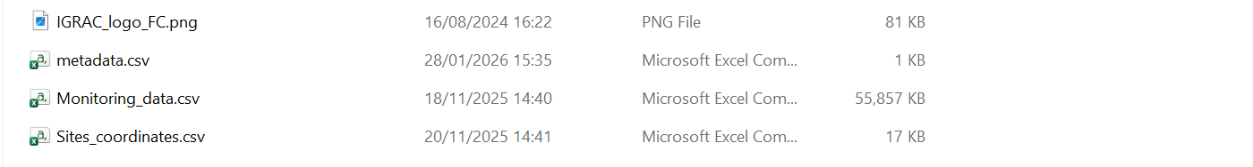
Figure 1: Files in input folder
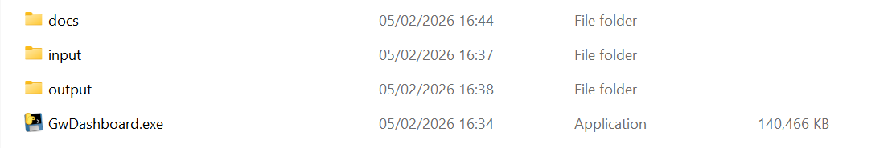
Figure 2: alignment of files

1) Monitoring_data.csv
This file contains the raw groundwater monitoring time series.
Required columns:
- Date: date of measurement (DD/MM/YYYY or YYYY-MM-DD)
- site: unique well identifier
- value column: groundwater level measurement measured either as depth or groundwater level elevation
Accepted value column names:
- depth → interpreted as groundwater depth
- water_level → interpreted as groundwater elevation
Examples:
Date | site | depth
01/01/2004 | AQ_001 | 12.40
15/01/2004 | AQ_001 | 12.35
Rules:
- Daily or monthly data are accepted, having at least one measurement each month is recommended
- Missing values should be empty or NaN
- Data should cover the analysis period (default: 2004–2023)
- Data should cover 80% of the analysis period meaning at least 16 years, for more information click: Groundwater levels reporting methodology (PDF)

2) Sites_coordinates.csv
This file provides spatial coordinates for each well
Required columns:
- site: unique well identifier must match Monitoring_data.csv
- X: longitude (WGS 84/ EPSG:4326)
- Y: latitude (WGS 84 / EPSG:4326)
Example:
site | X | Y
AQ_001 | -0.578 | 44.841
AQ_002 | -0.612 | 44.900
Rules:
- One row per site
- Decimal degrees only
- Wells without coordinates will not appear on the map, but they can be included for analysis of associated time series

3) metadata.csv
This file controls what the data means and how it is described in the dashboard
Format (2 columns only):
field | value

Example:
Type of unit | Province
Country | France
Name of unit | Aquitaine
Type of measurements | depth
Units | m b.g.l.
Number of wells
Accepted wells

Purpose and effects
- Define whether measurements are interpreted as depth or elevation
- Control how units are displayed in the dashboard
- Improves context box information
- Number of wells and Accepted wells must be left empty. These values are calculated automatically by the application
- If type of measurement is provided, it overrides automatic detection
Recognized unit formats:
- m b.g.l. → meters below ground level
- m a.m.s.l. → meters above mean sea level

4) IGRAC_logo_FC.png
Do not do anything. Keep it in the input file

Output files guide:
If the application runs successfully, you will find the following files in the output folder (or in the same folder as the .exe, depending on how the packaged version is configured):
- Accepted_data.csv
Monthly groundwater time series for accepted wells only (after the completeness filter). This is the cleaned dataset used for all calculations
- Rejected_Wells.xlsx
List of wells that were not accepted by the completeness filter, with the reason (e.g., insufficient data)
- MK_results.xlsx
Main results table per well, including Mann–Kendall trend/significance, Sen slope values (20y plus 10y/5y slopes where possible), coordinates, IQR, and CRI.
This file also contains a “Hydrograph” sheet with an embedded plot image
- Hydrograph_mean_normalized.png
A PNG figure of the mean normalized hydrograph with trendlines (used to embed the plot into MK_results.xlsx). You can open it directly if you want the figure as an image
- Dashboard_2pages_Selector_MK_CRI_Rank_SenSlope.html
The interactive dashboard (two pages/tabs):
Page 1 = indicator overview (pie + map + hydrograph) with dropdown selector
Page 2 = methodology summary (text)

