DevLab I2C Buzzer Module
Product Reference Manual
UNIT Electronics
2026-08-31

Contents
- Description
  - Applications
  - Available Documentation
- 1 The Board
  - 1.1 Board Identification
  - 1.2 Board Views
- 2 Ratings
  - 2.1 Electrical Limits
  - 2.2 Interface Characteristics
- 3 Functional Overview
  - 3.1 Integration Boundary
- 4 Connectors and Pinout
- 5 Board Operation
  - 5.1 Before Connecting
  - 5.2 I2C Bus Check
- 6 Mechanical Information
  - 6.1 Top View
  - 6.2 Bottom View
  - 6.3 Dimensional Data
- 7 Company Information
- 8 Reference Documentation
- 9 Appendix
  - 9.1 Schematic Status
  - 9.2 Document Control
  - 9.3 Data Requiring Confirmation

Description
The DevLab I2C Buzzer Module (MPN UE0175) is an I2C buzzer module in the UNIT Electronics DevLab family. The product-specific board views and any released drawings are collected under hardware/.

Applications
- Buzzer output in an I2C-based prototype.
- Evaluation of the module with a compatible host controller.

Available Documentation
A product-specific schematic was not present in the selected source package. See Chapter 8 for the available source files. Confirm the electrical interface against the product-specific pinout or schematic before connecting the board.

1 The Board

1.1 Board Identification
Item | Identification
Product | DevLab I2C Buzzer Module
Manufacturer Part Number (MPN) | UE0175
Function | Buzzer output

1.2 Board Views
The following views come from the selected UE0175 source package. They show component placement and board orientation; use a dimensioned drawing for mechanical tolerances.
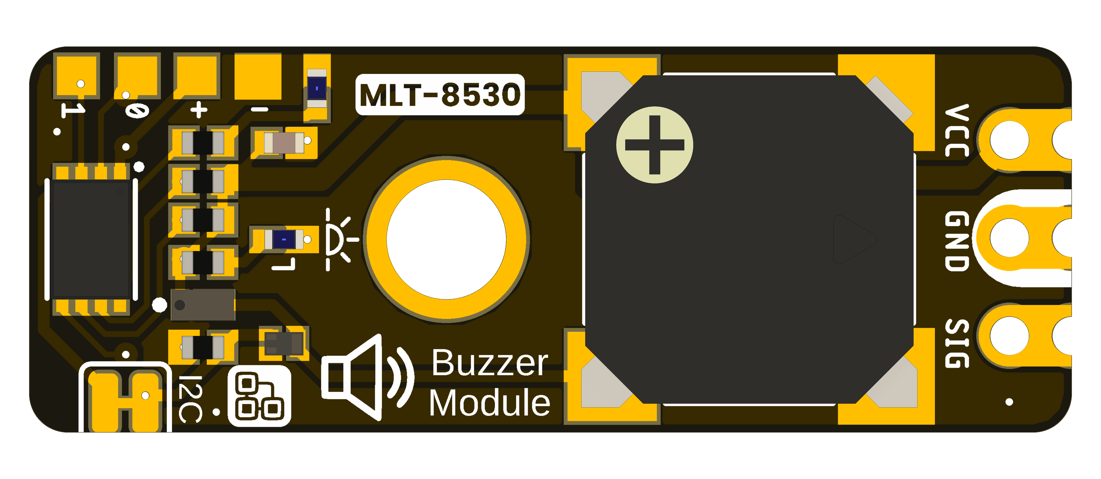
DevLab I2C Buzzer Module top view.
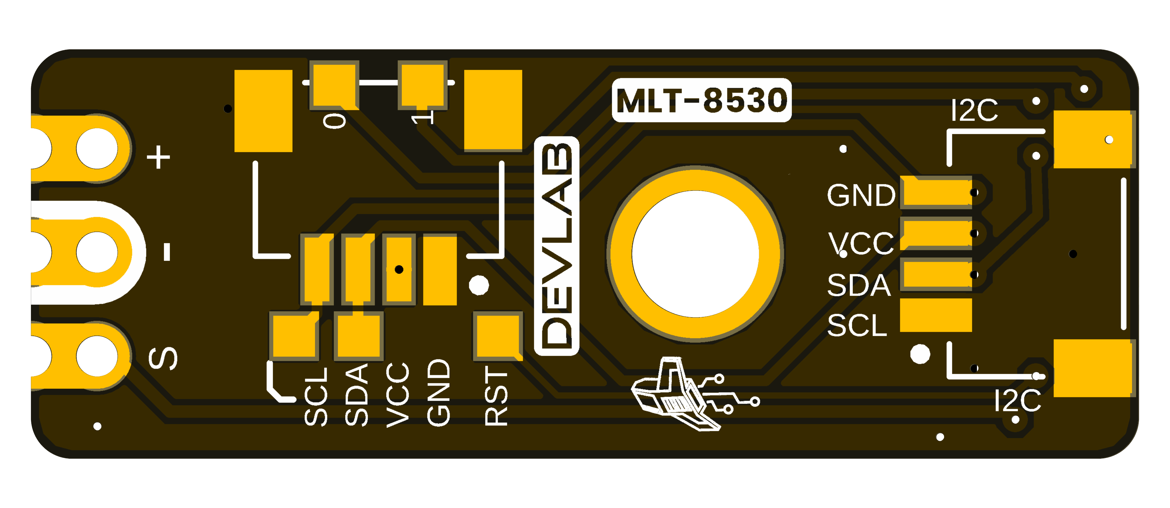
DevLab I2C Buzzer Module bottom view.

2 Ratings
The selected UE0175 source package does not establish a complete set of electrical ratings in this reference. Do not use values from another DevLab module as substitutes.

2.1 Electrical Limits
Supply range, I/O voltage limits, and current consumption require confirmation from the product-specific schematic and component data before integration.

2.2 Interface Characteristics
Confirm the I2C address, bus speed, pull-up arrangement, and connector orientation with the released UE0175 pinout or firmware documentation. An I2C scan only identifies responding addresses; it does not verify the device protocol.

3 Functional Overview
The DevLab I2C Buzzer Module provides buzzer output for an I2C-based system. The supplied board views identify the physical module, while the product-specific schematic and firmware documentation are needed to establish its internal signal path and command set.

3.1 Integration Boundary
Use the available UE0175 pinout, schematic, and firmware release to determine power, connector mapping, address, and commands. Until these are confirmed, treat the generic I2C scanner in software/ as a bus diagnostic only.

4 Connectors and Pinout
A released pinout drawing for the UE0175 I2C Buzzer Module was not present in the selected source package. The top and bottom views in Section 6 show the visible board labels, but they do not establish connector numbering, voltage limits, or signal direction. Verify these details against the product-specific schematic before connecting a cable or designing a carrier.

5 Board Operation

5.1 Before Connecting
Check the product-specific UE0175 pinout or schematic for power, ground, SDA, and SCL. The board views alone do not establish voltage limits or connector numbering.

5.2 I2C Bus Check
After confirming the wiring and supply limits, use the generic Arduino or MicroPython I2C scanner in software/examples/i2c/. Set the host SDA and SCL pins for your controller. A responding address confirms only that a device acknowledged on the bus; it does not identify the module or validate its measurement protocol.

6 Mechanical Information
The supplied board views identify the component and underside layouts of the UE0175 I2C Buzzer Module. Use the labeled drawings for fit checks; do not infer dimensions by scaling a render.

6.1 Top View
UE0175 I2C Buzzer Module top view.

6.2 Bottom View
UE0175 I2C Buzzer Module bottom view.

6.3 Dimensional Data
A controlled dimensioned drawing is not available in the selected source package. Verify the board outline, mounting pattern, component heights, and connector clearances before designing an enclosure or carrier.

7 Company Information
Item | Information
Company / brand | UNIT Electronics
Board ecosystem | DevLab
Product family | Atom
Website | UNIT Electronics
Address | Salvador 19, Cuauhtémoc, 06000 Mexico City, CDMX, Mexico
The product repository and controlled technical references are listed in the next chapter.

8 Reference Documentation
Reference | Location
Product repository | UE0175 I2C Buzzer Module
Top view | 3D board view
Bottom view | 3D board view
A product-specific pinout drawing was not included in the selected source package.

9 Appendix

9.1 Schematic Status
A product-specific schematic was not included in the selected source package.

9.2 Document Control
Item | Value
Product | DevLab I2C Buzzer Module
MPN | UE0175
Source | UNIT Electronics selected product source package

9.3 Data Requiring Confirmation
Electrical limits, I2C commands, and mechanical tolerances must be verified against product-specific released documentation.

