UNIT ATOM GT36537
I2C-Compatible LDR Ambient Light Sensor — Hardware Revision V0.3.1
UNIT Electronics
2026-08-31

Contents
- Description
  - Applications
  - DevLab Format Compatibility
  - Hardware Features
- 1 The Board
  - 1.1 Accessories {.section-page}
  - 1.2 Recommended Test Equipment
  - 1.3 Board Identification
  - 1.4 Board Components and Features
  - 1.5 Board Layout and Reference Designators {.section-page}
  - 1.6 Board Views {.section-page}
  - 1.7 Handling {.section-page}
- 2 Ratings
  - 2.1 Recommended Operating Conditions {.section-page}
  - 2.2 Digital Interface and Firmware Characteristics
  - 2.3 Onboard Interface Controller
  - 2.4 Module-Level Characteristics
  - 2.5 Electrical Precautions
- 3 Functional Overview
  - 3.1 Functional Block Diagram {.section-page}
  - 3.2 Operating Modes
  - 3.3 Digital Light Measurement {.page-break}
  - 3.4 I2C Communication Model {.page-break}
  - 3.5 User-Accessible DDP Functions {.section-page}
  - 3.6 Built-In Indicator
  - 3.7 Physical Interface Notes {.section-page}
- 4 Connectors & Pinouts
  - 4.1 General Pinout {.section-page}
  - 4.2 Signal and I2C Connection Guide {.page-break}
  - 4.3 Direct Sensor Contacts
  - 4.4 I2C Connection Positions {.section-page}
  - 4.5 Auxiliary and Factory Service Functions
  - 4.6 Indicators and I2C Bridge
- 5 Board Operation
  - 5.1 Required Hardware and Software {.section-page}
  - 5.2 Library Installation
  - 5.3 I2C Connection and Example Settings {.page-break}
  - 5.4 Single-Sensor Arduino Example {.page-break}
  - 5.5 Upload and Serial Output {.section-page}
  - 5.6 Troubleshooting {.section-page}
- 6 Mechanical Information
  - 6.1 Board Dimensions {.section-page}
  - 6.2 Integration Clearances {.section-page}
  - 6.3 Mechanical Data Not Specified
- 7 Company Information
- 8 Reference Documentation
- 9 Appendix
  - 9.1 Current Schematic {.section-page}
  - 9.2 Document Control {.section-page}
  - 9.3 Technical Data Not Specified in This Revision

Description
The DevLab I2C GT36537 LDR Ambient Light Sensor is an ambient-light sensor module developed by UNIT Electronics as part of the DevLab ecosystem. It combines a GT36537 photoresistor (LDR), wired as a voltage divider, with an onboard microcontroller-based interface controller, providing both I2C communication and direct access to the sensor’s raw analog signal.
The board provides three I2C connectors sharing the same bus, a dedicated RAW Signal Header for direct access to the unprocessed sensor output, and power/status indicators. The onboard microcontroller reads the GT36537 divider signal through its analog-to-digital converter (ADC) and makes the resulting measurements available through the I2C interface.

Applications
- I2C-connected ambient-light acquisition
- Direct analog light measurement during development, testing, and characterization
- Automatic display and indicator brightness control
- Smart lighting and home/industrial automation
- Day/night and relative-light detection
- Environmental and IoT light-level data logging
- Educational I2C and photoresistor experiments
- Integration into I2C sensor networks

DevLab Format Compatibility
As part of the DevLab ecosystem, the GT36537 module follows a compact form factor intended for rapid prototyping and integration with other DevLab modules. The board provides three I2C connectors carrying GND, VCC, SDA, and SCL, all wired to the same bus, giving multiple physical access points to the I2C interface and supporting different module integration and mounting configurations.
Connector pitch, mechanical drawings, and supply-voltage limits for this GT36537 revision are still pending publication; verify the current hardware documentation before connecting the module to a host.

Hardware Features
- GT36537 ambient-light photoresistor, wired as a voltage divider
- Onboard microcontroller handling I2C communication and ADC acquisition
- 7-bit I2C slave operation using the DevLab Device Protocol (DDP)
- Three I2C connection positions carrying GND, VCC, SDA, and SCL, all connected to the same bus
- Dedicated RAW Signal Header exposing the unprocessed GT36537 divider output, independent of the I2C interface
- Power and user/status indicators
- Dedicated test points for debug
The controller implements DevLab Device Protocol (DDP) v1.0, using DevLab Interface for I2C bus management. DevLab Interface is integrated into the module’s own library, so no separate bus-handling code is required. The GT36537 profile is identified by Device ID 0x0106, and the factory I2C address is 0x26.
Detailed electrical ratings, mechanical dimensions, and pinout diagrams for this GT36537 revision are still pending and will be published once the corresponding hardware assets are available.

1 The Board
The design supports two host paths. An I2C-capable controller can attach through any of the three I2C connectors, while a host or test instrument with an analog input can sample the dedicated RAW Signal Header directly. The GT36537 photoresistor (LDR) is wired as a voltage divider; its midpoint is read by the onboard microcontroller and made available through the I2C interface, and remains separately available as an unprocessed analog signal on the RAW Signal Header.
Detailed mechanical, pinout, and schematic assets for this GT36537 revision are still pending publication. The values in this chapter reflect the current confirmed design; items not yet released are marked accordingly.

1.1 Accessories
The module is supplied with a Qwiic-compatible cable for connection to the I2C interface.
Accessory | Purpose | Selection notes
JST/Qwiic-compatible cable | Connects GND, VCC, SDA, and SCL | Connector pitch and orientation for this GT36537 revision are pending publication; verify against the populated connector before use

1.2 Recommended Test Equipment
The following equipment may be used for integration, testing, and validation. These items are not included with the module.
Equipment | Purpose | Selection notes
I2C-capable host | Scans and communicates with the module | Use 7-bit addressing over the DevLab Device Protocol (DDP)
Analog test lead or carrier | Provides access to VCC, GND, and SIGNAL on the RAW Signal Header | SIGNAL must connect to a voltage-compatible ADC input
Logic analyzer | Checks I2C communication activity | Use input thresholds compatible with the powered board
Reference lux meter | Supports optical calibration and validation | Required for quantitative illuminance validation

1.3 Board Identification
Item | Value
Product | DevLab I2C GT36537 LDR Ambient Light Sensor
Brand / company | UNIT Electronics
Board ecosystem | DevLab
Product type | I2C-compatible ambient-light module with direct raw-signal access
Optical component | GT36537 photoresistor (LDR), wired as a voltage divider
Interface controller | 32-bit Arm Cortex-M0+ microcontroller; exact fitted part pending confirmation
Manufacturer Part Number (MPN) | Pending
Current board artwork | Pending
Product Reference | Pending — this chapter reflects the GT36537 revision in progress
Board, pinout, schematic, and documentation revisions are controlled independently.

1.4 Board Components and Features
Component / Feature | Function | Implementation / Notes
GT36537 photoresistor (LDR) | Changes resistance with incident visible light | Wired as a voltage divider; primary ambient-light sensing element
Onboard microcontroller | Reads the divider signal through its ADC and manages I2C communication | 32-bit Arm Cortex-M0+; exact fitted part pending confirmation
I2C connectors | Provide module power and I2C bus access | Three connectors, all wired to the same bus
RAW Signal Header | Provides direct access to VCC, GND, and the unprocessed sensor SIGNAL | Independent of the I2C interface; intended for analog measurement, testing, and characterization
Power indicator | Indicates that the board is powered | Onboard power LED
User / status indicator | Provides firmware-controlled status indication | Onboard status LED
Test points | Support debug and validation | Dedicated test points; assignment pending detailed publication

1.5 Board Layout and Reference Designators
Board-layout artwork, component placement, and reference designators for this GT36537 revision are still pending publication. The topology, top-view, and bottom-view images previously published for this repository belong to the prior TEMT6000 (UE0098) hardware revision and must not be used as a layout reference for the GT36537 module. This section will be completed once the corresponding hardware assets are released.
Refer to Chapter 4 for user connections once the released schematic and pinout are available.

1.6 Board Views
Top- and bottom-view images for this GT36537 revision are pending publication. A product photo and board-view images will be added once the corresponding hardware assets are available.

1.7 Handling
Use normal ESD precautions. Keep the sensor surface clean and optically unobstructed. Remove power before changing connectors.

2 Ratings
This chapter summarizes the electrical operating conditions and interface characteristics relevant to integrating the DevLab I2C GT36537 LDR Ambient Light Sensor. It covers the module supply, I2C operation, analog sensor path, and controller capabilities. Use these ratings to select a compatible power source and host interface and to identify the electrical characteristics that require application-specific verification.

2.1 Recommended Operating Conditions
Symbol | Description | Min. | Typ. | Max. | Unit
VCC | Module supply voltage | — | 3.3 or 5 | — | V
VI2C | I2C logic-high and pull-up voltage | — | VCC | — | V
fSCL | I2C clock frequency | 100 | — | 400 | kHz
VSIG | Direct analog SIGNAL voltage range | — | Not specified | — | V
ICC | Module supply current | — | Not specified | — | mA
TA | Module ambient operating temperature | Not specified | — | Not specified | °C
The VCC values are the supported nominal operating points; they are not complete-module absolute maximum ratings. The validated continuous supply range around each nominal point is not specified.
Use a current-limited source during initial bring-up. The I2C pull-ups follow the module supply, so the host must tolerate the actual bus voltage. When the module operates at 5 V with a 3.3 V host, bidirectional level translation may be required.
The direct SIGNAL range requires analog-stage verification and measurement. Module current consumption must include the controller, indicators, pull-ups, and sensor load. The complete-module ambient-temperature range has not been qualified. I2C pull-up resistance, bus capacitance, and complete-module absolute maximum ratings are also not specified.

2.2 Digital Interface and Firmware Characteristics
Parameter | Value | Description
I2C addressing | 7-bit slave | Valid configurable addresses are 0x08..0x77
Factory I2C address | 0x26 (7-bit) | Pass 0x26 directly to the host I2C library; 0x4C is the 8-bit write address, not the device address
Device protocol | DDP v1.0 | Command transaction followed by an exact-length read transaction
Logical Device ID | 0x0106 | GT36537 identity; independent of the I2C address
Firmware / hardware | 1.0 / 1.0 | Current observable controller profile
Capability bitmap | 0x000001B9 | I2C configuration, analog input, sensor data, relay, watchdog, and persistent configuration
Raw digital sample | 0 to 4095 | 12-bit ADC code returned as an unsigned 16-bit little-endian value
ADC update interval | Approximately 20 ms | Background acquisition; an I2C read returns the latest published sample
Command processing delay | 2 to 5 ms | Use 5 ms conservatively before reading
Pending setter timeout | 250 ms | Parameter must arrive before expiry
These values describe the currently documented digital behavior. Detailed DDP commands and transaction sequences are provided in Chapter 3.

2.3 Onboard Interface Controller
The onboard controller acquires the analog output of the GT36537 LDR divider and provides the processed sensor data through the module’s I2C interface. The controller is not exposed as a general-purpose microcontroller and is not intended for user programming.
Feature | Module implementation
Internal controller | 32-bit Arm Cortex-M0+
Sensor acquisition | 12-bit ADC
User digital interface | I2C
I2C addressing | 7-bit addressing
Supported I2C clock | 100 kHz and 400 kHz
Direct sensor access | Analog SIGNAL contact
Programming and debugging | Reserved for factory use

2.4 Module-Level Characteristics
The following characteristics are established for the current module implementation and are described in the preceding sections.
Characteristic | Current module specification
Nominal supply voltage | 3.3 V or 5 V
Digital interface | I2C, 7-bit slave
Factory I2C address | 0x26
Configurable I2C address range | 0x08 to 0x77
I2C clock frequency | 100 kHz to 400 kHz
Sensor acquisition | 12-bit ADC
Raw digital output | 0 to 4095
ADC update interval | Approximately 20 ms
Command processing delay | 2 to 5 ms
Direct analog access | SIGNAL contact on the RAW Signal Header
Additional characteristics such as complete-module absolute maximum ratings, supply-current limits, guaranteed analog-output accuracy, calibrated lux accuracy, board-level operating-temperature range, and environmental qualification are not specified unless explicitly stated elsewhere in this Product Reference.
Component-level ratings shall not be interpreted as guaranteed ratings of the complete module.

2.5 Electrical Precautions
- Use a current-limited 3.3 V or 5 V supply during engineering bring-up.
- Verify connector orientation and establish a common ground before applying power.
- Do not exceed the controller upper operating-voltage limit of 5.5 V.
- When operating the module at 5 V, verify host compatibility with the actual voltage present on SDA, SCL, and SIGNAL. Use appropriate level translation when required.
- During normal operation, use the I2C connection points only for I2C communication. The same physical signals are shared with the controller’s factory programming and debugging functions; SWD is not provided as a separate user interface.
- Do not attempt firmware replacement or external debugging through the I2C connection points. Programming, debugging, and reset functions are reserved for manufacturer use and factory diagnostics.
- Remove power before cutting, soldering, or reworking the I2C disable bridge or optional connector positions.
- Verify the current released schematic, component specifications, and interface documentation before production integration.

3 Functional Overview
The DevLab I2C GT36537 LDR Ambient Light Sensor combines a GT36537 photoresistor (LDR), wired as a voltage divider, with an onboard controller. The module provides two ways to observe light level: digital readings over I2C and direct access to the analog sensor signal at SIGNAL.
The GT36537 LDR itself is an analog device. The onboard controller samples its output, applies the selected averaging, and provides the latest raw reading through DevLab Device Protocol (DDP) v1.0.

3.1 Functional Block Diagram
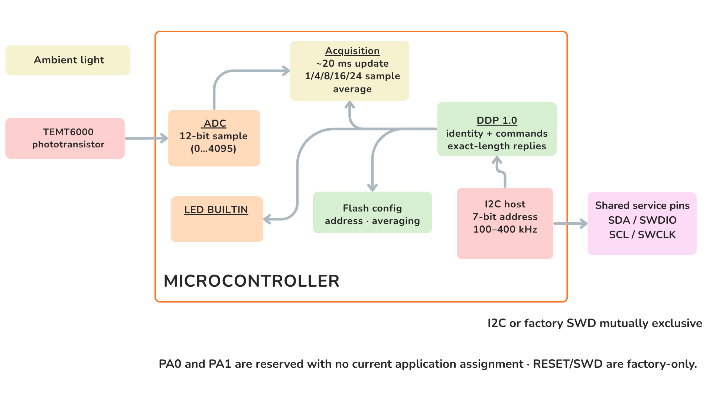
Figure 3.1 — Functional signal and control paths. Ambient light changes the LDR divider output. The signal is available at SIGNAL and is also acquired by the controller ADC for access over I2C.

3.2 Operating Modes
Mode | Connection | User-visible result
Digital I2C | VCC, GND, SDA, and SCL | Averaged 12-bit raw light reading through DDP
Direct analog | VCC, GND, and SIGNAL | Light-dependent voltage for a host ADC or measurement instrument
Both modes observe the same sensor path. An I2C read returns the latest available sample; it does not trigger a new light measurement. The direct analog output may be used independently for development, comparison, or application-specific calibration.

3.3 Digital Light Measurement
The onboard ADC produces an unsigned 12-bit value. Whether the value rises or falls with more light depends on which end of the voltage divider carries the LDR, under the actual supply, optical, and mechanical conditions.
Measurement property | Value
ADC resolution | 12 bits
Raw output range | 0..4095
Response format | Two bytes, [LSB, MSB]
Update interval | Approximately 20 ms
Selectable averaging | 1, 4, 8, 16, or 24 samples
The averaging setting controls the balance between response speed and stability:
Samples | Approximate time for a completely new average | Typical use
1 | 20 ms | Fast changes
4 | 80 ms | Low-latency smoothing
8 | 160 ms | General monitoring
16 | 320 ms | Stable ambient-light monitoring
24 | 480 ms | Maximum available smoothing
The result is a relative ADC reading, not a calibrated lux measurement. Quantitative lux measurements require calibration in the final enclosure and optical arrangement.

3.4 I2C Communication Model
The I2C host always initiates communication. The 7-bit I2C address selects the module, while the one-byte DDP selector identifies the requested function. These are independent values.
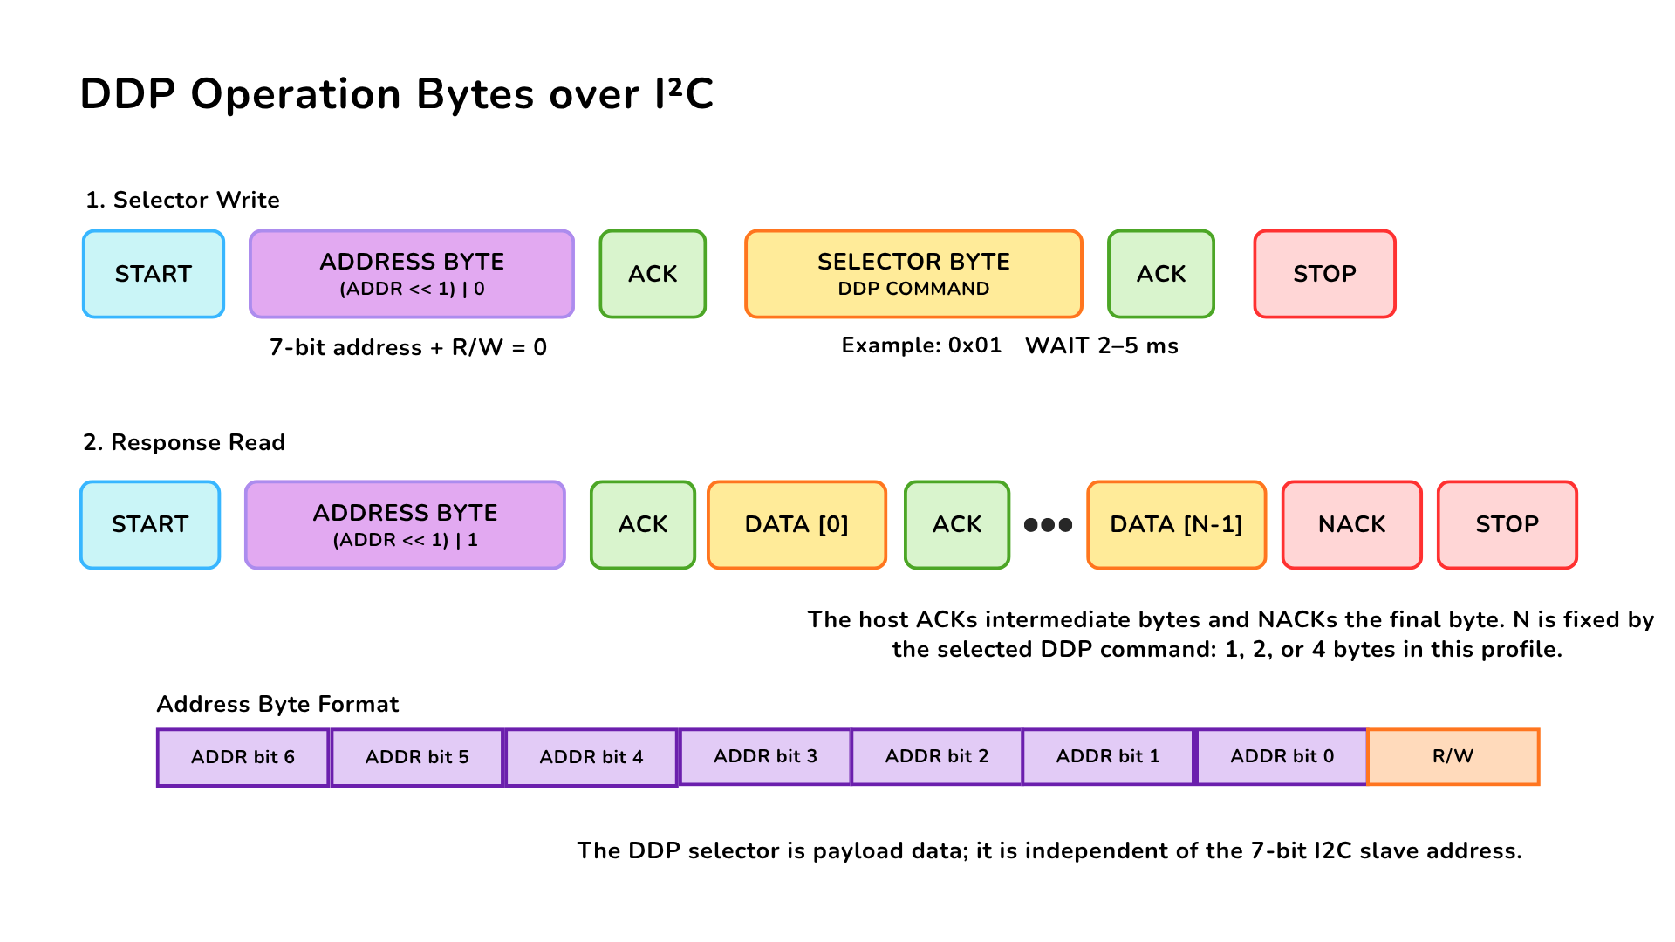
Figure 3.2 — DDP command and response over I2C. The host writes one DDP selector, issues STOP, waits 2–5 ms, and then reads the documented number of response bytes. The host acknowledges intermediate bytes and sends NACK after the final byte.
Communication property | Value
Factory 7-bit address | 0x26
Configurable address range | 0x08..0x77
I2C clock | 100 kHz to 400 kHz
Delay before response read | 2–5 ms; use 5 ms conservatively
Byte order for multi-byte values | Little endian
Supported response lengths | 1, 2, or 4 bytes, depending on the selected function
Pass 0x26 directly to an I2C library. Values 0x4C and 0x4D are the shifted write/read address bytes visible on the bus, not the 7-bit address used by typical host APIs.

3.5 User-Accessible DDP Functions
User function | DDP selector | Result
Identify the module | 0x00 | Device ID 0x0106
Read protocol version | 0x04 | DDP version 1.0
Read active I2C address | 0x20 | Current 7-bit address
Change I2C address | 0x21 | Stores and applies a new address in the valid range
Restore factory configuration | 0x23 | Restores default configuration; reset required
Read ambient-light data | 0x60 | Latest two-byte 12-bit raw sample
Set ADC averaging | 0x62 | Selects 1, 4, 8, 16, or 24 samples
Read ADC averaging | 0x63 | Returns the active averaging setting
Turn BUILTIN off/on | 0xA0 / 0xA1 | Drives the built-in indicator LOW/HIGH
Pulse BUILTIN | 0xA2 | Starts a non-blocking timed pulse
Set/read pulse time | 0xA3 / 0xA4 | Uses 1–40 units of 25 ms
The I2C address, averaging selection, and pulse duration are retained after a power cycle. Changing a stored value should be an occasional configuration operation rather than part of the normal measurement loop.
Detailed transaction handling is implemented by the DevLab_GT365xx Arduino library listed in Chapter 8, which uses DevLab Interface for I2C bus management.

Arduino Library Functions
All functions belong to the DevLab_GT365xx class. Functions that return bool return true on success. Readings are taken with the DDP read-ADC command (0x60) and are only available after a successful begin call.
Function | Description
DevLab_GT365xx(wire, address, clock) | Constructor. Defaults: Wire, address 0x26, 400000 Hz
begin() | Starts the I2C bus on the host’s default pins and verifies the GT36537 Device ID
begin(sdaPin, sclPin, clock) | Same as begin(), selecting the SDA/SCL pins and I2C clock
beginRecovered(sdaPin, sclPin, timeoutUs, restart) | Starts the bus with bus recovery before verifying the Device ID. Defaults: timeoutUs 20000, restart false
readRaw(rawValue) | Latest 12-bit ADC reading, 0 to 4095
readPercentage(percentage) | Raw reading as a percentage, raw × 100 / 4095
readInvertRaw(invertedValue) | Inverted 12-bit reading, 4095 − raw
readInvertPercentage(percentage) | Inverted reading as a percentage
busReady() | true if the I2C bus was started successfully
isConnected() | true if the GT36537 Device ID was verified at the configured address
deviceInfo() | Identity information read during begin
printInfo(out) | Prints the device information to a Print stream (default Serial)
protocol() | Access to the underlying DDP master for direct commands
bus() | Access to the underlying DevLab Interface bus object
The inverted functions are useful when the reading falls as light increases, which depends on which end of the voltage divider carries the LDR.

3.6 Built-In Indicator
The built-in status indicator is controlled through the DDP actuator functions. The shared DDP command names contain RELAY, but this product uses them for the built-in indicator and does not provide an electromechanical relay output.
The pulse duration is configurable from 25 ms to 1000 ms in 25 ms steps. A timed pulse runs without interrupting light measurements or I2C communication.

3.7 Physical Interface Notes
The SIGNAL contact provides direct access to the analog sensor path. Its complete board-level transfer function, source impedance, and guaranteed output range are not specified for the current revision. Use a high-impedance input and verify the actual range before connecting it to a lower-voltage ADC.
The PCB provides three I2C connection positions carrying GND, VCC, SDA, and SCL: one connector is populated by default and two horizontal positions are provided for optional 4-pin, 1.00 mm-pitch JST/Qwiic-compatible connectors. All three positions access the same I2C bus.
The I2C connection points share signals with the controller’s factory programming and debugging interface; there is no separate user-accessible SWD connector. Programming, debug, and reset functions are reserved for manufacturer programming and factory diagnostics, not user firmware replacement.
Two expansion pads are reserved and have no current user function. The I2C disable bridge is intended for applications that require the analog path without active I2C operation; remove power before cutting or restoring it.

4 Connectors & Pinouts
The user-accessible interfaces are described below by module function. The released documentation does not provide controlled contact numbers or a mating-connector part number, so the signal order must be checked against the connector orientation before producing a harness.

4.1 General Pinout
Connection group | Signals | Function
Direct sensor contacts | VCC, GND, SIG | Module power and direct access to the TEMT6000 analog signal
I2C connection positions | GND, VCC, SDA, SCL | Power and digital communication over the common I2C bus
Reserved expansion pads | Reserved | No current application assignment; electrical limits are not specified
The PCB has three physical I2C connection positions. One connector is populated by default, and two additional horizontal positions accept optional 4-pin, 1.00 mm-pitch JST/Qwiic-compatible connectors. All three positions are connected to the same I2C bus.

4.2 Signal and I2C Connection Guide
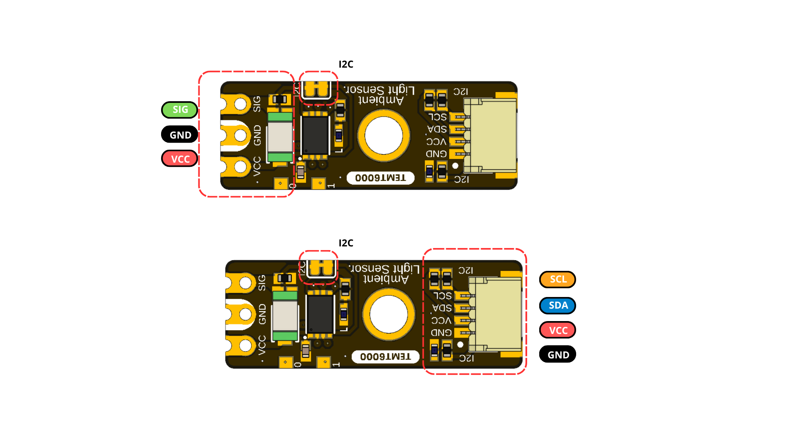
Figure 4.1 — Direct analog and I2C connection groups. The direct contacts provide SIG, GND, and VCC; the populated I2C connector provides SCL, SDA, VCC, and GND. Always follow the connector orientation shown on the board.

4.3 Direct Sensor Contacts
Label | Type | Description
VCC | Power | Module supply; nominal 3.3 V or 5 V operation
GND | Power | Common power and signal reference
SIG / SIGNAL | Analog | Direct light-dependent sensor signal; current transfer function unspecified
These three contacts are shown at the end opposite the populated I2C connector. SIG provides direct access to the TEMT6000 analog signal; it is not a separate specialized communication port.

4.4 I2C Connection Positions
Signal | Type | Description
GND | Power | Common return
VCC | Power | I2C peripheral supply; nominal 3.3 V or 5 V
SDA | Bidirectional I2C data | Host must tolerate the actual bus pull-up voltage
SCL | I2C clock | Supported at 100 kHz to 400 kHz
The two optional horizontal I2C connector positions use the same signal set and 1.00 mm pitch as the populated connector. Because all three positions are physical access points to the same bus, an optional connector may be used for an alternate cable orientation or bus continuation. Account for the loading and pull-ups of every attached device.
The I2C connection points share signals with the controller’s factory programming and debugging interface. These functions are mutually exclusive, and there is no separate user-accessible SWD connector.

4.5 Auxiliary and Factory Service Functions
Function | Documented role | Qualification status
Reserved expansion pad 1 | Reserved connection | No current application assignment; electrical limits unspecified
Reserved expansion pad 2 | Reserved connection | No current application assignment; electrical limits unspecified
Controller reset | Factory service function | Manufacturer programming and factory diagnostics only
Programming, debugging, and reset are intended primarily for development, manufacturing, and service purposes. Currently, user firmware programming is not supported or documented. During programming or diagnostics, I2C must be inactive and other bus devices must be isolated from the shared signals.

4.6 Indicators and I2C Bridge
The module provides a power indicator, a firmware-controlled built-in status indicator, and a normally closed solder bridge that connects the sensor’s raw output signal to the controller ADC input. Opening the bridge isolates the raw sensor signal from the ADC, and the connection can be restored by re-soldering the bridge. The controller ADC input used for sensor acquisition is internal to the module and is not an additional external contact.

5 Board Operation
This chapter shows how to verify one DevLab I2C GT36537 LDR Ambient Light Sensor and read its raw ambient-light value with Arduino. The examples use the DevLab_GT365xx library and support ESP32, RP2040/RP2350, and AVR hosts.

5.1 Required Hardware and Software
- DevLab I2C GT36537 module
- ESP32, RP2040/RP2350, or AVR development board acting as I2C host
- I2C connection for VCC, GND, SDA, and SCL
- USB cable for programming and Serial Monitor access
- Arduino IDE with the selected board package installed
- DevLab_GT365xx Arduino library

5.2 Library Installation
- Open Tools > Manage Libraries in Arduino IDE.
- Search for DevLab_GT365xx.
- Select the current release and click Install.
The library implements DDP v1.0 and uses DevLab Interface for I2C bus management. Its dependencies, DevLabDDP and DevLab_Interface, are installed together with it, so the sketch only includes DevLab_GT365xx.h and does not need separate bus-handling or bus-recovery code.

5.3 I2C Connection and Example Settings
Connect the module with power removed. Align the connector with the orientation printed on the board and verify VCC, GND, SDA, and SCL before applying power. A connection diagram for this GT36537 revision is pending publication.
Module | ESP32 | RP2040 / RP2350 | AVR | Function
VCC | 3.3 V or 5 V | 3.3 V or 5 V | 3.3 V or 5 V | Module supply
GND | GND | GND | GND | Common reference
SDA | GPIO6 | GPIO12 | Fixed board SDA pin | I2C data
SCL | GPIO7 | GPIO13 | Fixed board SCL pin | I2C clock
On RP2040 and RP2350 the examples use the Wire1 bus. AVR boards have fixed I2C pins (Uno/Nano: A4/A5, Mega: 20/21, Leonardo: 2/3) taken from the board variant. The pin numbers above match the repository examples; change SDA_PIN and SCL_PIN when the selected host board uses different I2C pins.
Important: The I2C pull-up voltage follows the module supply (VCC). When operating the module at 5 V, verify that the host I2C pins are 5 V tolerant. If the host operates at 3.3 V and is not 5 V tolerant, use appropriate bidirectional level translation between the module and the host.
The example uses the following settings:
Constant | Default | Purpose
SDA_PIN | GPIO6 (ESP32); GPIO12 (RP2040/RP2350) | Host SDA pin
SCL_PIN | GPIO7 (ESP32); GPIO13 (RP2040/RP2350) | Host SCL pin
I2C_FREQ | 400000 Hz | I2C clock
SENSOR_ADDRESS | 0x26 | Factory 7-bit module address
READ_INTERVAL_MS | 250 ms | Time between printed readings
If the module address was changed previously, update SENSOR_ADDRESS before uploading the sketch.

5.4 Single-Sensor Arduino Example
Open serialLightRead.ino from the library examples, or create it with the following sketch:
/**
* @file serialLightRead.ino
* @brief Verifies a GT36537 DDP device (ID 0x0106) on the I2C bus and prints
* its raw ADC0 reading and relative percentage over Serial.
*/
#include <Arduino.h>
#include <Wire.h>
#include <DevLab_GT365xx.h>
#if defined(ARDUINO_ARCH_RP2040) || defined(ARDUINO_ARCH_RP2350)
#define I2C_BUS Wire1
constexpr int SDA_PIN = 12;
constexpr int SCL_PIN = 13;
#elif defined(ARDUINO_ARCH_ESP32)
#define I2C_BUS Wire
constexpr int SDA_PIN = 6;
constexpr int SCL_PIN = 7;
#elif defined(ARDUINO_ARCH_AVR)
#define I2C_BUS Wire
constexpr int SDA_PIN = SDA;
constexpr int SCL_PIN = SCL;
#else
#error "Use an ESP32, RP2040, RP2350, or AVR master"
#endif
constexpr uint32_t I2C_FREQ = 400000UL;
constexpr uint8_t SENSOR_ADDRESS = 0x26U;
constexpr uint32_t READ_INTERVAL_MS = 250U;
DevLab_GT365xx sensor(I2C_BUS, SENSOR_ADDRESS, I2C_FREQ);
void setup() {
Serial.begin(9600);
sensor.beginRecovered(SDA_PIN, SCL_PIN);
if (!sensor.busReady()) {
Serial.println("ERROR: I2C bus is blocked");
return;
}
if (!sensor.isConnected()) {
Serial.println("ERROR: expected GT36537 DDP device ID 0x0106 at 0x26");
return;
}
sensor.printInfo();
Serial.println("GT36537 ready: PA2 ADC0 reads the LDR divider");
}
void loop() {
static uint32_t lastRead = 0U;
if (millis() - lastRead < READ_INTERVAL_MS) {
return;
}
lastRead = millis();
uint16_t raw = 0U;
if (sensor.readRaw(raw)) {
float percent = (raw * 100.0f) / 4095.0f;
Serial.printf("adc0=%u percent=%.1f\n", raw, percent);
} else {
Serial.println("ERROR: light read failed");
}
}
The complete example also supports AVR hosts, where Serial.printf() is not available and the output is printed with Serial.print() instead.
The following companion examples are provided:
Example | Purpose
serialLightReadInverted | Reports 4095 - raw with readInvertRaw() and readInvertPercentage() so that the value rises with more light
serialLightRawPlot | Streams one raw integer per line at 115200 baud for the Arduino Serial Plotter or python/serial_plotter.py
i2c_scanner | Scans the I2C bus at 115200 baud and prints the 7-bit address of every device that responds; a detected address only confirms that a device acknowledged, not that it is a GT36537
changeAddress | Serial tool at 115200 baud to scan for DDP devices and reassign the module address (factory address 0x26), for example scan or change 26 30

5.5 Upload and Serial Output
- Select the connected host board in Arduino IDE.
- Select its serial port.
- Compile and upload serialLightRead.ino.
- Open Serial Monitor at 9600 baud (115200 baud for serialLightRawPlot).
- Illuminate and cover the LDR to confirm that the printed value changes.
At startup, the sketch recovers and initializes the I2C bus, verifies that address 0x26 contains a DDP GT36537 with Device ID 0x0106, and prints the reported device information. It then prints adc0 and percent every 250 ms.
<DDP device information>
GT36537 ready: PA2 ADC0 reads the LDR divider
adc0=<value from 0 to 4095> percent=<0.0 to 100.0>
adc0=<value from 0 to 4095> percent=<0.0 to 100.0>
The readings are raw ADC values. They indicate relative light level and must not be interpreted directly as lux. Whether the value rises or falls with more light depends on which end of the voltage divider carries the LDR; use serialLightReadInverted if a value that rises with light is preferred.

5.6 Troubleshooting
Serial output or symptom | Check
ERROR: I2C bus is blocked | Wiring, connector orientation, shared ground, pull-up voltage, and unintended SDA/SCL drive
ERROR: expected GT36537 DDP device ID 0x0106 at 0x26 | Address setting, I2C pins, module power, and possible address collision
ERROR: light read failed after successful identification | Cable continuity, bus clock, supply stability, and I2C connections
Constant 0 or 4095 | Sensor obstruction, excessive illumination, supply, and module orientation
Value falls when light increases | Expected for some divider orientations; use serialLightReadInverted
Values change but lux is inaccurate | Calibrate the complete optical installation against a reference light meter
The complete Arduino examples and the DevLab_GT365xx library are listed in Chapter 8.

6 Mechanical Information
The current mechanical drawing defines the board outline and the dimensions shown below. Dimensions are in millimetres.

6.1 Board Dimensions
Figure 6.1 — Board dimensions.
Use the drawing itself as the dimensional reference; do not derive additional dimensions by scaling the image.

6.2 Integration Clearances
Leave optical clearance around the GT36537 LDR sensing surface and its field of view. Provide connector insertion and cable bend clearance at the populated I2C connector and at any optional connector position that will be assembled. Keep conductive fasteners away from contacts and factory service points, and avoid enclosure features that shadow the sensor or indicators.

6.3 Mechanical Data Not Specified
- Board thickness, dimensional tolerances, and finished mass
- Unannotated feature coordinates and edge clearances
- Optional connector population variants and mating-part numbers
- Connector insertion envelope, retention force, and cable bend radius
- Maximum top- and bottom-side component heights
- Optical axis, keep-out cone, and enclosure-window specification
- Reserved expansion-pad and factory service-point coordinates

7 Company Information
Item | Information
Company / brand | UNIT Electronics
Board ecosystem | DevLab
Product family | Atom
Website | UNIT Electronics
Address | Salvador 19, Cuauhtémoc, 06000 Mexico City, CDMX, Mexico
The product repository and controlled technical references are listed in the next chapter.

8 Reference Documentation
Reference | Location
Board topology | –
Board dimensions | –
Product repository | UNIT-Electronics-MX/unit_devlab_i2c_ldr_photoresistor_light_sensor
Hardware reference | hardware/README.md
English pinout | –
Spanish pinout | –
Board top view | –
Board bottom view | –
Current schematic | –
Software examples | C++ (Arduino)
Arduino library | UNIT-Electronics-MX/unit_devlab_gt365xx_library
Local DDP device profile | GT36537 DDP profile
Canonical DDP definitions and Arduino library | UNIT-Electronics-Labs/unit_devlab_ddp_library
Component page | –
GT36537 component datasheet | –
The released pinout, current board images, topology, dimensions, and schematic define the current visible interfaces, board layout, and mechanical envelope once they are published for this GT36537 revision. The component datasheet does not define complete-module ratings. The DDP profile defines runtime identity and digital data transport; it does not replace module-level electrical qualification.

9 Appendix

9.1 Current Schematic
The schematic documents the controller-based board, including the reference controller, LDR analog stage, I2C interfaces, status indicators, test points, and optional connectors.
Figure 9.1 — Electrical schematic.
The LDR divider signal is routed to the controller ADC input and the external VCC/GND/SIGNAL header. The reading is not a calibrated or guaranteed conversion to lux.
The I2C SDA and SCL signals are available at three physical connection positions: one connector populated by default and two optional horizontal positions. These signals are shared with the controller’s factory programming and debugging interface; there is no separate user-accessible SWD connector.

9.2 Document Control
Field | Value
Product | DevLab I2C GT36537 LDR Ambient Light Sensor
Product hierarchy | UNIT Electronics → DevLab board ecosystem → Atom family
Manufacturer Part Number (MPN) | UE0164
Current board artwork | –
Current pinout, topology, and dimensions | –
Available schematic | –
Product Reference | Version 1.0.0
Publication date | 2026-08-31
Interfaces | Three I2C connection positions on one bus; VCC/GND/SIGNAL header; reserved expansion pads; shared factory programming/debug signals

9.3 Technical Data Not Specified in This Revision
- Complete-module absolute-maximum ratings and current consumption
- I2C pull-up values and validated bus-loading limits
- Direct SIGNAL output range, loading characteristics, and ADC guidance
- Mechanical tolerances, board thickness, component heights, and finished mass
- Module-level optical, electrical, environmental, and EMC characterization

