DevLab I2C LDR Photoresistor Light Sensor
Product Reference Manual — MPN: UE0164
UNIT Electronics
2026-11-02

Contents
- Description
  - Applications
  - DevLab Format Compatibility
  - Hardware Features
- 1 The Board
  - 1.1 Accessories
  - 1.2 Recommended Test Equipment
  - 1.3 Board Identification
  - 1.4 Board Components and Features
  - 1.5 Board Layout and Reference Designators
  - 1.6 Board Views
  - 1.7 Handling
- 2 Ratings
  - 2.1 Recommended Operating Conditions
  - 2.2 Digital Interface and Firmware Characteristics
  - 2.3 Onboard Interface Controller
  - 2.4 Module-Level Characteristics
  - 2.5 Electrical Precautions
- 3 Functional Overview
  - 3.1 Functional Block Diagram
  - 3.2 Operating Modes
  - 3.3 Digital Light Measurement
  - 3.4 I2C Communication Model
  - 3.5 User-Accessible DDP Functions
  - 3.6 Built-In Indicator
  - 3.7 Physical Interface Notes
- 4 Connectors & Pinouts
  - 4.1 Released Pinout
  - 4.2 Connection Groups
- 5 Board Operation
  - 5.1 Required Hardware and Software
  - 5.2 Library Installation
  - 5.3 I2C Connection and Example Settings
  - 5.4 Single-Sensor Arduino Example
  - 5.5 Upload and Serial Output
  - 5.6 Troubleshooting
- 6 Mechanical Information
  - 6.1 Top View
  - 6.2 Bottom View
  - 6.3 Board Dimensions
- 7 Company Information
- 8 Reference Documentation
- 9 Appendix
  - 9.1 Schematic Status
  - 9.2 Document Control
  - 9.3 Technical Data Not Specified in This Revision

Description
The DevLab I2C GT36537 LDR Ambient Light Sensor is an ambient-light sensor module developed by UNIT Electronics as part of the DevLab ecosystem. It combines a GT36537 photoresistor (LDR), wired as a voltage divider, with an onboard microcontroller-based interface controller, providing both I2C communication and direct access to the sensor’s raw analog signal.
The board provides one populated I2C connector and two optional I2C connector positions on the same bus, plus a dedicated RAW Signal Header for direct access to the unprocessed sensor output, and power/status indicators. The onboard microcontroller reads the GT36537 divider signal through its analog-to-digital converter (ADC) and makes the resulting measurements available through the I2C interface.

Applications
- I2C-connected ambient-light acquisition
- Direct analog light measurement during development, testing, and characterization
- Automatic display and indicator brightness control
- Smart lighting and home/industrial automation
- Day/night and relative-light detection
- Environmental and IoT light-level data logging
- Educational I2C and photoresistor experiments
- Integration into I2C sensor networks

DevLab Format Compatibility
As part of the DevLab ecosystem, the GT36537 module follows a compact form factor intended for rapid prototyping and integration with other DevLab modules. The V1.0 pinout shows one populated 4-pin, 1 mm JST I2C connector and two optional connector positions carrying GND, VCC, SDA, and SCL. All positions access the same bus.
Product-specific top and bottom views, a dimension drawing, topology artwork, CAD files, and English and Spanish pinouts are available. The full schematic and complete-module electrical limits remain pending; verify the published pinout before connecting the module to a host.

Hardware Features
- GT36537 ambient-light photoresistor, wired as a voltage divider
- Onboard microcontroller handling I2C communication and ADC acquisition
- 7-bit I2C slave operation using the DevLab Device Protocol (DDP)
- Three I2C connection positions carrying GND, VCC, SDA, and SCL, all connected to the same bus
- Dedicated RAW Signal Header exposing the unprocessed GT36537 divider output, independent of the I2C interface
- Power and user/status indicators
- Dedicated test points for debug
The controller implements DevLab Device Protocol (DDP) v1.0, using DevLab Interface for I2C bus management. DevLab Interface is integrated into the module’s own library, so no separate bus-handling code is required. The GT36537 profile is identified by Device ID 0x0106, and the factory I2C address is 0x26.
The released V1.0 pinout diagrams are presented in Chapter 4, and the board views and dimension drawing in Chapter 6. Complete electrical ratings and mechanical tolerances remain to be confirmed.

1 The Board
The DevLab I2C LDR Photoresistor Light Sensor (MPN UE0164) uses a GT36537 photoresistor and an onboard interface controller. The board exposes the light-dependent signal directly at SIG and provides digital readings over I2C. The selected product package includes top and bottom 3D views, a topology drawing, dimensions, CAD models, and English and Spanish pinouts. A product-specific electrical schematic has not yet been supplied.

1.1 Accessories
The released pinout labels a populated 4-pin, 1 mm JST I2C connector. It also marks two optional connector positions. Check cable orientation against the pinout before applying power; the drawing does not establish an included cable.

1.2 Recommended Test Equipment
Equipment | Purpose
I2C-capable host | Discover the 7-bit address and read the module through DDP
High-impedance ADC or voltmeter | Observe the direct SIG contact after confirming its voltage range
Reference lux meter | Calibrate relative light readings when absolute illuminance is needed

1.3 Board Identification
Item | Value
Product | DevLab I2C LDR Photoresistor Light Sensor
Manufacturer Part Number (MPN) | UE0164
Sensor | GT36537 photoresistor (LDR)
Digital interface | I2C, DevLab Device Protocol (DDP)
User connections | GND, VCC, SDA, SCL, and direct SIG contact
Available artwork | Product-specific top/bottom views V1.0; topology and dimensions V1.0.0
Product Reference | Version 1.1.0

1.4 Board Components and Features
Component / feature | Function
GT36537 LDR | Changes resistance with incident light
Onboard controller | Acquires the sensor signal and responds on I2C
Populated I2C connector | Power and bus connection
Optional I2C connector positions | Additional physical access to the same bus after assembly
Direct SIG contact | Analog access to the light-dependent signal
Power and user LEDs | Indicators identified by the pinout
TX, RX, and RST pads | Service labels shown in the pinout; not general-purpose host connections

1.5 Board Layout and Reference Designators
The UE0164 topology artwork identifies the layout of this board. Use the product-specific pinout in Chapter 4 for user connections and the dimension drawing in Chapter 6 for mechanical layout. Do not infer circuit values or a complete netlist from the rendered views.
UE0164 board topology.

1.6 Board Views
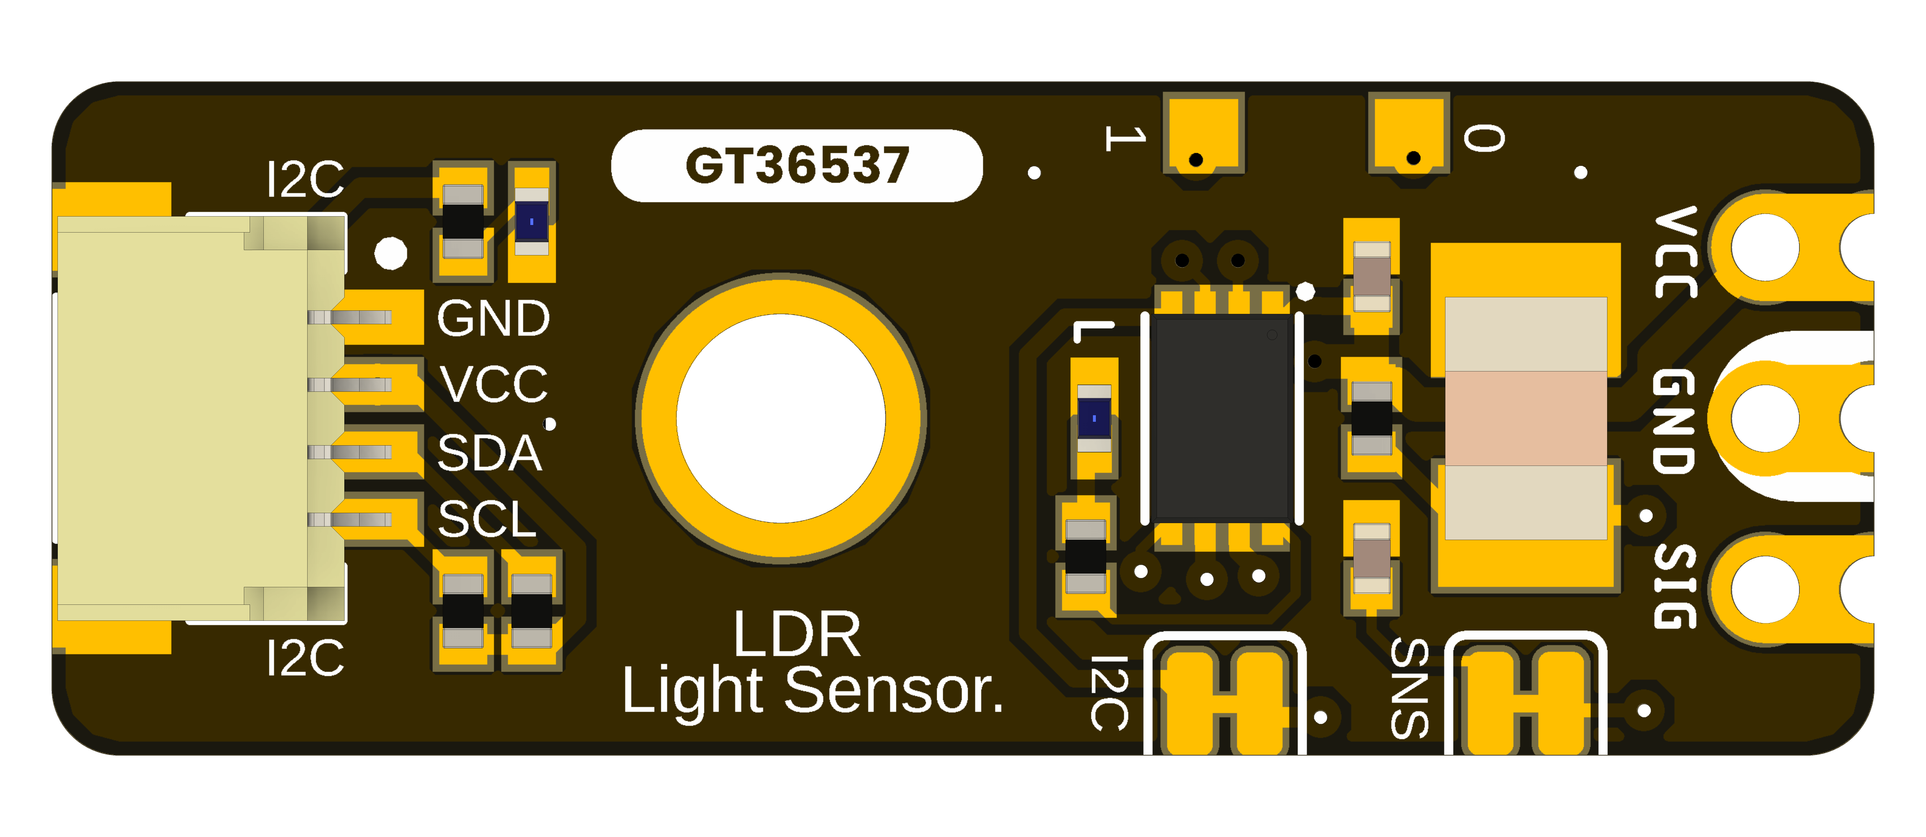
UE0164 top view with components.
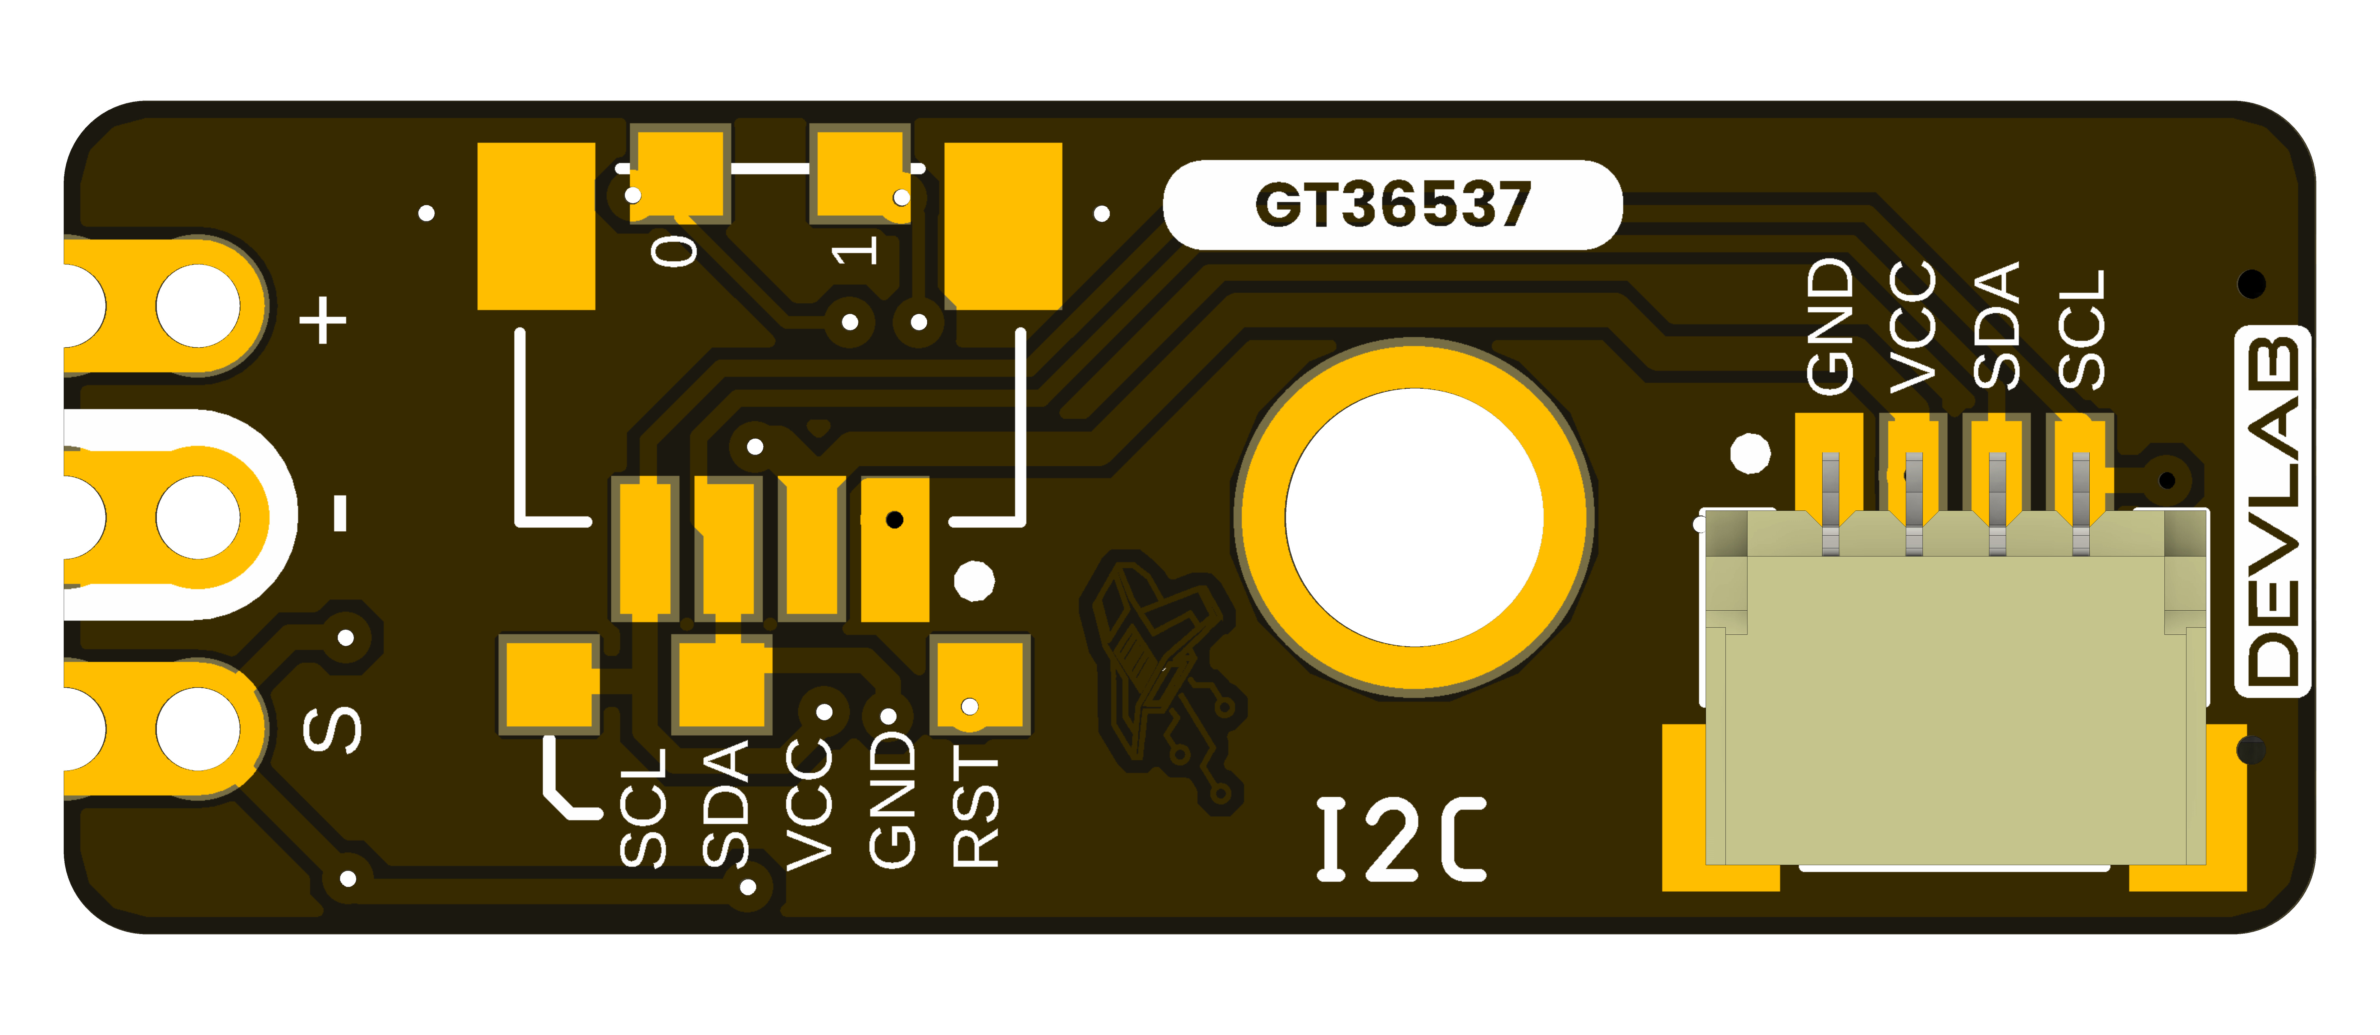
UE0164 bottom view.

1.7 Handling
Use normal ESD precautions. Keep the light-sensitive surface clean and unobstructed. Remove power before changing connectors or solder links.

2 Ratings
This chapter summarizes the electrical operating conditions and interface characteristics relevant to integrating the DevLab I2C GT36537 LDR Ambient Light Sensor. It covers the module supply, I2C operation, analog sensor path, and controller capabilities. Use these ratings to select a compatible power source and host interface and to identify the electrical characteristics that require application-specific verification.

2.1 Recommended Operating Conditions
Symbol | Description | Min. | Typ. | Max. | Unit
VCC | Module supply voltage | — | 3.3 or 5 | — | V
VI2C | I2C logic-high and pull-up voltage | — | VCC | — | V
fSCL | I2C clock frequency | 100 | — | 400 | kHz
VSIG | Direct analog SIGNAL voltage range | — | Not specified | — | V
ICC | Module supply current | — | Not specified | — | mA
TA | Module ambient operating temperature | Not specified | — | Not specified | °C
The VCC values are the supported nominal operating points; they are not complete-module absolute maximum ratings. The validated continuous supply range around each nominal point is not specified.
Use a current-limited source during initial bring-up. The I2C pull-ups follow the module supply, so the host must tolerate the actual bus voltage. When the module operates at 5 V with a 3.3 V host, bidirectional level translation may be required.
The direct SIGNAL range requires analog-stage verification and measurement. Module current consumption must include the controller, indicators, pull-ups, and sensor load. The complete-module ambient-temperature range has not been qualified. I2C pull-up resistance, bus capacitance, and complete-module absolute maximum ratings are also not specified.

2.2 Digital Interface and Firmware Characteristics
Parameter | Value | Description
I2C addressing | 7-bit slave | Valid configurable addresses are 0x08..0x77
Factory I2C address | 0x26 (7-bit) | Pass 0x26 directly to the host I2C library; 0x4C is the 8-bit write address, not the device address
Device protocol | DDP v1.0 | Command transaction followed by an exact-length read transaction
Logical Device ID | 0x0106 | GT36537 identity; independent of the I2C address
Firmware / hardware | 1.0 / 1.0 | Current observable controller profile
Capability bitmap | 0x00000199 | I2C configuration, analog input, sensor data, watchdog, and persistent configuration
Raw digital sample | 0 to 4095 | 12-bit ADC code returned as an unsigned 16-bit little-endian value
ADC update interval | Approximately 20 ms | Background acquisition; an I2C read returns the latest published sample
Command processing delay | 2 to 5 ms | Use 5 ms conservatively before reading
Pending setter timeout | 250 ms | Parameter must arrive before expiry
These values describe the currently documented digital behavior. Detailed DDP commands and transaction sequences are provided in Chapter 3.

2.3 Onboard Interface Controller
The onboard controller acquires the analog output of the GT36537 LDR divider and provides the processed sensor data through the module’s I2C interface. The controller is not exposed as a general-purpose microcontroller and is not intended for user programming.
Feature | Module implementation
Internal controller | 32-bit Arm Cortex-M0+
Sensor acquisition | 12-bit ADC
User digital interface | I2C
I2C addressing | 7-bit addressing
Supported I2C clock | 100 kHz and 400 kHz
Direct sensor access | Analog SIGNAL contact
Programming and debugging | Reserved for factory use

2.4 Module-Level Characteristics
The following characteristics are established for the current module implementation and are described in the preceding sections.
Characteristic | Current module specification
Nominal supply voltage | 3.3 V or 5 V
Digital interface | I2C, 7-bit slave
Factory I2C address | 0x26
Configurable I2C address range | 0x08 to 0x77
I2C clock frequency | 100 kHz to 400 kHz
Sensor acquisition | 12-bit ADC
Raw digital output | 0 to 4095
ADC update interval | Approximately 20 ms
Command processing delay | 2 to 5 ms
Direct analog access | SIGNAL contact on the RAW Signal Header
Additional characteristics such as complete-module absolute maximum ratings, supply-current limits, guaranteed analog-output accuracy, calibrated lux accuracy, board-level operating-temperature range, and environmental qualification are not specified unless explicitly stated elsewhere in this Product Reference.
Component-level ratings shall not be interpreted as guaranteed ratings of the complete module.

2.5 Electrical Precautions
- Use a current-limited 3.3 V or 5 V supply during engineering bring-up.
- Verify connector orientation and establish a common ground before applying power.
- Do not exceed the controller upper operating-voltage limit of 5.5 V.
- When operating the module at 5 V, verify host compatibility with the actual voltage present on SDA, SCL, and SIGNAL. Use appropriate level translation when required.
- During normal operation, use the I2C connection points only for I2C communication. The same physical signals are shared with the controller’s factory programming and debugging functions; SWD is not provided as a separate user interface.
- Do not attempt firmware replacement or external debugging through the I2C connection points. Programming, debugging, and reset functions are reserved for manufacturer use and factory diagnostics.
- Remove power before cutting, soldering, or reworking the I2C disable bridge or optional connector positions.
- Verify the product-specific schematic when released, component specifications, and interface documentation before production integration.

3 Functional Overview
The DevLab I2C GT36537 LDR Ambient Light Sensor combines a GT36537 photoresistor (LDR), wired as a voltage divider, with an onboard controller. The module provides two ways to observe light level: digital readings over I2C and direct access to the analog sensor signal at SIGNAL.
The GT36537 LDR itself is an analog device. The onboard controller samples its output, applies the selected averaging, and provides the latest raw reading through DevLab Device Protocol (DDP) v1.0.

3.1 Functional Block Diagram
Ambient light changes the GT36537 LDR resistance. Its divider signal follows two paths: direct access at SIG, and acquisition by the controller ADC for digital access over I2C. The product-specific topology and pinout drawings are linked in Chapters 4, 6, and 8.

3.2 Operating Modes
Mode | Connection | User-visible result
Digital I2C | VCC, GND, SDA, and SCL | Averaged 12-bit raw light reading through DDP
Direct analog | VCC, GND, and SIGNAL | Light-dependent voltage for a host ADC or measurement instrument
Both modes observe the same sensor path. An I2C read returns the latest available sample; it does not trigger a new light measurement. The direct analog output may be used independently for development, comparison, or application-specific calibration.

3.3 Digital Light Measurement
The onboard ADC produces an unsigned 12-bit value. Whether the value rises or falls with more light depends on which end of the voltage divider carries the LDR, under the actual supply, optical, and mechanical conditions.
Measurement property | Value
ADC resolution | 12 bits
Raw output range | 0..4095
Response format | Two bytes, [LSB, MSB]
Update interval | Approximately 20 ms
Selectable averaging | 1, 4, 8, 16, or 24 samples
The averaging setting controls the balance between response speed and stability:
Samples | Approximate time for a completely new average | Typical use
1 | 20 ms | Fast changes
4 | 80 ms | Low-latency smoothing
8 | 160 ms | General monitoring
16 | 320 ms | Stable ambient-light monitoring
24 | 480 ms | Maximum available smoothing
The result is a relative ADC reading, not a calibrated lux measurement. Quantitative lux measurements require calibration in the final enclosure and optical arrangement.

3.4 I2C Communication Model
The I2C host always initiates communication. The 7-bit I2C address selects the module, while the one-byte DDP selector identifies the requested function. These are independent values.
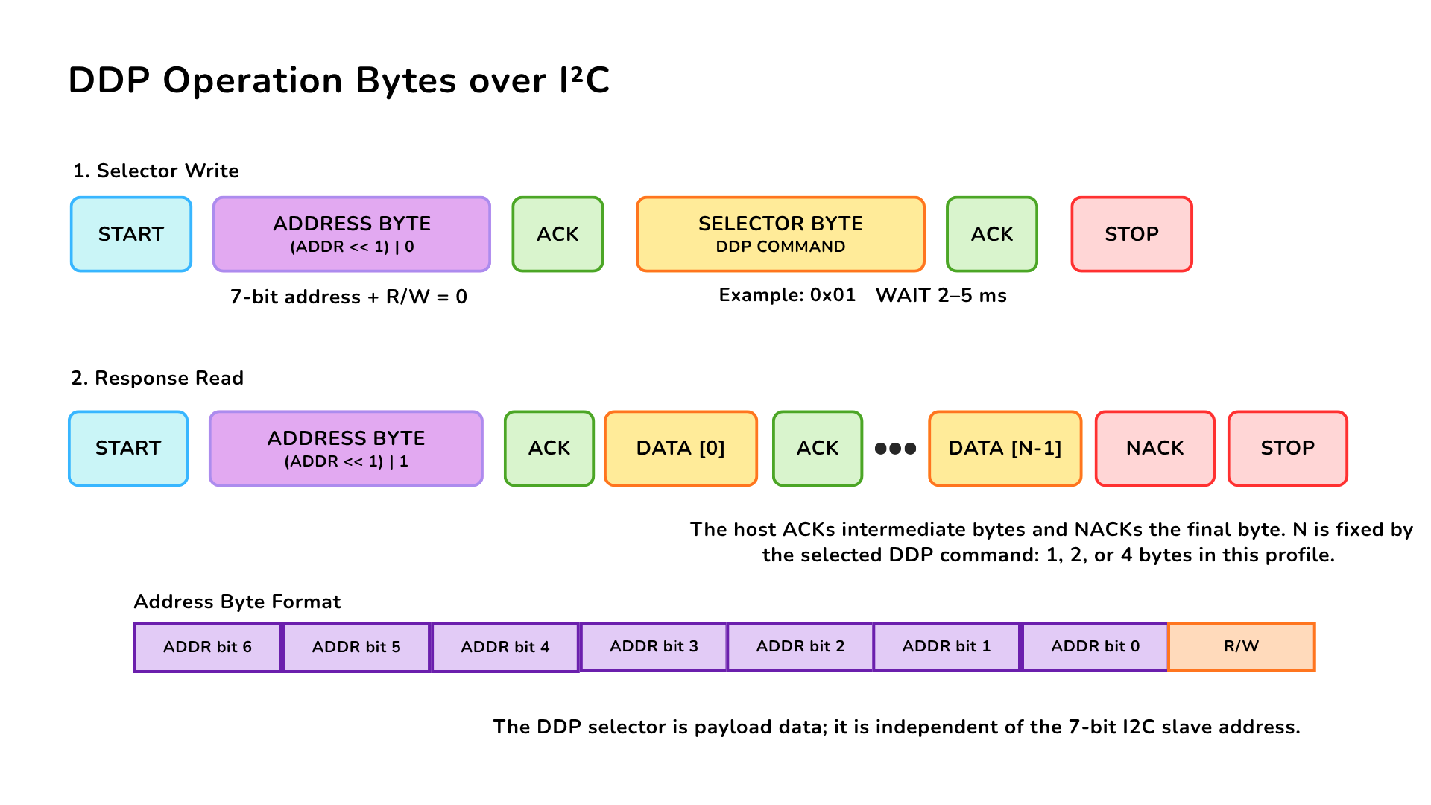
Figure 3.2 — DDP command and response over I2C. The host writes one DDP selector, issues STOP, waits 2–5 ms, and then reads the documented number of response bytes. The host acknowledges intermediate bytes and sends NACK after the final byte.
Communication property | Value
Factory 7-bit address | 0x26
Configurable address range | 0x08..0x77
I2C clock | 100 kHz to 400 kHz
Delay before response read | 2–5 ms; use 5 ms conservatively
Byte order for multi-byte values | Little endian
Supported response lengths | 1, 2, or 4 bytes, depending on the selected function
Pass 0x26 directly to an I2C library. Values 0x4C and 0x4D are the shifted write/read address bytes visible on the bus, not the 7-bit address used by typical host APIs.

3.5 User-Accessible DDP Functions
User function | DDP selector | Result
Identify the module | 0x00 | Device ID 0x0106
Read protocol version | 0x04 | DDP version 1.0
Read active I2C address | 0x20 | Current 7-bit address
Change I2C address | 0x21 | Stores and applies a new address in the valid range
Restore factory configuration | 0x23 | Restores default configuration; reset required
Read ambient-light data | 0x60 | Latest two-byte 12-bit raw sample
Read GT36537 sensor data | 0x80 | Same raw sample through the sensor-data namespace
Set ADC averaging | 0x62 | Selects 1, 4, 8, 16, or 24 samples
Read ADC averaging | 0x63 | Returns the active averaging setting
Turn BUILTIN off/on | 0xA0 / 0xA1 | Drives the built-in indicator LOW/HIGH
Pulse BUILTIN | 0xA2 | Starts a non-blocking timed pulse
Set/read pulse time | 0xA3 / 0xA4 | Uses 1–40 units of 25 ms
The I2C address, averaging selection, and pulse duration are retained after a power cycle. Changing a stored value should be an occasional configuration operation rather than part of the normal measurement loop.
Detailed transaction handling is implemented by the DevLab_GT365xx Arduino library listed in Chapter 8, which uses DevLab Interface for I2C bus management.

Arduino Library Functions
All functions belong to the DevLab_GT365xx class. Functions that return bool return true on success. Readings are taken with the DDP read-ADC command (0x60) and are only available after a successful begin call.
Function | Description
DevLab_GT365xx(wire, address, clock) | Constructor. Defaults: Wire, address 0x26, 400000 Hz
begin() | Starts the I2C bus on the host’s default pins and verifies the GT36537 Device ID
begin(sdaPin, sclPin, clock) | Same as begin(), selecting the SDA/SCL pins and I2C clock
beginRecovered(sdaPin, sclPin, timeoutUs, restart) | Starts the bus with bus recovery before verifying the Device ID. Defaults: timeoutUs 20000, restart false
readRaw(rawValue) | Latest 12-bit ADC reading, 0 to 4095
readPercentage(percentage) | Raw reading as a percentage, raw × 100 / 4095
readInvertRaw(invertedValue) | Inverted 12-bit reading, 4095 − raw
readInvertPercentage(percentage) | Inverted reading as a percentage
busReady() | true if the I2C bus was started successfully
isConnected() | true if the GT36537 Device ID was verified at the configured address
deviceInfo() | Identity information read during begin
printInfo(out) | Prints the device information to a Print stream (default Serial)
protocol() | Access to the underlying DDP master for direct commands
bus() | Access to the underlying DevLab Interface bus object
The inverted functions are useful when the reading falls as light increases, which depends on which end of the voltage divider carries the LDR.

3.6 Built-In Indicator
The firmware accepts DDP RELAY_* compatibility commands for the built-in indicator. This board has no electromechanical relay, and the GT36537 firmware does not advertise the RELAY capability bit. Use the commands only if the installed firmware supports them.
The pulse duration is configurable from 25 ms to 1000 ms in 25 ms steps. A timed pulse runs without interrupting light measurements or I2C communication.

3.7 Physical Interface Notes
The SIGNAL contact provides direct access to the analog sensor path. Its complete board-level transfer function, source impedance, and guaranteed output range are not specified for the current revision. Use a high-impedance input and verify the actual range before connecting it to a lower-voltage ADC.
The PCB provides three I2C connection positions carrying GND, VCC, SDA, and SCL: one connector is populated by default and two horizontal positions are provided for optional 4-pin, 1.00 mm-pitch JST/Qwiic-compatible connectors. All three positions access the same I2C bus.
The I2C connection points share signals with the controller’s factory programming and debugging interface; there is no separate user-accessible SWD connector. Programming, debug, and reset functions are reserved for manufacturer programming and factory diagnostics, not user firmware replacement.
Two expansion pads are reserved and have no current user function. The I2C disable bridge is intended for applications that require the analog path without active I2C operation; remove power before cutting or restoring it.

4 Connectors & Pinouts
The released V1.0 pinout for the UE0164 LDR Photoresistor Light Sensor shows the top and bottom board views. Check the view and connector orientation before wiring.

4.1 Released Pinout
UE0164 LDR Photoresistor Light Sensor pinout, top and bottom views.
Figure 4.1 — UE0164 pinout, English version. The Spanish version is linked in Section 8.

4.2 Connection Groups
Group | Labels in the released drawing | Purpose
Qwiic I2C connector | GND, VCC, SDA, SCL | Power and I2C bus connections
Direct contacts | VCC, GND, SIG | Power and direct signal access
Service pads | TX, RX, RST | Pads identified in the drawing; consult the hardware design before use
The drawing marks optional 4-pin, 1 mm JST connector positions and two solder links. Its notes say that opening the I2C link disables the I2C SIG signal and opening the SNS link disables the LDR filter. The pinout does not establish electrical limits or connector part numbers.

5 Board Operation
This chapter shows how to verify one DevLab I2C GT36537 LDR Ambient Light Sensor and read its raw ambient-light value with Arduino. The examples use the DevLab_GT365xx library and support ESP32, RP2040/RP2350, and AVR hosts.

5.1 Required Hardware and Software
- DevLab I2C GT36537 module
- ESP32, RP2040/RP2350, or AVR development board acting as I2C host
- I2C connection for VCC, GND, SDA, and SCL
- USB cable for programming and Serial Monitor access
- Arduino IDE with the selected board package installed
- DevLab_GT365xx Arduino library

5.2 Library Installation
- Open Tools > Manage Libraries in Arduino IDE.
- Search for DevLab_GT365xx.
- Select the current release and click Install.
The library implements DDP v1.0 and uses DevLab Interface for I2C bus management. Its dependencies, DevLabDDP and DevLab_Interface, are installed together with it, so the sketch only includes DevLab_GT365xx.h and does not need separate bus-handling or bus-recovery code.

5.3 I2C Connection and Example Settings
Connect the module with power removed. Align the connector with the orientation printed on the board and verify VCC, GND, SDA, and SCL before applying power. The released connection drawing is in Chapter 4.
Module | ESP32 | RP2040 / RP2350 | AVR | Function
VCC | 3.3 V or 5 V | 3.3 V or 5 V | 3.3 V or 5 V | Module supply
GND | GND | GND | GND | Common reference
SDA | GPIO6 | GPIO12 | Fixed board SDA pin | I2C data
SCL | GPIO7 | GPIO13 | Fixed board SCL pin | I2C clock
On RP2040 and RP2350 the examples use the Wire1 bus. AVR boards have fixed I2C pins (Uno/Nano: A4/A5, Mega: 20/21, Leonardo: 2/3) taken from the board variant. The pin numbers above match the repository examples; change SDA_PIN and SCL_PIN when the selected host board uses different I2C pins.
Important: The I2C pull-up voltage follows the module supply (VCC). When operating the module at 5 V, verify that the host I2C pins are 5 V tolerant. If the host operates at 3.3 V and is not 5 V tolerant, use appropriate bidirectional level translation between the module and the host.
The example uses the following settings:
Constant | Default | Purpose
SDA_PIN | GPIO6 (ESP32); GPIO12 (RP2040/RP2350) | Host SDA pin
SCL_PIN | GPIO7 (ESP32); GPIO13 (RP2040/RP2350) | Host SCL pin
I2C_FREQ | 400000 Hz | I2C clock
SENSOR_ADDRESS | 0x26 | Factory 7-bit module address
READ_INTERVAL_MS | 250 ms | Time between printed readings
If the module address was changed previously, update SENSOR_ADDRESS before uploading the sketch.

5.4 Single-Sensor Arduino Example
Open the repository example at software/examples/i2c/cpp_examples/serialLightRead/serialLightRead.ino. Its current source is reproduced below:
/**
* @file serialLightRead.ino
* @brief Verifies a GT36537 DDP device (ID 0x0106) on the I2C bus and prints
* its raw ADC0 reading and relative percentage over Serial.
*
* The GT36537 is an LDR read through PA2 (ADC_IN2, 12 bits). The value is a
* relative light measurement (0-4095), not lux: the direction of the reading
* depends on which end of the divider the LDR is connected to.
*/
#include <Arduino.h>
#include <Wire.h>
#include <DevLab_GT365xx.h>
#if defined(ARDUINO_ARCH_RP2040) || defined(ARDUINO_ARCH_RP2350)
#define I2C_BUS Wire1
constexpr int SDA_PIN = 12;
constexpr int SCL_PIN = 13;
#elif defined(ARDUINO_ARCH_ESP32)
#define I2C_BUS Wire
constexpr int SDA_PIN = 6;
constexpr int SCL_PIN = 7;
#elif defined(ARDUINO_ARCH_AVR)
// AVR has fixed I2C pins (Uno/Nano: A4/A5, Mega: 20/21, Leonardo: 2/3);
// SDA/SCL come from the board variant and begin() ignores the pin numbers.
#define I2C_BUS Wire
constexpr int SDA_PIN = SDA;
constexpr int SCL_PIN = SCL;
#else
#error "Use an ESP32, RP2040, RP2350, or AVR master"
#endif
constexpr uint32_t I2C_FREQ = 400000UL;
constexpr uint8_t SENSOR_ADDRESS = 0x26U;
constexpr uint32_t READ_INTERVAL_MS = 250U;
DevLab_GT365xx sensor(I2C_BUS, SENSOR_ADDRESS, I2C_FREQ);
void setup() {
Serial.begin(9600);
sensor.beginRecovered(SDA_PIN, SCL_PIN);
if (!sensor.busReady()) {
Serial.println("ERROR: I2C bus is blocked");
return;
}
if (!sensor.isConnected()) {
Serial.println("ERROR: expected GT36537 DDP device ID 0x0106 at 0x26");
return;
}
sensor.printInfo();
Serial.println("GT36537 ready: PA2 ADC0 reads the LDR divider");
}
void loop() {
static uint32_t lastRead = 0U;
if (millis() - lastRead < READ_INTERVAL_MS) {
return;
}
lastRead = millis();
uint16_t raw = 0U;
if (sensor.readRaw(raw)) {
float percent = (raw * 100.0f) / 4095.0f;
#if defined(ARDUINO_ARCH_AVR)
// AVR Serial has no printf(), and avr-libc printf lacks %f.
Serial.print("adc0=");
Serial.print(raw);
Serial.print(" percent=");
Serial.println(percent, 1);
#else
Serial.printf("adc0=%u percent=%.1f\n", raw, percent);
#endif
} else {
Serial.println("ERROR: light read failed");
}
}
The AVR branch prints with Serial.print() because Serial.printf() is not available there.
The following companion examples are provided:
Example | Purpose
serialLightReadInverted | Reports 4095 - raw with readInvertRaw() and readInvertPercentage() so that the value rises with more light
serialLightRawPlot | Streams one raw integer per line at 115200 baud for the Arduino Serial Plotter
i2c_scanner | Scans the I2C bus at 115200 baud and prints the 7-bit address of every device that responds; a detected address only confirms that a device acknowledged, not that it is a GT36537

5.5 Upload and Serial Output
- Select the connected host board in Arduino IDE.
- Select its serial port.
- Compile and upload serialLightRead.ino.
- Open Serial Monitor at 9600 baud (115200 baud for serialLightRawPlot).
- Illuminate and cover the LDR to confirm that the printed value changes.
At startup, the sketch recovers and initializes the I2C bus, verifies that address 0x26 contains a DDP GT36537 with Device ID 0x0106, and prints the reported device information. It then prints adc0 and percent every 250 ms.
<DDP device information>
GT36537 ready: PA2 ADC0 reads the LDR divider
adc0=<value from 0 to 4095> percent=<0.0 to 100.0>
adc0=<value from 0 to 4095> percent=<0.0 to 100.0>
The readings are raw ADC values. They indicate relative light level and must not be interpreted directly as lux. Whether the value rises or falls with more light depends on which end of the voltage divider carries the LDR; use serialLightReadInverted if a value that rises with light is preferred.

5.6 Troubleshooting
Serial output or symptom | Check
ERROR: I2C bus is blocked | Wiring, connector orientation, shared ground, pull-up voltage, and unintended SDA/SCL drive
ERROR: expected GT36537 DDP device ID 0x0106 at 0x26 | Address setting, I2C pins, module power, and possible address collision
ERROR: light read failed after successful identification | Cable continuity, bus clock, supply stability, and I2C connections
Constant 0 or 4095 | Sensor obstruction, excessive illumination, supply, and module orientation
Value falls when light increases | Expected for some divider orientations; use serialLightReadInverted
Values change but lux is inaccurate | Calibrate the complete optical installation against a reference light meter
The complete Arduino examples and the DevLab_GT365xx library are listed in Chapter 8.

6 Mechanical Information
The supplied board views identify the component and underside layouts of the UE0164 I2C LDR Photoresistor Light Sensor. Use the labeled drawings for fit checks; do not infer dimensions by scaling a render.

6.1 Top View
UE0164 I2C LDR Photoresistor Light Sensor top view.

6.2 Bottom View
UE0164 I2C LDR Photoresistor Light Sensor bottom view.

6.3 Board Dimensions
UE0164 I2C LDR Photoresistor Light Sensor dimension drawing.
Use the dimensions printed on the supplied drawing. PCB thickness, component heights, connector clearance, and manufacturing tolerances require separate verification.

7 Company Information
Item | Information
Company / brand | UNIT Electronics
Board ecosystem | DevLab
Product family | Atom
Website | UNIT Electronics
Address | Salvador 19, Cuauhtémoc, 06000 Mexico City, CDMX, Mexico
The product repository and controlled technical references are listed in the next chapter.

8 Reference Documentation
Reference | Location
Product repository | UE0164 LDR Photoresistor Light Sensor
Pinout V1.0, English | PDF · PNG
Pinout V1.0, Spanish | PDF · PNG
Top view | 3D board view
Bottom view | 3D board view
Board dimensions | Dimension drawing
Board topology | Topology drawing
CAD model | STEP
The released pinout documents the visible labels and connector orientation. It does not by itself establish supply limits, bus timing, or mating part numbers.

9 Appendix

9.1 Schematic Status
A product-specific UE0164 electrical schematic was not included in the selected source package. Do not substitute a schematic for a different light-sensor board. The released pinout in Chapter 4 documents user-visible connections, while the board views and dimension drawing in Chapter 6 document the physical layout.

9.2 Document Control
Field | Value
Product | DevLab I2C LDR Photoresistor Light Sensor
Manufacturer Part Number (MPN) | UE0164
Pinout | V1.0, English and Spanish
Board views | Product-specific top and bottom V1.0
Topology and dimensions | V1.0.0 drawings available
CAD models | F3D, IGES, and STEP available under hardware/mechanics/
Schematic | Pending product-specific release
Product Reference | Version 1.1.0
Publication date | 2026-11-02

9.3 Technical Data Not Specified in This Revision
- Complete-module absolute-maximum ratings and current consumption
- I2C pull-up values and validated bus-loading limits
- Direct SIG output range, loading characteristics, and ADC guidance
- Mechanical tolerances, board thickness, component heights, and finished mass
- Module-level optical, electrical, environmental, and EMC characterization

