DevLab I2C MPU-6050 6-Axis IMU Module
Product Reference — Hardware V1.0 — Mfr. Part #: UE0129
UNIT Electronics
2026-10-27

Contents
- Description
  - Applications
  - Hardware Features
- 1 The Module
  - 1.1 Board Identification
  - 1.2 Package Contents
- 2 Electrical Characteristics
  - 2.1 Confirmed Circuit Values
  - 2.2 Electrical Precautions
- 3 Functional Overview
  - 3.1 Block Diagram
  - 3.2 Sensor and Main I2C Path
  - 3.3 Auxiliary and Control Signals
  - 3.4 Power Section
  - 3.5 Communication Interfaces
  - 3.6 Library Features
  - 3.7 Board Topology
  - 3.8 Electrical Schematic
- 4 Connectors and Pinout
  - 4.1 Main Interface Edge (J2)
  - 4.2 Auxiliary and Control Edge (J5)
  - 4.3 Four-Position Connectors
  - 4.4 Solder Options
- 5 Board Operation
  - Hardware Interface
  - Example Operation
  - Basic Operation
  - Example Code
- 6 Mechanical Information
- 7 Company Information
- 8 Reference Documentation
- 9 Appendix
  - 9.1 Source Hierarchy
  - 9.2 Items Pending Validation
  - 9.3 Document Control

Description
The UNIT DevLab I2C MPU-6050 6-Axis IMU Module combines a three-axis accelerometer and a three-axis gyroscope. The board routes the MPU-6050 main and auxiliary I2C buses, interrupt and synchronization signals, and includes 3.3 V regulation and I2C level shifting.
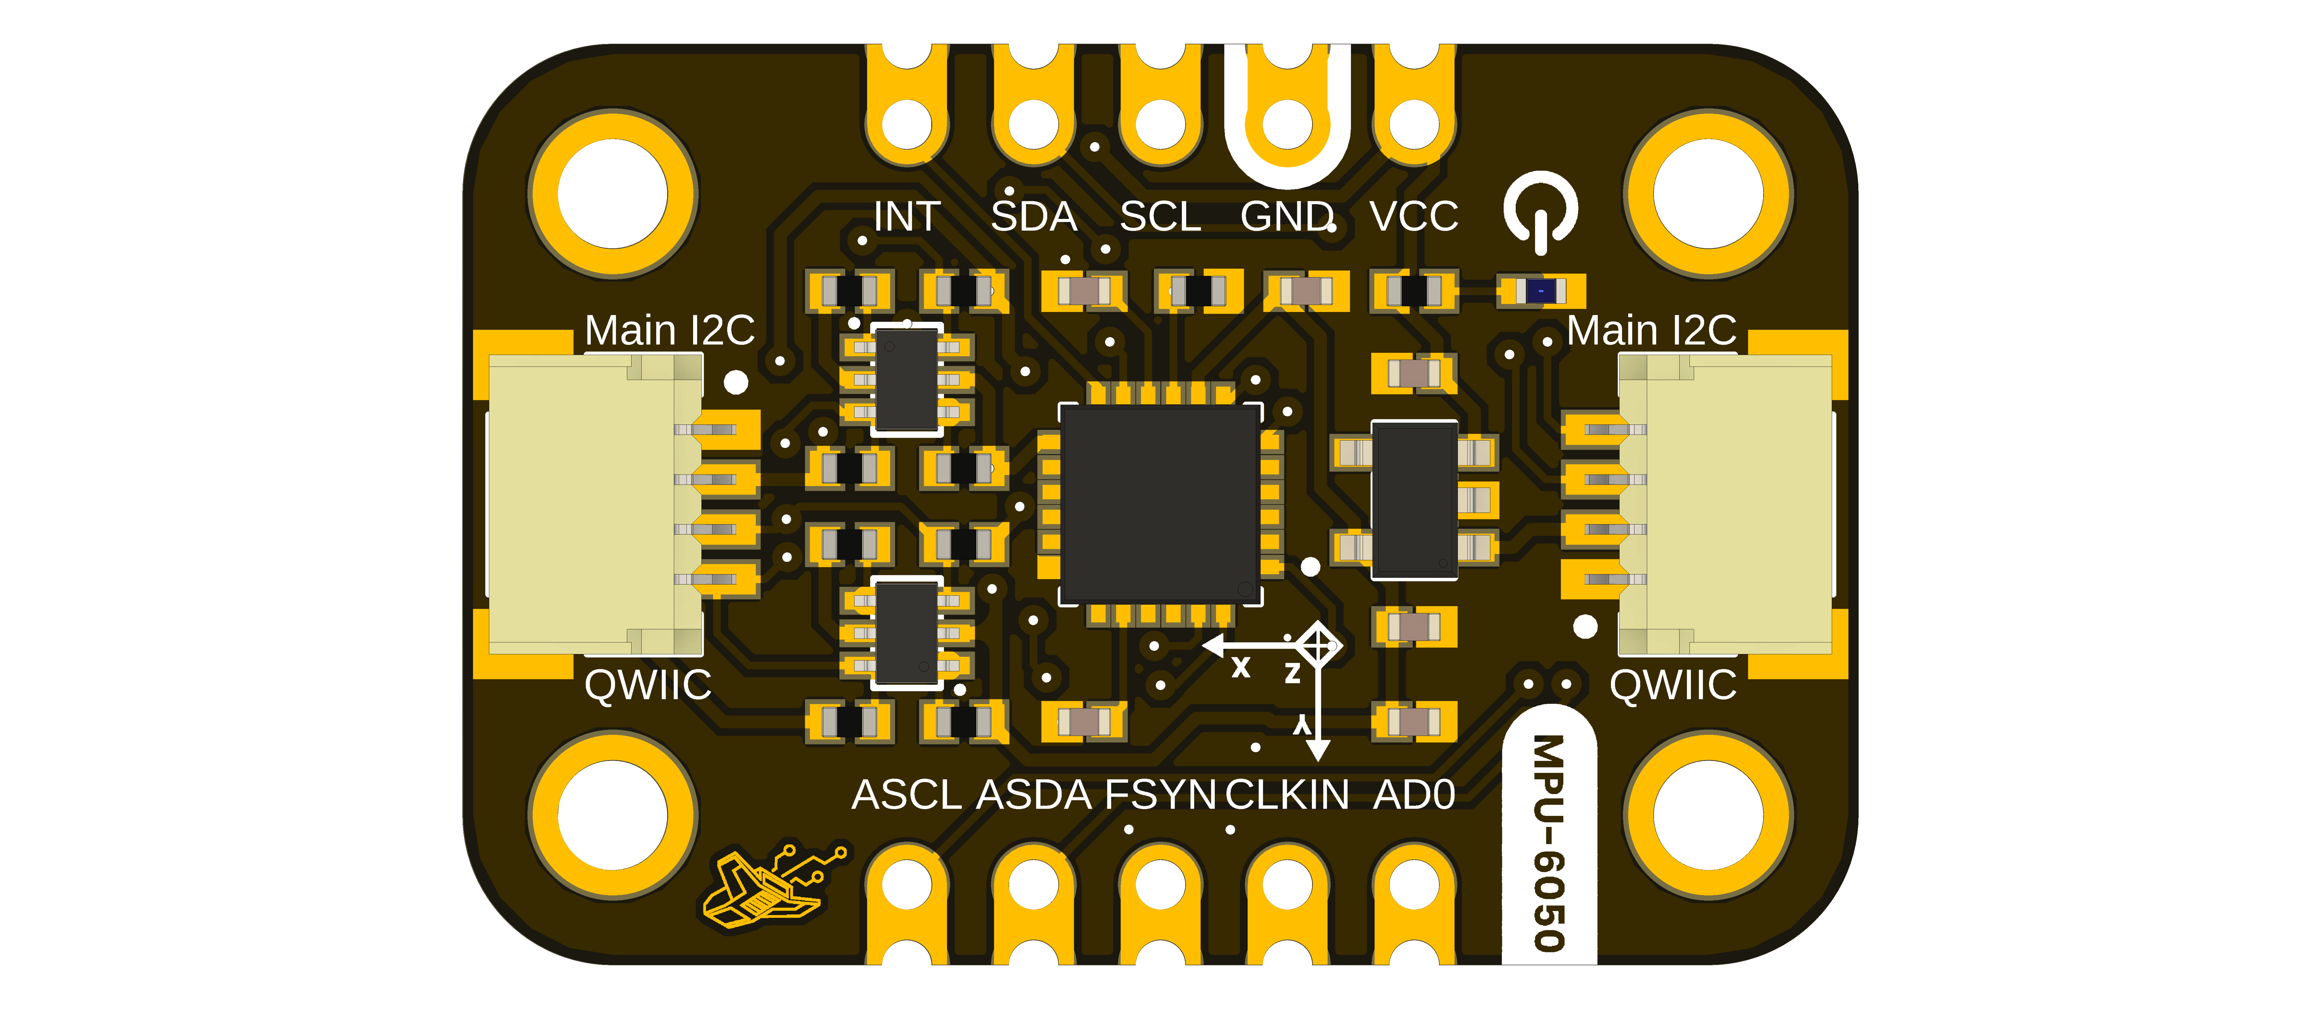
Top view of the UE0129 module.

Applications
- Evaluation of acceleration and angular-rate sensing
- Motion-sensing prototypes
- I2C sensor integration and educational experiments
- Experiments using interrupt, synchronization, and auxiliary-sensor signals

Hardware Features
- MPU-6050 three-axis accelerometer and three-axis gyroscope
- Six 16-bit ADCs, one for each accelerometer and gyroscope axis
- Selectable accelerometer ranges of ±2 g, ±4 g, ±8 g, and ±16 g
- Selectable gyroscope ranges of ±250, ±500, ±1000, and ±2000 dps
- 1024-byte sensor FIFO and digital-output temperature sensor
- Main I2C bus on two board connectors and an edge connection
- Auxiliary I2C bus on two board connectors and an edge connection
- INT, AD0, FSYNC, and CLKIN signals
- AP2112K-3.3 fixed 3.3 V regulator
- Two BSS138AKDW dual N-channel MOSFET arrays for I2C level shifting
- Red power indicator
- Four mounting holes and ten edge connections shown by the board artwork

1 The Module

1.1 Board Identification
Item | Value
Product | DevLab: I2C MPU-6050 6-Axis IMU Module
Manufacturer part number | UE0129
Hardware revision | V1.0
Inertial sensor | MPU-6050
Host interface | I2C
Product-reference revision | 0.2.0

1.2 Package Contents
The BOM includes one four-pin, 1 mm-pitch harness. Package contents and cable compatibility have not been formally validated; confirm them with the distributor before purchase or integration.

2 Electrical Characteristics

2.1 Confirmed Circuit Values
Symbol / parameter | Description | Value | Scope
VDD | Operating supply | 2.375 to 3.46 V | MPU-6050 sensor pins
VLOGIC | Logic reference | 1.71 V to VDD | MPU-6050 sensor pin
Accelerometer range | Selectable full scale | ±2, ±4, ±8, or ±16 g | MPU-6050 sensor
Gyroscope range | Selectable full scale | ±250, ±500, ±1000, or ±2000 dps | MPU-6050 sensor
ADC word length | Per accelerometer / gyroscope axis | 16 bit | MPU-6050 sensor
I2C operating frequency | Fast-mode maximum | 400 kHz | MPU-6050 sensor interface
Six-axis current | Gyroscope + accelerometer, DMP disabled | 3.8 mA typical | MPU-6050 sensor only
Six-axis + DMP current | Gyroscope + accelerometer + DMP | 3.9 mA typical | MPU-6050 sensor only
3V3 | Regulated output from U2 | 3.3 V nominal | AP2112K-3.3 regulator output
C1, C2 | Regulator input/output capacitors | 1 µF each | Individual BOM components
R5 | Power-indicator series resistor | 4.7 kΩ | Individual BOM component
R1–R4, R6–R10 | Pull-up / bias resistors | 10 kΩ each | Individual BOM components
The allowed voltage at the module VCC connections, module current consumption, host-side digital thresholds, and complete-module I2C clock limit are pending validation. The sensor, regulator, connector, MOSFET, resistor, and capacitor component ratings are not ratings for the complete module.

2.2 Electrical Precautions
- Establish a common GND before applying power or interface signals.
- Verify the module-level VCC range before applying power.
- Keep host signals within validated logic levels; those limits are not yet documented for the complete module.
- Treat INT as an output from the sensor and CLKIN, FSYNC, and AD0 as sensor inputs according to the released schematic.

3 Functional Overview

3.1 Block Diagram
The block diagram shows the main functional blocks of the MPU-6050 DevLab module and the signals available.
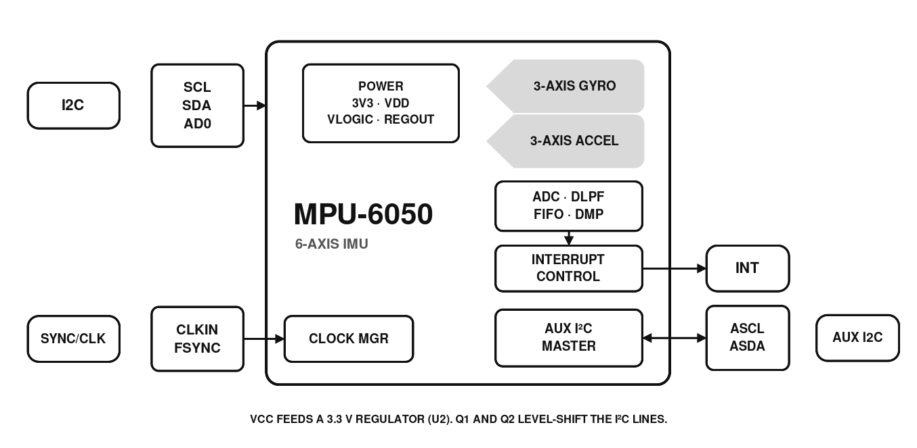
MPU-6050 block diagram.

3.2 Sensor and Main I2C Path
The MPU-6050 provides three-axis acceleration and three-axis angular-rate sensing with 16-bit conversion per axis and selectable full-scale ranges. Its 1024-byte FIFO can buffer sensor data. Q1 translates the main SCL and SDA lines between the module VCC domain and the sensor’s regulated 3.3 V domain. J1, J3, and J2 provide access to the main bus.

3.3 Auxiliary and Control Signals
Q2 translates the MPU-6050 auxiliary AUX_SCL and AUX_SDA lines to the board ASCL and ASDA connections. The board also routes INT, AD0, FSYNC, and CLKIN. The schematic shows R6 connected from AD0 to ground, and the module’s default I2C address is 0x68. The physical defaults of the FSYNC and CLKIN solder options shown in the artwork remain pending validation.

3.4 Power Section
The schematic identifies U2 as an AP2112K-3.3 regulator supplied from VCC. Its 3.3 V output powers both MPU-6050 supply pins and the sensor-side I2C pull-ups. The complete module input range is pending validation and must not be derived from the regulator’s component rating.
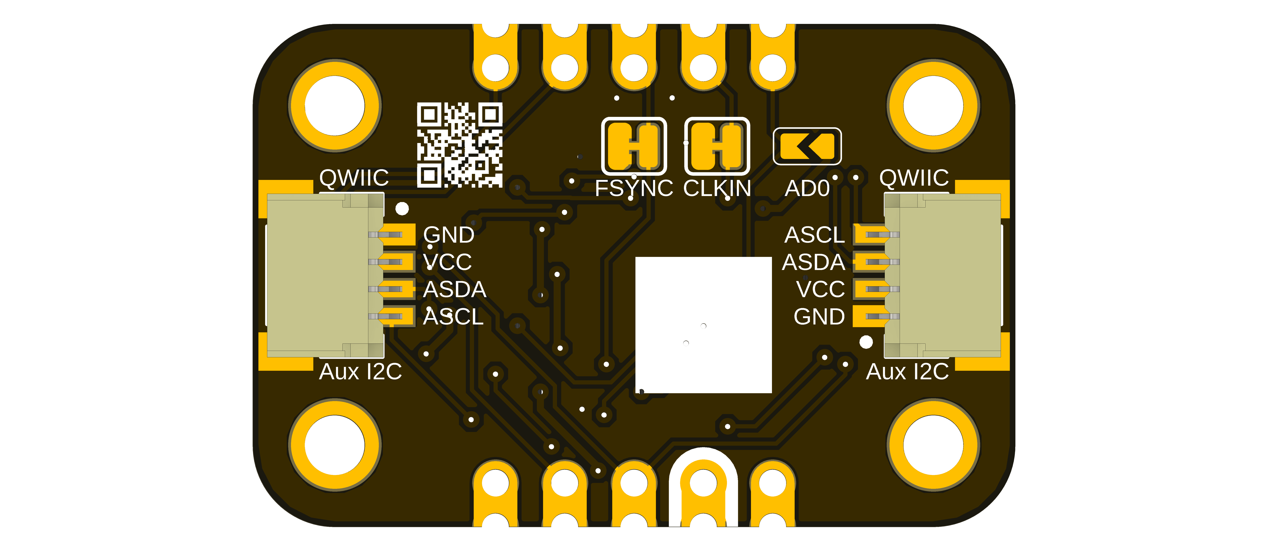
Bottom view of the UE0129 module, artwork V1.1.

3.5 Communication Interfaces
The MPU-6050 supports a single digital communication interface, I²C, providing connectivity with microcontrollers and embedded systems.
I²C Interface
- Standard Mode and Fast Mode
- Clock frequency up to 400 kHz
- Two selectable 7-bit I²C addresses: 0x68 and 0x69
- I²C address selection through the AD0 pin
The device supports two selectable 7-bit I²C addresses through the AD0 pin: when AD0 is low, the address is 0x68; when AD0 is high, the address is 0x69. On the DevLab module, AD0 is routed to the J5 connector and has a 10 kΩ resistor (R6) to ground. The module’s default I²C address is 0x68.

3.6 Library Features
The DevLab_MPU6050 library for Arduino-compatible boards communicates with the sensor through direct I²C register access. It is tested on ESP32 and compatible with other Arduino-compatible boards. The following table summarizes the sensor functions available through the library.
Function | Library call | Description
Initialization | begin(sda, scl, clock) | Starts I²C on custom pins (400 kHz by default), verifies WHO_AM_I, wakes the sensor, and applies the default configuration.
Data acquisition | readData(data) | Reads raw 16-bit accelerometer and gyroscope values for X, Y, and Z in a single 14-byte burst, plus the temperature in °C.
Accelerometer range | setAccelScale(scale) | Selects ±2 g, ±4 g, ±8 g, or ±16 g (values 0 to 3).
Gyroscope range | setGyroScale(scale) | Selects ±250, ±500, ±1000, or ±2000 °/s (values 0 to 3).
Digital low-pass filter | setDLPF(setting) | Selects the DLPF configuration in the CONFIG register (values 0 to 6).
Sample rate | sampleRateDiv(div) | Sets the sample rate divider (SMPLRT_DIV).
Clock source | setClkSource(source) | Selects the clock source in PWR_MGMT_1 (values 0 to 7).
Device identification | WhoAmI() | Returns the WHO_AM_I register value.
Interrupt pin | setIntPinCfg(cfg) | Configures INT polarity, output type, latch, clear-on-read, FSYNC, and I²C bypass.
Interrupt sources | enableInterrupt(), disableInterrupt() | Enables or disables data ready, I²C master, FIFO overflow, and motion interrupts.
Interrupt status | interruptStatus() | Reads INT_STATUS to identify which source fired.
The I²C address is passed to the library constructor and is not detected automatically. Use MPU6050_ADDRESS_AD0_LOW (0x68) or MPU6050_ADDRESS_AD0_HIGH (0x69) according to the AD0 level. The WHO_AM_I check in begin() expects 0x68 regardless of the selected address.
Default configuration applied by begin()
Parameter | Default value
Clock source | PLL with X-axis gyroscope reference
Sample rate divider | 7
Digital low-pass filter | Configuration 6
Gyroscope range | ±500 °/s
Accelerometer range | ±8 g
Use the configuration functions above to change these values after calling begin().
Example sketches
- BasicRead and MPU6050_BasicRead: read acceleration, angular rate, and temperature and print them over the serial port.
- I2CIdentify: initializes the sensor and reads the WHO_AM_I register.
- MPU6050_ConfigSweep: sweeps every combination of accelerometer range, gyroscope range, and DLPF setting and prints one reading per combination as CSV, useful for characterizing each setting.
- basic_Interrupt and MPU6050_Interrupt: enable the data-ready interrupt on the INT pin and count the interrupts it generates.

3.7 Board Topology
The released topology drawing locates the sensor, regulator, level shifters, connectors, and solder options on the top and bottom sides of the board.
Top and bottom board topology.

3.8 Electrical Schematic
The image below is rendered from the released V1.0 schematic. Use the original schematic PDF to inspect small component and net labels at full resolution.
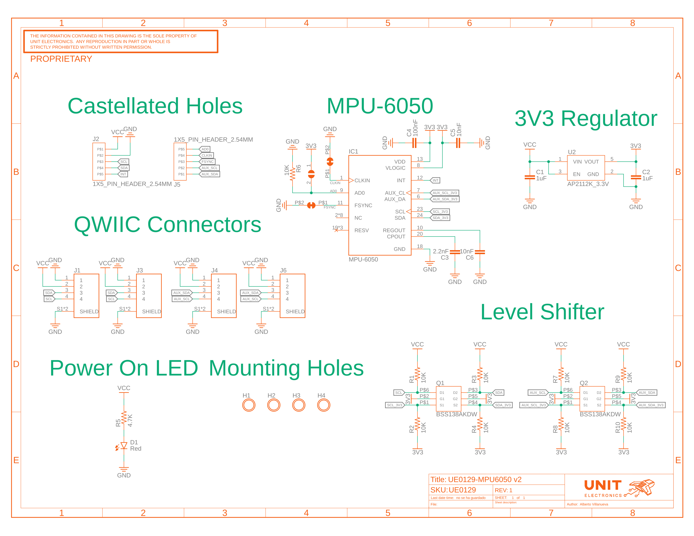
V1.0 electrical schematic.

4 Connectors and Pinout
The released pinout drawing shows the top and bottom board views and the connector signal labels. Confirm connector orientation on the physical board before assigning numeric pin positions or connecting a cable.
UE0129 pinout, top and bottom views.

4.1 Main Interface Edge (J2)
Board label | Direction / type | Function
VCC | Power input | Module input rail; allowed range pending validation
GND | Power | Common ground
SCL | I2C clock | Main host-side I2C clock
SDA | I2C data | Main host-side I2C data
INT | Output | MPU-6050 interrupt signal

4.2 Auxiliary and Control Edge (J5)
Board label | Direction / type | Function
AD0 | Input | MPU-6050 I2C address-selection input
CLKIN | Input | External clock input to the MPU-6050
FSYNC | Input | Frame-synchronization input
ASCL | I2C clock | Host-side auxiliary I2C clock
ASDA | I2C data | Host-side auxiliary I2C data

4.3 Four-Position Connectors
Reference | Signals | Bus
J1, J3 | VCC, GND, SDA, SCL | Main I2C
J4, J6 | VCC, GND, ASDA, ASCL | Auxiliary I2C
The BOM identifies all four as JST SM04B-SRSS-TB(LF)(SN) connectors. The artwork labels them QWIIC, but connector orientation, numeric pin numbering, and cable compatibility must be verified before assembly or connection.

4.4 Solder Options
The bottom artwork identifies options for FSYNC, CLKIN, and AD0. Their default copper states and intended operating configurations are pending validation.

5 Board Operation
The DevLab MPU-6050 module can be integrated into Arduino-compatible development boards through the I²C communication interface. Before running any application, install the DevLab_MPU6050 library from the Arduino Library Manager or download it from the official GitHub repository.

Hardware Interface
I²C Connection
Connect the module to the host board using the main I²C interface, available through the J2 header or the J1/J3 QWIIC connectors:
Module signal | Description | Host connection
VCC | Power supply | Host supply (approved range pending validation)
GND | Ground | Host ground
SDA | I²C data | Host SDA pin
SCL | I²C clock | Host SCL pin
The INT pin is optional and is only needed for interrupt-driven applications. Host GPIO numbers belong to the controller, not the module. The example below uses GPIO 6 for SDA and GPIO 7 for SCL on an ESP32 board(you can modify for your specific board):
#define SDA_PIN 6
#define SCL_PIN 7
Default I²C Address
Device | Address
MPU-6050 | 0x68
The module’s default 7-bit I²C address is 0x68. The sensor datasheet assigns 0x68 when AD0 is low and 0x69 when it is high.

Example Operation
After begin(), the library applies the following configuration:
Parameter | Resulting value
Clock source | PLL with X-axis gyroscope reference
Sample rate divider | 7
Digital low-pass filter | Configuration 6
Gyroscope full scale | ±500 °/s
Accelerometer full scale | ±8 g
I²C clock | 400 kHz

Basic Operation
The sensor reads three groups of values:
Value | Description
Accelerometer | Raw 16-bit acceleration for each axis (accX, accY, accZ)
Gyroscope | Raw 16-bit angular rate for each axis (gyrX, gyrY, gyrZ)
Temperature | Internal die temperature, in °C (temperatureC)
The accelerometer and gyroscope values are raw counts; their scale depends on the selected full-scale range.
- Connect the module to the microcontroller using the I²C interface.
- Open the Arduino IDE.
- Install the DevLab_MPU6050 library.
- Open the BasicRead example sketch provided with the library.
- Select the correct board and serial port.
- Compile and upload the example.
- Open the Serial Monitor to display the accelerometer, gyroscope, and temperature measurements.
During begin(), the library verifies communication by reading the WHO_AM_I register (expected value 0x68), wakes the sensor, and applies the default configuration. If initialization fails, check the wiring, the supply, and the I²C address.
Developers can modify the example code to configure:
- Accelerometer measurement range
- Gyroscope measurement range
- Digital low-pass filter
- Sample rate
- Clock source
- Interrupt generation

Example Code
Use the BasicRead example included with the library, or copy the following sketch into a new sketch:
#include <DevLab_MPU6050.h>
#define SDA_PIN 6
#define SCL_PIN 7
#define MPU6050_ADDR 0x68
DevLab_MPU6050 imu(Wire, MPU6050_ADDR);
SensorData data;
void setup() {
Serial.begin(115200);
delay(1000);
Serial.println("Inicializando MPU6050...");
if (!imu.begin(SDA_PIN, SCL_PIN, 400000)) {
Serial.println("ERROR: MPU6050 no encontrado.");
while (1) {
delay(1000);
}
}
Serial.println("MPU6050 inicializado correctamente.");
}
void loop() {
if (imu.readData(data)) {
Serial.print("aX = ");
Serial.print(data.accX / 4096.0f);
Serial.print(" | aY = ");
Serial.print(data.accY / 4096.0f);
Serial.print(" | aZ = ");
Serial.print(data.accZ / 4096.0f);
Serial.print(" | temp = ");
Serial.print(data.temperatureC, 2);
Serial.print(" | gX = ");
Serial.print(data.gyrX);
Serial.print(" | gY = ");
Serial.print(data.gyrY);
Serial.print(" | gZ = ");
Serial.println(data.gyrZ);
} else {
Serial.println("ERROR: fallo en la lectura del MPU6050.");
}
delay(1000);
}
Module-level I²C clock validation and the approved VCC range remain pending testing.

6 Mechanical Information
Released board dimensions drawing.
The released drawing labels a 27.94 × 18.46 mm board outline, four Ø2.2 mm mounting holes, and 21.94 × 12.46 mm hole-center spacing. The drawing also shows ten castellated edge connections. These are drawing values; mechanical tolerances and fit remain pending validation. Use the labeled dimensions rather than scaling the image.

7 Company Information
Item | Information
Company | UNIT Electronics
Website | https://uelectronics.com/
Address | Salvador 19, Cuauhtémoc, 06000 Mexico City, CDMX, Mexico
Product specifications and documentation may be revised. Use the repository and product page listed in the next chapter for the latest released material.

8 Reference Documentation
Reference | Location
Repository | UNIT-Electronics-MX/unit_devlab_i2c_mpu6050_6_axis_imu
Hardware notes | Hardware README
Sensor datasheet | MPU-6000 and MPU-6050 Product Specification, Revision 3.4
Module schematic | V1.0 schematic
Schematic image | V1.0 schematic PNG
Pinout | English PDF · Spanish PDF
Board topology | Top and bottom topology drawing
Board dimensions | Dimensioned drawing
Manufacturing BOM | V1.0 BOM
Experimental firmware | DevLab_MPU6050 basic readout
Sensor values in this reference are taken from the MPU-6050 portions of the Revision 3.4 product specification. Module-level limits require separate board validation.

9 Appendix

9.1 Source Hierarchy
This product reference uses the MPU-6000 and MPU-6050 Product Specification, Revision 3.4 for sensor characteristics, the released schematic for circuit connectivity, the manufacturing BOM for fitted component identities and values, and the released pinout, topology, board views, and dimensioned drawing for visible labels and physical features. A future approved validation report takes precedence if it conflicts with this edition.

9.2 Items Pending Validation
- Module VCC operating and absolute-maximum ratings
- Module current consumption and host-side logic levels
- Module-level I2C clock testing, board-default address, and configuration sequences
- Mechanical tolerances and physical fit against the dimensioned drawing
- Solder-option defaults and connector orientation
- Cable and ecosystem compatibility
- Validated firmware examples and measurement results

9.3 Document Control
Field | Value
Product | DevLab: I2C MPU-6050 6-Axis IMU Module
Manufacturer part number | UE0129
Hardware revision | V1.0
Product-reference revision | 0.2.0
Publication date | 2026-10-21
Firmware status | Experimental; not validated by this edition

