DevLab I2C MPU-6050 6-Axis IMU Module
Product Reference — Hardware V1.0 — Mfr. Part #: UE0129
UNIT Electronics
2026-08-03

Contents
- Description
  - Applications
  - Hardware Features
- 1 The Module
  - 1.1 Board Identification
  - 1.2 Package Contents
- 2 Electrical Characteristics
  - 2.1 Confirmed Circuit Values
  - 2.2 Electrical Precautions
- 3 Functional Overview
  - 3.1 Sensor and Main I2C Path
  - 3.2 Auxiliary and Control Signals
  - 3.3 Power Section
- 4 Connectors and Pinout
  - 4.1 Main Interface Edge (J2)
  - 4.2 Auxiliary and Control Edge (J5)
  - 4.3 Four-Position Connectors
  - 4.4 Solder Options
- 5 Board Operation
- 6 Mechanical Information
- 7 Company Information
- 8 Reference Documentation
- 9 Appendix
  - 9.1 Source Hierarchy
  - 9.2 Items Pending Validation
  - 9.3 Document Control

Description
The UNIT DevLab I2C MPU-6050 6-Axis IMU Module combines a three-axis accelerometer and a three-axis gyroscope. The board routes the MPU-6050 main and auxiliary I2C buses, interrupt and synchronization signals, and includes 3.3 V regulation and I2C level shifting.
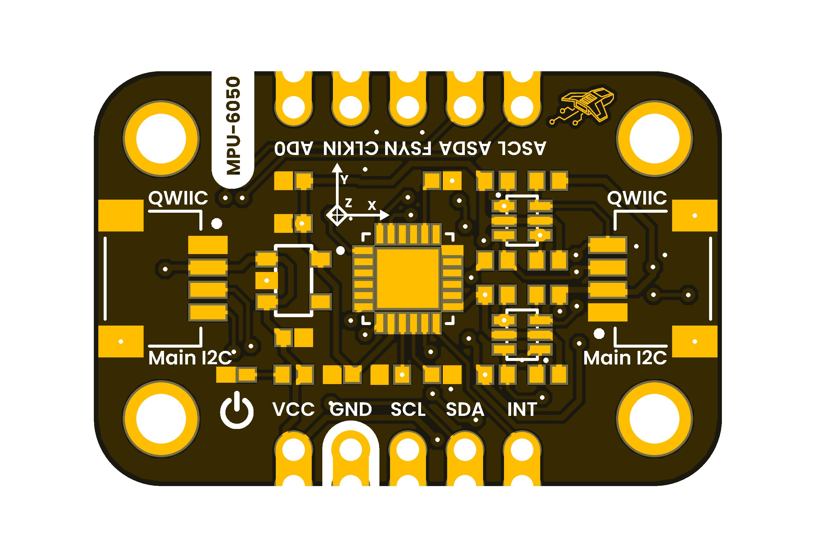

Applications
- Evaluation of acceleration and angular-rate sensing
- Motion-sensing prototypes
- I2C sensor integration and educational experiments
- Experiments using interrupt, synchronization, and auxiliary-sensor signals

Hardware Features
- MPU-6050 three-axis accelerometer and three-axis gyroscope
- Six 16-bit ADCs, one for each accelerometer and gyroscope axis
- Selectable accelerometer ranges of ±2 g, ±4 g, ±8 g, and ±16 g
- Selectable gyroscope ranges of ±250, ±500, ±1000, and ±2000 dps
- 1024-byte sensor FIFO and digital-output temperature sensor
- Main I2C bus on two board connectors and an edge connection
- Auxiliary I2C bus on two board connectors and an edge connection
- INT, AD0, FSYNC, and CLKIN signals
- AP2112K-3.3 fixed 3.3 V regulator
- Two BSS138AKDW dual N-channel MOSFET arrays for I2C level shifting
- Red power indicator
- Four mounting holes and ten edge connections shown by the board artwork

1 The Module

1.1 Board Identification
Item | Value
Product | DevLab: I2C MPU-6050 6-Axis IMU Module
Manufacturer part number | UE0129
Hardware revision | V1.0
Inertial sensor | MPU-6050
Host interface | I2C
Product-reference revision | 0.1.0

1.2 Package Contents
The BOM includes one four-pin, 1 mm-pitch harness. Package contents and cable compatibility have not been formally validated; confirm them with the distributor before purchase or integration.

2 Electrical Characteristics

2.1 Confirmed Circuit Values
Symbol / parameter | Description | Value | Scope
VDD | Operating supply | 2.375 to 3.46 V | MPU-6050 sensor pins
VLOGIC | Logic reference | 1.71 V to VDD | MPU-6050 sensor pin
Accelerometer range | Selectable full scale | ±2, ±4, ±8, or ±16 g | MPU-6050 sensor
Gyroscope range | Selectable full scale | ±250, ±500, ±1000, or ±2000 dps | MPU-6050 sensor
ADC word length | Per accelerometer / gyroscope axis | 16 bit | MPU-6050 sensor
I2C operating frequency | Fast-mode maximum | 400 kHz | MPU-6050 sensor interface
Six-axis current | Gyroscope + accelerometer, DMP disabled | 3.8 mA typical | MPU-6050 sensor only
Six-axis + DMP current | Gyroscope + accelerometer + DMP | 3.9 mA typical | MPU-6050 sensor only
3V3 | Regulated output from U2 | 3.3 V nominal | AP2112K-3.3 regulator output
C1, C2 | Regulator input/output capacitors | 1 µF each | Individual BOM components
R5 | Power-indicator series resistor | 4.7 kΩ | Individual BOM component
R1–R4, R6–R10 | Pull-up / bias resistors | 10 kΩ each | Individual BOM components
The allowed voltage at the module VCC connections, module current consumption, host-side digital thresholds, and complete-module I2C clock limit are pending validation. The sensor, regulator, connector, MOSFET, resistor, and capacitor component ratings are not ratings for the complete module.

2.2 Electrical Precautions
- Establish a common GND before applying power or interface signals.
- Verify the module-level VCC range before applying power.
- Keep host signals within validated logic levels; those limits are not yet documented for the complete module.
- Treat INT as an output from the sensor and CLKIN, FSYNC, and AD0 as sensor inputs according to the released schematic.

3 Functional Overview

3.1 Sensor and Main I2C Path
The MPU-6050 provides three-axis acceleration and three-axis angular-rate sensing with 16-bit conversion per axis and selectable full-scale ranges. Its 1024-byte FIFO can buffer sensor data. Q1 translates the main SCL and SDA lines between the module VCC domain and the sensor’s regulated 3.3 V domain. J1, J3, and J2 provide access to the main bus.

3.2 Auxiliary and Control Signals
Q2 translates the MPU-6050 auxiliary AUX_SCL and AUX_SDA lines to the board ASCL and ASDA connections. The board also routes INT, AD0, FSYNC, and CLKIN. The schematic shows R6 connected from AD0 to ground; the physical defaults of the solder options shown in the artwork remain pending validation.

3.3 Power Section
The schematic identifies U2 as an AP2112K-3.3 regulator supplied from VCC. Its 3.3 V output powers both MPU-6050 supply pins and the sensor-side I2C pull-ups. The complete module input range is pending validation and must not be derived from the regulator’s component rating.
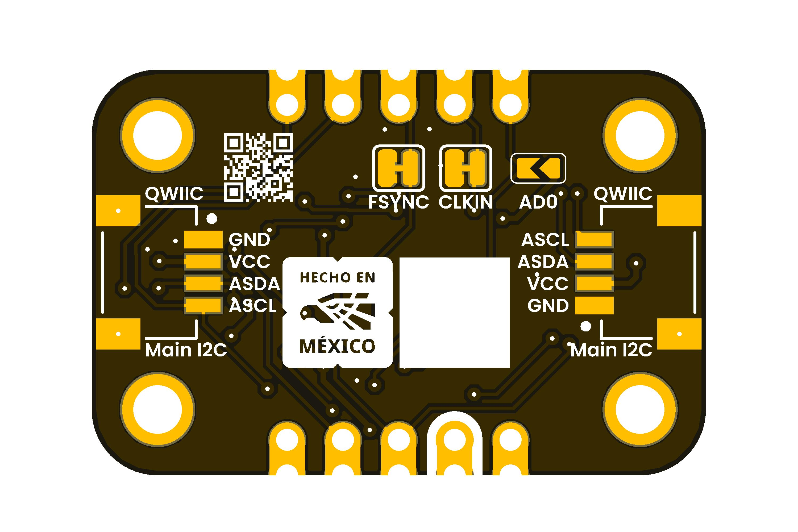

4 Connectors and Pinout

4.1 Main Interface Edge (J2)
Board label | Direction / type | Function
VCC | Power input | Module input rail; allowed range pending validation
GND | Power | Common ground
SCL | I2C clock | Main host-side I2C clock
SDA | I2C data | Main host-side I2C data
INT | Output | MPU-6050 interrupt signal

4.2 Auxiliary and Control Edge (J5)
Board label | Direction / type | Function
AD0 | Input | MPU-6050 I2C address-selection input
CLKIN | Input | External clock input to the MPU-6050
FSYNC | Input | Frame-synchronization input
ASCL | I2C clock | Host-side auxiliary I2C clock
ASDA | I2C data | Host-side auxiliary I2C data

4.3 Four-Position Connectors
Reference | Signals | Bus
J1, J3 | VCC, GND, SDA, SCL | Main I2C
J4, J6 | VCC, GND, ASDA, ASCL | Auxiliary I2C
The BOM identifies all four as JST SM04B-SRSS-TB(LF)(SN) connectors. The artwork labels them QWIIC, but connector orientation, numeric pin numbering, and cable compatibility must be verified before assembly or connection.

4.4 Solder Options
The bottom artwork identifies options for FSYNC, CLKIN, and AD0. Their default copper states and intended operating configurations are pending validation.

5 Board Operation
The DevLab_MPU6050 firmware under software/examples/arduino/ is experimental and is intentionally not reproduced here as a validated example. It configures host GPIO 12 as SDA, host GPIO 22 as SCL, sensor address 0x68, and a 400 kHz I2C clock. The GPIO values are controller assignments, not module pin numbers, and the complete setup remains pending validation.
For initial bench evaluation:
- Inspect the board and confirm the intended connector orientation.
- Verify the module VCC range from an approved test record before applying power.
- Connect module and host grounds.
- Connect the host I2C clock and data lines to SCL and SDA.
- Verify the AD0 configuration against the physical board. The sensor datasheet assigns 7-bit address 0x68 when AD0 is low and 0x69 when it is high.
- Confirm communication and sensor configuration with test equipment before relying on measurement data.
Host GPIO numbers belong to the controller, not the module. Module-level I2C clock validation, board-default address, configuration sequences, and example firmware are pending testing.

6 Mechanical Information
The artwork shows four mounting holes and ten castellated edge connections. A controlled dimensional drawing has not been supplied, so board dimensions, hole diameters, and mounting-hole coordinates are pending validation. Do not scale dimensions from the rendered image.

7 Company Information
Item | Information
Company | UNIT Electronics
Website | https://uelectronics.com/
Address | Salvador 19, Cuauhtémoc, 06000 Mexico City, CDMX, Mexico
Product specifications and documentation may be revised. Use the repository and product page listed in the next chapter for the latest released material.

8 Reference Documentation
Reference | Location
Repository | UNIT-Electronics-MX/unit_devlab_i2c_mpu6050_6_axis_imu
Hardware notes | Hardware README
Sensor datasheet | MPU-6000 and MPU-6050 Product Specification, Revision 3.4
Module schematic | V1.0 schematic
Manufacturing BOM | V1.0 BOM
Experimental firmware | DevLab_MPU6050 basic readout
Sensor values in this reference are taken from the MPU-6050 portions of the Revision 3.4 product specification. Module-level limits require separate board validation.

9 Appendix

9.1 Source Hierarchy
This product reference uses the MPU-6000 and MPU-6050 Product Specification, Revision 3.4 for sensor characteristics, the released schematic for circuit connectivity, the manufacturing BOM for fitted component identities and values, and the supplied top and bottom artwork for visible labels and physical features. A future approved dimensional drawing and validation report take precedence if they conflict with this edition.

9.2 Items Pending Validation
- Module VCC operating and absolute-maximum ratings
- Module current consumption and host-side logic levels
- Module-level I2C clock testing, board-default address, and configuration sequences
- Board dimensions and mounting-hole coordinates
- Solder-option defaults and connector orientation
- Cable and ecosystem compatibility
- Validated firmware examples and measurement results

9.3 Document Control
Field | Value
Product | DevLab: I2C MPU-6050 6-Axis IMU Module
Manufacturer part number | UE0129
Hardware revision | V1.0
Product-reference revision | 0.1.0
Publication date | 2026-08-03
Firmware status | Experimental; not validated by this edition

