DevLab I2C Push Button Module
Product Reference Manual
UNIT Electronics
2026-08-31

Contents
- Description
  - Applications
  - Available Documentation
- 1 The Board
  - 1.1 Board Identification
  - 1.2 Board Views
- 2 Ratings
  - 2.1 Electrical Limits
  - 2.2 Interface Characteristics
- 3 Functional Overview
  - 3.1 Integration Boundary
- 4 Connectors & Pinouts
  - 4.1 Released Pinout
  - 4.2 Connection Groups {.page-break}
- 5 Board Operation
  - 5.1 Before Connecting
  - 5.2 I2C Bus Check
- 6 Mechanical Information
  - 6.1 Top View
  - 6.2 Bottom View
  - 6.3 Board Dimensions
- 7 Company Information
- 8 Reference Documentation
- 9 Appendix
  - 9.1 Schematic Status
  - 9.2 Document Control
  - 9.3 Data Requiring Confirmation

Description
The DevLab I2C Push Button Module (MPN UE0168) is an I2C push button input module in the UNIT Electronics DevLab family. The product-specific board views and any released drawings are collected under hardware/.

Applications
- Push button input in an I2C-based prototype.
- Evaluation of the module with a compatible host controller.

Available Documentation
A product-specific schematic was not present in the selected source package. See Chapter 8 for the available source files. Confirm the electrical interface against the product-specific pinout or schematic before connecting the board.

1 The Board

1.1 Board Identification
Item | Identification
Product | DevLab I2C Push Button Module
Manufacturer Part Number (MPN) | UE0168
Function | Push button input

1.2 Board Views
The following views come from the selected UE0168 source package. They show component placement and board orientation; use a dimensioned drawing for mechanical tolerances.
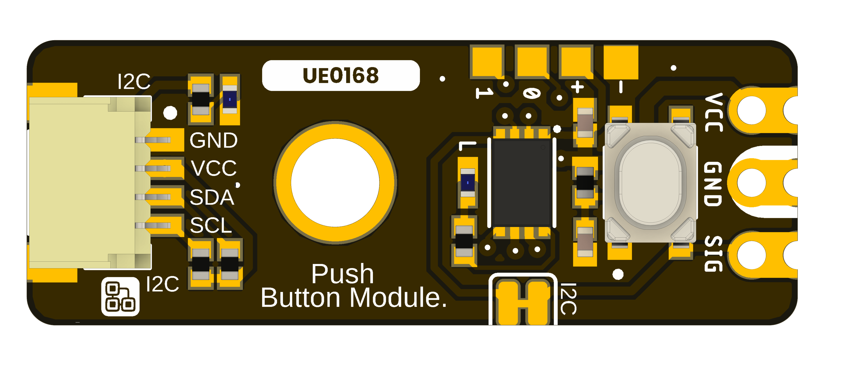
DevLab I2C Push Button Module top view.
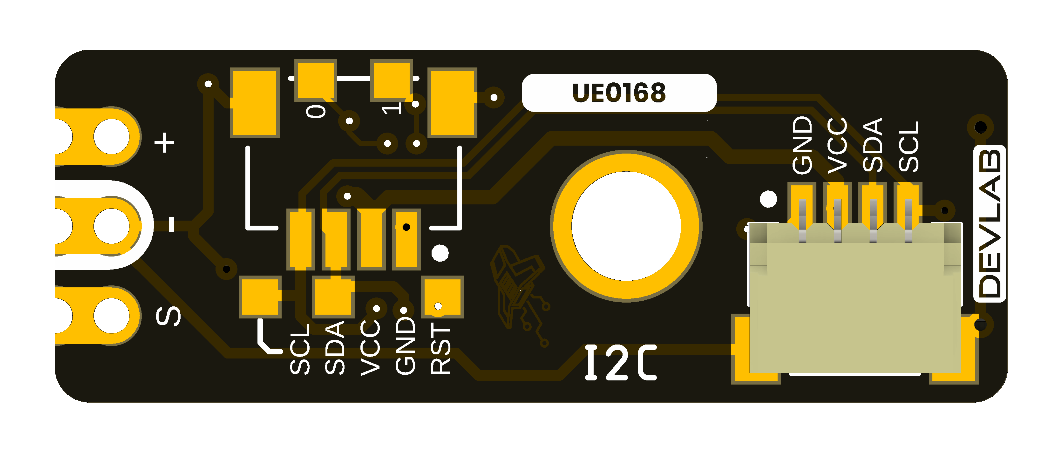
DevLab I2C Push Button Module bottom view.

2 Ratings
The selected UE0168 source package does not establish a complete set of electrical ratings in this reference. Do not use values from another DevLab module as substitutes.

2.1 Electrical Limits
Supply range, I/O voltage limits, and current consumption require confirmation from the product-specific schematic and component data before integration.

2.2 Interface Characteristics
Confirm the I2C address, bus speed, pull-up arrangement, and connector orientation with the released UE0168 pinout or firmware documentation. An I2C scan only identifies responding addresses; it does not verify the device protocol.

3 Functional Overview
The DevLab I2C Push Button Module provides push button input for an I2C-based system. The supplied board views identify the physical module, while the product-specific schematic and firmware documentation are needed to establish its internal signal path and command set.

3.1 Integration Boundary
Use the available UE0168 pinout, schematic, and firmware release to determine power, connector mapping, address, and commands. Until these are confirmed, treat the generic I2C scanner in software/ as a bus diagnostic only.

4 Connectors & Pinouts
The released V1.0 pinout for the UE0168 Push Button Module shows the top and bottom board views. Check the view and connector orientation before wiring.

4.1 Released Pinout
UE0168 Push Button Module pinout, top and bottom views.
Figure 4.1 — UE0168 pinout, English version. The Spanish version is linked in Section 8.

4.2 Connection Groups
Group | Labels in the released drawing | Purpose
Qwiic I2C connector | GND, VCC, SDA, SCL | Power and I2C bus connections
Direct contacts | VCC, GND, SIG | Power and direct signal access
Service pads | TX, RX, RST | Pads identified in the drawing; consult the hardware design before use
The drawing also marks two optional 4-pin, 1 mm JST connector positions. Its solder-link note says opening the marked pad disables the I2C SIG signal. The pinout does not establish electrical limits or connector part numbers.

5 Board Operation

5.1 Before Connecting
Check the product-specific UE0168 pinout or schematic for power, ground, SDA, and SCL. The board views alone do not establish voltage limits or connector numbering.

5.2 I2C Bus Check
After confirming the wiring and supply limits, use the generic Arduino or MicroPython I2C scanner in software/examples/i2c/. Set the host SDA and SCL pins for your controller. A responding address confirms only that a device acknowledged on the bus; it does not identify the module or validate its measurement protocol.

6 Mechanical Information
The supplied board views identify the component and underside layouts of the UE0168 I2C Push Button Module. Use the labeled drawings for fit checks; do not infer dimensions by scaling a render.

6.1 Top View
UE0168 I2C Push Button Module top view.

6.2 Bottom View
UE0168 I2C Push Button Module bottom view.

6.3 Board Dimensions
UE0168 I2C Push Button Module dimension drawing.
Use the dimensions printed on the supplied drawing. PCB thickness, component heights, connector clearance, and manufacturing tolerances require separate verification.

7 Company Information
Item | Information
Company / brand | UNIT Electronics
Board ecosystem | DevLab
Product family | Atom
Website | UNIT Electronics
Address | Salvador 19, Cuauhtémoc, 06000 Mexico City, CDMX, Mexico
The product repository and controlled technical references are listed in the next chapter.

8 Reference Documentation
Reference | Location
Product repository | UE0168 Push Button Module
Pinout V1.0, English | PDF · PNG
Pinout V1.0, Spanish | PDF · PNG
Top view | 3D board view
Bottom view | 3D board view
Board dimensions | Dimension drawing
Board topology | Topology drawing
CAD model | STEP
The released pinout documents the visible labels and connector orientation. It does not by itself establish supply limits, bus timing, or mating part numbers.

9 Appendix

9.1 Schematic Status
A product-specific schematic was not included in the selected source package.

9.2 Document Control
Item | Value
Product | DevLab I2C Push Button Module
MPN | UE0168
Source | UNIT Electronics selected product source package

9.3 Data Requiring Confirmation
Electrical limits, I2C commands, and mechanical tolerances must be verified against product-specific released documentation.

