DevLab I2C SCD41 Air Quality Sensor
Product Reference Manual
UNIT Electronics
2026-08-31

Contents
- Description
  - Applications
  - Available Documentation
- 1 The Board
  - 1.1 Board Identification
  - 1.2 Board Views
- 2 Ratings
  - 2.1 Electrical Limits
  - 2.2 Interface Characteristics
- 3 Functional Overview
  - 3.1 Integration Boundary
- 4 Connectors & Pinouts
  - 4.1 Released Pinout
  - 4.2 Connection Groups {.page-break}
- 5 Board Operation
  - 5.1 Before Connecting
  - 5.2 I2C Bus Check
- 6 Mechanical Information
  - 6.1 Top View
  - 6.2 Bottom View
  - 6.3 Board Dimensions
- 7 Company Information
- 8 Reference Documentation
- 9 Appendix
  - 9.1 Schematic Source
  - 9.2 Document Control
  - 9.3 Data Requiring Confirmation
  - 9.4 Board Schematic {.schematic-page}

Description
The DevLab I2C SCD41 Air Quality Sensor (MPN UE0179) is an I2C air quality sensing module in the UNIT Electronics DevLab family. The product-specific board views and any released drawings are collected under hardware/.

Applications
- Air quality sensing in an I2C-based prototype.
- Evaluation of the module with a compatible host controller.

Available Documentation
The UE0179 board schematic and pinout appear under hardware/. Chapter 8 lists the source files, and Appendix 9.4 shows the complete schematic.

1 The Board

1.1 Board Identification
Item | Identification
Product | DevLab I2C SCD41 Air Quality Sensor
Manufacturer Part Number (MPN) | UE0179
Function | Air quality sensing

1.2 Board Views
The following views come from the selected UE0179 source package. They show component placement and board orientation; use a dimensioned drawing for mechanical tolerances.
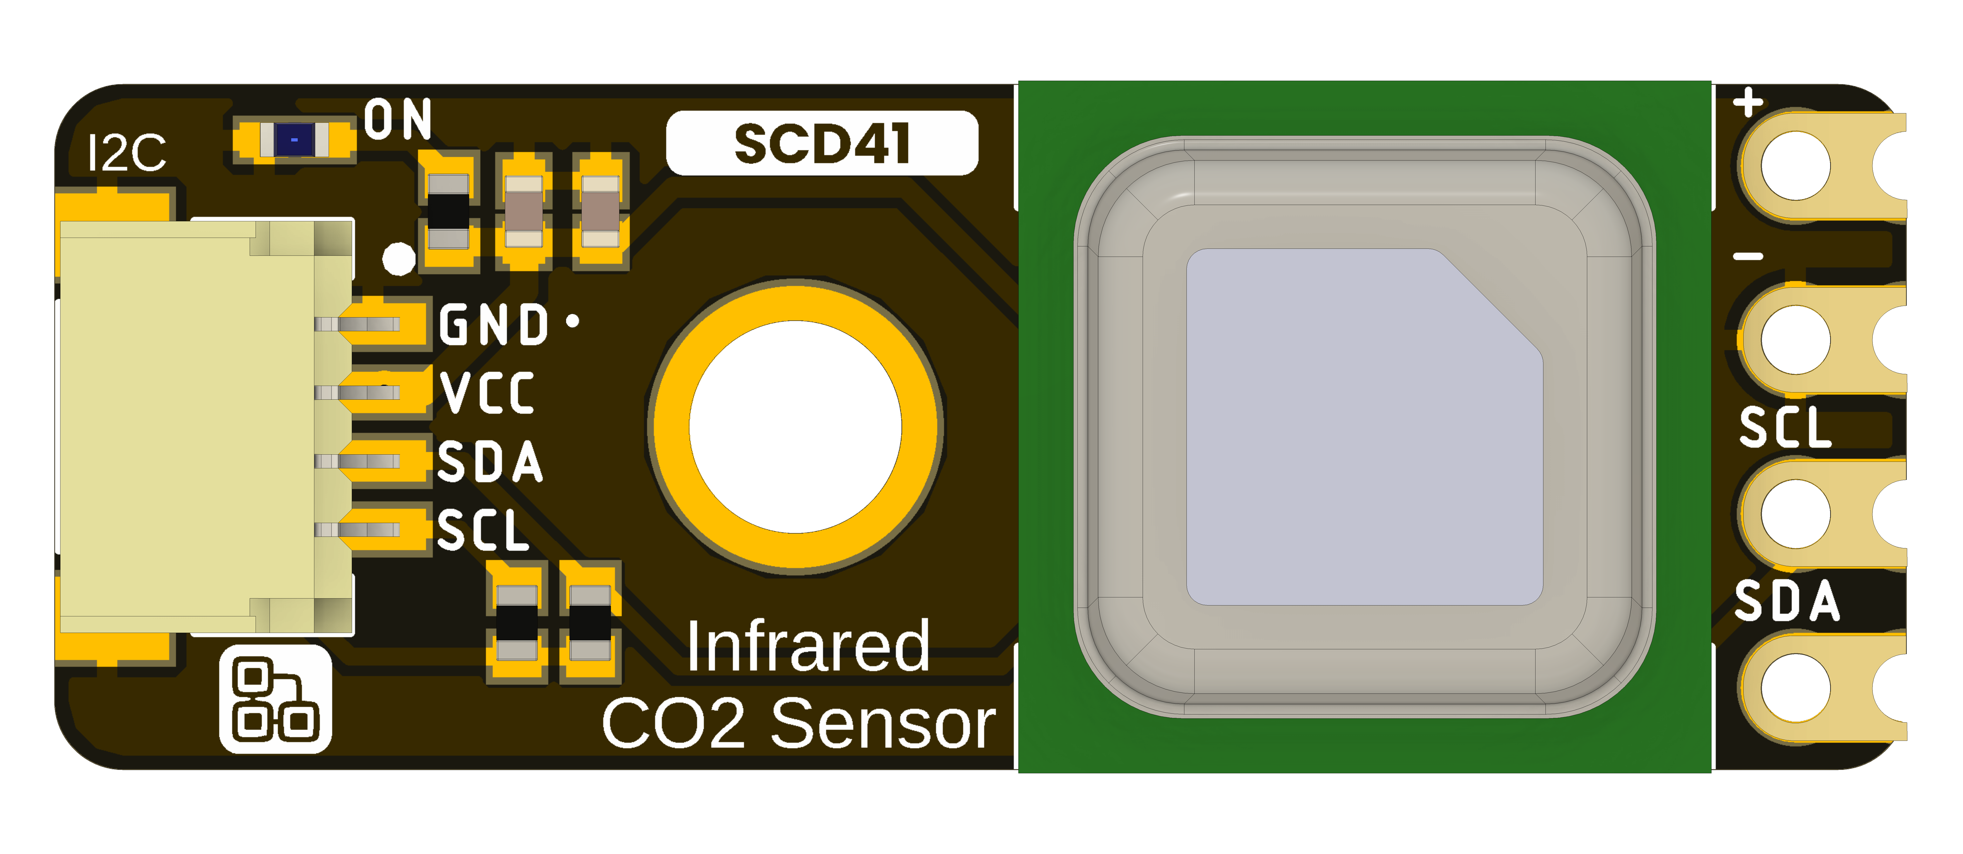
DevLab I2C SCD41 Air Quality Sensor top view.
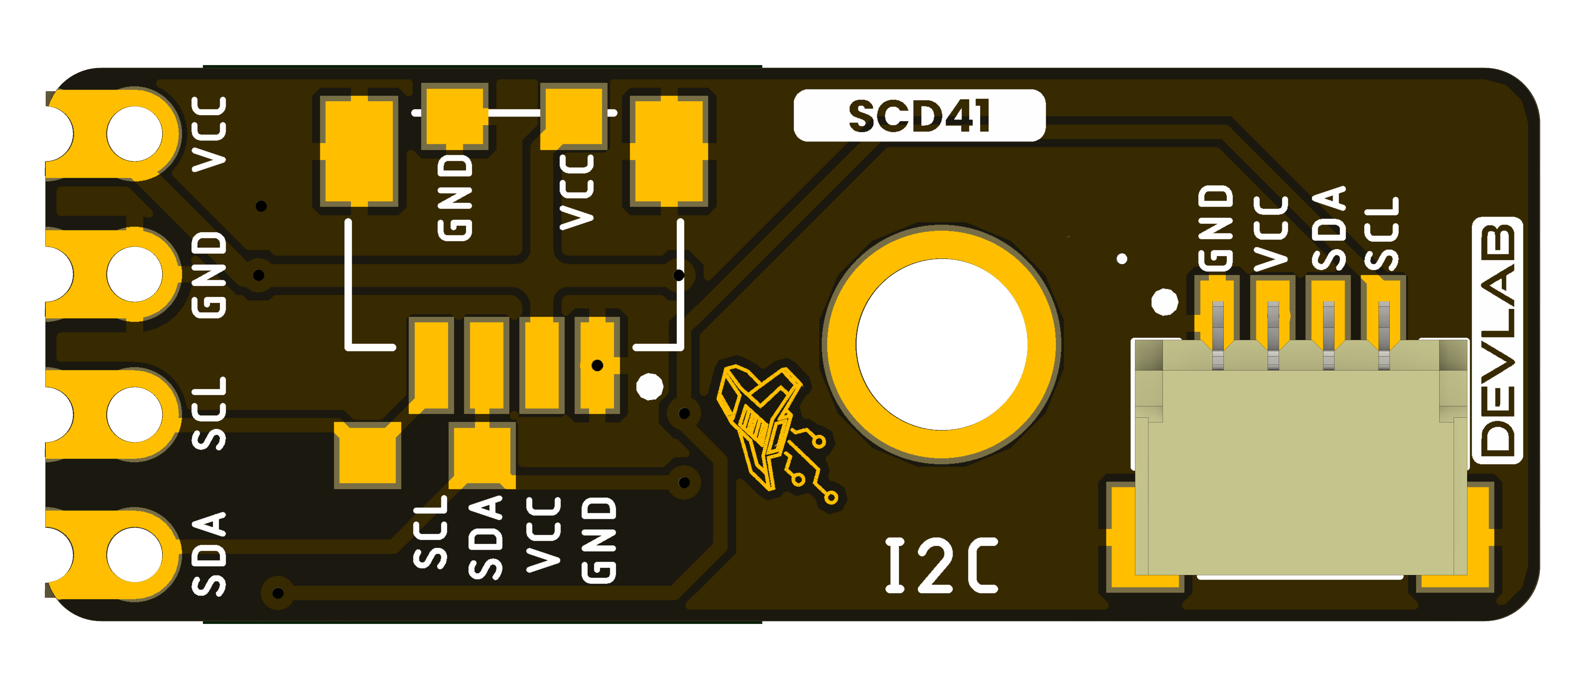
DevLab I2C SCD41 Air Quality Sensor bottom view.

2 Ratings
The selected UE0179 source package does not establish a complete set of electrical ratings in this reference. Do not use values from another DevLab module as substitutes.

2.1 Electrical Limits
Supply range, I/O voltage limits, and current consumption require confirmation from the product-specific schematic and component data before integration.

2.2 Interface Characteristics
Confirm the I2C address, bus speed, pull-up arrangement, and connector orientation with the released UE0179 pinout or firmware documentation. An I2C scan only identifies responding addresses; it does not verify the device protocol.

3 Functional Overview
The DevLab I2C SCD41 Air Quality Sensor provides air quality sensing for an I2C-based system. The UE0179 schematic shows the SCD41 sensor connected to VSYS, GND, SDA, and SCL. It shows SDA and SCL pull-ups to VSYS, supply decoupling capacitors, a power indicator, and three I2C hub connectors.

3.1 Integration Boundary
The UE0179 pinout and schematic identify the connector signals and board connections. The firmware release and sensor documentation establish the I2C address and commands. The generic I2C scanner in software/ serves as a bus diagnostic.

4 Connectors & Pinouts
The released V1.0 pinout for the UE0179 SCD41 Air Quality Sensor shows the top and bottom board views. Check the view and connector orientation before wiring.

4.1 Released Pinout
UE0179 SCD41 Air Quality Sensor pinout, top and bottom views.
Figure 4.1 — UE0179 pinout, English version. The Spanish version is linked in Section 8.

4.2 Connection Groups
Group | Labels in the released drawing | Purpose
Qwiic I2C connector | GND, VCC, SDA, SCL | Power and I2C bus connections
Board contacts | VCC, GND, SCL, SDA | Direct access to the labeled power and bus signals
The drawing also marks optional 4-pin, 1 mm JST connector positions. The pinout does not establish electrical limits or connector part numbers.

5 Board Operation

5.1 Before Connecting
Check the product-specific UE0179 pinout or schematic for power, ground, SDA, and SCL. The board views alone do not establish voltage limits or connector numbering.

5.2 I2C Bus Check
After confirming the wiring and supply limits, use the generic Arduino or MicroPython I2C scanner in software/examples/i2c/. Set the host SDA and SCL pins for your controller. A responding address confirms only that a device acknowledged on the bus; it does not identify the module or validate its measurement protocol.

6 Mechanical Information
The supplied board views identify the component and underside layouts of the UE0179 I2C SCD41 Air Quality Sensor. Use the labeled drawings for fit checks; do not infer dimensions by scaling a render.

6.1 Top View
UE0179 I2C SCD41 Air Quality Sensor top view.

6.2 Bottom View
UE0179 I2C SCD41 Air Quality Sensor bottom view.

6.3 Board Dimensions
UE0179 I2C SCD41 Air Quality Sensor dimension drawing.
Use the dimensions printed on the supplied drawing. PCB thickness, component heights, connector clearance, and manufacturing tolerances require separate verification.

7 Company Information
Item | Information
Company / brand | UNIT Electronics
Board ecosystem | DevLab
Product family | Atom
Website | UNIT Electronics
Address | Salvador 19, Cuauhtémoc, 06000 Mexico City, CDMX, Mexico
The product repository and controlled technical references are listed in the next chapter.

8 Reference Documentation
Reference | Location
Product repository | UE0179 SCD41 Air Quality Sensor
UE0179 board schematic | PDF
Pinout V1.0, English | PDF · PNG
Pinout V1.0, Spanish | PDF · PNG
Top view | 3D board view
Bottom view | 3D board view
Board dimensions | Dimension drawing
Board topology | Topology drawing
CAD model | STEP
The released pinout documents the visible labels and connector orientation. It does not by itself establish supply limits, bus timing, or mating part numbers.

9 Appendix

9.1 Schematic Source
The UE0179 V1.0 board schematic identifies the SCD41 sensor, I2C connectors, pull-ups, supply decoupling, power indicator, and test points.

9.2 Document Control
Item | Value
Product | DevLab I2C SCD41 Air Quality Sensor
MPN | UE0179
Source | UNIT Electronics selected product source package

9.3 Data Requiring Confirmation
Electrical limits, I2C commands, and mechanical tolerances must be verified against product-specific released documentation.

9.4 Board Schematic
The UE0179 board schematic shows the complete sensor and connector circuit.
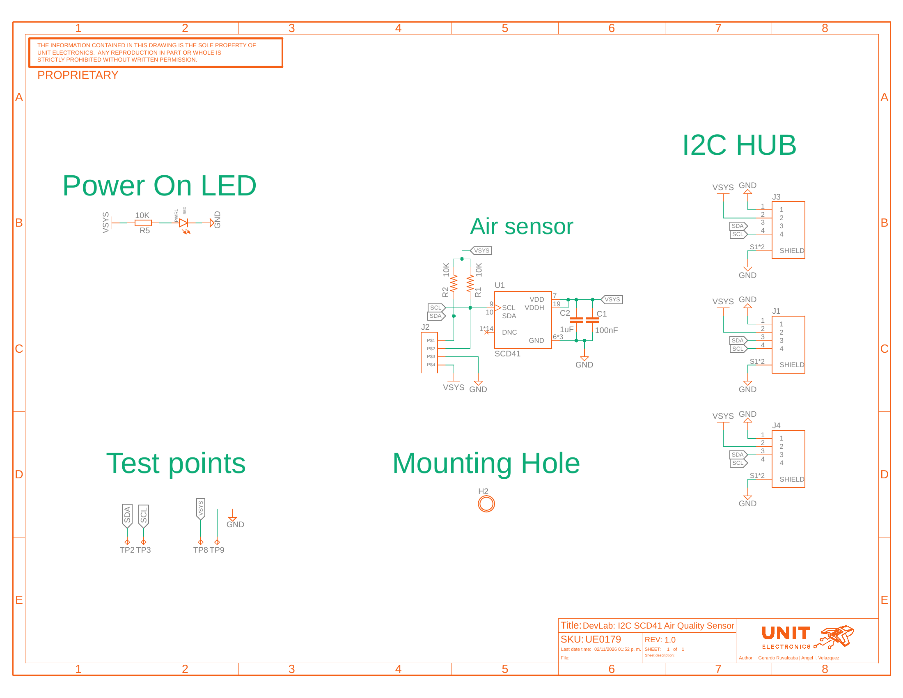
UE0179 I2C SCD41 Air Quality Sensor board schematic.

