UNIT I2S ES8311 Codec with Amplifier Module
Product Reference Manual
UNIT Electronics
2026-10-19

Contents
- Description
  - Applications
  - Hardware Features
- 1 The Board
  - 1.1 Accessories
  - 1.2 Board Identification
  - 1.3 Main Assemblies
  - 1.4 Board Views
  - 1.5 Handling
- 2 Ratings
  - 2.1 Recommended Operating Conditions
  - 2.2 Power Domains and Power Distribution
  - 2.3 Digital Interfaces
  - 2.4 Confirmed Component Values
  - 2.5 Application-Dependent and Uncharacterized Parameters
  - 2.6 Electrical Precautions
- 3 Functional Overview
  - 3.1 Block Diagram
  - 3.2 Board Topology
  - 3.3 Audio Codec
  - 3.4 Digital Audio Architecture
  - 3.5 Speaker Amplifier
  - 3.6 Analog Microphone Input
  - 3.7 Status Indicator
  - 3.8 AP2112K Power Management System
  - 3.9 Power Tree
  - 3.10 I2C Control
  - 3.11 Headphone / Jack Path
  - 3.12 I2C and QWIIC Expansion
  - 3.13 Combined System Operation
- 4 Connectors & Pinouts
  - 4.1 J4 Host Header Pinout
  - 4.2 Host Pinout Compatibility
  - 4.3 QWIIC Connector
  - 4.4 Microphone Connector
  - 4.5 Speaker Connections
  - 4.6 3.5 mm Audio Jack
  - 4.7 Power and Amplifier Control
  - 4.8 Test Pads and Assembly Options
- 5 Board Operation
  - 5.1 Getting Started with a Host Controller
  - 5.2 First Power-up and Inspection
  - 5.3 Control and Clock Workflow
  - 5.4 Recommended Bring-up Sequence
  - 5.5 Firmware Example Collection
  - 5.6 Audio Buffer Planning
  - 5.7 Recording Operation
  - 5.8 Playback and Recording Coexistence
  - 5.9 Troubleshooting Guide
- 6 Mechanical Information
  - 6.1 Component-side Envelope
  - 6.2 Bottom-side Envelope
  - 6.3 Mechanical Data Not Specified
- 7 Company Information
- 8 Reference Documentation
- 9 Appendix
  - 9.1 Schematic
  - 9.2 Technical References
  - 9.3 Values Not Specified by the Technical Documentation
  - 9.4 Document Control
  - 9.5 Source Inconsistencies
  - 9.6 Hardware Errata

Description
The UNIT I2S ES8311 Codec with Amplifier Module (UE0097) is a mono audio interface for a host controller. The ES8311 converts between analog audio and digital I2S/PCM audio. The board adds an NS4150B speaker amplifier, an analog microphone connector, a 3.5 mm audio jack, a two-pin speaker connector, an I2S header, and an I2C/QWIIC-style connector. An external host supplies clocks, audio data, control, and power.
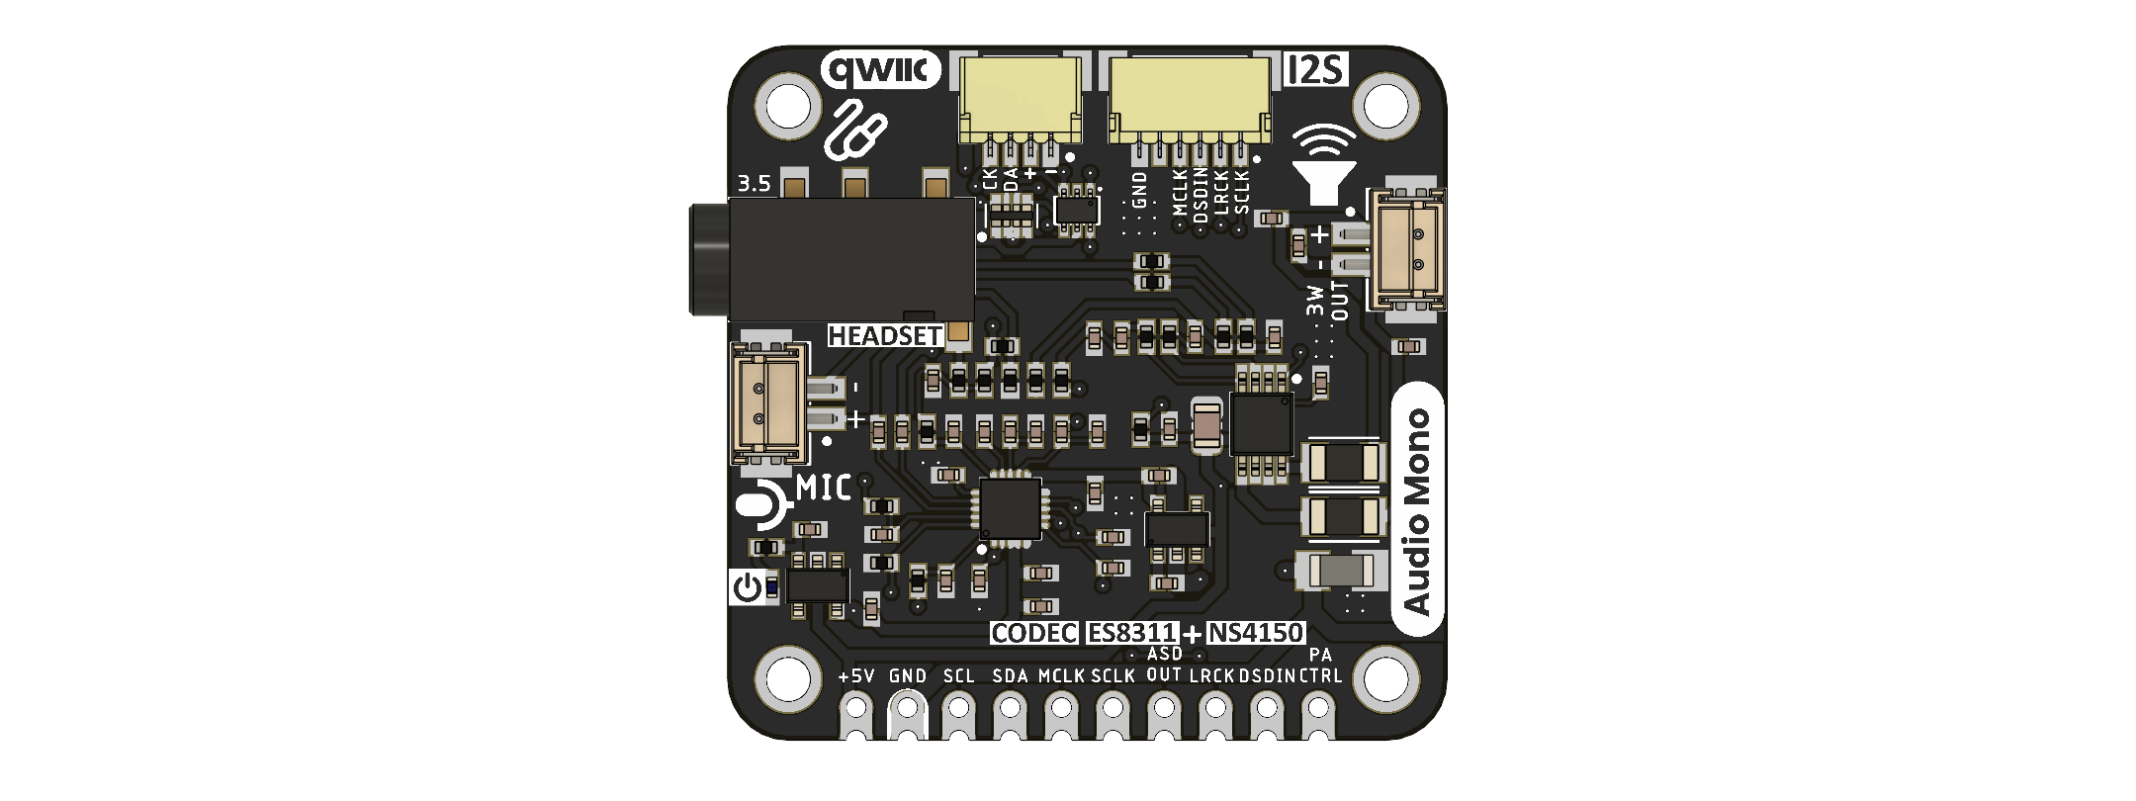
Top view of the audio module

Applications
- Voice recording and playback in embedded systems
- Intercoms, monitoring equipment, and voice interfaces
- Audio input and output experiments with I2S-capable controllers
- Prototyping with an external analog microphone and mono speaker
Application path | Host interface | Module audio connection
Microphone capture | I2C setup, I2S clocks, ASDOUT | J2 analog microphone input
Speaker playback | I2C setup, I2S clocks, DSDIN1, PA_CTRL | J1 differential speaker output
3.5 mm audio playback | I2C setup, I2S clocks, DSDIN1 | J3 analog output path
Bidirectional voice | I2C setup, I2S input and output | J2 input with J1 or J3 output
These are potential uses of the documented interfaces, not claims of application-level validation.

Hardware Features
- ES8311 mono codec with differential microphone input and I2S/PCM port
- NS4150B amplifier connected to the ES8311 differential output
- Separate speaker, microphone, 3.5 mm jack, 10-position header, and four-position QWIIC-style connectors
- Two AP2112K-3.3 regulators, power indicator, and amplifier control signal
- Four mounting holes and castellated 2.54 mm header positions

1 The Board

1.1 Accessories
Accessory | Purpose | Verified specification
I2S-capable host controller | Supplies digital audio and clocks
Power source | Supplies VCC and ground
Analog microphone | Connects to J2
Mono speaker | Connects to J1
3.5 mm plug or headset | Connects to J3
Four-position cable | Connects to J6
Connector mating part numbers, speaker impedance and power rating, microphone requirements, and cable orientation are not defined in the supplied board documentation.

1.2 Board Identification
Item | Value
Product | UNIT I2S ES8311 Codec with Amplifier Module
SKU / MPN | UE0097
Product family | UNIT DevLab ecosystem
Product type | Mono audio codec and amplifier module
Main component | ES8311
Amplifier | NS4150B
Schematic revision | 2.0
Image file revision | V1.1.0
Product Reference | Version 0.1.0

1.3 Main Assemblies
RefDes | Component | Schematic function
IC1 | ES8311 | Mono audio ADC, DAC, and digital audio interface
IC2 | NS4150B | Differential speaker amplifier
U1, U2 | AP2112K-3.3V | Separate 3.3 V regulator outputs
J1 | Two-position connector | Differential speaker output
J2 | Two-position connector | External microphone input
J3 | PJ-320D | 3.5 mm audio jack
J4 | 10-position castellated header | Power, I2C, I2S, and amplifier control
J6 | Four-position connector | Power, ground, SDA, and SCL
D1 | Green LED | Power indicator

1.4 Board Views
Top view of the module
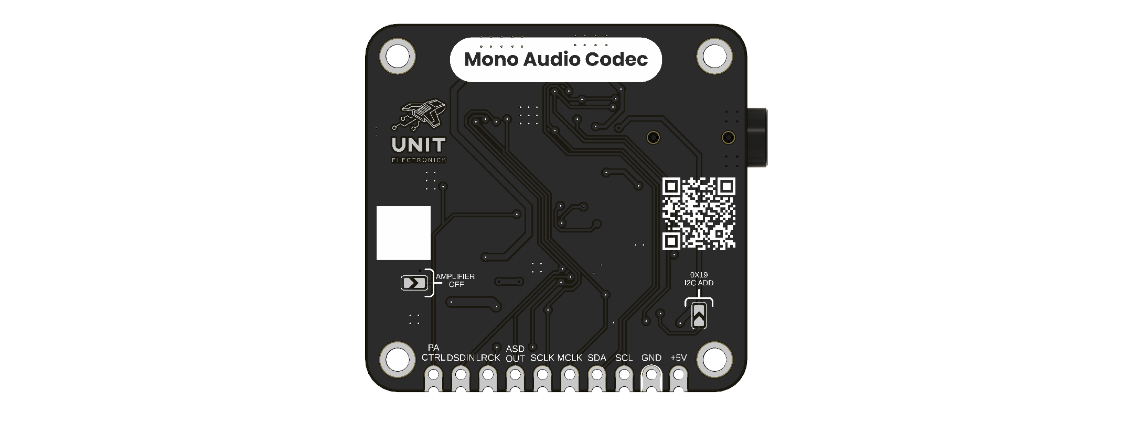
Bottom view of the module
The images show connector placement and silkscreen. For electrical connections in this reference, use the revision 2.0 schematic.

1.5 Handling
Observe normal ESD precautions. Remove power before changing microphone, speaker, jack, or host wiring. Verify connector pin 1, polarity, and voltage with the actual hardware revision before applying power.

2 Ratings
The ES8311 supply and audio figures in this chapter come from its User Guide. Blank cells indicate undocumented module ratings.

2.1 Recommended Operating Conditions
Parameter | Minimum | Typical | Maximum
ES8311 AVDD | 1.7 V | 3.3 V | 3.6 V
ES8311 PVDD | 1.6 V | 3.3 V | 3.6 V
ES8311 DVDD | 1.6 V | 3.3 V | 3.6 V
Module VCC input
Module 3V3 output current
Module speaker load
Module operating temperature
The board image labels the header supply as +5V. This identifies the intended nominal input marking, but the supplied documents give no validated module input range. The ES8311 supply values above do not define VCC limits because VCC also supplies both regulators and the amplifier.

2.2 Power Domains and Power Distribution
The schematic routes VCC to the NS4150B amplifier, the power LED, J4 and J6, and the inputs of U1 and U2. U1 produces the 3V3 net; U2 produces A_3V3. The ES8311 power pins and I2C address pull-up use 3V3. Its AVDD pin uses A_3V3. Analog and digital grounds meet through the shown zero-ohm coupling element.

2.3 Digital Interfaces
Interface | Board connection | Documented behavior
I2C control | J4 SDA/SCL and J6 SDA/SCL | ES8311 CE is pulled to 3V3 through R5; guide maps this to 7-bit address 0x19
Digital audio | J4 MCLK, SCLK, LRCK, ASDOUT, DSDIN1 | ES8311 supports I2S, left-justified, and DSP-A/B formats
Amplifier enable | J4 PA_CTRL | Connected to NS4150B CTRL through R12
Digital microphone | ES8311 multiplexed pins | Component capability; no external digital-microphone connector is documented
The guide describes ES8311 master and slave audio modes. It does not establish which mode a particular host application must use.

2.4 Confirmed Component Values
Parameter | Value
ADC signal-to-noise ratio | 100 dB
DAC signal-to-noise ratio | 110 dB
ADC output sample rate | Up to 96 kHz

2.5 Application-Dependent and Uncharacterized Parameters
Parameter | Module value
Total operating current
Amplifier output power and distortion
Validated speaker impedance
Microphone bias voltage and supported microphone types
Input gain and full-scale input at J2/J3
Module audio signal-to-noise ratio
End-to-end latency and noise
ESD, EMC, and environmental limits

2.6 Electrical Precautions
- Keep host ground common with the module and verify the VCC rail before connection. The +5V label does not document an allowable voltage range.
- J6 carries VCC in the schematic. Do not assume its supply is the 3.3 V normally associated with QWIIC accessories; check the connected device.
- Do not derive a safe speaker load or amplifier output power from the ES8311 headphone-driver specification. The speaker is driven by NS4150B.
- Do not connect a speaker output to a host logic or line-level input.

3 Functional Overview
The external host supplies power and I2C control and exchanges serial audio with the ES8311. The direction of the serial audio clocks depends on the codec mode. The ES8311 handles mono recording and playback. Its differential analog output feeds both a jack path and the NS4150B speaker amplifier in the schematic.

3.1 Block Diagram
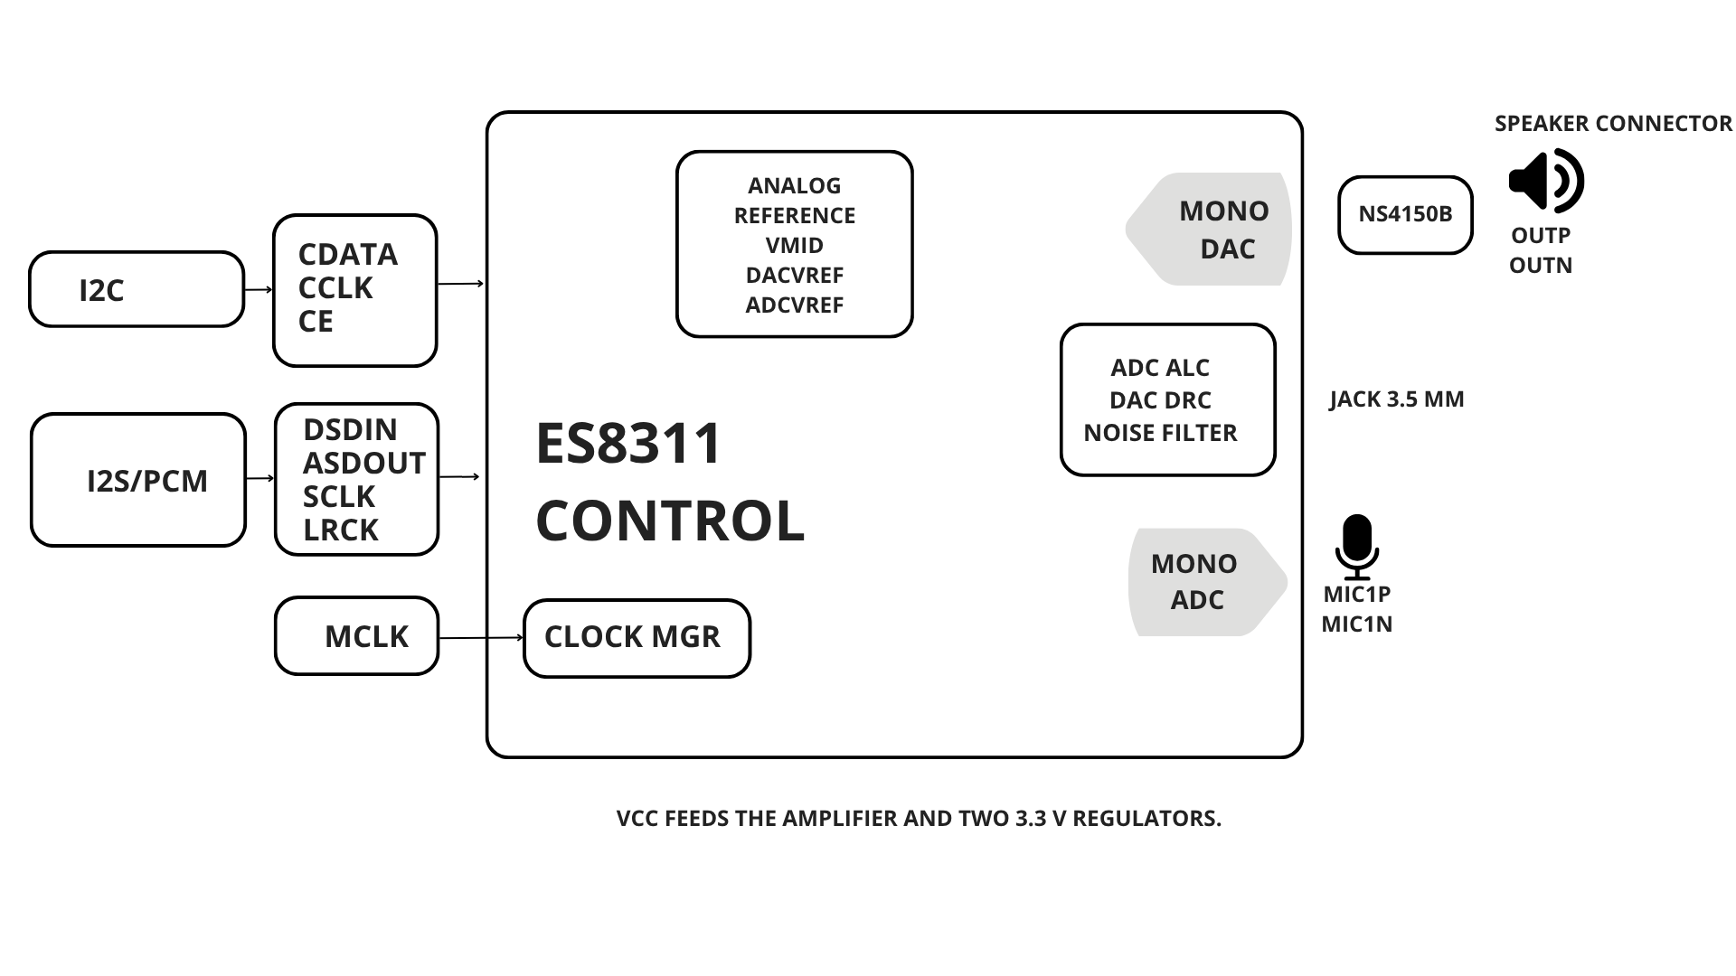
Functional block diagram of the ES8311 codec, microphone input, jack path, and NS4150B speaker amplifier

3.2 Board Topology
The top image shows the QWIIC-style and I2S connectors along one edge, the speaker connector, microphone connector, 3.5 mm jack, and a ten-position castellated header. The opposite image shows the amplifier-off and I2C-address markings.

3.3 Audio Codec
IC1 is the ES8311. Its recording path includes a differential analog input, microphone preamplifier, ADC, programmable gain, and automatic level control. The playback path includes a mono DAC and differential analog outputs. Configuration uses the I2C control interface. See the ES8311 User Guide for register-level programming and valid clock configurations.

3.4 Digital Audio Architecture
The serial audio port supports I2S, left-justified, and DSP-A/B formats. In each format, the codec sends the most significant data bit first. DSDIN1 receives playback samples for the DAC; ASDOUT sends captured ADC samples to the host. These data directions do not change with the clock mode. SCLK times the data bits, while LRCK identifies the audio frame alignment. The host and codec must use the same data format and word length.
Codec mode | SCLK and LRCK at J4 | Clock source at these pins
Slave (reset default) | Inputs | Host
Master | Outputs | ES8311
MCLK is an input in either mode. The codec can select MCLK or SCLK as its internal master-clock source through register settings. The ES8311 User Guide, sections 7 and 8, defines the format timing and clock-divider options.

3.5 Speaker Amplifier
IC2 is NS4150B. ES8311 OUTP and OUTN are AC-coupled into its differential input. Amplifier outputs PA_OUT+ and PA_OUT− reach J1 through zero-ohm links. PA_CTRL is exposed to the host and connects to the amplifier CTRL input.

3.6 Analog Microphone Input
J2 exposes the microphone input circuit for ES8311 MIC1P and MIC1N. The schematic includes resistors and capacitors around the input and bias network.

3.7 Status Indicator
D1 is a green power indicator connected from VCC through R9 to ground. It indicates presence of the module supply; it does not report codec or amplifier configuration.

3.8 AP2112K Power Management System
U1 and U2 are AP2112K-3.3V regulators. U1 creates 3V3 and U2 creates A_3V3 from VCC.

3.9 Power Tree
Source | Destination | Schematic connection
VCC | IC2, D1, J4, J6, U1, U2 | Direct module supply net
U1 / 3V3 | IC1 digital supply and I2C pull-up | Regulated net
U2 / A_3V3 | IC1 AVDD | Analog regulated net
AGND and GND | R8 | Zero-ohm ground coupling

3.10 I2C Control
I2C reads and writes codec registers; audio samples travel on the separate serial audio port. J4 pin 3 (SCL) and J6 pin 4 share the clock net, which reaches IC1 CCLK through zero-ohm R7. J4 pin 4 (SDA) and J6 pin 3 share the bidirectional data net, which reaches IC1 CDATA through zero-ohm R4.
R5 pulls CE to 3V3, selecting the 7-bit address 0x19 in the ES8311 User Guide. The guide specifies an I2C transfer rate below 400 kbit/s and recommends 1–4.7 kΩ pull-ups for CCLK and CDATA. The available schematic page does not show dedicated SCL/SDA pull-ups. Verify the pull-ups and their voltage on the assembled bus before connecting the host or another I2C device.

3.11 Headphone / Jack Path
The ES8311 differential outputs also reach J3, a PJ-320D 3.5 mm jack, through the schematic’s coupling and link components. MIC1P and ground are also present at the jack circuit.

3.12 I2C and QWIIC Expansion
J6 extends the same I2C bus as J4; it is not a separate controller or an I2S connection. Devices attached to J6 share the bus pull-ups and address space. J6 also carries the module VCC input net, not the regulated 3V3 net. Check the attached device’s supply and logic compatibility before connecting it.

3.13 Combined System Operation
A host configures the ES8311 by I2C, supplies suitable clocks, then transfers digital audio over the serial port. The host separately controls PA_CTRL when using the speaker amplifier.

4 Connectors & Pinouts
This chapter transcribes the revision 2.0 schematic. Pin numbering is electrical numbering in that schematic. Before wiring physical connectors, confirm pin-1 orientation on the actual board revision.

4.1 J4 Host Header Pinout
J4 is the ten-position castellated host header.
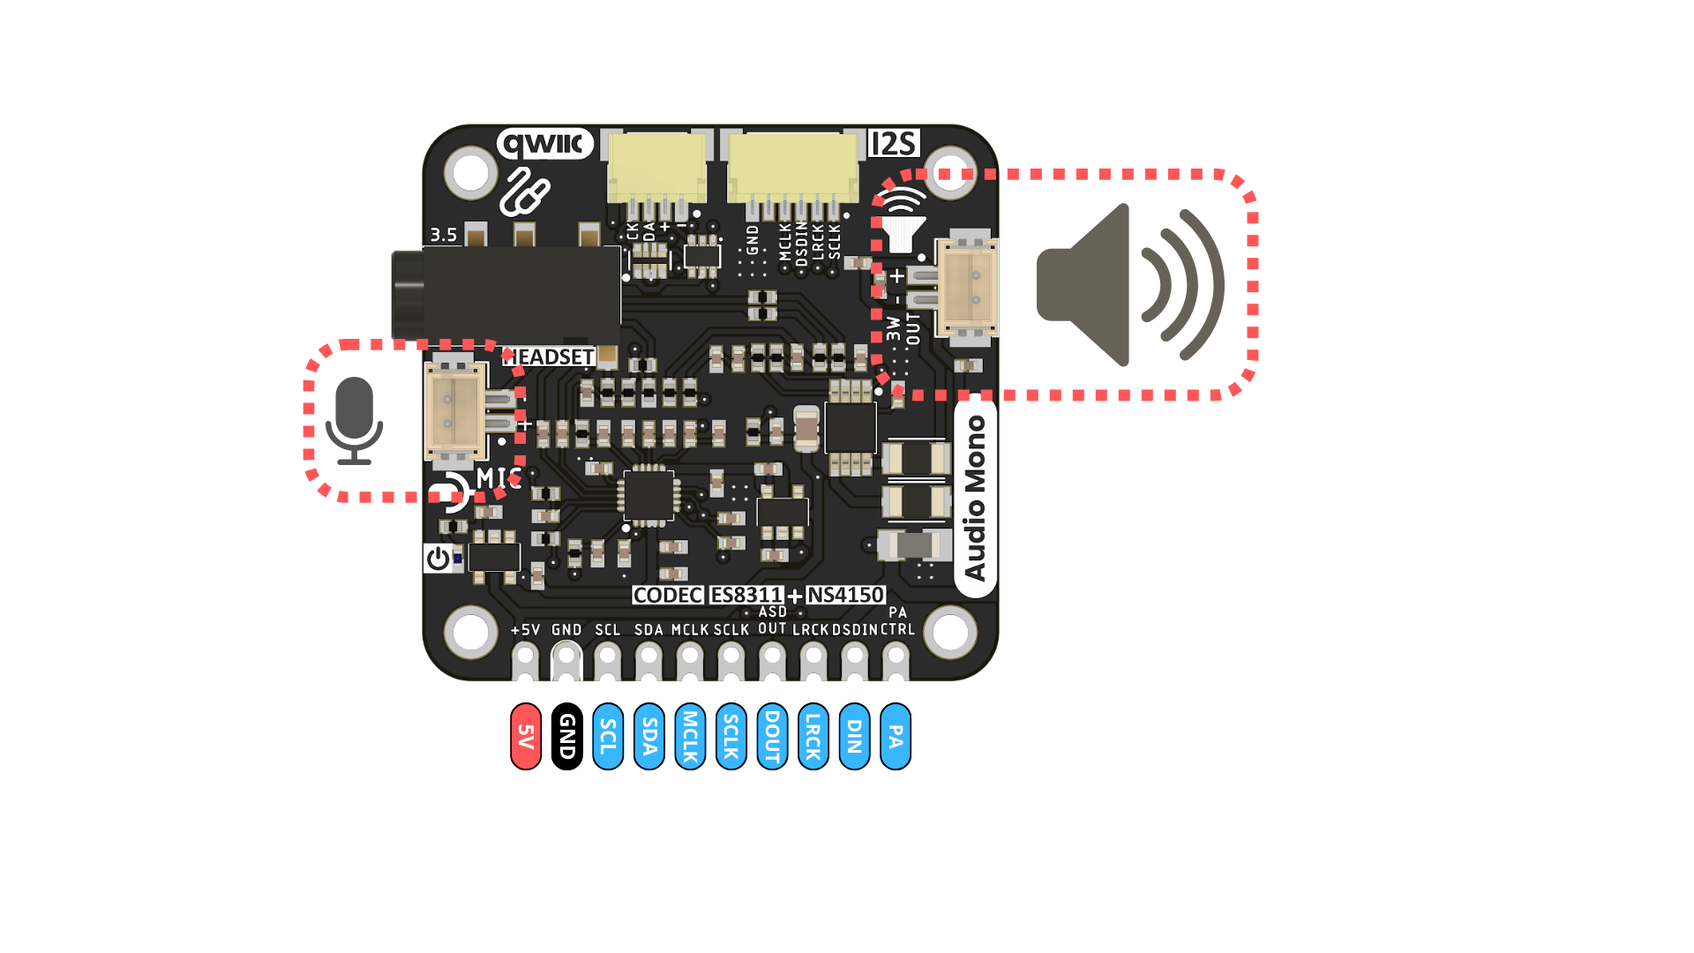
Directions are relative to the module.
J4 pin | Signal | Direction | Function
1 | VCC | Input | Module supply (+5V marking)
2 | GND | Return | Ground reference
3 | SCL | Input | I2C clock from host
4 | SDA | Bidirectional | I2C register data
5 | MCLK | Input | Codec master clock
6 | SCLK | Input / output | Serial audio bit clock
7 | ASDOUT | Output | ADC samples to host
8 | LRCK | Input / output | Audio frame clock
9 | DSDIN1 | Input | DAC samples from host
10 | PA_CTRL | Input | NS4150B amplifier control
SCLK and LRCK are inputs in slave mode and outputs in master mode.
The illustration abbreviates ASDOUT as DOUT, DSDIN1 as DIN, and PA_CTRL as PA. The board silkscreen abbreviates ASDOUT as OUT. These are digital audio and control signals, not the speaker output.

4.2 Host Pinout Compatibility
Host requirement | Module connection | Validated host mapping
I2C SCL / SDA | J4 pins 3 / 4
I2S MCLK / SCLK / LRCK | J4 pins 5 / 6 / 8
I2S ADC receive | J4 pin 7
I2S DAC transmit | J4 pin 9
Amplifier control | J4 pin 10
Supply / return | J4 pins 1 / 2
The module does not implement an Arduino Nano pinout. Host GPIO numbers, voltage compatibility, and required firmware depend on the chosen controller.

4.3 QWIIC Connector
J6 pin | Schematic net
1 | VCC
2 | AGND
3 | SDA
4 | SCL
The board calls J6 QWIIC, while the schematic connects its supply contact to VCC. Connector pitch, mating part, and safe voltage for attached devices are not established by the supplied documentation.

4.4 Microphone Connector
J2 is a two-position connector for the external analog microphone circuit. The schematic shows pin 1 on the MIC1P path and pin 2 on the MIC1N path. Connector polarity and microphone electrical requirements must be checked against the actual assembly.

4.5 Speaker Connections
J1 is the two-position speaker connector: pin 1 is OUT+ and pin 2 is OUT−. These are the differential outputs of the NS4150B amplifier. Neither contact is a ground return.

4.6 3.5 mm Audio Jack
J3 is a PJ-320D jack connected to the codec output path, MIC1P circuit, and analog ground. The supplied schematic does not define a tested headset wiring standard or a user-facing plug-contact pinout.

4.7 Power and Amplifier Control
VCC enters through J4 and is also present at J6. There is no USB, BOOT, or reset circuit on this module. J4 pin 10 carries PA_CTRL; the schematic connects it to IC2 CTRL through R12. The required logic thresholds and safe power-up sequence are not specified at module level.

4.8 Test Pads and Assembly Options
The images show solder options labelled amplifier off and I2C address. The revision 2.0 schematic shows a PA_CTRL-to-ground option and an ES8311 CE pull-up. The default assembled configuration and rework instructions for those options are not documented. Confirm the populated board before changing either option.

5 Board Operation
The module is a peripheral; setup is performed on an external host. The ES8311 User Guide provides component-level register and clock information. The repository currently contains no verified module-specific firmware example.

5.1 Getting Started with a Host Controller
Choose a host with an I2C controller and serial audio interface. Connect supply, ground, SCL, SDA, serial audio data, and PA_CTRL to the J4 functions in Chapter 4. Connect MCLK when selected as the codec’s internal clock source, and set the host’s SCLK and LRCK direction to match the mode in Section 3.4. Confirm power and logic compatibility before energizing the board. The correct host pin numbers and codec driver depend on the host platform.

5.2 First Power-up and Inspection
Inspect connector orientation and the actual revision. Apply the supply intended for that assembly using a current-limited source. The power LED should indicate VCC presence. Verify 3V3 and A_3V3 before connecting a speaker or microphone. The supplied documents contain no module current limit or production acceptance test.

5.3 Control and Clock Workflow
Use I2C to detect the codec at the 7-bit address 0x19 selected by the revision 2.0 schematic’s CE pull-up. Configure the serial audio format, word length, clock source, and clock dividers using the ES8311 User Guide. After reset the codec defaults to slave mode, so the host drives SCLK and LRCK. If master mode is selected, the codec drives those lines; the host must not drive them at the same time. MCLK remains an input when selected as the clock source. Enable the record and playback paths required by the application. A board-tested register sequence has not been supplied.

5.4 Recommended Bring-up Sequence
Step | Check | Expected observation
1 | Power | VCC, 3V3, and A_3V3 present
2 | Control | ES8311 responds at the configured I2C address
3 | Clocks | MCLK, SCLK, and LRCK follow the selected mode
4 | Playback | DSDIN1 carries audio data
5 | Record | ASDOUT carries audio data
6 | Amplifier | PA_CTRL selects the desired amplifier state
7 | External audio | J1, J2, and J3 work with verified loads
Measured pass/fail ranges for these checks are not published.

5.5 Firmware Example Collection
Platform | Verified example
Arduino C++
MicroPython
Other hosts
No module-specific example has been validated in this repository.

5.6 Audio Buffer Planning
Allocate host-side buffers for the selected sample format, clock rate, and latency target. The module itself has no application RAM or storage. Buffer size, DMA strategy, and supported host configurations depend on the host system and are not specified here.

5.7 Recording Operation
J2 supplies the ES8311 analog microphone path. Configure input selection, gain, filtering, and ADC output format using the User Guide. Confirm the microphone’s electrical needs separately. There is no board-validated microphone model or sensitivity figure in the supplied sources.

5.8 Playback and Recording Coexistence
The ES8311 supports simultaneous ADC and DAC paths at component level. The module routes playback toward the jack and amplifier. A host application must coordinate clocks, serial audio slots, buffer flow, and PA_CTRL. No combined-system performance or tested configuration is documented.

5.9 Troubleshooting Guide
Symptom | Check
No I2C response | VCC, ground, 3V3, J4 pin 3 SCL / pin 4 SDA, bus pull-ups, CE population, 7-bit address
No digital audio | Clock source, SCLK/LRCK direction, matching format and word length, DSDIN1/ASDOUT routing
No speaker sound | PA_CTRL, speaker on J1, amplifier VCC, playback path
No microphone signal | J2 wiring, input bias, ADC path, gain and routing
Unexpected noise | Supply and ground arrangement, clock wiring, analog connections
These are diagnostic checks, not validated fault signatures.

6 Mechanical Information
The available top and bottom board images show a compact module with four mounting holes, a 10-position castellated header, a 3.5 mm jack, and audio connectors. They are tagged V1.1.0 and are illustrative for the revision 2.0 electrical reference.

6.1 Component-side Envelope
Component side
Allow clearance for the 3.5 mm plug, microphone and speaker plugs, the QWIIC-style and I2S connectors, and host wiring.

6.2 Bottom-side Envelope
Bottom side
Maintain clearance around solder pads and mounting holes. The available image does not establish a controlled hole pattern or board thickness.

6.3 Mechanical Data Not Specified
Dimension | Value
Board length
Board width
PCB thickness
Mounting-hole diameter
Mounting-hole center coordinates
Maximum component height, top
Maximum component height, bottom
Connector keep-outs
Use a controlled mechanical drawing or physical measurement before designing an enclosure or carrier. No such drawing is supplied in the available package.

7 Company Information
Item | Information
Company | UNIT Electronics
Website | https://uelectronics.com/
Product-specific support contact
Product-specific warranty terms
The product repository and source documents are listed in Chapter 8.

8 Reference Documentation
Reference | Location | Use in this Product Reference
Board schematic, revision 2.0 | hardware/resources/unit_sch_v_2_0_0_i2s_es8311_codec_with_amplifier_module.pdf | Board connections and component identifiers
ES8311 User Guide, Rev 1.11, September 2018 | hardware/resources/es8311_user_guide.pdf | Codec capabilities, supply conditions, I2C address, and audio interface
Top board image, V1.1.0 | hardware/img/unit_top_v_1_1_0_i2s_es8311_codec_with_amplifier_module.png | Visual identification and labels
Bottom board image, V1.1.0 | hardware/img/unit_bottom_v_1_1_0_i2s_es8311_codec_with_amplifier_module.png | Visual identification and labels
Module-specific amplifier datasheet
Controlled mechanical drawing
Verified firmware example
The local PDFs are source documents, not generated by this Product Reference build. The ES8311 guide describes the codec component; it does not certify the electrical or acoustic performance of the assembled module.

9 Appendix

9.1 Schematic
The source drawing is Revision 2.0 schematic. Its title block states sheet 1 of 2, while the supplied PDF contains one page. A second page has not been supplied.

9.1.1 Codec, Power, Amplifier, and Connectors
The available PDF page includes IC1 ES8311, IC2 NS4150B, U1/U2 regulators, J1/J2/J3/J4/J6, microphone bias, and ground coupling.

9.1.2 Additional Schematic Sheet
Field | Value
Additional sheet file
Additional circuits

9.1.3 Controlled Mechanical Drawing
Field | Value
Drawing file
Drawing revision

9.2 Technical References
- The board schematic revision 2.0 defines the circuit and connector signal names.
- The ES8311 User Guide Rev 1.11 defines codec component characteristics and register-level interface behavior.
- The V1.1.0 top and bottom images identify visible parts and labels but do not validate the revision 2.0 electrical implementation.

9.3 Values Not Specified by the Technical Documentation
Missing board-level item | Value
Validated VCC input range
Module current and power budget
Speaker load and amplifier power rating
Microphone electrical compatibility
3.5 mm plug-contact standard
Connector mating part numbers
Overall dimensions and mounting coordinates
Environmental limits and qualification
Tested codec initialization and firmware
Rev 2.0 assembly-to-image correspondence

9.4 Document Control
Field | Value
Product | UNIT I2S ES8311 Codec with Amplifier Module
SKU / MPN | UE0097
Schematic revision | 2.0
Board image file revision | V1.1.0
Product Reference | Version 0.1.0
Publication date | 2026-10-19
Firmware revision

9.5 Source Inconsistencies
- The board image filenames contain V1.1.0; the schematic title block identifies revision 2.0. The available sources do not reconcile them.
- The schematic title block identifies sheet 1 of 2, but the supplied PDF has one page.
- The images call J6 QWIIC and mark the board supply +5V. The schematic connects J6 supply to VCC, not to the regulated 3V3 net.
- The ES8311 guide cover displays Rev 1.00 while its page footers display Rev 1.11. Component facts in this document are cited to the supplied file.

9.6 Hardware Errata
Erratum | Status | Resolution
No verified hardware erratum is included in the supplied sources.

