DevLab I2S ICS-43434 MEMS Microphone
Preliminary Product Reference — Hardware V1.0 — Mfr. Part #: UE0149
UNIT Electronics
2026-08-03

Contents
- Description
  - Applications
  - Hardware Features
- 1 The Module
  - 1.1 Board Identification
  - 1.2 Package Contents
- 2 Electrical Characteristics
  - 2.1 Currently Documented Values
  - 2.2 Electrical Precautions
- 3 Functional Overview
  - 3.1 Audio Signal Path
  - 3.2 Channel Selection
  - 3.3 Power Section
- 4 Connectors and Pinout
  - 4.1 Edge Connections
  - 4.2 Six-Position JST-SH Connector
  - 4.3 Solder Options
- 5 Preliminary Operation Notes
- 6 Mechanical Information
- 7 Company Information
- 8 Reference Documentation
- 9 Appendix
  - 9.1 Source Hierarchy
  - 9.2 Items Pending Validation
  - 9.3 Document Control

Description
The UNIT DevLab I²S ICS-43434 MEMS Microphone is a compact digital-audio module based on the bottom-port ICS-43434 MEMS microphone. The microphone integrates signal conditioning, a 24-bit analog-to-digital converter, decimation and anti-aliasing filters, power management, and an I²S output.
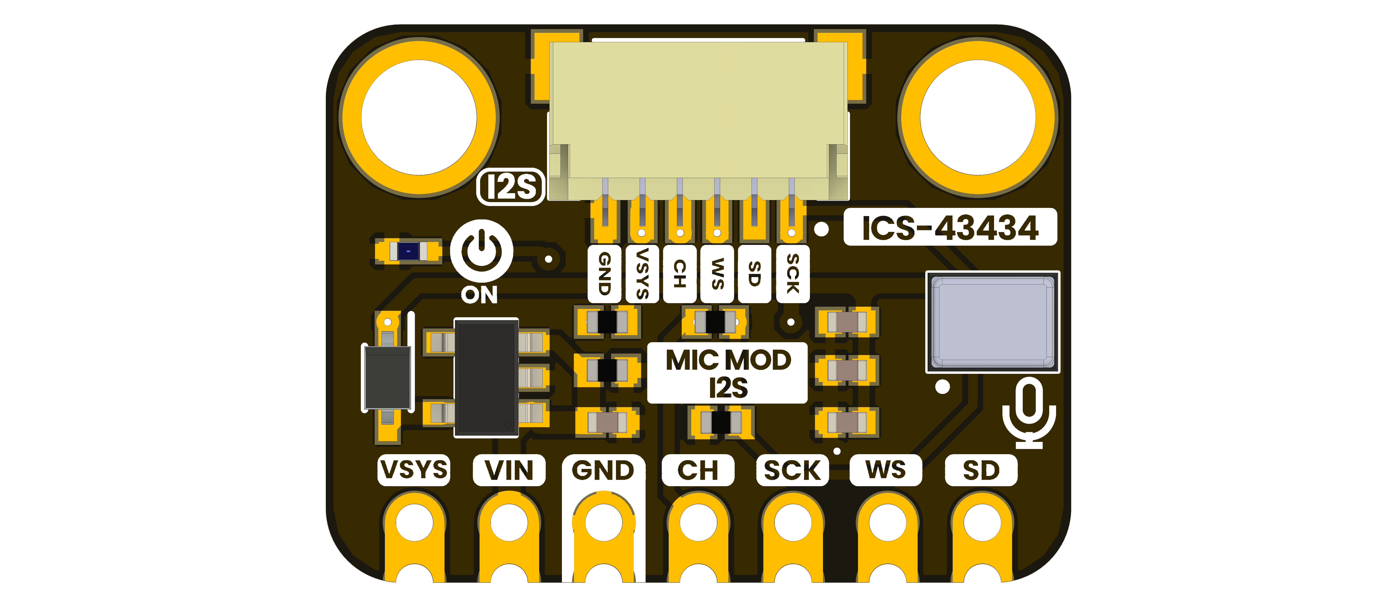

Applications
- Voice capture and recognition prototypes
- Intercom and teleconferencing systems
- Acoustic sensing and security projects
- Stereo or microphone-array experiments
- Educational I²S audio acquisition

Hardware Features
- ICS-43434 bottom-port digital MEMS microphone
- 24-bit I²S serial audio output
- Left/right time-slot selection through the CH signal
- AP2112K fixed 3.3 V onboard regulator
- Seven 2.54 mm edge connections
- Six-position, 1.0 mm-pitch JST-SH connector
- Power indicator and selectable solder options shown on the V1.0 artwork

1 The Module

1.1 Board Identification
Item | Value
Product | DevLab: I2S ICS-43434 MEMS Microphone
Manufacturer part number | UE0149
Hardware revision shown | V1.0
Microphone | ICS-43434
Digital audio interface | I²S
Product-reference revision | 0.1.0, preliminary

1.2 Package Contents
The BOM includes one four-conductor, 1.0 mm-pitch QWIIC-style harness. Confirm the contents of a purchased product with the distributor because package contents have not yet been formally released. The BOM also identifies J1 as a six-position connector, so harness-to-J1 compatibility remains to be verified.

2 Electrical Characteristics

2.1 Currently Documented Values
Symbol / parameter | Description | Value | Scope
VDD | ICS-43434 microphone supply | 1.62 to 3.63 V | Microphone pin
ADC output | Digital sample width | 24 bit | Microphone I²S output
SNR | Signal-to-noise ratio | 64 dBA typical | Microphone characteristic
Frequency response | Stated audio band | 60 Hz to 20 kHz | EMMIC-ICS43434 reference
Sensitivity tolerance | Unit-to-unit tolerance | ±1 dB | Microphone characteristic
VREG | U3 regulated output | 3.3 V nominal | BOM identification
The allowed voltage at the module’s VIN pin and the electrical behavior of VSYS have not been verified from a released schematic. Do not substitute the microphone VDD range or the AP2112K component rating for a module input rating.

2.2 Electrical Precautions
- Connect GND between the host and module before applying power or clocks.
- Drive SCK, WS, and CH only within the validated logic domain; the module-level input thresholds remain pending.
- Do not drive SD; it is an output from the microphone.
- Keep the bottom acoustic port free from debris, flux, adhesive, and enclosure pressure.
- Confirm VIN, VSYS, and JST supply behavior on the schematic or physical board before first power-up.

3 Functional Overview

3.1 Audio Signal Path
The ICS-43434 senses pressure at its bottom acoustic port, conditions the MEMS signal, converts it to digital audio, and places 24-bit samples on SD. A host controller supplies SCK and WS; no master clock line is exposed by the module.

3.2 Channel Selection
CH selects the I²S time slot used by the microphone. A low level selects the left channel and a high level selects the right channel. Two modules can share the clock and data timing when their channel selections and data connection are implemented according to the ICS-43434 application requirements.

3.3 Power Section
The manufacturing BOM identifies an AP2112K-3.3TRG1 regulator, Schottky diode, decoupling capacitors, orange indicator LED, and associated resistors. The exact VIN/VSYS power path and solder-option defaults remain pending until a released module schematic is available.
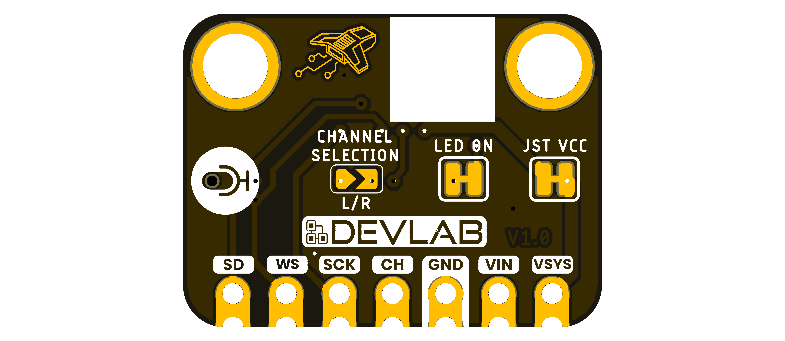

4 Connectors and Pinout

4.1 Edge Connections
Board label | Direction | Function
VSYS | Power | Module system rail
VIN | Input | Module supply input; allowed range pending
GND | Power | Common ground
CH | Input | Left/right I²S channel selection
SCK | Input | I²S serial bit clock
WS | Input | I²S word select / left-right clock
SD | Output | I²S serial audio data

4.2 Six-Position JST-SH Connector
The V1.0 top artwork labels the connector signals, from the leftmost contact in the rendered top view, as GND, VSYS, CH, WS, SD, and SCK. Verify orientation on the physical board before making a cable; the present document does not assign connector pin numbers.

4.3 Solder Options
The bottom artwork identifies L/R, LED ON, and JST VCC options. Their default copper states and exact circuit connections are pending schematic verification.

5 Preliminary Operation Notes
The firmware under software/examples/i2s/ is experimental and remains under test, so it is intentionally not reproduced as a validated example here.
For initial bench work:
- Inspect the board and ensure the bottom acoustic port is unobstructed.
- Verify the VIN/VSYS power path against a schematic or measured board.
- Connect the host and module grounds.
- Connect host I²S bit clock to SCK, word select to WS, and receive data to SD.
- Set CH low for the left time slot or high for the right time slot.
- Start with conservative audio settings and confirm framing using a logic analyzer before relying on captured sample values.
Host GPIO numbers are controller-specific and are not module pin numbers. Clock limits, tested sample rates, sample alignment, and controller examples will be added after validation.

6 Mechanical Information
The board provides two mounting holes, seven edge connections, and a right-angle JST-SH connector. A controlled dimensional drawing has not yet been added, so do not scale dimensions from the rendered image.
Allow clearance beneath the ICS-43434 bottom acoustic port. Do not cover the port with a flat enclosure wall, adhesive, solder mask contamination, or mounting hardware.

7 Company Information
Item | Information
Company | UNIT Electronics
Website | https://uelectronics.com/
Address | Salvador 19, Cuauhtémoc, 06000 Mexico City, CDMX, Mexico
Product specifications and documentation may be revised. Use the repository and product page listed in the next chapter for the latest released material.

8 Reference Documentation
Reference | Location
Repository | UNIT-Electronics-MX/unit_devlab_i2s_ics_43434_mems_microphone
Hardware notes | Hardware README
Microphone reference | EMMIC-ICS43434 PDF
Manufacturing BOM | ICS-43434 module BOM
Experimental firmware | I²S example
The three-page EMMIC-ICS43434 file is a third-party breakout-board reference, not the complete manufacturer datasheet for the ICS-43434 and not a DevLab module datasheet. Use it only for the characteristics explicitly cited in this preliminary document.

9 Appendix

9.1 Source Hierarchy
This preliminary product reference follows the V1.0 board artwork for visible signal labels, the manufacturing BOM for fitted component identities, and the local EMMIC-ICS43434 document for the limited microphone values quoted here. A future released schematic and complete manufacturer datasheet take precedence if they conflict with this edition.

9.2 Items Pending Validation
- Module schematic and controlled pin-number drawing
- Module VIN and VSYS operating and absolute-maximum ratings
- Digital input thresholds, current consumption, and clock limits
- Tested sample rates and controller-specific I²S configurations
- Board dimensions and mounting-hole coordinates
- Solder-option defaults and JST cable orientation
- Acoustic and environmental module-level characterization

9.3 Document Control
Field | Value
Product | DevLab: I2S ICS-43434 MEMS Microphone
Manufacturer part number | UE0149
Hardware artwork covered | V1.0
Product-reference revision | 0.1.0, preliminary
Publication date | 2026-08-03
Firmware status | Experimental; not validated by this edition

