DevLab PDM ICS-41350 MEMS Microphone
Product Reference — Hardware V1.1 — Mfr. Part #: UE0148
UNIT Electronics
2026-08-03

Contents
- Description
  - Applications
  - Hardware Features
- 1 The Module
  - 1.1 Board Identification
  - 1.2 Package Contents
- 2 Electrical Characteristics
  - 2.1 ICS-41350 Characteristics
  - 2.2 Electrical Precautions
- 3 Functional Overview
  - 3.1 Audio Signal Path
  - 3.2 Operating Modes
  - 3.3 Channel Selection
  - 3.4 Power Section
- 4 Connectors and Pinout
  - 4.1 Edge Connections
  - 4.2 Four-Position Connector
  - 4.3 Solder Options
- 5 Board Operation
- 6 Mechanical Information
- 7 Company Information
- 8 Reference Documentation
- 9 Appendix
  - 9.1 Source Hierarchy
  - 9.2 Items Pending Validation
  - 9.3 Document Control

Description
The UNIT DevLab PDM ICS-41350 MEMS Microphone is a compact digital-audio module built around the bottom-port TDK InvenSense ICS-41350. The microphone contains a MEMS element, impedance-converter amplifier, and fourth-order sigma-delta modulator that produces a 1-bit pulse-density-modulated output.
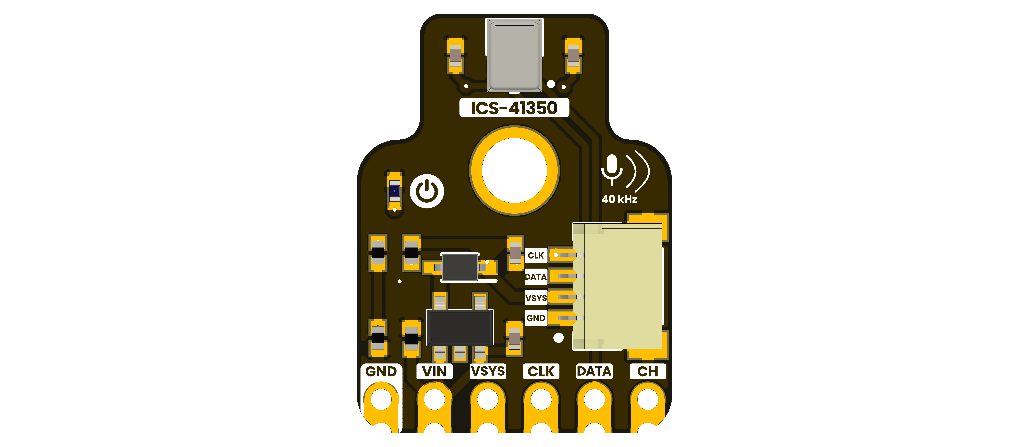

Applications
- Voice capture and recognition prototypes
- Microphone-array development
- Camera, security, and surveillance audio
- Low-power ambient sound analysis and keyword spotting
- Ultrasonic sensing experiments in high-performance mode

Hardware Features
- ICS-41350 bottom-port digital MEMS microphone
- PDM clock and data interface
- Clock-selected low-power, standard, high-performance, and sleep modes
- Sensor channel selection for shared-data stereo configurations
- AP2112K-3.3TRG1 fixed 3.3 V regulator identified by the BOM
- Six 2.54 mm edge/header connections
- Four-position, 1.0 mm-pitch right-angle connector
- Orange indicator LED and two solder options shown on the V1.1 artwork

1 The Module

1.1 Board Identification
Item | Value
Product | DevLab PDM ICS-41350 MEMS Microphone
Manufacturer part number | UE0148
Hardware revision shown | V1.1
Microphone | TDK InvenSense ICS-41350
Digital audio interface | PDM
Product-reference revision | 0.1.0

1.2 Package Contents
The manufacturing BOM includes one four-conductor, 1.0 mm-pitch QWIIC-style harness. Confirm purchased-product contents with the distributor. The BOM identifies J2 as a four-position, 1.0 mm-pitch connector, but cable orientation and end-to-end pin order remain pending validation.

2 Electrical Characteristics

2.1 ICS-41350 Characteristics
The values in this section apply to the ICS-41350 sensor. They are not complete module ratings.
Parameter | Low-power mode | Standard mode | High-performance mode | Scope
Clock frequency | 400–800 kHz | 1.0–3.3 MHz | 4.1–4.8 MHz | Sensor CLK
Sensitivity, typical | −26 dB FS | −26 dB FS | −32 dB FS | Sensor, 1 kHz and 94 dB SPL
SNR, typical | 63 dBA | 64 dBA | 64 dBA | Sensor
Supply current, typical | 185 µA | 430 µA | 650 µA | Sensor at VDD = 1.8 V, no load
Acoustic overload point, typical | 120 dB SPL | 120 dB SPL | 126 dB SPL | Sensor, 10% THD

Parameter | Minimum | Typical | Maximum | Scope
Sensor supply voltage, VDD | 1.65 V | — | 3.63 V | ICS-41350 supply pin
Sleep-mode clock | — | — | Below 200 kHz | ICS-41350 CLK
Sleep current | — | 12 µA | 20 µA | ICS-41350
Digital input high, VIH | 0.65 × VDD | — | — | ICS-41350 digital input
Digital input low, VIL | — | — | 0.35 × VDD | ICS-41350 digital input
Regulated output | — | 3.3 V nominal | — | U3 identity from BOM; module behavior pending
The permitted voltage at module VIN, the behavior and limits of VSYS, host logic compatibility, and total module current are pending schematic verification and module-level validation. Do not substitute the sensor VDD range, the regulator limits, the diode ratings, or the connector rating for a module input rating.

2.2 Electrical Precautions
- Keep the host and module grounds connected during operation.
- Do not drive DATA; it is the microphone output.
- Apply CLK and CH only after the module power and logic domains have been verified against a released schematic or a measured board.
- Keep the bottom acoustic port free from debris, flux, adhesive, and enclosure obstruction.
- Verify VIN, VSYS, J2 supply routing, and solder-option states before first power-up.

3 Functional Overview

3.1 Audio Signal Path
The ICS-41350 senses pressure through its bottom acoustic port and emits the 1-bit output of a fourth-order sigma-delta modulator on DATA. A host supplies CLK and performs PDM decimation or passes the stream to a compatible codec.

3.2 Operating Modes
The sensor selects its operating mode from the applied clock frequency: below 200 kHz for sleep, 400 to 800 kHz for low power, 1.0 to 3.3 MHz for standard, and 4.1 to 4.8 MHz for high performance. These are ICS-41350 characteristics; tested module and host configurations remain pending validation.

3.3 Channel Selection
At the ICS-41350 SELECT pin, low selects the right channel (DATA1) and high, tied to sensor VDD, selects the left channel (DATA2). The V1.1 board artwork labels an exposed CH connection and a CH SELECTION L/R solder option. Their exact circuit mapping and default state are pending schematic verification.

3.4 Power Section
The BOM identifies an AP2112K-3.3TRG1 regulator, NSR0320MW2T1G Schottky diode, 1 µF power capacitors, a 100 nF microphone decoupling capacitor, an orange indicator LED, and associated resistors. The exact VIN/VSYS path and the LED-enable default remain pending schematic verification.
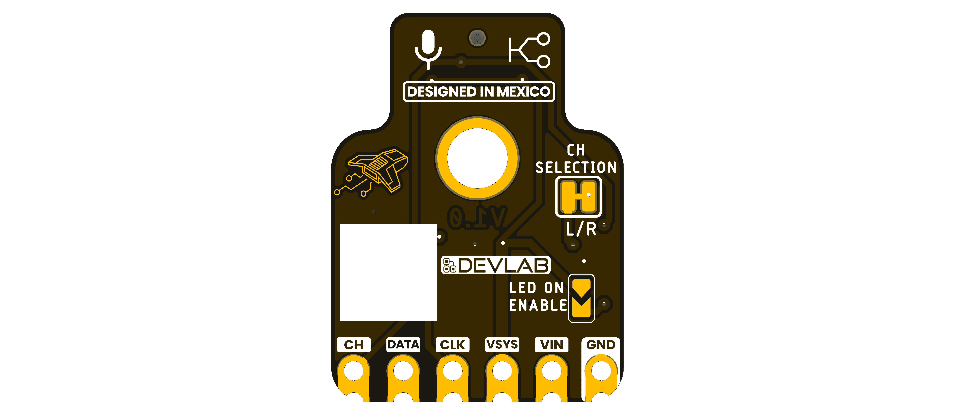

4 Connectors and Pinout

4.1 Edge Connections
Board label | Direction | Function
GND | Power | Common ground
VIN | Input | Module power-section input; allowed range pending
VSYS | Power | Module system rail; electrical behavior pending
CLK | Input | PDM clock input
DATA | Output | PDM microphone data
CH | Input | Channel-selection signal; module mapping pending schematic verification

4.2 Four-Position Connector
The V1.1 top artwork labels the connector signals, from top to bottom in the rendered view, as CLK, DATA, VSYS, and GND. The manufacturing BOM calls J2 a four-position, 1.0 mm-pitch right-angle connector. Verify physical orientation before connecting a cable; this edition does not assign connector pin numbers.

4.3 Solder Options
The bottom artwork identifies CH SELECTION L/R and LED ON ENABLE options. Their default copper states and exact circuit connections are pending schematic verification.

5 Board Operation
No firmware example has been validated for this module, so this reference does not present host code as a tested procedure.
For initial bench validation:
- Inspect the board and ensure the bottom acoustic port is unobstructed.
- Verify the VIN/VSYS power path, supply range, and logic domain against a released schematic or measured board.
- Connect host and module grounds.
- Connect the host PDM clock output to CLK and PDM data input to DATA.
- Configure the channel only after verifying how board CH and the solder option connect to the ICS-41350 SELECT pin.
- Apply a clock in the intended ICS-41350 mode range and verify timing with a logic analyzer before relying on captured samples.
Host GPIO numbers are controller-specific and are not module pin numbers. Tested decimation settings, sample rates, host mappings, and module-level logic limits remain pending validation.

6 Mechanical Information
The rendered V1.1 artwork shows six castellated edge connections, a four-position right-angle connector, and a central circular opening. A controlled dimensional drawing and mounting coordinates are not available, so dimensions must not be scaled from the render.
The ICS-41350 itself uses a 3.5 mm × 2.65 mm × 0.98 mm bottom-port package. Those sensor-package dimensions are not the dimensions of the module. Allow clearance around the acoustic path and keep it free of adhesive, debris, and mounting obstruction.

7 Company Information
Item | Information
Company | UNIT Electronics
Website | https://uelectronics.com/
Address | Salvador 19, Cuauhtémoc, 06000 Mexico City, CDMX, Mexico
Product specifications and documentation may be revised. Use the repository and product page listed in the next chapter for the latest released material.

8 Reference Documentation
Reference | Location
Repository | Public URL pending
Hardware notes | Public URL pending
Microphone datasheet | TDK InvenSense ICS-41350
Manufacturing BOM | Reviewed local source; public URL pending
The local microphone source is TDK InvenSense document DS-000047, revision 1.1, dated 2016-06-23. Sensor values in this reference come from that document; module component identities come from the manufacturing BOM; visible module labels come from the V1.1 artwork.

9 Appendix

9.1 Source Hierarchy
This product reference follows the V1.1 board artwork for visible signal labels, the manufacturing BOM for fitted component identities, and TDK InvenSense datasheet DS-000047 revision 1.1 for ICS-41350 characteristics. A released module schematic and module-level validation take precedence if they conflict with this edition.

9.2 Items Pending Validation
- Module schematic and controlled connector pin-number drawing
- Module VIN and VSYS operating and absolute-maximum ratings
- Module logic levels and total current consumption
- Tested PDM clock modes, decimation settings, sample rates, and host mappings
- Board dimensions and mounting coordinates
- Solder-option defaults and J2 cable orientation
- Module-level acoustic, environmental, and ultrasonic characterization

9.3 Document Control
Field | Value
Product | DevLab PDM ICS-41350 MEMS Microphone
Manufacturer part number | UE0148
Hardware artwork covered | V1.1
Product-reference revision | 0.1.0
Publication date | 2026-08-03
Firmware status | No validated example included in this edition

