Power Supply for Breadboard with Qwiic
Product Reference Manual — Hardware Revision V1.0
UNIT Electronics
2026-06-30

Contents
- Description
  - Applications
  - Hardware Features
- 1 The Board
  - 1.1 Board Identification {.section-page}
  - 1.2 Included and Recommended Items {.section-page}
  - 1.3 Main Assemblies {.section-page}
  - 1.4 Board Views {.section-page}
  - 1.5 Handling {.section-page}
- 2 Ratings
  - 2.1 Recommended Operating Conditions {.section-page}
  - 2.2 Electrical Notes {.section-page}
  - 2.3 Power-Domain Scope {.section-page}
- 3 Functional Overview
  - 3.1 Power Distribution Architecture {.section-page}
  - 3.2 USB-C Power Delivery {.section-page}
  - 3.3 Qwiic Expansion {.section-page}
  - 3.4 Breadboard Integration {.section-page}
- 4 Connectors and Pinout
  - 4.1 General Pinout Description {.section-page}
  - 4.2 Qwiic I²C Connector {.section-page}
  - 4.3 Output Connections {.section-page}
- 5 Board Operation
  - 5.1 Initial Power-Up {.section-page}
  - 5.2 Standalone PD Selection {.section-page}
  - 5.3 I²C Monitoring with Arduino {.section-page}
  - 5.4 Operational Precautions {.section-page}
- 6 Mechanical Information
  - 6.1 Installation Notes {.section-page}
- 7 Company Information
- 8 Reference Documentation
- 9 Appendix
  - 9.1 Source Migration {.section-page}
  - 9.2 Documentation Scope {.section-page}
  - 9.3 Document Control {.section-page}

Description
The DevLab Power Supply for Breadboard with Qwiic is a USB Type-C-powered power-distribution module for breadboard-based electronic prototyping. It acts as a USB Power Delivery (PD) sink, negotiates a profile from a compatible source, and routes the negotiated VUSB rail to selectable breadboard outputs. An onboard TPS54302 buck regulator supplies a separate 3.3 V rail.
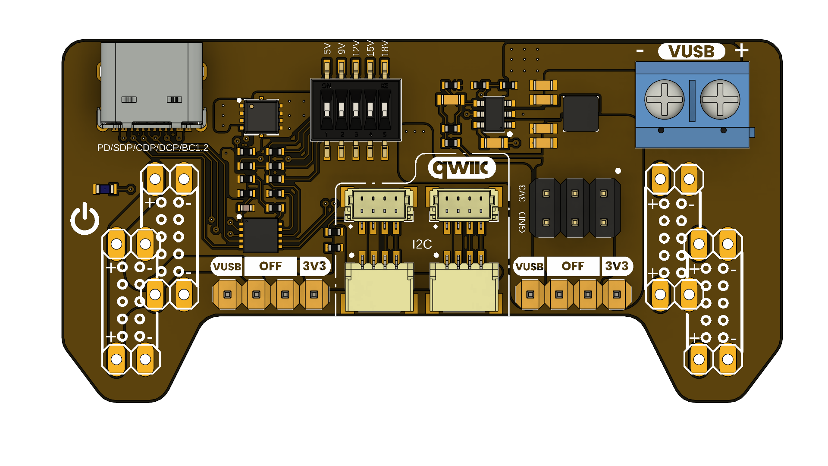
Power Supply for Breadboard with Qwiic top view

Applications
- Breadboard power distribution and mixed-voltage prototyping
- USB-C PD source and cable evaluation
- Embedded-system, sensor, and peripheral development
- Laboratory education, validation, and early hardware testing

Hardware Features
- USB Type-C PD input with HUSB238 PD-sink controller
- Selectable VUSB profiles supported by the attached PD source
- TPS54302-based 3.3 V output rail
- Independent left and right breadboard-rail selection
- Screw-terminal and header outputs for VUSB, 3.3 V, and ground
- Qwiic-compatible I²C connectors for 3.3 V peripherals
- DIP-switch PD configuration and optional HUSB238 I²C access
The module is mechanically intended for common 54 mm and 64 mm breadboard rail formats. Output voltage and available current depend on the negotiated PD profile, source, cable, thermal conditions, and external load.

1 The Board
The Power Supply for Breadboard with Qwiic provides a compact power entry and distribution point for solderless breadboards. A USB-C PD source supplies the module. The selected VUSB rail and the regulated 3.3 V rail can be assigned to the two breadboard sides independently, which supports both single-voltage and mixed-voltage prototypes.

1.1 Board Identification
Item | Value
Product | Power Supply for Breadboard with Qwiic
Manufacturer part number | UE0113
Product family | UNIT Electronics DevLab
Product type | USB-C PD breadboard power-distribution module
Hardware revision | V1.0
Product Reference | Version 1.0.0
PD controller | HUSB238
3.3 V regulator | TPS54302

1.2 Included and Recommended Items
The released V1.0 datasheet lists the following accessory items: 16 single-row male headers, one Qwiic 4-pin JST 1.0 mm harness, and two jumper caps.
For safe operation, use a USB-C charger that supports the needed PD profile, a USB-C cable rated for the expected voltage and current, and a breadboard with the appropriate rail spacing. Verify the source profile before connecting a load.

1.3 Main Assemblies
RefDes | Component or connector | Function
J1 | USB Type-C connector | PD power input
IC1 | HUSB238 | PD negotiation controller
SW1 | DIP switch | PD voltage-profile selection
U1 | TPS54302 | 3.3 V buck regulator
L1 | Power LED | Power indication
J6 | Screw terminal | VUSB output access
JP7 | Pin header | 3.3 V output access
JP3 / JP4 | Selector headers | Left and right rail-voltage selection
JP1 / JP2 | Left headers | Breadboard power connection
JP5 / JP6 | Right headers | Breadboard power connection

1.4 Board Views

Top view
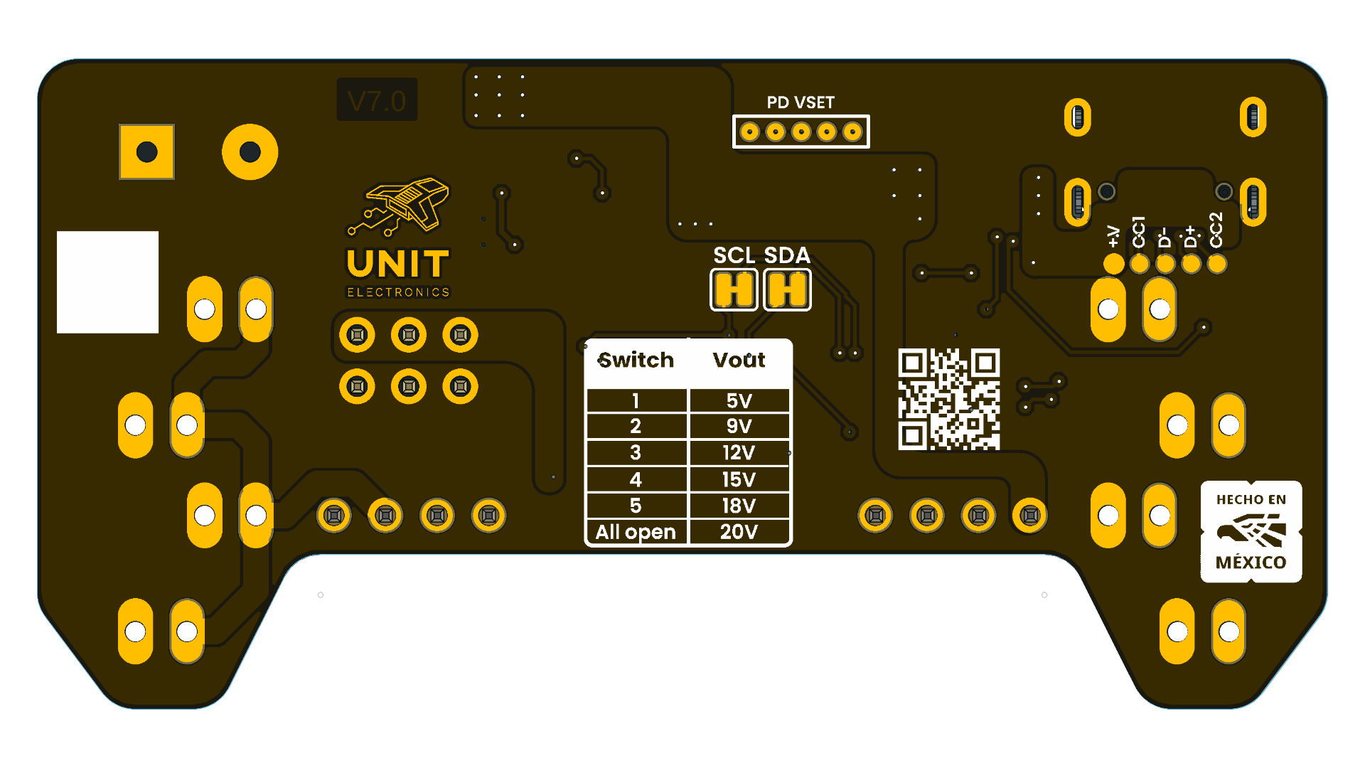
Bottom view

1.5 Handling
Disconnect USB-C power before moving rail-selection jumpers, inserting the board into a breadboard, or changing wiring. Keep high-voltage VUSB wiring away from the 3.3 V logic rail and confirm polarity before connecting a load.

2 Ratings
The following values are migrated from the released V1.0 product datasheet. They describe intended module operation and do not replace the limits in the HUSB238 or TPS54302 component datasheets.

2.1 Recommended Operating Conditions
Parameter | Description | Min | Typ | Max | Unit
VIN | USB Type-C PD input voltage | 5 | — | 20 | V
VBUS | USB PD negotiated output voltage | 5 | 9 / 12 / 15 | 20 | V
V3V3 | Regulated 3.3 V output rail | 3.2 | 3.3 | 3.4 | V
I3V3 | 3.3 V regulator output current | — | — | 2 | A
IBUS | Breadboard output current | — | — | 5 | A
VIH | I²C high-level input voltage | 0.7 × VCC | — | 5.5 | V
VIL | I²C low-level input voltage | — | — | 0.3 × VCC | V
ICC | Module supply current | — | 3.1 | — | mA
fI2C | I²C communication frequency | 0 | 100 | 400 | kHz
TOPD | USB PD supported profiles | 5 | 9 / 12 / 15 | 20 | V
TAMB | Recommended ambient temperature | -20 | 25 | 85 | °C

2.2 Electrical Notes
- PD voltage can be selected through the onboard DIP-switch resistor network or dynamically through the HUSB238 I²C interface. I²C configuration takes precedence over DIP-switch selection.
- The 3.3 V output capability depends on input voltage, thermal dissipation, board airflow, and load conditions.
- Qwiic/STEMMA QT connectors share 3.3 V, ground, SDA, and SCL for daisy-chain operation.
- VBUS output current depends on the available source profile, cable, and electrical characteristics of the attached PD power adapter.
- For stable 3.3 V regulation, use a 9 V, 12 V, 15 V, or 20 V PD profile. At 5 V, the input must remain above 4.5 V under load to avoid TPS54302 UVLO.

2.3 Power-Domain Scope
VUSB is the negotiated USB-C PD output rail. 3V3 is generated by the TPS54302 and is intended for low-voltage logic and Qwiic peripherals. Both rails share ground but must not be treated as interchangeable. Available current for a specific setup is limited by the PD source, cable, selected profile, onboard consumption, temperature, and connected load.

3 Functional Overview
The module receives power from a USB-C PD source, negotiates a compatible fixed profile through the HUSB238 controller, and distributes that negotiated VUSB rail to the screw terminal and selectable breadboard headers. In parallel, the TPS54302 converts VUSB to a regulated 3.3 V rail for logic and Qwiic peripherals.

3.1 Power Distribution Architecture
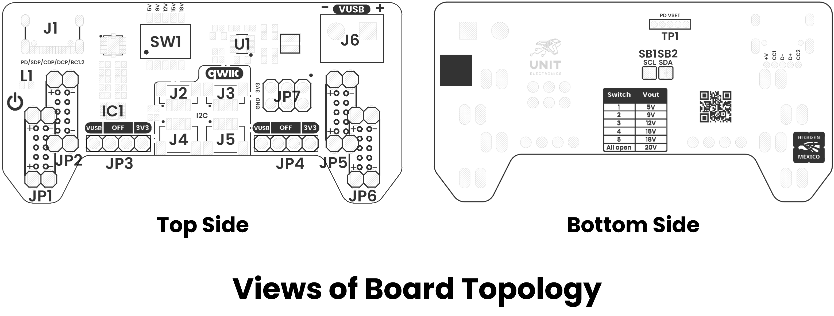
Board topology
The left and right breadboard rails have independent selectors. Each selector can route VUSB, disconnect the rail, or route 3.3 V. This makes it possible to use a higher PD voltage for one rail while retaining 3.3 V logic on the other.
Selection | Function
VUSB | Routes the negotiated USB-C PD voltage to the rail
OFF | Disconnects the rail output
3V3 | Routes the regulated 3.3 V rail to the rail

3.2 USB-C Power Delivery
The HUSB238 performs USB-C PD-sink negotiation with a compatible source. The available profiles are determined by the charger and cable; selecting a profile does not create a voltage that the source did not advertise. The released datasheet describes 5 V, 9 V, 12 V, 15 V, and 20 V as the standard profiles, and also mentions 18 V where that profile is offered by the source.
Use the onboard DIP switch for standalone configuration. When HUSB238 I²C access is enabled, a host controller can monitor the connection and apply dynamic selection; I²C configuration has priority over the DIP-switch setting.

3.3 Qwiic Expansion
The Qwiic-compatible JST 1.0 mm connectors expose a shared 3.3 V I²C bus: SDA, SCL, 3.3 V, and ground. Optional solder jumpers connect the HUSB238 to that bus for monitoring and control. Leave those jumpers open when the controller must remain isolated from the external Qwiic network.
The I²C bus is a 3.3 V logic domain. Do not apply VUSB to SDA, SCL, or the Qwiic power pin.

3.4 Breadboard Integration
The mechanical layout aligns with common 54 mm and 64 mm breadboard rail formats. The two sides permit independent power assignment for cases such as:
Left rail | Right rail | Typical use
3.3 V | 3.3 V | Logic and sensor prototype
VUSB | 3.3 V | Mixed power and logic system
12 V | 3.3 V | Motor driver with microcontroller
OFF | VUSB | Single high-voltage rail test
The 12 V example assumes that the source provides and the module has selected that VUSB profile.

4 Connectors and Pinout
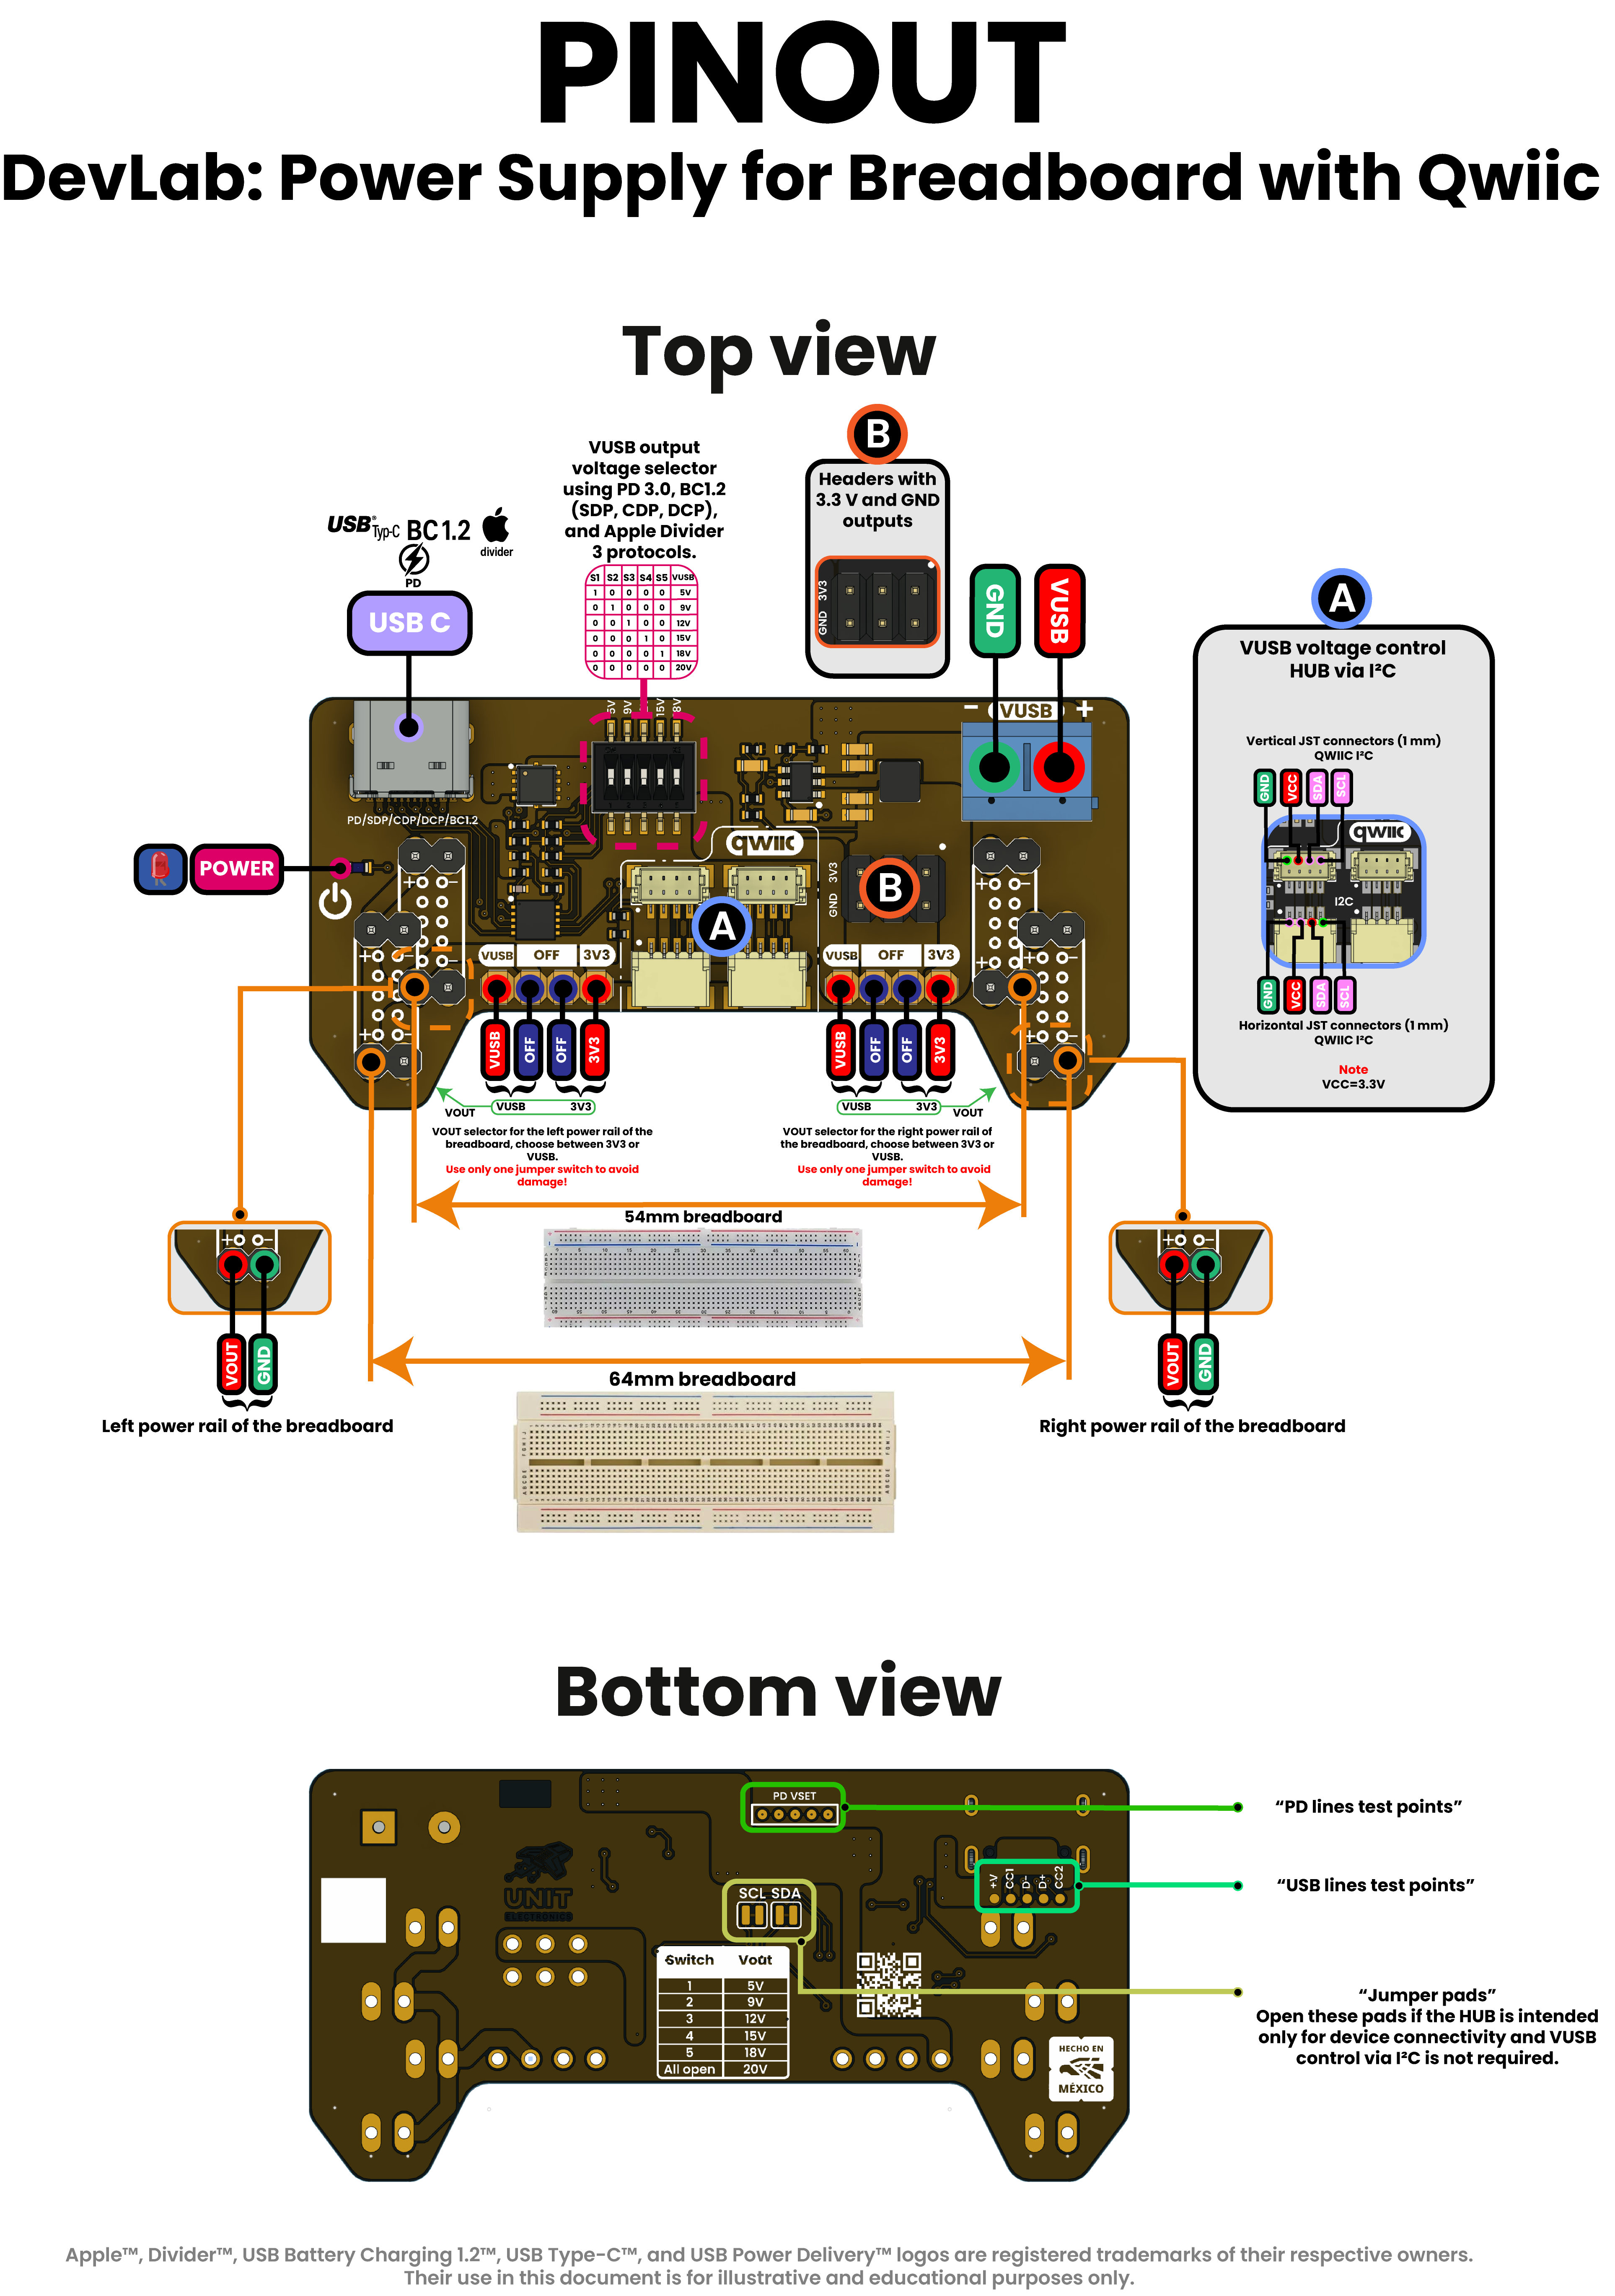
General pinout

4.1 General Pinout Description
Label | Function | Notes
VUSB | USB PD output rail | Negotiated PD voltage; 5 V to 20 V according to the attached source and selected profile
3V3 | Regulated output | Generated by the TPS54302 regulator
GND | Ground reference | Common reference for power and signals
SDA | I²C data | Qwiic/STEMMA QT bus; optional HUSB238 access
SCL | I²C clock | Qwiic/STEMMA QT bus; optional HUSB238 access
USB-C | PD input | Power input from a compatible USB-C PD source
DIP SW | PD configuration | Selects the standalone PD request configuration
Qwiic | I²C connector | JST 1.0 mm, 3.3 V peripheral interface
VOUT | Breadboard power output | Selected power rail for external circuits
GND OUT | Breadboard ground | Ground output for external circuits
Header A | Breadboard interface | Power-rail connection
Header B | Auxiliary power header | VUSB, 3.3 V, and ground outputs

4.2 Qwiic I²C Connector
Pin | Voltage level | Function
VCC | 3.3 V module rail | Power for a connected 3.3 V-compatible peripheral
GND | 0 V | Common ground
SDA | 1.8 V to VCC | I²C serial data
SCL | 1.8 V to VCC | I²C serial clock
The board’s Qwiic/STEMMA QT connectors share one 3.3 V SDA/SCL bus and are intended for daisy-chain connectivity. Use one voltage-selection jumper configuration per rail; conflicting selections can damage the module or connected hardware.

4.3 Output Connections
The screw terminal exposes VUSB for a direct external connection. The breadboard headers distribute the voltage selected by their corresponding left or right selector. Disconnect power before changing selector jumpers or moving the module between breadboards.

5 Board Operation

5.1 Initial Power-Up
- With USB-C disconnected, set both breadboard-rail selectors to OFF.
- Insert the module in the intended breadboard position and inspect that each header aligns with the intended power rail.
- Connect a compatible USB-C PD source and cable.
- Confirm the negotiated VUSB profile before connecting a load.
- Set each rail independently to VUSB, 3V3, or leave it OFF.
- Verify voltage and polarity with a meter before connecting sensitive or high-current circuitry.

5.2 Standalone PD Selection
The onboard DIP switch configures the HUSB238 request when no external I²C controller overrides it. Use only profiles supported by the connected source. An unavailable request must not be assumed to result in the selected voltage; measure VUSB before use.

5.3 I²C Monitoring with Arduino
When the optional HUSB238-to-Qwiic connections are enabled, an external 3.3 V microcontroller can access the controller through I²C. The released example uses an ESP32-compatible controller with SDA on GPIO6, SCL on GPIO7, and the default HUSB238 address 0x08.
Install the Adafruit_HUSB238 library and use the supplied example:
software/examples/cpp_examples/husb238_detection_only/husb238_detection_only.ino
The example initializes I²C, detects the HUSB238, and reports the PD profiles advertised by the attached source. It is a detection example; it does not validate the connected load or replace a voltage measurement.

5.4 Operational Precautions
- Do not change rail jumpers while the module is powered.
- Keep the VUSB rail isolated from 3.3 V-only devices and I²C signals.
- Use a cable and PD source rated for the requested voltage and expected load.
- The maximum usable output current is installation-dependent; respect source, cable, regulator, thermal, breadboard, and connected-device limits.
- For a 3.3 V load, prefer a 9 V or higher PD input profile as documented in the electrical notes.

6 Mechanical Information
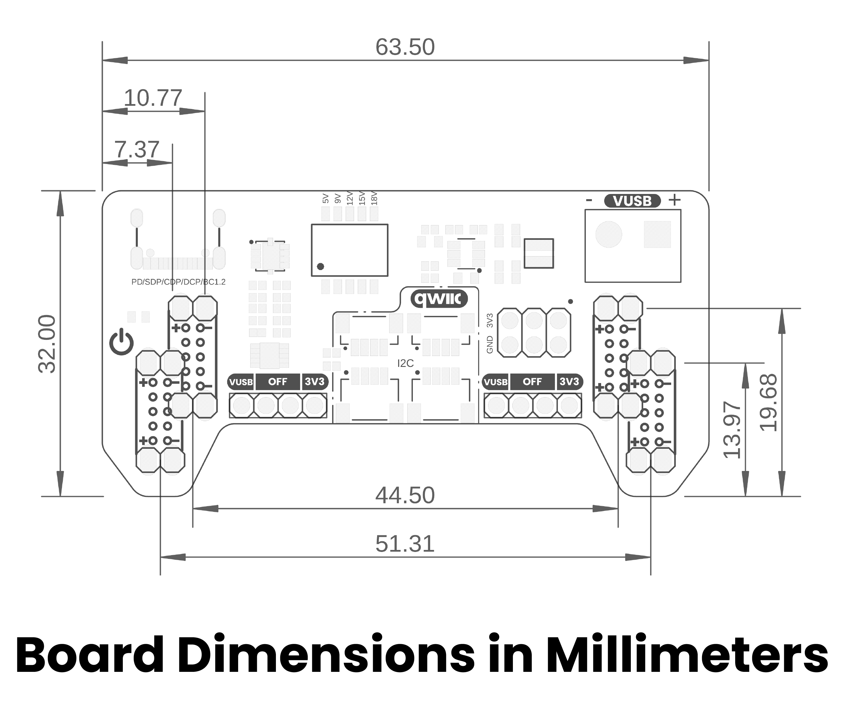
Mechanical dimensions in millimeters
All dimensions in the drawing are in millimeters. The board is designed to align with common 54 mm and 64 mm solderless-breadboard rail formats. Confirm actual clearance around the USB-C connector, screw terminal, jumper caps, and Qwiic cable before final assembly.

6.1 Installation Notes
Support the board while inserting or removing it from a breadboard to avoid bending headers. Do not use the Qwiic cable or USB-C cable as a mechanical support. Keep adequate clearance for wiring attached to the VUSB terminal and for heat dissipation from the regulator under load.

7 Company Information
Item | Value
Company | UNIT Electronics
Website | https://uelectronics.com/
Address | Salvador 19, Cuauhtémoc, 06000, Mexico City, CDMX, Mexico
Product family | DevLab
For product support, current documentation, and software examples, use the product wiki and repository listed in the next chapter.

8 Reference Documentation
Reference | Link or repository file
Product wiki | Power Supply for Breadboard with Qwiic wiki
Source repository | UNIT-Electronics-MX/unit_devlab_power_supply_for_breadboard_with_qwiic
Board schematic | V1.0 schematic
General pinout | English pinout
HUSB238 controller | hardware/resources/unit_datasheet_v_1_0_0_ue0113_husb238.pdf
TPS54302 regulator | hardware/resources/unit_datasheet_v_1_0_0_ue0113_tps54302.pdf
Arduino IDE | arduino.cc/en/software
Component datasheets describe the individual devices. The ratings and mechanical information in this reference remain specific to the UE0113 module.

9 Appendix

9.1 Source Migration
This editable product reference is migrated from the released PDF:
hardware/unit_datasheet_v_1_0_0_ue0113_Power_Supply_for_Breadboard_with_Qwiic.pdf
The original PDF is retained as a released historical artifact. The Markdown chapters under tools/product-reference/chapters/ are the source for future generated PDF and DOCX editions.

9.2 Documentation Scope
The module’s negotiated VUSB output depends on the USB-C PD source and cable. The listed component ratings do not independently establish all module-level limits. Before high-voltage or high-current use, verify the selected profile, measure the output, and account for all connected hardware.
The released V1.0 datasheet mentions an 18 V PD profile in descriptive text, while its ratings tables enumerate 5 V, 9 V, 12 V, 15 V, and 20 V. This reference treats 18 V as source-dependent rather than as a guaranteed standard profile.

9.3 Document Control
Item | Value
Product reference version | 1.0.0
Hardware revision | V1.0
Manufacturer part number | UE0113
Released datasheet date | 2026-06-30
Editable source | tools/product-reference/

