TCAN1051HVD CAN Transceiver Module
Product Reference Manual — V1.0.0 — Mfr. Part #: UE0085
UNIT Electronics
2026-07-31

Contents
- Description
  - Applications
  - Hardware Features
- 1 The Board
  - 1.1 Package Contents
  - 1.2 Main Components
- 2 Ratings and Electrical Characteristics
  - 2.1 Recommended Operating Conditions
  - 2.2 Selected Transceiver Characteristics
  - 2.3 Absolute Maximum Ratings
- 3 Functional Overview
  - 3.1 Signal Path
  - 3.2 Power Architecture
  - 3.3 Bus Termination
  - 3.4 Bus Protection
- 4 Connectors and Pinouts
  - 4.1 Signal Reference
  - 4.2 J1 Controller Connector
  - 4.3 J2 CAN Bus Terminal
  - 4.4 Castellated Headers
- 5 Board Operation
  - 5.1 Before Connecting the Module
  - 5.2 Basic Connection
  - 5.3 Power-Up Check
  - 5.4 Controller Configuration
  - 5.5 Troubleshooting
- 6 Mechanical Information
  - 6.1 Board Views
- 7 Company Information
- 8 Reference Documentation
- 9 Appendix
  - 9.1 Schematic
  - 9.2 Design Notes

Description
The DevLab TCAN1051HVD CAN Transceiver Module is a compact physical-layer interface for Classic CAN and CAN FD networks. It connects a microcontroller or stand-alone CAN controller to the differential CAN bus through the CTX (TXD), CRX (RXD), CANH, and CANL signals.
The module is built around the Texas Instruments TCAN1051HVD, a fault-protected high-speed CAN transceiver with a separate VIO supply. An onboard boost converter and 3.3 V regulator generate the transceiver and logic rails from VIN. The VIO selector allows direct use with either 3.3 V or 5 V controllers.
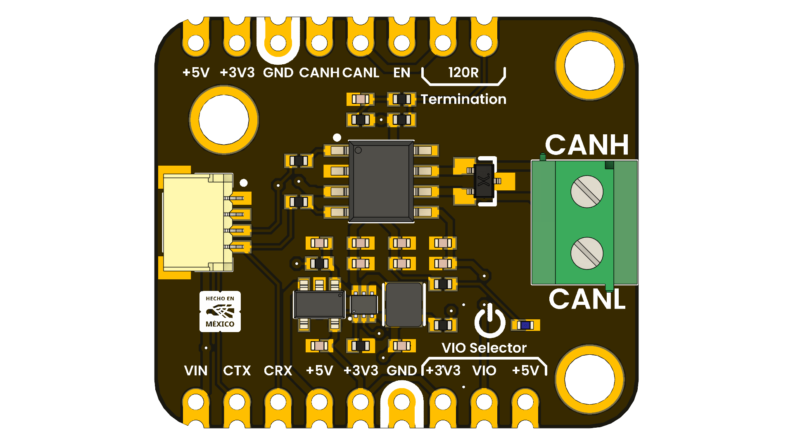
This module implements the CAN physical layer only. The host must provide a CAN controller or a microcontroller with an integrated CAN/TWAI peripheral.

Applications
- Industrial automation and distributed control
- Robotics and mobile platforms
- Building and environmental control
- Automotive prototyping and diagnostics
- CANopen, DeviceNet, NMEA 2000, ISOBUS, and other CAN-based networks

Hardware Features
- TCAN1051HVD high-speed, fault-protected CAN transceiver
- Classic CAN and CAN FD operation up to 2 Mbps
- Selectable 3.3 V or 5 V logic interface (VIO)
- Onboard TPS61023 5 V boost converter and AP2112K 3.3 V regulator
- Switchable split 120 Ω termination (2 × 60 Ω with 4.7 nF center capacitor)
- PESD2CANFD24L-UX protection device on CANH and CANL
- 22 Ω series resistors on CTX and CRX
- 3.81 mm screw terminal for the CAN bus
- 4-pin, 1 mm-pitch connector for VIN, GND, CTX, and CRX
- Castellated headers for breadboard, carrier-board, or direct-wire integration
- Power indicator LED and exposed regulator enable signal

1 The Board
The module separates the controller-side logic interface from the differential CAN bus. Controller signals are available at the lower castellated header and the 4-pin connector, while CANH and CANL are available at the upper header and the screw terminal.
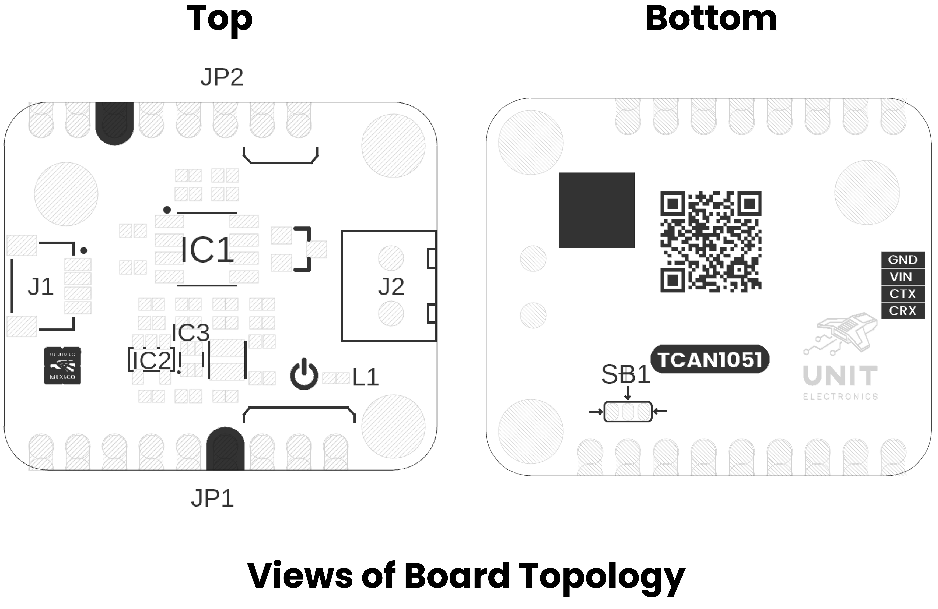

1.1 Package Contents
- 1 × DevLab TCAN1051HVD CAN Transceiver Module (UE0085)
Headers, mating cables, and bus wiring are not included unless stated by the product listing.

1.2 Main Components
Reference | Component | Function
IC1 | TCAN1051HVD | CAN physical-layer transceiver
IC2 | AP2112K-3.3 | 3.3 V linear regulator
IC3 | TPS61023 | 5 V boost converter
D1 | PESD2CANFD24L-UX | CANH/CANL transient protection
D2 | Green LED | Power indication
J1 | 4-pin, 1 mm-pitch connector | VIN, GND, CTX, and CRX interface
J2 | 2-position, 3.81 mm terminal | CANH and CANL bus connection
JP1 | Termination selector | Connects the onboard split 120 Ω termination
SB1 / JP4 | VIO selector | Selects 3.3 V or 5 V logic levels

2 Ratings and Electrical Characteristics

2.1 Recommended Operating Conditions
Symbol | Description | Min | Typ | Max | Unit
VIN | Module input voltage | 3.3 | — | 5.0 | V
VCC | TCAN1051HVD bus supply | 4.5 | 5.0 | 5.5 | V
VIO | Selected I/O level-shifting supply | 2.8 | 3.3 / 5.0 | 5.5 | V
IO(RXD) | Recommended CRX output-current range | −2 | — | 2 | mA
TA | IC operating free-air temperature | −55 | — | 125 | °C
CAN FD | Supported data rate for the TCAN1051HVD variant | — | — | 2 | Mbps
VIN is the module-level input recommendation. VCC, VIO, I/O current, temperature, and CAN FD values are TCAN1051HVD specifications. The complete assembled module has not been independently qualified over the full IC temperature range.

2.2 Selected Transceiver Characteristics
Unless noted otherwise, values below are specified by Texas Instruments over the recommended operating conditions.
Symbol | Description | Min | Typ | Max | Unit
VIH | CTX high-level input voltage | 0.7 × VIO | — | — | V
VIL | CTX low-level input voltage | — | — | 0.3 × VIO | V
VOH | CRX high-level output voltage at −2 mA | 0.8 × VIO | — | — | V
VOL | CRX low-level output voltage at 2 mA | — | — | 0.2 × VIO | V
VO(DOM), CANH | Dominant CANH output voltage | 2.75 | — | 4.5 | V
VO(DOM), CANL | Dominant CANL output voltage | 0.5 | — | 2.25 | V
VOD(DOM) | Dominant differential output, 50–65 Ω load | 1.5 | — | 3.0 | V
VCM | Receiver common-mode range | −30 | — | 30 | V
tPROP(LOOP) | Total loop delay | — | 100 / 110 | 160 / 175 | ns

2.3 Absolute Maximum Ratings
Absolute maximum ratings are stress limits, not normal operating conditions.
Symbol | Description | Min | Max | Unit
VCC | TCAN1051HVD 5 V supply | −0.3 | 7 | V
VIO | TCAN1051HVD I/O supply | −0.3 | 7 | V
VBUS | CANH or CANL, H-suffix device | −70 | 70 | V
VDIFF | CANH-to-CANL differential voltage, H-suffix device | −70 | 70 | V
IO(RXD) | CRX output current | −8 | 8 | mA
TJ | IC junction temperature | −55 | 150 | °C
TSTG | IC storage temperature | −65 | 150 | °C
Do not apply the ±70 V bus-fault rating to VIN, CTX, CRX, EN, VIO, 3V3, or 5V.

3 Functional Overview

3.1 Signal Path
CTX drives the TCAN1051HVD TXD input. A logic LOW requests a dominant bus state, and a logic HIGH requests a recessive state. The transceiver converts this logic signal into the CANH/CANL differential output.
CRX is driven by the TCAN1051HVD RXD output. CRX is LOW when the receiver detects a dominant bus state and HIGH when it detects a recessive state. The CRX output level follows the selected VIO rail.
The TCAN1051HVD includes dominant-timeout, thermal-shutdown, and undervoltage protection. The bus and logic pins present high impedance when the transceiver is unpowered.

3.2 Power Architecture
VIN feeds the TPS61023 boost converter, which generates the 5 V transceiver supply. The AP2112K then generates the 3.3 V rail. Both regulated rails are exposed on the castellated headers.
The VIO selector connects the transceiver I/O supply to either 3.3 V or 5 V:
Host logic | VIO selector
3.3 V MCU or CAN controller | 3V3
5 V MCU or CAN controller | 5V
Select exactly one side of the VIO solder selector. Bridging both sides shorts the 3.3 V and 5 V rails and can damage the module or host.
EN controls the TPS61023 regulator. The onboard bias enables the regulator for normal use; driving EN LOW disables the generated supply rails and transceiver.

3.3 Bus Termination
The onboard termination is a split 120 Ω network made from two 60 Ω resistors. Its midpoint is AC-coupled to ground by 4.7 nF to reduce common-mode noise.
Close the 120R Termination selector only when this module is installed at one physical end of the CAN trunk. A correctly wired point-to-point bus normally has one 120 Ω terminator at each end (approximately 60 Ω measured between CANH and CANL with power removed). Leave the selector open at intermediate nodes.

3.4 Bus Protection
CANH and CANL are protected by a PESD2CANFD24L-UX device. The TCAN1051HVD H-suffix transceiver provides a ±70 V bus-fault rating and a ±30 V receiver common-mode range. These protections improve robustness but do not replace correct grounding, cabling, termination, or system-level surge design.

4 Connectors and Pinouts

4.1 Signal Reference
Label | Direction | Description
VIN | Power input | Module input supply, 3.3 V to 5.0 V
GND | Power | Common module and bus reference
CTX | Input | Controller transmit signal; LOW = dominant
CRX | Output | Controller receive signal; LOW = dominant
CANH | Bus I/O | CAN high bus line
CANL | Bus I/O | CAN low bus line
EN | Input | 5 V boost-converter enable; LOW disables the module
5V | Power output | Generated 5 V transceiver rail
3V3 | Power output | Generated 3.3 V logic rail
VIO | Power | Selected transceiver logic supply (3.3 V or 5 V)

4.2 J1 Controller Connector
J1 is a 4-position, 1 mm-pitch connector. Use the bottom-side silkscreen to confirm pin order before connecting a cable.
Signal | Connection
GND | Host ground
VIN | Host power supply
CTX | Host CAN TX output
CRX | Host CAN RX input

4.3 J2 CAN Bus Terminal
Position | Signal | Connection
Upper | CANH | CAN bus high line
Lower | CANL | CAN bus low line

4.4 Castellated Headers
The castellated pads duplicate the controller, bus, regulator, and control signals for solderless prototyping or carrier-board mounting. Their labels are printed directly on the top silkscreen.


5 Board Operation

5.1 Before Connecting the Module
- Confirm that the host includes a CAN controller or CAN-capable peripheral.
- With power removed, set VIO to match the host logic voltage (3.3 V or 5 V).
- Enable the onboard 120 Ω termination only if this node is at an end of the CAN trunk.
- Check CANH/CANL polarity and provide a common ground where required by the system design.

5.2 Basic Connection
Module | Host or bus
VIN | 3.3 V to 5.0 V supply
GND | Host/bus reference ground
CTX | CAN controller TX output
CRX | CAN controller RX input
CANH | CANH trunk conductor
CANL | CANL trunk conductor
Keep the CANH/CANL pair twisted, minimize stubs, and place termination only at the two physical ends of the main bus.

5.3 Power-Up Check
After applying VIN:
- The green power LED should illuminate.
- The 5V rail should measure approximately 5 V.
- The 3V3 rail should measure approximately 3.3 V.
- CRX should idle HIGH at the selected VIO level when the bus is recessive.
- CANH and CANL should both be near the recessive common-mode level when idle.
Do not continue if either regulator rail is shorted, if the device becomes hot, or if the VIO selector connects both rails.

5.4 Controller Configuration
Configure the host CAN controller with the same nominal bit rate as every other node. CAN FD data-phase timing must also match when CAN FD is used. The TCAN1051HVD supports Classic CAN and CAN FD data rates up to 2 Mbps; protocol timing, message identifiers, filters, and acknowledgments are handled by the host controller and software.

5.5 Troubleshooting
Symptom | Checks
No power LED | VIN polarity/level, GND continuity, EN state
Host receives nothing | VIO setting, CRX pin mapping, bit rate, CANH/CANL polarity
Bus errors or missing ACK | Second active node, matching bit rate, two end terminators
Communication degrades with cable length | Twisted pair, stub length, topology, termination, bit rate
Bus held dominant | CTX stuck LOW, incorrect host pin mode, wiring short

6 Mechanical Information
The nominal board outline is 29.83 mm × 25.40 mm. The drawing below also identifies the 3 mm mounting holes and principal spacing dimensions. All values are in millimeters.
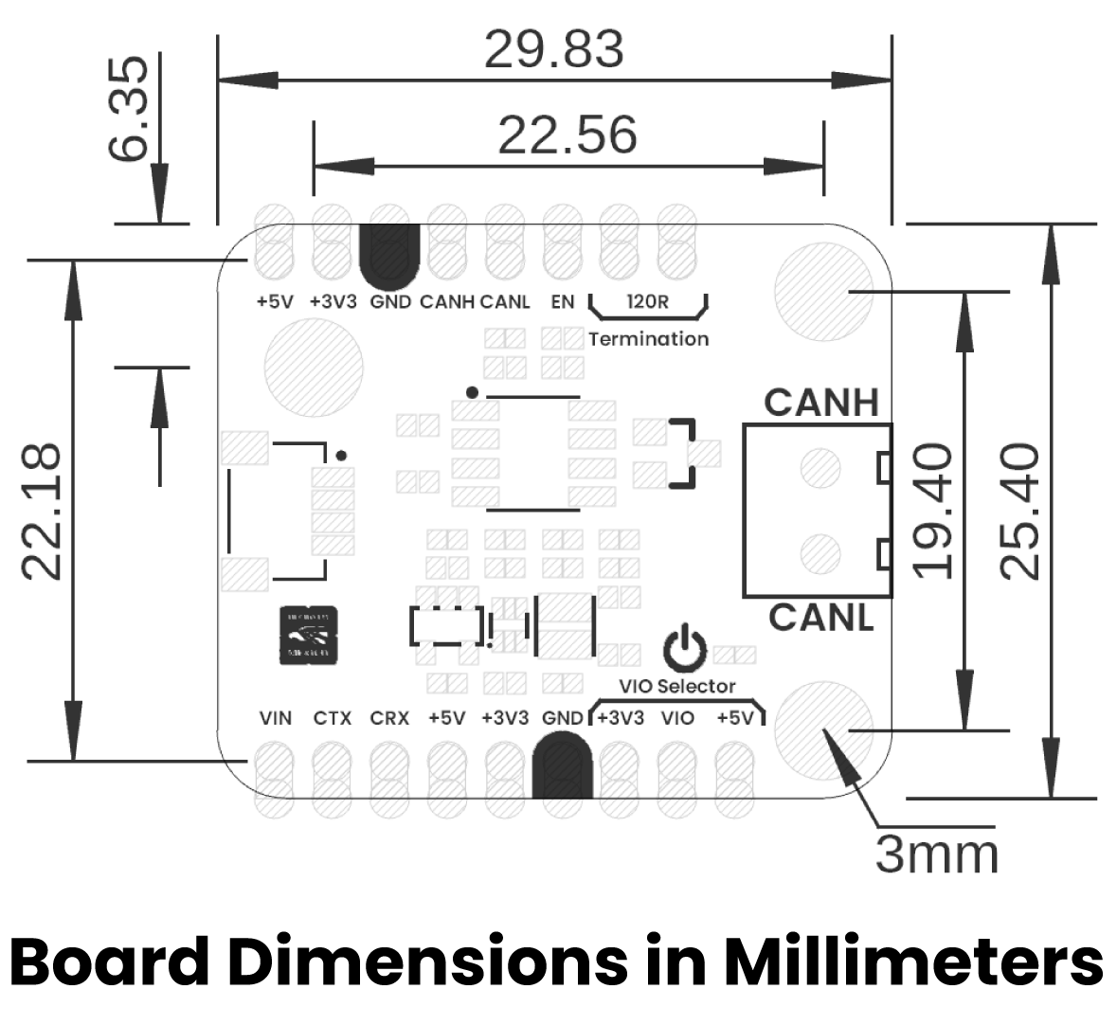
Use the released mechanical drawing or a physical sample when designing mating enclosures or production fixtures; the rendered image is not a 1:1 fabrication template.

6.1 Board Views
Top | Bottom
 | 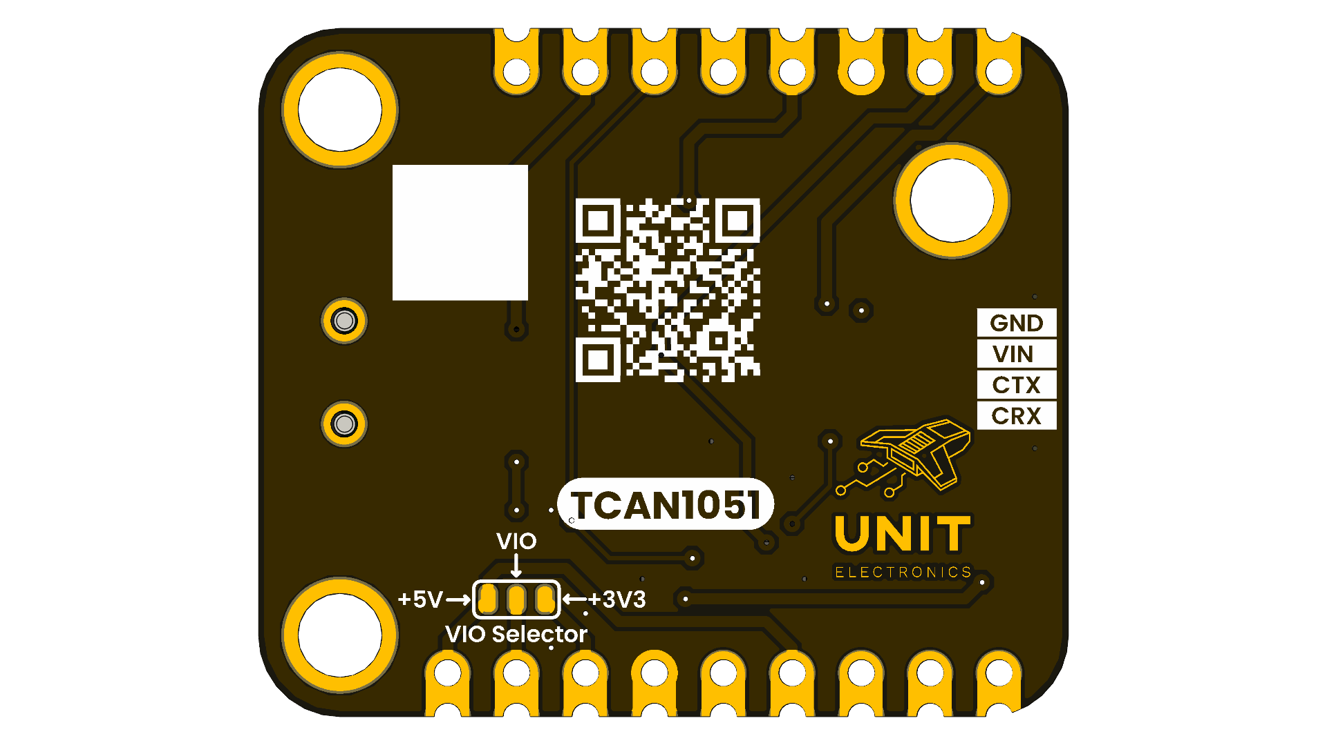

7 Company Information
Company name | UNIT Electronics
Company website | https://uelectronics.com/
Company Address | Salvador 19, Cuauhtémoc, 06000 Mexico City, CDMX

8 Reference Documentation
Reference | Link
Product repository | UNIT-Electronics-MX/unit_devlab_tcan1051hvd_can_transceiver_module
TCAN1051HV datasheet | Texas Instruments SLLSES8E
ISO 11898-2 overview | Refer to ISO 11898-2:2016 for the high-speed CAN physical layer
The released schematic and the manufacturer datasheet are also included in the repository under hardware/ and hardware/resources/datasheet/.

9 Appendix

9.1 Schematic
The complete revision 1 schematic is distributed with this product reference:
Open the UE0085 TCAN1051HVD module schematic

9.2 Design Notes
- R1 provides the switchable 120 Ω termination.
- R2 and R3 form the 2 × 60 Ω split termination.
- C5 (4.7 nF) AC-couples the split-termination midpoint to ground.
- R4 and R5 (22 Ω) are in series with CTX and CRX.
- D1 protects CANH and CANL.
- The S (silent-mode) pin is fixed for normal transceiver operation on this module and is not exposed as a user control.

