UNIT ATOM TEMT6000
I2C-Compatible Ambient Light Sensor — Hardware Revision V0.3.1
UNIT Electronics
2026-08-31

Contents
- Description
  - Applications
  - DevLab Format Compatibility
  - Hardware Features
- 1 The Board
  - 1.1 Accessories {.section-page}
  - 1.2 Recommended Test Equipment
  - 1.3 Board Identification
  - 1.4 Board Components and Features
  - 1.5 Board Layout and Reference Designators {.section-page}
  - 1.5 Board Views {.section-page}
  - 1.6 Handling {.section-page}
- 2 Ratings
  - 2.1 Recommended Operating Conditions {.section-page}
  - 2.2 Digital Interface and Firmware Characteristics
  - 2.3 Onboard Interface Controller
  - 2.4 TEMT6000 Maximum Ratings
  - 2.5 TEMT6000 Characteristics {.section-page}
  - 2.6 Analog Signal Path
  - 2.7 Module-Level Characteristics
  - 2.8 Electrical Precautions
- 3 Functional Overview
  - 3.1 Functional Block Diagram {.section-page}
  - 3.2 Operating Modes
  - 3.3 Digital Light Measurement {.page-break}
  - 3.4 I2C Communication Model {.page-break}
  - 3.5 User-Accessible DDP Functions {.section-page}
  - 3.6 Built-In Indicator
  - 3.7 Physical Interface Notes {.section-page}
- 4 Connectors & Pinouts
  - 4.1 General Pinout {.section-page}
  - 4.2 Signal and I2C Connection Guide {.page-break}
  - 4.3 Direct Sensor Contacts
  - 4.4 I2C Connection Positions {.section-page}
  - 4.5 Auxiliary and Factory Service Functions
  - 4.6 Indicators and I2C Bridge
- 5 Board Operation
  - 5.1 Required Hardware and Software {.section-page}
  - 5.2 Library Installation
  - 5.3 I2C Connection and Example Settings {.page-break}
  - 5.4 Single-Sensor Arduino Example {.page-break}
  - 5.5 Upload and Serial Output {.section-page}
  - 5.6 Troubleshooting {.section-page}
- 6 Mechanical Information
  - 6.1 Board Dimensions {.section-page}
  - 6.2 Integration Clearances {.section-page}
  - 6.3 Mechanical Data Not Specified
- 7 Company Information
- 8 Reference Documentation
- 9 Appendix
  - 9.1 Current V2.0.0 Schematic {.section-page}
  - 9.2 Document Control {.section-page}
  - 9.3 Required Technical Releases

Description
The UNIT ATOM TEMT6000 is an ambient-light sensor module developed by UNIT Electronics as part of the DevLab ecosystem. It combines a TEMT6000 visible-light phototransistor with an onboard interface controller, providing both I2C communication and direct access to the sensor’s analog signal.
The board provides direct VCC, GND, and SIG contacts, reserved expansion pads, power and status indicators, and a solder bridge for disabling the I2C interface. The onboard controller acquires the TEMT6000 signal through its analog-to-digital converter (ADC) and makes the resulting measurements available through the I2C interface.

Applications
- I2C-connected ambient-light acquisition
- Direct analog light measurement during development and calibration
- Automatic display and indicator brightness control
- Day/night and relative-light detection
- Environmental data logging
- Educational I2C, ADC, and phototransistor experiments

DevLab Format Compatibility
As part of the DevLab Atom family, the TEMT6000 module follows a compact and standardized form factor intended for rapid prototyping and integration with other DevLab modules. The board provides three 4-pin, 1.00 mm-pitch I2C connection positions carrying GND, VCC, SDA, and SCL. One connector is populated by default, while two additional horizontal positions are available for optional JST/Qwiic-compatible connectors. This arrangement provides multiple physical access points to the same I2C interface and supports different module integration and mounting configurations.
The module is designed for nominal 3.3 V or 5 V operation. Before connecting it to a host, verify the supply voltage, I2C pull-up voltage, connector orientation, and applicable electrical ratings. When operating the module at 5 V with a 3.3 V host, level translation may be required.

Hardware Features
- TEMT6000 ambient-light phototransistor
- 32-bit Arm Cortex-M0+ controller with 16 KB Flash and 2 KB SRAM, using its internal HSI at up to 24 MHz
- Nominal 3.3 V and 5 V operation; controller upper operating limit of 5.5 V
- 7-bit I2C slave operation from 100 kHz to 400 kHz
- Three I2C connection positions carrying GND, VCC, SDA, and SCL: one populated by default and two optional horizontal positions
- Direct analog SIG access with adjacent VCC and GND contacts
- Two reserved expansion pads with no current application assignment
- Internal ADC acquisition of the TEMT6000 analog signal
- Shared I2C and factory programming signals
- Factory-only SWD/reset functions, power indicator, and built-in status indicator
- Cuttable solder bridge for disabling I2C operation
- Manufacturer Part Number (MPN): UE0098
The controller implements DevLab Device Protocol (DDP) v1.0. The TEMT6000 profile is identified by Device ID 0x0102; command TEMT6000_RAW (0x80) returns a 12-bit ADC sample in an unsigned 16-bit little-endian response. The current controller firmware reports factory address 0x20, firmware/hardware version 1.0, and capabilities 0x000001B9.
The I2C data and clock signals are shared with the controller’s factory programming interface; therefore, I2C communication and SWD programming cannot be used simultaneously. SWD and reset functions are reserved for manufacturer programming and advanced factory diagnostics, not for user firmware replacement.

1 The Board
The design supports two host paths. A Qwiic-capable controller can attach through the I2C positions, while an ADC-capable host or test instrument can sample the exposed SIG contact directly. Factory programming and debugging reuse the I2C signals; they are not a separate user interface.

1.1 Accessories
The module is supplied with a Qwiic-compatible cable for connection to the I2C interface.
Accessory | Purpose | Selection notes
JST/Qwiic-compatible cable | Connects GND, VCC, SDA, and SCL | Verify 1.00 mm pitch, connector orientation, and contact order against the populated connector

1.2 Recommended Test Equipment
The following equipment may be used for integration, testing, and validation. These items are not included with the module.
Equipment | Purpose | Selection notes
I2C-capable host | Scans and communicates with the module | Use 7-bit addressing and an I2C clock from 100 kHz through 400 kHz
Analog test lead or carrier | Provides access to VCC, GND, and SIG | SIG must connect to a voltage-compatible ADC input
Logic analyzer | Checks I2C communication activity | Use input thresholds compatible with the powered board
Reference lux meter | Supports optical calibration and validation | Required for quantitative illuminance validation

1.3 Board Identification
Item | Value
Product | UNIT ATOM TEMT6000 Ambient Light Sensor
Brand / company | UNIT Electronics
Board ecosystem | DevLab
Product family | Atom
Product type | I2C-compatible and direct-analog ambient-light module
Optical component | TEMT6000
Interface controller | 32-bit Arm Cortex-M0+; 16 KB Flash and 2 KB SRAM
Manufacturer Part Number (MPN) | UE0098
Current board artwork
Product Reference | Version 1.1.0
Board, pinout, schematic, and documentation revisions are controlled independently.

1.4 Board Components and Features
Component / Feature | Function | Implementation / Notes
TEMT6000 sensor | Converts visible light to photocurrent | Primary ambient-light sensing element
Interface controller | Samples and processes the sensor signal for I2C access | 32-bit Arm Cortex-M0+ with 16 KB Flash and 2 KB SRAM
I2C connections | Provide module power and I2C bus access | J1 is populated by default; J3 and J4 support optional horizontal 4-pin, 1.00 mm-pitch JST/Qwiic-compatible connectors
Direct contacts | Provide direct access to VCC, GND, and analog SIG | Intended for analog signal access and external ADC measurement
I2C disable bridge | Allows the I2C interface to be disabled | Cut JP1 to disable I2C operation
Power indicator | Indicates that the board is powered | Onboard PWR indicator
Built-in status indicator | Provides firmware-controlled status indication | Onboard USR_LED indicator
Reserved expansion pads | Provide connections reserved for future expansion | No user function is currently assigned
Factory service functions | Support controller programming, debugging, and reset | Reserved for manufacturer use; programming signals share the I2C interface

1.5 Board Layout and Reference Designators
Figure 1.1 — Location of components and reference designators on the top and bottom sides of the PCB.
This drawing is a component-location reference. It helps locate parts named in the schematic and in the table below; it does not define connector pin order or indicate that every connector footprint is populated.
The top side contains the TEMT6000 sensor (Q1), interface controller (IC1), direct VCC/GND/SIG contacts (J2), and the I2C connector installed by default (J1). The bottom side provides two additional footprints, J3 and J4, for optional horizontal I2C connectors. J1, J3, and J4 carry the same GND, VCC, SDA, and SCL signals and provide access to the same I2C bus.
The drawing also locates the I2C-disable bridge (JP1), the power and status indicators, and factory test points. Refer to Chapter 4 for user connections and to the released schematic for circuit-level information.
Ref. | Description
Q1 | TEMT6000 ambient-light sensor
IC1 | Onboard interface controller
J1 | Factory-populated 4-pin, 1.00 mm-pitch I2C connector
J3, J4 | Two optional horizontal 4-pin, 1.00 mm-pitch I2C connector positions
J2 | Direct VCC/GND/SIG contacts
JP1 | Cuttable bridge for disabling I2C operation
PWR | Power indicator
USR_LED | Built-in status indicator
TP1–TP7 | Factory test points

1.5 Board Views
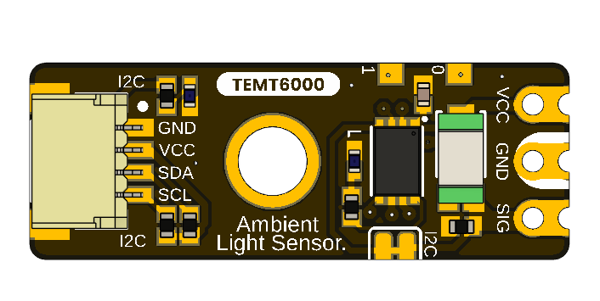
The top view shows the direct sensor contacts, controller, sensor, mounting hole, indicator circuitry, and the factory-populated I2C connector.
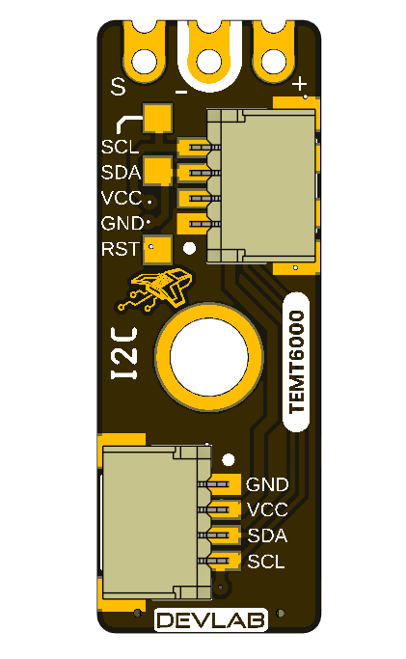
The bottom view shows the I2C connection points, reserved expansion pads, factory service markings, and the optional horizontal connector positions. The I2C signals are shared with the controller’s factory programming and debugging interface; there is no separate user-accessible SWD connector.

1.6 Handling
Use normal ESD precautions. Keep the transparent sensor package clean and optically unobstructed. Remove power before changing connectors or modifying the I2C solder bridge.

2 Ratings
This chapter summarizes the electrical operating conditions and interface characteristics relevant to integrating the UNIT ATOM TEMT6000. It covers the module supply, I2C operation, analog sensor path, controller capabilities, and ambient-light sensor characteristics. Use these ratings to select a compatible power source and host interface and to identify the electrical characteristics that require application-specific verification.

2.1 Recommended Operating Conditions
Symbol | Description | Min. | Typ. | Max. | Unit
VCC | Module supply voltage | — | 3.3 or 5 | — | V
VI2C | I2C logic-high and pull-up voltage | — | VCC | — | V
fSCL | I2C clock frequency | 100 | — | 400 | kHz
VSIG | Direct analog SIG voltage range | — | Not specified | — | V
ICC | Module supply current | — | Not specified | — | mA
TA | Module ambient operating temperature | Not specified | — | Not specified | °C
The VCC values are the supported nominal operating points; they are not complete-module absolute maximum ratings. The validated continuous supply range around each nominal point is not specified.
Use a current-limited source during initial bring-up. The I2C pull-ups follow the module supply, so the host must tolerate the actual bus voltage. When the module operates at 5 V with a 3.3 V host, bidirectional level translation may be required.
The direct SIG range requires analog-stage verification and measurement. Module current consumption must include the controller, indicators, pull-ups, and sensor load. The complete-module ambient-temperature range has not been qualified. I2C pull-up resistance, bus capacitance, and complete-module absolute maximum ratings are also not specified.

2.2 Digital Interface and Firmware Characteristics
Parameter | Value | Description
I2C addressing | 7-bit slave | Valid configurable addresses are 0x08..0x77
Factory I2C address | 0x20 (7-bit) | Pass 0x20 directly to the host I2C library; 0x40 is the 8-bit write address, not the device address
Device protocol | DDP v1.0 | Command transaction followed by an exact-length read transaction
Logical Device ID | 0x0102 | TEMT6000 identity; independent of the I2C address
Firmware / hardware | 1.0 / 1.0 | Current observable controller profile
Capability bitmap | 0x000001B9 | I2C configuration, analog input, sensor data, relay, watchdog, and persistent configuration
Raw digital sample | 0 to 4095 | 12-bit ADC code returned as an unsigned 16-bit little-endian value
ADC update interval | Approximately 20 ms | Background acquisition; an I2C read returns the latest published sample
Command processing delay | 2 to 5 ms | Use 5 ms conservatively before reading
Pending setter timeout | 250 ms | Parameter must arrive before expiry
These values describe the currently documented digital behavior. Detailed DDP commands and transaction sequences are provided in Chapter 3.

2.3 Onboard Interface Controller
The onboard controller acquires the analog output of the TEMT6000 and provides the processed sensor data through the module’s I2C interface. The controller is not exposed as a general-purpose microcontroller and is not intended for user programming.
Feature | Module implementation
Internal controller | 32-bit Arm Cortex-M0+
Sensor acquisition | 12-bit ADC
User digital interface | I2C
I2C addressing | 7-bit addressing
Supported I2C clock | 100 kHz and 400 kHz
Direct sensor access | Analog SIG contact
Programming and debugging | Reserved for factory use

2.4 TEMT6000 Maximum Ratings
These component-level reference ratings describe a TEMT6000 profile. They are not absolute maximum ratings for the complete module and do not establish limits for the controller, indicators, pull-ups, connectors, or other board components.
Parameter | Symbol | Value | Unit
Collector-emitter voltage | VCEO | 6 | V
Emitter-collector voltage | VECO | 1.5 | V
Collector current | IC | 20 | mA
Power dissipation at 25 °C | PV | 100 | mW
Junction temperature | Tj | 100 | °C
Component operating temperature | Tamb | −40 to +100 | °C

2.5 TEMT6000 Characteristics
The following component-level reference characteristics apply at 25 °C unless otherwise noted. They are not guaranteed complete-module performance values.
Parameter | Test condition | Min. | Typ. | Max. | Unit
Collector dark current | VCE = 5 V, Ev = 0 | — | 3 | 50 | nA
Collector light current | Ev = 20 lx, CIE illuminant A, VCE = 5 V | 3.5 | 10 | 16 | µA
Collector light current | Ev = 100 lx, CIE illuminant A, VCE = 5 V | — | 50 | — | µA
Collector-emitter capacitance | VCE = 0 V, f = 1 MHz, dark | — | 16 | — | pF
Collector-emitter saturation voltage | Ev = 20 lx, IPCE = 1.2 µA | — | 0.1 | — | V
Angle of half sensitivity | — | — | ±60 | — | degrees
Peak sensitivity wavelength | — | — | 570 | — | nm
Spectral bandwidth at half sensitivity | — | 440 | — | 800 | nm

2.6 Analog Signal Path
The TEMT6000 analog signal is developed across a 10 kΩ resistor (R1) to ground. The resulting SIGNAL net is connected to the controller ADC input and the external VCC/GND/SIG contacts.
As a first-order estimate, VSIGNAL ≈ IPCE × 10 kΩ outside saturation. Applying the typical 100 lx photocurrent from the comparative TEMT6000 data gives an estimated signal of approximately 0.50 V. This calculation is an engineering estimate and must not be interpreted as a guaranteed or calibrated lux output.
The direct SIG range, analog transfer accuracy, source impedance, loading behavior, and complete-module response still require measurement and qualification.

2.7 Module-Level Characteristics
The following characteristics are established for the current module implementation and are described in the preceding sections.
Characteristic | Current module specification
Nominal supply voltage | 3.3 V or 5 V
Digital interface | I2C, 7-bit slave
Factory I2C address | 0x20
Configurable I2C address range | 0x08 to 0x77
I2C clock frequency | 100 kHz to 400 kHz
Sensor acquisition | 12-bit ADC
Raw digital output | 0 to 4095
ADC update interval | Approximately 20 ms
Command processing delay | 2 to 5 ms
Direct analog access | SIG contact connected to the TEMT6000 signal path
Sensor load resistor | 10 kΩ to GND
Additional characteristics such as complete-module absolute maximum ratings, supply-current limits, guaranteed analog-output accuracy, calibrated lux accuracy, board-level operating-temperature range, and environmental qualification are not specified unless explicitly stated elsewhere in this Product Reference.
Component-level ratings shall not be interpreted as guaranteed ratings of the complete module.

2.8 Electrical Precautions
- Use a current-limited 3.3 V or 5 V supply during engineering bring-up.
- Verify connector orientation and establish a common ground before applying power.
- Do not exceed the controller upper operating-voltage limit of 5.5 V.
- When operating the module at 5 V, verify host compatibility with the actual voltage present on SDA, SCL, and SIG. Use appropriate level translation when required.
- During normal operation, use the I2C connection points only for I2C communication. The same physical signals are shared with the controller’s factory programming and debugging functions; SWD is not provided as a separate user interface.
- Do not attempt firmware replacement or external debugging through the I2C connection points. Programming, debugging, and reset functions are reserved for manufacturer use and factory diagnostics.
- Remove power before cutting, soldering, or reworking the I2C disable bridge or optional connector positions.
- Verify the current released schematic, component specifications, and interface documentation before production integration.

3 Functional Overview
The UNIT ATOM TEMT6000 combines an ambient-light phototransistor with an onboard controller. The module provides two ways to observe light level: digital readings over I2C and direct access to the analog sensor signal at SIG.
The TEMT6000 itself is an analog device. The onboard controller samples its output, applies the selected averaging, and provides the latest raw reading through DevLab Device Protocol (DDP) v1.0.

3.1 Functional Block Diagram
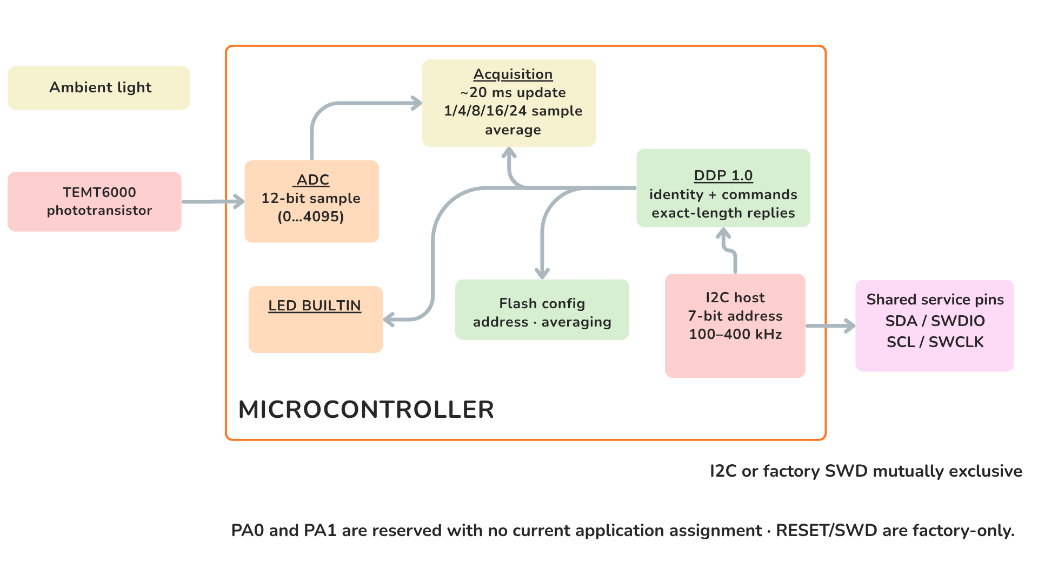
Figure 3.1 — Functional signal and control paths. Ambient light changes the TEMT6000 output. The signal is available at SIG and is also acquired by the controller ADC for access over I2C.

3.2 Operating Modes
Mode | Connection | User-visible result
Digital I2C | VCC, GND, SDA, and SCL | Averaged 12-bit raw light reading through DDP
Direct analog | VCC, GND, and SIG | Light-dependent voltage for a host ADC or measurement instrument
Both modes observe the same sensor path. An I2C read returns the latest available sample; it does not trigger a new light measurement. The direct analog output may be used independently for development, comparison, or application-specific calibration.

3.3 Digital Light Measurement
The onboard ADC produces an unsigned 12-bit value. A higher value represents a higher sensor output under the actual supply, optical, and mechanical conditions.
Measurement property | Value
ADC resolution | 12 bits
Raw output range | 0..4095
Response format | Two bytes, [LSB, MSB]
Update interval | Approximately 20 ms
Selectable averaging | 1, 4, 8, 16, or 24 samples
The averaging setting controls the balance between response speed and stability:
Samples | Approximate time for a completely new average | Typical use
1 | 20 ms | Fast changes
4 | 80 ms | Low-latency smoothing
8 | 160 ms | General monitoring
16 | 320 ms | Stable ambient-light monitoring
24 | 480 ms | Maximum available smoothing
The result is a relative ADC reading, not a calibrated lux measurement. Quantitative lux measurements require calibration in the final enclosure and optical arrangement.

3.4 I2C Communication Model
The I2C host always initiates communication. The 7-bit I2C address selects the module, while the one-byte DDP selector identifies the requested function. These are independent values.
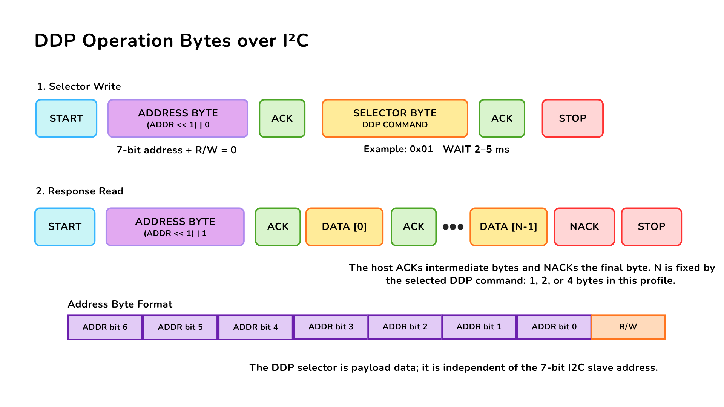
Figure 3.2 — DDP command and response over I2C. The host writes one DDP selector, issues STOP, waits 2–5 ms, and then reads the documented number of response bytes. The host acknowledges intermediate bytes and sends NACK after the final byte.
Communication property | Value
Factory 7-bit address | 0x20
Configurable address range | 0x08..0x77
I2C clock | 100 kHz to 400 kHz
Delay before response read | 2–5 ms; use 5 ms conservatively
Byte order for multi-byte values | Little endian
Supported response lengths | 1, 2, or 4 bytes, depending on the selected function
Pass 0x20 directly to an I2C library. Values 0x40 and 0x41 are the shifted write/read address bytes visible on the bus, not the 7-bit address used by typical host APIs.

3.5 User-Accessible DDP Functions
User function | DDP selector | Result
Identify the module | 0x00 | Device ID 0x0102
Read protocol version | 0x04 | DDP version 1.0
Read active I2C address | 0x20 | Current 7-bit address
Change I2C address | 0x21 | Stores and applies a new address in the valid range
Restore factory configuration | 0x23 | Restores default configuration; reset required
Read ambient-light data | 0x60 or 0x80 | Latest two-byte 12-bit raw sample
Set ADC averaging | 0x62 | Selects 1, 4, 8, 16, or 24 samples
Read ADC averaging | 0x63 | Returns the active averaging setting
Turn BUILTIN off/on | 0xA0 / 0xA1 | Drives the built-in indicator LOW/HIGH
Pulse BUILTIN | 0xA2 | Starts a non-blocking timed pulse
Set/read pulse time | 0xA3 / 0xA4 | Uses 1–40 units of 25 ms
The I2C address, averaging selection, and pulse duration are retained after a power cycle. Changing a stored value should be an occasional configuration operation rather than part of the normal measurement loop.
Detailed transaction handling is already implemented by the maintained C++ and MicroPython examples listed in Chapter 8.

3.6 Built-In Indicator
The built-in status indicator is controlled through the DDP actuator functions. The shared DDP command names contain RELAY, but this product uses them for the built-in indicator and does not provide an electromechanical relay output.
The pulse duration is configurable from 25 ms to 1000 ms in 25 ms steps. A timed pulse runs without interrupting light measurements or I2C communication.

3.7 Physical Interface Notes
The SIG contact provides direct access to the analog sensor path. Its complete board-level transfer function, source impedance, and guaranteed output range are not specified for the current revision. Use a high-impedance input and verify the actual range before connecting it to a lower-voltage ADC.
The PCB provides three I2C connection positions carrying GND, VCC, SDA, and SCL: one connector is populated by default and two horizontal positions are provided for optional 4-pin, 1.00 mm-pitch JST/Qwiic-compatible connectors. All three positions access the same I2C bus.
The I2C connection points share signals with the controller’s factory programming and debugging interface; there is no separate user-accessible SWD connector. Programming, debug, and reset functions are reserved for manufacturer programming and factory diagnostics, not user firmware replacement.
Two expansion pads are reserved and have no current user function. The I2C disable bridge is intended for applications that require the analog path without active I2C operation; remove power before cutting or restoring it.

4 Connectors & Pinouts
The user-accessible interfaces are described below by module function. The released documentation does not provide controlled contact numbers or a mating-connector part number, so the signal order must be checked against the connector orientation before producing a harness.

4.1 General Pinout
Connection group | Signals | Function
Direct sensor contacts | VCC, GND, SIG | Module power and direct access to the TEMT6000 analog signal
I2C connection positions | GND, VCC, SDA, SCL | Power and digital communication over the common I2C bus
Reserved expansion pads | Reserved | No current application assignment; electrical limits are not specified
The PCB has three physical I2C connection positions. One connector is populated by default, and two additional horizontal positions accept optional 4-pin, 1.00 mm-pitch JST/Qwiic-compatible connectors. All three positions are connected to the same I2C bus.

4.2 Signal and I2C Connection Guide
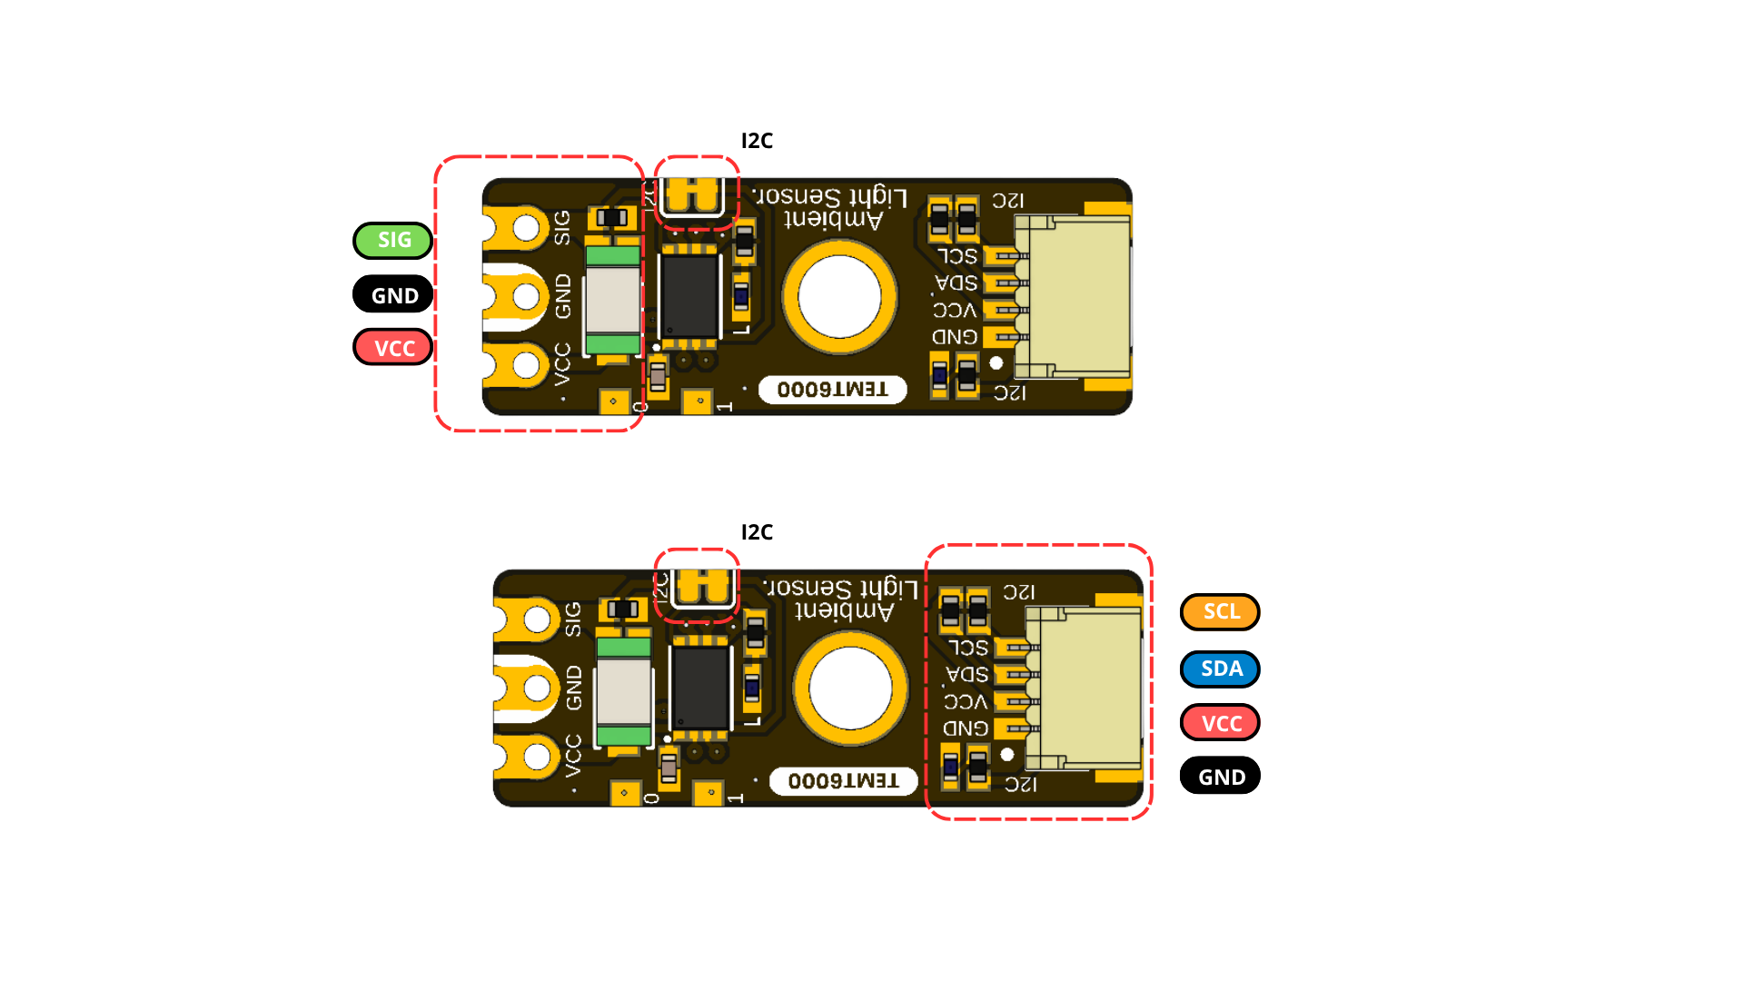
Figure 4.1 — Direct analog and I2C connection groups. The direct contacts provide SIG, GND, and VCC; the populated I2C connector provides SCL, SDA, VCC, and GND. Always follow the connector orientation shown on the board.

4.3 Direct Sensor Contacts
Label | Type | Description
VCC | Power | Module supply; nominal 3.3 V or 5 V operation
GND | Power | Common power and signal reference
SIG / SIGNAL | Analog | Direct light-dependent sensor signal; current transfer function unspecified
These three contacts are shown at the end opposite the populated I2C connector. SIG provides direct access to the TEMT6000 analog signal; it is not a separate specialized communication port.

4.4 I2C Connection Positions
Signal | Type | Description
GND | Power | Common return
VCC | Power | I2C peripheral supply; nominal 3.3 V or 5 V
SDA | Bidirectional I2C data | Host must tolerate the actual bus pull-up voltage
SCL | I2C clock | Supported at 100 kHz to 400 kHz
The two optional horizontal I2C connector positions use the same signal set and 1.00 mm pitch as the populated connector. Because all three positions are physical access points to the same bus, an optional connector may be used for an alternate cable orientation or bus continuation. Account for the loading and pull-ups of every attached device.
The I2C connection points share signals with the controller’s factory programming and debugging interface. These functions are mutually exclusive, and there is no separate user-accessible SWD connector.

4.5 Auxiliary and Factory Service Functions
Function | Documented role | Qualification status
Reserved expansion pad 1 | Reserved connection | No current application assignment; electrical limits unspecified
Reserved expansion pad 2 | Reserved connection | No current application assignment; electrical limits unspecified
Controller reset | Factory service function | Manufacturer programming and factory diagnostics only
Programming, debugging, and reset are intended primarily for development, manufacturing, and service purposes. Currently, user firmware programming is not supported or documented. During programming or diagnostics, I2C must be inactive and other bus devices must be isolated from the shared signals.

4.6 Indicators and I2C Bridge
The module provides a power indicator, a firmware-controlled built-in status indicator, and a normally closed solder bridge that connects the sensor’s raw output signal to the controller ADC input. Opening the bridge isolates the raw sensor signal from the ADC, and the connection can be restored by re-soldering the bridge. The controller ADC input used for sensor acquisition is internal to the module and is not an additional external contact.

5 Board Operation
This chapter shows how to verify one UNIT ATOM TEMT6000 and read its raw ambient-light value with Arduino. The example supports the Pulsar ESP32-C6 and Pulsar RP2350 host boards.

5.1 Required Hardware and Software
- UNIT ATOM TEMT6000 module
- Pulsar ESP32-C6 or Pulsar RP2350 development board
- I2C connection for VCC, GND, SDA, and SCL
- USB cable for programming and Serial Monitor access
- Arduino IDE with the selected board package installed
- DevLab_TEMT6000 Arduino library

5.2 Library Installation
- Open Tools > Manage Libraries in Arduino IDE.
- Search for DevLab_TEMT6000.
- Select the current release and click Install.
- Allow Arduino IDE to install the DevLabDDP dependency when prompted.
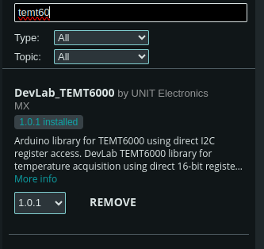
Figure 5.1 — DevLab_TEMT6000 in Arduino Library Manager. The installed package provides the TEMT6000 examples and installs the DDP communication dependency used by the sketch below.

5.3 I2C Connection and Example Settings
Connect the module with power removed.
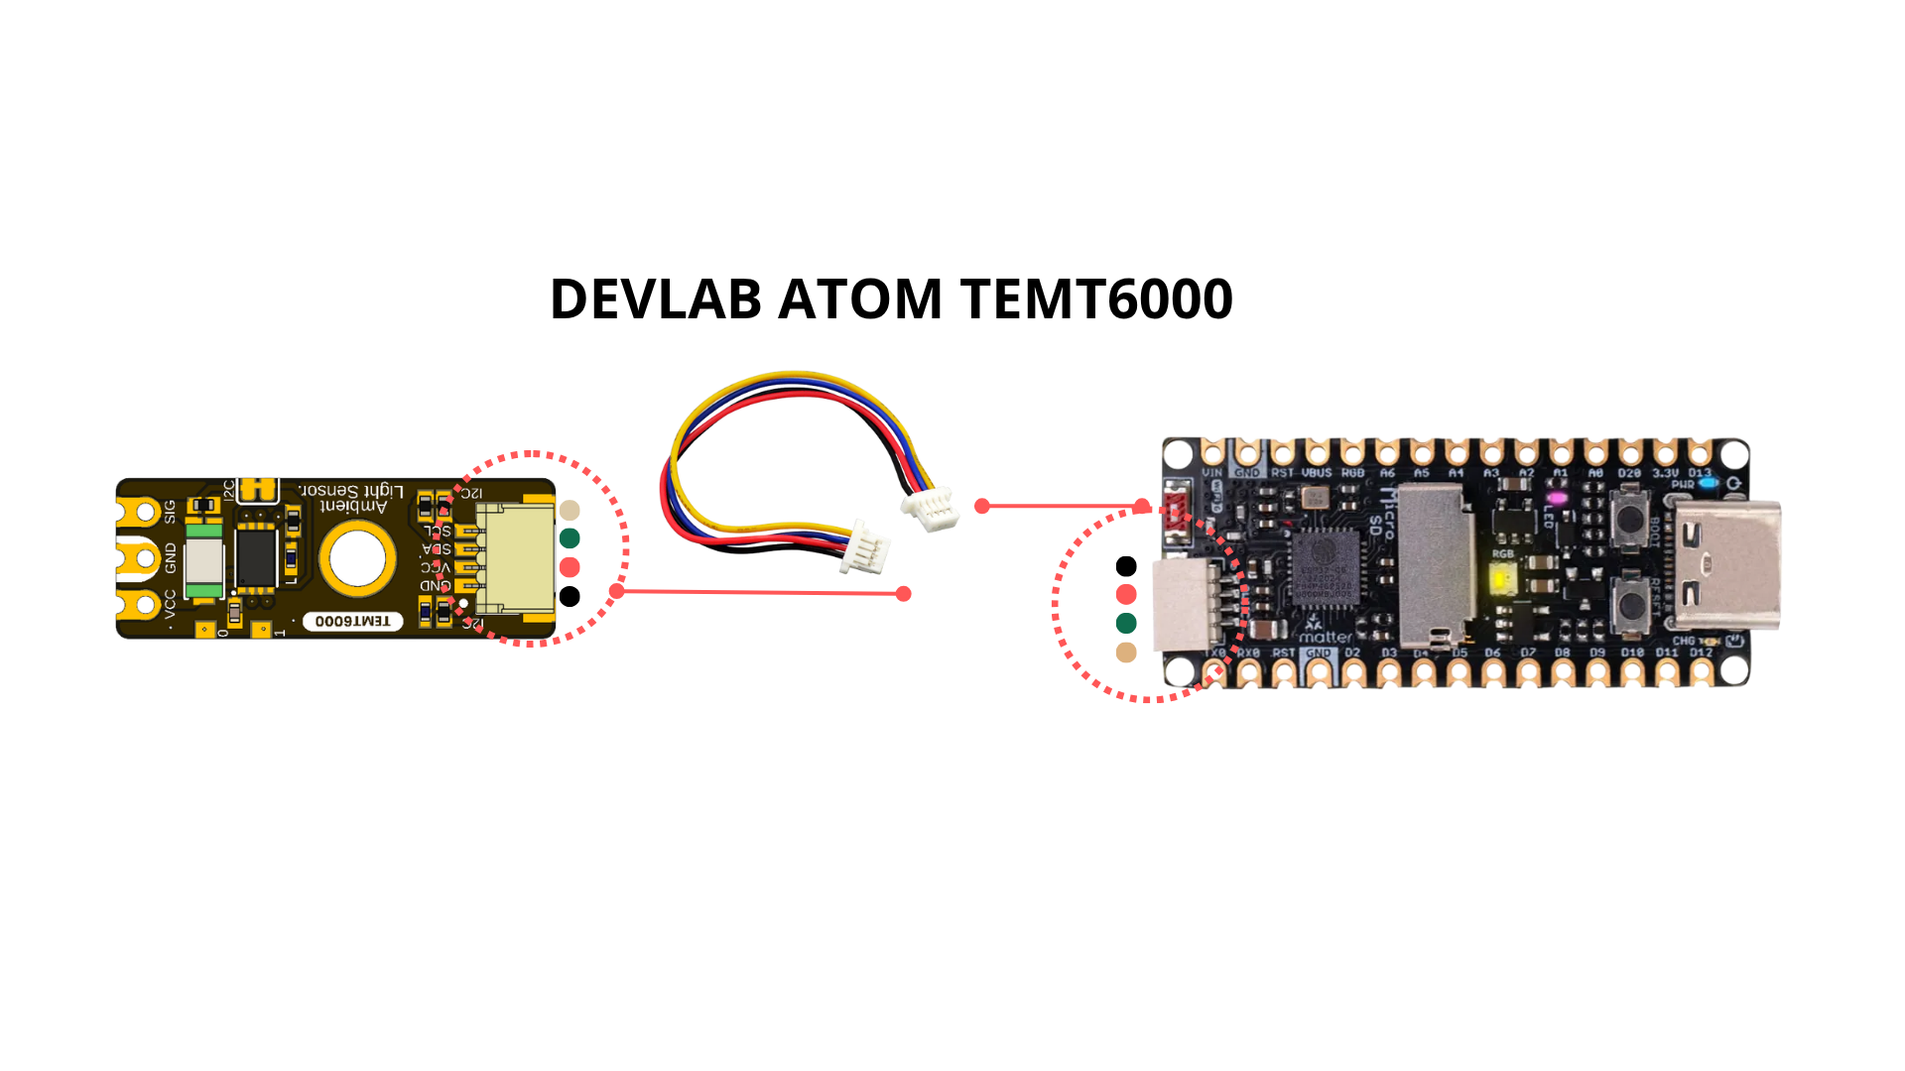
Figure 5.2 — I2C connection to a Pulsar ESP32-C6 host. Align the connector with the orientation shown and verify VCC, GND, SDA, and SCL before applying power.
Module | Pulsar ESP32-C6 | Pulsar RP2350 | Function
VCC | 3.3 V or 5 V | 3.3 V or 5 V | Module supply
GND | GND | GND | Common reference
SDA | GPIO6 | GPIO24 | I2C data
SCL | GPIO7 | GPIO25 | I2C clock
The pin numbers above match singleSensor.ino. Change I2C_SDA and I2C_SCL when the selected host board uses different I2C pins.
Important: The I2C pull-up voltage follows the module supply (VCC). When operating the module at 5 V, verify that the host I2C pins are 5 V tolerant. If the host operates at 3.3 V and is not 5 V tolerant, use appropriate bidirectional level translation between the module and the host.
The example uses the following settings:
Constant | Default | Purpose
I2C_SDA | GPIO6 on Pulsar ESP32-C6; GPIO24 on Pulsar RP2350 | Host SDA pin
I2C_SCL | GPIO7 on Pulsar ESP32-C6; GPIO25 on Pulsar RP2350 | Host SCL pin
I2C_FREQ | 400000 Hz | I2C clock
SENSOR_ADDRESS | 0x20 | Factory 7-bit module address
READ_INTERVAL_MS | 1000 ms | Time between printed readings
If the module address was changed previously, update SENSOR_ADDRESS before uploading the sketch.

5.4 Single-Sensor Arduino Example
Open or create singleSensor.ino, then use the following sketch:
/**
* @file singleSensor.ino
* @brief Verifies a single TEMT6000 DDP device on the I2C bus and prints
* its raw light readings over Serial at a fixed interval.
* @author Cesar Bautista
*/
#include <Arduino.h>
#include <Wire.h>
#include <DevLabDDP.h>
#include <DevLabI2CBusRecovery.h>
#if defined(ARDUINO_ARCH_RP2040)
#define I2C_BUS Wire
constexpr uint8_t I2C_SDA = 24U, I2C_SCL = 25U;
#elif defined(ARDUINO_ARCH_ESP32)
#define I2C_BUS Wire
constexpr uint8_t I2C_SDA = 6U, I2C_SCL = 7U;
#else
#error "Use Pulsar ESP32-C6 or Pulsar RP2350"
#endif
constexpr uint32_t I2C_FREQ = 400000;
constexpr uint8_t SENSOR_ADDRESS = 0x20;
constexpr uint32_t READ_INTERVAL_MS = 1000U;
DevLabDDP::Master master(I2C_BUS, DevLabDDP::DEVICE_TEMT6000);
bool deviceVerified = false;
void setup() {
Serial.begin(115200);
delay(500);
if (!devlabBeginI2cBusRecovered(
I2C_BUS, I2C_SDA, I2C_SCL, I2C_FREQ, 100)) {
Serial.println("ERROR: I2C bus is blocked");
return;
}
DevLabDDP::DeviceInfo info;
deviceVerified = master.matchesExpectedDevice(SENSOR_ADDRESS, &info);
if (!deviceVerified) {
Serial.println("ERROR: address is not a DDP TEMT6000 (ID 0x0102)");
return;
}
DevLabDDP::printDeviceInfo(
Serial,
SENSOR_ADDRESS,
info,
DevLabDDP::DEVICE_TEMT6000);
Serial.println("adc0_raw");
}
void loop() {
uint16_t raw;
if (deviceVerified && master.readAdc(SENSOR_ADDRESS, 0, raw)) {
Serial.println(raw);
} else {
Serial.println("ERR");
}
delay(READ_INTERVAL_MS);
}

5.5 Upload and Serial Output
- Select the connected Pulsar ESP32-C6 or Pulsar RP2350 board in Arduino IDE.
- Select its serial port.
- Compile and upload singleSensor.ino.
- Open Serial Monitor at 115200 baud.
- Illuminate and cover the TEMT6000 to confirm that the printed value changes.
At startup, the sketch recovers and initializes the I2C bus, verifies that address 0x20 contains a DDP TEMT6000 with Device ID 0x0102, and prints the reported device information. It then prints the heading adc0_raw and one reading per second.
<DDP device information>
adc0_raw
<value from 0 to 4095>
<value from 0 to 4095>
The readings are raw ADC values. They indicate relative light level and must not be interpreted directly as lux.

5.6 Troubleshooting
Serial output or symptom | Check
ERROR: I2C bus is blocked | Wiring, connector orientation, shared ground, pull-up voltage, and unintended SDA/SCL drive
ERROR: address is not a DDP TEMT6000 (ID 0x0102) | Address setting, I2C pins, module power, and possible address collision
ERR after successful identification | Cable continuity, bus clock, supply stability, and I2C connections
Constant 0 or 4095 | Sensor obstruction, excessive illumination, supply, and module orientation
Values change but lux is inaccurate | Calibrate the complete optical installation against a reference light meter
The complete Arduino examples and the reusable DDP library are listed in Chapter 8.

6 Mechanical Information
The current mechanical drawing defines the board outline and the dimensions shown below. Dimensions are in millimetres.

6.1 Board Dimensions
Figure 6.1 — Board dimensions.
The drawing specifies a 27 mm × 10 mm board outline and a 3 mm mounting hole. It also shows the hole centerline 5 mm from the side edge and 10.8 mm from the connector-end edge. Use the drawing itself as the dimensional reference; do not derive additional dimensions by scaling the image.

6.2 Integration Clearances
Leave optical clearance around the transparent TEMT6000 sensor package and its field of view. Provide connector insertion and cable bend clearance at the populated I2C connector and at any optional connector position that will be assembled. Keep conductive fasteners away from contacts and factory service points, and avoid enclosure features that shadow the sensor or indicators.

6.3 Mechanical Data Not Specified
- Board thickness, dimensional tolerances, and finished mass
- Unannotated feature coordinates and edge clearances
- Optional connector population variants and mating-part numbers
- Connector insertion envelope, retention force, and cable bend radius
- Maximum top- and bottom-side component heights
- Optical axis, keep-out cone, and enclosure-window specification
- Reserved expansion-pad and factory service-point coordinates

7 Company Information
Item | Information
Company / brand | UNIT Electronics
Board ecosystem | DevLab
Product family | Atom
Website | UNIT Electronics
Address | Salvador 19, Cuauhtémoc, 06000 Mexico City, CDMX, Mexico
The product repository and controlled technical references are listed in the next chapter.

8 Reference Documentation
Reference | Location
Board topology | Current resource
Board dimensions | Current resource
Product repository | UNIT-Electronics-MX/unit_devlab_temt600_ambient_light_sensor
Hardware reference | hardware/README.md
English pinout | Released pinout — English
Spanish pinout | Released pinout — Spanish
Board top view | V0.3.1 resource
Board bottom view | V0.3.1 resource
Current schematic | V2.0.0
Software examples | C++ and MicroPython
Arduino library | UNIT-Electronics-MX/unit_devlab_temt6000_library
Local DDP device profile | TEMT6000 DDP profile
Canonical DDP definitions and Arduino library | UNIT-Electronics-Labs/unit_devlab_ddp_library
Comparative component page | Vishay TEMT6000X01 — reference only
TEMT6000 component datasheet | Vishay Semiconductors, TEMT6000X01 Ambient Light Sensor, document 81579 — comparative reference only
The released pinout, current board images, topology, dimensions, and schematic define the current visible interfaces, board layout, and mechanical envelope. The Vishay datasheet is retained only as a comparative TEMT6000X01 profile; it does not establish the exact orderable part fitted to this module or define complete-module ratings. The DDP profile defines runtime identity and digital data transport; it does not replace module-level electrical qualification.

9 Appendix

9.1 Current V2.0.0 Schematic
The current schematic is documented in hardware/unit_sch_v_2_0_0_ue0098_temt6000.pdf. It documents the controller-based V0.3.1 board, including the reference controller, TEMT6000 analog stage, I2C interfaces, status indicators, test points, and optional connectors.
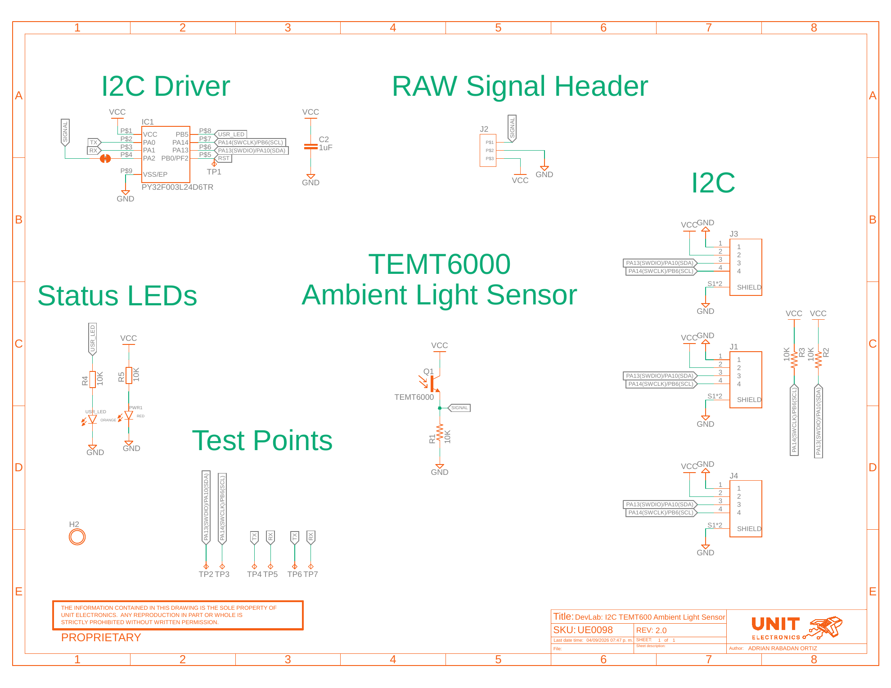
Figure 9.1 — Current V2.0.0 electrical schematic.
The sensor signal uses a 10 kΩ resistor (R1) to ground and is routed to the controller ADC input and the external VCC/GND/SIG header. As a first-order estimate outside saturation, VSIGNAL ≈ IPCE × 10 kΩ; this is not a calibrated or guaranteed conversion to lux.
The I2C SDA and SCL signals are available at three physical connection positions: one connector populated by default and two optional horizontal positions. These signals are shared with the controller’s factory programming and debugging interface; there is no separate user-accessible SWD connector.

9.2 Document Control
Field | Value
Product | UNIT ATOM TEMT6000 Ambient Light Sensor
Product hierarchy | UNIT Electronics → DevLab board ecosystem → Atom family
Manufacturer Part Number (MPN) | UE0098
Current board artwork | V0.3.1
Current pinout, topology, and dimensions | V3.1.0
Available schematic | Current V2.0.0
Product Reference | Version 1.1.0
Publication date | 2026-08-31
Interfaces | Three I2C connection positions on one bus; VCC/GND/SIG header; reserved expansion pads; shared factory programming/debug signals

9.3 Required Technical Releases
- V0.3.1 bill of materials
- Exact controller package/ordering suffix and controlled manufacturer programming release
- Exact oscillator/timing tolerances and uniform future DDP status behavior
- Complete-module supply/logic absolute-maximum ratings and current consumption
- Pull-up values and bus-loading limits
- Direct SIG transfer, loading, range, and ADC guidance
- Mechanical tolerances, board thickness, component heights, and finished mass
- Module-level optical, electrical, environmental, and EMC characterization

