UNIT ATOM TEMT6000
I2C-Compatible Ambient Light Sensor — Hardware Revision V0.3.1
UNIT Electronics
2026-08-31

Contents
- Description
  - Applications
  - DevLab Format Compatibility
  - Hardware Features
- 1 The Board
  - 1.1 Accessories {.section-page}
  - 1.2 Board Identification
  - 1.3 Identified Assemblies
  - 1.4 Board Views {.section-page}
  - 1.5 Handling {.section-page}
- 2 Ratings
  - 2.1 Current Module Operating Conditions {.section-page}
  - 2.2 Interface Controller Characteristics
  - 2.3 TEMT6000 Maximum Ratings
  - 2.4 TEMT6000 Characteristics {.section-page}
  - 2.5 Current Analog Circuit Scope
  - 2.6 Unspecified Current-Module Characteristics {.section-page}
  - 2.7 Electrical Precautions
- 3 Functional Overview
  - 3.1 Functional Block Diagram {.section-page}
  - 3.2 Operating Modes
  - 3.3 Digital Light Measurement {.page-break}
  - 3.4 I2C Communication Model {.page-break}
  - 3.5 User-Accessible DDP Functions {.section-page}
  - 3.6 Built-In Indicator
  - 3.7 Physical Interface Notes {.section-page}
- 4 Connectors & Pinouts
  - 4.1 General Pinout {.section-page}
  - 4.2 Signal and I2C Connection Guide {.page-break}
  - 4.3 Direct Sensor Contacts
  - 4.4 Qwiic I2C Positions A and B {.section-page}
  - 4.5 Auxiliary and Factory Service Functions
  - 4.6 Indicators and I2C Bridge
- 5 Board Operation
  - 5.1 Required Hardware and Software {.section-page}
  - 5.2 Library Installation
  - 5.3 I2C Connection and Example Settings {.page-break}
  - 5.4 Single-Sensor Arduino Example {.page-break}
  - 5.5 Upload and Serial Output {.section-page}
  - 5.6 Troubleshooting {.section-page}
- 6 Mechanical Information
  - 6.1 Current Board Envelope {.section-page}
  - 6.2 Integration Clearances
  - 6.3 Mechanical Data Not Specified {.section-page}
- 7 Company Information
- 8 Reference Documentation
- 9 Appendix
  - 9.1 Current V2.0.0 Schematic {.section-page}
  - 9.2 Document Control {.section-page}
  - 9.3 Required Technical Releases
  - 9.4 Source Notes and Inconsistencies {.section-page}
  - 9.5 Current Firmware Limitations

Description
The UNIT ATOM TEMT6000 is an ambient-light sensor module developed by UNIT Electronics as part of the DevLab ecosystem. It combines a TEMT6000 visible-light phototransistor with an onboard interface controller, providing both I²C communication and direct access to the sensor’s analog signal.
The board provides two alternative Qwiic connection positions, direct VCC, GND, and SIG contacts, reserved PA0 and PA1 pads, power and built-in status indicators, and a solder bridge for disabling the I²C interface. The controller reads the sensor through its PA2 ADC input. The built-in indicator is controlled through PB5, while the I²C interface uses PB6/SCL and PA10/SDA. These pins are also shared with the factory programming interface as SWCLK and SWDIO.

Applications
- I2C-connected ambient-light acquisition
- Direct analog light measurement during development and calibration
- Automatic display and indicator brightness control
- Day/night and relative-light detection
- Environmental data logging
- Educational I2C, ADC, and phototransistor experiments

DevLab Format Compatibility
As part of the DevLab Atom family, the TEMT6000 module uses a compact, standardized format for rapid prototyping and integration into sensing systems. It provides direct access to the analog signal through the VCC, GND, and SIG contacts, while the onboard controller publishes digital sensor readings through I²C. The module is intended for nominal 3.3 V or 5 V operation. The controller guidance uses a conservative 2.0–5.5 V range; complete-module electrical limits require the current schematic and validation.
The board has two optional positions for horizontal 4-pin, 1.00 mm-pitch JST/Qwiic connectors carrying GND, VCC, SDA, and SCL. They provide alternative I²C connection points. Before connection, confirm the populated connector and its orientation, and ensure the host tolerates the actual I²C pull-up voltage; a 3.3 V host may require level translation when the module is powered at 5 V. The pull-up resistance is not specified by the released documentation.

Hardware Features
- TEMT6000 ambient-light phototransistor
- 32-bit Arm Cortex-M0+ controller with 16 KB Flash and 2 KB SRAM, using its internal HSI at up to 24 MHz
- Nominal 3.3 V and 5 V operation; controller upper operating limit 5.5 V
- 7-bit I2C slave operation from 100 kHz through 400 kHz
- Qwiic GND, VCC, SDA, and SCL routing
- Direct analog SIG access with adjacent VCC and GND
- Reserved PA0 and PA1 pads with no current application assignment
- Internal sensor ADC connection to controller pin PA2
- Shared PB6/SCL/SWCLK / PA10/SDA/SWDIO controller mapping
- Factory-only SWD/reset functions, power LED, and PB5-controlled built-in LED
- Cuttable solder bridge for disabling I2C operation
- Manufacturer Part Number (MPN) UE0098
The controller implements DevLab Device Protocol (DDP) v1.0. The TEMT6000 profile is identified by Device ID 0x0102; command TEMT6000_RAW (0x80) returns a 12-bit ADC sample in an unsigned 16-bit little-endian response. The current controller firmware reports factory address 0x20, firmware/hardware 1.0, and capabilities 0x000001B9.
SWDIO shares physical pin PA10 with SDA, and SWCLK shares PB6 with SCL; there is no separate SWD port and the two modes are mutually exclusive. SWD/reset are reserved for manufacturer programming and advanced factory diagnostics, not user firmware replacement.

1 The Board
The design supports two host paths. A Qwiic-capable controller can attach through the I2C positions, while an ADC-capable host or test instrument can sample the exposed SIG contact directly. Factory debug reuses the same controller pins and physical port as I2C; it is not a separate user interface.

1.1 Accessories
No accessory bundle is specified. Typical integration items are:
Accessory | Purpose | Selection notes
Qwiic cable | Connects GND, VCC, SDA, and SCL | Verify 1.0 mm pitch, orientation, and contact order; connectors are shown as optional
I2C-capable host | Scans and communicates with the module | Use 7-bit addressing and a clock from 100 kHz through 400 kHz
Analog test lead or carrier | Accesses VCC, GND, and SIG | SIG must connect to a voltage-compatible ADC input
Logic analyzer | Checks I2C activity | Use input thresholds compatible with the powered board
Reference lux meter | Supports optical calibration | Required for quantitative illuminance validation

1.2 Board Identification
Item | Value
Product | UNIT ATOM TEMT6000 Ambient Light Sensor
Brand / company | UNIT Electronics
Board ecosystem | DevLab
Product family | Atom
Product type | I2C-compatible and direct-analog ambient-light module
Optical component | TEMT6000
Interface controller | 32-bit Arm Cortex-M0+; 16 KB Flash and 2 KB SRAM; fitted suffix not asserted
Manufacturer Part Number (MPN) | UE0098
Current board artwork
Available schematic | Current hardware schematic V2.0.0
Product Reference | Version 1.1.0
Board, pinout, schematic, and documentation revisions are controlled independently.

1.3 Identified Assemblies
Assembly | Function | Source status
TEMT6000 sensor | Converts visible light to photocurrent | Functional identity shown by board/pinout artwork; manufacturer and exact suffix unconfirmed
Interface controller | Samples or processes the sensor for I2C access | 32-bit Arm Cortex-M0+; 16 KB Flash and 2 KB SRAM; exact fitted variant not confirmed; conservative controller voltage guidance is 2.0–5.5 V
Qwiic positions A and B | I2C power and bus access | Shown as optional horizontal JST connectors
Direct contacts | VCC, GND, and analog SIG | Identified on the top view
I2C disable bridge | Disconnects or disables I2C when cut | Function identified; exact circuit unspecified
Power and built-in LEDs | Power and firmware indication | BUILTIN is driven by controller PB5
PA0/PA1 and service functions | Reserved GPIO and factory reset/debug | PA0/PA1 have no current application; SWD aliases share the I2C port
Internal controller mapping | PA2 ADC, PB5 built-in actuator, PB6/SCL/SWCLK, PA10/SDA/SWDIO | Current firmware/hardware mapping

1.4 Board Views
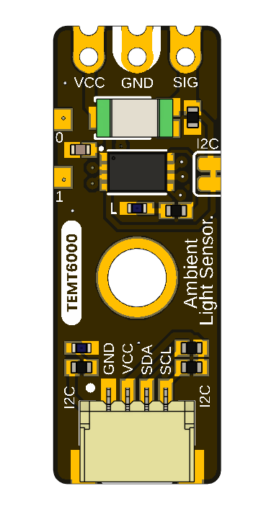
The top view shows the direct sensor contacts, controller, sensor, mounting hole, indicator circuitry, and one Qwiic connector position.
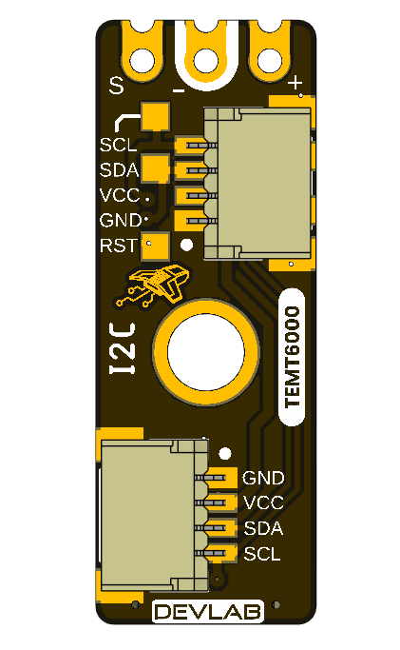
The bottom view labels Qwiic, the SWD aliases on that same port, reset, and the second optional connector position.

1.5 Handling
Use normal ESD precautions. Keep the transparent sensor package clean and optically unobstructed. Remove power before changing connectors or modifying the I2C solder bridge. Do not attach an SWD probe or attempt to replace the firmware. SWD/reset access is reserved for the manufacturer and advanced factory diagnostics; I2C must be inactive and isolated before factory SWD use.

2 Ratings
A current V2.0.0 schematic is now available for the V0.3.1 board. This chapter separates values confirmed by that schematic from comparative TEMT6000X01 reference data and explicitly marks current module values that still require electrical release or qualification. The external component data does not identify the exact part fitted to the board.

2.1 Current Module Operating Conditions
Parameter | Value | Status
Nominal module supply | 3.3 V or 5 V | Supported operating points; use a current-limited source during bring-up
Controller operating-voltage guidance | 2.0–5.5 V | Conservative controller-only range used until the exact fitted variant is confirmed; it includes nominal 3.3 V and 5 V operation
I2C logic domain | Follows the actual bus pull-up rail | At 5 V, use a 5 V-tolerant host or bidirectional level translation
I2C bus speed | 100 kHz to 400 kHz | Supported operating range
I2C addressing | 7-bit slave | Valid configurable addresses are 0x08..0x77
Factory I2C address | 0x20 (7-bit) | Use 0x20 in I²C libraries. 0x40 is the 8-bit write address, not the device address.
Device protocol | DDP v1.0 | Command transaction followed by an exact-length read transaction
Logical Device ID | 0x0102 | TEMT6000 identity; independent of I2C address
Firmware / hardware | 1.0 / 1.0 | Current observable controller profile
Capability bitmap | 0x000001B9 | I2C config, analog input, sensor data, relay, watchdog, persistent config
Raw digital sample | 0 to 4095 | 12-bit ADC code returned as unsigned 16-bit little endian
ADC update interval | Approximately 20 ms | Background acquisition; I2C read returns latest published sample
Command processing delay | 2 to 5 ms | Use 5 ms conservatively before reading
Pending setter timeout | 250 ms | Parameter must arrive before expiry
Direct SIG range | Not specified | Requires current analog-stage schematic and measurement
Module current consumption | Not specified | Controller, LEDs, pull-ups, and sensor load are undocumented
Module ambient temperature | Not specified | No complete-module qualification supplied
The 2.0–5.5 V guidance applies only to the controller. It does not validate 5 V operation for every circuit on the module. The direct SIG path and I2C levels are referenced to the powered system, so every attached host must tolerate the resulting voltage or use level translation. Complete-module absolute maximums, pull-up resistance, and current consumption still require the schematic and qualification.

2.2 Interface Controller Characteristics
The supplied UE0102 reference manual identifies a PY32F003L24D6TR and publishes 1.7–5.5 V and −40 to +85 °C for that separate development board. It does not establish which ordering suffix was procured for this UE0098 assembly. This document therefore uses the narrower 2.0–5.5 V range as conservative guidance for the controller until the exact fitted variant is confirmed.
Feature | Controller capability
CPU and application clock | 32-bit Arm Cortex-M0+; internal HSI at up to 24 MHz; external HSE oscillator not used
Memory | 16 KB Flash and 2 KB SRAM
Controller operating-voltage guidance | 2.0–5.5 V; conservative range used because the exact fitted variant is not confirmed
ADC | One 12-bit ADC, up to 10 external channels, conversion range 0..VCC
I2C | Standard mode 100 kHz, Fast mode 400 kHz, 7-bit addressing
GPIO | Up to 18 I/Os, all available as external interrupts
Timers | TIM1, TIM3, TIM14, TIM16, TIM17, LPTIM, IWDG, WWDG, SysTick, IRTIM
Other interfaces | SPI, two USARTs, DMA, RTC, CRC-32, two comparators, UID; SWD is reserved for factory use on this module
The controller range applies to the controller only. It does not establish the pull-up resistance, complete-module current, or absolute maximum of every external contact.

2.3 TEMT6000 Maximum Ratings
The values below are included only as a comparative TEMT6000 profile. They are not proof that a Vishay part is fitted, are not guaranteed for the fitted sensor, and do not define limits for the controller, LEDs, pull-ups, connectors, or complete board.
Parameter | Symbol | Value | Unit
Collector-emitter voltage | VCEO | 6 | V
Emitter-collector voltage | VECO | 1.5 | V
Collector current | IC | 20 | mA
Power dissipation at 25 °C | PV | 100 | mW
Junction temperature | Tj | 100 | °C
Component operating temperature | Tamb | −40 to +100 | °C

2.4 TEMT6000 Characteristics
Unless noted otherwise, the values are specified at 25 °C and are provided for comparison only. Production specifications must come from the confirmed fitted part and module-level validation.
Parameter | Test condition | Min. | Typ. | Max. | Unit
Collector dark current | VCE = 5 V, Ev = 0 | — | 3 | 50 | nA
Collector light current | Ev = 20 lx, CIE illuminant A, VCE = 5 V | 3.5 | 10 | 16 | µA
Collector light current | Ev = 100 lx, CIE illuminant A, VCE = 5 V | — | 50 | — | µA
Collector-emitter capacitance | VCE = 0 V, f = 1 MHz, dark | — | 16 | — | pF
Collector-emitter saturation voltage | Ev = 20 lx, IPCE = 1.2 µA | — | 0.1 | — | V
Angle of half sensitivity | — | — | ±60 | — | degrees
Peak sensitivity wavelength | — | — | 570 | — | nm
Spectral bandwidth at half sensitivity | — | 440 | — | 800 | nm
The component values in Sections 2.3 and 2.4 are published by Vishay in document 81579. The complete source is listed in Chapter 8, Reference Documentation.

2.5 Current Analog Circuit Scope
The V2.0.0 schematic shows the TEMT6000 sensor with a 10 kΩ resistor (R1) to ground and the resulting SIGNAL net connected to controller PA2/ADC0 and the RAW Signal Header. As a first-order estimate, VSIGNAL ≈ IPCE × 10 kΩ outside saturation. Applying the 100 lx typical current from the comparative datasheet predicts about 0.50 V; this is not a guaranteed calibrated lux output.
The schematic also documents the PY32F003L24D6TR controller, the I2C lines on PA10/SDA and PB6/SCL, the status LEDs, pull-ups, test points, and the two optional I2C connector positions. Direct SIG range, transfer accuracy, and complete-module behavior still require measurement and qualification.

2.6 Unspecified Current-Module Characteristics
- Complete-module absolute maximum, current consumption, and power-up behavior
- Exact oscillator/timing tolerance and electrical bus-loading limits
- Pull-up resistance, bus capacitance allowance, and level compatibility
- Direct analog transfer function, load resistance, range, accuracy, and source impedance
- Guaranteed lux range, accuracy, repeatability, response time, and calibration
- Exact controller package/ordering suffix, released firmware image, and update procedure
- Board-level temperature, ESD, EMC, humidity, and ingress ratings

2.7 Electrical Precautions
- Use a current-limited 3.3 V or 5 V supply for engineering bring-up.
- Verify connector orientation and share ground before applying power.
- Do not exceed the controller upper operating limit of 5.5 V.
- At 5 V, confirm host tolerance at SDA, SCL, and SIG, or add suitable level translation before connection.
- During normal operation, use the shared PA10/SDA/SWDIO and PB6/SCL/SWCLK lines only for I2C. SWD is an alternate factory function on these same physical lines, not a separate user interface.
- Remove power before cutting or reworking the I2C solder bridge.
- Confirm the current schematic and interface specification before production.

3 Functional Overview
The UNIT ATOM TEMT6000 combines an ambient-light phototransistor with an onboard controller. The module provides two ways to observe light level: digital readings over I2C and direct access to the analog sensor signal at SIG.
The TEMT6000 itself is an analog device. The onboard controller samples its output, applies the selected averaging, and provides the latest raw reading through DevLab Device Protocol (DDP) v1.0.

3.1 Functional Block Diagram
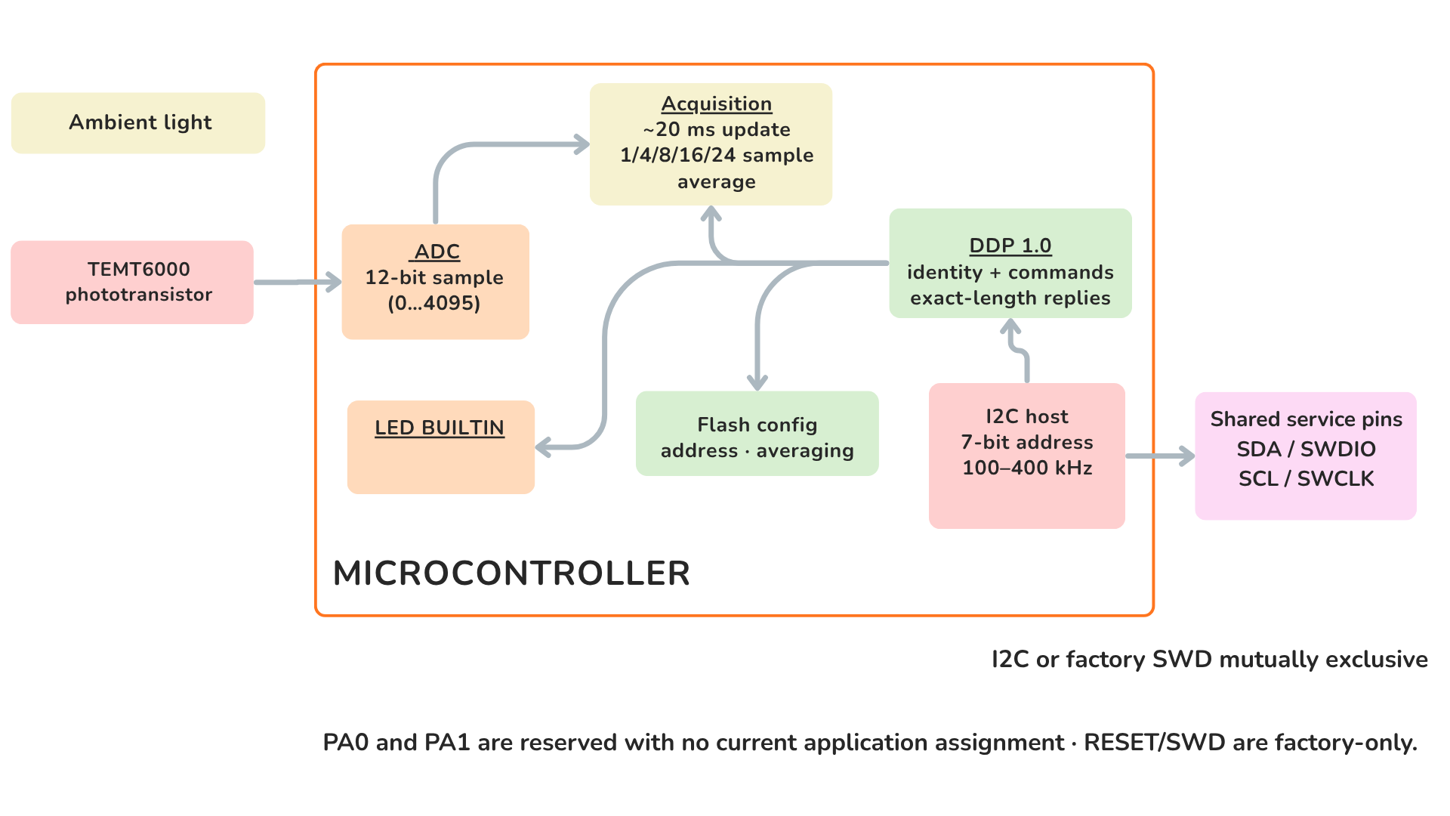
Figure 3.1 — Functional signal and control paths. Ambient light changes the TEMT6000 output. The signal is available at SIG and is also sampled through PA2/ADC0 for access over I2C.

3.2 Operating Modes
Mode | Connection | User-visible result
Digital I2C | VCC, GND, SDA, and SCL | Averaged 12-bit raw light reading through DDP
Direct analog | VCC, GND, and SIG | Light-dependent voltage for a host ADC or measurement instrument
Both modes observe the same sensor path. An I2C read returns the latest available sample; it does not trigger a new light measurement. The direct analog output may be used independently for development, comparison, or application-specific calibration.

3.3 Digital Light Measurement
The onboard ADC produces an unsigned 12-bit value. A higher value represents a higher sensor output under the actual supply, optical, and mechanical conditions.
Measurement property | Value
ADC resolution | 12 bits
Raw output range | 0..4095
Response format | Two bytes, [LSB, MSB]
Update interval | Approximately 20 ms
Selectable averaging | 1, 4, 8, 16, or 24 samples
The averaging setting controls the balance between response speed and stability:
Samples | Approximate time for a completely new average | Typical use
1 | 20 ms | Fast changes
4 | 80 ms | Low-latency smoothing
8 | 160 ms | General monitoring
16 | 320 ms | Stable ambient-light monitoring
24 | 480 ms | Maximum available smoothing
The result is a relative ADC reading, not a calibrated lux measurement. Quantitative lux measurements require calibration in the final enclosure and optical arrangement.

3.4 I2C Communication Model
The I2C host always initiates communication. The 7-bit I2C address selects the module, while the one-byte DDP selector identifies the requested function. These are independent values.
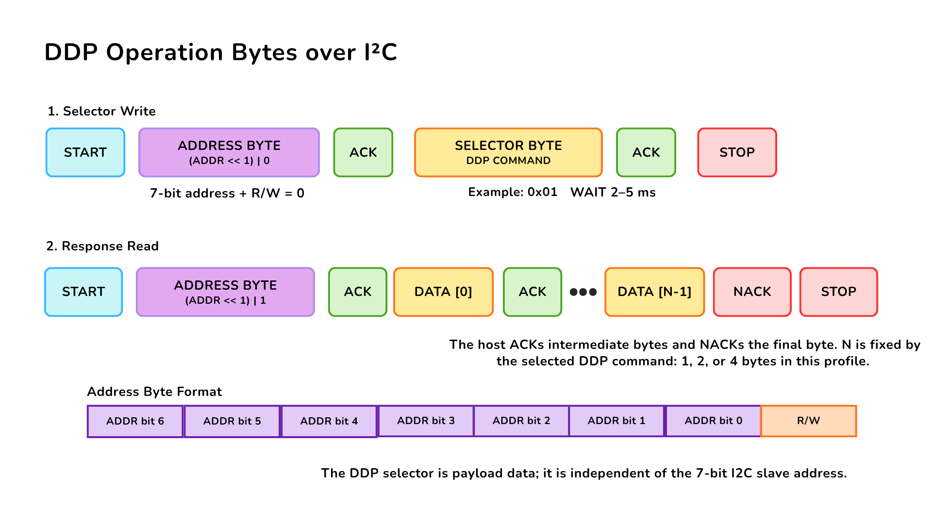
Figure 3.2 — DDP command and response over I2C. The host writes one DDP selector, issues STOP, waits 2–5 ms, and then reads the documented number of response bytes. The host acknowledges intermediate bytes and sends NACK after the final byte.
Communication property | Value
Factory 7-bit address | 0x20
Configurable address range | 0x08..0x77
I2C clock | 100 kHz to 400 kHz
Delay before response read | 2–5 ms; use 5 ms conservatively
Byte order for multi-byte values | Little endian
Supported response lengths | 1, 2, or 4 bytes, depending on the selected function
Pass 0x20 directly to an I2C library. Values 0x40 and 0x41 are the shifted write/read address bytes visible on the bus, not the 7-bit address used by typical host APIs.

3.5 User-Accessible DDP Functions
User function | DDP selector | Result
Identify the module | 0x00 | Device ID 0x0102
Read protocol version | 0x04 | DDP version 1.0
Read active I2C address | 0x20 | Current 7-bit address
Change I2C address | 0x21 | Stores and applies a new address in the valid range
Restore factory configuration | 0x23 | Restores default configuration; reset required
Read ambient-light data | 0x60 or 0x80 | Latest two-byte 12-bit raw sample
Set ADC averaging | 0x62 | Selects 1, 4, 8, 16, or 24 samples
Read ADC averaging | 0x63 | Returns the active averaging setting
Turn BUILTIN off/on | 0xA0 / 0xA1 | Drives the built-in indicator LOW/HIGH
Pulse BUILTIN | 0xA2 | Starts a non-blocking timed pulse
Set/read pulse time | 0xA3 / 0xA4 | Uses 1–40 units of 25 ms
The I2C address, averaging selection, and pulse duration are retained after a power cycle. Changing a stored value should be an occasional configuration operation rather than part of the normal measurement loop.
Detailed transaction handling is already implemented by the maintained C++ and MicroPython examples listed in Chapter 8.

3.6 Built-In Indicator
PB5/BUILTIN is a user indicator controlled through the DDP actuator functions. The shared DDP command names contain RELAY, but this product uses them for the built-in indicator and does not provide an electromechanical relay output.
The pulse duration is configurable from 25 ms to 1000 ms in 25 ms steps. A timed pulse runs without interrupting light measurements or I2C communication.

3.7 Physical Interface Notes
The SIG contact provides direct access to the analog sensor path. Its complete board-level transfer function, source impedance, and guaranteed output range are not specified for the current revision. Use a high-impedance input and verify the actual range before connecting it to a lower-voltage ADC.
The normal I2C signals share controller pins with the service labels shown on the board: PA10 is SDA/SWDIO, and PB6 is SCL/SWCLK. There is no separate SWD connector. For normal product use, connect these lines as SDA and SCL.
PA0 and PA1 are reserved and have no current user function. The I2C disable bridge is intended for applications that require the analog path without active I2C operation; remove power before cutting or restoring it.

4 Connectors & Pinouts
Pin labels below come from the released English pinout. It does not provide controlled contact numbers or a mating-connector part number, so the signal order must be checked against connector orientation before producing a harness.

4.1 General Pinout

Figure 4.1 — Released general pinout for hardware revision V0.3.1.

4.2 Signal and I2C Connection Guide
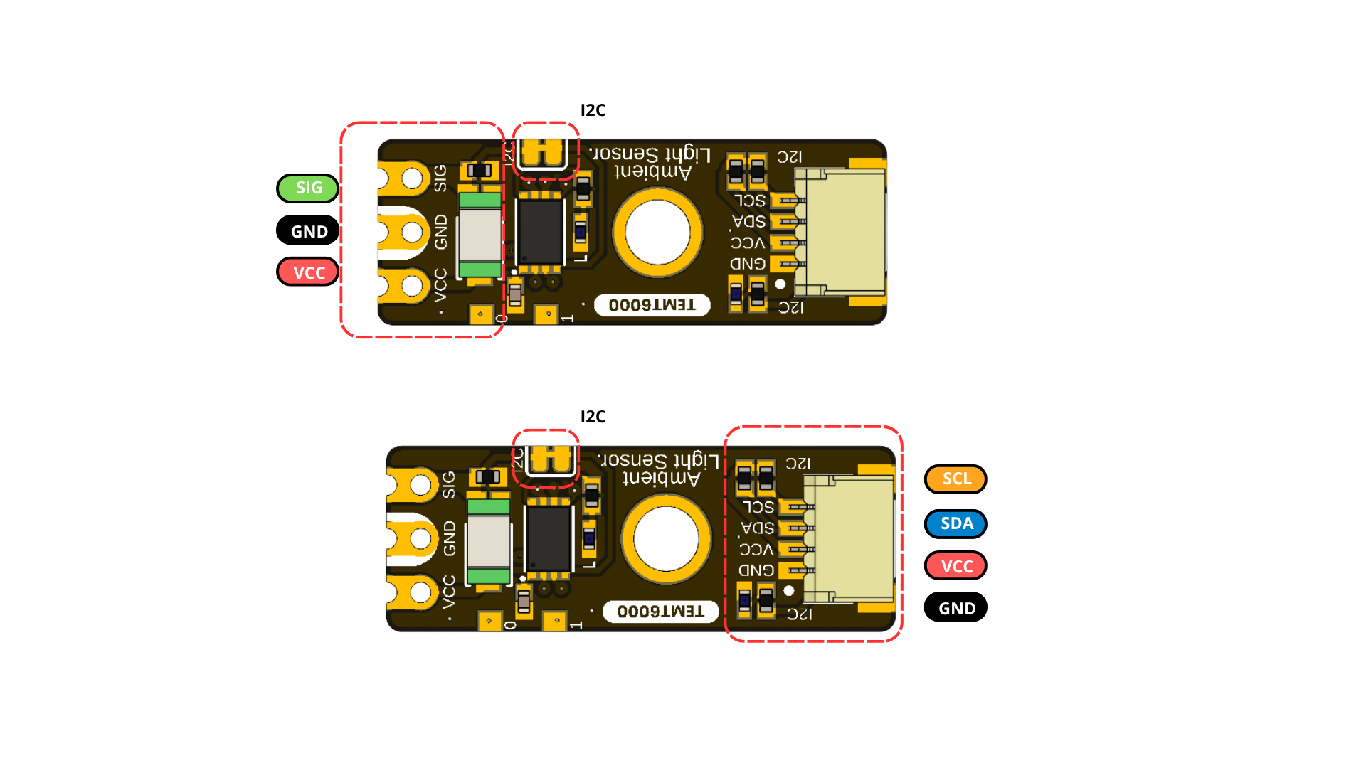
Figure 4.2 — Direct analog and I2C connection groups. The direct contacts provide SIG, GND, and VCC; the Qwiic connector provides SCL, SDA, VCC, and GND. Always follow the connector orientation shown on the board.

4.3 Direct Sensor Contacts
Label | Type | Description
VCC | Power | Module supply; nominal 3.3 V or 5 V operation
GND | Power | Common power and signal reference
SIG / SIGNAL | Analog | Direct light-dependent sensor signal; current transfer function unspecified
These three contacts are shown at the end opposite the primary Qwiic connector.

4.4 Qwiic I2C Positions A and B
Signal | Type | Description
GND | Power | Common return
VCC | Power | I2C peripheral supply; nominal 3.3 V or 5 V
SDA / SWDIO | Bidirectional I2C / factory debug data | One physical PA10 line; normal use is SDA; host must tolerate the bus pull-up voltage
SCL / SWCLK | I2C clock / factory debug clock | One physical PB6 line; normal use is SCL at 100 kHz to 400 kHz
The pinout shows two possible horizontal 1.0 mm JST connector positions and marks JST connectors as optional. Verify which position is populated on the ordered assembly. Parallel connectors are intended for bus pass-through, but that topology must be confirmed by the current schematic.
I2C and SWD are multiplexed on this same physical port: PA10 is SDA/SWDIO, and PB6 is SCL/SWCLK. They are mutually exclusive, and there is no independent SWD connector or pin pair.

4.5 Auxiliary and Factory Service Functions
Label | Documented role | Qualification status
PA0 | GPIO / reserved pin | No current application assignment; electrical limits unspecified
PA1 | GPIO / reserved pin | No current application assignment; electrical limits unspecified
RESET | System reset | Factory service only; not intended for routine user operation
Do not connect an SWD probe or drive reset/debug functions. They are not user interfaces, and the product is not designed for user firmware replacement. Manufacturer diagnostics must make I2C inactive and isolate other bus devices before selecting SWD on the shared pins.

4.6 Indicators and I2C Bridge
The pinout identifies a POWER LED, a firmware-controlled BUILTIN LED, and a cuttable bridge used to disable I2C. Controller pin PB5 drives BUILTIN. Indicator polarity/current and bridge net connections still require the current schematic. The sensor ADC input is mapped internally to controller PA2; it is not an additional external contact in this pinout.

5 Board Operation
This chapter shows how to verify one UNIT ATOM TEMT6000 and read its raw ambient-light value with Arduino. The example supports the Pulsar ESP32-C6 and Pulsar RP2350 host boards.

5.1 Required Hardware and Software
- UNIT ATOM TEMT6000 module
- Pulsar ESP32-C6 or Pulsar RP2350 development board
- I2C connection for VCC, GND, SDA, and SCL
- USB cable for programming and Serial Monitor access
- Arduino IDE with the selected board package installed
- DevLab_TEMT6000 Arduino library

5.2 Library Installation
- Open Tools > Manage Libraries in Arduino IDE.
- Search for DevLab_TEMT6000.
- Select the current release and click Install.
- Allow Arduino IDE to install the DevLabDDP dependency when prompted.
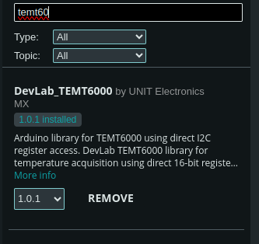
Figure 5.1 — DevLab_TEMT6000 in Arduino Library Manager. The installed package provides the TEMT6000 examples and installs the DDP communication dependency used by the sketch below.

5.3 I2C Connection and Example Settings
Connect the module with power removed.
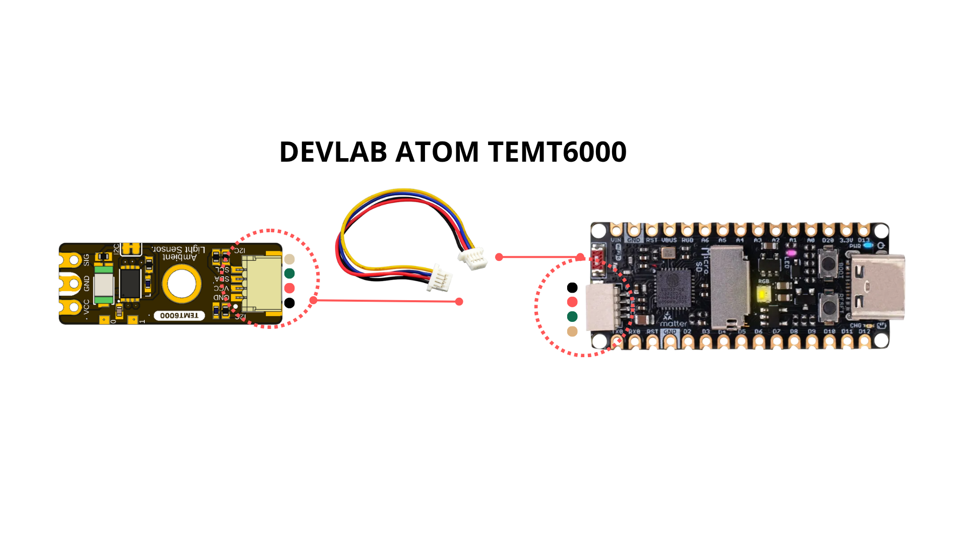
Figure 5.2 — Qwiic connection to a Pulsar ESP32-C6 host. Align the connector with the orientation shown and verify VCC, GND, SDA, and SCL before applying power.
Module | Pulsar ESP32-C6 | Pulsar RP2350 | Function
VCC | 3.3 V or 5 V | 3.3 V or 5 V | Module supply
GND | GND | GND | Common reference
SDA | GPIO6 | GPIO24 | I2C data
SCL | GPIO7 | GPIO25 | I2C clock
The pin numbers above match singleSensor.ino. Change I2C_SDA and I2C_SCL when the selected host board uses different I2C pins. At 5 V, confirm that the host accepts the bus pull-up voltage or use bidirectional level translation.
The example uses the following settings:
Constant | Default | Purpose
I2C_SDA | GPIO6 on Pulsar ESP32-C6; GPIO24 on Pulsar RP2350 | Host SDA pin
I2C_SCL | GPIO7 on Pulsar ESP32-C6; GPIO25 on Pulsar RP2350 | Host SCL pin
I2C_FREQ | 400000 Hz | I2C clock
SENSOR_ADDRESS | 0x20 | Factory 7-bit module address
READ_INTERVAL_MS | 1000 ms | Time between printed readings
If the module address was changed previously, update SENSOR_ADDRESS before uploading the sketch.

5.4 Single-Sensor Arduino Example
Open or create singleSensor.ino, then use the following sketch:
/**
* @file singleSensor.ino
* @brief Verifies a single TEMT6000 DDP device on the I2C bus and prints
* its raw ADC0 readings over Serial at a fixed interval.
* @author Cesar Bautista
*/
#include <Arduino.h>
#include <Wire.h>
#include <DevLabDDP.h>
#include <DevLabI2CBusRecovery.h>
#if defined(ARDUINO_ARCH_RP2040)
#define I2C_BUS Wire
constexpr uint8_t I2C_SDA = 24U, I2C_SCL = 25U;
#elif defined(ARDUINO_ARCH_ESP32)
#define I2C_BUS Wire
constexpr uint8_t I2C_SDA = 6U, I2C_SCL = 7U;
#else
#error "Use Pulsar ESP32-C6 or Pulsar RP2350"
#endif
constexpr uint32_t I2C_FREQ = 400000;
constexpr uint8_t SENSOR_ADDRESS = 0x20;
constexpr uint32_t READ_INTERVAL_MS = 1000U;
DevLabDDP::Master master(I2C_BUS, DevLabDDP::DEVICE_TEMT6000);
bool deviceVerified = false;
void setup() {
Serial.begin(115200);
delay(500);
if (!devlabBeginI2cBusRecovered(
I2C_BUS, I2C_SDA, I2C_SCL, I2C_FREQ, 100)) {
Serial.println("ERROR: I2C bus is blocked");
return;
}
DevLabDDP::DeviceInfo info;
deviceVerified = master.matchesExpectedDevice(SENSOR_ADDRESS, &info);
if (!deviceVerified) {
Serial.println("ERROR: address is not a DDP TEMT6000 (ID 0x0102)");
return;
}
DevLabDDP::printDeviceInfo(
Serial,
SENSOR_ADDRESS,
info,
DevLabDDP::DEVICE_TEMT6000);
Serial.println("adc0_raw");
}
void loop() {
uint16_t raw;
if (deviceVerified && master.readAdc(SENSOR_ADDRESS, 0, raw)) {
Serial.println(raw);
} else {
Serial.println("ERR");
}
delay(READ_INTERVAL_MS);
}

5.5 Upload and Serial Output
- Select the connected Pulsar ESP32-C6 or Pulsar RP2350 board in Arduino IDE.
- Select its serial port.
- Compile and upload singleSensor.ino.
- Open Serial Monitor at 115200 baud.
- Illuminate and cover the TEMT6000 to confirm that the printed value changes.
At startup, the sketch recovers and initializes the I2C bus, verifies that address 0x20 contains a DDP TEMT6000 with Device ID 0x0102, and prints the reported device information. It then prints the heading adc0_raw and one reading per second.
<DDP device information>
adc0_raw
<value from 0 to 4095>
<value from 0 to 4095>
The readings are raw ADC values. They indicate relative light level and must not be interpreted directly as lux.

5.6 Troubleshooting
Serial output or symptom | Check
ERROR: I2C bus is blocked | Wiring, connector orientation, shared ground, pull-up voltage, and unintended SDA/SCL drive
ERROR: address is not a DDP TEMT6000 (ID 0x0102) | Address setting, I2C pins, module power, and possible address collision
ERR after successful identification | Cable continuity, bus clock, supply stability, and I2C connections
Constant 0 or 4095 | Sensor obstruction, excessive illumination, supply, and module orientation
Values change but lux is inaccurate | Calibrate the complete optical installation against a reference light meter
The complete Arduino examples and the reusable DDP library are listed in Chapter 8.

6 Mechanical Information
The current package provides rendered top and bottom views for V0.3.1 but no controlled current-revision dimension drawing. Legacy V0.0.1 dimensions are archived under hardware/resources/old/ and describe a materially different, shorter analog-only board.

6.1 Current Board Envelope
The board has a narrow module outline, direct contacts at one end, at least one central mounting feature, and optional horizontal Qwiic connector positions. Rendered views are suitable for identification, not production measurement.

6.2 Integration Clearances
Leave optical clearance around the transparent TEMT6000 sensor package and its field of view. Provide connector insertion and cable bend clearance at every populated Qwiic position. Keep conductive fasteners away from pads and service signals, and avoid enclosure features that shadow the sensor or LEDs.

6.3 Mechanical Data Not Specified
- Board length, width, thickness, tolerances, and finished mass
- Hole diameters, coordinates, and edge clearances
- Optional connector population variants and mating-part numbers
- Connector insertion envelope, retention force, and cable bend radius
- Maximum top- and bottom-side component heights
- Optical axis, keep-out cone, and enclosure-window specification
- PA0/PA1 and service-pad coordinates
Do not scale production dimensions from the images or reuse the archived V0.0.1 mechanical values for V0.3.1.

7 Company Information
Item | Information
Company / brand | UNIT Electronics
Board ecosystem | DevLab
Product family | Atom
Website | UNIT Electronics
Address | Salvador 19, Cuauhtémoc, 06000 Mexico City, CDMX, Mexico
The product repository and controlled technical references are listed in the next chapter.

8 Reference Documentation
Reference | Location
Product repository | UNIT-Electronics-MX/unit_devlab_temt600_ambient_light_sensor
Hardware reference | hardware/README.md
English pinout | Released pinout — English
Spanish pinout | Released pinout — Spanish
Board top view | V0.3.1 resource
Board bottom view | V0.3.1 resource
Current schematic | V2.0.0
Software examples | C++ and MicroPython
Arduino library | UNIT-Electronics-MX/unit_devlab_temt6000_library
Local DDP device profile | TEMT6000 DDP profile
Canonical DDP definitions and Arduino library | UNIT-Electronics-Labs/unit_devlab_ddp_library
Comparative component page | Vishay TEMT6000X01 — reference only
Source of component values in Sections 2.3 and 2.4 | Vishay Semiconductors, TEMT6000X01 Ambient Light Sensor, document 81579 — reference only
The released pinout, current board images, and V2.0.0 schematic define the current visible interfaces and circuit topology. The Vishay datasheet is retained only as a comparative TEMT6000X01 profile; it does not establish the exact orderable part fitted to this module or define complete-module ratings. The DDP profile defines runtime identity and digital data transport; it does not replace module-level electrical qualification.

9 Appendix

9.1 Current V2.0.0 Schematic
The current schematic is documented in hardware/unit_sch_v_2_0_0_ue0098_temt6000.pdf. It documents the controller-based V0.3.1 board, including the PY32F003L24D6TR, TEMT6000 analog stage, I2C interfaces, status LEDs, test points, and optional connectors.
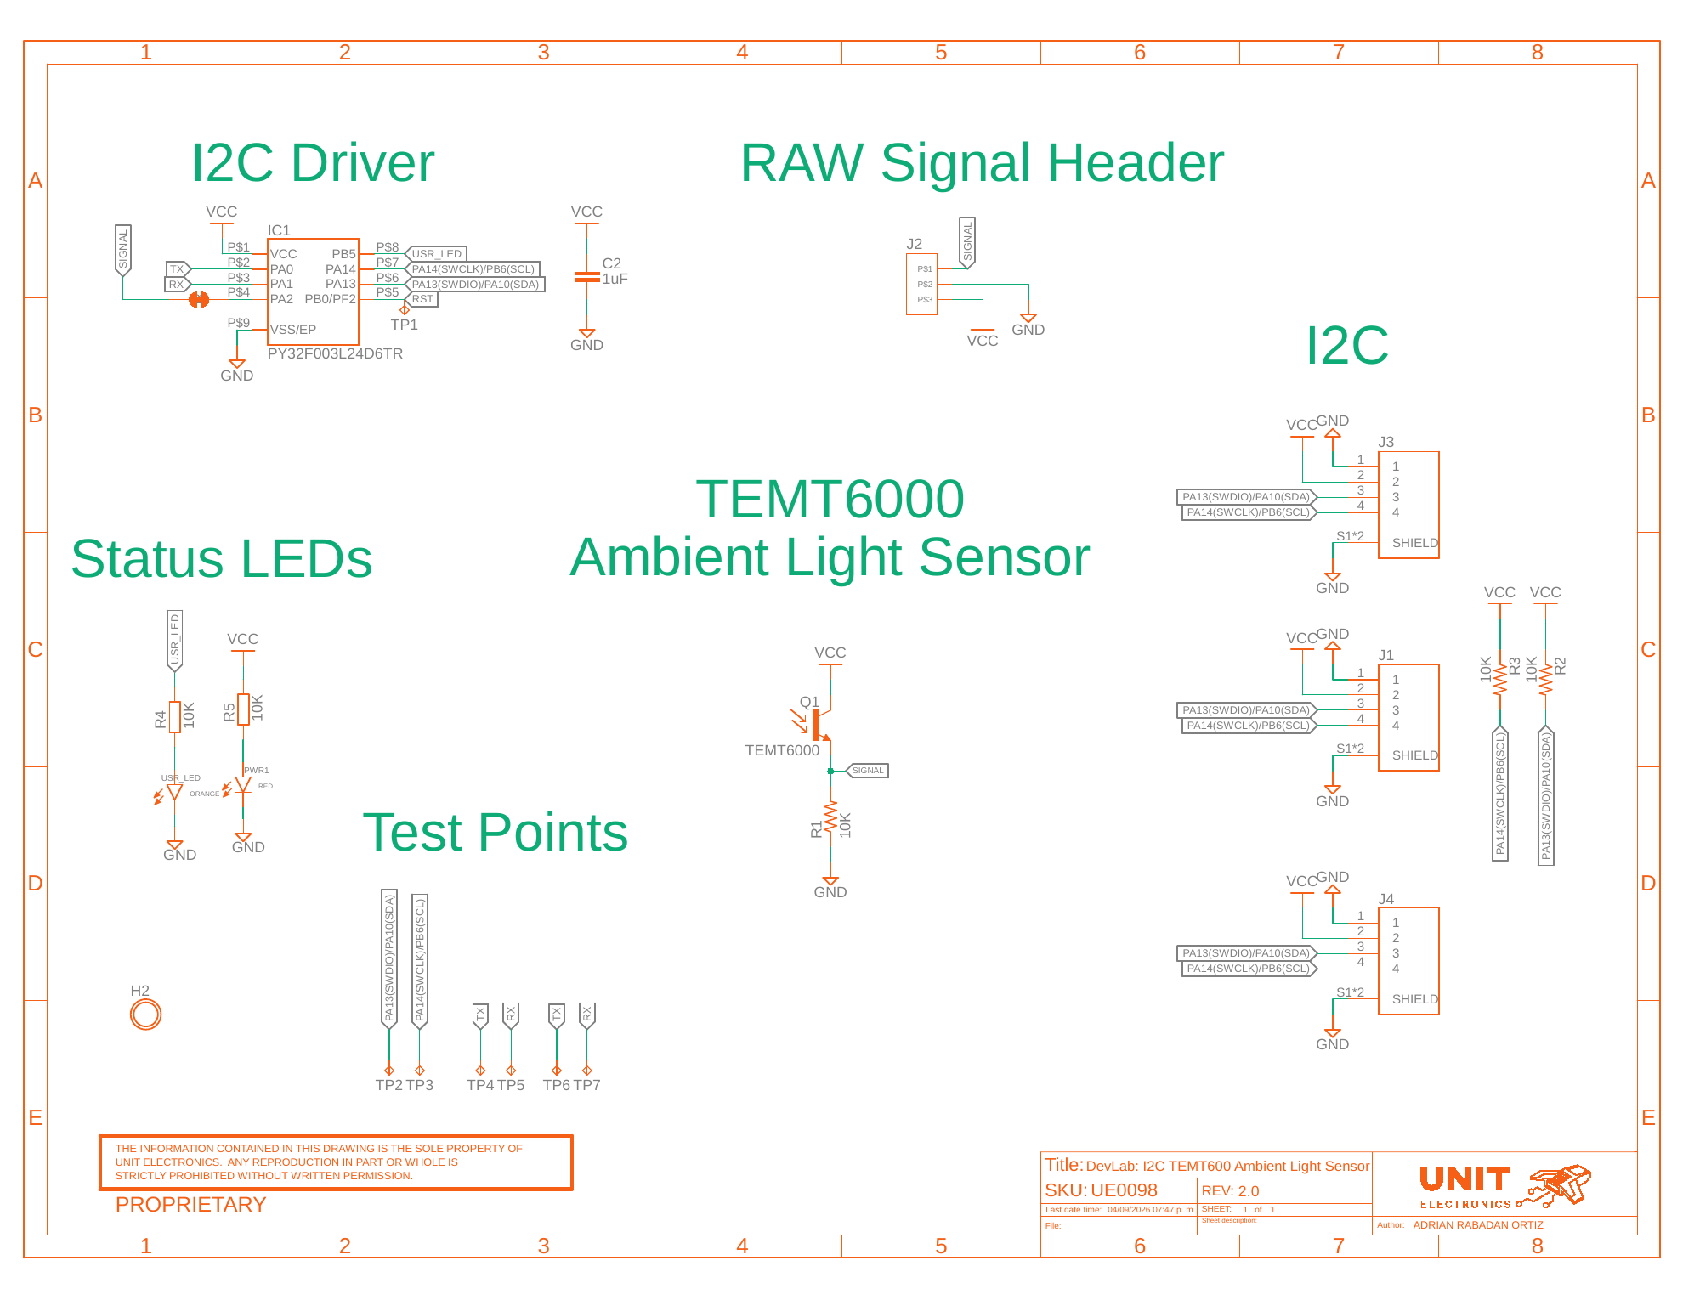
Figure 9.1 — Current V2.0.0 electrical schematic.
The sensor signal uses a 10 kΩ resistor (R1) to ground and is routed to controller PA2/ADC0 and the RAW Signal Header. The I2C bus uses PA10/SDA and PB6/SCL, with the same physical lines reserved for factory SWD aliases.

9.2 Document Control
Field | Value
Product | UNIT ATOM TEMT6000 Ambient Light Sensor
Product hierarchy | UNIT Electronics → DevLab board ecosystem → Atom family
Manufacturer Part Number (MPN) | UE0098
Current board artwork | V0.3.1
Current pinout | V3.1.0
Available schematic | Current V2.0.0
Product Reference | Version 1.1.0
Publication date | 2026-08-31
Interfaces | Qwiic I2C with shared factory SWD, analog, and auxiliary pads

9.3 Required Technical Releases
- V0.3.1 bill of materials
- Exact controller package/ordering suffix, released firmware image, and update procedure
- Exact oscillator/timing tolerances and uniform future DDP status behavior
- Complete-module supply/logic absolute-maximum ratings and current consumption
- Pull-up values and bus-loading limits
- Direct SIG transfer, loading, range, and ADC guidance
- Current-revision controlled mechanical drawing
- Module-level optical, electrical, environmental, and EMC characterization

9.4 Source Notes and Inconsistencies
- Current board images and pinout resources use different revision-number formats in their filenames and storage directories.
- Current pinout artwork calls the product DevLab: I2C TEMT6000; this reference identifies UNIT Electronics as the company that creates and develops the DevLab board ecosystem, with Atom as a product family within it.
- The V2.0.0 schematic now documents the onboard controller and I2C/debug resources shown by the current pinout.
- Archived V0.0.1 dimensions, topology, and board views do not describe the longer V0.3.1 controller-based board.
- Qwiic positions A and B are marked optional; released assembly variants and controlled contact numbering are not supplied.
- Earlier examples treated the sensor as a digital threshold input. The sensor signal is analog; I2C operation is provided by the new onboard controller.
- Current firmware maps PA2 to ADC0 and PB5 to the relay-compatible actuator block. Digital-I/O commands 0x40..0x43 are not implemented; exposed PA0/PA1 remain unassigned.

9.5 Current Firmware Limitations
- The WATCHDOG capability is announced, but the current watchdog command does not operate an active hardware IWDG and must remain experimental.
- GET_RESET_INFO is not implemented and NRST behavior is incomplete.
- An internal ADC error can be returned as 0x0FFF, indistinguishable from a legitimate full-scale sample.
- Current main-loop code does not call the available prolonged-BUSY recovery.
- There is no sample timestamp, sample counter, or calibrated lux result.

