UNIT PULSAR RP2350
Product Reference — Hardware Revision V1.3.0
UNIT Electronics
2026-08-03

Contents
- Description
  - Applications
  - Hardware Features
- 1 The Board
  - 1.1 Accessories {.section-page}
  - 1.2 Board Identification
  - 1.3 Main Assemblies
  - 1.4 Board Views {.section-page}
  - 1.5 Handling {.section-page}
- 2 Ratings
  - 2.1 Recommended Operating Conditions {.section-page}
  - 2.2 Power-Domain Scope
  - 2.3 Digital Interfaces
  - 2.4 Confirmed Component Values
  - 2.5 Unspecified Board Characteristics {.section-page}
  - 2.6 Electrical Precautions {.section-page}
- 3 Functional Overview
  - 3.1 Block Diagram {.section-page}
  - 3.2 Board Topology {.section-page}
  - 3.3 Processor {.section-page}
  - 3.4 Memory Architecture: Flash and PSRAM {.section-page}
  - 3.5 HSTX Video Output {.section-page}
  - 3.6 MicroSD Card Socket {.section-page}
  - 3.7 LED Indicators {.section-page}
  - 3.8 AP2112K and MCP73831 Power Management System {.section-page}
  - 3.9 Power Tree {.section-page}
  - 3.10 BMI270 Motion Sensor {.section-page}
  - 3.11 PDM Microphone {.section-page}
  - 3.12 I2C and QWIIC Expansion {.section-page}
  - 3.13 Combined System Operation {.section-page}
- 4 Connectors & Pinouts
  - 4.1 General Pinout {.section-page}
  - 4.2 Arduino NANO Pinout Compatibility {.section-page}
  - 4.3 QWIIC Connector {.section-page}
  - 4.4 MicroSD Connector {.section-page}
  - 4.5 Battery Connections
  - 4.6 HSTX 22-pin Connector {.section-page}
  - 4.7 USB-C, BOOT, and Reset
  - 4.8 SWD and Test Pads {.section-page}
- 5 Board Operation
  - 5.1 Getting Started with Arduino IDE {.section-page}
  - 5.2 First Power-up and Inspection
  - 5.3 BOOT and Reset Workflow
  - 5.4 Recommended Bring-up Sequence {.section-page}
  - 5.5 C++ Example Collection {.section-page}
  - 5.6 Memory Planning {.section-page}
  - 5.7 Storage Operation {.section-page}
  - 5.8 Video, Sensor, and Audio Coexistence {.section-page}
  - 5.9 Troubleshooting Guide {.section-page}
- 6 Mechanical Information
  - 6.1 Component-side Envelope {.section-page}
  - 6.2 Bottom-side Envelope {.section-page}
  - 6.3 Mechanical Data Not Specified {.section-page}
- 7 Company Information
- 8 Reference Documentation
- 9 Appendix
  - 9.1 Schematic
  - 9.2 Technical References
  - 9.3 Values Not Specified by the Technical Documentation {.section-page}
  - 9.4 Document Control {.section-page}
  - 9.5 Source Inconsistencies {.section-page}

Description
The UNIT PULSAR RP2350 is a multi-interface development board in the UNIT DevLab ecosystem, built around the Raspberry Pi RP2350A microcontroller. The V1.3 design combines external QSPI flash and PSRAM with motion sensing, PDM audio, microSD, USB-C, battery support, addressable RGB indicators, QWIIC I2C, and a 22-pin HSTX expansion connector.
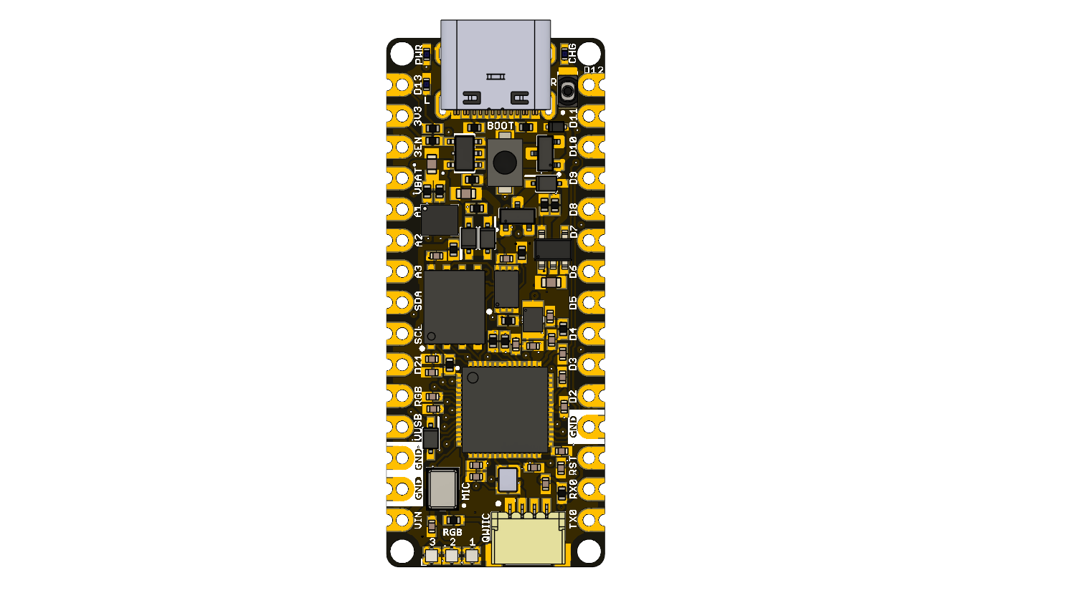

Applications
- RP2350 firmware and peripheral prototyping
- Motion and PDM audio acquisition
- microSD data logging
- HSTX graphics experiments
- External-memory and multicore applications
- Education and subsystem validation

Hardware Features
- RP2350A microcontroller with external W25Q128 128 Mbit QSPI flash
- APS6404L-3SQR-ZR 8 MiB PSRAM
- BMI270 six-axis inertial measurement unit
- ICS-41350 digital PDM microphone
- Four-bit SDIO microSD connection
- Three WS2812-compatible RGB LEDs plus power, charge, and user indicators
- USB-C, QWIIC, battery, edge-pad, SWD, and HSTX connections
This Product Reference describes characteristics defined by the V1.3 design files. Board-level values absent from those sources are identified as unspecified.

1 The Board
The UNIT PULSAR RP2350 is a development board for evaluating the Raspberry Pi RP2350A and building applications that combine high-speed digital output, removable storage, motion sensing, digital audio, external memory, and general-purpose I/O. Hardware revision V1.3.0 places the controller, QSPI flash, PSRAM, power components, indicators, and user controls on the top side. The microSD socket, battery connection, onboard microphone, debug pads, and HSTX connector are accessible from the bottom side.

1.1 Accessories
The following optional accessories are recommended for use with the UNIT PULSAR RP2350A. Select accessories according to the interfaces and features required by the application.
Accessory | Purpose | Selection notes
QWIIC cable | External I2C expansion | 4-pin, 1 mm pitch cable for connecting compatible 3.3 V QWIIC devices
USB-C data cable | Power, programming, and USB serial | Must support data; a charge-only cable cannot upload firmware
MicroSD card | Removable storage and data logging | Class 10 microSD card; FAT32 formatting is recommended for the provided examples
UNIT DevLab DVI to FPC Adapter | HSTX DVI-compatible video output | Recommended adapter for using the board’s HSTX video interface through the 22-pin FPC connector
22-pin FPC cable | Connection between the HSTX connector and DVI adapter | 22-position, 0.5 mm pitch; planned for future availability from UNIT Electronics
LiPo 3.7 V 650 mAh Battery | Battery-powered operation | Recommended single-cell LiPo battery; verify polarity and connector orientation before connection
Verify connector type, orientation, polarity, voltage domain, and pinout before connecting accessories.

1.2 Board Identification
Item | Value
Product | UNIT PULSAR RP2350
Product family | UNIT DevLab ecosystem
Product type | Multi-interface RP2350A development board
Main component | Raspberry Pi RP2350A, QFN-60
Hardware revision | V1.3.0
Product Reference | Version 0.1.0
Primary programming interface | USB-C / RP2350 USB boot workflow
Debug interface | SWD pads on bottom side
Hardware revision and documentation revision are identified independently.

1.3 Main Assemblies
RefDes | Component | Function
IC3 | RP2350A | Main processor and peripheral controller
IC1 | W25Q128JVPIQ | 128 Mbit (16 MiB) external QSPI flash
IC4 | APS6404L-3SQR-ZR | 8 MiB external PSRAM
IC5 | BMI270 | Six-axis accelerometer and gyroscope
MK1 | ICS-41350 | Digital PDM microphone
U1 | AP2112K-3.3TRG1 | Fixed 3.3 V LDO
IC2 | MCP73831T-2ACI/OT | Single-cell Li-Ion/Li-Polymer charge controller
XTAL1 | XOS20012000LT00351005 | 12 MHz reference oscillator
MICRO_SD-HOLDER | 47309-2651 | Removable microSD storage
LED1–LED3 | WS2812 1010 | Cascaded addressable RGB indicators
J1 | HCZZ0032-4 | Four-position QWIIC-style I2C connector
J5 | FH34SRJ-22S-0.5SH(50) | 22-position HSTX FFC/FPC connector
JP1 | PH2.0 2P | Two-position battery connection

1.4 Board Views
The top view identifies the USB-C connector, BOOT and reset controls, edge-pad labels, RP2350A, flash, PSRAM, QWIIC connector, oscillator, and three RGB LEDs.
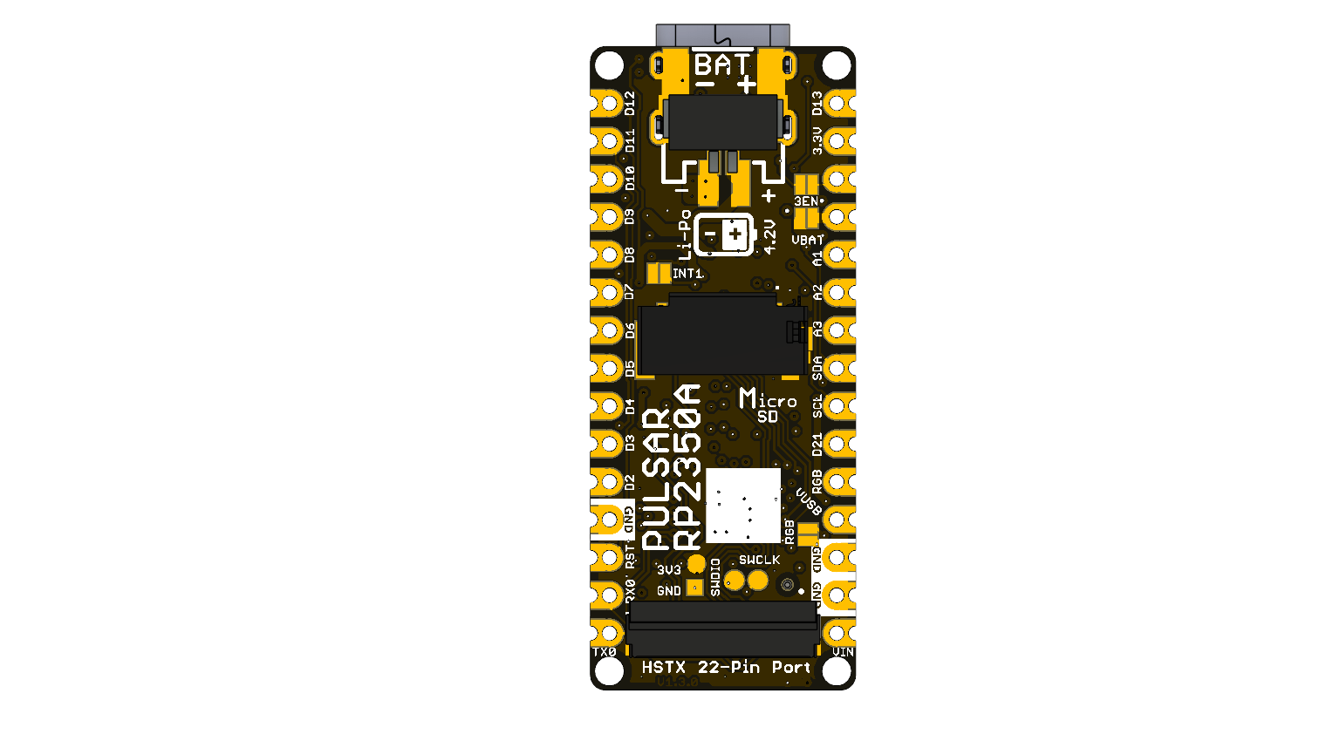
The bottom view identifies the battery polarity marks, microSD socket, microphone acoustic port, SWD pads, HSTX connector, and V1.3.0 revision marking.

1.5 Handling
Handle the board using normal ESD precautions. Avoid touching the microphone port, connector contacts, or exposed test pads. Remove power before inserting or removing FFC/FPC and battery connectors. Keep conductive objects away from the bottom-side battery and microSD areas when the board is energized.

2 Ratings
This chapter separates values established by the design files from limits that require measurement or a released board-level specification. A component’s absolute maximum or operating range is not automatically the rating of the complete PULSAR board.

2.1 Recommended Operating Conditions
Use USB-C as the documented power and programming path. Board-level limits not defined by the available technical documentation are marked as not specified.
Parameter | Design-defined value | Board-level status
Regulated logic rail | 3.3 V nominal | Defined by AP2112K-3.3; load capability not specified
USB VBUS net | +5 V nominal | Shown by schematic net label; USB source quality is external
RP2350 system clock | Up to 150 MHz | RP2350 component capability; board default depends on firmware
Board reference oscillator | 12 MHz | XTAL1 oscillator frequency
Internal SRAM | 520 kB | RP2350 component resource
External flash | 128 Mbit / 16 MiB | W25Q128JVPIQ onboard memory
External PSRAM | 8 MiB | APS6404L-3SQR-ZR onboard memory
VIN input | Not specified | No board-level input range supplied
Battery input | Not specified | Cell chemistry, range, and cable compatibility not specified
Ambient temperature | Not specified | No board-level environmental range supplied

2.2 Power-Domain Scope
The schematic uses +5V, VBUS, VIN, VBAT, VSYS, and 3.3V net names. These labels describe circuit connectivity, not interchangeable power inputs. The AP2112K creates the 3.3 V logic rail from VSYS; the MCP73831 manages the battery charging path. Diodes and MOSFETs participate in source routing.
The following values must remain separate:
- RP2350A ratings: apply only at RP2350A pins under the conditions in the Raspberry Pi datasheet.
- Regulator ratings: describe U1 and do not state how much current remains available after onboard loads.
- Charger ratings: describe IC2; actual charge current depends on the board programming network.
- Connector ratings: describe the connector hardware, not the permitted board supply voltage.
- Board ratings: apply to the complete board rather than an individual component.

2.3 Digital Interfaces
All onboard digital peripherals are connected to the board’s 3.3 V logic domain. External logic compatibility must nevertheless be checked against the RP2350A input/output specifications and the power state of both devices.
Interface | Board connection | Electrical note
Internal I2C | GPIO8 / GPIO9 | BMI270 bus with onboard pull-ups
QWIIC I2C | GPIO24 / GPIO25 | Connector also supplies 3.3 V and GND
microSD | GPIO2–GPIO7 | Full SDIO group; wiki uses SPI-compatible subset
PDM | GPIO10 / GPIO11 | Clock output and microphone data input
HSTX | GPIO12–GPIO19 | High-speed driven pairs; reserve while video is active
WS2812 data | GPIO1 | Drives three cascaded onboard LEDs
SWD | SWDIO / SWCLK | Use a 3.3 V target reference

2.4 Confirmed Component Values
Symbol / parameter | Value | Scope
RP2350 internal SRAM | 520 kB | RP2350A component
RP2350 system clock | 150 MHz maximum nominal | RP2350A component
QSPI flash capacity | 128 Mbit | IC1
PSRAM capacity | 8 MiB | IC4
PDM microphone supply | 1.65 to 3.63 V | ICS-41350 component only
LDO output | 3.3 V nominal | U1 component selection
Oscillator frequency | 12 MHz | XTAL1

2.5 Unspecified Board Characteristics
- VIN, VBAT, and USB operating and absolute-maximum ranges
- Available 3.3 V current for external loads
- Battery charge current and supported cell/cable compatibility
- Source priority and reverse-current behavior among USB, VIN, and battery
- Total current consumption in boot, idle, storage, video, and audio modes
- GPIO drive and input thresholds as exposed by each connector
- Validated QSPI, PSRAM, SDIO, PDM, I2C, and HSTX operating rates
- Board-level temperature, humidity, ESD, and thermal performance

2.6 Electrical Precautions
- Begin first power-up from a current-limited USB source.
- Connect ground before external clocks, data, or analog signals.
- Do not connect a battery without documented polarity, chemistry, voltage, connector, and charge-current compatibility.
- Do not power the 3.3 V rail simultaneously from the board regulator and an external source unless that operating mode is explicitly approved.
- Do not share GPIO12–GPIO19 with other driven circuits while HSTX video is active.
- Remove power before changing FFC/FPC, microSD, or battery connections.

3 Functional Overview
The UNIT PULSAR RP2350 is organized around the RP2350A processor, with dedicated external memories and fixed onboard peripherals. Firmware can use each block independently or combine acquisition, storage, user feedback, and video in one application.

3.1 Block Diagram
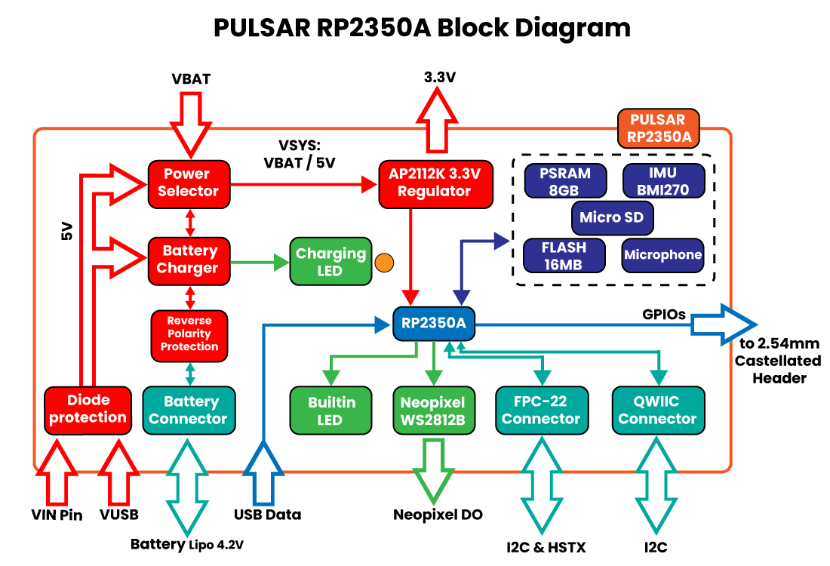
The RP2350A controls every data path. W25Q128 flash stores executable code and nonvolatile application data. PSRAM extends working memory. The microSD socket provides removable storage. BMI270 and ICS-41350 devices provide motion and audio input. QWIIC and edge pads expose expansion signals, while HSTX and the LEDs provide high-speed and visual outputs.

3.2 Board Topology
The top side groups programming, processing, memory, and user-visible controls. USB-C, BOOT, reset, QSPI flash, PSRAM, RP2350A, QWIIC, and RGB indicators are visible from this side. The bottom side groups removable storage, battery, audio, SWD, and HSTX connections.
Board region | Main elements | Design intent
USB end | USB-C, BOOT, reset, power/charge indicators | Programming and initial power-up
Upper center | power-path devices and PSRAM | Source routing and working-memory expansion
Center | RP2350A and 12 MHz oscillator | Processing and clock generation
Lower center | QSPI flash and PDM microphone area | boot storage and audio acquisition
QWIIC end | three RGB LEDs and QWIIC connector | status display and external I2C
Bottom side | battery, microSD, BMI270, SWD, HSTX | storage, sensing, debug, and video expansion
The two edge-pad rows expose power, analog, serial, and general-purpose signals. Some HSTX-routed signals are shared with edge positions, so firmware ownership must be decided before enabling high-speed video.

3.3 Processor
RP2350A is the main controller. According to the Raspberry Pi component datasheet, the device provides two selectable processor architectures: dual Arm Cortex-M33 or dual Hazard3 RISC-V cores, with a nominal system frequency up to 150 MHz. Firmware selects one architecture for a given build; it does not execute Arm and RISC-V code simultaneously.
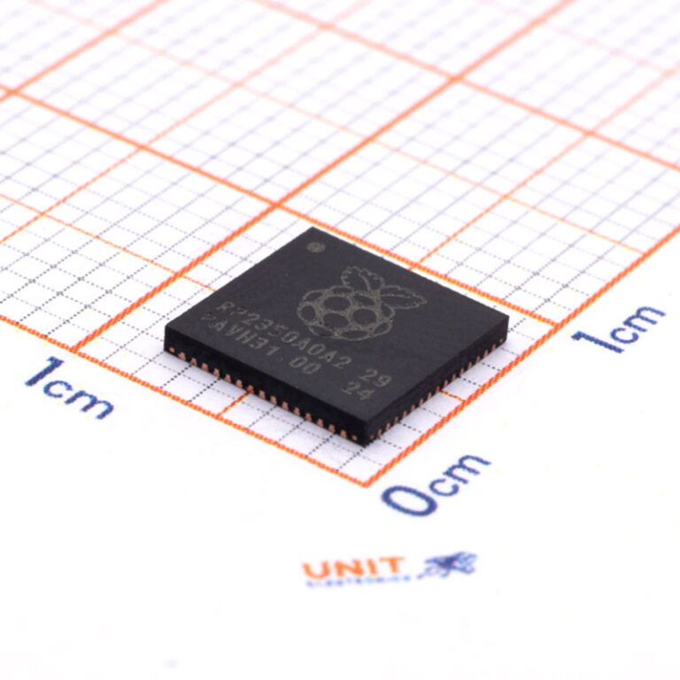
Raspberry Pi RP2350A QFN-60 microcontroller
The processor integrates 520 kB of on-chip SRAM arranged in ten banks, USB 1.1 host/device control with an embedded PHY, ADC inputs shared with GPIO, fixed serial peripherals, PWM, DMA, three PIO blocks with twelve state machines, and one HSTX peripheral. The PULSAR design routes a selected subset of these functions to onboard devices and external connectors.
The on-chip SRAM is the lowest-latency working memory. It contains stacks, heaps, interrupt data, time-critical buffers, and code copied from flash when a framework requires it. DMA and multicore applications must coordinate access to shared buffers and peripherals.

3.4 Memory Architecture: Flash and PSRAM
The W25Q128JVPIQ provides 128 Mbit (16 MiB) of external QSPI flash. It stores the boot image, application firmware, and any filesystem or data region defined by the selected board-package partition scheme. The BOOT control participates in the RP2350 USB boot workflow used to load recovery or update images.
The APS6404L-3SQR-ZR provides 8 MiB of external PSRAM with chip select on GPIO0. In the Arduino workflow, the board configuration must set PSRAM CS to GPIO0 and select the 8 MiB capacity. Static objects can be placed in PSRAM with the core’s PSRAM attribute; dynamic objects can be allocated with pmalloc() and released with free().
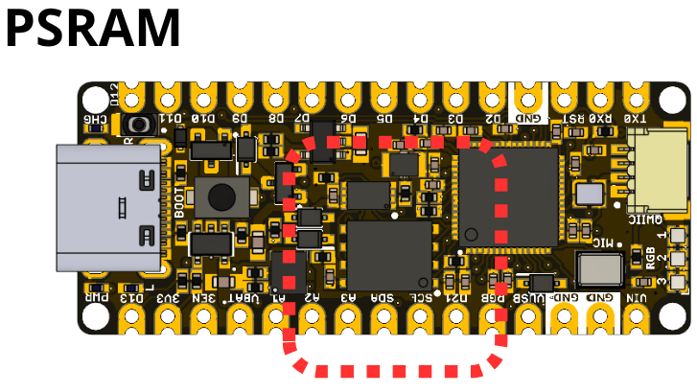
External PSRAM location
PSRAM is suited to framebuffers, file buffers, captured audio, sensor history, and large application structures. Interrupt flags, frequently accessed state, and timing-critical data should remain in internal SRAM. The application must check allocation results and avoid assuming that all configured PSRAM remains free after global/static allocations.

3.5 HSTX Video Output
The HSTX peripheral serializes data at high speed and can generate the pseudo-differential TMDS signals used by DVI-compatible displays. The wiki and PCB routing define four channel pairs:
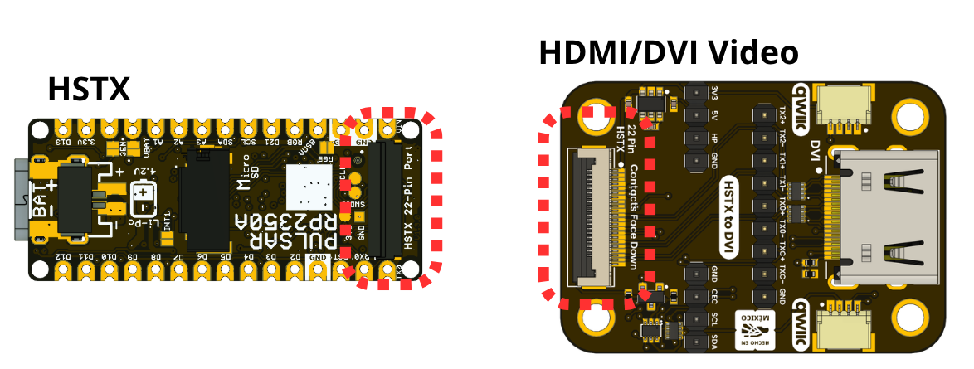
HSTX connector location
TMDS channel | Positive GPIO | Negative GPIO | Function
Clock | 14 | 15 | Pixel/link clock pair
Data 0 | 18 | 19 | TMDS data channel 0
Data 1 | 16 | 17 | TMDS data channel 1
Data 2 | 12 | 13 | TMDS data channel 2
The 22-position HSTX connector carries these signals and returns. The wiki uses the UDVI HSTX library with a 320 × 240 RGB565 framebuffer, drawing primitives, text, and partial-screen updates. This resolution is an implementation profile from the wiki, not a limit of the connector or RP2350A.
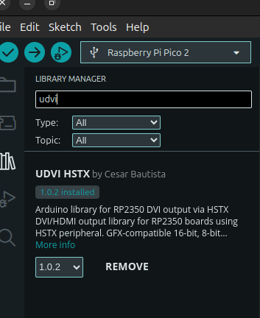
UDVI HSTX library in Arduino Library Manager
While HSTX is enabled, GPIO12–GPIO19 are actively driven and must not be shared with another output or an attached circuit that drives the same nets. Display adapters must match the connector contact order and differential-pair routing.

3.6 MicroSD Card Socket
The 47309-2651 socket is connected to a complete four-bit SDIO signal group:
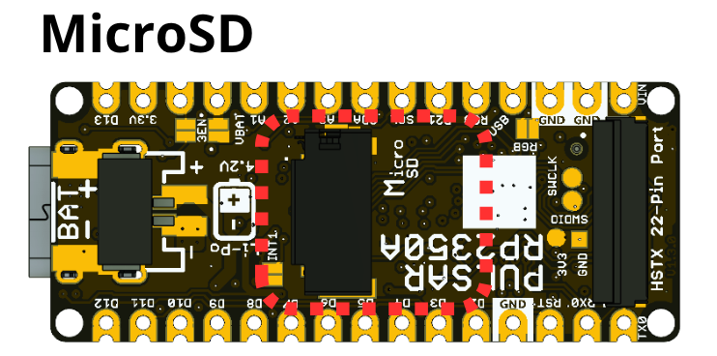
microSD socket location
Signal | GPIO | SPI-mode role in current examples
SDIO_CLK | 2 | SCK
SDIO_CMD | 3 | MOSI
SDIO_DAT0 | 4 | MISO
SDIO_DAT1 | 5 | Not used by SPI mode
SDIO_DAT2 | 6 | Not used by SPI mode
SDIO_DAT3 | 7 | Chip select
The wiki examples use the SPI-compatible subset through SPI and SDFS for initialization, file creation, reading, directory enumeration, and logging. Software with four-bit SDIO support can additionally use DAT1 and DAT2. File writes should be flushed and closed before power removal or card extraction.
Card capacity, speed class, and filesystem support are software-dependent. The wiki workflow uses FAT32 for initial validation.

3.7 LED Indicators
Three WS2812-compatible 1010 RGB LEDs form a serial chain driven by GPIO1. Firmware transmits one ordered color frame for all three pixels, enabling status colors, progress animation, and user feedback with a single GPIO.
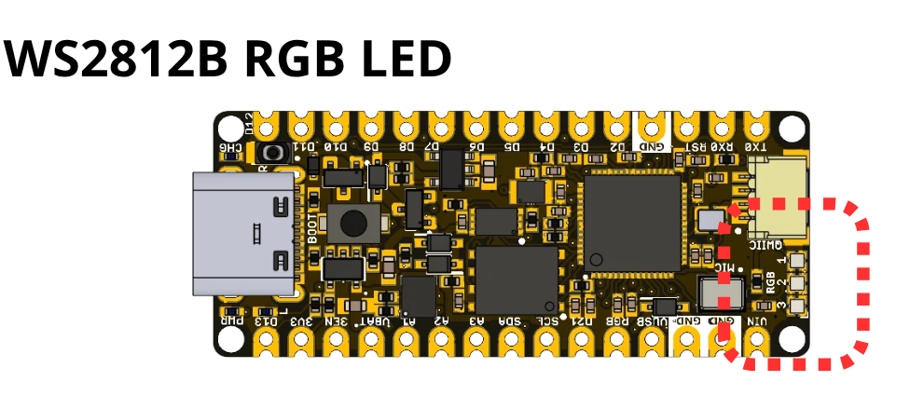
WS2812 RGB LED locations
The board also contains a user indicator on GPIO20 (D13 / BUILTIN1), a power indicator, and a charge-status indicator. The user and RGB indicators are firmware-controlled. The power indicator follows its rail circuit. The charge indicator follows the MCP73831 status output and is not a general-purpose GPIO indicator.
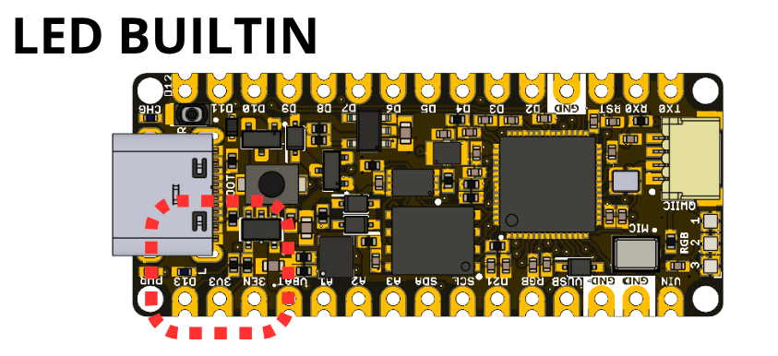
Built-in user LED location
Applications should limit RGB brightness where power consumption or thermal rise matters. Updating the RGB chain is independent from HSTX video output.

3.8 AP2112K and MCP73831 Power Management System
U1 is an AP2112K fixed 3.3 V LDO. It converts the VSYS power rail into the 3.3 V domain used by RP2350A, memories, sensors, indicators, and the QWIIC connector. The 3EN control is associated with regulator enable and is pulled up in the available schematic.
IC2 is an MCP73831 single-cell Li-Ion/Li-Polymer charge controller. It connects the USB-derived supply, charge programming network, VBAT, and status indicator. The actual charge current is set by the charge-configuration network; the charger’s component maximum is not a module-level charge-current rating.
Schottky diodes and MOSFETs implement source routing and protection around USB, VIN, VSYS, and battery nets. Do not assume ideal-diode behavior, seamless switchover, or reverse-current protection beyond what is explicitly defined by the schematic and module specifications.

3.9 Power Tree
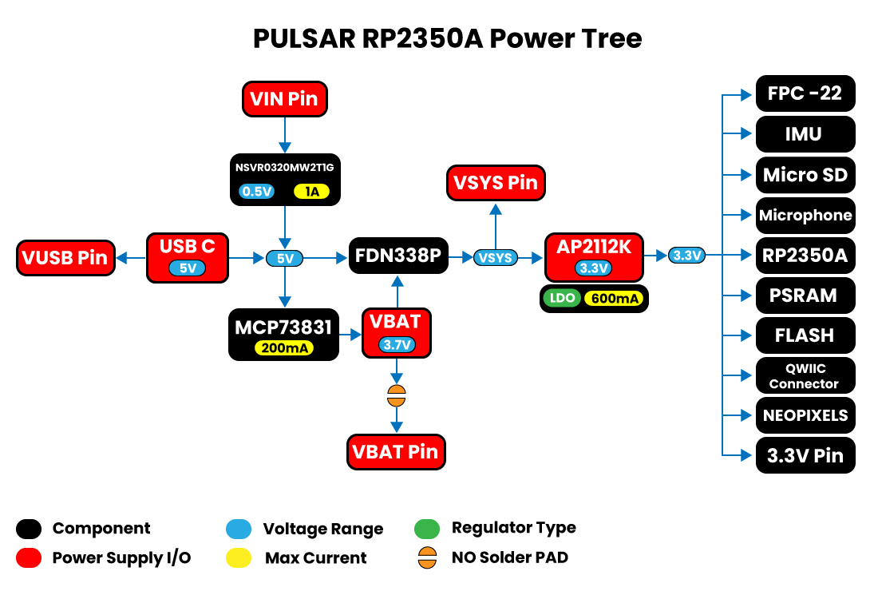
The diagram is a functional power tree, not a replacement for the schematic. USB-C VBUS, VIN, and battery are represented in the power-path design. Board-level limits, source priority, and transient behavior are not specified by the available documentation.
The 3.3 V rail supplies onboard logic and is also exposed at the edge and QWIIC connector. Available current for an external load equals regulator capability minus all board consumption and thermal derating; that value is not specified at module level.

3.10 BMI270 Motion Sensor
The BMI270 combines a three-axis accelerometer and three-axis gyroscope. It is connected to GPIO8 (SDA) and GPIO9 (SCL) on the internal/user I2C bus. The wiki initializes it by scanning its supported address options and then reads acceleration and angular-rate samples.
Typical board applications include orientation interfaces, motion-triggered logging, gesture input, vibration observation, and control of HSTX graphics. Measurement ranges, filtering, output data rate, and interrupt behavior are configured through the BMI270 driver and are not fixed by the PCB.

3.11 PDM Microphone
The ICS-41350 is an onboard digital MEMS microphone. RP2350A supplies its PDM clock on GPIO10 and receives the one-bit data stream on GPIO11. The software PDM stack clocks the microphone, decimates the stream, and produces PCM sample buffers for analysis, visualization, streaming, or storage.
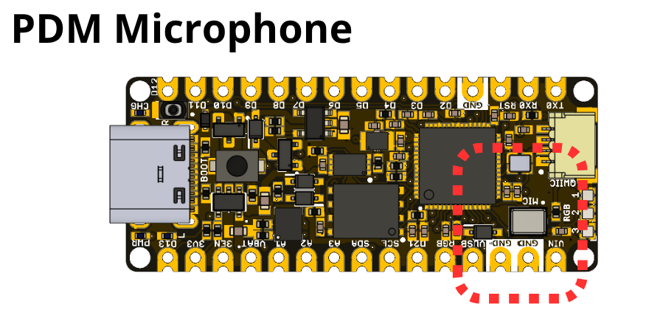
PDM microphone location
The acoustic port must remain unobstructed. Enclosures, adhesive, contamination, and board mounting can affect acoustic performance. Board-level sensitivity, noise, frequency response, and enclosure behavior depend on the mechanical and acoustic implementation and are not specified at module level.

3.12 I2C and QWIIC Expansion
The board provides two distinct I2C routes. GPIO8/GPIO9 serve the onboard BMI270 and are also represented by SDA/SCL edge labels. GPIO24/GPIO25 feed the four-position QWIIC connector and HSTX connector positions.
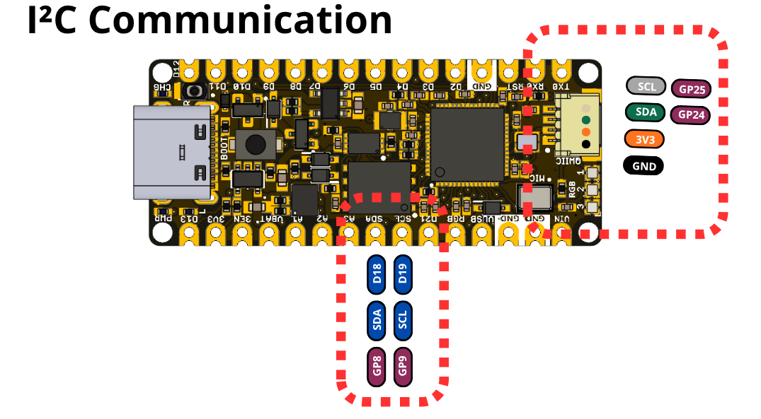
I2C and QWIIC connections
This separation lets an application keep the IMU bus independent from external QWIIC sensors. The wiki includes bus scanning, BMI270 access, EEPROM byte and block operations, hexadecimal dumps, and structured EEPROM records. External pull-ups, device addresses, bus capacitance, and cable length must be considered when attaching multiple devices.

3.13 Combined System Operation
The board is designed for concurrent use of its subsystems. For example, the BMI270 can control an HSTX-rendered object while PSRAM holds large graphics or history buffers; the microphone or an I2C sensor can produce records stored on microSD; and RGB LEDs can show acquisition, storage, or fault state.
A robust application initializes one subsystem at a time, checks every return value, keeps high-rate and interrupt data in internal SRAM, moves large buffers to PSRAM, flushes storage before shutdown, and yields enough execution time for USB and framework services. The repository’s C++ examples implement each stage separately before the combined application.

4 Connectors & Pinouts
Pin labels describe hardware revision V1.3. GPIO numbers identify RP2350A signals; framework aliases depend on the selected board definition.

4.1 General Pinout
Board label | RP2350A | Primary board role | Shared resource
TX0 / D1 | GPIO18 | UART-capable digital I/O | HSTX Data0 pair
RX0 / D0 | GPIO19 | UART-capable digital I/O | HSTX Data0 pair
D2 | GPIO17 | Digital I/O | HSTX Data1 pair
D3 | GPIO16 | Digital I/O | HSTX Data1 pair
D4 | GPIO15 | Digital I/O | HSTX clock pair
D5 | GPIO14 | Digital I/O | HSTX clock pair
D6 | GPIO13 | Digital I/O | HSTX Data2 pair
D7 | GPIO12 | Digital I/O | HSTX Data2 pair
D8 | USB_DM (pin 51) | USB D- (native RP2350A USB PHY) | Same differential pair as the USB-C connector, via 22 Ω series resistor R10
D9 | USB_DP (pin 52) | USB D+ (native RP2350A USB PHY) | Same differential pair as the USB-C connector, via 22 Ω series resistor R11
D10 / SS | GPIO21 | Digital I/O | General-purpose
D11 / MOSI | GPIO23 | Digital I/O | General-purpose
D12 / MISO | GPIO20 | Digital I/O | General-purpose
D13 / SCK / LED | GPIO22 | Digital I/O and user LED | BUILTIN1
A1 / D15 | GPIO29 / ADC3 | Analog-capable I/O | Also routed to HSTX connector
A2 / D16 | GPIO27 / ADC1 | Analog-capable I/O | Edge pad
A3 / D17 | GPIO26 / ADC0 | Analog-capable I/O | Edge pad
SDA / D18 | GPIO8 | I2C data | BMI270 bus
SCL / D19 | GPIO9 | I2C clock | BMI270 bus
D21 | GPIO10 | PDM clock | ICS-41350 clock
RGB | GPIO1 | RGB-chain output | Three onboard WS2812 LEDs
Power and control positions include 3V3, 3EN, VBAT, VUSB, VIN, RST, and multiple GND pads. Their physical presence does not establish unreleased input or load limits.

4.2 Arduino NANO Pinout Compatibility
The board uses two parallel 15-position edge rows inspired by the Arduino Nano layout. This provides a familiar mechanical and labeling pattern, but it is not a statement of full electrical or shield compatibility.
Important differences include:
- RP2350A uses a 3.3 V logic domain.
- Several conventional positions have PULSAR-specific functions such as VBAT, 3EN, RGB, and microphone clock.
- GPIO12–GPIO19 are shared with the HSTX video route.
- D8 and D9 are not general-purpose GPIO: they carry the RP2350A’s native USB D-/D+ signals (the same differential pair used by the USB-C connector), each through a 22 Ω series resistor. Do not drive them as digital I/O.
- Analog channel labels do not form a simple sequential GPIO order.
- The board includes bottom-side connectors and components that may conflict mechanically with some carriers.
Before installing the board into a Nano-style carrier, compare every power, reset, analog, and digital position and verify bottom-side clearance.

4.3 QWIIC Connector
J1 is a four-position, 1 mm-pitch right-angle connector carrying:
Signal | RP2350A connection | Function
GND | Ground | Common return
3.3 V | Regulated rail | Peripheral supply; available current not specified
SDA | GPIO24 | External I2C data
SCL | GPIO25 | External I2C clock
The QWIIC bus is separate from the GPIO8/GPIO9 bus used by BMI270. A controlled contact-number and mating-cable drawing is not included, so verify the physical orientation against controlled connector data when producing a harness.

4.4 MicroSD Connector
Socket signal | GPIO | Description
CLK | 2 | SDIO clock / SPI SCK
CMD | 3 | SDIO command / SPI MOSI
DAT0 | 4 | SDIO data 0 / SPI MISO
DAT1 | 5 | SDIO data 1
DAT2 | 6 | SDIO data 2
DAT3 | 7 | SDIO data 3 / SPI chip select
Detect | Dedicated socket contact | Card-detect handling depends on firmware routing
VDD | 3.3 V | Card supply
GND / shields | Ground | Return and mechanical shield
Insert and remove a card only when filesystem activity has stopped. Software must flush and close files before power removal.

4.5 Battery Connections
JP1 is a two-position PH2.0 battery connector associated with VBAT and the battery return. Polarity markings are present on the bottom side. The MCP73831 charge controller is designed for a single-cell Li-Ion/Li-Polymer system, but the compatible cell, connector, polarity convention, charge current, and operating range are not specified by the available module-level documentation.
Do not connect a battery based solely on connector fit. Reversed polarity or an unsupported chemistry can damage the board or cell.

4.6 HSTX 22-pin Connector
J5 is a 22-position, 0.5 mm-pitch FFC/FPC connector. The schematic exposes D0–D7 (GPIO12–GPIO19), A0/GPIO28, A1/GPIO29, GPIO24/SDA, GPIO25/SCL, 3.3 V, and interleaved returns. HSTX video uses the eight GPIO12–GPIO19 signals as four TMDS pairs.
The flex-cable contact side, complete numbered contact table, cable length, and display adapter are not specified by a controlled mechanical drawing. Do not infer pin 1 from an unannotated photograph.

4.7 USB-C, BOOT, and Reset
The USB-C connector carries VBUS and the RP2350A USB data pair. The schematic shows the required USB-C configuration resistors and ESD protection. USB is the preferred programming and first-power interface.
BOOT selects the ROM USB boot path used for firmware recovery or initial programming. Reset restarts RP2350A while power remains applied. Exact button timing depends on the selected toolchain, but the common sequence is to hold BOOT while resetting or connecting USB, then release BOOT after enumeration.

4.8 SWD and Test Pads
Bottom-side pads expose SWDIO, SWCLK, 3.3 V reference, and GND for an external debug probe. SWD supports firmware loading and source-level debug when the toolchain and processor architecture are configured consistently.
Use short connections, share ground, and let the probe sense the target’s 3.3 V rail. Do not use the reference pad to power the complete board unless the debug probe is explicitly rated and the board power path permits it.

5 Board Operation
The procedures below define the board workflow described by the technical wiki and the compilable sketches under software/cpp_examples/.

5.1 Getting Started with Arduino IDE
- Install Arduino IDE 2.x.
- Add the UNIT package index to Additional Boards Manager URLs: https://raw.githubusercontent.com/UNIT-Electronics/Uelectronics-RP2040-Arduino-Package/main/package_Uelectronics_rp2040_index.json
- Install the UNIT Electronics RP2040/RP2350 package.
- Select Generic RP2350 or an installed PULSAR-specific board definition.
- Select the RP2350A chip variant, 16 MiB flash, PSRAM CS GPIO0, and 8 MiB PSRAM.
- Connect a USB-C data cable and select the enumerated serial/boot port.
- Open the basic Blink sketch and upload it.
The repository examples were compile-checked with the UNIT RP2350 core using a 16 MiB flash and 8 MiB PSRAM configuration. Compile success confirms API and library compatibility; electrical operation also depends on the connected hardware and selected configuration.

5.2 First Power-up and Inspection
Use USB-C for initial power. Inspect component orientation, connector seating, solder bridges, and the microphone port before energizing the board. If available, use a current-limited source and monitor the 3.3 V rail.
Do not attach a battery, external VIN, HSTX adapter, microSD card, or QWIIC peripheral for the first power check. Confirm the power indicator and absence of unexpected heating, then establish USB enumeration and upload behavior.

5.3 BOOT and Reset Workflow
For a normal update, the selected framework may reset the board into its upload mode automatically. If automatic upload is unavailable:
- Disconnect external driven signals.
- Hold BOOT.
- Press and release reset, or connect USB while BOOT is held.
- Release BOOT after the ROM boot interface appears.
- Copy or upload the generated firmware using the toolchain instructions.
- Reset again to run the application from external flash.
SWD provides an alternative when debugging startup code or recovering a board whose USB application does not enumerate.

5.4 Recommended Bring-up Sequence
Order | Subsystem | What the step establishes
1 | User LED | Core execution, GPIO20, and upload path
2 | USB serial | Host communication and diagnostic output
3 | ADC | Basic analog input path
4 | RGB chain | GPIO1 timing and three-pixel order
5 | BMI270 I2C | GPIO8/GPIO9 and onboard sensor communication
6 | QWIIC I2C | GPIO24/GPIO25 and external expansion
7 | PSRAM | GPIO0 selection, capacity detection, and allocation
8 | microSD | SPI-compatible subset, card access, and filesystem
9 | PDM | GPIO10/GPIO11 clock and audio capture
10 | HSTX | GPIO12–GPIO19 pairing and display output
11 | Combined application | Memory ownership and subsystem coexistence
Testing one subsystem at a time makes pin conflicts and library configuration errors easier to isolate.

5.5 C++ Example Collection
The software/cpp_examples/ directory contains 28 complete sketches:
Group | Sketches | Coverage
Blink | 2 | basic and serial-debug LED operation
ADC | 2 | continuous reading and threshold indication
WS2812 | 3 | color sequence, brightness, running pixel
I2C | 7 | scan, BMI270, EEPROM byte/block/dump/structure/multiple devices
microSD | 4 | initialize, read/write, list, log
HSTX | 3 | test pattern, drawing primitives, system monitor
Complete application | 1 | BMI270-controlled HSTX cube
PSRAM | 5 | detect, static/dynamic allocate, test, monitor
PDM | 1 | capture PCM samples through the PDM library
The examples reconcile known wiki/API differences: user LED GPIO20, SDFS capacity through FSInfo, directory open mode, flush() return type, and release of pmalloc() memory through free().

5.6 Memory Planning
Keep stacks, interrupt state, frequently accessed variables, and small DMA descriptors in internal SRAM. Place large framebuffers, logging queues, and historical data in PSRAM. Check every allocation and track free internal and external heap separately.
HSTX RGB565 graphics can consume a large buffer; microSD and USB also require working memory. Avoid allocating every maximum-size buffer at startup without a documented memory budget.

5.7 Storage Operation
Configure the microSD SPI subset on GPIO2, GPIO3, GPIO4, and GPIO7 for the current SDFS examples. Initialize the card, verify filesystem information, open only the files needed, call flush() after important writes, and close handles before removal or reset.
For data logging, buffer short records in RAM and write them in bounded batches rather than performing filesystem operations from an interrupt handler.

5.8 Video, Sensor, and Audio Coexistence
HSTX reserves GPIO12–GPIO19 and may generate continuous DMA/interrupt load. BMI270 uses GPIO8/GPIO9, PDM uses GPIO10/GPIO11, and microSD uses GPIO2–GPIO7, so the fixed signal sets do not overlap. They still compete for processor time, DMA channels, SRAM, PSRAM bandwidth, and power.
Use bounded update rates, partial display redraws, buffered audio acquisition, and nonblocking storage tasks. A combined application should expose health information over USB serial or RGB status rather than failing silently.

5.9 Troubleshooting Guide
Symptom | Checks
No USB device | Data-capable cable, BOOT/reset sequence, host port, 3.3 V rail
Blink does not run | GPIO20 mapping, selected board/FQBN, successful upload
PSRAM unavailable | PSRAM CS GPIO0, 8 MiB option, allocation result
BMI270 not found | GPIO8/GPIO9 configuration, address selection, library
microSD fails | FAT32, GPIO2/3/4/7, SDFS configuration, card seating
PDM returns no data | GPIO10 clock, GPIO11 data, PDM buffer/callback setup
HSTX display blank | pair order, adapter/cable orientation, supported timing
Unstable combined app | internal heap, PSRAM use, blocking loops, pin conflicts
Record the exact board revision, package/core version, library versions, compiler output, power source, and reproduction steps for every bring-up issue.

6 Mechanical Information
Hardware revision V1.3.0 uses a narrow development-board layout with two parallel edge-pad rows, four corner mounting holes, USB-C at one end, and the 22-pin HSTX connector at the opposite end.

6.1 Component-side Envelope
USB-C, pushbuttons, QWIIC, and the tallest top-side components require vertical and tool-access clearance. Edge castellations/pads must remain accessible for headers, carrier sockets, or direct soldering.

6.2 Bottom-side Envelope
The battery connector, microSD socket, microphone, and HSTX connector require bottom-side clearance. An enclosure must not obstruct the microphone acoustic port or prevent card and flex-cable insertion.

6.3 Mechanical Data Not Specified
A controlled board-outline drawing, PCB thickness, mounting-hole coordinates, keep-outs, connector insertion envelopes, and component height table are not present in the supplied package. Do not derive production dimensions from the rendered images.
An enclosure or carrier design requires independently controlled values for:
- overall board length, width, and thickness;
- edge-row pitch and row spacing;
- mounting-hole diameter and coordinates;
- USB-C, QWIIC, battery, microSD, and HSTX access envelopes;
- top/bottom maximum component height;
- microphone acoustic keep-out; and
- insertion/removal paths for card, battery plug, and FFC/FPC cable.

7 Company Information
Item | Information
Company | UNIT Electronics
Website | UNIT Electronics
Address | Salvador 19, Cuauhtémoc, 06000 Mexico City, CDMX, Mexico
The repository and Product Wiki in the next chapter provide the product’s hardware, software, and reference documentation.

8 Reference Documentation
Reference | Location
Product repository | UNIT-Electronics-MX/unit_pulsar_rp2350a
Hardware reference | hardware/README.md
Technical wiki | PULSAR RP2350 wiki
Getting Started | Setup guide
C++ examples | software/cpp_examples
Board schematic | V1.3 schematic
RP2350 component datasheet | Raspberry Pi RP2350 Datasheet
The wiki is the implementation guide for the board’s intended operation, but it is not a source of module-level electrical ratings. The supplied legacy Product Reference DOCX is also excluded as a technical source because its content describes a PULSAR ESP32-H2 rather than this RP2350A board.

9 Appendix

9.1 Schematic
The following three sheets are rendered from unit_sch_v_1_3_0_pulsar_rp2350a.pdf. The PDF remains the authoritative electrical drawing. The title block still contains PULSAR RP230A and revision 1.0.0; this label differs from the UNIT PULSAR RP2350 name and RP2350A controller described in this reference.

9.1.1 Processor, Memory, USB, I/O, and Power Entry
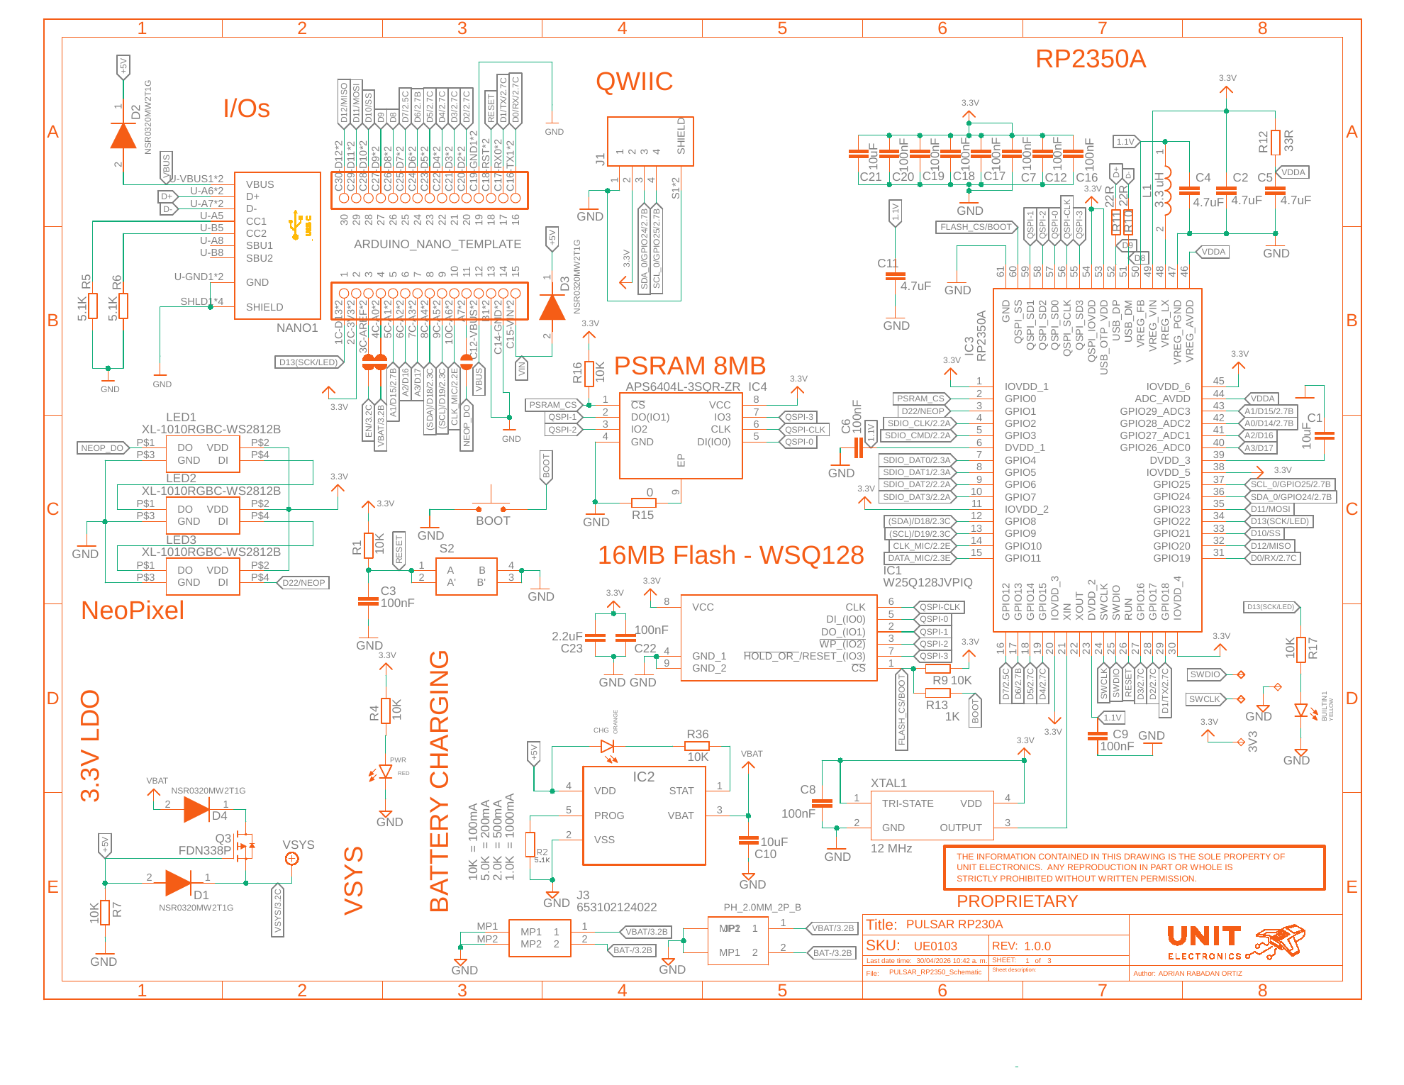

9.1.2 microSD, BMI270, HSTX Connector, and PDM Microphone
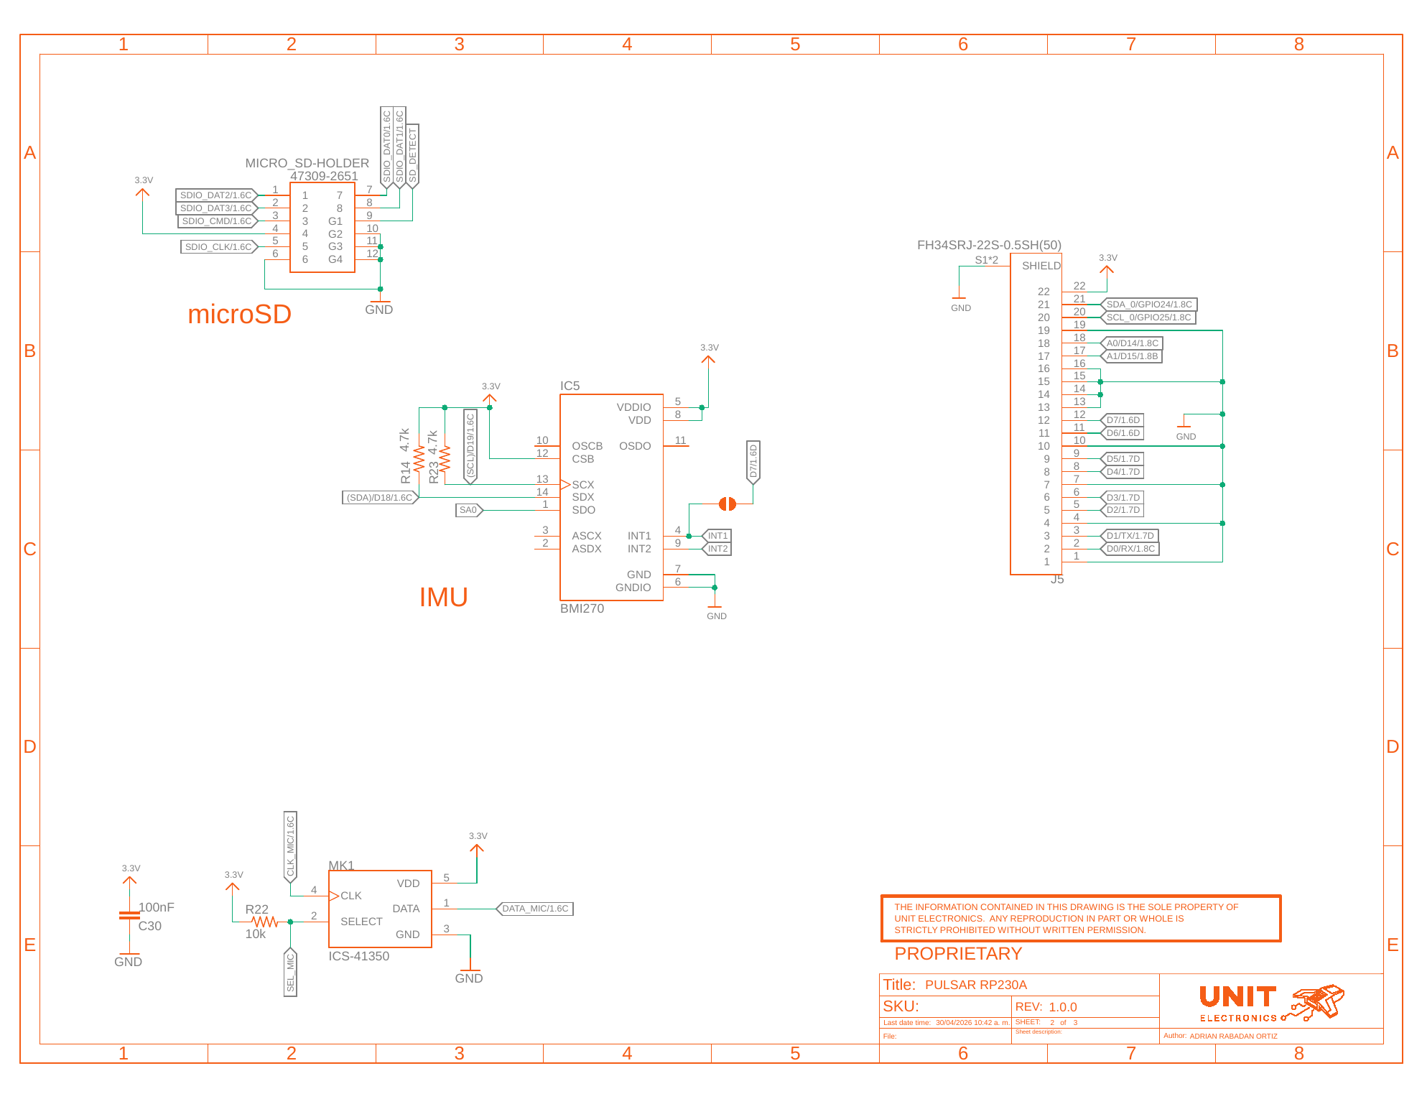

9.1.3 3.3 V Regulator
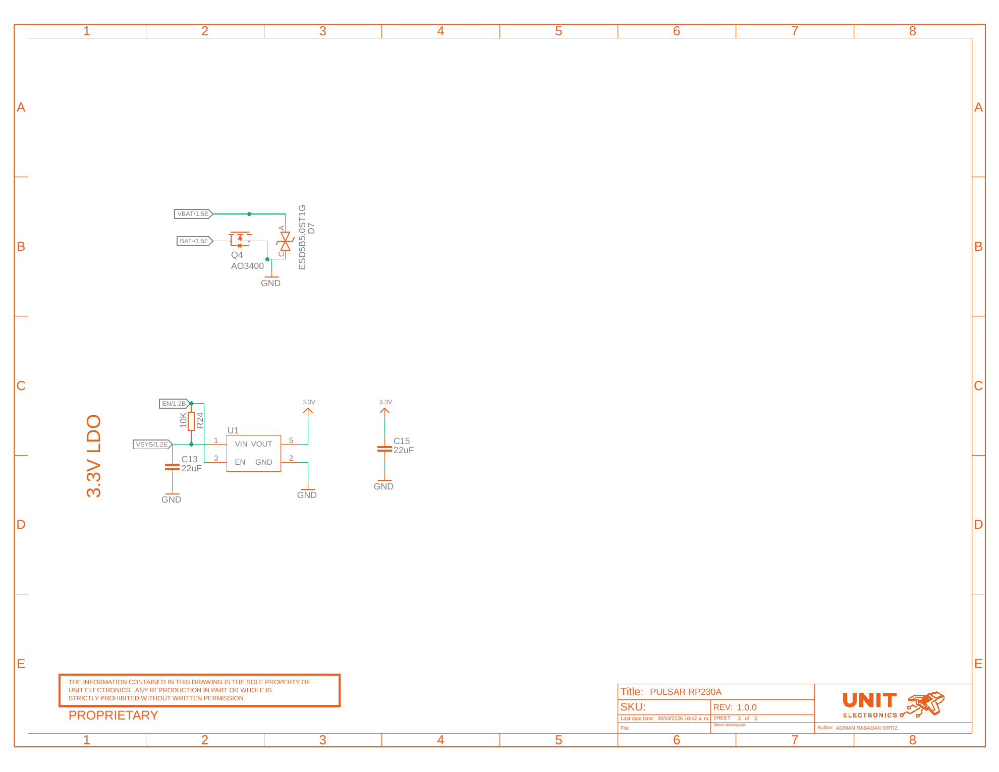

9.2 Technical References
- The V1.3 schematic defines board connectivity and component designators.
- The official Raspberry Pi RP2350 datasheet defines RP2350A component capabilities and limits.
- The technical wiki defines intended subsystem operation and firmware workflow.
- The compile-checked C++ example collection reconciles wiki code with the installed UNIT RP2350 core APIs.

9.3 Values Not Specified by the Technical Documentation
- A schematic title block matching UNIT PULSAR RP2350 V1.3.0
- Module VIN, VBAT, USB, and 3.3 V rail electrical limits
- Power-source priority, charge current, and compatible battery connection
- Complete numbered HSTX and QWIIC connector drawings
- D8 and D9 edge-pad disposition
- Board dimensions, mounting coordinates, and mechanical keep-outs
- Current consumption, thermal behavior, and validated interface rates
- Module-level runtime performance for the wiki and C++ examples
- Complete pinout, topology, and dimension drawings

9.4 Document Control
Field | Value
Product | UNIT PULSAR RP2350
Product family | UNIT DevLab ecosystem
Hardware revision | V1.3.0
Product Reference | Version 0.1.0
Publication date | 2026-08-03
Firmware | 28 compile-checked examples

9.5 Source Inconsistencies
- The board uses an RP2350A, but the schematic title block says PULSAR RP230A and revision 1.0.0.
- The supplied legacy Product Reference DOCX describes an ESP32-H2 board and is not applicable to UNIT PULSAR RP2350.
- Wiki microSD examples use SPI mode, while the V1.3 schematic exposes a full four-bit SDIO group. Both are represented correctly: SPI uses the compatible CLK/CMD/DAT0/DAT3 subset.
- The wiki’s original Blink definition used GPIO22, while the V1.3 schematic connects D13 / BUILTIN1 to GPIO20. Repository examples follow GPIO20.

