UNIT DevLab PULSAR RP2350A
Preview Product Reference — Hardware Artwork V1.3.0 — Mfr. Part #: UE0103
UNIT Electronics
2026-08-03

Contents
- Description
  - Applications
  - Hardware Features
- 1 The Board
  - 1.1 Board Identification
  - 1.2 Confirmed Assemblies
  - 1.3 Package Contents
- 2 Electrical Characteristics
  - 2.1 Confirmed Component and Rail Values
  - 2.2 Pending Module-Level Characteristics
  - 2.3 Electrical Precautions
- 3 Functional Overview
  - 3.1 Processing and Boot Memory
  - 3.2 Internal and External Memory
  - 3.3 Motion Sensing and I2C Expansion
  - 3.4 microSD Storage
  - 3.5 HSTX Video Output
  - 3.6 PDM Audio Input
  - 3.7 Visual Indicators and User Feedback
  - 3.8 Power Distribution and Battery Support
  - 3.9 Combined System Operation
- 4 Connectors and Pinout
  - 4.1 Edge Connections
  - 4.2 Fixed Peripheral Mapping
  - 4.3 QWIIC Connector
  - 4.4 HSTX Connector
  - 4.5 Programming and Battery Connections
- 5 Pre-production Operation Notes
  - 5.1 Current Wiki Coverage
- 6 Mechanical Information
- 7 Company Information
- 8 Reference Documentation
- 9 Appendix
  - 9.1 Source Hierarchy
  - 9.2 Items Pending Validation
  - 9.3 Document Control
  - 9.4 Source Inconsistencies

Description
The UNIT DevLab PULSAR RP2350A is a multi-interface development board built around the Raspberry Pi RP2350A microcontroller. The pre-production V1.3 design combines external QSPI flash and PSRAM with motion sensing, PDM audio, microSD, USB-C, battery support, addressable RGB indicators, QWIIC I2C, and a 22-pin HSTX expansion connector.
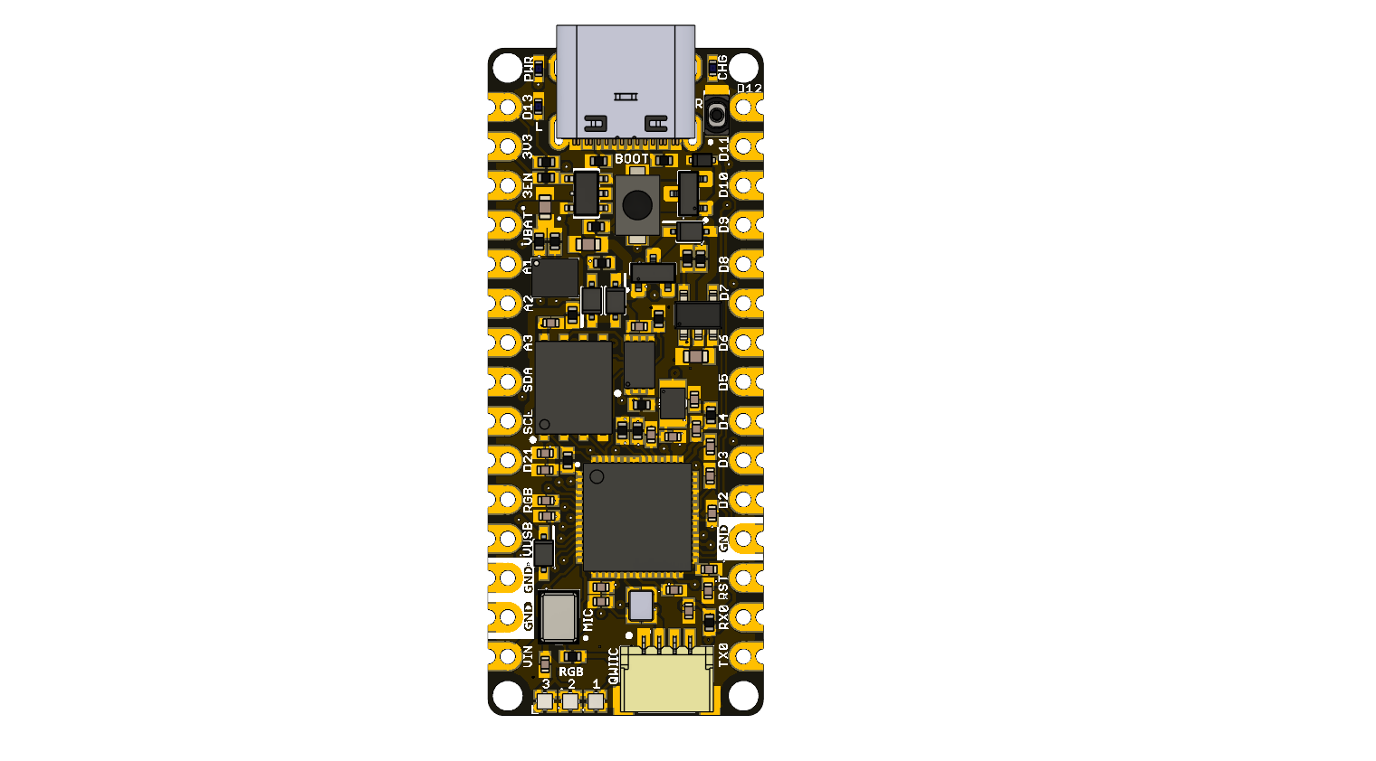

Applications
- RP2350 firmware and peripheral prototyping
- Motion and PDM audio acquisition
- microSD data logging
- HSTX graphics experiments
- External-memory and multicore applications
- Education and subsystem validation

Hardware Features
- RP2350A microcontroller with external W25Q128 128 Mbit QSPI flash
- APS6404L-3SQR-ZR 8 MiB PSRAM
- BMI270 six-axis inertial measurement unit
- ICS-41350 digital PDM microphone
- Four-bit SDIO microSD connection
- Three WS2812-compatible RGB LEDs plus power, charge, and user indicators
- USB-C, QWIIC, battery, edge-pad, SWD, and HSTX connections
The hardware design is complete and awaiting fabrication. This Product Reference is a preview; values requiring measurement on manufactured units are marked pending confirmation.

1 The Board

1.1 Board Identification
Item | Value
Product | UNIT DevLab PULSAR RP2350A
Product type | Multi-interface development board
Manufacturer Part Number | UE0103
Main component | Raspberry Pi RP2350A
Hardware artwork | V1.3.0
Product Reference | 0.1.0, preview

1.2 Confirmed Assemblies
RefDes | Fitted component | Board function
IC1 | W25Q128JVPIQ | 128 Mbit (16 MiB) QSPI flash
IC3 | RP2350A | Main microcontroller
IC4 | APS6404L-3SQR-ZR | 8 MiB PSRAM
IC5 | BMI270 | Six-axis IMU
MK1 | ICS-41350 | Digital PDM microphone
U1 | AP2112K-3.3TRG1 | Fixed 3.3 V LDO
IC2 | MCP73831T-2ACI/OT | Single-cell charge controller
LED1–LED3 | WS2812 1010 | Addressable RGB indicator chain
MICRO_SD-HOLDER | 47309-2651 | microSD socket

1.3 Package Contents
Package contents have not been formally released. No cable or battery is claimed as included in this preview edition.

2 Electrical Characteristics

2.1 Confirmed Component and Rail Values
Parameter | Value | Scope / evidence
Regulated board rail | 3.3 V nominal | AP2112K-3.3TRG1 output shown in schematic and BOM
USB supply net | +5 V nominal | USB-C VBUS net label in schematic
External flash capacity | 128 Mbit (16 MiB) | W25Q128JVPIQ part identification
External PSRAM capacity | 8 MiB | APS6404L-3SQR-ZR schematic annotation and BOM
RP2350 internal SRAM | 520 KiB | RP2350 component datasheet
RP2350 nominal maximum system clock | 150 MHz | RP2350 component datasheet; not a module test result
Board oscillator | 12 MHz | XTAL1 schematic and BOM
PDM microphone supply range | 1.65 to 3.63 V | ICS-41350 BOM description; component rating only
The 3.3 V rail, USB net label, microphone supply range, and individual power component ratings do not establish complete board ratings.

2.2 Pending Module-Level Characteristics
- Allowed VIN and VBAT operating and absolute-maximum ranges
- 3.3 V rail output current available to external loads
- USB, battery, and VIN source-selection behavior under all conditions
- Battery charge current and compatible cell/cable specification
- GPIO thresholds, drive limits, and mixed-supply behavior at board connectors
- Total current consumption and thermal limits
- Validated SDIO, HSTX, PDM, PSRAM, and QSPI clock rates

2.3 Electrical Precautions
- Do not infer a board input limit from the AP2112K or MCP73831 component rating.
- Do not attach a battery until polarity, chemistry, connector fit, and charge settings have been validated for the assembly.
- Connect a common ground before applying external signals.
- Treat all exposed I/O as belonging to the 3.3 V RP2350A domain unless a released board specification states otherwise; tolerance to other levels is pending validation.

3 Functional Overview

3.1 Processing and Boot Memory
The RP2350A is the central controller for the board and provides the GPIO, ADC, I2C, PIO, USB, and HSTX resources used by the onboard subsystems. Program storage is provided by the external W25Q128JVPIQ QSPI flash, with a capacity of 128 Mbit (16 MiB). The BOOT pushbutton controls the flash boot-selection path, and the reset control restarts the RP2350A without removing board power.
The board is intended to be programmed through USB-C using the UNIT RP2040/RP2350 board package or another RP2350-compatible toolchain. The wiki uses the user LED as the first upload and execution check before enabling the remaining peripherals.

3.2 Internal and External Memory
The RP2350A provides 520 KiB of internal SRAM for low-latency program data. An APS6404L-3SQR-ZR adds 8 MiB of external PSRAM for framebuffers, acquisition buffers, large arrays, and other data that would otherwise consume internal SRAM. Its chip-select is connected to GPIO0.
In the Arduino workflow described by the wiki, selecting PSRAM CS = GPIO 0 enables the board definition to initialize this memory. Applications can then place static buffers in PSRAM or request dynamic allocations from its heap. Time-critical data can remain in internal SRAM while display buffers, logged data, and other large objects are kept in PSRAM.

3.3 Motion Sensing and I2C Expansion
The onboard BMI270 six-axis IMU uses the internal I2C pair on GPIO8 (SDA) and GPIO9 (SCL). Firmware reads its accelerometer and gyroscope data over this bus for motion, orientation, and user-interface applications.
The QWIIC connector provides a separate I2C path on GPIO24 (SDA) and GPIO25 (SCL), together with 3.3 V and GND. This allows external sensors, EEPROMs, and other I2C peripherals to operate without taking over the BMI270 bus. The wiki documents scanning and device access on both available I2C pin pairs.

3.4 microSD Storage
The microSD socket is electrically connected to GPIO2–GPIO7 as CLK, CMD, and DAT0–DAT3, allowing the RP2350A to use the complete four-bit SDIO signal group. The current wiki examples use the SPI-compatible subset:
microSD operation | GPIO | Schematic signal
Clock | 2 | SDIO_CLK
Command / MOSI | 3 | SDIO_CMD
Data / MISO | 4 | SDIO_DAT0
Chip select in SPI mode | 7 | SDIO_DAT3
This arrangement supports filesystem operations such as card initialization, file creation, reading, directory listing, and sensor-data logging. GPIO5 and GPIO6 provide DAT1 and DAT2 when software uses the full four-bit SDIO bus.

3.5 HSTX Video Output
The RP2350A HSTX peripheral can serialize display data into four pseudo-differential TMDS channel pairs for DVI-compatible video. The wiki defines the routed pair order as follows:
TMDS channel | Positive GPIO | Negative GPIO
Clock | 14 | 15
Data 0 | 18 | 19
Data 1 | 16 | 17
Data 2 | 12 | 13
These GPIOs are available through the 22-pin HSTX connector. When video output is active, the eight pins are driven as a group and must be treated as reserved for that function. The wiki describes a 320 × 240 RGB565 framebuffer workflow, drawing primitives, text rendering, and partial-screen updates; PSRAM is available for large application buffers where supported by the display stack.

3.6 PDM Audio Input
The onboard ICS-41350 converts acoustic pressure into a one-bit PDM data stream. The RP2350A supplies the microphone clock on GPIO10 and receives data on GPIO11. A PDM-capable software peripheral decimates this stream into signed PCM samples that can be processed, displayed, or stored on microSD.
The microphone is already connected on the PCB; no external audio wiring is required for onboard capture. Sample rate, buffering, filtering, and storage format are selected by the application software.

3.7 Visual Indicators and User Feedback
Three cascaded WS2812-compatible RGB LEDs share a single data input on GPIO1. Because the LEDs are connected as a serial chain, firmware sends one ordered color frame to update all three devices. They can provide status, progress, alerts, or application-specific color feedback.
The board also includes a GPIO20 user indicator (D13 / BUILTIN1), a power indicator, and a charge-status indicator. The RGB chain and user LED are independently controlled.

3.8 Power Distribution and Battery Support
USB VBUS, VIN, and the battery circuit feed the board power path. The AP2112K-3.3TRG1 generates the 3.3 V rail used by the RP2350A and onboard peripherals. The MCP73831 provides the single-cell battery-charging function, with the charge indicator reporting the controller status. Schottky diodes and MOSFETs implement the source-routing and protection paths shown in the schematic.
The hardware design is complete and awaiting fabrication. Final module-level input ranges, available rail current, charge configuration, and source-priority behavior will be confirmed on the first manufactured units.

3.9 Combined System Operation
The subsystems are intended to operate together: the BMI270 or PDM microphone can provide acquisition data, PSRAM can hold large working buffers, microSD can store results, the RGB LEDs can report state, and HSTX can present a graphical interface. The wiki’s complete-application chapter combines motion sensing and video output and describes moving large buffers out of internal SRAM to keep the RP2350A responsive.
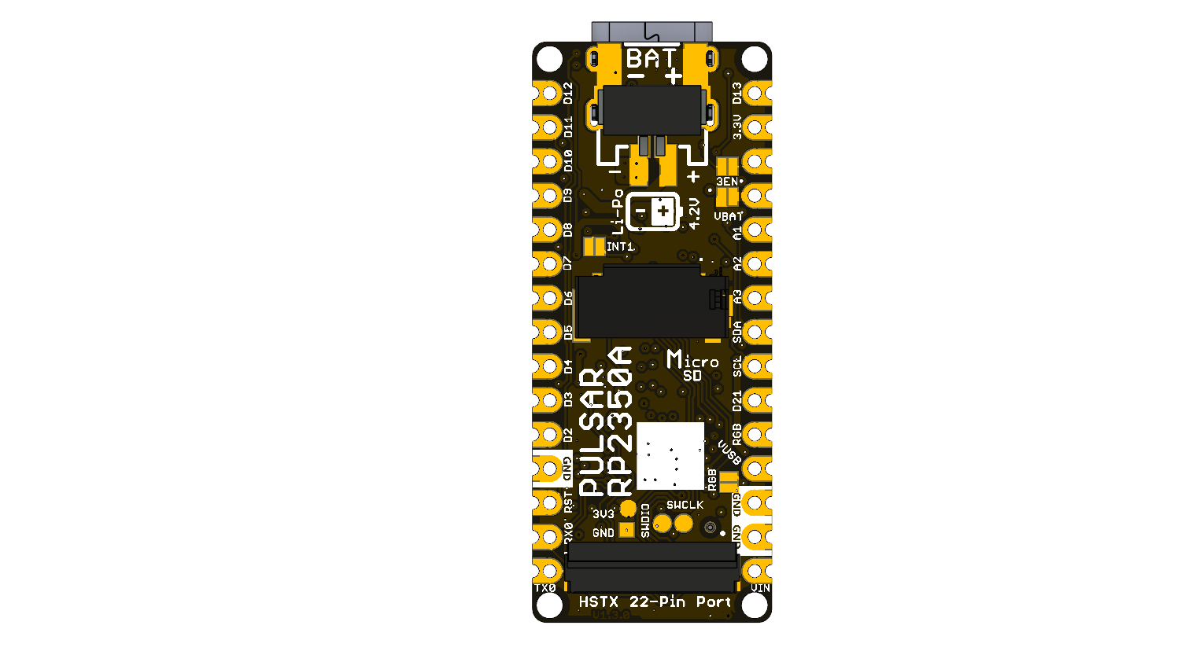

4 Connectors and Pinout

4.1 Edge Connections
Board label | RP2350A connection | Function / status
TX0 / D1 | GPIO18 | Digital I/O / UART-capable
RX0 / D0 | GPIO19 | Digital I/O / UART-capable
D2, D3, D4, D5, D6, D7 | GPIO17, 16, 15, 14, 13, 12 | Digital I/O; also routed to HSTX connector
D8, D9 | Pending | Artwork labels exist; schematic shows no RP2350A connection
D10 / SS | GPIO21 | Digital I/O
D11 / MOSI | GPIO22 | Digital I/O
D12 / MISO | GPIO23 | Digital I/O
D13 / SCK / LED | GPIO20 | Digital I/O and user indicator
A1 / D15 | GPIO29 / ADC3 | Analog-capable digital I/O
A2 / D16 | GPIO27 / ADC1 | Analog-capable digital I/O
A3 / D17 | GPIO26 / ADC0 | Analog-capable digital I/O
SDA / D18 | GPIO8 | Internal/user I2C data
SCL / D19 | GPIO9 | Internal/user I2C clock
D21 | GPIO10 | PDM clock net
RGB | GPIO1 | WS2812 data
3V3, 3EN, VBAT, VUSB, VIN | Power | See Section 2; operating limits pending
RST | Reset | RP2350A reset control
GND | Ground | Common return

4.2 Fixed Peripheral Mapping
Peripheral | Signal mapping
PSRAM | CS=GPIO0; data/clock on the schematic QSPI nets
microSD | CLK=GPIO2, CMD=GPIO3, DAT0=GPIO4, DAT1=GPIO5, DAT2=GPIO6, DAT3=GPIO7
BMI270 | SDA=GPIO8, SCL=GPIO9
PDM microphone | CLK=GPIO10, DATA=GPIO11
HSTX signal group | GPIO12 through GPIO19
QWIIC | SDA=GPIO24, SCL=GPIO25, 3.3 V, GND
RGB LED chain | DATA=GPIO1

4.3 QWIIC Connector
J1 is a four-position, 1 mm-pitch right-angle connector. The schematic shows GND, 3.3 V, GPIO24/SDA, and GPIO25/SCL. A controlled contact-number/orientation drawing and compatible cable specification are pending validation.

4.4 HSTX Connector
J5 is a 22-position, 0.5 mm-pitch FFC/FPC connector. It exposes D0–D7, A0/GPIO28, A1/GPIO29, GPIO24/SDA, GPIO25/SCL, 3.3 V, and return positions. Use the released schematic for prototype tracing; the complete controlled connector pin-number table remains pending validation.

4.5 Programming and Battery Connections
The bottom artwork shows SWDIO, SWCLK, 3.3 V, and GND programming pads. JP1 is a two-position battery connection. Battery polarity is marked on the artwork, but a compatible battery/cable assembly is not specified by this preview.

5 Pre-production Operation Notes
The technical wiki documents the intended firmware workflow and subsystem operation. Those examples are not reproduced in this Product Reference; their results will be confirmed on the first manufactured units. The complete sketches are maintained under software/cpp_examples/.
For initial bench work:
- Inspect the board and confirm its artwork revision.
- Review the V1.3 schematic and the pending electrical limits in Section 2.
- Power through USB-C for first inspection; do not connect a battery or an external VIN source until its limits and polarity have been validated.
- Establish a common ground before attaching test equipment or peripherals.
- Validate the user LED and serial upload path before enabling external memory, storage, sensors, audio, or HSTX output.
- Confirm each peripheral mapping against Section 4 and observe the signals with suitable test equipment before relying on captured data.
Host framework aliases, GPIO initialization, PSRAM setup, SDIO support, and HSTX library behavior depend on the selected board package. The wiki is an implementation work-in-progress and may contain mappings that predate the V1.3 schematic review.

5.1 Current Wiki Coverage
- Board setup and LED validation
- ADC and WS2812 examples
- Internal and external I2C examples
- microSD experiments
- HSTX display experiments
- PSRAM allocation examples
- PDM microphone capture
- A combined demonstration application
Results, performance claims, and troubleshooting instructions from these chapters remain pending confirmation on manufactured hardware.

6 Mechanical Information

The artwork shows two parallel edge-pad rows, four corner mounting holes, USB-C at one end, and the HSTX connector at the opposite end. The microSD and battery connectors are mounted on the bottom side.
A controlled dimension drawing, board thickness, keep-out definitions, connector envelopes, and mounting-hole coordinates were not supplied. All mechanical dimensions are pending validation; do not scale them from the rendered images.

7 Company Information
Item | Information
Company | UNIT Electronics
Website | UNIT Electronics
Address | Salvador 19, Cuauhtémoc, 06000 Mexico City, CDMX, Mexico
Product specifications and documentation may change during preview. Consult the repository and Product Wiki in the next chapter for current released sources.

8 Reference Documentation
Reference | Location
Product repository | UNIT-Electronics-MX/unit_pulsar_rp2350a
Hardware reference | hardware/README.md
Technical wiki | PULSAR RP2350 wiki
Getting Started | Preview setup guide
C++ examples | software/cpp_examples
Board schematic | V1.3 schematic
RP2350 component datasheet | Raspberry Pi RP2350 Datasheet
The wiki is the implementation guide for the board’s intended operation, but it is not a source of module-level electrical ratings. The supplied legacy Product Reference DOCX is also excluded as a technical source because its content describes a PULSAR ESP32-H2 rather than this RP2350A board.

9 Appendix

9.1 Source Hierarchy
- V1.3 schematic, manufacturing BOM, and V1.3 board artwork for fitted components, visible labels, and board connections.
- Official Raspberry Pi RP2350 datasheet for RP2350A component characteristics only.
- Technical wiki for intended subsystem operation and firmware workflow.

9.2 Items Pending Validation
- Correction of the schematic title block from PULSAR RP230A / REV 1.0.0 to match the RP2350A V1.3 source package
- Module VIN, VBAT, USB, and 3.3 V rail electrical limits
- Power-source priority, battery charge current, and compatible battery cable
- Complete controlled HSTX and QWIIC connector pin-number/orientation drawings
- D8 and D9 edge-pad connectivity
- Board dimensions, mounting-hole coordinates, and mechanical keep-outs
- Validated clock rates, current consumption, and thermal behavior
- Reconciliation and test of all technical-wiki examples against V1.3 hardware
- Controlled pinout, topology, and dimensions artwork

9.3 Document Control
Field | Value
Product | UNIT DevLab PULSAR RP2350A
Manufacturer Part Number | UE0103
Hardware artwork covered | V1.3.0
Product Reference | 0.1.0, preview
Publication date | 2026-08-03
Hardware status | Design complete; awaiting fabrication
Firmware status | Implementation documented in the wiki; results pending confirmation on manufactured units

9.4 Source Inconsistencies
- The V1.3 schematic filename, artwork, and BOM identify RP2350A, but the schematic title block says PULSAR RP230A and revision 1.0.0.
- The supplied Product Reference DOCX describes an ESP32-H2 board and is not applicable to PULSAR RP2350A.
- Some wiki chapters describe SPI-oriented microSD examples, while the V1.3 schematic shows a four-bit SDIO connection on GPIO2–GPIO7. This edition follows the schematic and leaves software behavior pending validation.

