TouchDot S3
Product Reference / Datasheet — Hardware V0.1.2 — Mfr. Part #: UE0072
UNIT Electronics
2026-07-31

Contents
- Description
  - Applications
  - Software Support
  - Hardware Features
- 1 The Board
  - 1.1 Package Contents
  - 1.2 Board Identification
- 2 Electrical Characteristics
  - 2.1 Documented Operating Values
  - 2.2 Electrical Precautions
  - 2.3 Power Paths
- 3 Functional Overview
  - 3.1 Processing and Wireless Connectivity
  - 3.2 Wearable I/O
  - 3.3 User Feedback and Controls
  - 3.4 I²C / QWIIC Expansion
  - 3.5 microSD Storage
  - 3.6 Battery and USB-C
  - 3.7 Debug and Expansion Access
- 4 Connectors and Pinouts
  - 4.1 Top and Bottom Pinout
  - 4.2 Sewable Pads
  - 4.3 QWIIC-Compatible Connector (J2)
  - 4.4 microSD Socket (J4, SPI Mode)
  - 4.5 Expansion Header (2 × 6)
  - 4.6 Serial Programming Header (1 × 6)
  - 4.7 JTAG and USB Test Points
- 5 Board Operation
  - 5.1 First Power-Up
  - 5.2 Arduino LED Test
  - 5.3 QWIIC / I²C Test
  - 5.4 microSD Use
  - 5.5 Battery Operation
  - 5.6 Shared-Pin Considerations
- 6 Mechanical Information
- 7 Company Information
- 8 Reference Documentation
- 9 Appendix
  - 9.1 Schematic
  - 9.2 Source Hierarchy and Revision Notes
  - 9.3 Document Control

Description
The UNIT TouchDot S3 is a compact, circular development board based on the Espressif ESP32-S3-MINI-1 module. Its sewable-pad layout is intended for wearables, interactive textiles, IoT prototypes, and compact smart devices. The board combines 2.4 GHz Wi-Fi and Bluetooth Low Energy connectivity with capacitive-touch inputs, analog inputs, USB-C programming, battery operation, microSD storage, a QWIIC-compatible I²C connector, and onboard visual feedback.
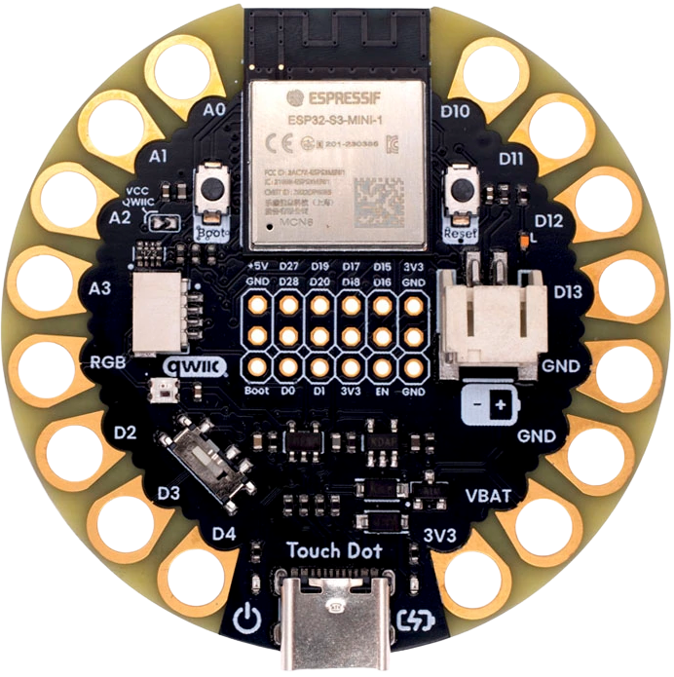

Applications
- Wearable electronics and e-textiles
- Capacitive-touch user interfaces
- Battery-powered IoT nodes and data loggers
- Educational embedded-system projects
- Interactive art and compact connected devices

Software Support
TouchDot S3 can be programmed through the Arduino ecosystem, MicroPython, or Espressif ESP-IDF. The repository includes setup notes and examples for GPIO, ADC, I²C, SPI/microSD, the WS2812 LED, wireless communication, and deep sleep.

Hardware Features
- Espressif ESP32-S3-MINI-1-N8 module with dual-core Xtensa LX7 CPU
- 2.4 GHz 802.11 b/g/n Wi-Fi and Bluetooth Low Energy
- 16 sewable pads: 11 multiplexed GPIO pads, one NeoPixel data pad, two ground pads, one battery-voltage pad, and one 3.3 V pad
- Capacitive-touch and analog functions exposed on the sewable pads
- USB-C connector for power, native USB data, programming, and charging
- PH 2.0 mm Li-ion/LiPo battery connector and onboard charge management
- QWIIC-compatible 4-pin I²C connector at 3.3 V
- microSD socket connected through SPI
- WS2812B-2020 addressable RGB LED and a user LED
- Boot and reset buttons, power switch, and power/charge indicators
- Expansion, serial-programming, JTAG, and USB test-point access

1 The Board

1.1 Package Contents
- 1 × TouchDot S3 development board (UE0072)
USB-C cable, Li-ion/LiPo battery, QWIIC cable, headers, microSD card, and external peripherals are not included unless stated by the distributor.

1.2 Board Identification
Item | Value
Product | UNIT TouchDot S3
Manufacturer part number | UE0072
Documented hardware revision | V0.1.2
Current released pinout artwork | V0.2.0
Main module | ESP32-S3-MINI-1-N8
Logic rail | 3.3 V
The hardware-revision value identifies the released schematic and mechanical artwork. The pinout-artwork revision identifies the drawing itself and does not change the board hardware revision.

2 Electrical Characteristics

2.1 Documented Operating Values
Symbol | Description | Value | Unit
VUSB | USB-C input supply | 5 | V
VCC | Digital logic and QWIIC supply | 3.3 | V
VBAT | Single-cell Li-ion/LiPo battery input | Battery rail | —
ADCRES | ADC resolution used by the board documentation | 12 | bit
FI2C | Typical I²C bus frequency | 400 | kHz
These are interface values documented by the project, not absolute maximum ratings. Refer to the ESP32-S3-MINI-1, regulator, charger, and peripheral component datasheets before designing near a component limit.

2.2 Electrical Precautions
- GPIO, touch, ADC, UART, SPI, and I²C signals use 3.3 V logic. Do not apply 5 V directly to an ESP32-S3 GPIO.
- Keep analog input voltage within the 3.3 V supply domain.
- Use a protected, compatible single-cell Li-ion/LiPo battery with the correct PH 2.0 connector polarity shown in the pinout.
- Turn the board off before changing wiring or inserting/removing a microSD card.
- The 5 V expansion pin is a power rail, not a 5 V-tolerant logic reference.

2.3 Power Paths
The board can be powered from USB-C or the battery connector. The AP2112K LDO provides the 3.3 V rail. The power switch controls normal board operation, while the onboard charge circuit supports battery charging from USB-C. The red PWR and amber CHRG indicators show power and charging state respectively.

3 Functional Overview

3.1 Processing and Wireless Connectivity
The ESP32-S3-MINI-1-N8 module provides the application processor, flash storage, 2.4 GHz Wi-Fi, and Bluetooth Low Energy. The board exposes native USB D+ and D− signals through USB-C and dedicated test points.

3.2 Wearable I/O
Large plated holes around the board edge may be soldered, clipped, or sewn with conductive thread. The signal pads expose GPIO1–4, GPIO7–11, GPIO17, GPIO18, and GPIO45. GPIO1–4 and GPIO7–11 also provide analog and/or capacitive-touch functions as marked on the board pinout.

3.3 User Feedback and Controls
- L3 / D13: user LED on GPIO7
- L4 / D25: WS2812B-2020 RGB LED data input on GPIO45; its data output is routed to the D25 sewable pad for chaining compatible LEDs
- PB1: Boot button associated with GPIO0
- PB2: Reset button connected to EN
- SW1: board power switch
- L1 / L2: power and charge indicators

3.4 I²C / QWIIC Expansion
The four-pin QWIIC-compatible connector exposes GND, 3.3 V, SDA/GPIO5, and SCL/GPIO6. Solder bridge SB1 enables the connector supply. The signal order and 3.3 V domain must be checked before attaching a cable or third-party module.

3.5 microSD Storage
The bottom-side microSD socket operates in SPI mode. GPIO21 is chip select, GPIO9 is MOSI, GPIO7 is SCK, and GPIO8 is MISO. Pull-up resistors for GPIO8, GPIO9, and GPIO21 are associated with the microSD interface.

3.6 Battery and USB-C
The PH 2.0 connector accepts a compatible single-cell Li-ion/LiPo battery. USB-C supplies power, charges the battery through the onboard charge circuit, and connects the ESP32-S3 native USB interface for programming and data.

3.7 Debug and Expansion Access
The board includes a 2 × 6 expansion header, a six-pin serial-programming row, JTAG test points, and USB D+/D− test points. These interfaces expose additional GPIO and system signals while preserving the compact circular form factor.
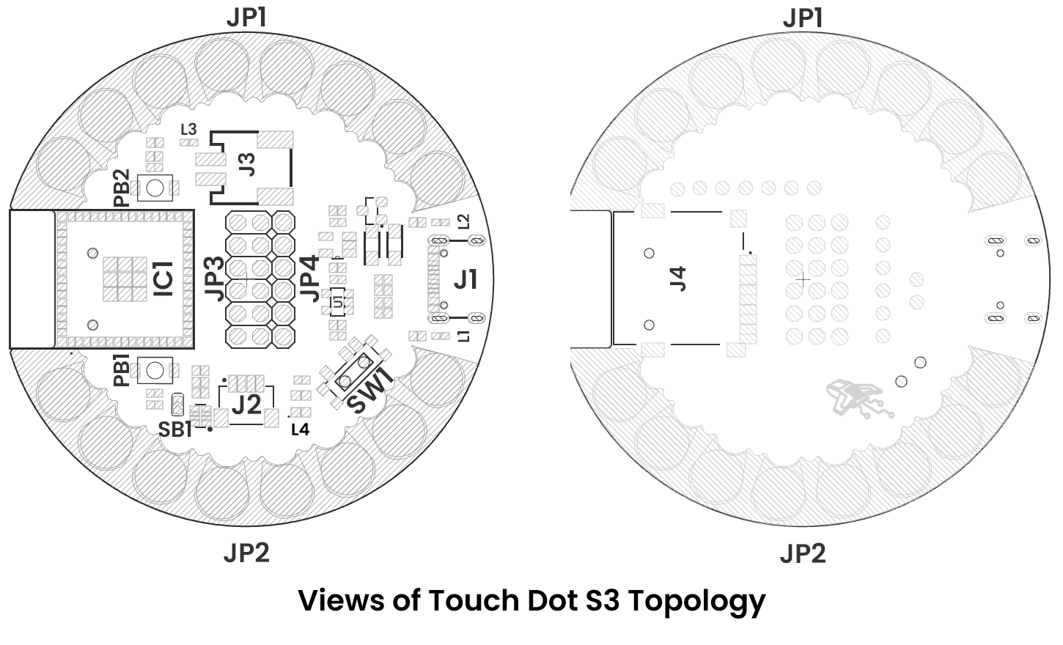
Reference | Description
IC1 | Espressif ESP32-S3 module
U1 | AP2112K 3.3 V LDO regulator
PB1 / PB2 | Boot / reset push buttons
SW1 | Power switch
L1 / L2 | Power / charge indicators
L3 | User LED on GPIO7 (D13)
L4 | WS2812B-2020 RGB LED on GPIO45 (D25)
SB1 | QWIIC VCC enable solder bridge
J1 | USB-C connector
J2 | QWIIC-compatible I²C connector
J3 | PH 2.0 battery connector
J4 | microSD socket
JP1 / JP2 | Sewable pads
JP3 / JP4 | GPIO, system, and power headers

4 Connectors and Pinouts

4.1 Top and Bottom Pinout
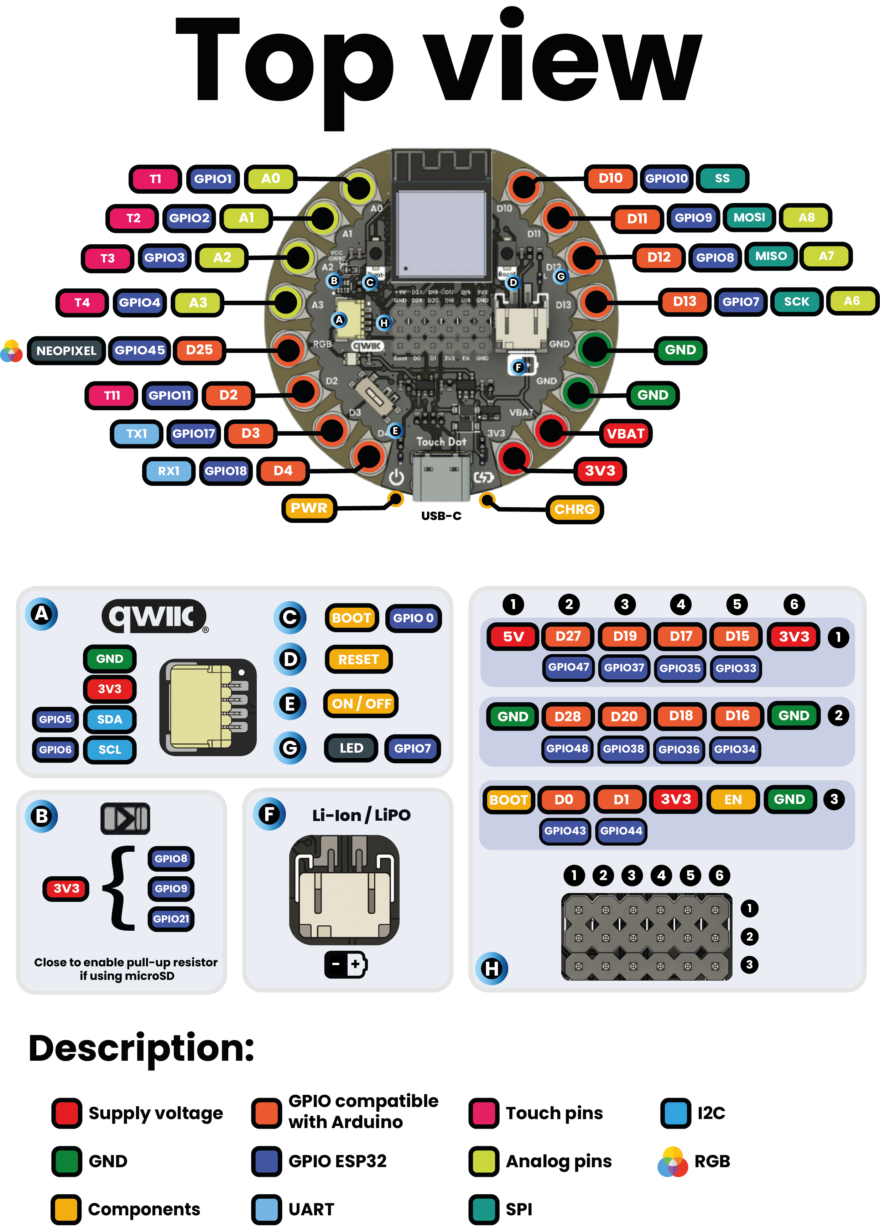
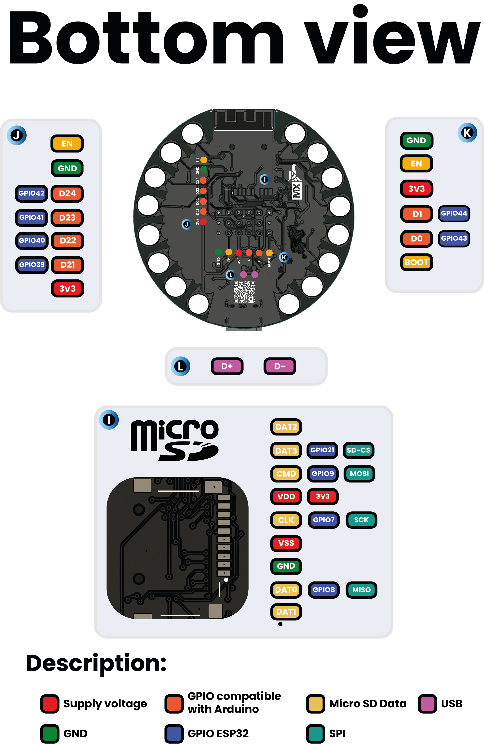

4.2 Sewable Pads
Board label | ESP32-S3 signal | Additional function
A0 / T1 | GPIO1 | ADC, touch
A1 / T2 | GPIO2 | ADC, touch
A2 / T3 | GPIO3 | ADC, touch
A3 / T4 | GPIO4 | ADC, touch
D25 / NeoPixel | GPIO45 | WS2812 data output
D2 / T11 | GPIO11 | Touch
D3 / TX1 | GPIO17 | UART1 TX
D4 / RX1 | GPIO18 | UART1 RX
D10 / SS / T10 | GPIO10 | SPI chip select, touch
D11 / MOSI / A8 / T9 | GPIO9 | SPI MOSI, ADC, touch
D12 / MISO / A7 / T8 | GPIO8 | SPI MISO, ADC, touch
D13 / SCK / A6 / T7 | GPIO7 | SPI clock, ADC, touch, user LED
GND (2 pads) | GND | Ground return
VBAT | Battery rail | Battery supply access
3V3 | 3.3 V rail | Regulated supply access

4.3 QWIIC-Compatible Connector (J2)
Pin | Signal | ESP32-S3 GPIO
1 | GND | —
2 | 3.3 V | —
3 | SDA / A4 / T5 | GPIO5
4 | SCL / A5 / T6 | GPIO6

4.4 microSD Socket (J4, SPI Mode)
microSD pin | Name | SPI function | ESP32-S3 GPIO
1 | DAT2 | Not used in SPI mode | —
2 | DAT3 / CD | CS | GPIO21
3 | CMD | MOSI | GPIO9
4 | VDD | 3.3 V | —
5 | CLK | SCK | GPIO7
6 | VSS | GND | —
7 | DAT0 | MISO | GPIO8
8 | DAT1 | Not used in SPI mode | —

4.5 Expansion Header (2 × 6)
Position | Row 1 | Row 2
1 | 5 V | GND
2 | D27 / GPIO47 | D28 / GPIO48
3 | D19 / GPIO37 | D20 / GPIO38
4 | D17 / GPIO35 | D18 / GPIO36
5 | D15 / GPIO33 | D16 / GPIO34
6 | 3.3 V | GND

4.6 Serial Programming Header (1 × 6)
Pin | Signal | ESP32-S3 connection
1 | GND | GND
2 | EN / Reset | EN
3 | 3.3 V | 3.3 V rail
4 | D1 | GPIO44 (RX0)
5 | D0 | GPIO43 (TX0)
6 | Boot | GPIO0
The D0/D1 labels follow the released board artwork. When connecting an external serial adapter, cross its TX and RX lines according to signal direction and verify the 3.3 V logic level.

4.7 JTAG and USB Test Points
Label | Signal
D21 | GPIO39 / MTCK
D22 | GPIO40 / MTDO
D23 | GPIO41 / MTDI
D24 | GPIO42 / MTMS
D+ | USB D+
D− | USB D−

5 Board Operation

5.1 First Power-Up
- Inspect the board for damage, debris, or shorts.
- With the power switch off, connect a data-capable USB-C cable to a computer or regulated 5 V USB supply.
- Move the power switch to ON. The PWR indicator should illuminate.
- Select an ESP32-S3 target in the chosen development environment and select the board’s USB serial port.
- If automatic download mode does not start, hold Boot, momentarily press Reset, and then release Boot.

5.2 Arduino LED Test
The following sketch checks the user LED on D13/GPIO7. GPIO7 is also the microSD clock, so do not run this test while accessing a card.
constexpr int LED_PIN = 7;
void setup() {
pinMode(LED_PIN, OUTPUT);
}
void loop() {
digitalWrite(LED_PIN, HIGH);
delay(500);
digitalWrite(LED_PIN, LOW);
delay(500);
}

5.3 QWIIC / I²C Test
The default documented I²C pins are SDA on GPIO5 and SCL on GPIO6. Confirm that SB1 enables QWIIC VCC before expecting the connector to power a peripheral.
#include <Wire.h>
void setup() {
Serial.begin(115200);
Wire.begin(5, 6);
for (uint8_t address = 1; address < 127; ++address) {
Wire.beginTransmission(address);
if (Wire.endTransmission() == 0) {
Serial.printf("I2C device: 0x%02X\n", address);
}
}
}
void loop() {}

5.4 microSD Use
Use SPI pins CS=GPIO21, MOSI=GPIO9, MISO=GPIO8, and SCK=GPIO7. Format a supported card with FAT32 before use. Because GPIO7 also drives the user LED and GPIO7–9 are exposed on sewable pads, attached circuits must not contend with the microSD bus.

5.5 Battery Operation
Turn the board off before attaching a battery. Check connector polarity against the released pinout, insert a compatible single-cell Li-ion/LiPo battery, and then turn the power switch on. When USB-C is connected, the CHRG indicator may illuminate while the onboard circuit charges the battery. Do not use a damaged, swollen, reversed-polarity, or incompatible battery.

5.6 Shared-Pin Considerations
The ESP32-S3 pin matrix permits multiple functions on a GPIO, but a physical pin can only serve compatible roles at a given time. In particular:
- GPIO7 is D13, A6/T7, user LED, and microSD SCK.
- GPIO8 is D12, A7/T8, and microSD MISO.
- GPIO9 is D11, A8/T9, and microSD MOSI.
- GPIO21 is the microSD chip-select signal.
- GPIO5 and GPIO6 are the default QWIIC I²C bus.
- GPIO45 drives the onboard WS2812 and the NeoPixel chain-output pad.
Plan firmware and external wiring so these functions do not conflict.

6 Mechanical Information
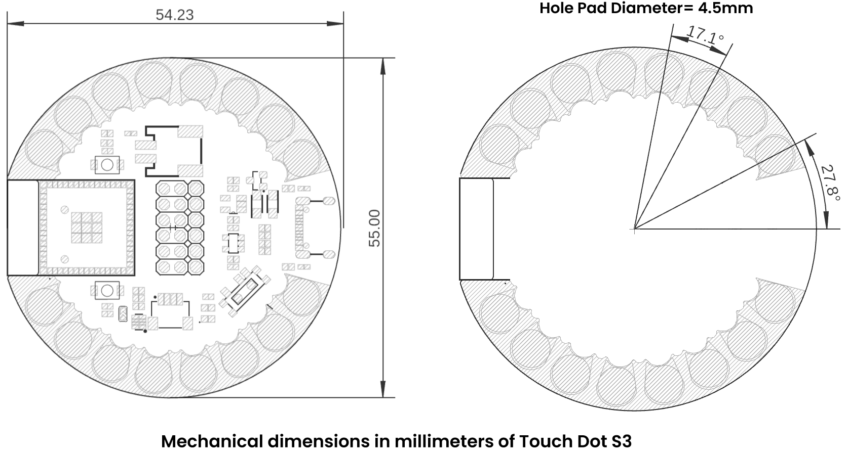
All dimensions are in millimeters unless otherwise noted. Use the released dimension drawing as the controlling reference for enclosure, textile, and mounting design. Allow clearance for the USB-C plug, battery connector, microSD card insertion, power switch, and any components soldered to the sewable pads or expansion headers.

7 Company Information
Item | Information
Company | UNIT Electronics
Website | https://uelectronics.com/
Address | Salvador 19, Cuauhtémoc, 06000 Mexico City, CDMX, Mexico
Product specifications and documentation may be revised. Use the repository and product page listed in the next chapter for the latest released material.

8 Reference Documentation
Reference | Link
Product wiki | wiki.uelectronics.com/wiki/unit-touchdot-s3
GitHub repository | github.com/UNIT-Electronics-MX/unit_touchdot_s3
Product page | uelectronics.com/producto/unit-touchdot-s3
Hardware resources | repository hardware directory
ESP32-S3 documentation | Espressif ESP32-S3
Arduino IDE | arduino.cc/en/software
Thonny IDE | thonny.org
Visual Studio Code | code.visualstudio.com

9 Appendix

9.1 Schematic
The released V0.1.2 schematic is available in the repository:
TouchDot S3 schematic PDF

9.2 Source Hierarchy and Revision Notes
This product reference consolidates the maintained repository README, hardware README, V0.1.2 schematic and mechanical/topology artwork, V0.2.0 pinout artwork, and the existing programming documentation. If values conflict, use the newest released hardware source for the applicable board revision and verify the signal on the physical board before connecting external hardware.
The serial D0/D1 Arduino labels differ between some legacy text and the current V0.2.0 pinout artwork. This document follows the V0.2.0 artwork for its header table and retains the underlying GPIO numbers so users can identify the signal unambiguously.

9.3 Document Control
Field | Value
Product | TouchDot S3
Manufacturer part number | UE0072
Hardware revision covered | V0.1.2
Pinout artwork used | V0.2.0
Product-reference revision | 1.0.0
Publication date | 2026-07-31

